***perform Importing table contents from Mysql to Hive using Sqoop.***

*INPUT:-*

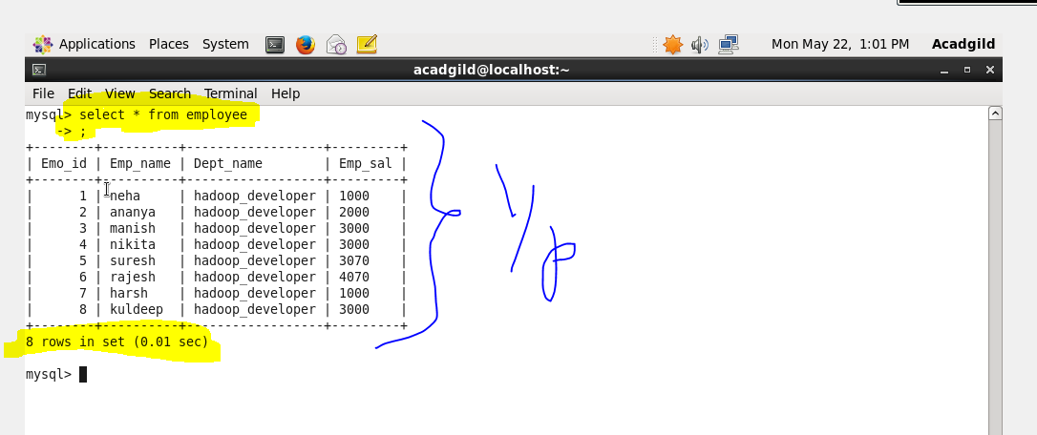

*IMPORT AND ITS EXPLANATION :-*

*Sqoop import-import is used when we are importing data from rdbms to Hadoop ecosystem*

*connect -> It is used to give the JDBC Url of database*

*Username🡪user name of database*

*P🡪password of database*

*table 🡪 give the table you want to copy from MySql*

*target-dir🡪 temporary target directory used by Sqoop for transferring which will be deleted after the import is finished*

*hive-import🡪 Indicating a hive import*

*hive-table🡪table which will be created and on which data will be written(in our case employee-mysql)*

*m1🡪number of mappers that should run*

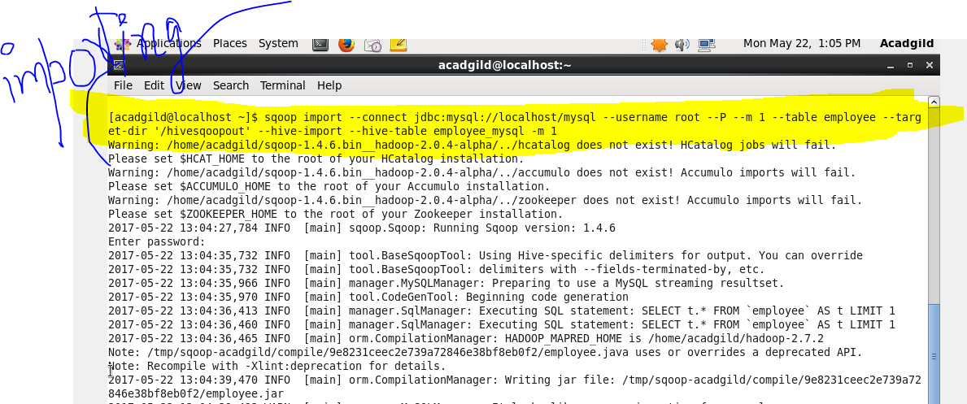

*the table is successfully imported to HIive:-*

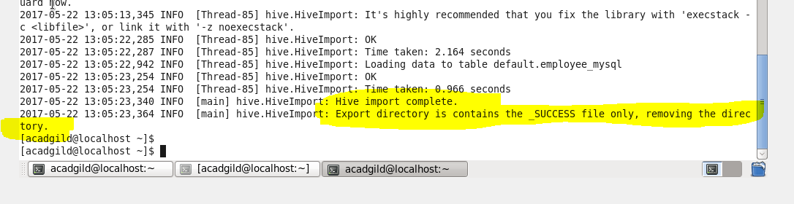

*OUTPUT:-*

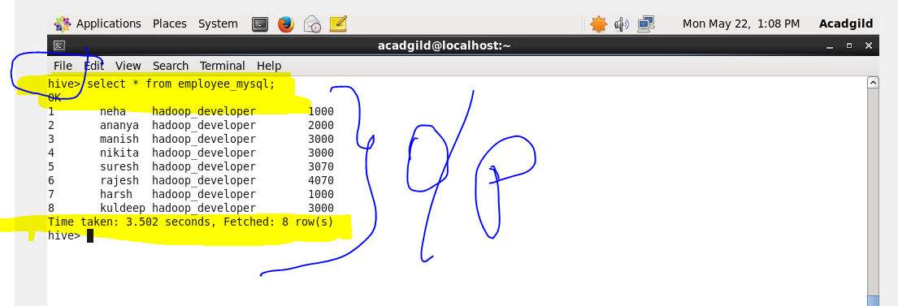

*->Explain and perform Importing table contents from Mysql to HBase using Sqoop:-*

*INPUT:-*

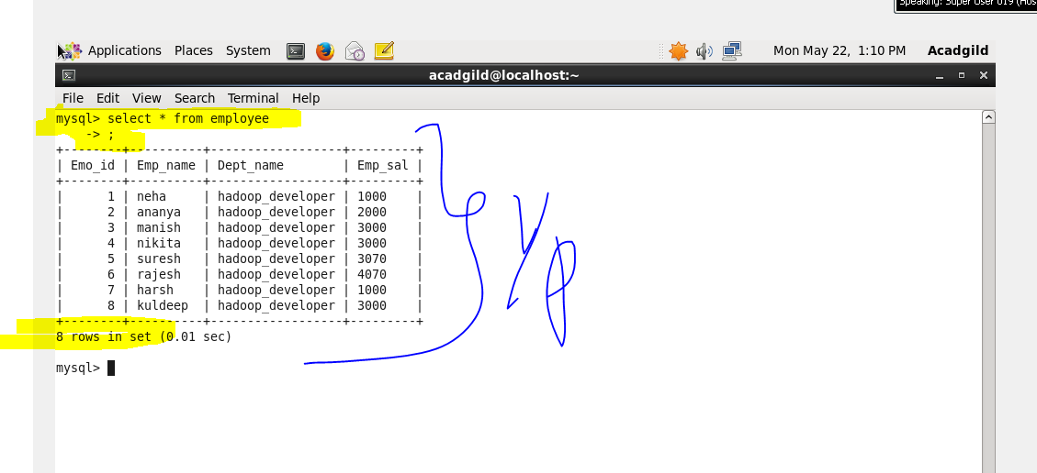

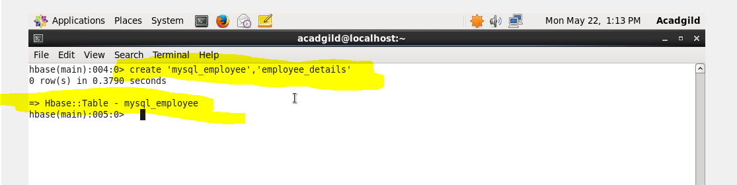

*SQOOP COMMAND TO IMPORT AND ITS EXPLANATION :-*

*Sqoop import-import is used when we are importing data from rdbms to Hadoop ecosystem*

*connect -> It is used to give the JDBC Url of database*

*Username🡪user name of database*

*P🡪password of database*

*table 🡪 give the table you want to copy from MySql*

*h base-table🡪 the table in Hbase where It should be copied(here it is My sql_ employee)*

*-olumn family🡪given the column family as employee details*

*H base-row key 🡪which column should be taken as row key*

*-m1🡪number of mappers that should run*

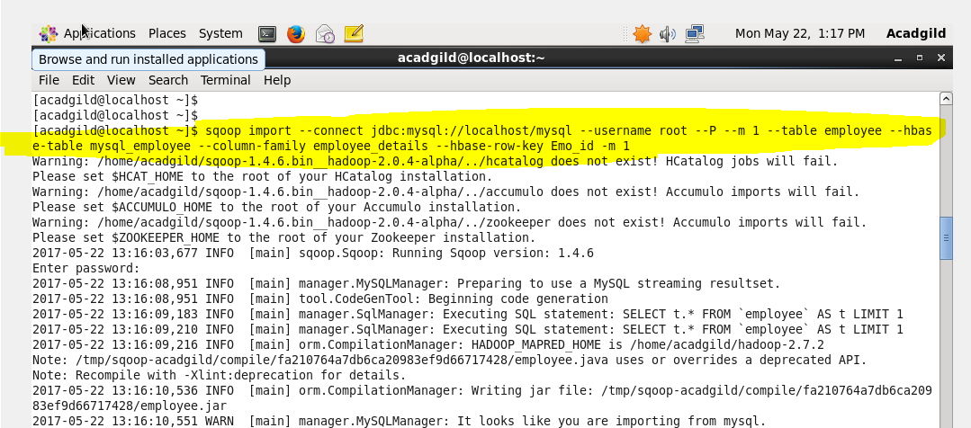

*From the above picture the table is successfully imported to Hbase:-*

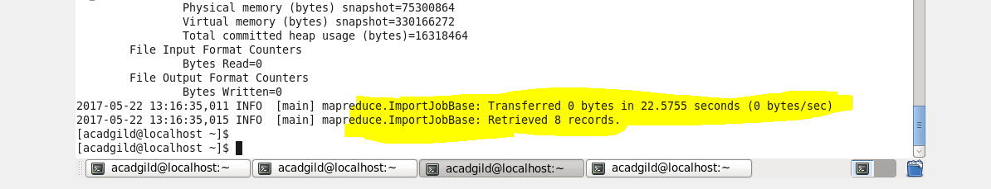

*OUTPUT:-*

