*Task 1 remove commas present inside double quotes*

Driver :

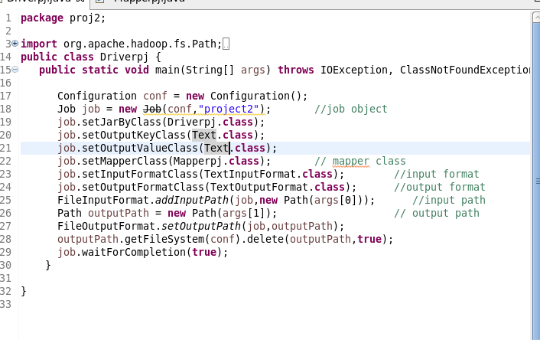

Mapper:

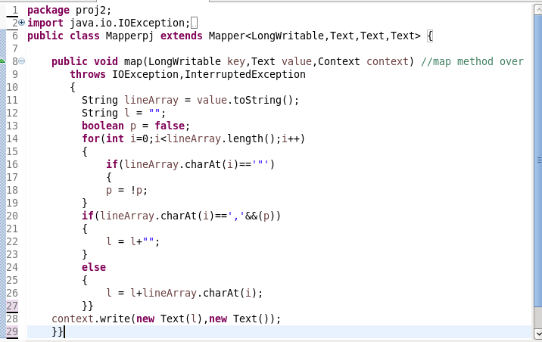

*Jar file:*

*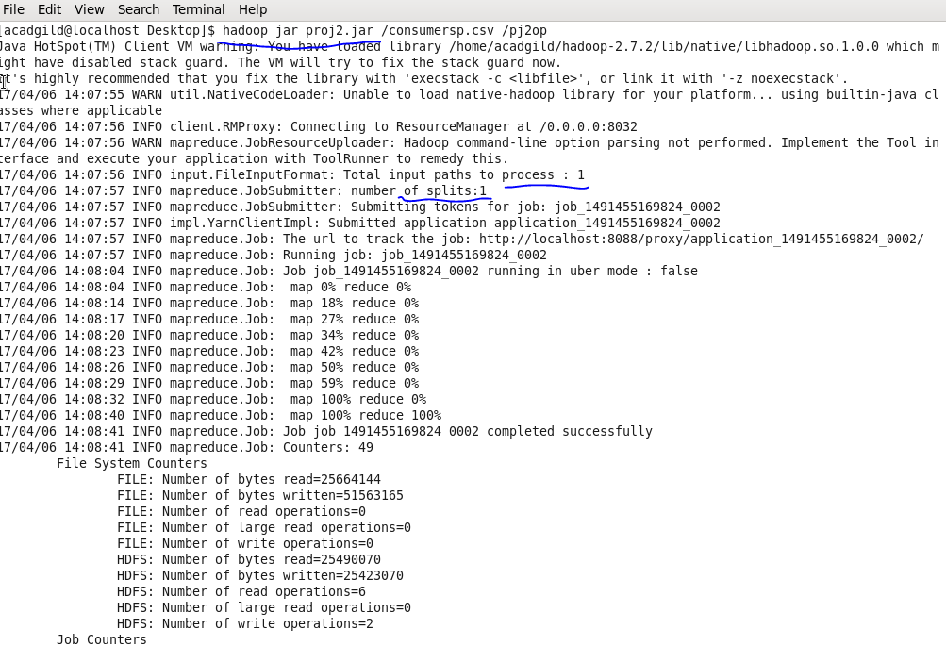*

*O/P:*

*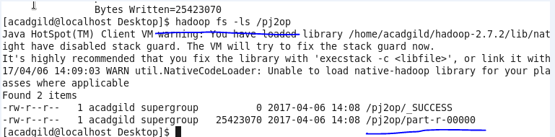*

*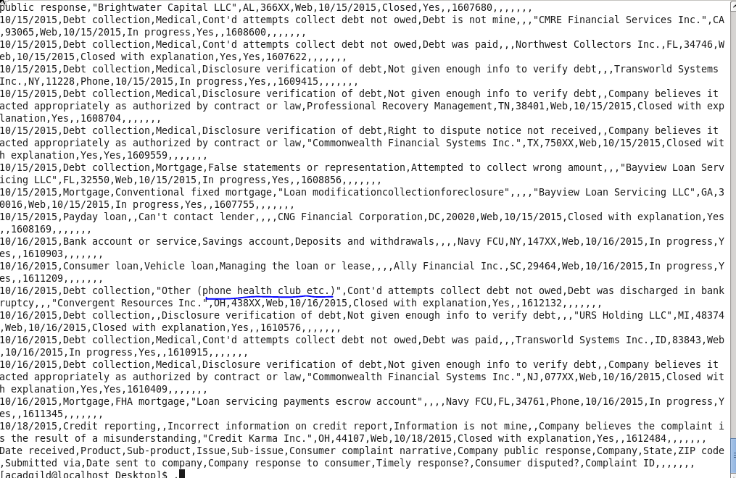*

*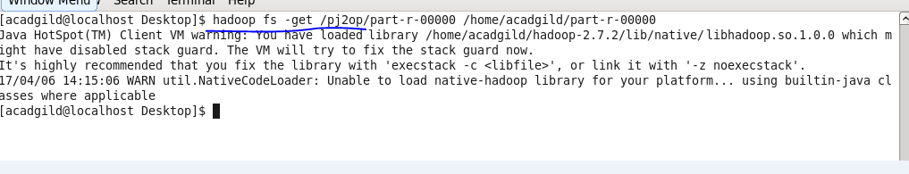*

*Task1*

*Wap to get no of complaints which got timely response:*

*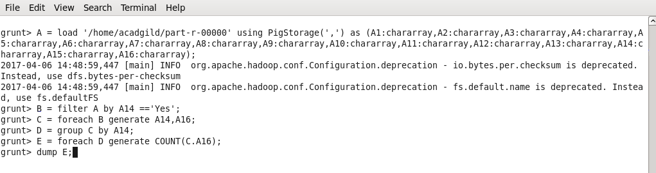*

*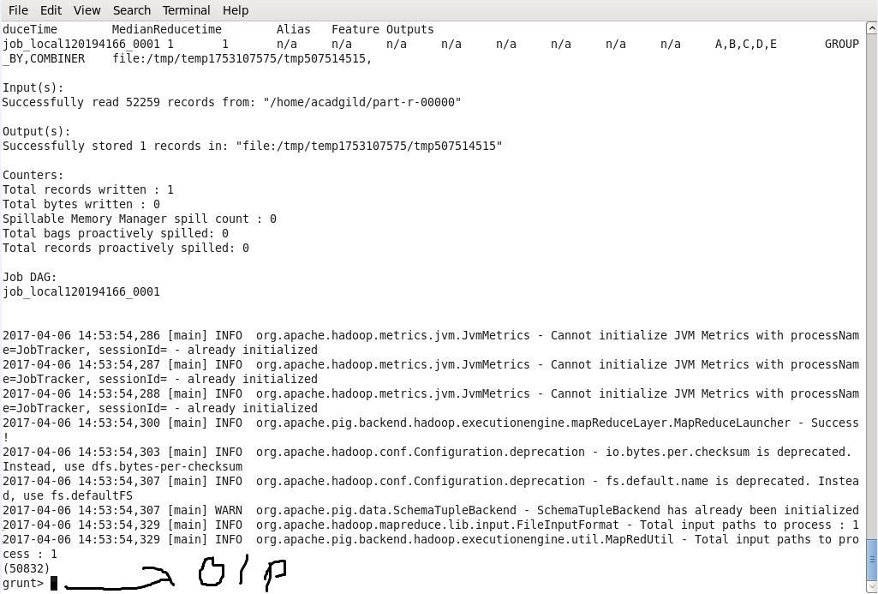*

*Task 2*

*No of complaimnt forwarded (consumer forum):*

*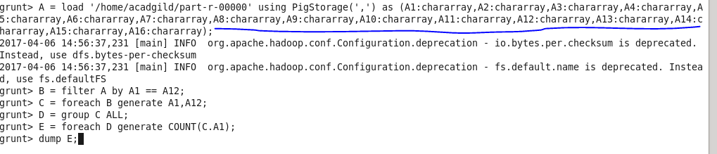*

*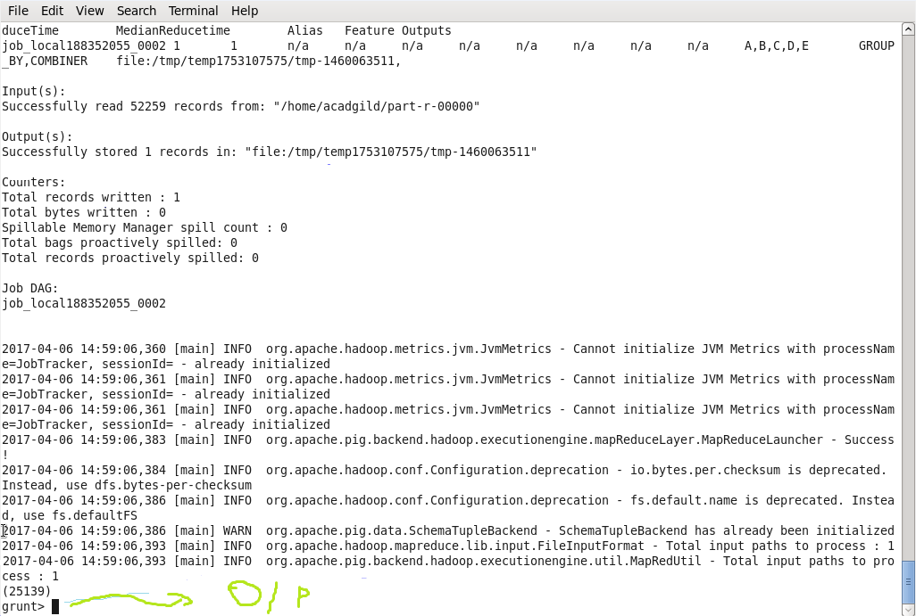*

*Task 3*

*List of companies topping in complain chart:*

*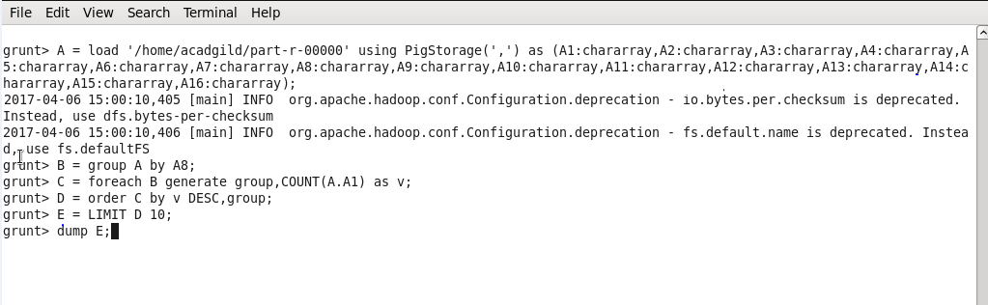*

*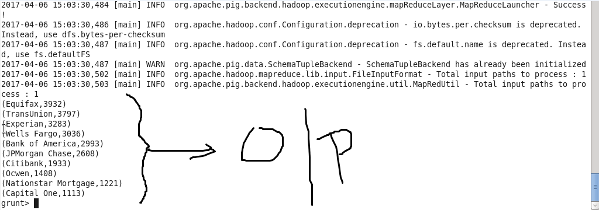*

*Task 4:*

*No of complaints with product type debt collection*

*