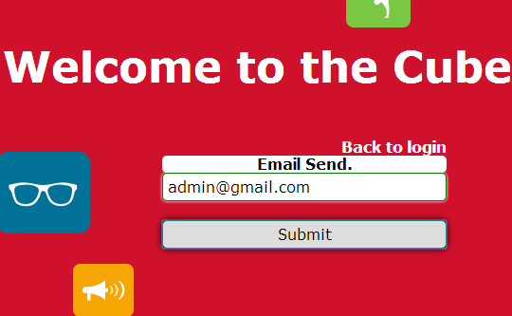

Pops up should be “ mail sent successfully”

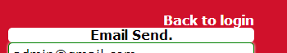

“Back to login” login is a little bit touching the pops up box. There should be gap

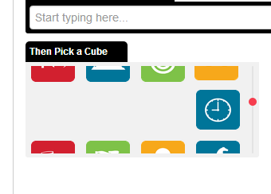

After posting a cube we get changed image icon of cube creating GUI issue

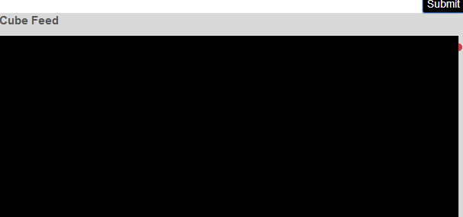

After posting a cube we get this image from cube feed > cube sent

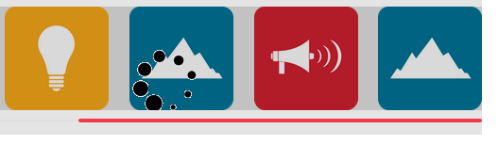

In profile > cube image is getting hided by the screen background.

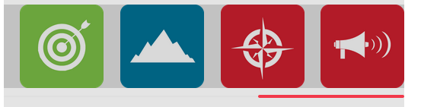

In profile > cube image is getting hided by the screen background > cube received

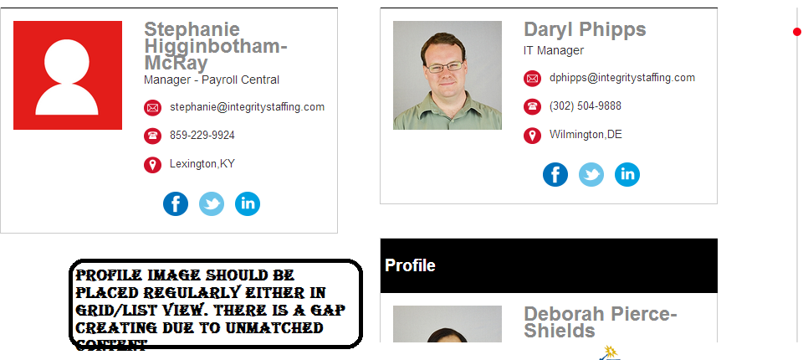

Search then go to profile and there is some problem with name and its position as it is not aligned properly specially when name contains long character or position contents long character

cube icon when is selected, it should be covered with deep line and without any pixcel gap at the corner. As there is some pixceleted gap at the corner

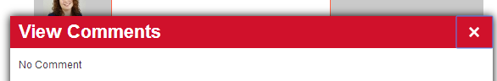

During cancel if user go to close button it creates an automatically a box structure which should not be there.

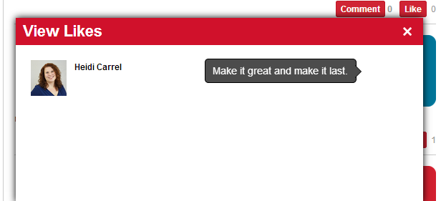

When user takes cursor to the corner a part of cube is shown there, on hovering cursor it populates cube description on likes box /page as shown. It should be like this that particular cube should not show such details when there is something on it like comment box or like page

It confuse users how it’s coming on blank page.

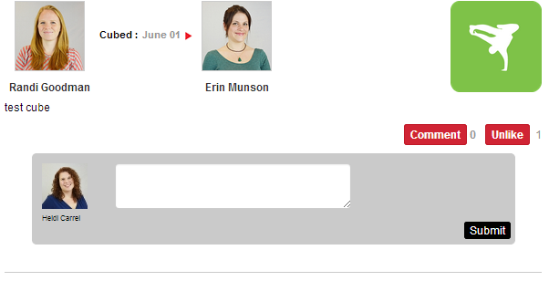

On clicking comment this box is populated > after that if a user click on box then automatically application get rolled up or down

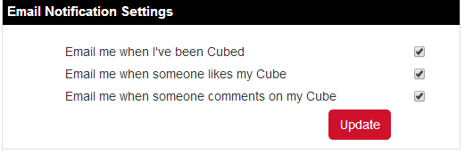

Update button should be aligned properly either at the side or in the middle.

In cube translator many of the cube are not getting clicked.