**GREEN COMET FUNCTIONALITY ISSUE AND BUGS REPORT DATED 29/4/2014**

* Password is not getting updated with new password or old password is not getting change with new password.
* In virtual task > create a task > and without saving it > make it publish

Then during edit option the screen comes like this

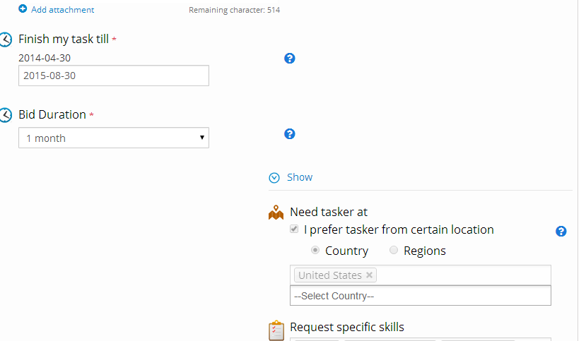

* In the same page during edit option > try to upload a new image as it was not uploaded earlier then sometimes image is not getting uploaded successfully
* Again there must be hand cursor at all functional buttons and link
* During updating of post task > go for editing country location > then new country list windows appears which is not clear it display not readable list of country. It should be properly visible.

Check with snapshot attached below

* 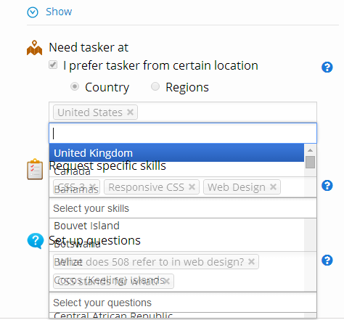
* On every page this is shown which is not properly aligned. It should be aligned properly

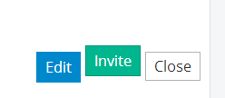

* Send request page > click on a person name > to send request page then details comes up in new window > as shown in below page
* This below message is coming at right side of the screen at connection and tasks functions

No need of this message or make it fully functional

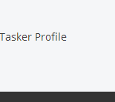

* 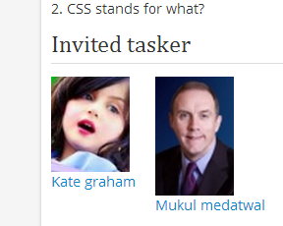
* During the step of post task option we find these three option at heading as shown below

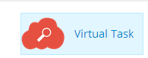 1 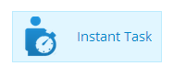2

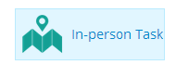3

* Just compare with these two figures shown above match the pattern of written text one is touching the boundary while 3rd one is good. but the best one is 2nd .

All these should be like 2nd one which is best among all the three.

* Spelling mistake. Its “Description” not “discription”
* 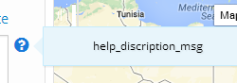
* Below shown snap is in grid view but shown there as list view that should be corrected

Either there should be grid view at the place of list view or the format should be changed

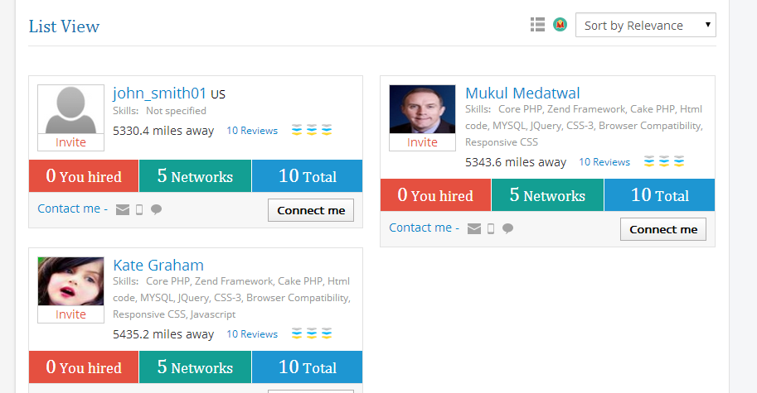

* In same page “connect me” button do not work. Its not functional.