**GREEN COMMETS BUGS REPORT ON 26/03/2014**

**VIRTUAL TASK ISSUE**

* **Create task option**

**Comment:-After description …attachment option is not responding it’s not displaying image after uploading**

**Actual: - It should display the image i.e. uploaded**

* **Region option to choose tasker location is not responding**

**Comment:-If users enter any region name it is not accepted**

**Actual: - it should accept the character entered by the user**

* **After publish...in select country option**

**Comment:-Region is not editable**

**Actual:- If country is changed then accordingly region can also be changed**

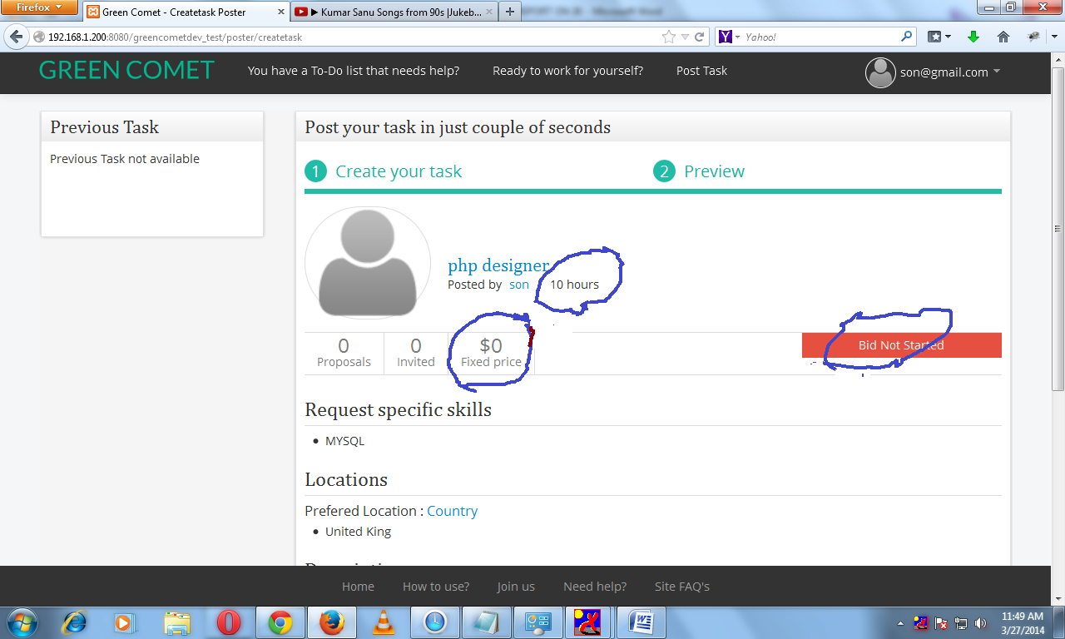

* **In given snap ….bugs are**

1. **By default estimated hour is showing 10 hours only ….however user enters any other value**
2. **Fixed price ….this price is accepting zero value which should not be actually**
3. **For any start date and end date sometimes …it shows bid not started**

* **If difference between start date and end date is 20 days**

1. **Bid duration as 1 month > then publish or save > it shows 7 days left**

**INPERSON TASK ISSUE**

* **I am willing to pay …it takes any value for any number and popup is displayed according to the amount entered by the user**

This task requires $0– do you have $0 to use on this task? This is displayed for all value i.e. if 2 then popup for 2 and like that

* **Fully Editable it is not like virtual task option as there was editing option with new edit space**

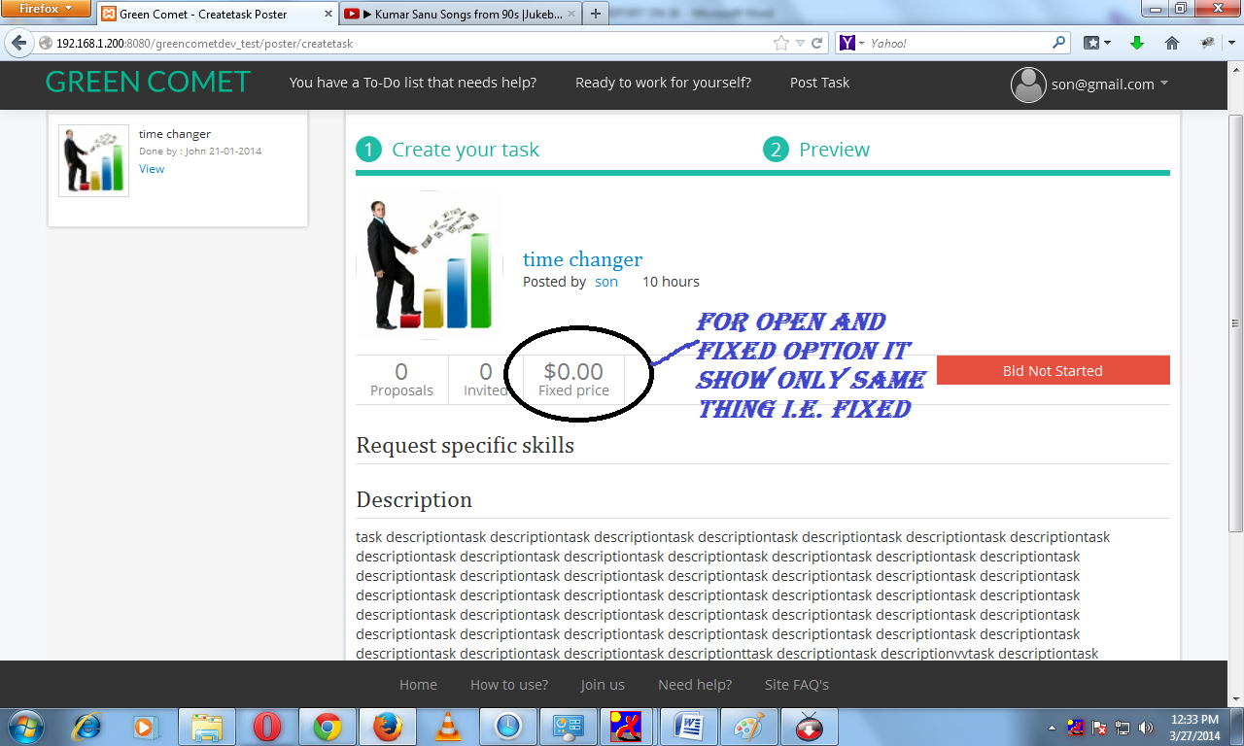

* **In the given snap check the box written in blue letter and marked as black circle**

**But after close or posting it shows its original status**

**INPERSON TASK**

* **In this case during edit option**

1. **Only description part and miles is editable and rest is not then what is the use of edit button**

**GREEN COMET BUGS REPORT ON 31/03/2014**

**PROFILE OPTION**

* **In name it accepting only numbers however it pops up message that “alphabets are allowed” but if user enters only numbers then it accepted**
* **In contact information …in phone number option if user enters only alphabets then it do not show any pops up rather it gets accepted. in this box all characters are allowed**
* **Chat id and social media it allows all characters even blank …after update click it takes a lots of time in updating**
* **In address information after selecting country ….others selection is not working**

**ABOUT US**

* **In this option certificates and tag line option accepts any value like. (dot) tag line also accepting null value**

**ACCOUNT SETTING**

* **In card details**

**Card name accepting dot value**

**Card number ….after entering number it pops up a message to enter numbers**

**PORTFOLLIO**

* **In task name pops up is not shown properly**
* **Reference is not working i.e. if it sets to dot value it do not shows any pops up**
* **Task finish date is accepting old date which should not be**

**NOTIFICATION**

* **In billing address first box do not shows message properly shows only red line**
* **State , region, city is not displayed properly**
* **Zip code accepting any value i.e. dot also**

**MY TASK**

* **In this option most of the things are still not working**
* **Search option select task, archive option etc**

**CHANGE PASSWORD**

* **Old password option …pops up is not displayed properly**

**SOME MORE STUFFS**

1. **Button color of invite option should be of same as edit or it should be changed after its working**

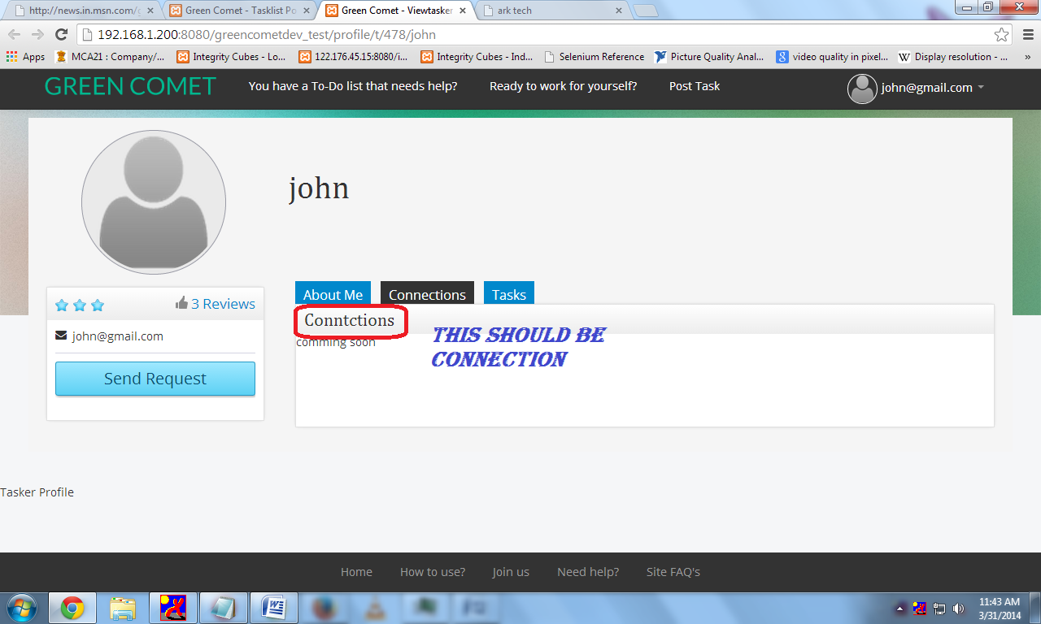

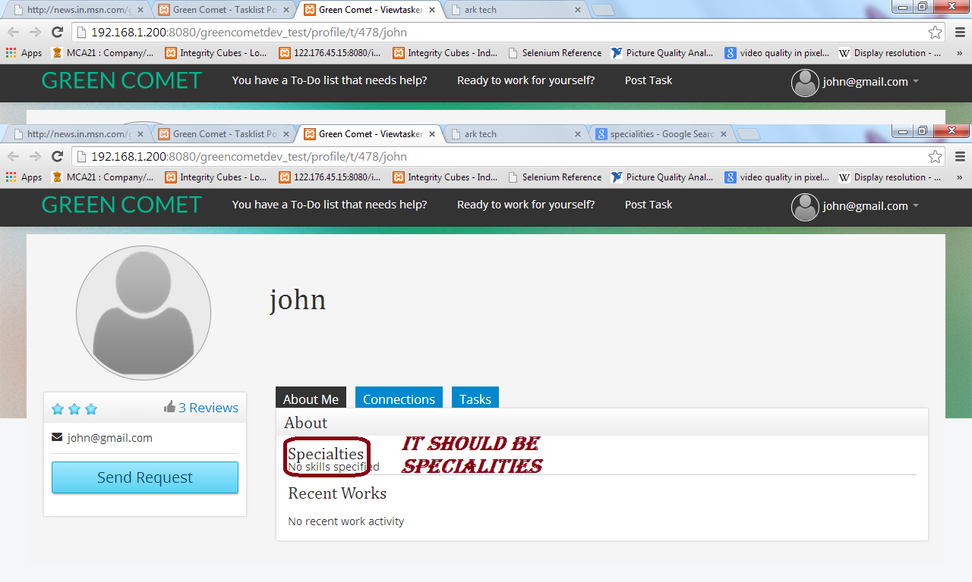

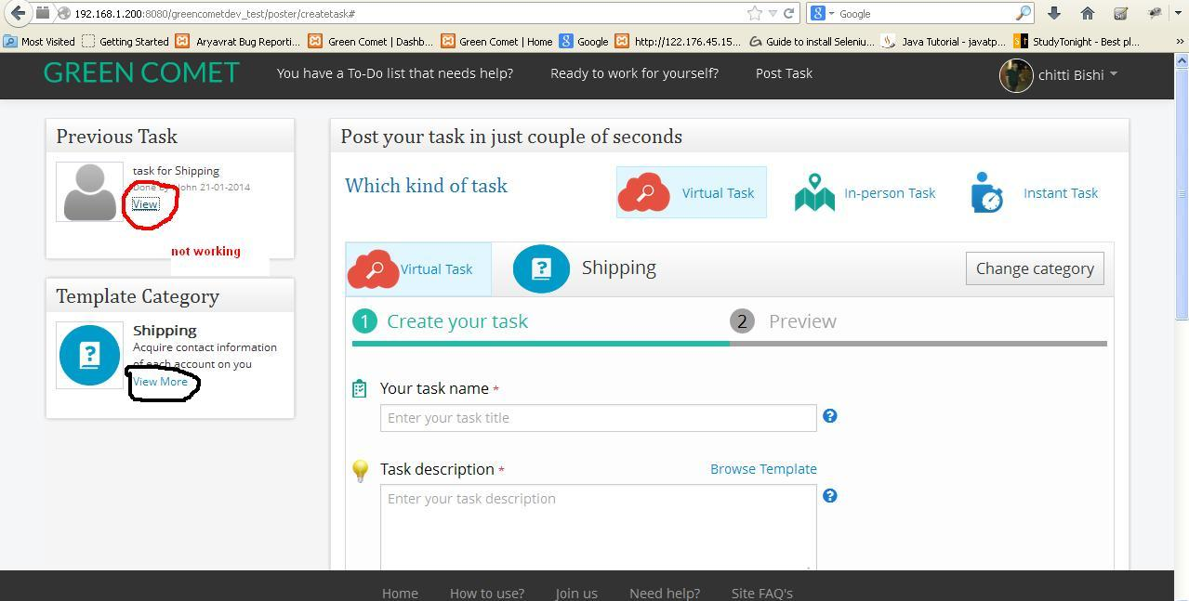

**View button is not working for the special cases in two scenarios**