Student Fees Manager

A Project Work
Submitted in partial fulfillment of Bachelor of Engineering (BE)

In
Computer Science & Engineering
(Session: 2018-19)



Submitted By

Name

Enroll No:

Name

Enroll No:

Name

Enroll No:

Name

Enroll No:

Under the Guidance of

Prof. ---------------------------

(Computer Sc. & Engg.)

DEPARTMENT OF COMPUTER SCIENCE & ENGINEERING
Shri Ram Institute of Science & Technology, Jabalpur (M.P.)
Rajeev Gandhi Proudyogiki Vishwavidyalaya, Bhopal (M.P.)


CERTIFICATE

This is to certify that
--------------NAme------------------
Enroll. No : ****************
-----------------NAme----------------
Enroll. No : ******************
---------------NAme------------------
Enroll. No: ******************
Students of 6th semester, Computer Sc. & Engg. S.R.I.S.T., Jabalpur have duly completed their minor project entitled “Student Fees Manager” for the partial fulfillment of the requirement for the degree of Bachelor of Engineering as per R.G.P.V., Bhopal.

They have successfully implemented and tested this project, which meets all the requirements specified under my guidance.

Prof. ----------------------------- Dr. ----------------------------
(Project Guide ) (Principal)

CERTIFICATE

This is to certify that
--------------NAme------------------
Enroll. No : ****************
-----------------NAme----------------
Enroll. No : ******************
---------------NAme------------------
Enroll. No: ******************

Students of 6th semester, Computer Sc. & Engg. S.R.I.S.T., Jabalpur have duly completed their minor project entitled “Student Fees Manager” for the partial fulfillment of the requirement for the degree of Bachelor of Engineering as per R.G.P.V., Bhopal.

They have successfully implemented and tested this project, which meets all the requirements specified under my guidance.

INTERNAL EXAMINOR EXTERNAL EXAMINOR

DATE: DATE:

ACKNOWLEDGEMENT

We sincerely express indebtedness to esteemed and revered guide “---------------------”, Lecturer in COMPUTER SCIENCE DEPARTMENT for her invaluable guidance, supervision and encouragement throughout the work. Without his kind patronage and guidance the synopsis would not have taken shape.

We take this opportunity to express deep sense of gratitude to “/---------------------------”, Head of “COMPUTER SCIENCE” for his encouragement and kind approval. Also we thank him in providing the computer lab facility. We would like to express our sincere regards to him for advice and counseling from time to time.

We owe sincere thanks to all the lecturers in “COMPUTER SCIENCE” for their advice and counseling time to time.

Dated: Name 1
Place: JABALPUR Name 2
Name 3
Name 4

DECLAREATION

We hereby declare that the project synopsis entitled “Student Fees Manager” which is being submitted in partial fulfillment of the requirement for award of the Degree of Bachelor of Engineering in Computer Science and Engineering to “RAJIV GANDHI PROUDYOGIKI VISHWAVIDYALAYA, BHOPAL (M.P.)” is an authentic record of our own work done under the guidance of Prof. --------------------, Department of Computer Science & Engineering, SHRI RAM INSTITUDE OF SCIENCE AND TECHNOLOGY.

The matter has not been submitted earlier for the award of any other degree.

Dated: Name 1
Place: JABALPUR Name 2
Name 3
Name 4
INDEX

- INTRODUCTION 10
- ANALYSIS 14
  - OBJECTIVE OF PROJECT
  - REQUIREMENT GATHERING
  - FEASIEILITY STUDY
  - HARDWARE REQUIREMENT
  - SOFTWARE REQUREMENT
  - TOOLS USED
  - SOFTWARE REQUREMENT LIFE CYCLE
  - COST ESTIMATION
- DESIGN
  - INPUT REQUIREMENT
  - USE CASE DIAGRAM
  - CLASS DIAGRAM
  - ER DIAGRAM
  - DATA FLOW DIAGRAM
  - CONTROL FLOW DIAGRAM
  - SYSTEM FLOW DIAGRAM
- CODING
- TESTING
- OUTPUT
- SWOT ANALYSIS
- CONCLUSION
- REFERENCE

INTRODUCTION

1.1 Introduction:
This project “Student Fees Management System” provides us a simple interface for maintainance of student information.It can be used by educational institutes or colleges to maintain the records of students easily. Achieving this objective is difficult using a manual system as the information is scattered, can be redundant and collecting relevant information may be very time consuming. All these problems are solved using this project. Throughout the project the focus has been on presenting information in an easy and intelligible manner.

The project provides facilities profile creation of students thus reducing paperwork and automating the record genreration process in an educational institution.

Scope of the Project:-
Without a Student Fees Managment System, managing and maintaining the details of the student is a tedious job for any organization. Student Information system will store all the details of the students including their background information, educational qualifications, personal details and all the information related to Student .
Purpose of project is to maintain details of the students such as storing
information about:
- Student id
- Student password
- Student name
- Student DOB
- Student mailing address
- Gender
- Registration date
- Student status
- Contact no
- Qualification
- City
- Resume
- Image

1.3 MODULES:
The entire project mainly consists of
1 modules, which is
- Institute module
1.3.1 Institute module:
- Regitration
- Add Student.
- Add Courses.
- Update Courses.
- Update Profile
- Update password
- Remove student
- See enquiry
- Submit fees
- Analystics
- Print Reciepts
- Export – Import
- Mail Database

Analysis

OBJECTIVES OF PROJECT

Objective:-
The objective of Student Fees Management System is to allow the administrator of any organization to edit and find out the personal and allows details of a student the student to keep up to date his profile .It’ll also facilitate keeping all the records of students, such as their id, name, mailing address, phone number, DOB etc. So all the information about A student will be available in a few seconds. Overall, it’ll make Student Information Management an easier job for the administrator and the student of any organization. The main purpose of this SRS document is to illustrate the requirements of the project Student information System and is intended to help any organization to maintain and manage its student’s personal data.
- Personal details: Details of student such as user id, phone number, address, image, resume, e-mail address etc.
- Contact details: Details of contact associated with the student.
- SRS: System requirement Specification
- Administrator: A Login Id representing the user is an administrator & can access all the records details

1.3 MODULES:
The entire project mainly consists of 7 modules, which are
- Admin module ( Institute )

1.3.1 Institute module:
- Regitration
- Add Student.
- Add Courses.
- Update Courses.
- Update Profile
- Update password
- Remove student
- See enquiry
- Submit fees
- Analystics
- Print Reciepts
- Export – Import
- Mail Database
- And Many more
REQUIREMENT SPECIFICATION

2.1 INTRODUCTION:
To be used efficiently, all computer software needs certain hardware components or the other software resources to be present on a computer. These pre-requisites are known as(computer) system requirements and are often used as a guideline as opposed to an absolute rule. Most software defines two sets of system requirements: minimum and recommended. With increasing demand for higher processing power and resources in newer versions of software, system requirements tend to increase over time. Industry analysts suggest that this trend plays a biggerpart in driving upgrades to existing computer systems than technological advancements.

3.3 FEASIBILITY STUDY

The feasibility of the project is analysed in this phase and business proposal is put forth with a very general plan for the project and some cost estimates. During system analysis the feasibility study of the proposed system is to be carried out. This is to ensure that the proposed system is not a burden to the company. For feasibility analysis, some understanding of the major requirements for the system is essential.

Three key considerations involved in the feasibility analysis are:

3.3.1 Economic Feasibility

This study is carried out to check the economic impact will have on the system will have on the organization. The amount of fund that the company can pour into the research and development of the system is limited. The expenditures must be justified. Thus the developed system as well within the budget and this was achieved because most of the technologies used are freely available. Only the customised products have to be purchased.

3.3.2 Technical Feasibility

This study is carried out to check the technical feasibility, that is,the technical requirements of the system. Any system developed must not have a high demand on the available available technical resources. This will lead to high demands being placed on the client. The developed system must have a modest requirement, as only minimal or null changes for the implementing this system.

3.3.3 Operational Feasibility

The aspect of study is to check the level of acceptance of the system by the user. This includes the process of training the user to use the system efficiently. The user must not feel threatened by the system, instead must accept it as a necessity. The level of acceptance by the users solely depends on the methods that are employed to educate the user about the system and to make him familiar with it. His level of confidence must be raised so that he is also able to make some constructive criticism, which is welcomed, as he is the final user of the system.

2.2 HARDWARE REQUIREMENTS:

The most common set of requirements defined by any operating system or software application is the physical computer resources, also known as hardware. A hardware requirements list is often accompanied by a hardware compatibility list (HCL), especially in case of operating systems. An HCL lists tested, compatibility and sometimes incompatible hardware devices for a particular operating system or application. The following sub-sections discuss the various aspects of hardware requirements.

HARDWARE REQUIREMENTS FOR PRESENT PROJECT:
PROCESSOR : Intel dual Core, i3
RAM : 1 GB
HARD DISK : 80 GB

2.3 SOFTWARE REQUIREMENTS:

Software Requirements deal with defining software resource requirements and pre-requisites that need to be installed on a computer to provide optimal functioning of an application. These requirements or pre-requisites are generally not included in the software installation package and need to be installed separately before the software is installed.

SOFTWARE REQUIREMENTS FOR PRESENT PROJECT:

OPERATING SYSTEM | Windows 7/ XP/8
FRONT END AND BACK END | Java Fx
TOOLS | Netbeans , Scene builder , SQLite Express
DATABASE | SQLite Database

CLIENTS AND TOOLS:
NETBEANS - NetBeans is an integrated development environment (IDE) for Java. NetBeans allows applications to be developed from a set of modular software components called modules. NetBeans runs on Windows, macOS, Linux and Solaris. In addition to Java development, it has extensions for other languages like PHP, C, C++, HTML5,[4] and JavaScript. Applications based on NetBeans, including the NetBeans IDE, can be extended by third party developers.

JavaFX Scene Builder - A Visual Layout Tool for JavaFX Applications
JavaFX Scene Builder is a visual layout tool that lets users quickly design JavaFX application user interfaces, without coding. Users can drag and drop UI components to a work area, modify their properties, apply style sheets, and the FXML code for the layout that they are creating is automatically generated in the background. The result is an FXML file that can then be combined with a Java project by binding the UI to the application’s logic.

SSQLITE EXPERT: THE EXPERT WAY TO SQLITE
SQLite Expert is a powerful tool designed to simplify the development of SQLite3 databases. It is a feature rich administration and development tool for SQLite designed to answer the needs of all users from writing simple SQL queries to developing complex databases.
The graphical interface supports all SQLite features. It includes a visual query builder, an SQL editor with syntax highlighting and code completion, visual table and view designers and powerful import and export capabilities.
Supported platforms: Windows 2000, XP, Vista, 7, 8, 10.

SOFTWARE DEVOLPMENT LIFE CYCLE

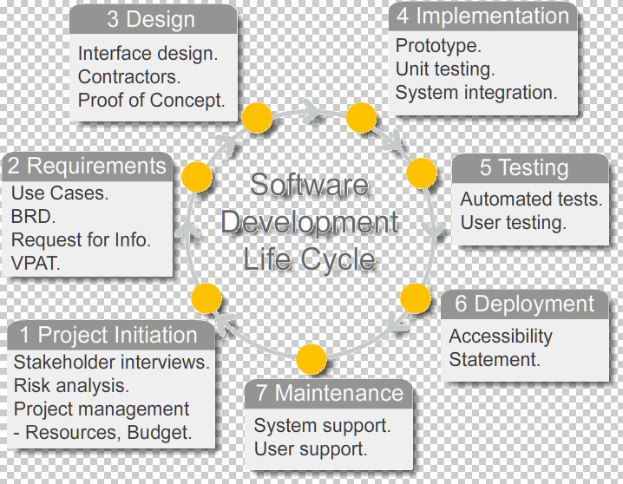

Software cost estimation

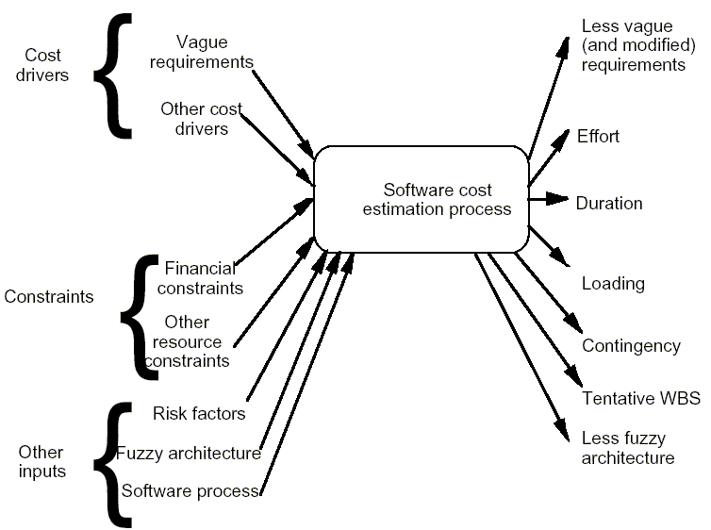

CHAPTER 4
DESIGN

4.1 SYSTEM DESIGN:

4.1.1INTRODUCTION TO UML:

UML Design

The Unified Modeling Language (UML) is a standard language for specifying, visualizing, constructing, and documenting the software system and its components. It is a graphical language , which provides a vocabulary and set of semantics and rules. The UML focuses on the conceptual and physical representation of the system. It captures the decisions and understandings about systems that must be constructed. It is used to understand, design, configure, maintain, and control information about the systems.

The UML is a language for:

- Visualizing

- Specifying

- Constructing

- Documenting

Visualizing

Through UML we see or visualize an existing system and ultimately we visualize how the system is going to be after implementation. Unless we think, we cannot implement. UML helps to visualize, how the components of the system communicate and interact with each other.

Specifying

Specifying means building, models that are precise, unambiguous and complete UML addresses the specification of all the important analysis design, implementation decisions that must be made in developing and deploying a software system.

Constructing

UML models can be directly connected to a variety of programming language through mapping a model from UML to a programming language like JAVA or C++ or VB. Forward Engineering and Reverse Engineering is possible through UML.

Documenting

The Deliverables of a project apart from coding are some Artifacts, which are critical in controlling, measuring and communicating about a system during its developing requirements, architecture, desire, source code, project plans, tests, prototypes releasers, etc...

4.2 UML Approach

UML Diagram

A diagram is the graphical presentation of a set of elements, most often rendered as a connected graph of vertices and arcs . you draw diagram to visualize a system from different perspective, so a diagram is a projection into a system. For all but most trivial systems, a diagram represents an elided view of the elements that make up a system. The same element may appear in all diagrams, only a few diagrams , or in no diagrams at all. In theory, a diagram may contain any combination of things and relationships. In practice, however, a small number of common combinations arise, which are consistent with the five most useful views that comprise the architecture of a software-intensive system. For this reason, the UML includes nine such diagrams:

  - Class diagram

  - Object diagram

  - Use case diagram

  - Sequence diagram

  - Collaboration diagram

  - State chart diagram

  - Activity diagram

  - Component diagram

  - Deployment diagram

USE CASE DIAGRAM:

A usecase diagram in the Unified Modeling Language(UML) is atype of behavioral diagram defined by and created from a use-case analysis.its purpose is to present a graphical overview of the functionality provided by a system in terms of actors, their goals(represented as use cases),and any dependencies between those use cases.

Use case diagrams are formally included in two modeling languages defined by the OMG:theunfied modeling language(UML) and the systems modeling language(sysML)

Use case Diagram

use case- Instiute Admin

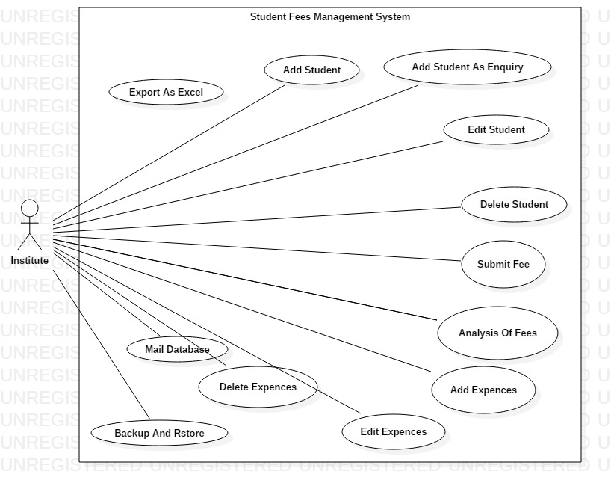

Class Diagram

A Class is a category or group of things that has similar attributes and common behavior. A Rectangle is the icon that represents the class it is divided into three areas. The upper most area contains the name, the middle; area contains the attributes and the lowest areas show the operations. Class diagrams provides the representation that developers work from. Class diagrams help on the analysis side, too.

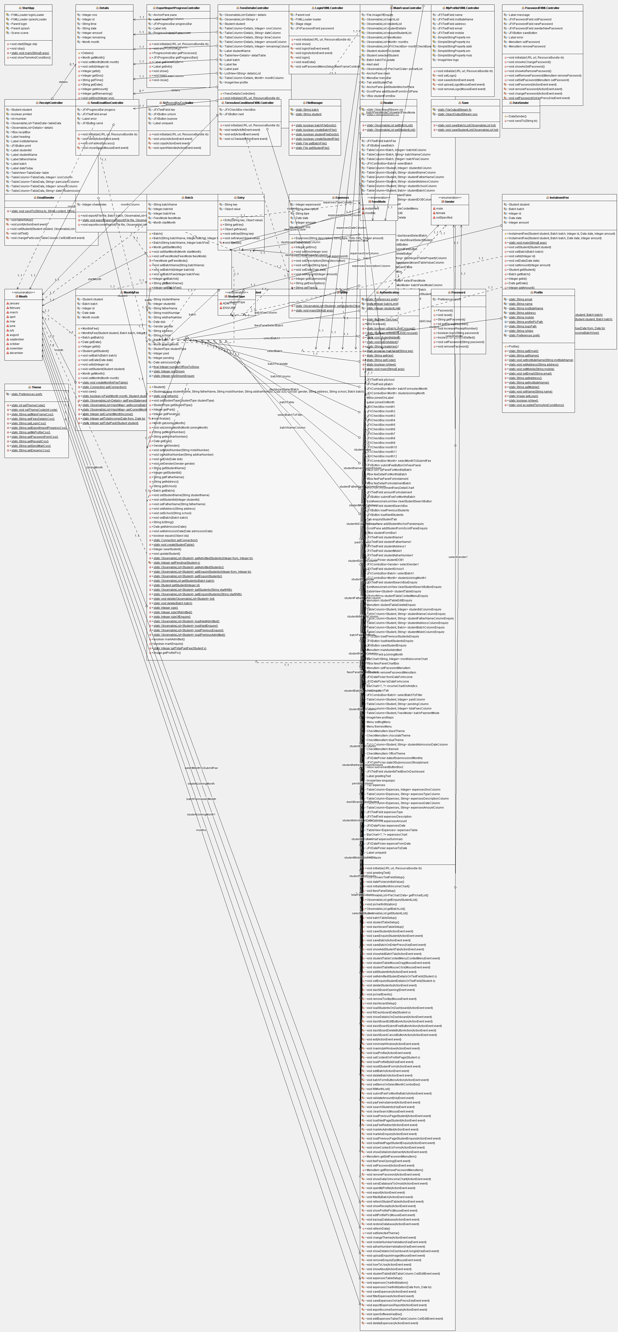

E-R DIAGR AM :

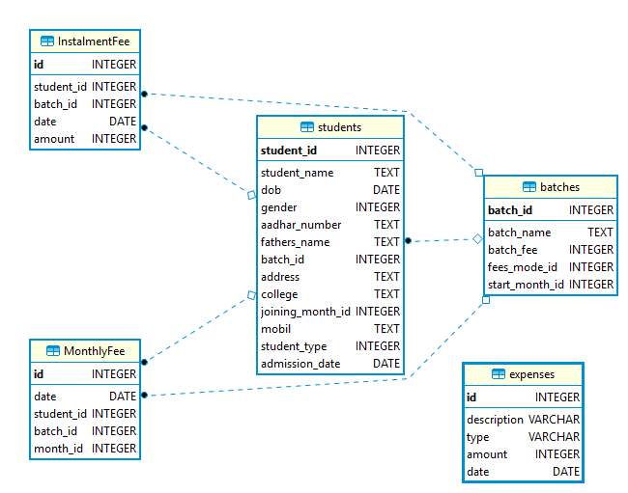

CHAPTER 5
CODING

5 Coding:

Student.java

package models;

import java.io.File;
import java.io.FileInputStream;
import java.io.Serializable;
import java.sql.Connection;
import java.sql.DriverManager;
import java.sql.PreparedStatement;
import java.sql.ResultSet;
import java.sql.Statement;
import java.sql.Date;
import java.util.Comparator;
import java.util.Iterator;
import javafx.collections.FXCollections;
import javafx.collections.ObservableList;
import javafx.scene.image.Image;
import prefrences.Authentication;
import prefrences.Profile;

public class Student implements Serializable{

private String studentName;
private Integer studentId;
private String fatherName;
private String mobilNumber;
private String addharNumber;
private Date dob;
private Gender gender;
private String address;
private String school;
private Batch batch;
private Month joiningMonth;
private StudentType studentType = StudentType.ADMITTED;
private Integer paid = 0;
private Integer pending =0;
private Date admissionDate;

public static final Integer numberOfRowToShow = 100;
public static Integer rowShown = 0;
public static Integer rowShownEnquiry = 0;

public static void refresh(){
rowShown = 0;
rowShownEnquiry = 0;
}

public Student() {
gender = Gender.notSpecified;
admissionDate = new Date(new java.util.Date().getTime());
}

public void setStudentType(StudentType studentType) {
this.studentType = studentType;
}

public StudentType getStudentType() {
return studentType;
}

public Integer getPaid() {
return paid;
}

public Integer getPending() {
return pending;
}

@Override
protected void finalize() throws Throwable {
System.out.println("models.Student.finalize()"+ this);;
}

public Student(String studentName, String fatherName, String mobilNumber, String addharNumber, Date dob, Gender gender, String address, String school, Batch batch) {
this.studentName = studentName;
this.fatherName = fatherName;
this.mobilNumber = mobilNumber;
this.addharNumber = addharNumber;
this.dob = dob;
this.gender = gender;
this.address = address;
this.school = school;
this.batch = batch;
}

public Month getJoiningMonth() {
return joiningMonth;
}

public void setJoiningMonth(Month joiningMonth) {
this.joiningMonth = joiningMonth;
}

public String getMobilNumber() {
return mobilNumber;
}

public String getAddharNumber() {
return addharNumber;
}

public Date getDob() {
return dob;
}

public Gender getGender() {
return gender;
}

public void setMobilNumber(String mobilNumber) {
this.mobilNumber = mobilNumber;
}

public void setAddharNumber(String addharNumber) {
this.addharNumber = addharNumber;
}

public void setDob(Date dob) {
this.dob = dob;
}

public void setGender(Gender gender) {
this.gender = gender;
}

public String getStudentName() {
return studentName;
}

public Integer getStudentId() {
return studentId;
}

public String getFatherName() {
return fatherName;
}

public String getAddress() {
return address;
}

public String getSchool() {
return school;
}

public Batch getBatch() {
return batch;
}

public void setStudentName(String studentName) {
this.studentName = studentName;
}

public void setStudentId(Integer studentId) {
this.studentId = studentId;
}

public void setFatherName(String fatherName) {
this.fatherName = fatherName;
}

public void setAddress(String address) {
this.address = address;
}

public void setSchool(String school) {
this.school = school;
}

public void setBatch(Batch batch) {
this.batch = batch;
}

@Override
public String toString() {
return studentName ;
}

public Date getAdmissionDate() {
return admissionDate;
}

public void setAdmissionDate(Date admissionDate) {
this.admissionDate = admissionDate;
}

@Override
public boolean equals(Object obj) {
if(obj instanceof Student){
Student s =(Student)obj;
if(s.studentId == this.studentId){
return true;
}
}else{
return false;
}
return false;
}

public static Connection getConnection() throws Exception{
Connection connection = null;
Class.forName("org.sqlite.JDBC");
connection = DriverManager.getConnection("jdbc:sqlite:database.db");
return connection;
}

public static void createStudentTable(){
Connection con;
try {
con = getConnection();

String sql ="CREATE TABLE [students](" +
" [student_name] TEXT NOT NULL, " +
" [student_id] INTEGER PRIMARY KEY AUTOINCREMENT NOT NULL, " +
" [dob] DATE, " +
" [gender] INTEGER, " +
" [aadhar_number] TEXT, " +
" [fathers_name] TEXT, " +
" [batch_id] INTEGER NOT NULL REFERENCES [batches]([batch_id]) ON DELETE CASCADE, " +
" [address] TEXT, " +
" [college] TEXT, " +
" [joining_month_id] INTEGER, " +
" [mobil] TEXT, " +
" [student_type] INTEGER NOT NULL DEFAULT 1"
+ " ,[admission_date] DATE);";
Statement ps = con.createStatement();
ps.executeUpdate(sql);
ps.close();
con.close();
} catch (Exception ex) {
System.out.println("models.Student.createStudentTable()");
System.out.println(ex.getMessage());
}
}

public Integer saveStudent() throws Exception{
int id = -1;
Connection con = getConnection();
String sql = "INSERT INTO students (student_name , "
+ "fathers_name ,"
+ " address , "
+ "aadhar_number ,"
+ " college , "
+ "dob , "
+ "gender ,"
+ " mobil , "
+ " joining_month_id , "
+ "batch_id , student_type , admission_date) "
+ "VALUES (?,?,?,?,?,?,?,?,?,? , ?, ? );";
PreparedStatement ps = con.prepareStatement(sql, Statement.RETURN_GENERATED_KEYS);
ps.setString(1 , studentName);
ps.setString(2 , fatherName);
ps.setString(3 , address);
ps.setString(4 , addharNumber);
ps.setString(5 , school);
ps.setDate(6, dob);
ps.setInt(7, gender.getId());
ps.setString(8, mobilNumber);
if(getJoiningMonth()==null){
ps.setInt(9, -1);
}else{
ps.setInt(9, getJoiningMonth().getIndex());
}

ps.setInt(10, batch.getBatchId());
ps.setInt(11, getStudentType().getId());
ps.setDate(12, admissionDate);

ps.executeUpdate();
ResultSet rs = ps.getGeneratedKeys();
if(rs.next()){
id = rs.getInt(1);
}

Authentication.studentAdded();
con.close();
return id;
}

public void updateStudent() throws Exception{
Connection con = getConnection();
String sql = "UPDATE students SET "
+ "student_name = ? ,"
+ " fathers_name = ? ,"
+ " aadhar_number=? ,"
+ " address = ? ,"
+ " batch_id = ? ,"
+ " college = ? ,"
+ " dob = ? ,"
+ " gender = ? ,"
+ " mobil = ? , "
+ " joining_month_id = ?"
+ " where student_id = ?";
PreparedStatement ps = con.prepareStatement(sql, Statement.RETURN_GENERATED_KEYS);
ps.setString(1 , studentName);
ps.setString(2 , fatherName);
ps.setString(3 , addharNumber);
ps.setString(4 , address);
ps.setInt(5, batch.getBatchId());
ps.setString(6 , school);
ps.setDate(7, dob);
ps.setInt(8, gender.getId());
ps.setString(9, mobilNumber);
if(getJoiningMonth()==null){
ps.setInt(10, -1);
}else{
ps.setInt(10, getJoiningMonth().getIndex());
}
ps.setInt(11, studentId);

ps.executeUpdate();
ps.close();;
con.close();
}

public static ObservableList<Student> getAdmittedStudents(Integer from , Integer to) throws Exception{

Connection con = getConnection();
ObservableList<Student> list = FXCollections.observableArrayList();
String sql = "SELECT student_name ,"
+ " fathers_name ,"
+ " address ,"
+ " aadhar_number ,"
+ " college ,"
+ " dob ,"
+ " gender ,"
+ " mobil , "
+ "students.batch_id ,"
+ " batch_name ,"
+ " batch_fee ,"
+ " student_id ,"
+ " joining_month_id , "
+ " start_month_id ,"
+ " fees_mode_id , student_type"
+ " from "
+ "students inner join batches on"
+ " students.batch_id = batches.batch_id and student_type = ? limit ? , ?";

PreparedStatement ps = con.prepareStatement(sql);
ps.setInt(1, StudentType.getADMITTED().getId());
ps.setInt(2, from);
ps.setInt(3, to);
ResultSet rs = ps.executeQuery();

while(rs.next()){
Student s = new Student();
s.studentName = rs.getString(1);
s.fatherName = rs.getString(2);
s.address = rs.getString(3);
s.addharNumber = rs.getString(4);
s.school = rs.getString(5);
s.dob = rs.getDate(6);
s.gender = Gender.getGender(rs.getInt(7));
s.mobilNumber = rs.getString(8);
s.batch = new Batch(rs.getString(10), rs.getInt(9) , rs.getInt(11));
s.studentId = rs.getInt(12);
int jm = rs.getInt(13);
if(jm!=-1){
s.joiningMonth = Month.getMonth(jm);
}else{
s.joiningMonth = null;
}
jm = rs.getInt(14);
if(jm!=-1){
s.batch.setStartMonth(Month.getMonth(jm));
}else{
s.getBatch().setStartMonth(null);
}

s.batch.setFeesMode(FeesMode.getFeesMode(rs.getInt(15)));
s.setStudentType(StudentType.getStudentType(rs.getInt(16)));
s.paid = getTotalPaidFee(s);
s.pending = getPending(s);
list.add(s);
}

con.close();

return list;
}

private static Integer getPending(Student s){
if(s.getBatch().getFeesMode() == FeesMode.instalment){
return (s.getBatch().getBatchFee() - s.getPaid());
}else{
return -1;
}
}
public static ObservableList<Student> getAdmittedStudents() throws Exception{

Connection con = getConnection();
ObservableList<Student> list = FXCollections.observableArrayList();
String sql = "SELECT student_name ,"
+ " fathers_name ,"
+ " address ,"
+ " aadhar_number ,"
+ " college ,"
+ " dob ,"
+ " gender ,"
+ " mobil , "
+ "students.batch_id ,"
+ " batch_name ,"
+ " batch_fee ,"
+ " student_id ,"
+ " joining_month_id , "
+ " start_month_id ,"
+ " fees_mode_id , student_type "
+ " from "
+ "students inner join batches on"
+ " students.batch_id = batches.batch_id and student_type = ? limit "+ numberOfRowToShow;

PreparedStatement ps = con.prepareStatement(sql);
ps.setInt(1, StudentType.ADMITTED.getId());
ResultSet rs = ps.executeQuery();
while(rs.next()){
Student s = new Student();
s.studentName = rs.getString(1);
s.fatherName = rs.getString(2);
s.address = rs.getString(3);
s.addharNumber = rs.getString(4);
s.school = rs.getString(5);
s.dob = rs.getDate(6);
s.gender = Gender.getGender(rs.getInt(7));
s.mobilNumber = rs.getString(8);
s.batch = new Batch(rs.getString(10), rs.getInt(9) , rs.getInt(11));
s.studentId = rs.getInt(12);
int jm = rs.getInt(13);
if(jm!=-1){
s.joiningMonth = Month.getMonth(jm);
}else{
s.joiningMonth = null;
}
jm = rs.getInt(14);
if(jm!=-1){
s.batch.setStartMonth(Month.getMonth(jm));
}else{
s.getBatch().setStartMonth(null);
}

s.batch.setFeesMode(FeesMode.getFeesMode(rs.getInt(15)));
s.setStudentType(StudentType.getStudentType(rs.getInt(16)));
s.paid = getTotalPaidFee(s);
s.pending = getPending(s);
list.add(s);
}

con.close();

return list;
}

public static ObservableList<Student> getEnquiryStudents(Integer from , Integer to) throws Exception{

Connection con = getConnection();
ObservableList<Student> list = FXCollections.observableArrayList();
String sql = "SELECT student_name ,"
+ " fathers_name ,"
+ " address ,"
+ " aadhar_number ,"
+ " college ,"
+ " dob ,"
+ " gender ,"
+ " mobil , "
+ "students.batch_id ,"
+ " batch_name ,"
+ " batch_fee ,"
+ " student_id ,"
+ " joining_month_id , "
+ " start_month_id ,"
+ " fees_mode_id , student_type , admission_date "
+ " from "
+ "students inner join batches on"
+ " students.batch_id = batches.batch_id and student_type = ? limit "+from+" , "+to;

PreparedStatement ps = con.prepareStatement(sql);
ps.setInt(1, StudentType.getENQUIRY().getId());
ResultSet rs = ps.executeQuery();

while(rs.next()){
Student s = new Student();
s.studentName = rs.getString(1);
s.fatherName = rs.getString(2);
s.address = rs.getString(3);
s.addharNumber = rs.getString(4);
s.school = rs.getString(5);
s.dob = rs.getDate(6);
s.gender = Gender.getGender(rs.getInt(7));
s.mobilNumber = rs.getString(8);
s.batch = new Batch(rs.getString(10), rs.getInt(9) , rs.getInt(11));
s.studentId = rs.getInt(12);
int jm = rs.getInt(13);
if(jm!=-1){
s.joiningMonth = Month.getMonth(jm);
}else{
s.joiningMonth = null;
}
jm = rs.getInt(14);
if(jm!=-1){
s.batch.setStartMonth(Month.getMonth(jm));
}else{
s.getBatch().setStartMonth(null);
}

s.batch.setFeesMode(FeesMode.getFeesMode(rs.getInt(15)));
s.setStudentType(StudentType.getStudentType(rs.getInt(16)));
s.setAdmissionDate(rs.getDate(17));
s.paid = getTotalPaidFee(s);
s.pending = getPending(s);
list.add(s);
}

con.close();

return list;
}
public static ObservableList<Student> getEnquiryStudents() throws Exception{

Connection con = getConnection();
ObservableList<Student> list = FXCollections.observableArrayList();
String sql = "SELECT student_name ,"
+ " fathers_name ,"
+ " address ,"
+ " aadhar_number ,"
+ " college ,"
+ " dob ,"
+ " gender ,"
+ " mobil , "
+ "students.batch_id ,"
+ " batch_name ,"
+ " batch_fee ,"
+ " student_id ,"
+ " joining_month_id , "
+ " start_month_id ,"
+ " fees_mode_id , student_type , admission_date "
+ " from "
+ "students inner join batches on"
+ " students.batch_id = batches.batch_id and student_type = ? limit "+ numberOfRowToShow;

PreparedStatement ps = con.prepareStatement(sql);
ps.setInt(1, StudentType.ENQUIRY.getId());
ResultSet rs = ps.executeQuery();
while(rs.next()){
Student s = new Student();
s.studentName = rs.getString(1);
s.fatherName = rs.getString(2);
s.address = rs.getString(3);
s.addharNumber = rs.getString(4);
s.school = rs.getString(5);
s.dob = rs.getDate(6);
s.gender = Gender.getGender(rs.getInt(7));
s.mobilNumber = rs.getString(8);
s.batch = new Batch(rs.getString(10), rs.getInt(9) , rs.getInt(11));
s.studentId = rs.getInt(12);
int jm = rs.getInt(13);
if(jm!=-1){
s.joiningMonth = Month.getMonth(jm);
}else{
s.joiningMonth = null;
}
jm = rs.getInt(14);
if(jm!=-1){
s.batch.setStartMonth(Month.getMonth(jm));
}else{
s.getBatch().setStartMonth(null);
}

s.batch.setFeesMode(FeesMode.getFeesMode(rs.getInt(15)));
s.setStudentType(StudentType.getStudentType(rs.getInt(16)));
s.setAdmissionDate(rs.getDate(17));
s.paid = getTotalPaidFee(s);
s.pending = getPending(s);
list.add(s);
}

con.close();

return list;
}

public static ObservableList getStudents(Batch batch) throws Exception{
Connection con = getConnection();
ObservableList<Student> list = FXCollections.observableArrayList();
String sql = "SELECT student_name ,"
+ " fathers_name ,"
+ " address ,"
+ " aadhar_number ,"
+ " college ,"
+ " dob ,"
+ " gender ,"
+ " mobil , "
+ "students.batch_id ,"
+ " batch_name ,"
+ " batch_fee ,"
+ " student_id ,"
+ " joining_month_id ,"
+ " start_month_id ,"
+ " fees_mode_id from "
+ "students inner join batches on"
+ " students.batch_id = batches.batch_id where students.batch_id = (?)";

PreparedStatement ps = con.prepareStatement(sql);
ps.setInt(1, batch.getBatchId());
ResultSet rs = ps.executeQuery();
while(rs.next()){
Student s = new Student();
s.studentName = rs.getString(1);
s.fatherName = rs.getString(2);
s.address = rs.getString(3);
s.addharNumber = rs.getString(4);
s.school = rs.getString(5);
s.dob = rs.getDate(6);
s.gender = Gender.getGender(rs.getInt(7));
s.mobilNumber = rs.getString(8);
s.batch = new Batch(rs.getString(10), rs.getInt(9) , rs.getInt(11));
s.studentId = rs.getInt(12);
int jm = rs.getInt(13);
if(jm!=-1){
s.joiningMonth = Month.getMonth(jm);
}else{
s.joiningMonth = null;
}

jm = rs.getInt(14);
if(jm!=-1){
s.batch.setStartMonth(Month.getMonth(jm));
}else{
s.getBatch().setStartMonth(null);
}

s.batch.setFeesMode(FeesMode.getFeesMode(rs.getInt(15)));
s.paid = getTotalPaidFee(s);
s.pending = getPending(s);
list.add(s);
}
con.close();

return list;
}

public static Student getStudent(Integer id) throws Exception{
Connection con = getConnection();
Student s = null;
String sql = "SELECT student_name ,"
+ " fathers_name ,"
+ " address ,"
+ " aadhar_number ,"
+ " college ,"
+ " dob ,"
+ " gender ,"
+ " mobil , "
+ "students.batch_id ,"
+ " batch_name , "
+ "batch_fee ,"
+ " student_id ,"
+ " joining_month_id ,"
+ " start_month_id ,"
+ " fees_mode_id from "
+ "students inner join batches on"
+ " students.batch_id = batches.batch_id where students.student_id = (?)";

PreparedStatement ps = con.prepareStatement(sql);
ps.setInt(1, id);
ResultSet rs = ps.executeQuery();
while(rs.next()){
s = new Student();
s.studentName = rs.getString(1);
s.fatherName = rs.getString(2);
s.address = rs.getString(3);
s.addharNumber = rs.getString(4);
s.school = rs.getString(5);
s.dob = rs.getDate(6);
s.gender = Gender.getGender(rs.getInt(7));
s.mobilNumber = rs.getString(8);
s.batch = new Batch(rs.getString(10), rs.getInt(9) , rs.getInt(11));
s.studentId = rs.getInt(12);
int jm = rs.getInt(13);
if(jm!=-1){
s.joiningMonth = Month.getMonth(jm);
}else{
s.joiningMonth = null;
}

jm = rs.getInt(14);
if(jm!=-1){
s.batch.setStartMonth(Month.getMonth(jm));
}else{
s.getBatch().setStartMonth(null);
}

s.batch.setFeesMode(FeesMode.getFeesMode(rs.getInt(15)));
s.paid = getTotalPaidFee(s);
s.pending = getPending(s);

}
con.close();

return s;
}

public static ObservableList<Student> getStudents(String startWith) throws Exception{
Connection con = getConnection();
ObservableList<Student> students = FXCollections.observableArrayList();
Student s = null;
String sql = "SELECT student_name ,"
+ " fathers_name ,"
+ " address ,"
+ " aadhar_number ,"
+ " college ,"
+ " dob ,"
+ " gender ,"
+ " mobil , "
+ "students.batch_id ,"
+ " batch_name , "
+ "batch_fee ,"
+ " student_id ,"
+ " joining_month_id ,"
+ " start_month_id ,"
+ " fees_mode_id from "
+ "students inner join batches on"
+ " students.batch_id = batches.batch_id where "
+ "( student_name LIKE ? or student_id LIKE ? or mobil LIKE ? ) and student_type = ? ;";

PreparedStatement ps = con.prepareStatement(sql);
ps.setString(1, startWith+"%");
ps.setString(2, startWith+"%");
ps.setString(3, startWith+"%");
ps.setInt(4, StudentType.ADMITTED.getId());
ResultSet rs = ps.executeQuery();
while(rs.next()){
s = new Student();
s.studentName = rs.getString(1);
s.fatherName = rs.getString(2);
s.address = rs.getString(3);
s.addharNumber = rs.getString(4);
s.school = rs.getString(5);
s.dob = rs.getDate(6);
s.gender = Gender.getGender(rs.getInt(7));
s.mobilNumber = rs.getString(8);
s.batch = new Batch(rs.getString(10), rs.getInt(9) , rs.getInt(11));
s.studentId = rs.getInt(12);
int jm = rs.getInt(13);
if(jm!=-1){
s.joiningMonth = Month.getMonth(jm);
}else{
s.joiningMonth = null;
}

jm = rs.getInt(14);
if(jm!=-1){
s.batch.setStartMonth(Month.getMonth(jm));
}else{
s.getBatch().setStartMonth(null);
}

s.batch.setFeesMode(FeesMode.getFeesMode(rs.getInt(15)));
s.paid = getTotalPaidFee(s);
s.pending = getPending(s);

students.add(s);

}
con.close();

return students;
}

public static ObservableList<Student> getEnquiryStudents(String startWith) throws Exception {
Connection con = getConnection();
ObservableList<Student> students = FXCollections.observableArrayList();
Student s = null;
String sql = "SELECT student_name ,"
+ " fathers_name ,"
+ " address ,"
+ " aadhar_number ,"
+ " college ,"
+ " dob ,"
+ " gender ,"
+ " mobil , "
+ "students.batch_id ,"
+ " batch_name , "
+ "batch_fee ,"
+ " student_id ,"
+ " joining_month_id ,"
+ " start_month_id ,"
+ " fees_mode_id from "
+ "students inner join batches on"
+ " students.batch_id = batches.batch_id where (student_name LIKE ? "
+ "or student_id LIKE ? "
+ "or address LIKE ? "
+ "or batch_name LIKE ? "
+ "or mobil LIKE ? ) and student_type = ? ;";

PreparedStatement ps = con.prepareStatement(sql);
ps.setString(1, "%"+startWith + "%");
ps.setString(2, startWith + "%");
ps.setString(3, "%"+startWith + "%");
ps.setString(4, "%"+startWith + "%");
ps.setString(5, startWith + "%");
ps.setInt(6, StudentType.ENQUIRY.getId());
ResultSet rs = ps.executeQuery();
while (rs.next()) {
s = new Student();
s.studentName = rs.getString(1);
s.fatherName = rs.getString(2);
s.address = rs.getString(3);
s.addharNumber = rs.getString(4);
s.school = rs.getString(5);
s.dob = rs.getDate(6);
s.gender = Gender.getGender(rs.getInt(7));
s.mobilNumber = rs.getString(8);
s.batch = new Batch(rs.getString(10), rs.getInt(9), rs.getInt(11));
s.studentId = rs.getInt(12);
int jm = rs.getInt(13);
if (jm != -1) {
s.joiningMonth = Month.getMonth(jm);
} else {
s.joiningMonth = null;
}

jm = rs.getInt(14);
if (jm != -1) {
s.batch.setStartMonth(Month.getMonth(jm));
} else {
s.getBatch().setStartMonth(null);
}

s.batch.setFeesMode(FeesMode.getFeesMode(rs.getInt(15)));
s.paid = getTotalPaidFee(s);
s.pending = getPending(s);

students.add(s);

}
con.close();

return students;
}

public static void delete(ObservableList<Student> list) throws Exception{
Connection con = getConnection();
Student s = null;

String sql = "delete from students WHERE student_id = ?";
Iterator<Student> itr = list.iterator();
while(itr.hasNext()){
PreparedStatement ps = con.prepareStatement(sql);
ps.setInt(1, itr.next().getStudentId());
int i = ps.executeUpdate();
System.err.println(i + " recorders deleted");
}

con.close();

}

public static void delete(Batch batch) throws Exception{
Connection con = getConnection();

String sql = "delete from students WHERE batch_id = ?";
PreparedStatement ps = con.prepareStatement(sql);
ps.executeUpdate();
con.close();

}

public static class SortById implements Comparator<Student>{
@Override
public int compare(Student o1, Student o2) {
return Integer.compare(o1.studentId, o2.studentId);
}

}

public static Integer size() throws Exception{
Connection con = getConnection();
String sql = "SELECT COUNT(student_id) from students";
PreparedStatement ps = con.prepareStatement(sql);
ResultSet rs = ps.executeQuery();
int size = 0;
if(rs.next()){
size = rs.getInt(1);
}
con.close();
return size;
}
public static Integer sizeOfAdmitted() throws Exception{
Connection con = getConnection();
String sql = "SELECT COUNT(student_id) from students where student_type = ? ";
PreparedStatement ps = con.prepareStatement(sql);
ps.setInt(1 , StudentType.ADMITTED.getId());
ResultSet rs = ps.executeQuery();
int size = 0;
if(rs.next()){
size = rs.getInt(1);
}
con.close();
return size;
}
public static Integer sizeOfEnquiry() throws Exception{
Connection con = getConnection();
String sql = "SELECT COUNT(student_id) from students where student_type = ? ";
PreparedStatement ps = con.prepareStatement(sql);
ps.setInt(1 , StudentType.ENQUIRY.getId());
ResultSet rs = ps.executeQuery();
int size = 0;
if(rs.next()){
size = rs.getInt(1);
}
con.close();
return size;
}

public static ObservableList<Student> loadNextAdmitted() throws Exception{
System.err.println(rowShown + " , " + numberOfRowToShow );
ObservableList<Student> students = FXCollections.observableArrayList();
if(numberOfRowToShow*(rowShown/numberOfRowToShow)>size()){
return students;
}else{
rowShown = rowShown + numberOfRowToShow;
students = getAdmittedStudents(rowShown, numberOfRowToShow);
return students;
}
}
public static ObservableList<Student> loadNextEnquiry() throws Exception{
System.out.println(rowShownEnquiry + " , " + numberOfRowToShow );
ObservableList<Student> students = FXCollections.observableArrayList();
if(numberOfRowToShow*(rowShownEnquiry/numberOfRowToShow)>sizeOfEnquiry()){
return students;
}else{
rowShownEnquiry = rowShownEnquiry + numberOfRowToShow;
students = getEnquiryStudents(rowShownEnquiry, numberOfRowToShow);
return students;
}
}
public static ObservableList<Student> loadPreviousEnquiry() throws Exception{
ObservableList<Student> students = FXCollections.observableArrayList();
if(rowShownEnquiry!=0){
students = getEnquiryStudents(rowShownEnquiry-numberOfRowToShow, numberOfRowToShow);
rowShownEnquiry = rowShownEnquiry-numberOfRowToShow;
return students;
}else{
return students;
}

}

public static ObservableList<Student> loadPreviousAdmitted() throws Exception{
ObservableList<Student> students = FXCollections.observableArrayList();
if(rowShown!=0){
students = getAdmittedStudents(rowShown-numberOfRowToShow, numberOfRowToShow);
rowShown = rowShown-numberOfRowToShow;
return students;
}else{
return students;
}

}

public boolean markAdmitted(){
boolean flag = false;
try{
Connection con = getConnection();
PreparedStatement ps = con.prepareStatement("UPDATE students SET student_type = ? where student_id = ?");
ps.setInt(1, studentType.ADMITTED.getId());
ps.setInt(2, studentId);

int i = ps.executeUpdate();
if(i>0){
flag = true;
}

java.util.Date date = new java.util.Date();
int month = date.getMonth()+1;

String sql = "UPDATE students SET joining_month_id = ? where student_id = ?";
ps = con.prepareStatement(sql);
ps.setInt(1, month);
ps.setInt(2, studentId);
ps.executeUpdate();

con.close();

}catch(Exception ex){
ex.printStackTrace();
}
return flag ;

}
public boolean markEnquiry(){
boolean flag = false;
try{
Connection con = getConnection();
PreparedStatement ps = con.prepareStatement("UPDATE students SET student_type = ? where student_id = ?");
ps.setInt(1, studentType.ENQUIRY.getId());
ps.setInt(2, studentId);

int i = ps.executeUpdate();
if(i>0){
flag = true;
}

con.close();

}catch(Exception ex){
ex.printStackTrace();
}
return flag ;

}

public static Integer getTotalPaidFee(Student s){
if(s.batch.getFeesMode() == FeesMode.instalment){
return InstalmentFee.getTotalPaid(s);
}else{
return MonthlyFee.getTotalPaid(s);
}
}

public Image getProfilePic(){
try{
File file = new File(Profile.profilePicPath+"/"+studentId);
String[] pics = file.list();
if(pics==null){
return new Image(getClass().getResourceAsStream("/images/avtar.png"));
}
int i = pics.length;
if(i==0){
return new Image(getClass().getResourceAsStream("/images/avtar.png"));
}else{
return new Image(new FileInputStream(new File(file , (i-1)+".jpg")));
}
}catch(Exception ex){
ex.printStackTrace();
return new Image(getClass().getResourceAsStream("/images/avtar.png"));
}

}

}

Batch.java
/*
* To change this license header, choose License Headers in Project Properties.
* To change this template file, choose Tools | Templates
* and open the template in the editor.
*/
package models;

import java.io.Serializable;
import java.sql.Connection;
import java.sql.DriverManager;
import java.sql.PreparedStatement;
import java.sql.ResultSet;
import java.sql.Statement;
import java.util.ArrayList;
import java.util.Iterator;
import javafx.collections.FXCollections;
import javafx.collections.ObservableList;
import static models.Student.getConnection;
import prefrences.Authentication;

public class Batch implements Serializable{
private String batchName;
private Integer batchId;
private Integer batchFee;
private FeesMode feesMode;
private Month startMonth;

public Batch() {
}

public Batch(String batchName, Integer batchId , Integer batchFee ) {
this.batchName = batchName;
this.batchId = batchId;
this.batchFee = batchFee;
}

public Month getStartMonth() {
return startMonth;
}

public void setStartMonth(Month startMonth) {
this.startMonth = startMonth;
}

public Batch(String batchName, Integer batchFee) {
this.batchName = batchName;
this.batchFee = batchFee;
}

public void setFeesMode(FeesMode feesMode) {
this.feesMode = feesMode;
}

public FeesMode getFeesMode() {
return feesMode;
}

public void setBatchName(String batchName) {
this.batchName = batchName;
}

public void setBatchId(Integer batchId) {
this.batchId = batchId;
}

public void setBatchFee(Integer batchFee) {
this.batchFee = batchFee;
}

public Integer getBatchId() {
return batchId;
}

public String getBatchName() {
return batchName;
}

public Integer getBatchFee() {
return batchFee;
}

@Override
public String toString() {
return batchName; //To change body of generated methods, choose Tools | Templates.
}

public static Connection getConnection() throws Exception{
Connection connection = null;
Class.forName("org.sqlite.JDBC");
connection = DriverManager.getConnection("jdbc:sqlite:database.db");
return connection;
}

public static void createBatchTable(){
try{
Connection con = getConnection();
String sql = "CREATE TABLE [batches](" +
" [batch_name] TEXT NOT NULL, " +
" [batch_id] INTEGER PRIMARY KEY AUTOINCREMENT, " +
" [batch_fee] INTEGER NOT NULL, " +
" [fees_mode_id] INTEGER NOT NULL, " +
" [start_month_id] INTEGER);";
Statement ps = con.createStatement();
ps.executeUpdate(sql);
ps.close();
con.close();
}catch(Exception ex){
System.out.println("models.Batch.createBatchTable()");
System.out.println(ex.getMessage());
}
}

public Integer saveBatch() throws Exception{
Connection con = getConnection();
String sql = "insert into batches (batch_name ,batch_fee, fees_mode_id , start_month_id)"+
" values(?,? ,? , ?)";

PreparedStatement ps = con.prepareStatement(sql , Statement.RETURN_GENERATED_KEYS);
ps.setString(1, getBatchName());
ps.setInt(2, getBatchFee());
ps.setInt(3, getFeesMode().getIndex());
if(getStartMonth()!=null){
ps.setInt(4, getStartMonth().getIndex());
}else{
ps.setInt(4, -1);
}

int i = ps.executeUpdate();
ResultSet rs = ps.getGeneratedKeys();
if(rs.next()){
i = rs.getInt(1);
}
System.out.println(i + " is key updated");
Authentication.batchAdded();
ps.close();
con.close();
return i;
}

public static ObservableList<Batch> getBatches() throws Exception{
Connection con = getConnection();
String sql = "select batch_name ,batch_id ,batch_fee , fees_mode_id , start_month_id from batches ";
ObservableList<Batch> list = FXCollections.observableArrayList();
PreparedStatement ps = con.prepareStatement(sql);
ResultSet rs = ps.executeQuery();
while(rs.next()){
Batch batch = new Batch();
batch.setBatchId(rs.getInt(2));
batch.setBatchName(rs.getString(1).toUpperCase());
batch.setBatchFee(rs.getInt(3));
batch.setFeesMode(FeesMode.getFeesMode(rs.getInt(4)));
int m = rs.getInt(5);
if(m!=-1){
batch.setStartMonth(Month.getMonth(m));
}else{
batch.setStartMonth(null);
}
list.add(batch);
System.out.println(batch + " row getted");
}

ps.close();
con.close();
return list;
}

public static void main(String[] args) throws Exception{
System.out.println(getConnection());
createBatchTable();
System.out.println(getBatches());
}

public static void delete(ObservableList<Batch> list) throws Exception{

Connection con = getConnection();
String sql = "delete from batches WHERE batch_id = ?";
Iterator<Batch> itr = list.iterator();
while(itr.hasNext()){
Batch batch = itr.next();
PreparedStatement ps = con.prepareStatement(sql);
ps.setInt(1,batch.getBatchId());
int i = ps.executeUpdate();
System.err.println(i + "batch recorders deleted" );
}
con.close();
}

public void upadte() throws Exception{
String sql = "UPDATE batches SET"
+ " batch_name=? ,"
+ " batch_fee = ?"
+ " where batch_id = ?";
Connection con = getConnection();
PreparedStatement ps = con.prepareStatement(sql);
ps.setString(1 , batchName);
ps.setInt(2, batchFee);
ps.setInt(3, batchId);
ps.executeUpdate();
con.close();
}

public Integer getStundentCount(){
try{
Connection con = getConnection();
String sql = "SELECT COUNT(student_id) FROM students WHERE batch_id = ?";
PreparedStatement ps = con.prepareStatement(sql);
ps.setInt(1 ,this.batchId);
ResultSet rs = ps.executeQuery();
int size = 0;
if(rs.next()){
size = rs.getInt(1);
}
con.close();

return size;
}catch(Exception ex){

ex.printStackTrace();
return 0;
}
}

@Override
protected void finalize() throws Throwable {
System.out.println("models.Batch.finalize() " + this );
}
}

LoginFXMLController.java

package controllers;
import com.jfoenix.controls.JFXPasswordField;
import java.net.URL;
import java.util.ResourceBundle;
import javafx.application.Platform;
import javafx.collections.ObservableList;
import javafx.concurrent.Task;
import javafx.event.ActionEvent;
import javafx.fxml.FXML;
import javafx.fxml.FXMLLoader;
import javafx.fxml.Initializable;
import javafx.scene.Parent;
import javafx.scene.Scene;
import javafx.scene.control.Alert;
import javafx.scene.image.Image;
import javafx.scene.input.KeyCode;
import javafx.scene.input.KeyEvent;
import javafx.stage.Stage;
import javafx.stage.StageStyle;
import models.Batch;
import models.Expenses;
import models.InstalmentFee;
import models.MonthlyFee;
import models.Student;
import prefrences.Password;
import prefrences.Profile;
import prefrences.Theme;

public class LoginFXMLController implements Initializable {

Parent root;
FXMLLoader loader ;
Stage stage = new Stage();

@FXML
private JFXPasswordField password;

@Override
public void initialize(URL url, ResourceBundle rb) {
// TODO
try {
loader = new FXMLLoader(getClass().getResource("/FXML/MainFrame.fxml"));
root = loader.load();
stage.initStyle(StageStyle.DECORATED);
Scene scene = new Scene(root);
stage.setScene(scene);
stage.setMaximized(true);

try{
stage.getIcons().add(Profile.getLogo());
}catch(Exception ex){
ex.printStackTrace();
}
System.err.println("Theme code: " + Theme.getThemeCode());
System.err.println(Theme.getMainFrameCss());

scene.getStylesheets().add(getClass().
getResource(Theme.getMainFrameCss()).toExternalForm());

scene.getStylesheets().add(getClass().
getResource(Theme.getDynamicCss()).toExternalForm());

readData();;

} catch (Exception ec) {
ec.printStackTrace();
}
}

public void show(){
stage.show();
}

@FXML
private void login(KeyEvent event) {
if(event.getCode().equals(KeyCode.ENTER)){
login();
}
}

@FXML
private void login(ActionEvent event) {
login();
}

private void login(){

String pass = password.getText();
if(pass!=null){
if(new Password().login(pass)){
((Stage)(password.getScene().getWindow())).close();
stage.show();
}else{
Alert alert = new Alert(Alert.AlertType.WARNING);
alert.setContentText("You Entered Wrong Password !!");
alert.show();
}
}

}

// Reading data

public void readData(){
stage.setTitle(Profile.getInstituteName());
Task task = new Task() {
@Override
protected Object call() throws Exception {
try {
System.out.println(".call()" +" initialixation data");
Batch.createBatchTable();
Student.createStudentTable();
MonthlyFee.createMonthlyFeeTable();
InstalmentFee.createInstalmentFeeTable();
Expenses.createExpensesTable();

ObservableList batches = Batch.getBatches();
ObservableList students = Student.getAdmittedStudents();
ObservableList enquiruStudents = Student.getEnquiryStudents();
MainFrameController con = (MainFrameController) (loader.getController());

setPasswordMenuSetup(con);

con.getBatchList().addAll(batches);

con.getStudentList().addAll(students);
con.getEnquiryStudentList().addAll(enquiruStudents);
con.pichartInitilization();
con.dashboardSetup();

con.initializeMonthIncomeChart();

System.err.println("Password is : " + new Password().getPassword());

} catch (Exception ex) {
ex.printStackTrace();
}
return null;
}
};
Thread t = new Thread(task);
t.setDaemon(true);
t.start();
}

private void setPasswordMenuSetup(MainFrameController con ){
Password p = new Password();
if(p.isPasswordSetted()){
con.getSetPasswordMenuItem().setText("Change Password");
con.getRemovePasswordMenuItem().setVisible(true);
}else{
con.getSetPasswordMenuItem().setText("Set Password");
con.getRemovePasswordMenuItem().setVisible(false);
}
}

}

CHAPTER 6
TESTING

6.1 INTRODUCTION TO SYSTEM TESTING:

The purpose of testing is to discover errors. Testing is the process of trying to discover every conceivable fault or weakness in a work product. It provides a way to check the functionality of components, sub-assemblies, assemblies and/or a finished product It is the process of exercising software with the intent of ensuring that the
Software system meets its requirements and user expectations and does not fail in an unacceptable manner. There are various types of test. Each test type addresses a specific testing requirement.

TYPES OF TESTING:

Unit testing:
Unit testing involves the design of test cases that validate that the internal program logic is functioning properly, and that program inputs produce valid outputs. All decision branches and internal code flow should be validated. It is the testing of individual software units of the application .it is done after the completion of an individual unit before integration. This is a structural testing, that relies on knowledge of its construction and is invasive. Unit tests perform basic tests at component level and test a specific business process, application, and/or system configuration. Unit tests ensure that each unique path of a business process performs accurately to the documented specifications and contains clearly defined inputs and expected results.

Integration testing:
Integration tests are designed to test integrated software components to determine if they actually run as one program. Testing is event driven and is more concerned with the basic outcome of screens or fields. Integration tests demonstrate that although the components were individually satisfaction, as shown by successfully unit testing, the combination of components is correct and consistent. Integration testing is specifically aimed at exposing the problems that arise from the combination of components.

Functional test:
Functional tests provide systematic demonstrations that functions tested are available as specified by the business and technical requirements, system documentation, and user manuals.
Functional testing is centered on the following items:
Valid Input : identified classes of valid input must be accepted.
Invalid Input : identified classes of invalid input must be rejected.
Functions : identified functions must be exercised.
Output : identified classes of application outputs must be exercised.
Systems/Procedures: interfacing systems or procedures must be invoked.

Organization and preparation of functional tests is focused on requirements, key functions, or special test cases. In addition, systematic coverage pertaining to identify Business process flows; data fields, predefined processes, and successive processes must be considered for testing. Before functional testing is complete, additional tests are identified and the effective value of current tests is determined.

System Test:
System testing ensures that the entire integrated software system meets requirements. It tests a configuration to ensure known and predictable results. An example of system testing is the configuration oriented system integration test. System testing is based on process descriptions and flows, emphasizing pre-driven process links and integration points.

White Box Testing:
White Box Testing is a testing in which in which the software tester has knowledge of the inner workings, structure and language of the software, or at least its purpose. It is purpose. It is used to test areas that cannot be reached from a black box level.

Black Box Testing:
Black Box Testing is testing the software without any knowledge of the inner workings, structure or language of the module being tested. Black box tests, as most other kinds of tests, must be written from a definitive source document, such as specification or requirements document, such as specification or requirements document. It is a testing in which the software under test is treated, as a black box .you cannot “see” into it. The test provides inputs and responds to outputs without considering how the software works.
Unit Testing:
Unit testing is usually conducted as part of a combined code and unit test phase of the software lifecycle, although it is not uncommon for coding and unit testing to be conducted as two distinct phases.

Test strategy and approach
Field testing will be performed manually and functional tests will be written in detail.

Test objectives
- All field entries must work properly.
- Pages must be activated from the identified link.
- The entry screen, messages and responses must not be delayed.

Features to be tested
- Verify that the entries are of the correct format
- No duplicate entries should be allowed
- All links should take the user to the correct page.

Integration Testing:
Software integration testing is the incremental integration testing of two or more integrated software components on a single platform to produce failures caused by interface defects.
The task of the integration test is to check that components or software applications, e.g. components in a software system or – one step up – software applications at the company level – interact without error.
Test Results:
All the test cases mentioned above passed successfully. No defects encountered.

Acceptance Testing:
User Acceptance Testing is a critical phase of any project and requires significant participation by the end user. It also ensures that the system meets the functional requirements.
Test Results:
All the test cases mentioned above passed successfully. No defects encountered.

8.CONCLUSION:

Since we are entering details of the Students in the” Student Fees Manager”, data will be secured. Using this application we can retrieve Student’s fee history with a single click. Thus processing information will be faster. It guarantees accurate maintenance of Student details. It easily reduces the book keeping task and thus reduces the human effort and increases accuracy speed.

9. BIBLOGRAPHY

- JavaFX in Action by Simon Morris
- Introduction by Example written by Carl.P.Dea, Mark Heckler, Gerrit Grunwald, Jose Pereda and Sean Phillips
- JavaFX - Oracle Documentation
- http://java.sun.com/tutorial

