Common HTTP Status Codes
HTTP status codes represent the result of the server's attempt to process a request. They are divided into 5 classes based on the first digit:
1xx: Informational
- 100 Continue: The server has received the request headers, and the client should proceed to send the body.
- 101 Switching Protocols: The server is switching protocols.
2xx: Success
- 200 OK: The request was successful, and the server responded with the requested data.
- 201 Created: The request was successful, and the server created a resource (typically used with POST).
- 204 No Content: The request was successful, but there’s no content to return (e.g., DELETE request).
3xx: Redirection
- 301 Moved Permanently: The resource has been permanently moved to a new URL.
- 302 Found: The resource has temporarily moved to a different URL.
- 304 Not Modified: The resource hasn’t been modified since the last request, so no content is returned.
4xx: Client Error
- 400 Bad Request: The server cannot process the request due to client error (e.g., malformed request syntax).
- 401 Unauthorized: Authentication is required and failed or hasn't been provided.
- 403 Forbidden: The server understood the request, but it is refusing to authorize it.
- 404 Not Found: The requested resource could not be found.
- 405 Method Not Allowed: The request method (e.g., POST, PUT) is not allowed for the resource.
- 422 Unprocessable Entity: The server understands the content type of the request but can't process the contained instructions.
5xx: Server Error
- 500 Internal Server Error: A generic error indicating something went wrong on the server’s side.
- 502 Bad Gateway: The server received an invalid response from an inbound server.
- 503 Service Unavailable: The server is temporarily unable to handle the request (e.g., due to overload or maintenance).
- 504 – Gateway Timeout error

2) Different methods-
1. GET
- Purpose: Used to retrieve data from the server.
- Idempotent: Yes (repeating the request will give the same result without side effects).
- Safe: Yes (it does not modify any resource).
- Example: Fetching a list of users or a specific user’s data.
  - GET /users – Get all users.
  - GET /users/{id} – Get a user by ID.
- Use case: Retrieve information without changing the state of the server.

2. POST
- Purpose: Used to send data to the server to create a new resource.
- Idempotent: No (each request may result in a different outcome, such as creating multiple resources).
- Safe: No (it can modify the server state).
- Example: Creating a new user.
  - POST /users – Create a new user.
- Use case: Submit form data, or upload a file.

3. PUT
- Purpose: Used to update or replace an existing resource.
- Idempotent: Yes (repeating the request will result in the same outcome).
- Safe: No (it modifies the resource).
- Example: Updating a user’s information.
  - PUT /users/{id} – Replace the user’s details with the new data.
- Use case: Update existing resources with a complete replacement (e.g., updating a user’s profile).

4. PATCH
- Purpose: Used to partially update an existing resource (only modifying the fields specified in the request).
- Idempotent: Yes (repeating the request will result in the same outcome).
- Safe: No (it modifies the resource).
- Example: Updating only the email of a user.
  - PATCH /users/{id} – Update only the email of the specified user.
- Use case: Modify a part of a resource without changing its whole state.

5. DELETE
- Purpose: Used to delete a resource on the server.
- Idempotent: Yes (deleting a resource twice will have the same effect as deleting it once).
- Safe: No (it removes data).
- Example: Deleting a user.
  - DELETE /users/{id} – Delete the user with the specified ID.
- Use case: Remove a resource permanently.

6. HEAD
- Purpose: Similar to GET, but it only retrieves the headers (no body content).
- Idempotent: Yes.
- Safe: Yes.
- Example: Checking metadata or headers without retrieving the actual content.
  - HEAD /users/{id} – Get headers for the user’s data.
- Use case: To check if a resource exists or get metadata about a resource.

7. OPTIONS
- Purpose: Used to retrieve the allowed HTTP methods for a specific resource.
- Idempotent: Yes.
- Safe: Yes.
- Example: Asking the server what methods are allowed for a particular resource.
  - OPTIONS /users/{id} – Retrieve which methods are supported on the /users/{id} resource.
- Use case: Find out which HTTP methods are allowed on a resource (useful for CORS pre-flight requests).

8. TRACE
- Purpose: Used to diagnose network issues by performing a loop-back test along the path to the target resource.
- Idempotent: Yes.
- Safe: Yes.
- Example: Sending a trace request to find routing information.
  - TRACE /users – Trace the route to the /users endpoint.
- Use case: Debugging and tracing network requests (rarely used in production environments for security reasons).
9. CONNECT
- Purpose: Used to establish a tunnel to the server (mostly used for SSL/TLS connections).
- Idempotent: Yes.
- Safe: Yes.
- Example: Establishing a tunnel for HTTPS communication.
  - CONNECT www.example.com:443 – Establish a tunnel to the example.com server.
- Use case: Often used by proxies to establish a connection.
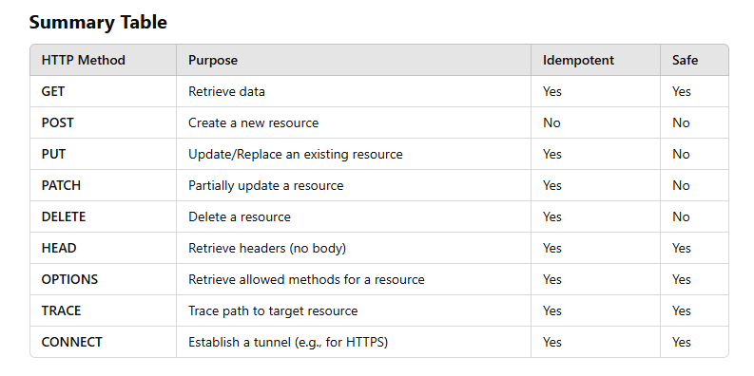

3) URI Identification: Each resource is typically identified by a URI (Uniform Resource Identifier), which is essentially the URL of the resource. For example, https://api.example.com/users/{id} can identify a user resource, where {id} is the unique identifier for that user.

