Source- Playwright MCP + AI Agents — A Practical Setup Guide | ShapeMyInterview
Playwright MCP Agents-

- Playwright MCP provides 3 agents- Planner, Generator and Healer
Prerequisties-
Node.js 18+ — run node --version
VS Code 1.105 or later — agents need this version
GitHub Copilot signed in with an active model
Playwright 1.56 or later — run npx playwright –version
Steps to follow to create agents-
- Create a folder and open in VSCode
- Check or configure github co-pilot chat extension in VScode
- Open terminal > git bash in VScode
- Run npm init -y to initialize the project
- Package.json will be created
- Then run npm init playwright@latest
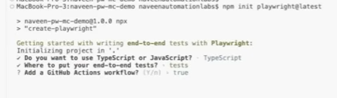
- Then initialize the playwright agents run-
npx playwright init-agents --loop=vscode
It will create 3 agents
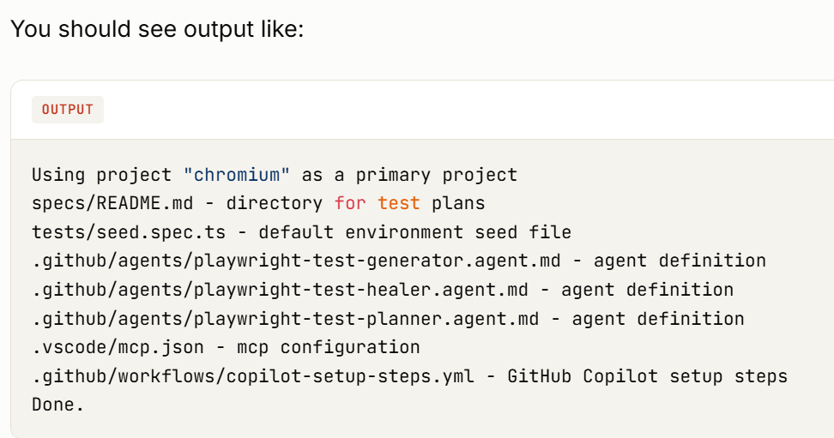
This creates:
- Three .agent.md files — the definitions for each agent
- A seed spec — the baseline test agents run before starting
- An MCP configuration file
- A GitHub Copilot workflow (for cloud coding agent — optional)
— Start the MCP server in VS Code
- Open Command Palette: Cmd + Shift + P (Mac) or Ctrl + Shift + P (Windows/Linux)
- Type: MCP: List Servers
- Find playwright-test in the list
- Click Start
First launch takes 20–30 seconds while Playwright initializes.
Verify the setup
- Open Copilot Chat: Cmd + Ctrl + I (Mac) or Ctrl + Alt + I (Windows)
- In the chat mode dropdown at the bottom, you should see three new modes:
  - playwright-test-planner
  - playwright-test-generator
  - playwright-test-healer
- We can modify the agents instructions and guardrails in agents.md file
- Then create copilot-instruction.md file
- Create AGENTS.md at route level of the project- Every .agent.md file above tells its agent to read AGENTS.md first. This file is your project's rulebook — it holds the conventions every agent should follow.
- Then create a basic folder structure run the command
mkdir -p src/pages src/fixtures src/utils tests/data specs
- Then create the basic fixtures
Create src/fixtures/base.ts
This is the custom fixture that every test will import from.
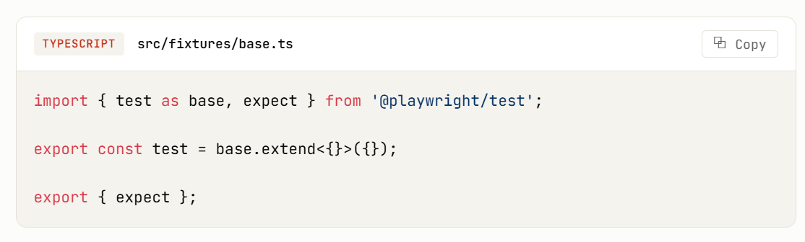
- Create src/pages/BasePage.ts
The base class that all page objects extend.

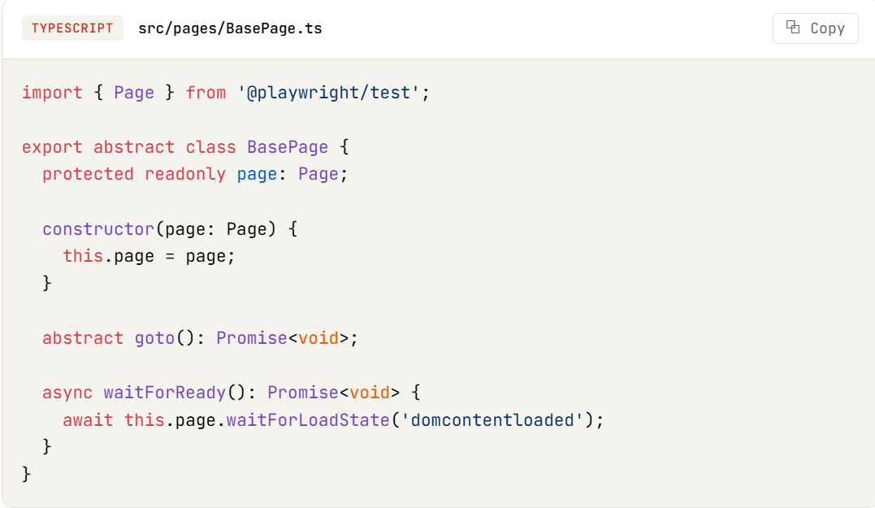

Update tests/seed.spec.ts
Replace the auto-generated seed with a real baseline test that agents can reference:
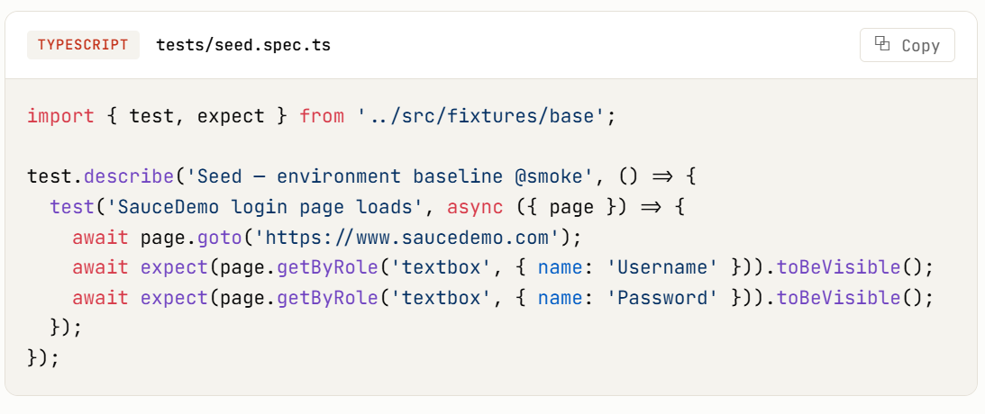
Create tests/data/users.json
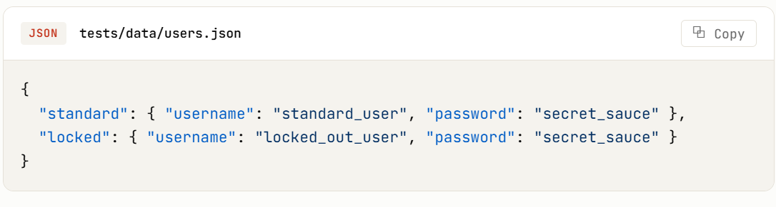
- To run the test
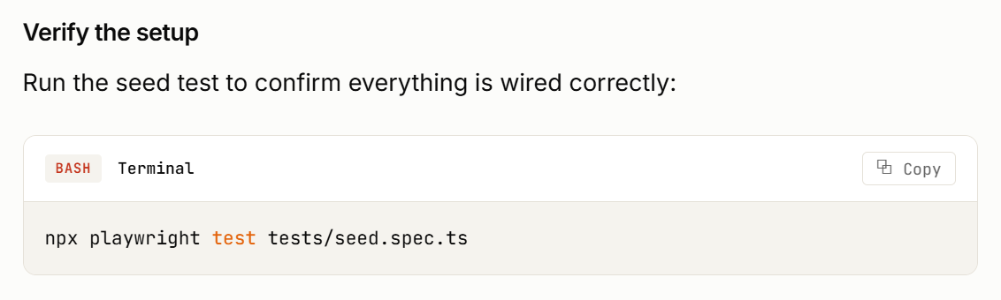
- Running the planner
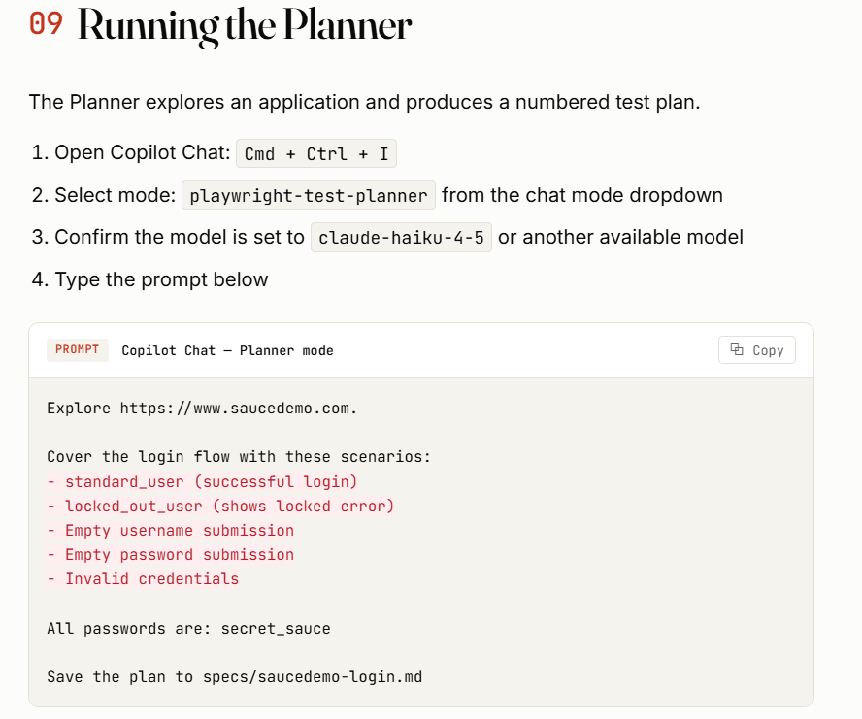
The Planner will:
- Open a Chromium browser window
- Navigate to SauceDemo
- Take accessibility snapshots
- Test each scenario in the live app
- Write a numbered Markdown plan to specs/saucedemo-login.md
What to verify in the plan
- Scenarios are numbered (1.1, 1.2, 2.1, etc.)
- Each scenario has clear preconditions
- Steps include expected results
- Assertions are specific and meaningful, not just "page loaded"
- Tags are applied (@smoke, @regression, @critical)
If any scenario is unclear or wrong, edit the plan file by hand before continuing. The plan is the source of truth — fixing it here is cheaper than fixing generated code later.
- Running the Generator

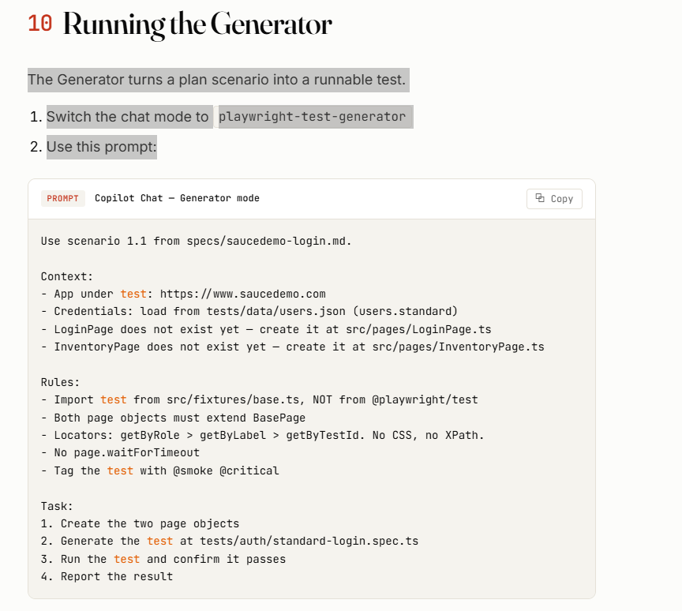
The Generator will:
- Read the plan file
- Open a Chromium browser to verify locators
- Create src/pages/LoginPage.ts (asks before creating)
- Create src/pages/InventoryPage.ts (asks before creating)
- Write the spec file
- Run the test
- Iterate until it passes
Approve each file creation when prompted, or enable auto-approval in the chat settings.
What to verify after generation
Open each generated file and check:
- Imports come from ../../src/fixtures/base, not @playwright/test
- Page objects extend BasePage
- All locators use getByRole, getByLabel, or getByTestId
- No CSS selectors, no XPath, no page.waitForTimeout
- No expect() calls inside page objects
- Test title has the tags applied
If any of these are violated, do not accept the code as-is. This is the review skill.
- Running the Healer-
