- List out the framework components –

Automation Framework-
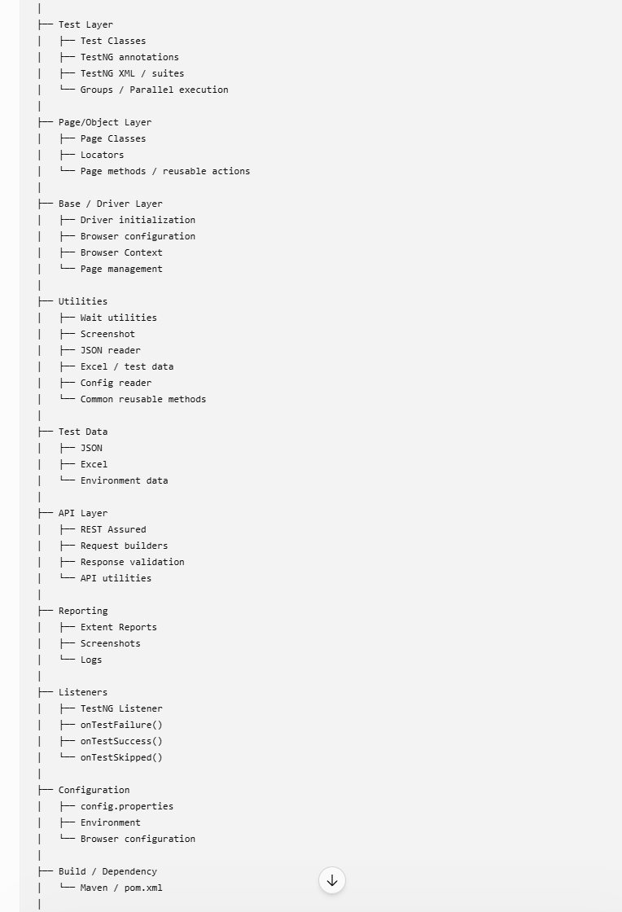

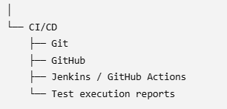

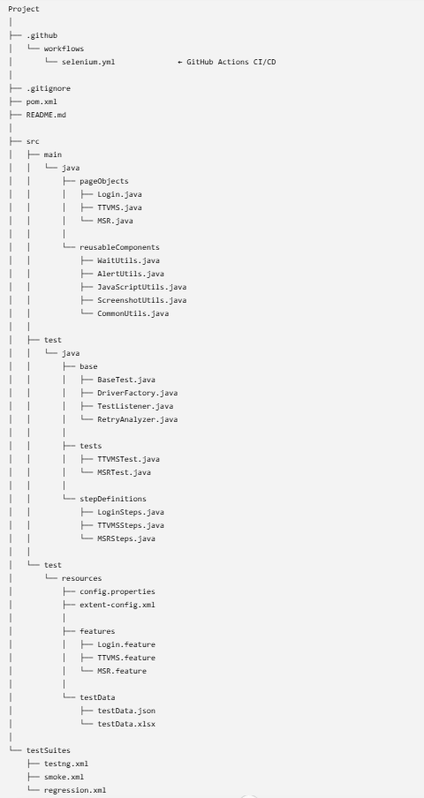
public class ReusableComponents {

// Wait methods
public static void implicitWait() { }
public static void explicitWait() { }
public static void waitForPageLoad() { }

// Alert methods
public static void acceptAlert() { }
public static void dismissAlert() { }
public static String getAlertText() { }

// JavaScript methods
public static void scrollToElement() { }
public static void clickUsingJS() { }

// Screenshot methods
public static void takeScreenshot() { }

// Other common methods
public static void switchToFrame() { }
public static void switchToWindow() { }
}

Waits-
waitForElementVisible()
waitForElementClickable()
waitForElementInvisible()
waitForText()
waitForPageLoad()
waitForAlert()
waitForURL()
...

- Did you use listeners and how you can connect it ?
Ans) Yes, we used TestNG listeners for test execution events, mainly for reporting, logging and failure handling. We implemented ITestListener and used methods such as onTestStart(), onTestSuccess(), onTestFailure() and onTestSkipped().
The listener is connected to TestNG either using @Listeners at the test class level or through the TestNG XML configuration. When TestNG executes a test, it automatically invokes the corresponding listener methods based on the test result.
Connect listeners-
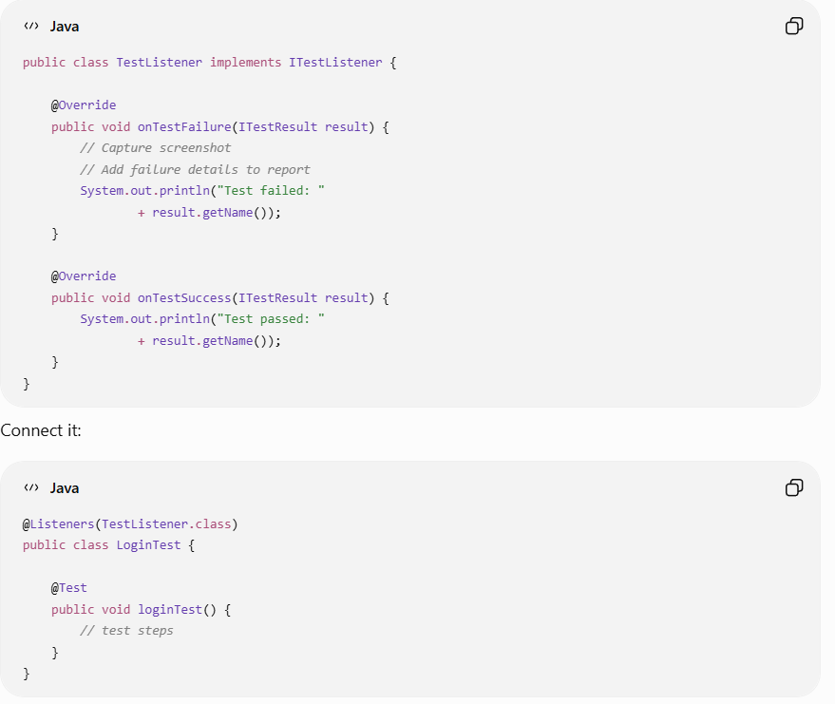
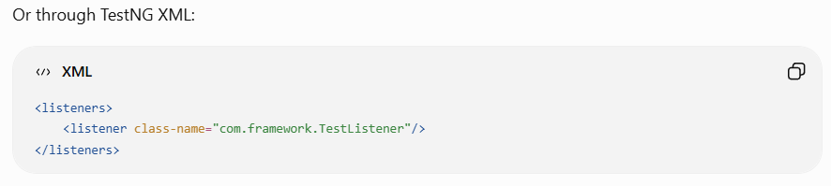
- You migrated Java Selenium framework to Playwright. How was the migration done?
Ans) We didn't simply replace Selenium APIs one-to-one. We first analyzed the existing Selenium framework and identified the reusable components such as test structure, page objects, test data, utilities, reporting, configuration and TestNG execution. Then we replaced the browser automation layer with Playwright while retaining the overall test architecture where applicable.
For example, Selenium WebDriver and WebElement-based interactions were replaced with Playwright's Browser, BrowserContext, Page and Locator APIs. Existing Page Object classes were redesigned using Playwright locators and page methods. We also adapted synchronization because Playwright provides auto-waiting for many actions, so several explicit Selenium waits were no longer required.
After migrating representative test cases, we executed the old Selenium and new Playwright tests against the same scenarios, compared results and then migrated the remaining regression suite incrementally.
- When @Test fails, exactly what happens in your framework?
Ans) "When a @Test method fails, TestNG captures the failure result and invokes the onTestFailure() method of the registered listener implementing ITestListener. Inside this method, we can retrieve the failed test method name, exception details, assertion error and stack trace using ITestResult. We can also capture a screenshot, log the failure with a timestamp, and update the execution report with the failure details. This helps us identify exactly which test failed and why."

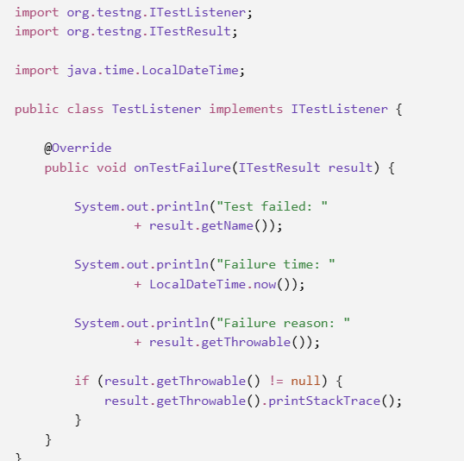
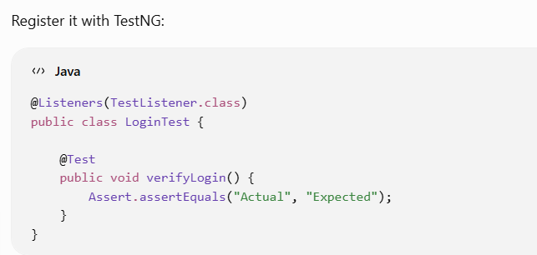
- In OnTestFailure configure screenshot capture ?
Ans) OntestFailure implement the method to take screenshots.

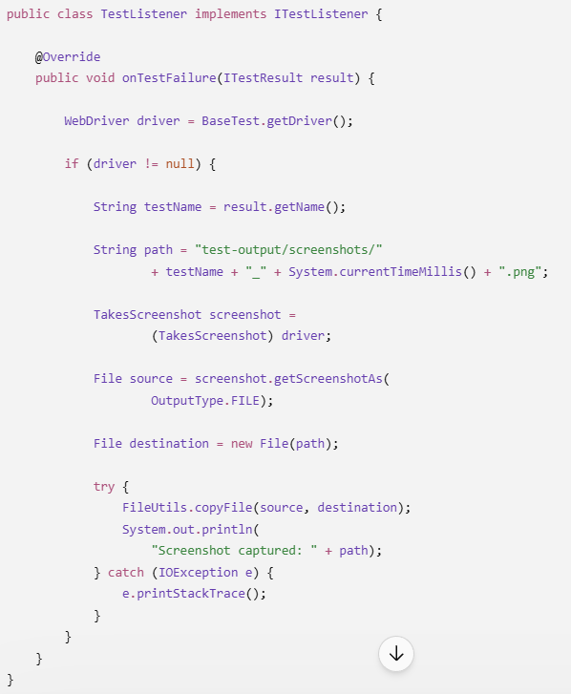
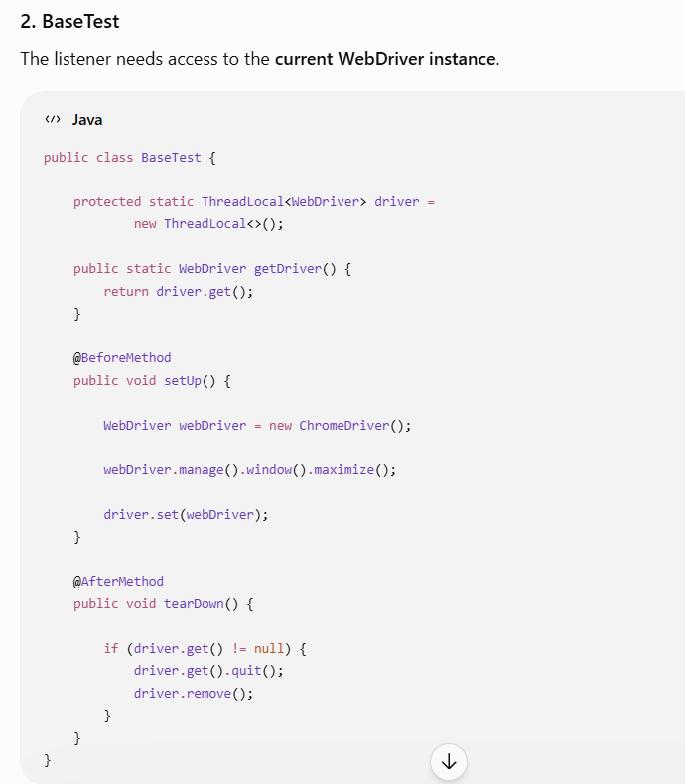
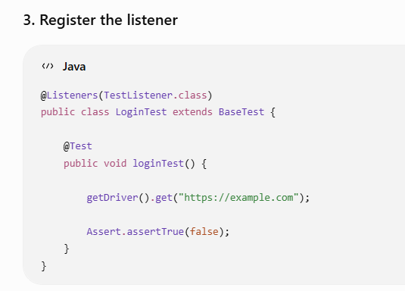
The listener gets the current WebDriver from the framework's driver manager/base class. We maintain the driver instance using ThreadLocal, and the listener retrieves the driver for the current execution thread.
