Playwright MCP+AI Agents+GitHub copilot- Automation
- What is MCP ?
Ans) MCP (Model Context Protocol) is an open standard that enables AI applications to connect LLMs with external tools, data, and systems through a standardized client-server architecture.
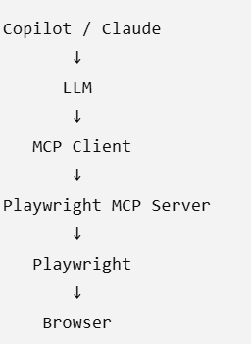
This is why you can ask an AI agent to navigate, inspect elements, click, type, take screenshots, etc. The LLM decides what it wants to do, while the MCP server provides the mechanism to perform those actions.
- Agents of playwright MCP?
Ans)
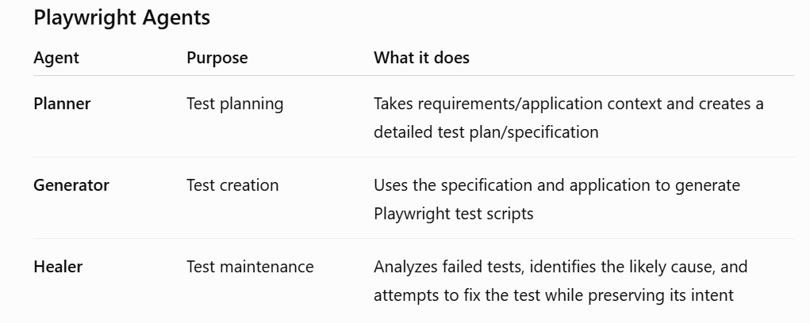
Planner- Its job is to translate requirements into a structured test plan/specification.
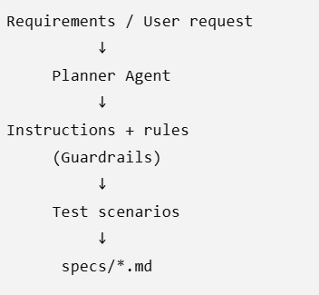
Generator- The Generator takes the specification and application information and converts it into automation. It can use browser interaction tools to understand the application's UI and generate appropriate locators/actions/assertions
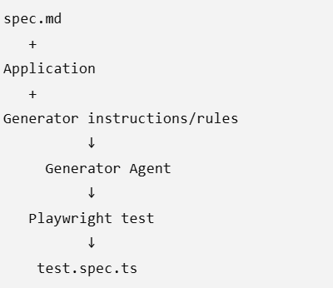
Healer- This is the self-healing/maintenance agent
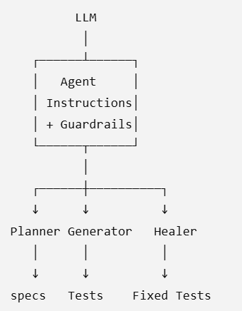

- Guardrails- Guardrails are rules and constraints that control how an AI agent should behave and what it should or should not do.
They help ensure the agent's output is safe, consistent, and aligned with the intended task.
- Orchestration - is the process of coordinating multiple AI agents, tools, or workflows to complete a task in the correct sequence.
Example: Planner → Generator → Test Execution → Healer.
- Workflow is a predefined sequence of steps or tasks that an AI system follows to complete a specific job.
Example- Planner → Generator → Execute Tests → Healer → Re-run Tests
So, Orchestration = coordinating the components, while Workflow = the sequence of steps they follow.
- GenAI VS Agentic AI ?
Ans) GenAI (Generative AI) generates content based on a prompt — such as text, code, test cases, or documentation.
Agentic AI goes beyond generating content: it can plan, use tools, take actions, observe results, and continue working toward a goal with some level of autonomy.
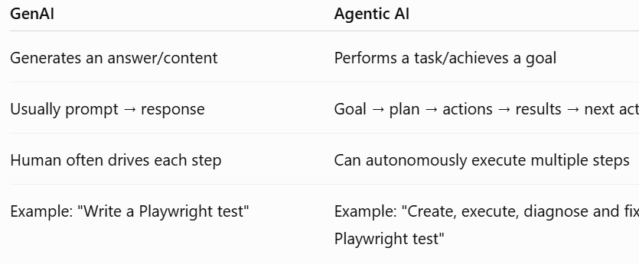
Simple way to remember:
GenAI = Generate
Agentic AI = Think + Act + Observe + Repeat
In your Playwright setup, Planner, Generator and Healer are examples of agentic workflows built using GenAI/LLMs + tools such as Playwright MCP.

- What is LLM ?
Ans) LLM (Large Language Model) is an AI model trained on large amounts of data that understands natural language and generates human-like responses. It acts as the reasoning engine behind AI applications such as Copilot and Claude.
- Tokens- Tokens are the small pieces of text that an LLM processes. A token can be a whole word, part of a word, punctuation, or other text.
- Context Window- is the maximum amount of information, measured in tokens, that an LLM can consider at one time.
If the context becomes too large, older information may need to be truncated, summarized, or otherwise managed depending on the application/model
- ML and DL ?
Ans)
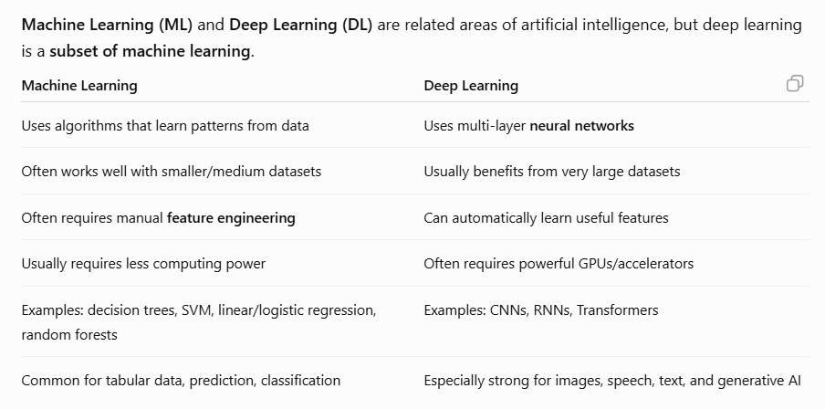
- What is embeddings ?
Ans) Embeddings are a way of converting text, images, or other data into numbers (vectors) so that an AI system can understand their meaning and similarity.
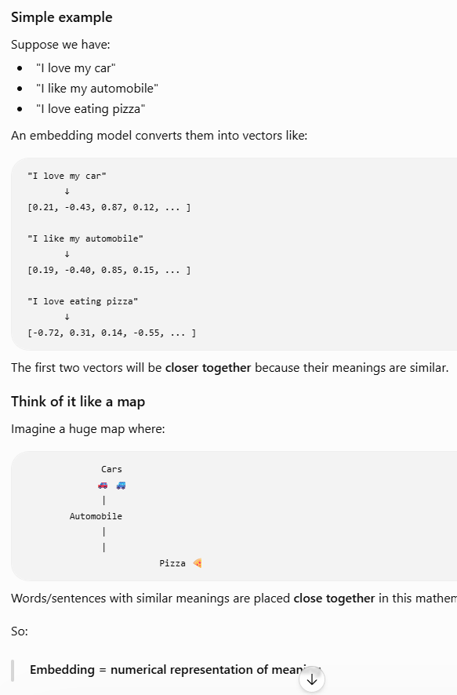
- Why are embeddings important in AI?
Ans)
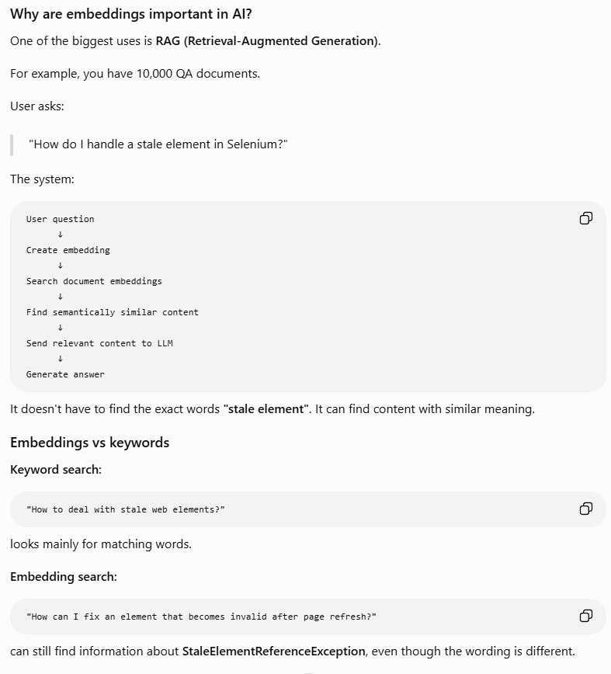
- System Prompt and User prompt ?
Ans) A system prompt defines the AI's role, behavior, rules, and constraints.
It tells the model how it should behave.
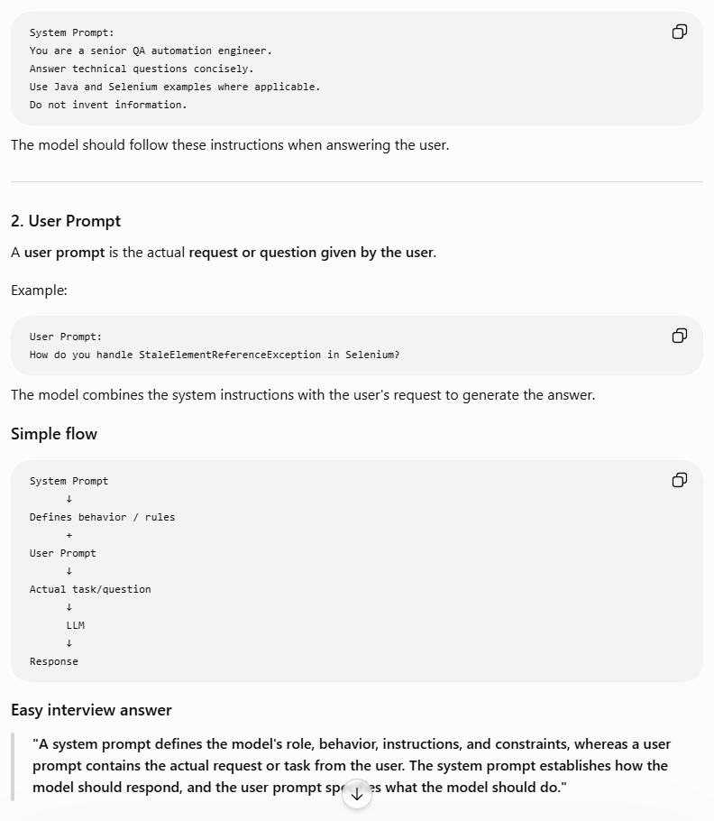
"A system prompt defines the agent's overall behavior, instructions and guardrails. A skill file such as SKILL.md can provide specialized instructions and procedures that the agent follows when using that particular skill. The skill file is therefore similar in purpose to additional instructions, but it isn't necessarily the system prompt itself."
- What is function calling ?
Ans)
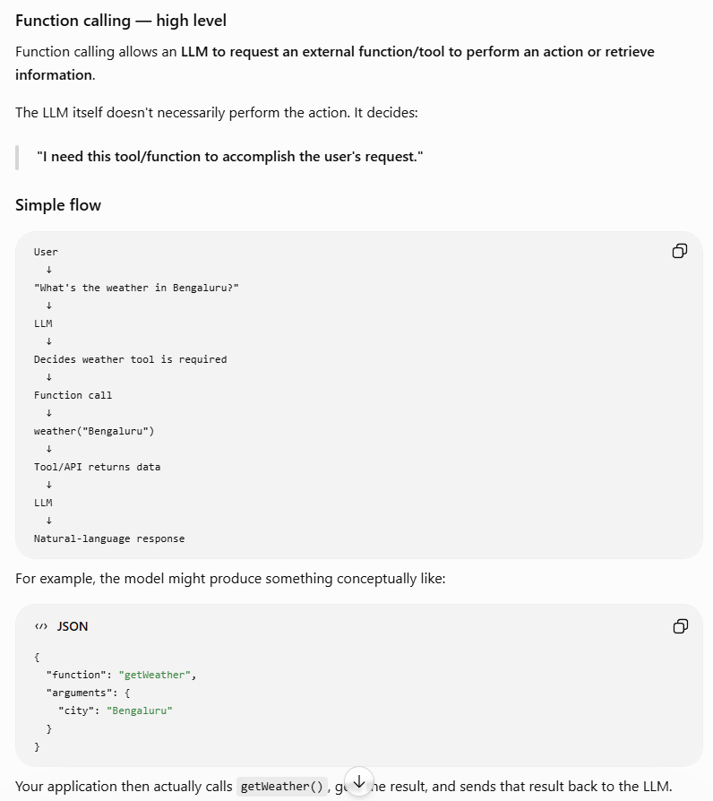
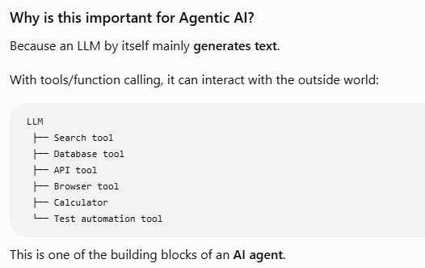
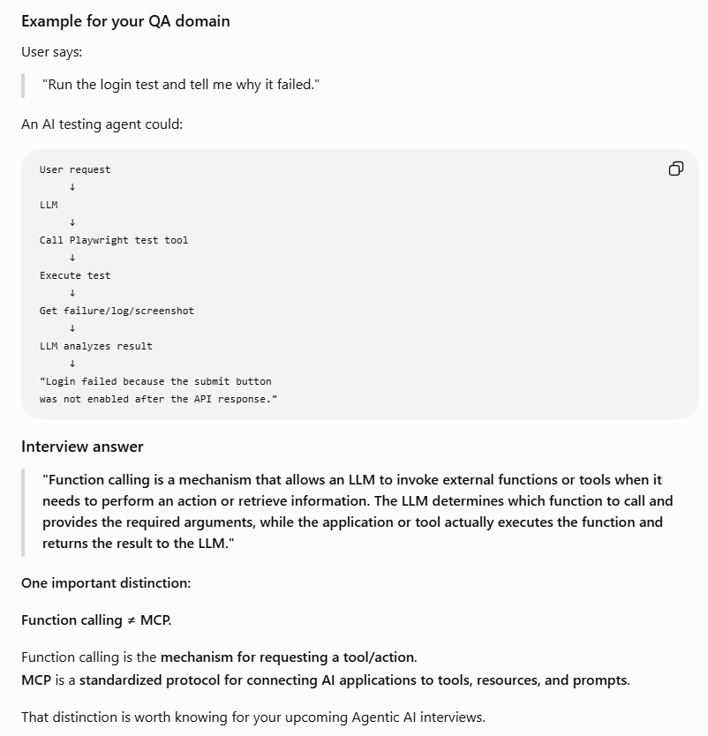
- Explain below all ?
Ans)
