- Playwright Architecture-

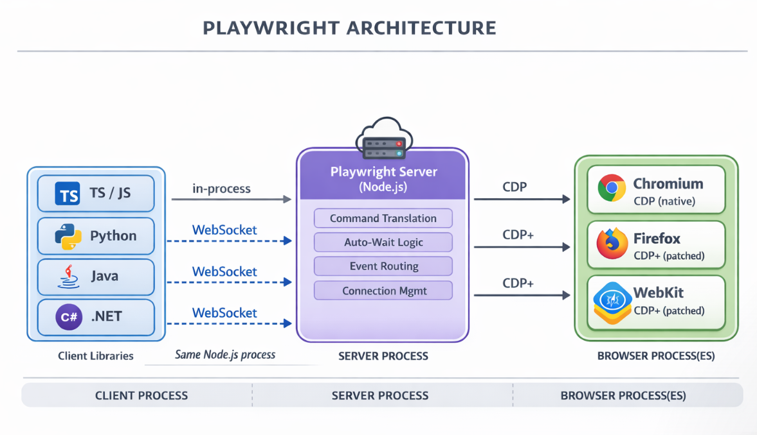
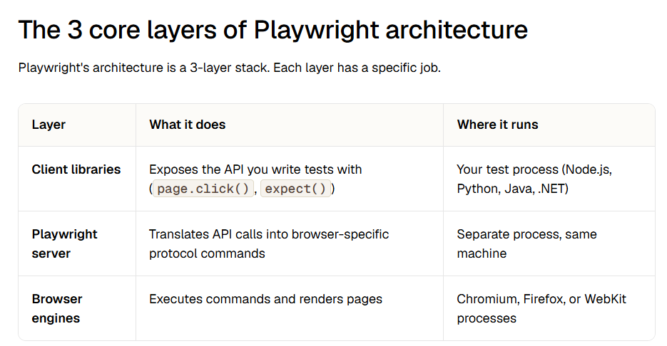
Playwright architecture is the internal system of layers, protocols, and processes that connects your test code to the browser. It follows a client-server model where the test script (client) communicates with a server process, which then controls browser engines through the Chrome DevTools Protocol (CDP).
Your test file doesn't talk to the browser directly. It sends instructions to a Playwright Server process over a WebSocket connection. That server then translates your instructions into CDP commands and forwards them to the browser engine.
This is fundamentally different from how Selenium works. Selenium uses HTTP requests for each command. Playwright keeps a persistent WebSocket connection open.

Short answer- "Playwright uses a client-driven architecture. Our test code interacts with Playwright through language bindings, and Playwright communicates with the browser engines to perform automation. It supports Chromium, Firefox and WebKit and provides a unified API across browsers. The architecture also enables features like browser-context isolation, auto-waiting, network interception and tracing."

- What is CDP (Chrome DevTools Protocol)?
Ans) CDP (Chrome DevTools Protocol) is the low-level messaging protocol that Playwright uses to control Chromium-based browsers. It sends JSON-formatted commands for navigation, DOM manipulation, network interception, and more.
- What is the architecture of Playwright?
Playwright uses a 3-layer client-server architecture. Your test code (client) communicates with a Playwright Server process over WebSocket, and the server controls browser engines (Chromium, Firefox, WebKit) through the Chrome DevTools Protocol.
- What protocol does Playwright use?
Playwright uses the Chrome DevTools Protocol (CDP) to communicate with browsers. For Chromium, it uses CDP natively. For Firefox and WebKit, the Playwright team contributes patches that add a CDP-compatible protocol layer directly into these browsers.
- What is the difference between Playwright and Selenium architecture?
Playwright uses a persistent WebSocket connection with CDP to control browsers, while Selenium uses HTTP requests with the WebDriver protocol. Playwright patches browser engines directly for cross-browser support, while Selenium relies on vendor-maintained WebDriver implementations.
- What is the Playwright design pattern?
Playwright's recommended design pattern is the Page Object Model (POM), where each page of your application is represented by a class that encapsulates its elements and actions. Combined with Playwright's fixture system for dependency injection, this creates clean, maintainable test code.
- Can Playwright test multiple browsers at once?
Yes. Playwright natively supports Chromium, Firefox, and WebKit. You can configure multiple projects in your playwright.config.ts, each targeting a different browser. All 3 browsers run with the same API & the same behavioral guarantees because Playwright controls the protocol layer for each engine.
- What are Browser, BrowserContext and Page in Playwright?
A Browser represents an instance of a browser such as Chromium, Firefox or WebKit.
A BrowserContext is an isolated browser session or profile created within a Browser. Each context has its own isolated browser state, such as cookies, local storage, session storage, permissions and other context-level settings. This provides test isolation without launching a completely separate browser process.
A Page represents a single browser tab within a BrowserContext. We use the Page object to navigate to URLs and perform actions such as locating elements, clicking, filling forms and making assertions.
The relationship can be visualized as:
Browser → BrowserContext → Page
One Browser can have multiple BrowserContexts, and each BrowserContext can contain multiple Pages.
- Why does Playwright use BrowserContext instead of creating a new browser for every test?
Ans) "BrowserContexts provide lightweight and isolated sessions within the same browser instance. This gives us test isolation while avoiding the overhead of launching a completely new browser process for every test, which improves execution efficiency and supports parallel testing."
- Autowaiting mechanism in playwright ?
Ans) “Playwright auto-waiting is a built-in mechanism where locator actions automatically wait for the required actionability conditions before performing the action. For example, before a click, Playwright waits for the element to be visible, stable, enabled, and able to receive events. In certain scenarios where we need to wait for a specific application event or state, we can use Playwright's explicit waiting mechanisms, such as waitForResponse(), waitForURL(), or expect() assertions. We should avoid hard waits such as Thread.sleep().

“Unlike Selenium, where we frequently use explicit waits to handle synchronization, Playwright has auto-waiting built into its locator actions, which significantly reduces flaky tests.”

- Waits in playwrite.
Wait Type | Java Syntax | Default Timeout
Auto-waiting | page.locator("#btn").click(); | 30 sec
Locator wait | page.locator("#btn").waitFor(); | 30 sec
Assertion wait | assertThat(page.locator("#msg")).isVisible(); | 5 sec
URL wait | page.waitForURL("**/dashboard"); | 30 sec
Response/API wait | page.waitForResponse(...); | 30 sec
Fixed/Hard wait | page.waitForTimeout(3000); | No timeout — waits exactly 3 sec
- How do you bypass UI login using API authentication ?
Ans) "Instead of performing the login through the UI for every test, I can authenticate through an API and reuse the authenticated session in Playwright.
I would create an APIRequestContext, call the login/authentication API with the required credentials, obtain the authentication token or session information, and then use that authenticated state when creating the browser context.
This bypasses the UI login and makes the tests faster and less dependent on the login page."
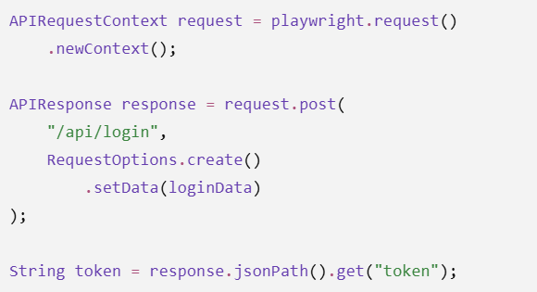
Then the token can be used when creating the browser context, depending on how the application authenticates:
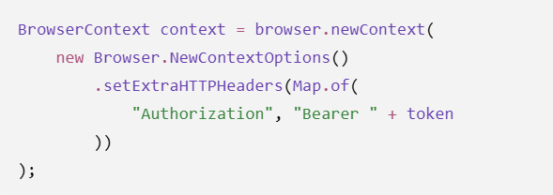
Authentication could use:
- Bearer/JWT token
- Cookies
- Session ID
- Local storage
- OAuth tokens
So your approach depends on how the application implements authentication.
- Playwright fixture ?
Ans) Fixtures in Playwright are used to provide reusable test setup and teardown. They allow us to create and manage objects such as the browser, browser context, page, or test data, and make them available to tests without repeating the setup code.
Playwright's built-in fixture mechanism is primarily associated with the Playwright Test framework in JavaScript/TypeScript. Since I'm using Playwright with Java and TestNG, I would achieve a similar fixture-like setup using TestNG annotations such as @BeforeSuite, @BeforeMethod, @AfterMethod, and reusable BaseTest methods.
