- Launch browser-
Playwright playwright=Playwright.create();
// creating object of playwright, create () is a static method here
- browser=playwright.chromium().launch(new BrowserType.LaunchOptions().setChannel("chrome").setHeadless(headless));
//launch method to launch the browser instance, setchannel to launch local driver instead of chromium bundled, setHeadless accept boolean to create headed or headless mode.
- browser.newContext();
// Creates an isolated browser context (session) within the same browser.
- How do you handle forms, inputs, and button interactions in Playwright?
Ans) For forms and inputs, I prefer user-facing locators such as getByLabel() or getByPlaceholder() and use fill() to enter data. For buttons, I use getByRole() with the button's accessible name and perform the click() action.
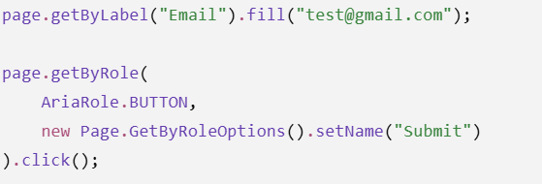
- How do you handle alerts, dialogs, and popups? and Window or Tab handle?
Ans) I handle JavaScript alerts, confirmations, and prompts using Playwright's page.onDialog() event. I register the dialog handler before triggering the action, retrieve the message using dialog.message(), and use dialog.accept() or dialog.dismiss() depending on the requirement.
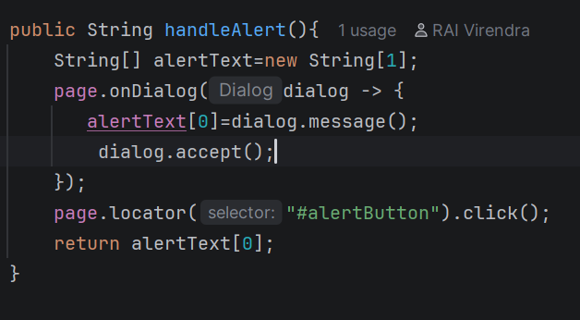
Window or Tab handle- In Playwright, a new tab or window is represented as a Page. I use context.waitForPage() to wait for the new page while triggering the action that opens it. Once the new Page object is returned, I can interact with it independently.
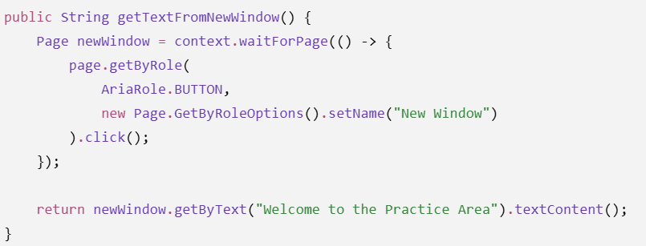

Switch between the window- Unlike Selenium, Playwright doesn't require switchTo() or window handles. Each tab or window is represented by a Page object. I store the page references and directly interact with the required Page object.
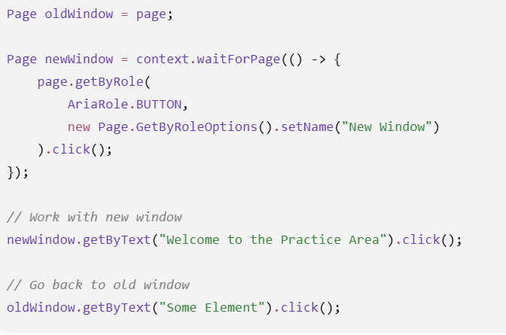
- How do you capture screenshots and videos in Playwright?
Ans) For screenshots, I use page.screenshot(). For video recording, I enable setRecordVideoDir() while creating the browser context. For debugging and failure analysis, I can use Playwright tracing with screenshots, snapshots, and sources, and save the trace as a ZIP file.
//capture current page screenshot
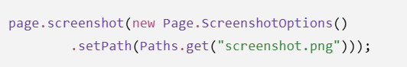
//enable video when creating new context
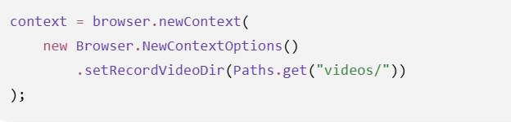
Then


// Enable tracing- open the resulting trace.zip in Trace Viewer to inspect screenshots, DOM snapshots, network/activity, and source information.
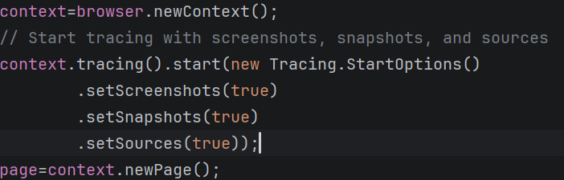
Closing the trace
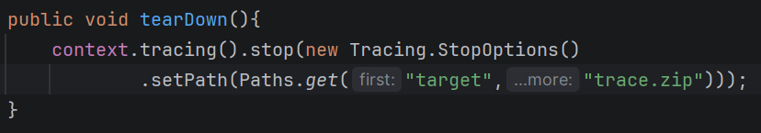
- How do you validate UI text, attributes, and visibility in Playwright?
Ans) For text, I can use textContent() to retrieve the text, but for assertions I prefer Playwright's expect(locator).toHaveText() or toContainText().
For attributes, I can retrieve the value using getAttribute(), or directly validate it using expect(locator).toHaveAttribute().
For visibility, I can use isVisible(), but for test validation I generally use expect(locator).toBeVisible()
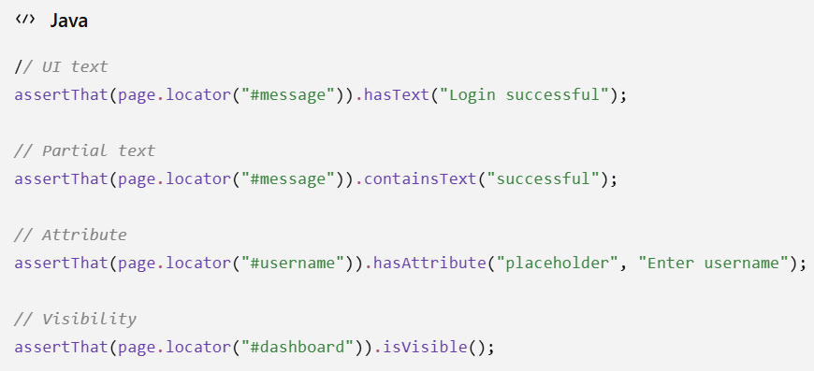
- How would you locate element using CSS and xPath in playwright ?
Ans) Using page.locator()
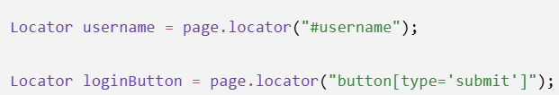
"Although Playwright supports CSS and XPath, I generally prefer stable user-facing locators such as getByRole(), getByLabel(), and getByTestId() where applicable. CSS or XPath can be used when those locators aren't suitable."
- How does soft assertion worked in playwright ?
Ans) A soft assertion records the assertion failure but does not immediately stop the test execution. The test continues with the remaining steps, and the test is reported as failed after the assertions are evaluated.
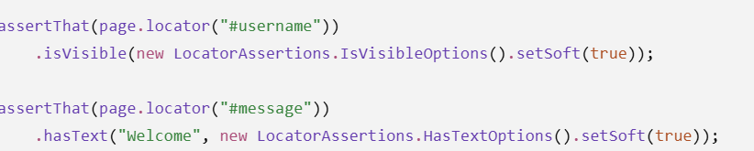
- How do you handle console logs and browser logs ?
Ans) In Playwright, I can capture browser console messages using the page.onConsoleMessage() event listener. I can capture uncaught JavaScript errors using page.onPageError(). I can register these listeners in my BaseTest or framework setup so that console errors and page errors are captured automatically for every test.
Important distinction: onConsoleMessage() captures messages written to the browser's console, while onPageError() captures uncaught exceptions in the page.
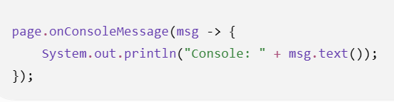
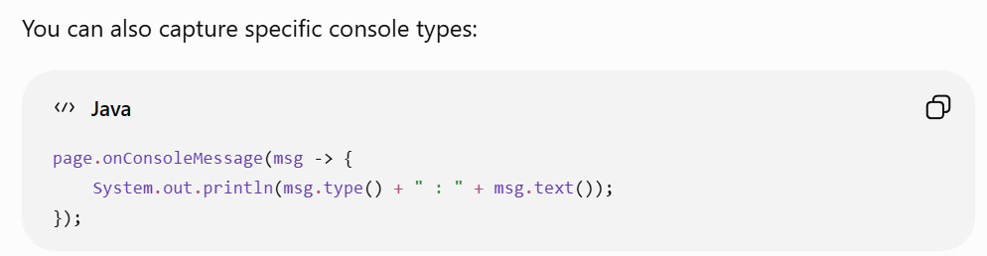
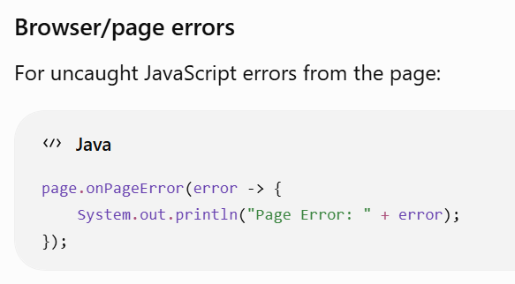
- How do you perform retry of failed testcases ?
Ans) "In Playwright Test, retries can be configured in the Playwright configuration using the retries option. For example, setting retries: 2 means a failed test can be retried up to two times.
Since I'm using Playwright with Java and TestNG, I would use TestNG's retry mechanism, typically by implementing IRetryAnalyzer and configuring it for the required tests.
I would keep retries limited because retries should not hide genuine application defects. I would also capture the trace, screenshot, logs, and other evidence from the failed attempt to investigate the root cause.
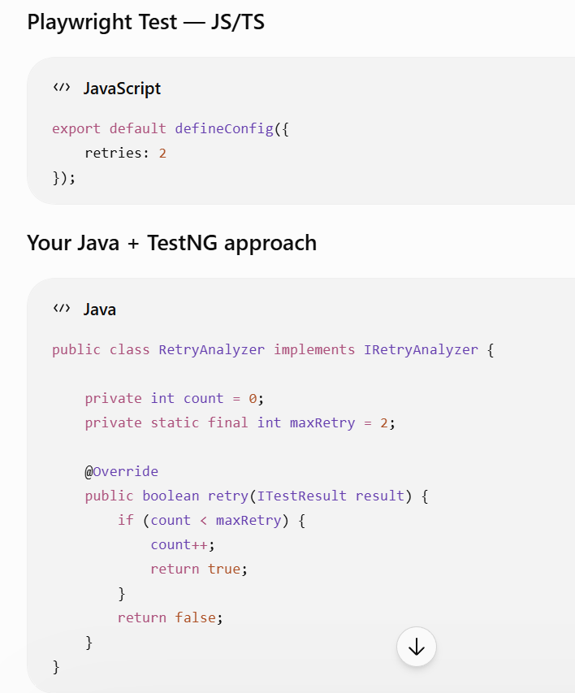
- Why is BrowserContext isolation important when running Playwright tests in parallel?
Ans) BrowserContext isolation is important for parallel execution because it provides an independent browser session for each test. This prevents cookies, authentication, local storage, and other browser state from leaking between tests. As a result, tests can run concurrently without interfering with each other, reducing flaky and non-deterministic failures. Playwright's test runner provides context isolation by default, which makes parallel execution safer and more reliable.
- How do you extract tokens from API responses and reuse them in UI sessions?
Ans) I authenticate through the API, extract the access token from the JSON response using JSONPath, and store it. For subsequent API calls I pass it through the Authorization header. If I need to reuse it for UI testing, I inject the token into the Playwright BrowserContext through the application's authentication mechanism, such as cookies or localStorage, allowing the UI test to start with an authenticated session.
- How do you generate and publish HTML reports in Playwright?
Ans) In my Playwright Java framework, I'm using TestNG for test execution and reporting. TestNG generates the HTML execution report, and I can integrate a reporting library such as ExtentReports or Allure through TestNG listeners when a richer report is required. I can also capture Playwright screenshots, videos, or traces and attach them to the report, especially for failed tests. In CI/CD, I publish the generated report as an artifact.
- How do you generate dynamic test data during execution?
Ans) “External utilities are not always required. For simple dynamic data, I use Java's built-in capabilities such as UUID, Random, and timestamps. When I need realistic or large volumes of data, I can use a library such as Faker. The main objective is to avoid hardcoded or duplicate test data and make tests independent, reusable, and suitable for parallel execution.”

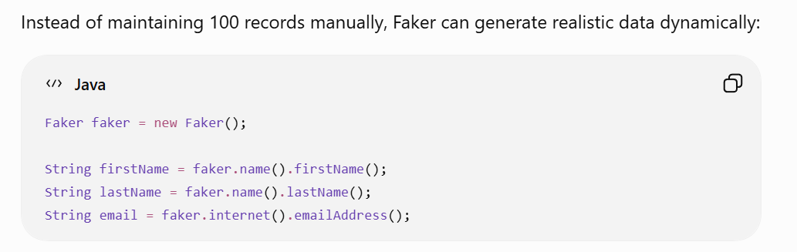
- How do you handle dropdown and custom select component ?
Ans) 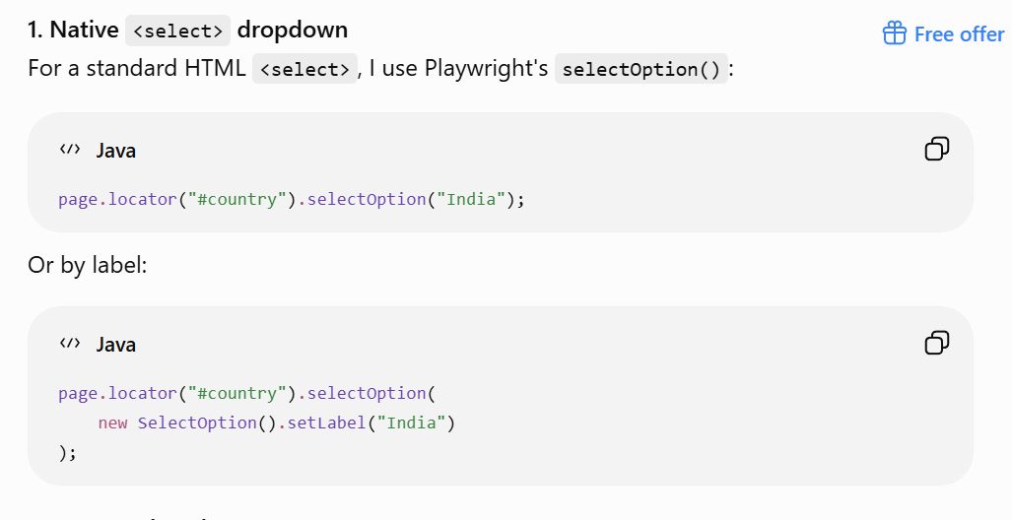
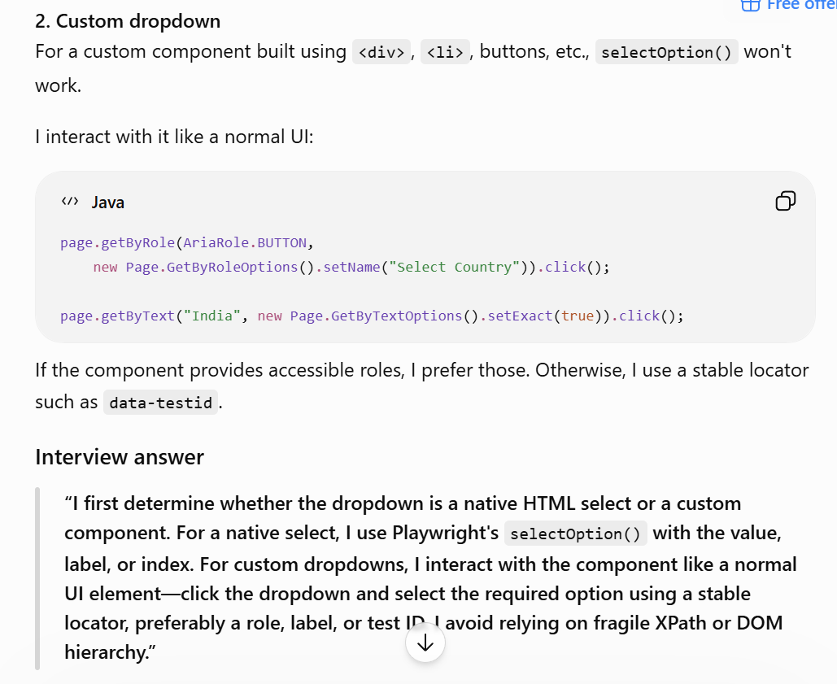
- How do you handle flaky assertions in Playwright?
Ans) Common causes are:
- UI/API response not completed
- Dynamic content
- Incorrect locator
- Animation or asynchronous updates
- Backend/data dependency
Use web first assertion-
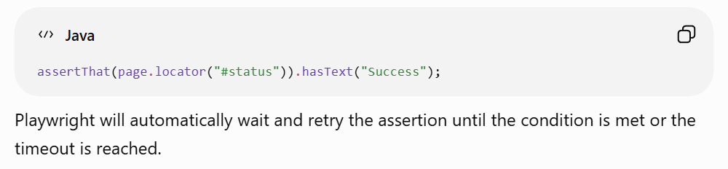
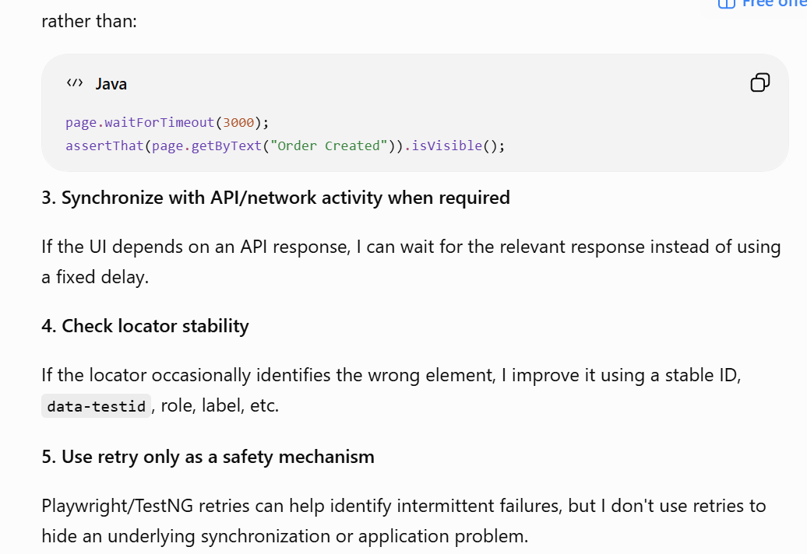
- How do you handle flaky test in playwright ?
Ans) My approach is:
- Identify the cause
  - Unstable locators
  - Timing/synchronization issues
  - Dynamic UI elements
  - API/network delays
  - Test-data dependency
  - Environment issues
  - Tests interfering with each other during parallel execution
- Use Playwright's auto-waiting and web-first assertions
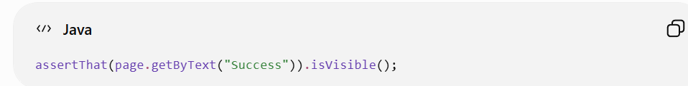
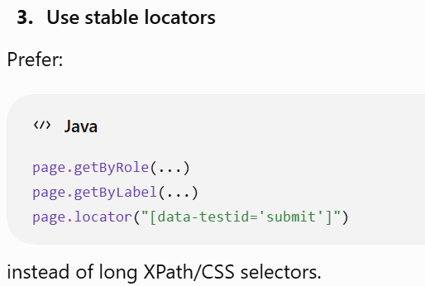
- Handle API/network synchronization
If the UI depends on an API response, I wait for the relevant response/state rather than using arbitrary delays.
- Keep tests isolated
Each test should have independent browser context and test data so parallel execution doesn't cause interference.
- Use Playwright tracing, screenshots and videos
For failures, I capture artifacts to understand whether the problem is with the application, locator, timing, or environment.
- Use retries carefully
Playwright/TestNG retry mechanisms can help with genuinely intermittent failures, but I treat retries as a safety mechanism, not the solution.
Strong interview answer
“For flaky tests, I first analyze the root cause instead of blindly adding retries. I check synchronization, locator stability, dynamic UI behavior, API/network dependencies, test-data issues, environment problems, and parallel-test interference. I use Playwright's auto-waiting and web-first assertions, stable locators, and proper API or network synchronization. I also use screenshots, videos, and traces for debugging. Once the root cause is fixed, I use retries only as a safety mechanism for occasional transient failures.”
Good distinction for your interview:
Flaky assertion → focus mainly on assertion/synchronization.
Flaky test → investigate the entire test lifecycle, including data, environment, network, isolation, and dependencies.
- How do you handle Shadow DOM elements in Playwright?
Ans) Playwright has built-in support for Shadow DOM, so in most cases I don't need to manually access the shadow root using JavaScript.
If the element is inside an open Shadow DOM, Playwright's locators can pierce the shadow DOM automatically.

Closed shadow DOM- I cannot directly locate elements inside it through normal Playwright locators. In that situation, I would normally look for a public interaction exposed by the component, or work with the application's testability hooks rather than trying to break the encapsulation.

In Selenium-

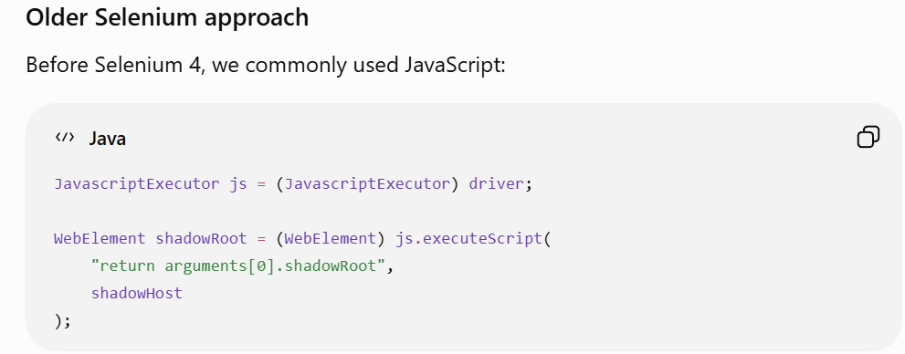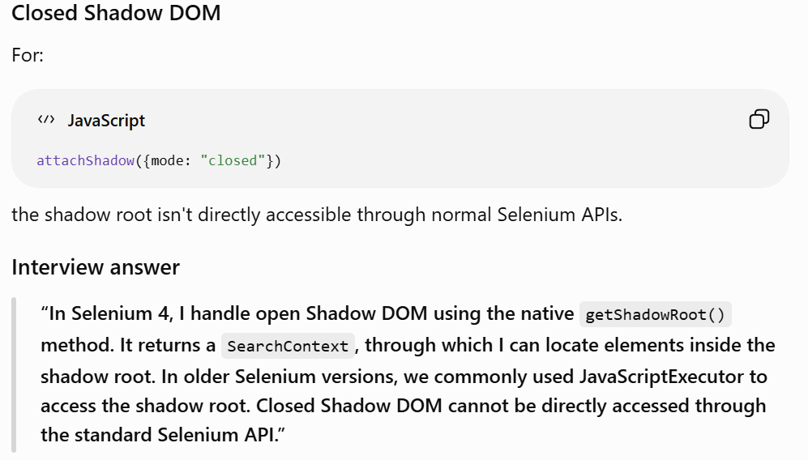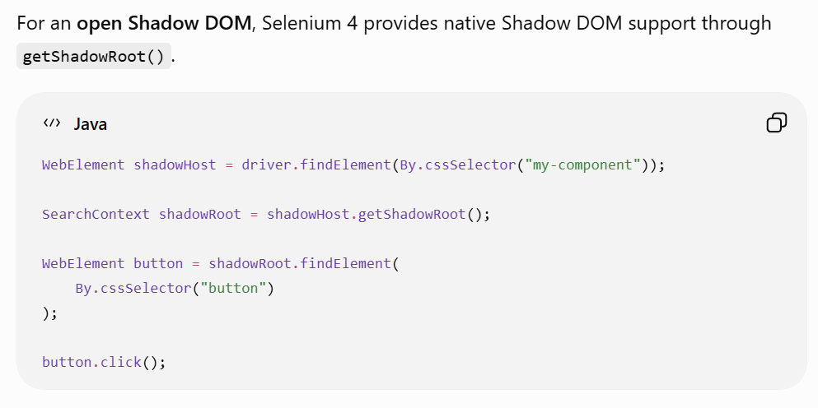
- How do you handle test dependencies in Playwright tests?
Ans) Since I'm using Playwright with Java and TestNG, I can manage dependencies using TestNG's dependsOnMethods or dependsOnGroups. For example, an update test can depend on a create test. However, I generally avoid excessive test dependencies because they make the suite fragile and prevent effective parallel execution. Wherever possible, I make tests independent by creating the required state using API calls or test fixtures and then perform the UI validation
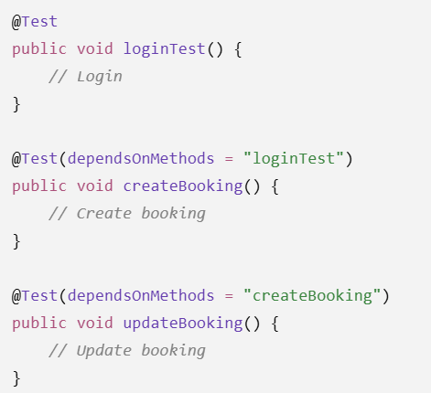
- How do you implement an API + UI hybrid test flow in code?
Ans) In a hybrid API + UI test, I use the API layer to prepare the required test state or authenticate the user, and then use Playwright for the UI validation. For example, I can create a record through an API, extract its ID from the response using JSONPath, navigate to the application, search for that ID in the UI, and validate the displayed data. This approach reduces unnecessary UI operations, makes the test faster, and also helps isolate whether an issue is in the API/backend or the UI.
- How would you architect an enterprise Playwright framework supporting thousands of tests, multiple teams, parallel execution, and independent release pipelines?
Ans) For an enterprise Playwright + Java + TestNG framework, I would focus on modularity, ownership, isolation, scalability, and CI/CD independence.
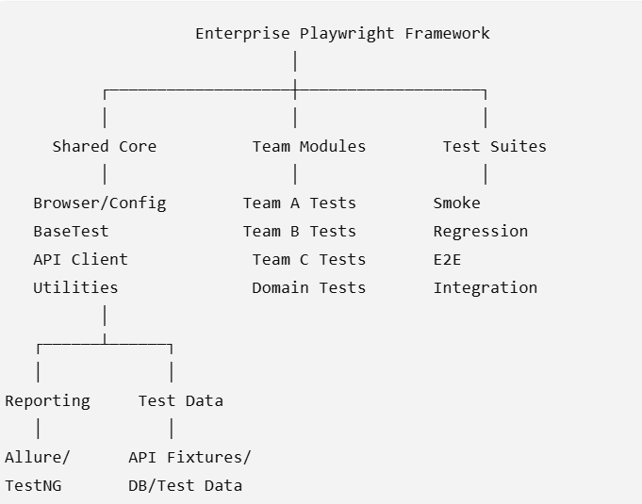
I would use:
- Page Objects for page-level behavior
- Component Objects for reusable components
- Centralized locator strategy
- Reusable API clients
- Common utilities only where genuinely shared
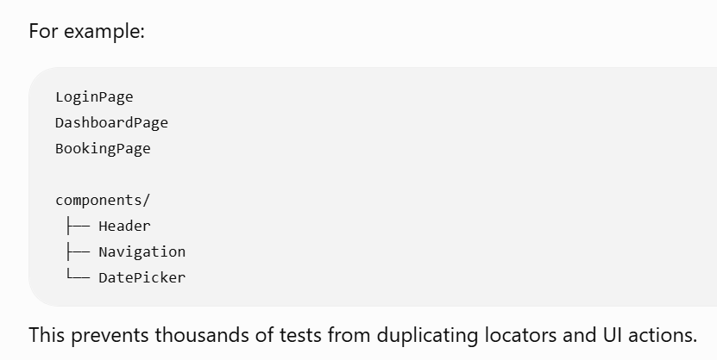
Test isolation
Every test should have an independent:
- BrowserContext
- Authentication state
- Test data
- Temporary files/session state
I would partition tests by:
- Team
- Feature
- Suite
- Tags/groups
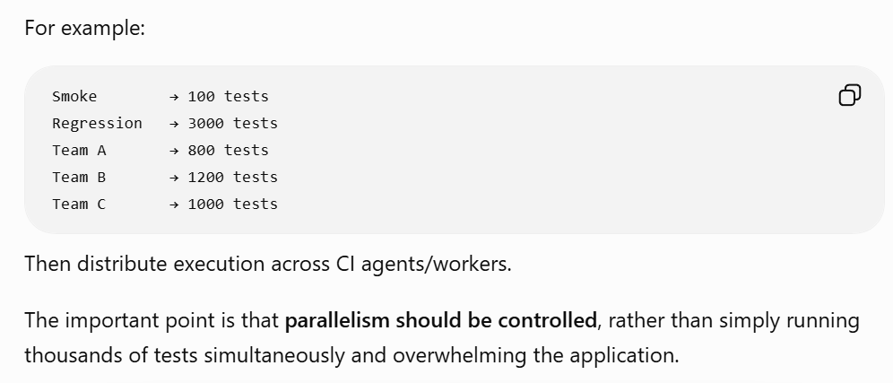
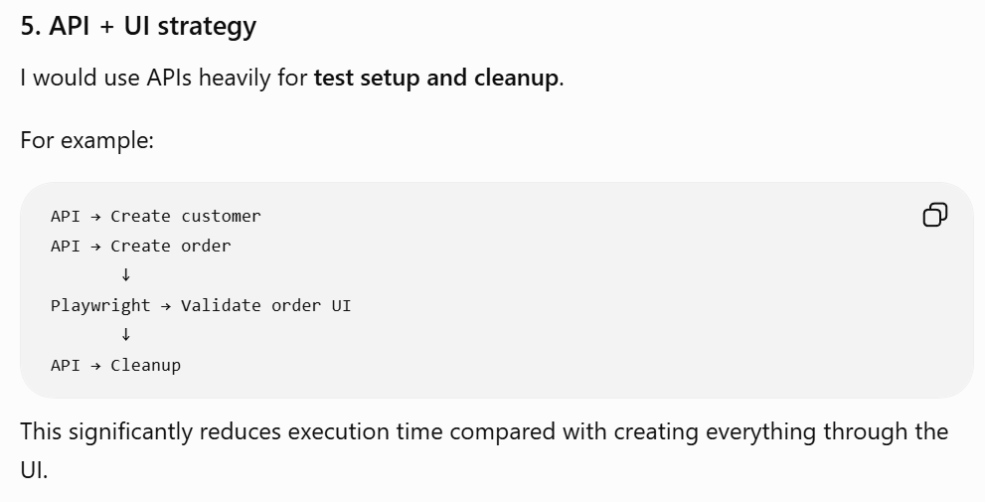
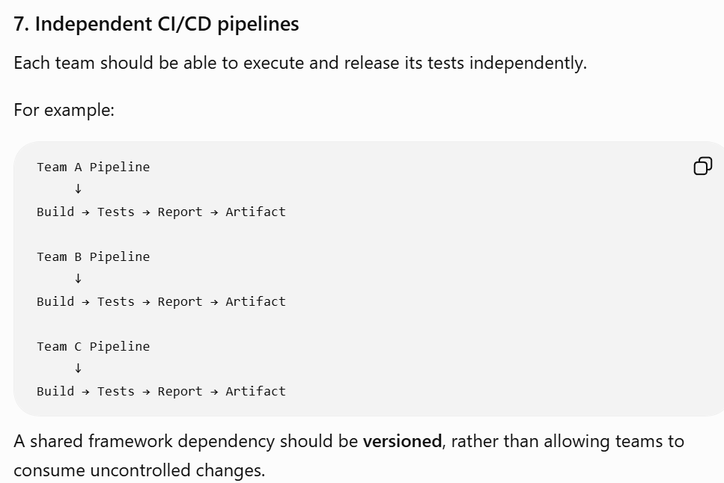
8. Reporting and failure analysis
For thousands of tests, reporting needs to provide:
- Pass/fail/skipped
- Duration
- Failure reason
- Screenshots
- Video where required
- Trace
- Logs
- Environment/browser information
I would publish reports and artifacts from CI so teams can investigate failures without rerunning locally.
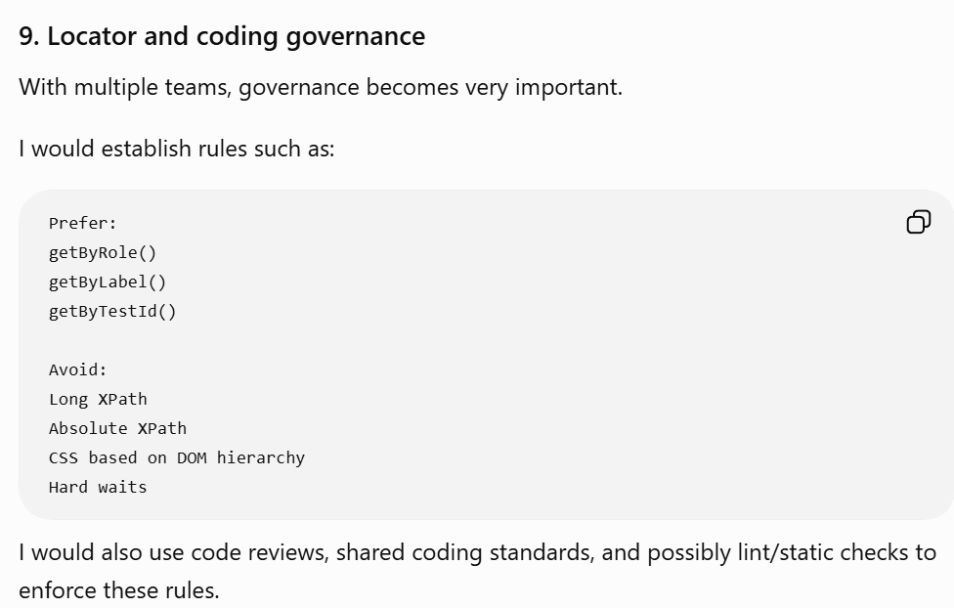
- How would you build a systematic approach to detecting, quarantining, measuring, and eliminating flaky Playwright tests across an enterprise suite?
Ans) For an enterprise suite, I would treat flakiness as an engineering metric, not simply as a test failure. I would build a closed-loop process: detect → classify → quarantine → measure → fix → verify → prevent recurrence.
1. Detect flaky tests
First, collect execution history from CI.
For every test, capture:
- Test name / ID
- Git commit/build
- Browser/environment
- Duration
- Pass/fail/skip
- Retry count
- Failure reason
- Screenshot/video/trace
- Worker/parallel execution information
A test that passes on retry after initially failing is an important signal.
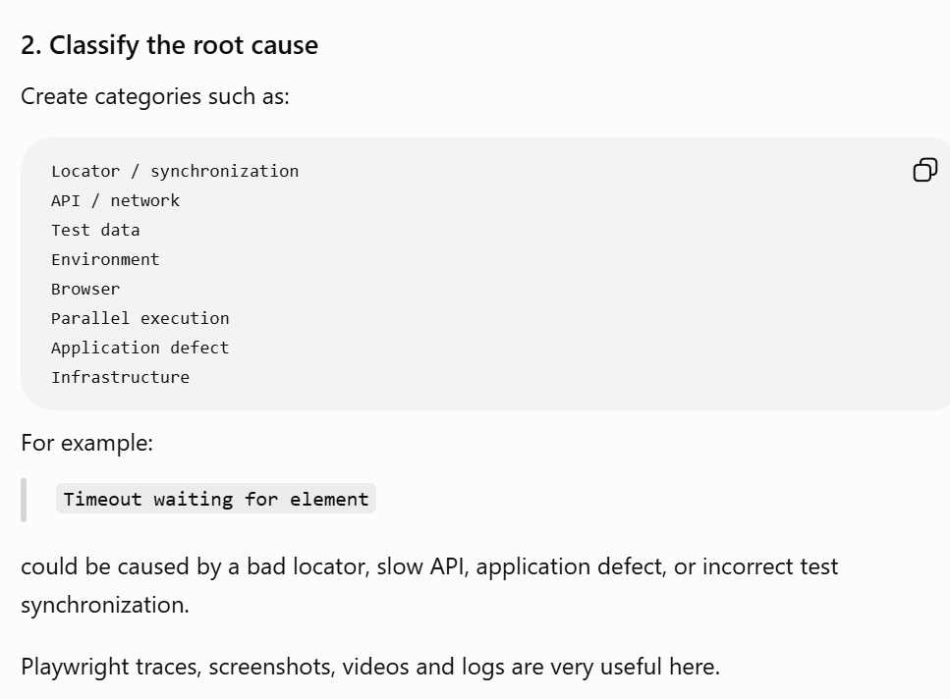
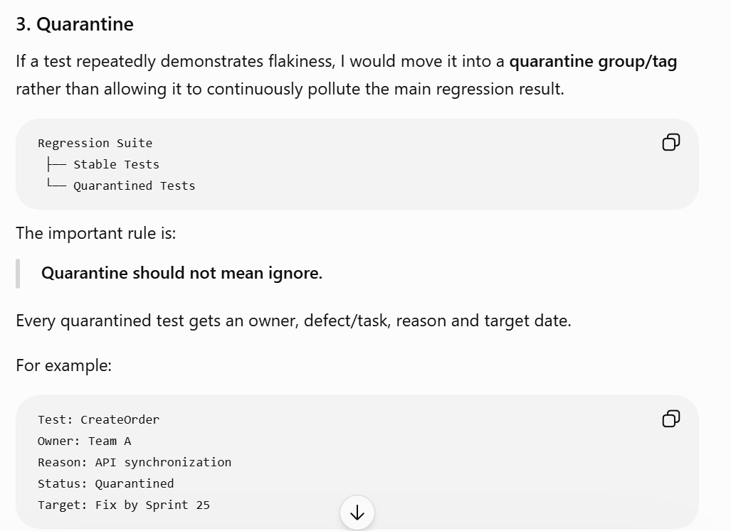
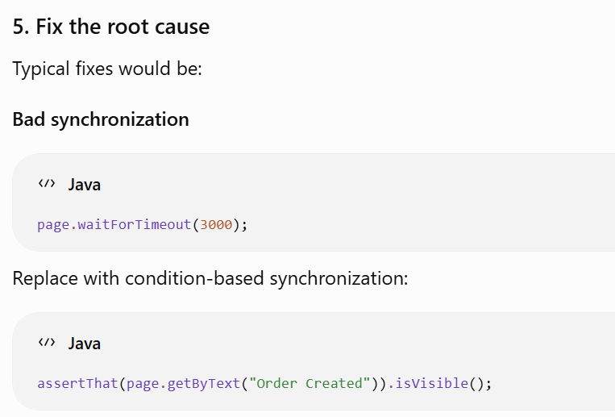
Unstable locator
Replace DOM-dependent XPath with a stable role, label or test ID.
Shared test data
Generate isolated data for each test.
Parallel interference
Use independent BrowserContexts and independent test data.
API dependency
Wait for the actual API response/state rather than guessing with a fixed delay.
6. Verify before removing quarantine
After fixing a test, I wouldn't immediately put it back into regression.
I would execute it repeatedly across:
- Multiple CI runs
- Required browsers
- Parallel workers
- Relevant environments
7. Prevent new flaky tests
I would introduce quality gates into the framework and CI:
- No hard-coded waits
- Stable locator standards
- Independent test data
- BrowserContext isolation
- Proper API/UI synchronization
- Mandatory artifacts for failures
- Code review for automation changes
- Flakiness monitoring
- How do you handle dynamic elements in Playwright?
Ans) “For dynamic elements, I avoid relying on changing attributes or fixed DOM positions. I use stable locators such as roles, labels, test IDs, or partial attribute matching when necessary. I also take advantage of Playwright's auto-waiting and web-first assertions for elements that appear or change asynchronously. For dynamic lists or tables, I locate the required row or component based on its unique content rather than its position. I avoid hard-coded waits and synchronize with the actual UI state.”
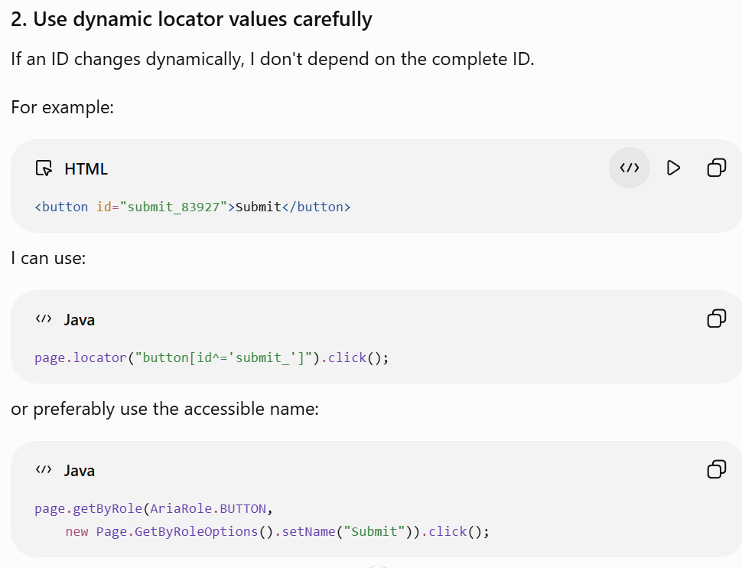
- How do you handle frequent UI changes in Playwright automation?
Ans) “For applications with frequent UI changes, I try to minimize the framework's dependency on the DOM structure. I use stable, user-facing locators such as roles, labels and test IDs, and centralize locators and UI interactions through Page Objects and reusable component objects. I also work with developers to introduce stable data-testid attributes for critical elements. I keep business logic in the tests and UI implementation in the page/component layer, so when the UI changes, I can update the locator in one place. Where possible, I use APIs for test-data setup to further reduce UI dependency.”
- How do you handle global setup and teardown?
Ans) I would handle global setup/teardown using TestNG lifecycle annotations, while keeping browser/context management in a common BaseTest.
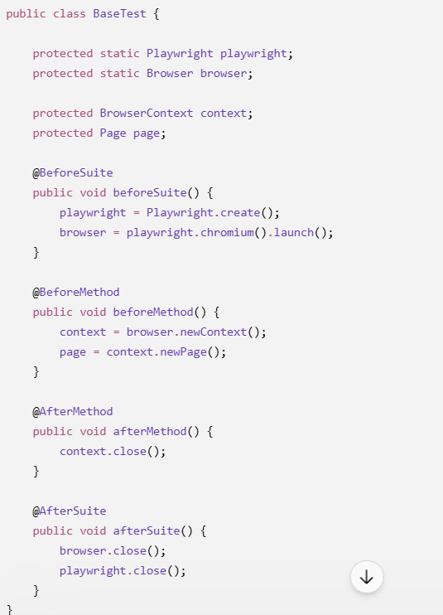
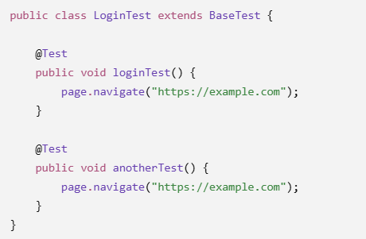
- How do you integrate Playwright tests with CI/CD pipelines (Jenkins/GitHub Actions)?
Ans) In my Playwright Java framework, I integrate CI/CD using GitHub Actions. I create a playwright-test.yml workflow under .github/workflows. I configure it to trigger on push and pull requests for the required branches. The workflow checks out the code, sets up Java, installs the Playwright browsers, and executes mvn clean test. TestNG handles the test execution and reporting, and I upload the test reports and Playwright artifacts such as screenshots or traces when the job completes. The same Maven command can also be configured in Jenkins as a build step.”
- How do you implement parallel execution with worker threads?
Ans) “In my Playwright Java framework, I use TestNG for parallel execution. I configure the TestNG suite with parallel and a thread-count, for example five worker threads. Each parallel test gets its own Playwright BrowserContext and Page, while the browser instance can be shared. This provides session and data isolation between tests. I also avoid shared mutable static variables and use ThreadLocal or thread-safe fixture management where required. Before enabling high parallelism, I make sure the test data and application environment can support concurrent execution.”
- How do you schedule Playwright test runs?
Ans) Using CI/CD configure in cron time in github action workflow file-
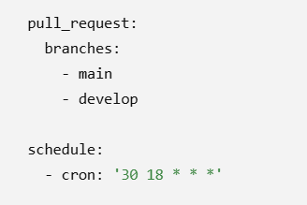
means 18:30 UTC every day, which is midnight IST (00:00).
Playwright itself doesn't schedule test execution. In my framework, I use the CI/CD tool for scheduling. For GitHub Actions, I configure the schedule trigger in the workflow YAML using a cron expression, along with push and pull-request triggers. The scheduled job checks out the code, installs the Playwright browsers if required, and executes mvn clean test. Similarly, in Jenkins I can configure a scheduled build using cron and execute the same Maven command.
- How do you test keyboard and mouse actions (hover, drag-drop, etc.)?
Ans)
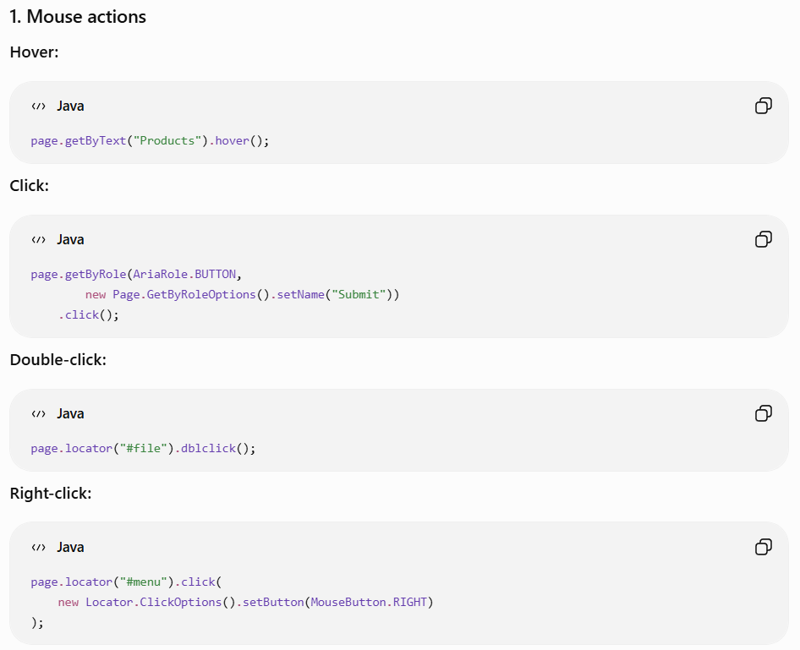
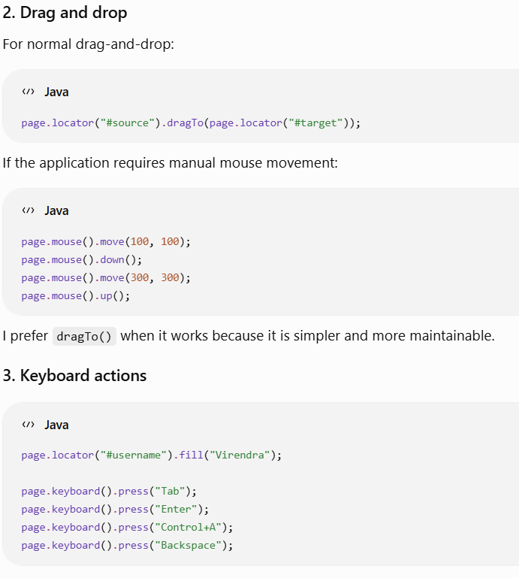
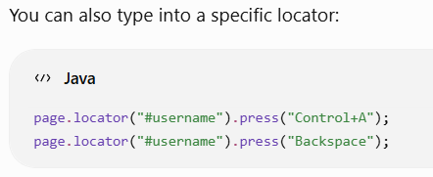
- How do you upload and download files in Playwright?
Ans)

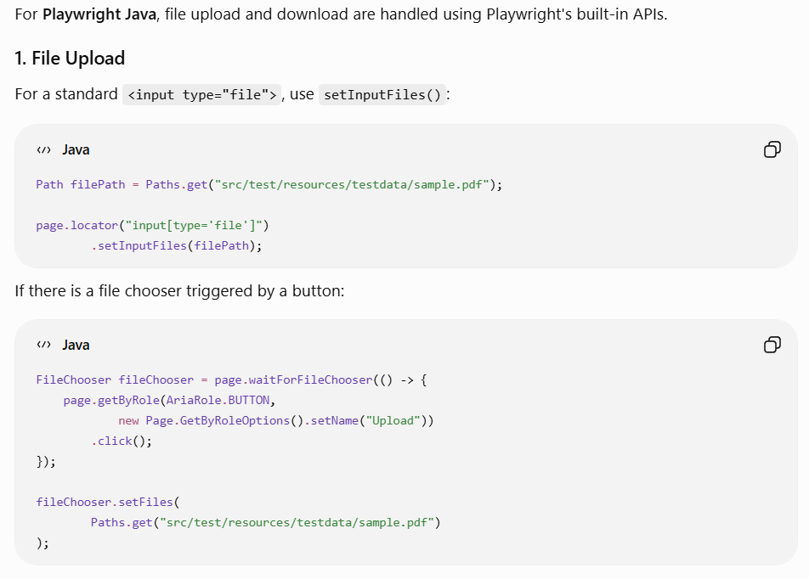
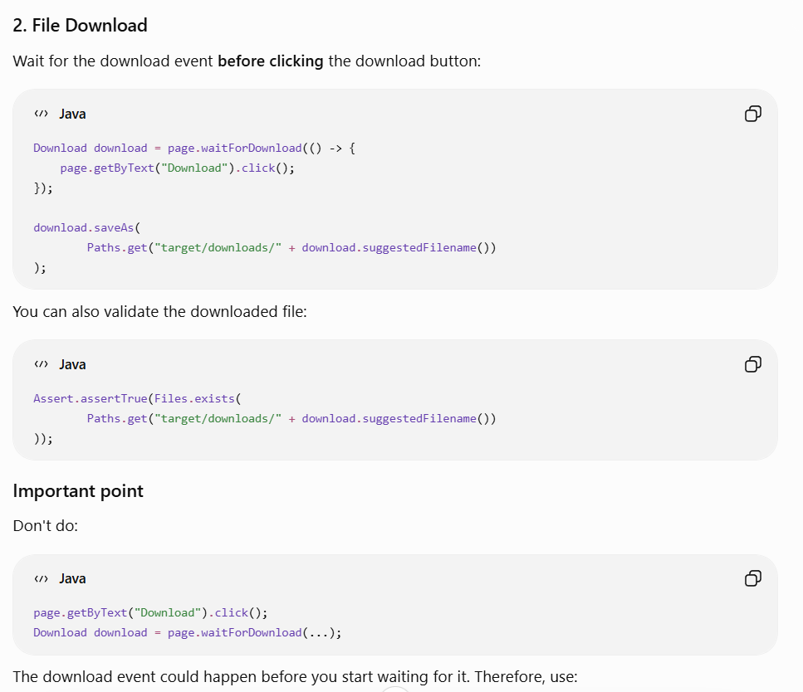
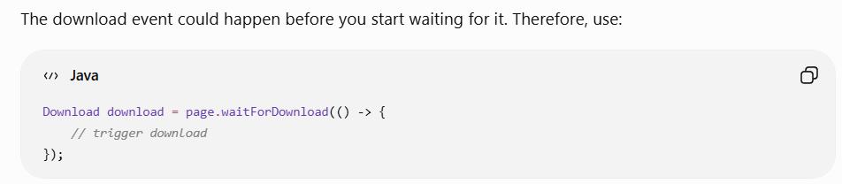

- How would you test a UI when one of its backend APIs is unavailable or returns intermittent failures?
Ans) I would use Playwright's network interception. First, I identify the API called by the UI and intercept it using page.route(). I can use route.fulfill() to return a controlled 500 or 503 response and verify how the UI handles the failure. For intermittent failures, I can maintain a request counter and make the first request fail while allowing subsequent requests to continue. This helps validate error messages, retry mechanisms, fallback behavior and recovery without depending on the actual backend being unstable.
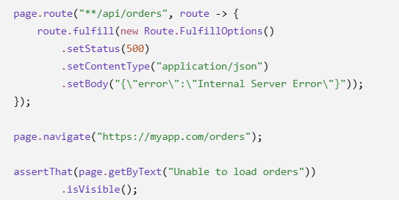
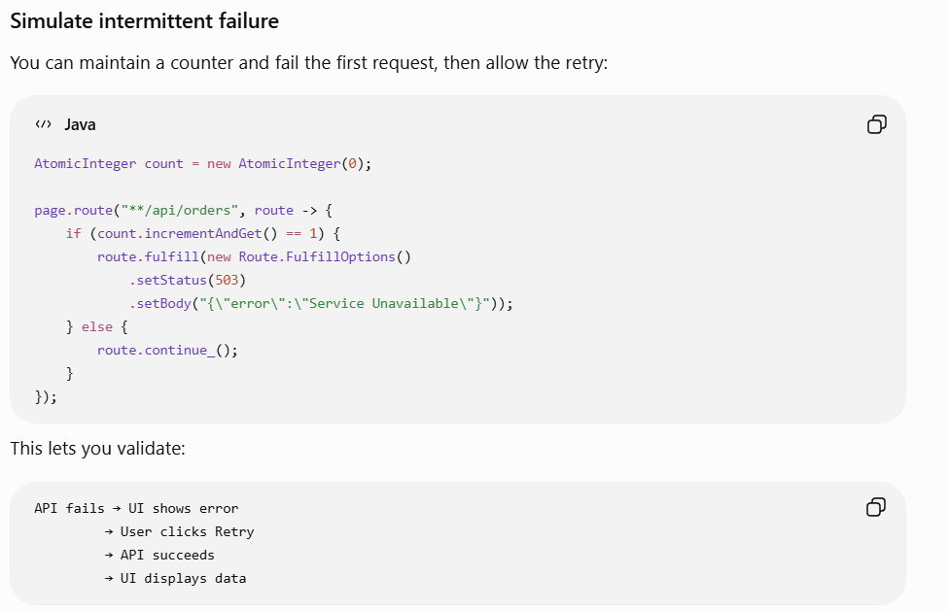
- How would you test a real-time application that receives important updates through WebSockets?
Ans) For a real-time application, I would use Playwright's WebSocket support to monitor the WebSocket connection and incoming messages. I would trigger the business event that causes the WebSocket message, capture the received message, and then validate that the corresponding UI is updated without a page refresh. I would also test scenarios such as connection failure, reconnection, multiple messages, message ordering and invalid events. If I need deterministic testing, I can mock or intercept the WebSocket communication where appropriate.
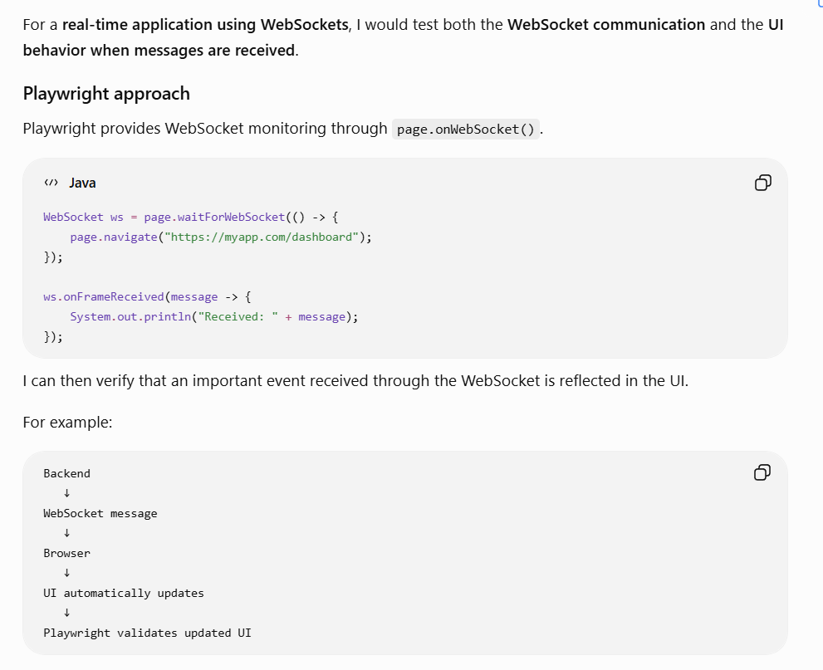
What I would validate
- WebSocket connection is established.
- Expected messages/events are received.
- Correct message is reflected in the UI.
- UI updates without page refresh.
- Multiple messages are handled correctly.
- Connection interruption/reconnection is handled.
- Invalid or unexpected messages don't break the UI.
- Message ordering is maintained when order matters.

- How would you locate the second matching element without using an XPath index?
Ans) If I need the second matching element, I prefer to first create a locator for the common elements and then use Playwright’s locator API rather than an XPath index. For example, page.locator("button").filter(...).nth(1) targets the second matching element. Since Playwright uses zero-based indexing, nth(1) means the second element.
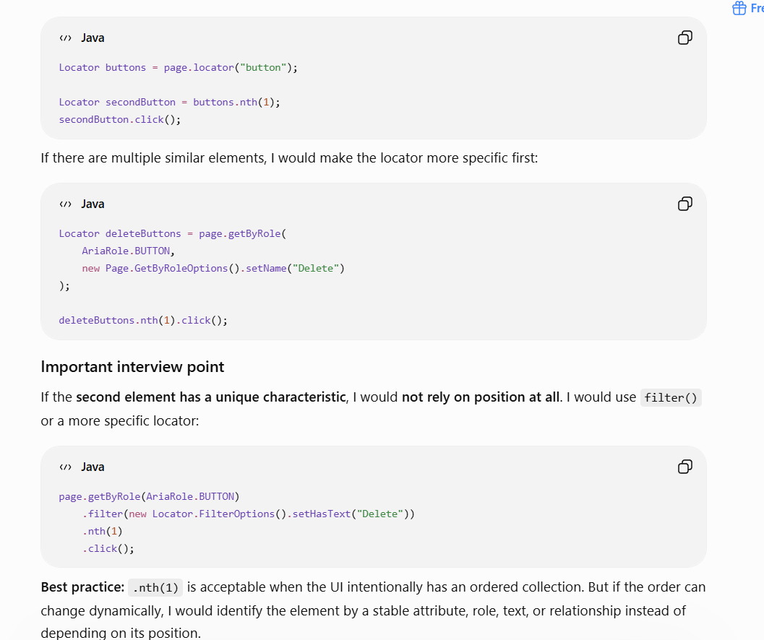

- "How do you handle Playwright browser installation in a restricted corporate network?"
Ans) I wouldn't make browser installation part of test execution. In a corporate environment, especially behind a proxy or firewall, I would pre-install the required Playwright browsers as part of environment or CI setup. The Playwright version used by the framework and the browser version would be kept consistent. If browser downloads are required, the corporate proxy would be configured appropriately. This prevents tests from failing because Playwright is trying to download a browser at runtime.
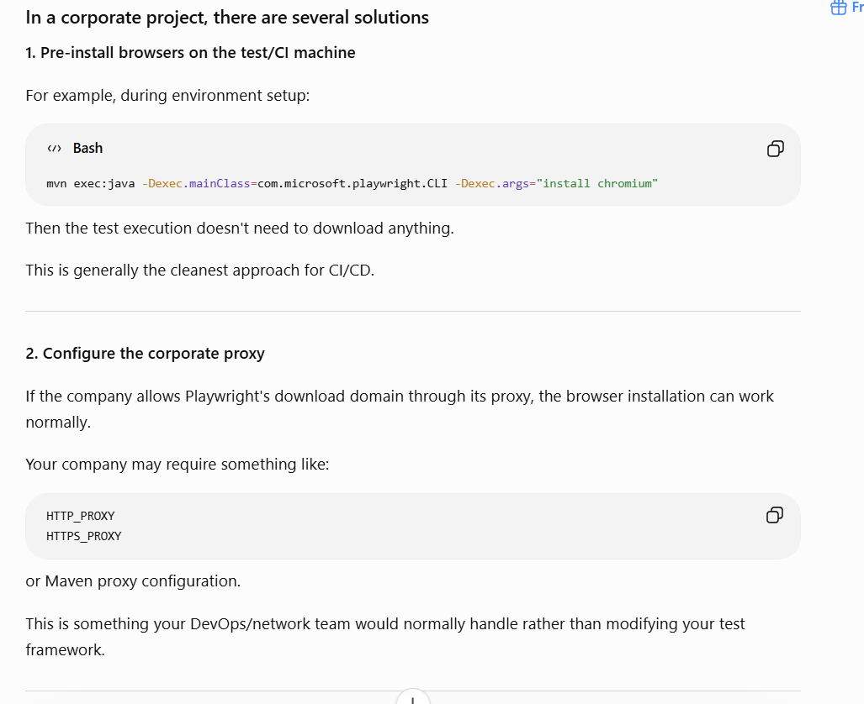
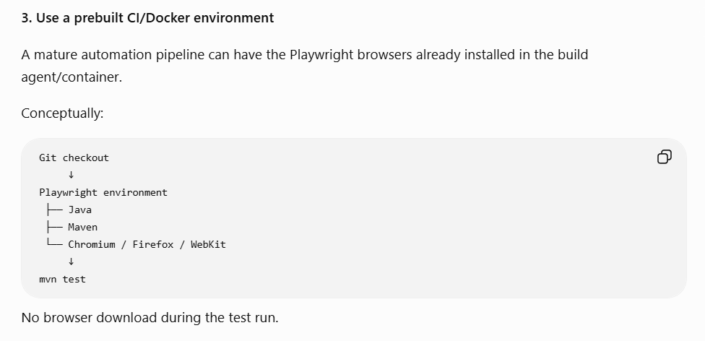
- How would you design reusable locator methods for complex components such as tables, grids, dropdowns, date pickers, and autocomplete fields?
Ans) I would create reusable component-level methods rather than exposing raw locators throughout the tests. Each complex UI component gets its own reusable class, with stable locator strategies and business-oriented methods. Tests then interact with the component through methods such as selectRow(), selectOption(), selectDate(), or selectSuggestion().”

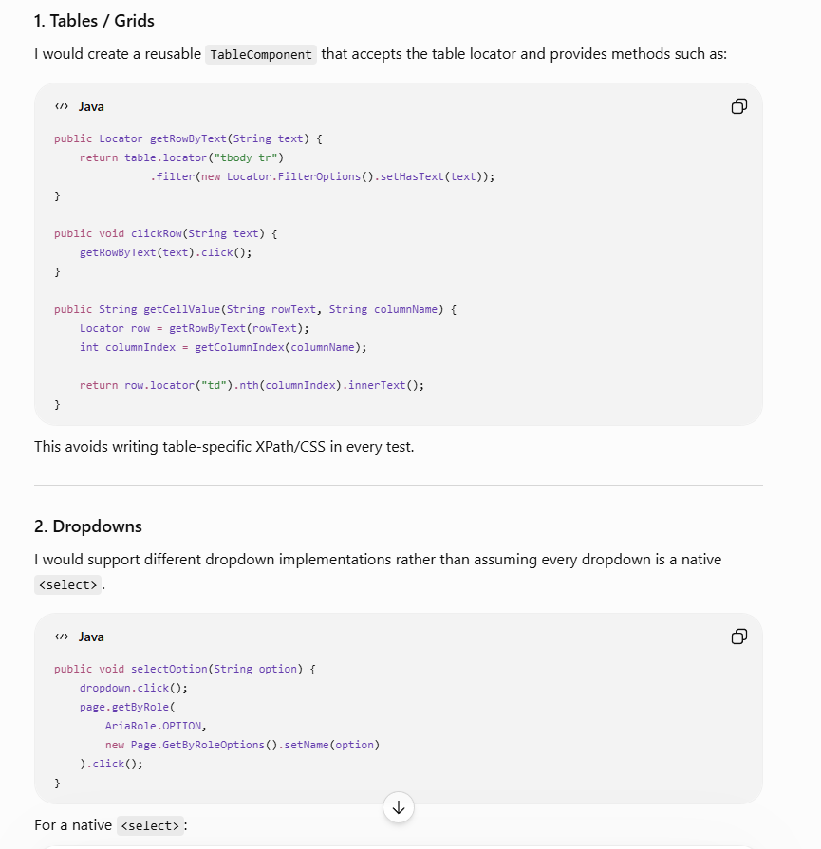
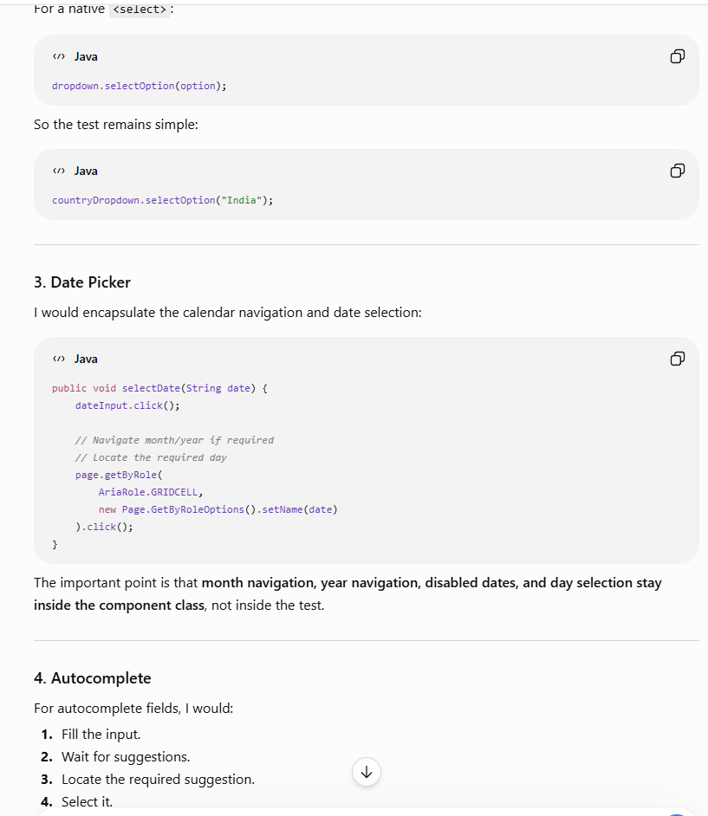
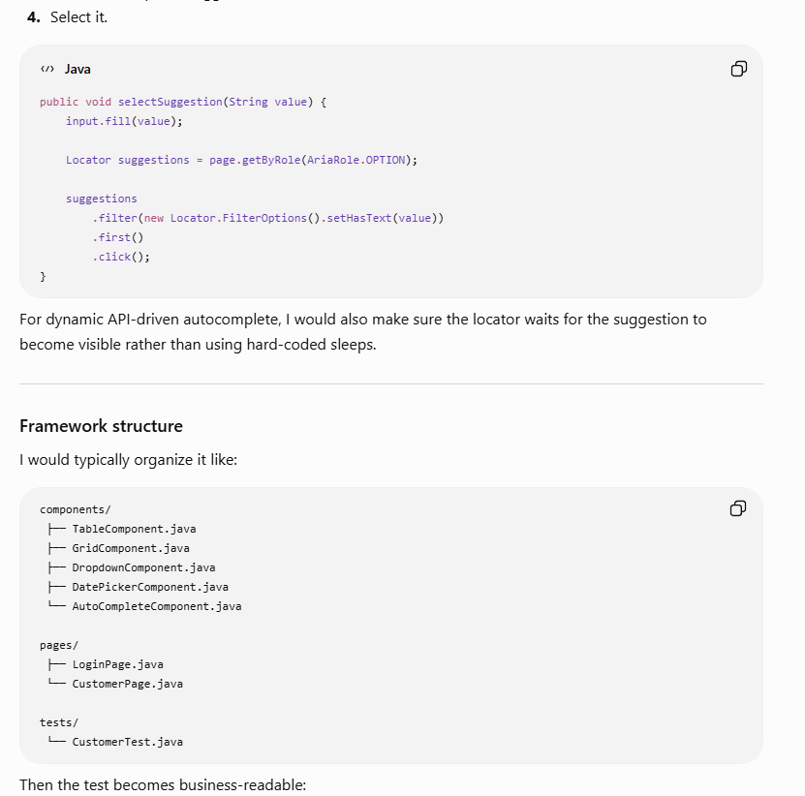
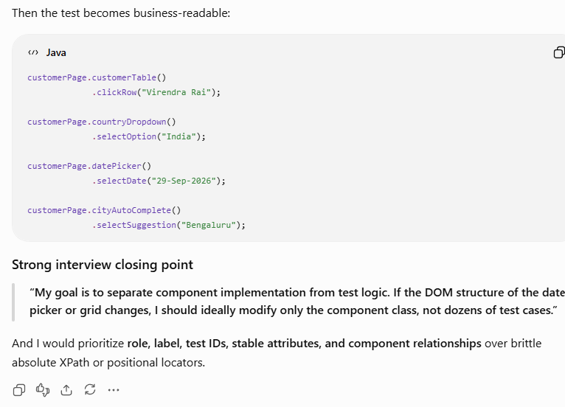
- How do you wait for page navigation or URL changes?
Ans) I use Playwright’s auto-waiting and explicit URL assertions depending on what I need to validate. If clicking an element causes navigation, I perform the click and then wait/assert for the expected URL using expect(page).toHaveURL().
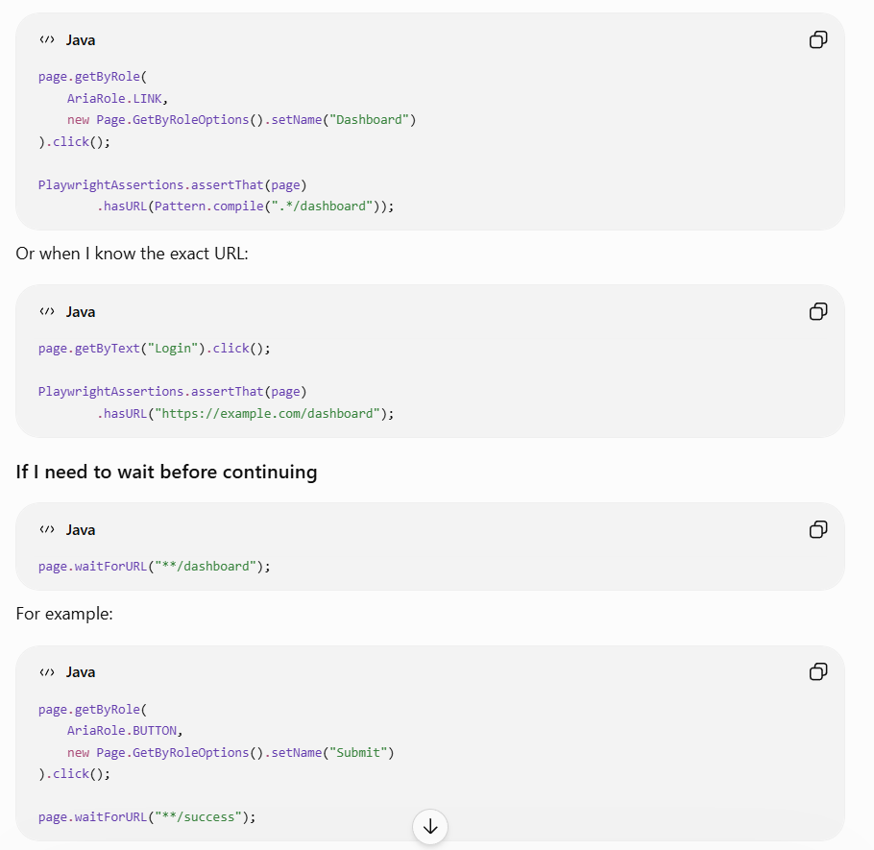
I would explain this in an interview:
- waitForURL() → when I need to explicitly wait for navigation/URL change.
- hasURL() / toHaveURL() assertion → when I want to validate that navigation reached the expected URL.
- Avoid Thread.sleep() because it introduces unnecessary fixed delays and can still be unreliable.
For modern Playwright, I generally prefer assertions such as hasURL(), because Playwright assertions automatically retry until the expected condition is met or the timeout is reached.
Best interview line:
“I wait for the condition I care about—usually the expected URL or a specific page element—not for an arbitrary amount of time.”

