- Architecture of Selenium WebDriver (Selenium 4)?
Ans) Selenium WebDriver follows the W3C WebDriver protocol. The Selenium client library sends HTTP requests to the browser driver, such as ChromeDriver or GeckoDriver. The driver acts as a bridge between Selenium and the actual browser. The browser driver translates the WebDriver commands into browser-specific actions, executes them, and sends the response back to the Selenium client.

Test Code → Selenium Client → WebDriver HTTP/W3C command → Browser Driver → Browser → Response back
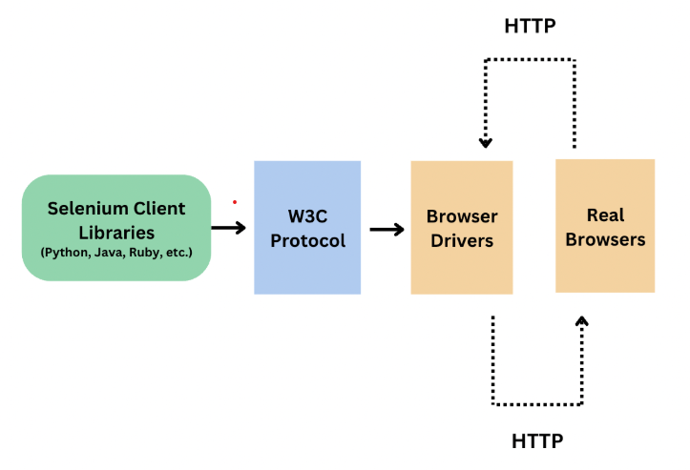

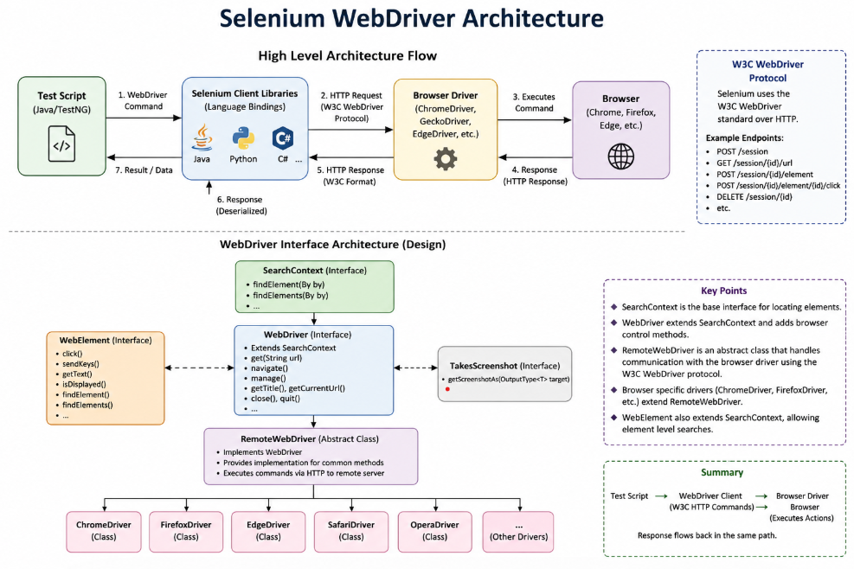

"Selenium WebDriver follows the W3C WebDriver standard. From the Java API perspective, SearchContext is the base interface, and WebDriver extends SearchContext. RemoteWebDriver implements WebDriver and provides the common implementation for sending WebDriver commands. Browser-specific drivers such as ChromeDriver and FirefoxDriver extend RemoteWebDriver.
When we execute a command such as driver.get(), the Selenium client sends the command using the W3C WebDriver protocol to the appropriate browser driver. The browser driver communicates with the actual browser, executes the action, and returns the response back through the same communication path."

- Different waits in selenium?
Ans)
Implicit wait- Implicit wait tells WebDriver to wait for a specified amount of time when trying to locate an element before throwing NoSuchElementException. It is applied globally to element searches for the lifetime of the WebDriver session.
driver.manage().timeouts().implicitlyWait(Duration.ofSeconds(10));

Explicit wait- Explicit wait is used to wait for a specific condition on a specific element or situation. WebDriver repeatedly checks the condition until it becomes true or the timeout expires. Once the condition is satisfied, execution continues immediately.
WebDriverWait wait = new WebDriverWait(driver, Duration.ofSeconds(10));
wait.until(ExpectedConditions.visibilityOfElementLocated(
By.id("username")));

Methods –
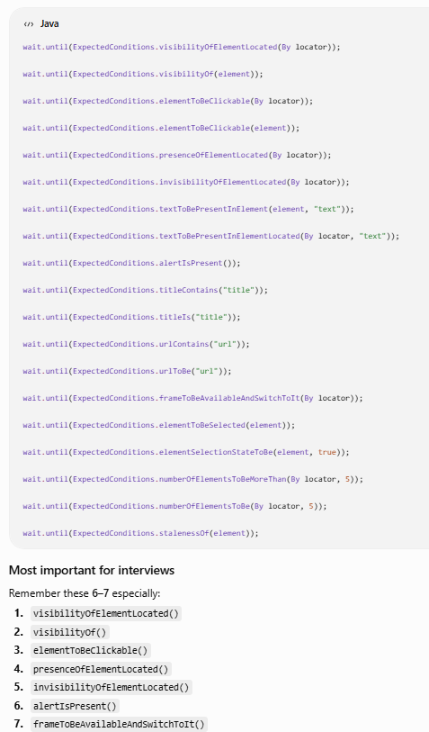

Fluent wait- FluentWait is a configurable type of explicit wait where we can define the maximum timeout, polling interval, and exceptions that should be ignored while waiting for a condition.

Wait<WebDriver> wait = new FluentWait<>(driver)
.withTimeout(Duration.ofSeconds(30))
.pollingEvery(Duration.ofSeconds(2))
.ignoring(NoSuchElementException.class);
WebElement element = wait.until(
d -> d.findElement(By.id("username")));

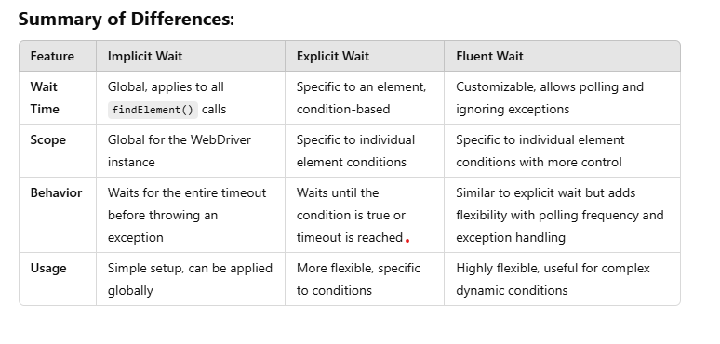
- "You have a Selenium test suite with around 500 tests. It works reliably on your local machine, but in Jenkins/GitHub Actions around 10–15% of the tests randomly fail. How would you investigate and fix the flaky tests?"
Ans) "First, I would identify whether the failures are consistent or genuinely flaky. I would look at the failed test names, exception types, screenshots, browser logs and execution logs from multiple CI runs.
Then I would categorize the failures. The common areas I'd investigate are synchronization, locator stability, browser/environment differences, test-data dependency, test isolation, parallel execution and application/backend instability.
Since the tests are stable locally but fail in CI, I would specifically compare the CI and local environments — browser and driver versions, headless configuration, screen resolution, OS, network latency, application availability and environment variables.
For synchronization issues, I would replace hard-coded sleeps with appropriate explicit waits and wait for meaningful application conditions rather than simply waiting for an element to exist.
If tests are running in parallel, I'd check whether tests are sharing WebDriver instances, test data, files, database records or other mutable state. Each test should have proper isolation, and WebDriver should generally be managed per test/\.
I would also verify that locators are stable and that tests don't depend on execution order.
Finally, I would reproduce the failure by rerunning only the failed tests and, if necessary, running them repeatedly in CI. After identifying the root cause, I'd fix the framework or test rather than simply adding retries. I would use retries only as a temporary mitigation for genuinely transient infrastructure failures."

- "How do you distinguish between a synchronization problem and an application defect?"
Ans) "I would first reproduce the failure and look at the exact exception and evidence. If Selenium throws TimeoutException or NoSuchElementException, I would verify whether the application element was actually available at that point.
I would check the browser network logs to see whether the dependent API request completed successfully, whether it returned an error, and how long it took. I would compare that against the application's expected SLA rather than assuming that anything above five seconds is a defect.
If the API completed successfully within the expected SLA but the element appeared later in the DOM, then it's more likely a synchronization or automation issue.
If the API is returning 4xx/5xx, timing out, returning incorrect data, or consistently exceeding the defined SLA, then I would investigate it as an application/backend issue.
I would also check browser console errors, screenshots, DOM state and application logs if available. Finally, I would reproduce the same scenario manually and through automation to determine whether the problem is application-side or test-side."
Selenium failure
│
├── Element not present yet?
│ └── Synchronization issue
│
├── API failed / wrong response?
│ └── Application/API defect
│
├── API successful but UI rendering delayed?
│ └── Synchronization/UI issue
│
├── Works sequentially but fails parallel?
│ └── Test-data / isolation / framework issue
│
└── Only CI fails?
└── Environment / browser / headless / timing issue

- "How would you design WebDriver management for parallel execution? Would you use a single WebDriver instance, static WebDriver, or ThreadLocal WebDriver? Explain why."
Ans) “For parallel execution, I would configure TestNG with parallel execution and an appropriate thread count. For WebDriver management, I would use ThreadLocal<WebDriver> so that each execution thread gets its own WebDriver instance. This prevents different tests running in parallel from sharing the same browser session and causing synchronization or data issues.”
- You have designed a Selenium framework using Page Object Model. Now your application has around 100 pages, and many pages contain common elements such as the header, navigation menu, footer, logout button, etc.
How would you design your Page Object Model so that you don't duplicate these common elements across 100 page classes?
Ans) “I would create a separate BasePage or CommonPage class containing common elements and reusable methods such as logout, navigation menu, header, footer, etc. Individual page classes can extend this common page class and reuse those methods. This avoids duplication and makes maintenance easier. If some common components are independent, I can also create separate component classes and compose them into page objects.”
- Difference bw findElement and findElements()?
Ans) In Selenium WebDriver, findElement() and findElements() are methods declared in the SearchContext interface.
- findElement() is used to locate a single web element and returns a WebElement. If no matching element is found, it throws a NoSuchElementException. If multiple elements match, it returns the first matching element.
- findElements() is used to locate multiple web elements and returns a List<WebElement>. If no matching elements are found, it returns an empty list.
For example, I use findElement() to locate a login button and findElements() to retrieve all links on a webpage.
- Stale element reference exception ?
Ans)
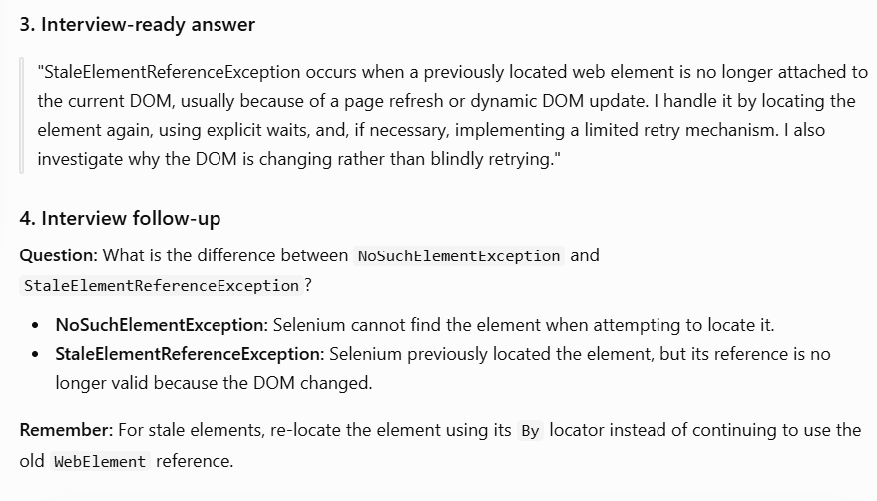
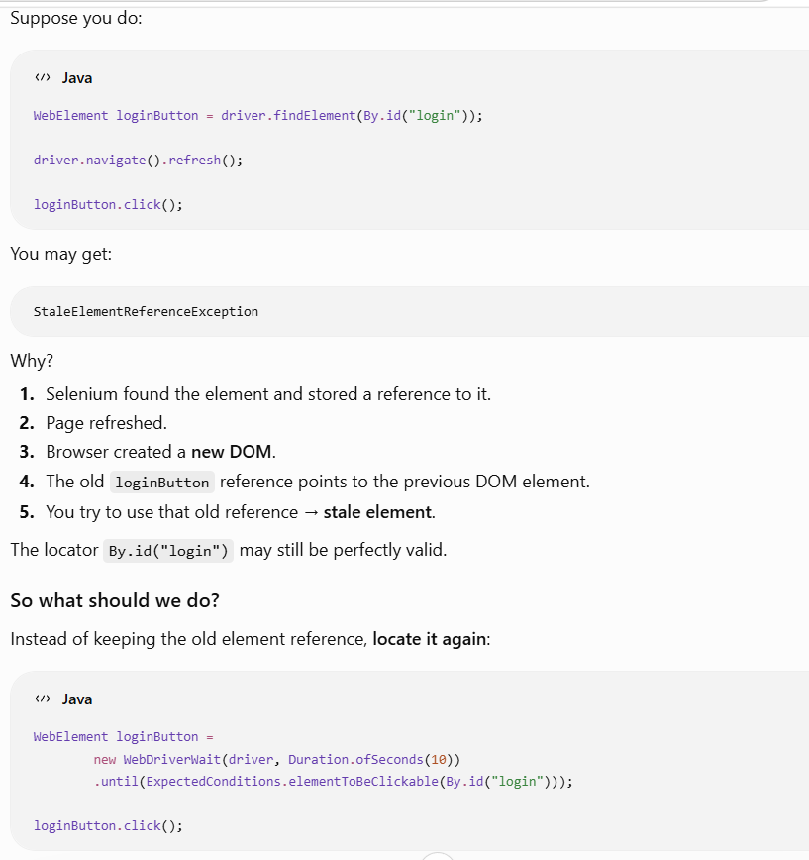
- How would you design a singleton class and where to use in automation framework ?
Ans) A Singleton class is a class that allows only one instance of itself to be created and provides a global access point to that instance. I would make the constructor private, maintain a private static instance, and expose a public static getInstance() method. In an automation framework, Singleton can be useful for managing shared resources such as configuration, reporting, logging, or database connections. However, I would avoid using a simple Singleton for WebDriver in a parallel execution framework because it can cause thread-safety issues. For parallel execution, I would use ThreadLocal WebDriver."

