Q1.Node.js is a powerful and popular JavaScript runtime used to build server-side applications. Unlike traditional JavaScript that runs only in the browser, Node.js allows developers to use JavaScript to write backend code and build fast, scalable web servers.

2Key features of Node.js
Node.js unique, such as its event-driven architecture, non-blocking I/O, and asynchronous programming model.

3 Unlike traditional JavaScript that runs only in the browser, Node.js allows developers to use JavaScript to write backend code and build fast, scalable web servers.

SCREENSHOTS
1
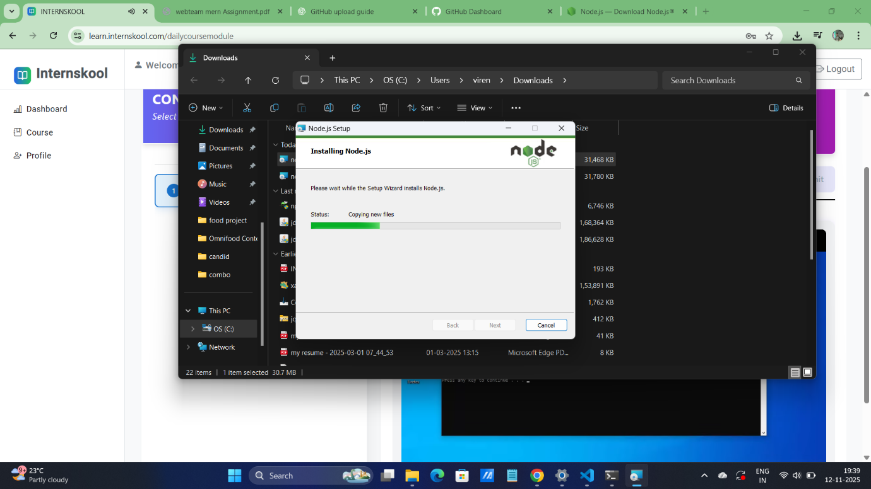

2
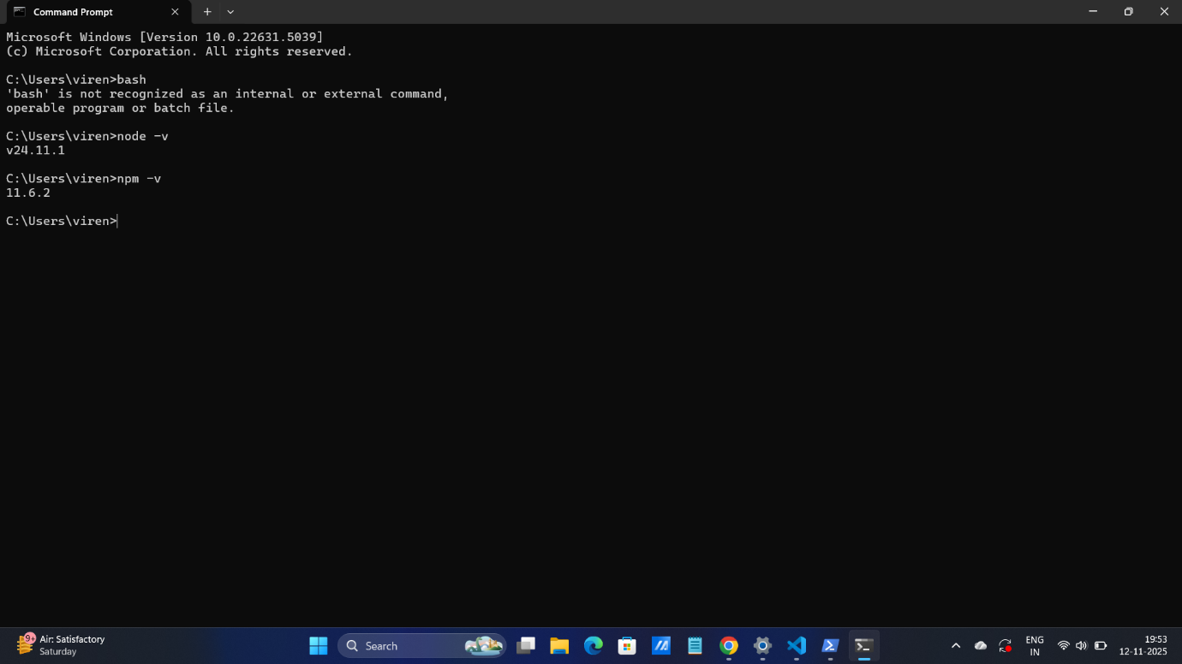

3
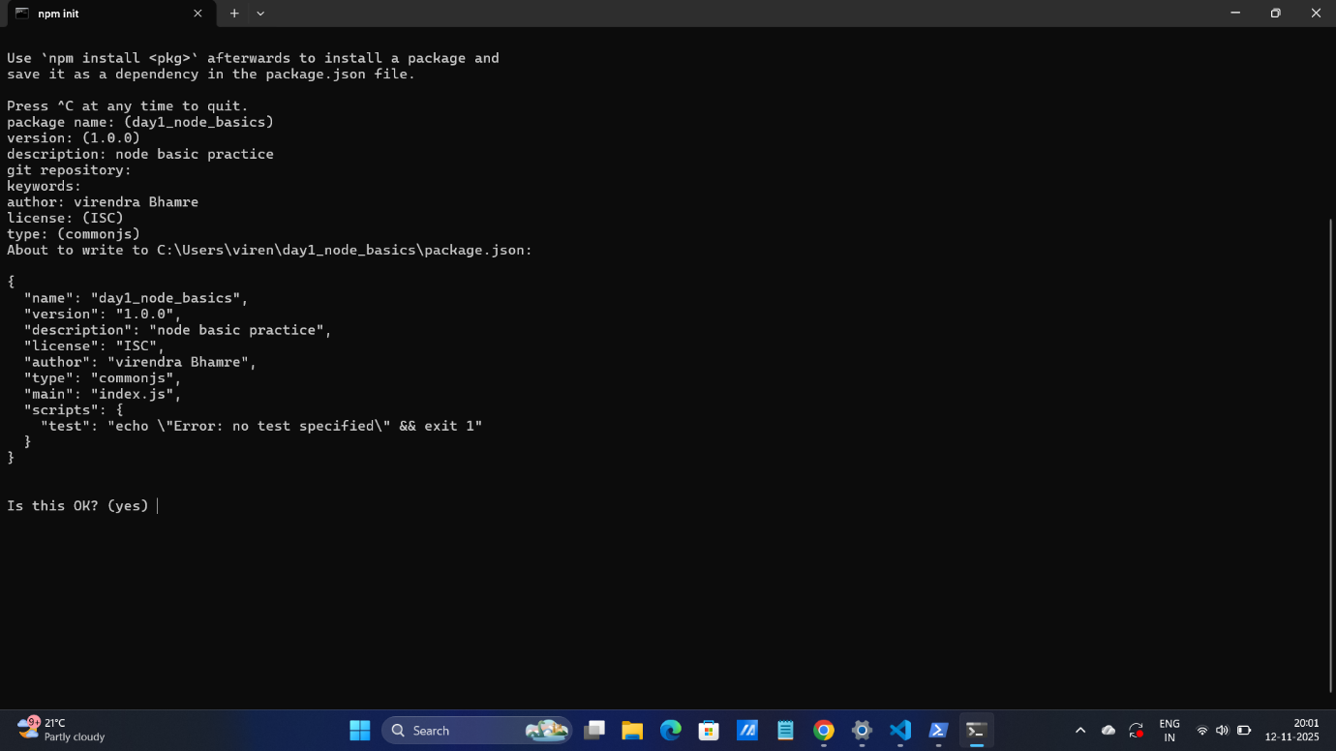

4
