Tasks to Complete:
- Create a new folder named day7_express_route_params
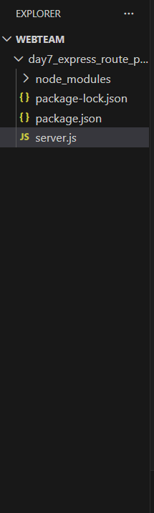

- Write a short explanation of:
• What are route parameters in Express.js?
Route parameters are dynamic values in the URL defined using a colon (:).
They allow Express to capture parts of the URL as variables.
Example:
/student/:id →
If user visits /student/5, then { id: "5" }
Used for identifying specific resources like:
- A specific user
- A product by ID
- A student by ID

• How they are different from query parameters
Route parameters and query parameters both pass values through the URL, but they work differently. Route parameters are part of the actual URL path and are used when you want to get one specific item. Example: /student/3 means you want the student with ID 3. Query parameters come after a ? in the URL and are mostly used for extra or optional information. Example: /student?id=3 also sends the value 3, but it is not part of the main path — it is just extra data. In short, route parameters are used to identify a particular resource, while query parameters are used for filters or optional details.

- In server.js, create an Express server with a hardcoded array of students (id, name, course)
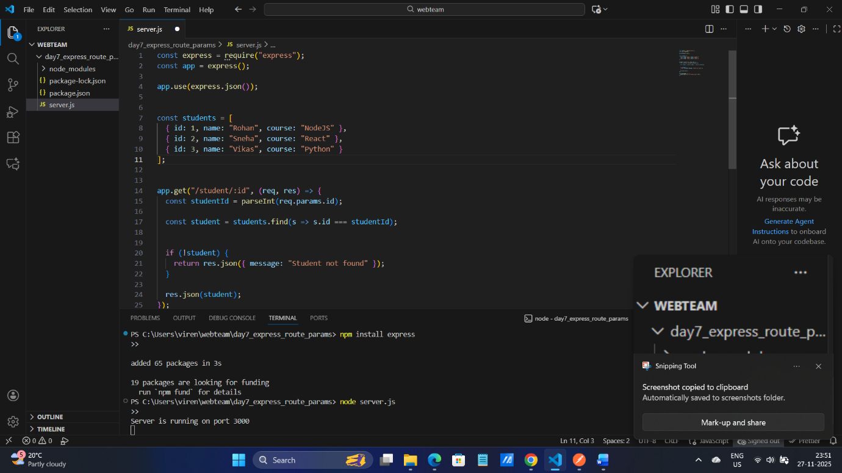

4. Create a dynamic GET route /student/:id
• Use route parameter to find and return student details by ID
• Example: /student/2 returns JSON object of student with ID 2
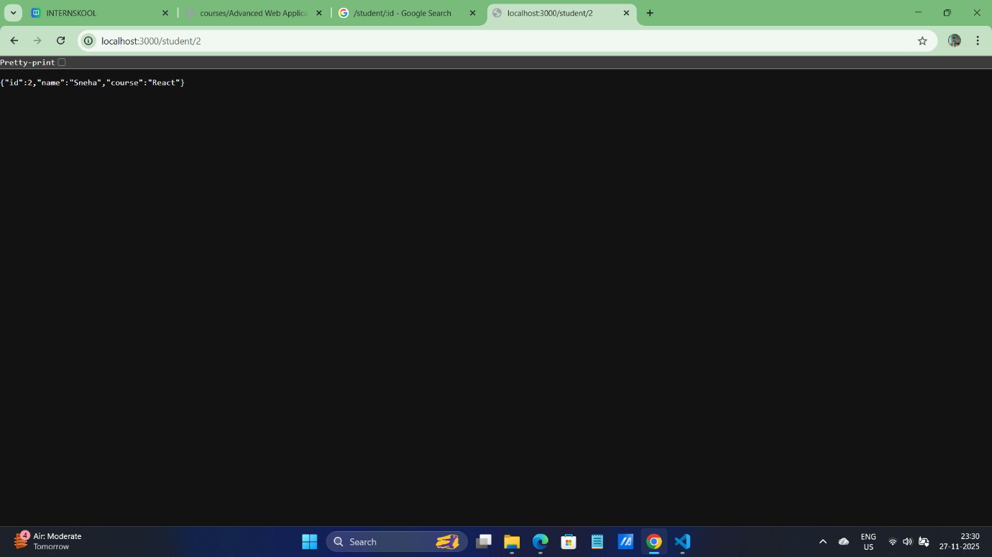

5. Add error handling:
• If student not found, return a message: "Student not found"
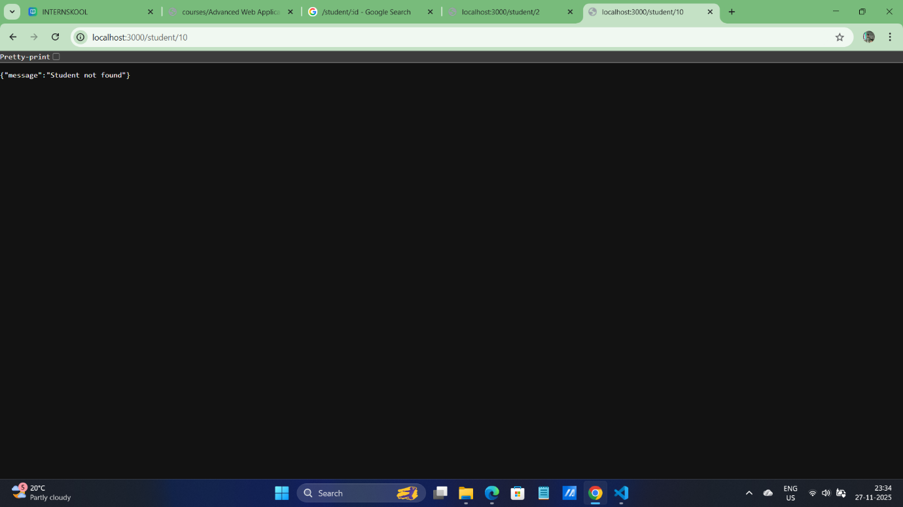

6. Test your API using Postman or browser
