Tasks to Complete:
1. Create a new folder named day2_node_modules_fs
2. Write a short explanation of:
• What are modules in Node.js?
A module in Node.js is a reusable block of code that can be imported and used in other parts of an application. Modules help in organizing code into smaller, manageable pieces, adhering to the DRY principle.
Modules can be categorized into:
- Core Modules: Built into Node.js (e.g., fs, http, path).
- Local Modules: Custom modules created by own.

• Difference between core modules and custom modules
Core modules are the built-in modules that come with Node.js, like fs, http, and path. You don’t need to install or create them — they’re ready to use for handling files, servers, and other system tasks.
Custom modules, on the other hand, are the ones you create yourself — your own .js files like math.js or utils.js. You use them to organize and reuse your own code across different parts of your project.

3. Create a custom module math.js with the following exported functions:
• add(a, b)
• subtract(a, b)
• multiply(a, b)
• divide(a, b)

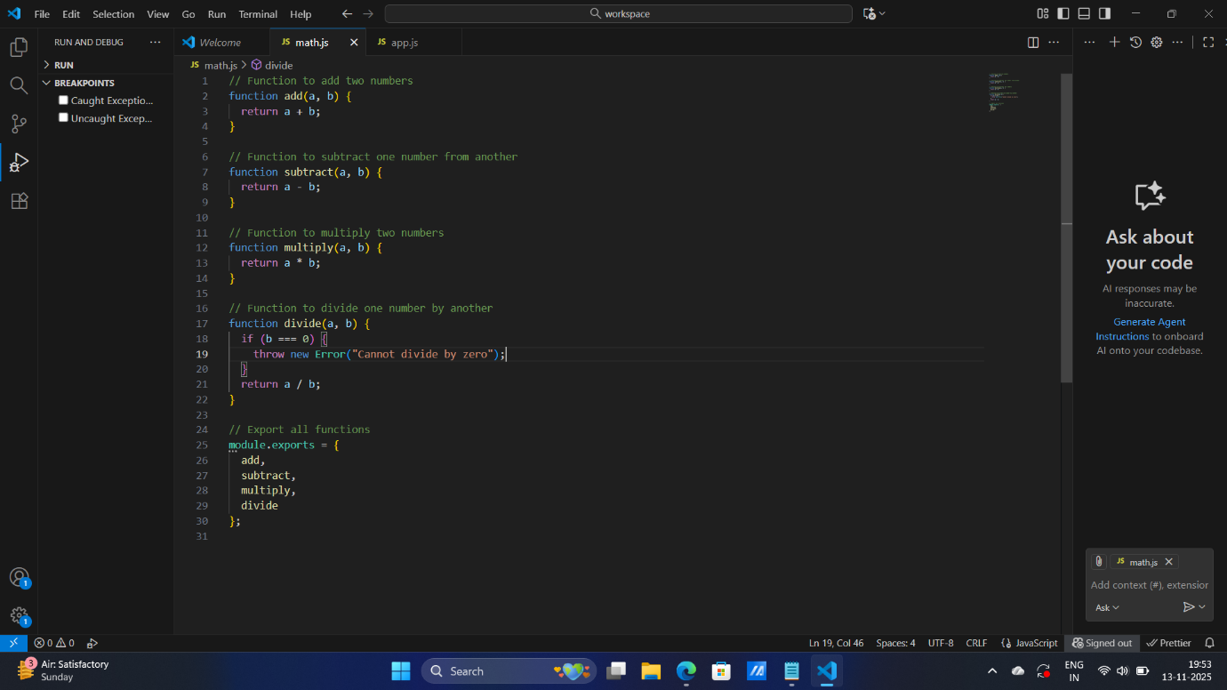

4. In your main file app.js, import the math.js module and use each function with
example values.
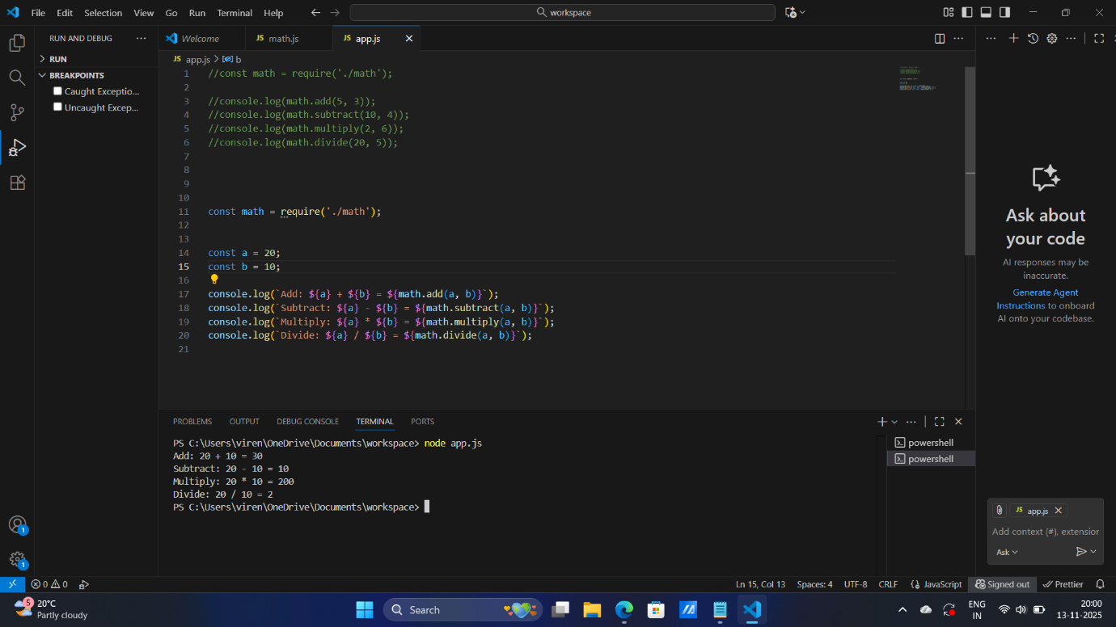

5. Use the built-in fs module to:
• Create a file log.txt
• Write the result of all math operations to this file
• Read and display the content of log.txt in the terminal
