Tasks to Complete:

- Create a new folder named day6_express_rest_api

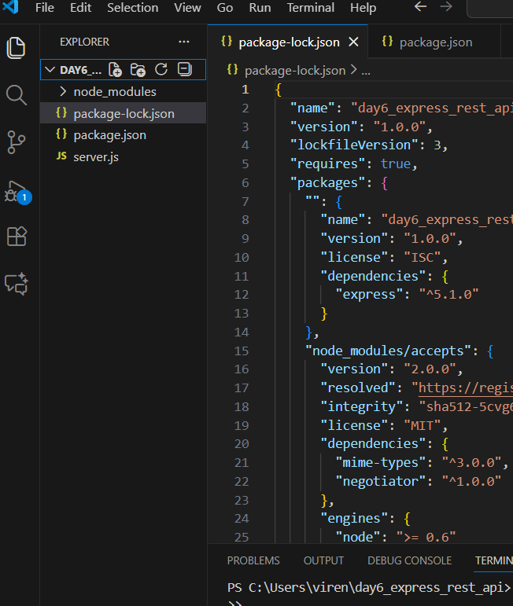

2. Write a short explanation of:
• What is a REST API?
A REST API (Representational State Transfer API) is a way for applications to communicate over the internet using simple HTTP methods like GET, POST, PUT, DELETE.
It allows a client (like Postman or a website) to request or send data to a server in a structured format, usually JSON.

✅ Difference Between GET and POST Methods
GET
- Used to retrieve/fetch data from the server
- Does not send a body
- Example: Fetch list of students
- GET /students
POST
- Used to send data to the server
- Sends data in the request body
- Example: Add a new student
- POST /add-student
- {
- "name": "Virendra",
- "age": 22,
- "course": "NodeJS"
}

3. Install Express (if not already done):
npm install express
Already Done
4. Create a file server.js that includes:
• A route /students with method GET that returns a hardcoded list of student objects in JSON
• A route /add-student with method POST that accepts student data (name, age, course) and prints it to the console
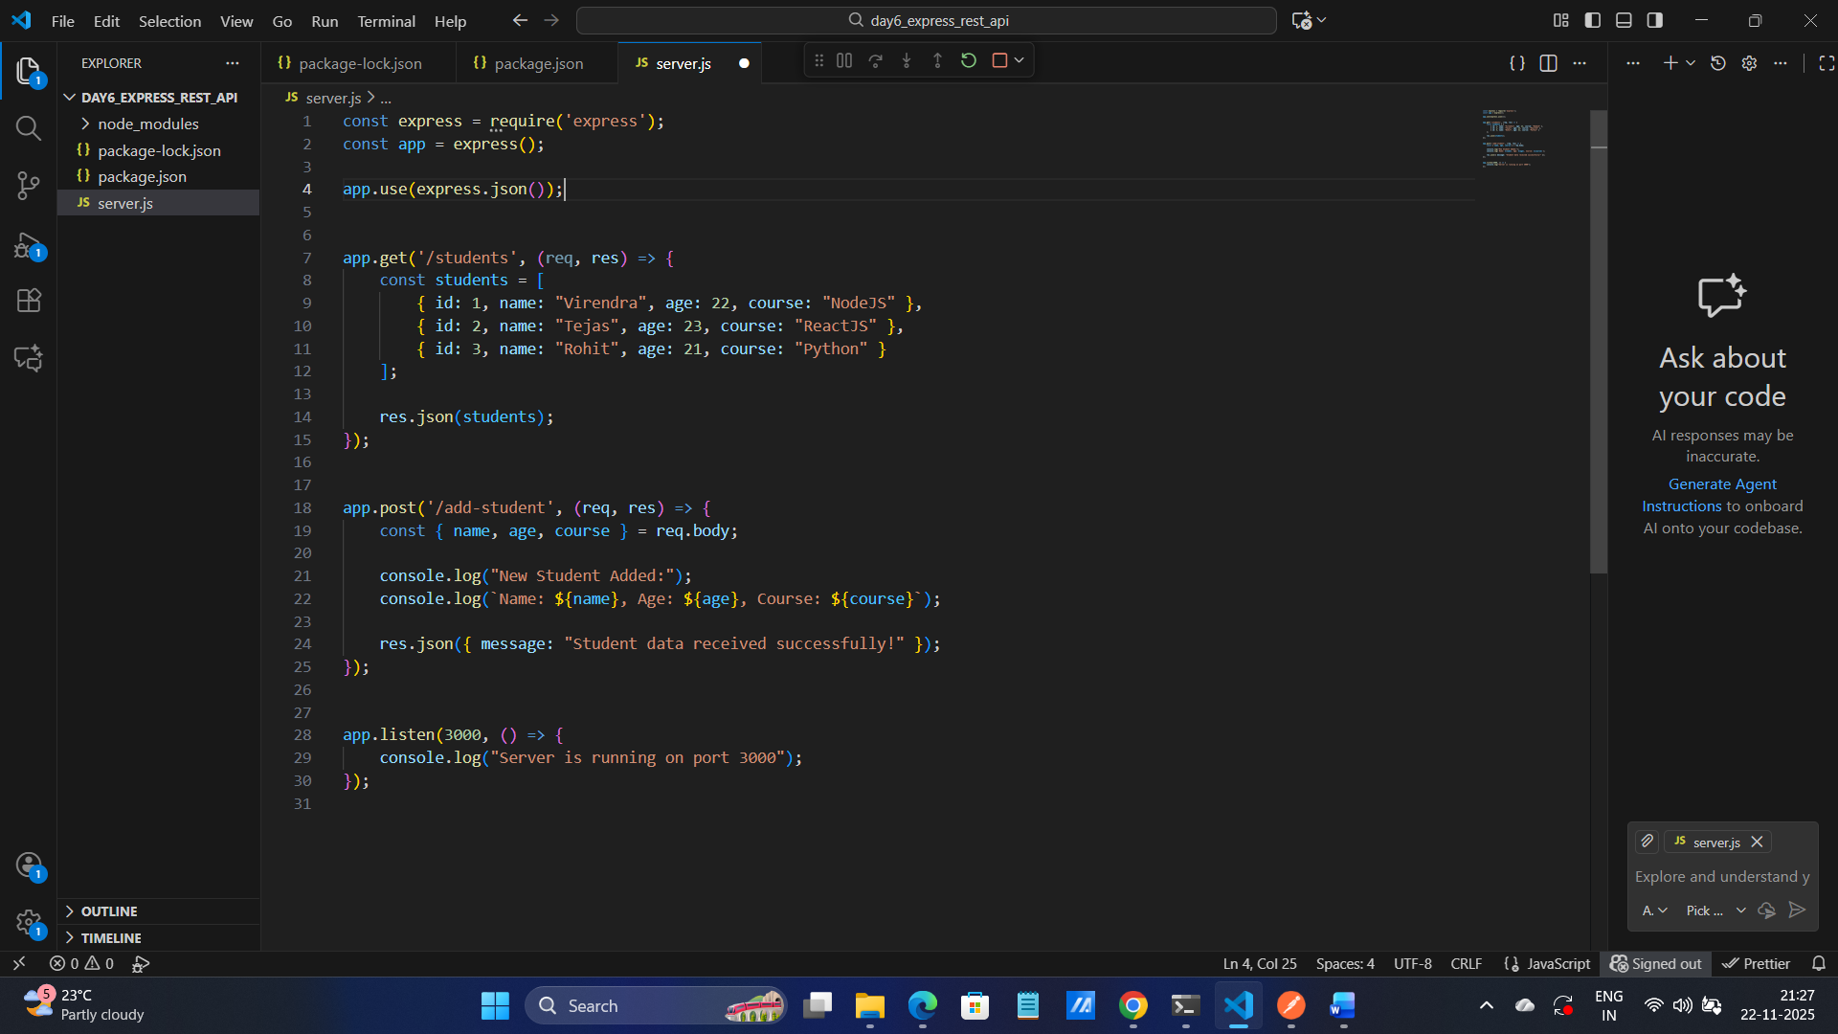

5. Test both routes using Postman:
• Send GET request to /students
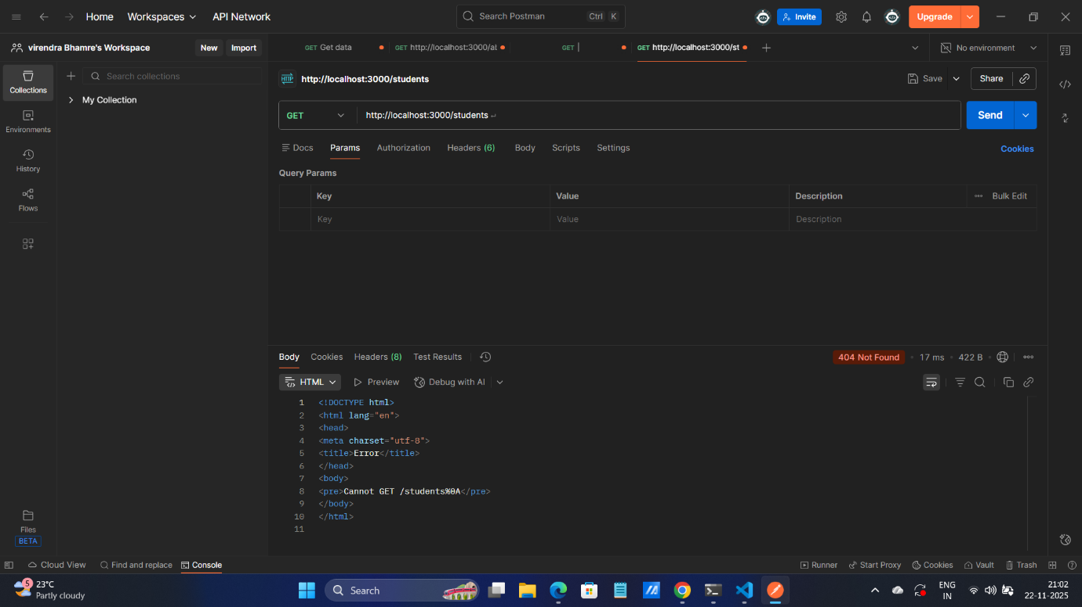

• Send POST request to /add-student with JSON body

