1. Create a new folder named day5_express_basics
2. Write a short explanation of:
• What is Express.js?
Express.js is a minimal and flexible web framework for Node.js.
It makes it easier to create servers, handle routes, manage requests, and build web applications.

2. Key Features of Express & Why It’s Used with Node.js
Key Features
- Simple and clean routing system
- Middleware support
- Fast and lightweight
- Easy to integrate with databases
- Supports templates, JSON, APIs, etc.
Why used with Node.js
- Node.js alone is low-level (manual routing, headers, responses)
- Express provides shortcuts and structure → making server creation faster and easier
- Great for building APIs and web apps

3. Install Express using npm
Open terminal in your project folder and run:
npm install express

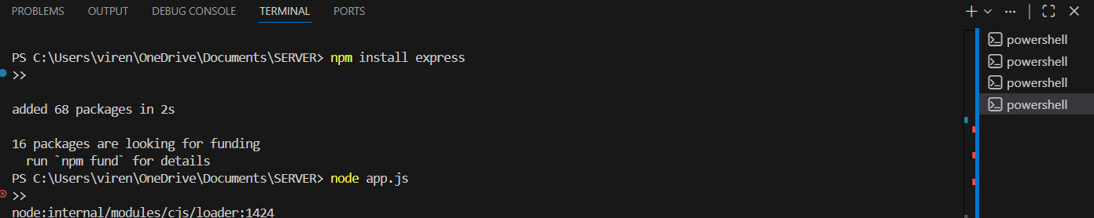

4. Create a file app.js and write an Express server that:
• Listens on port 3000
• Responds with "Welcome to Express Server" on /
• Responds with "About Page" on /about • Responds with "Contact Page" on /contact

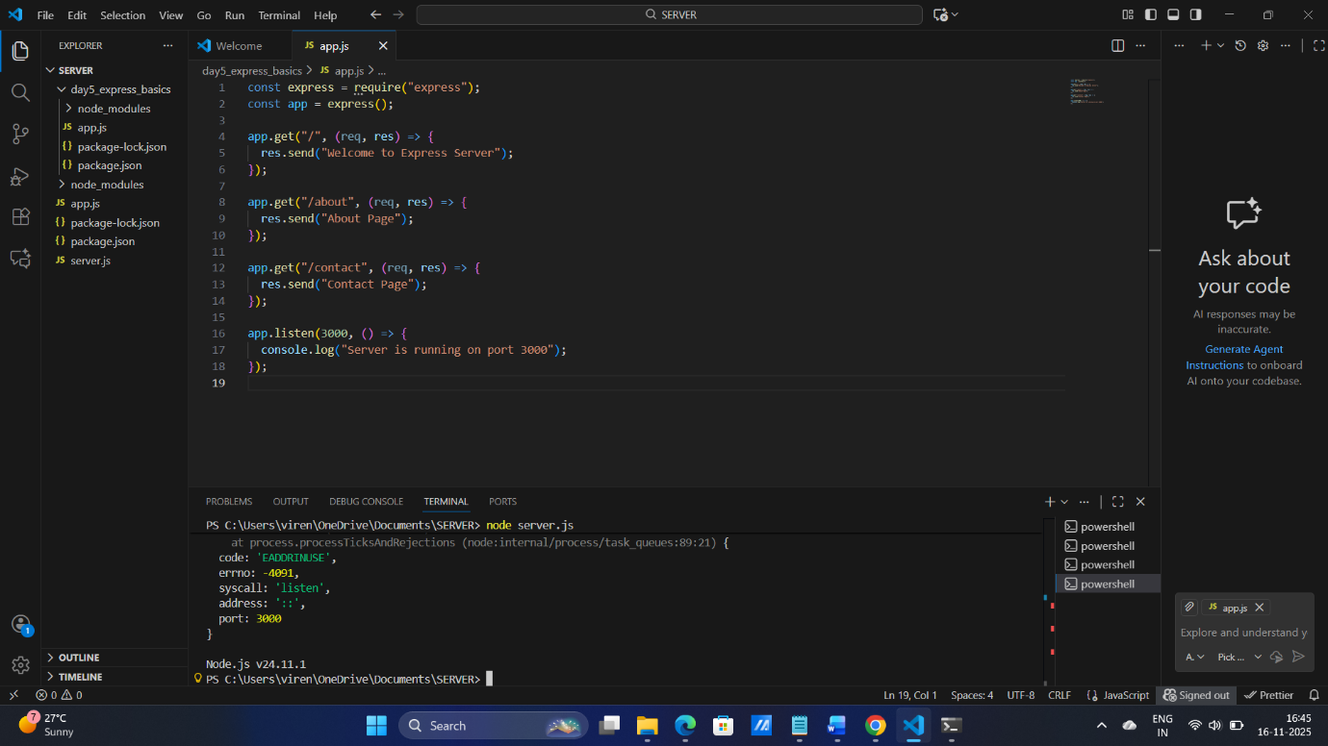

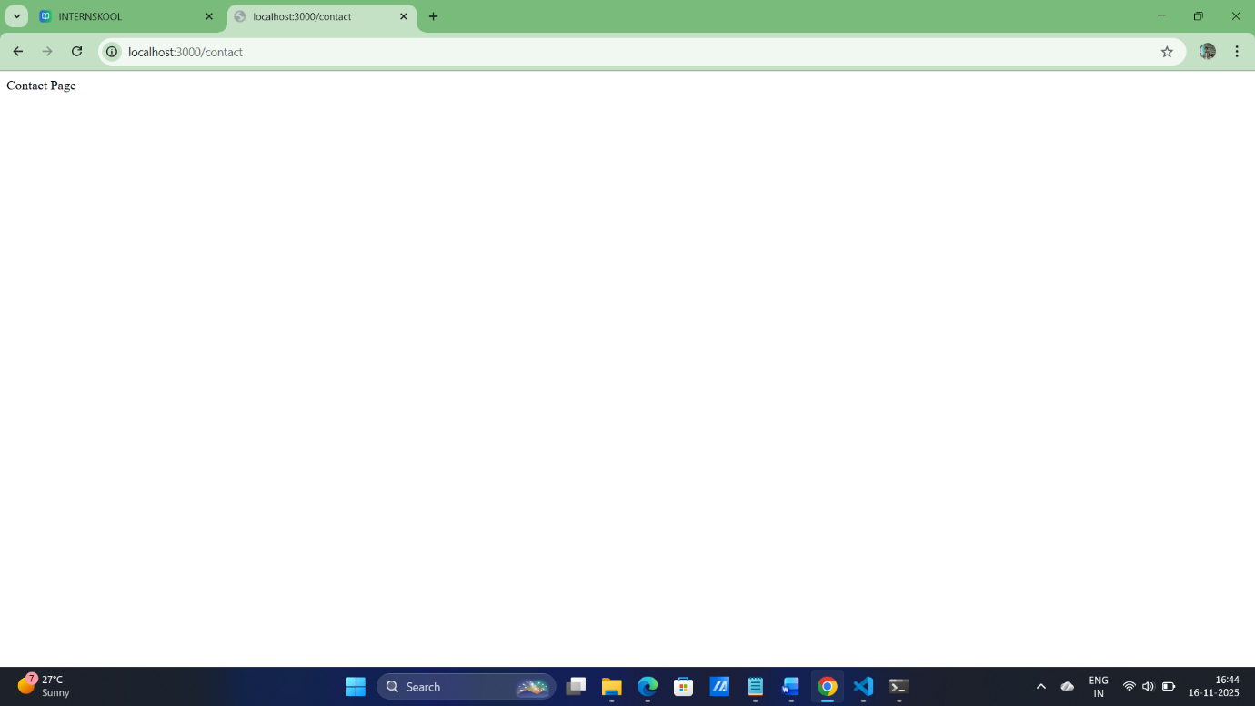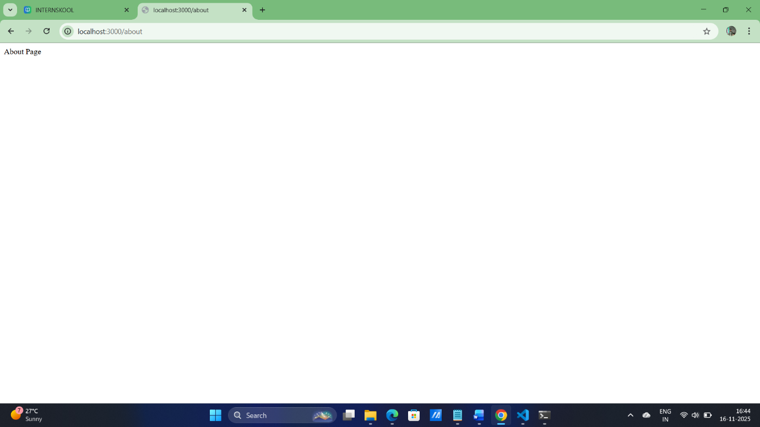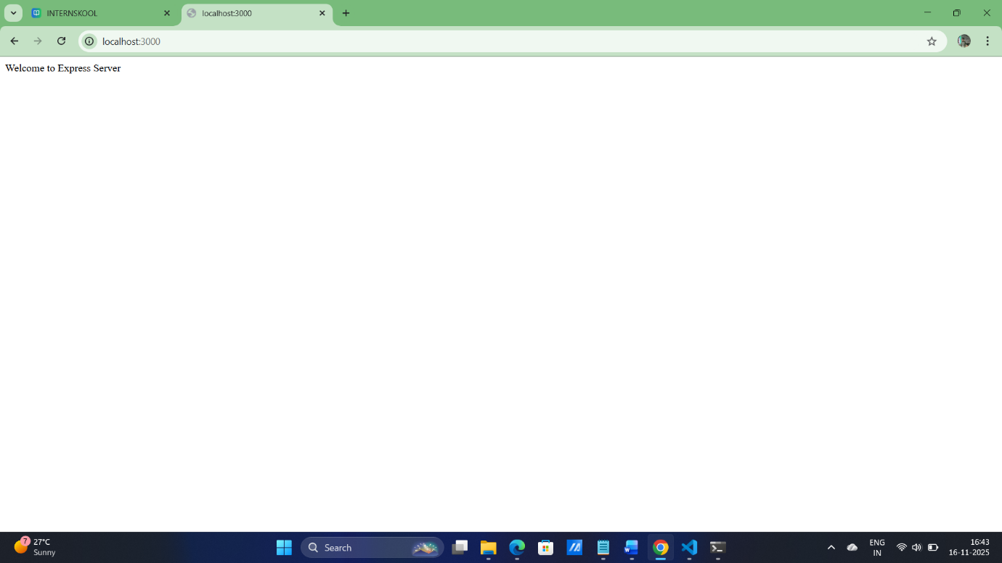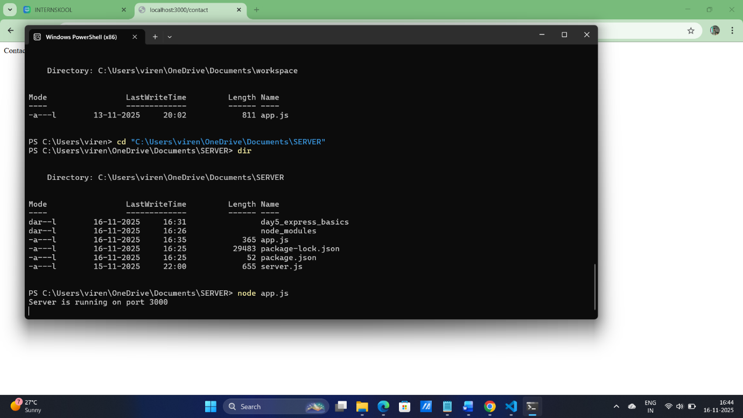

5. Run the server using node app.js and test the routes in browser or Postman Documentation & Submission:
o Screenshots of browser/Postman output for /
, /about, /contact
o Short explanation of Express and its benefits
Express.js is a lightweight and flexible web application framework for Node.js.
It makes it easier to build servers, handle routing, and create APIs.

Benefits of Express.js
- Easy routing: Simple methods (get, post, etc.) to handle different URLs.
- Middleware support: You can easily add functions for logging, authentication, validation, etc.
- Fast development: Reduces boilerplate code compared to raw Node.js.
- Flexible and minimal: You only add what you need.
- JSON & API friendly: Perfect for building RESTful APIs.
- Large community: Lots of tutorials, packages, and support.

