1. Create a new folder named day3_node_http_server
2. Write a short explanation of:
• What is the http module in Node.js?
The http module in Node.js is a built-in module that allows Node.js to create web servers.
It helps the server receive requests from the client (browser/Postman) and send back responses.
It is used for:
- Creating servers
- Handling incoming requests
- Sending responses
- Listening on a specific port

• How it is used to create a server?
- The http module is a core module in Node.js used to build web servers.
- It lets Node handle client requests and send responses.
- Using http.createServer(), we create a server and define how it should respond.
- Using server.listen(port), the server starts running and waits for incoming requests.

3. Create a file server.js
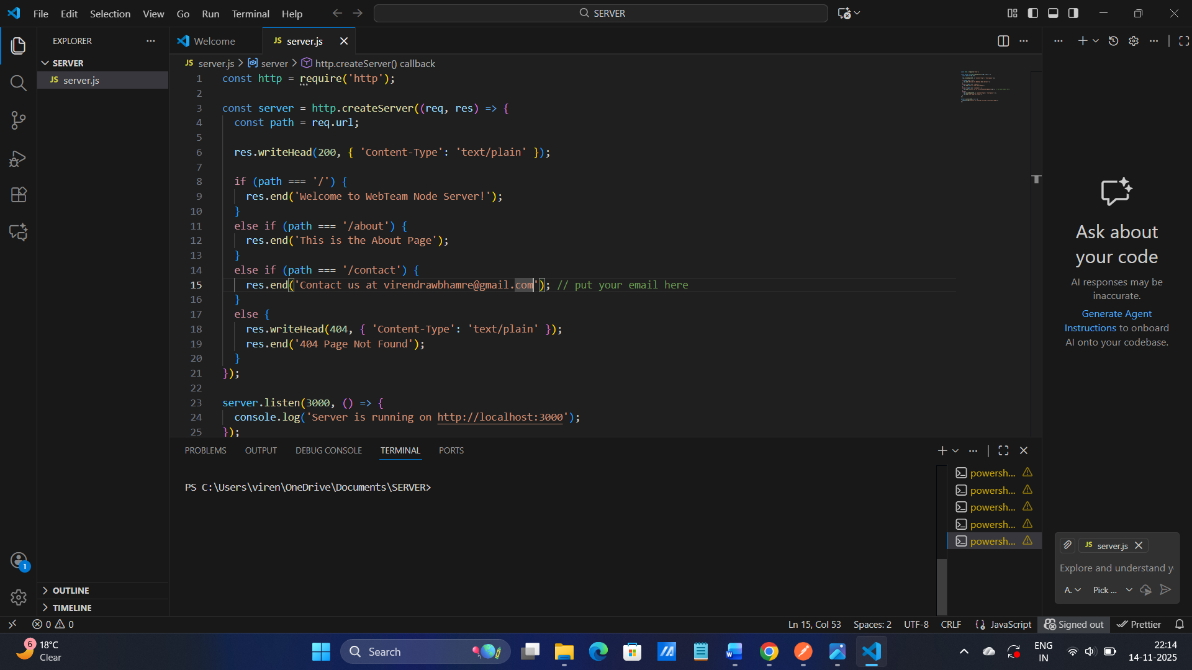

4. Using the http module, write code to:
Create a server that listens on port 3000
• Respond with "Welcome to WebTeam Node Server!" when user opens http://localhost:3000

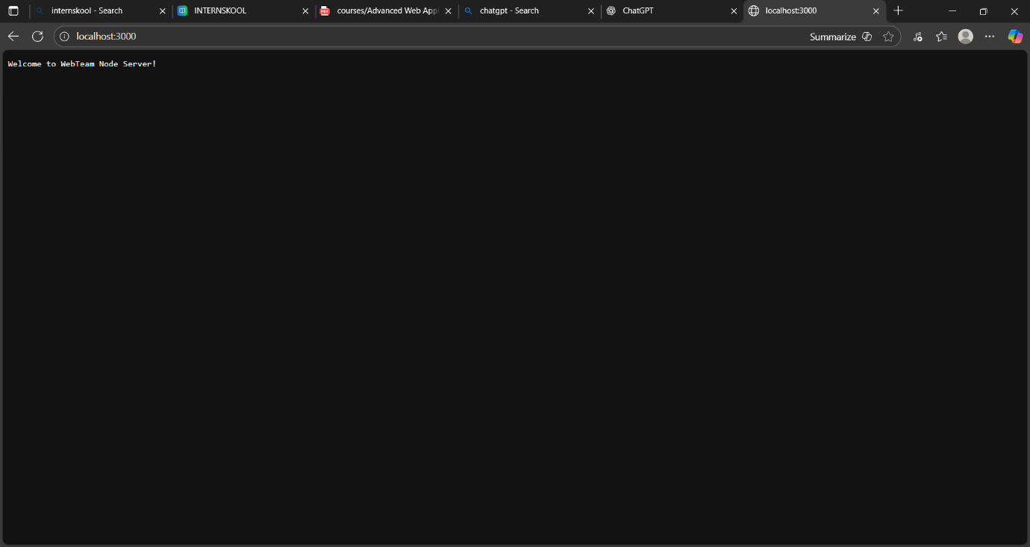

5. Modify your server to respond differently based on the URL path:
• /about → Respond with "This is the About Page"
• /contact → Respond with "Contact us at (mansion self email id) "
• Any other path → Respond with "404 Page Not Found"

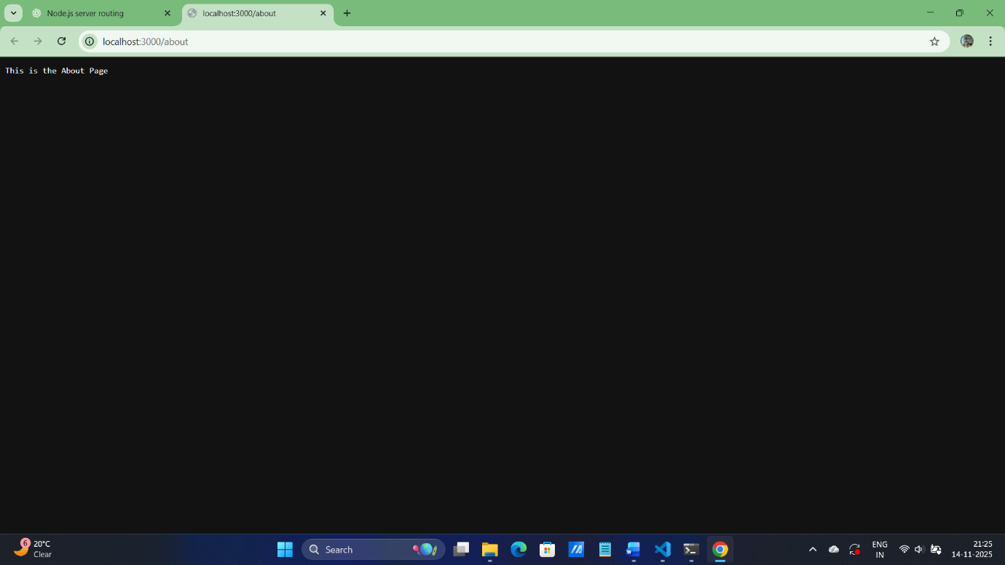

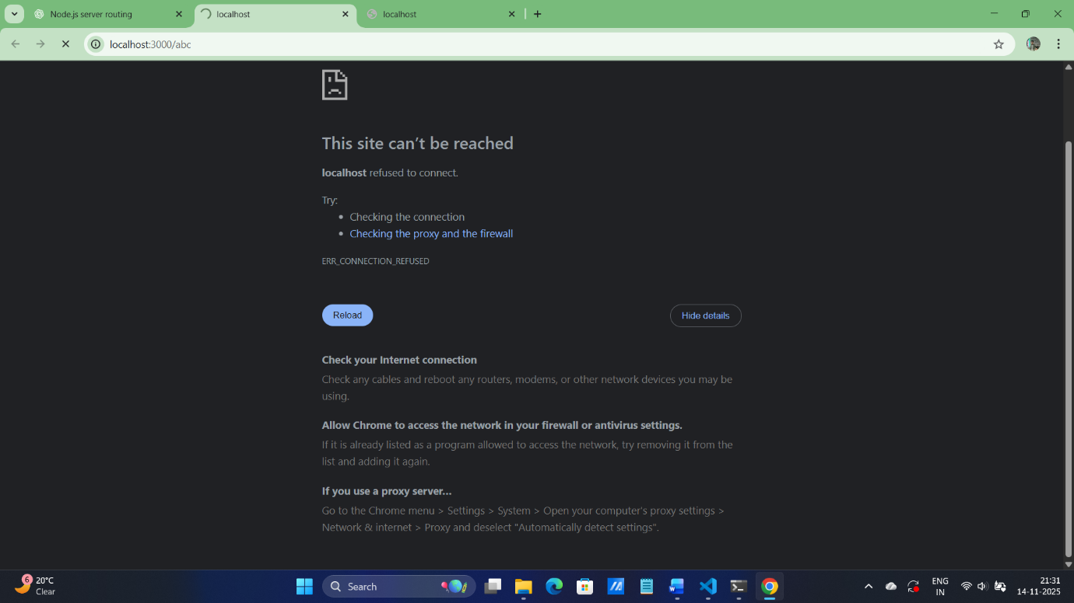

6. Run the server using node server.js and test in browser or Postman Documentation & Submission: 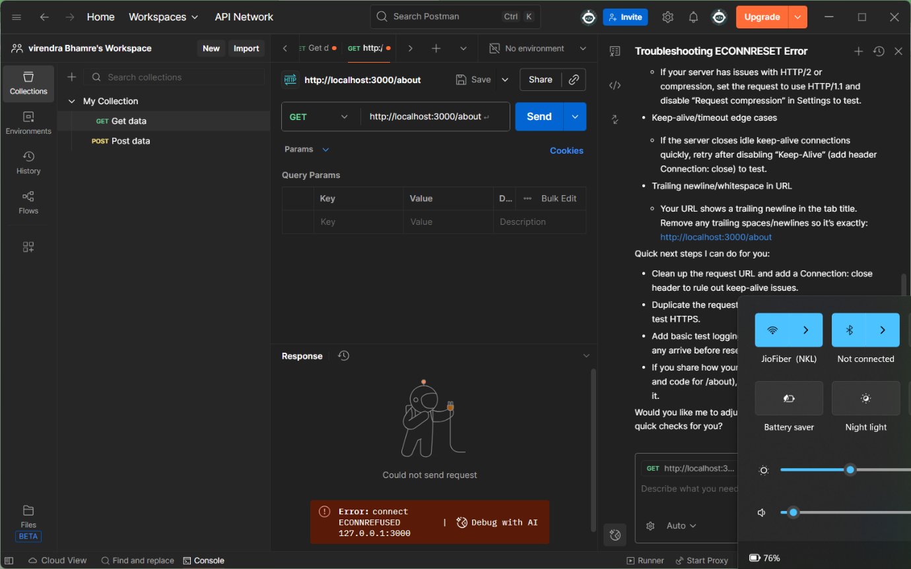

I will required certain amount of time to well know about postman.

