Tasks to Complete:
1. Create a new folder named day8_express_json_middleware
2. Write a short explanation of:
• What is middleware in Express.js?
Middleware in Express.js is a function that runs between the request and response cycle. It can modify the request, response, run some logic, or stop the request before it reaches the final route.
• Common use cases of middleware
• Common use cases of middleware
- Parsing request data (e.g., express.json())
- Logging request details
- Authentication & authorization
- Error handling
- Serving static files
- Validating user input

3. Setup an Express app in server.js
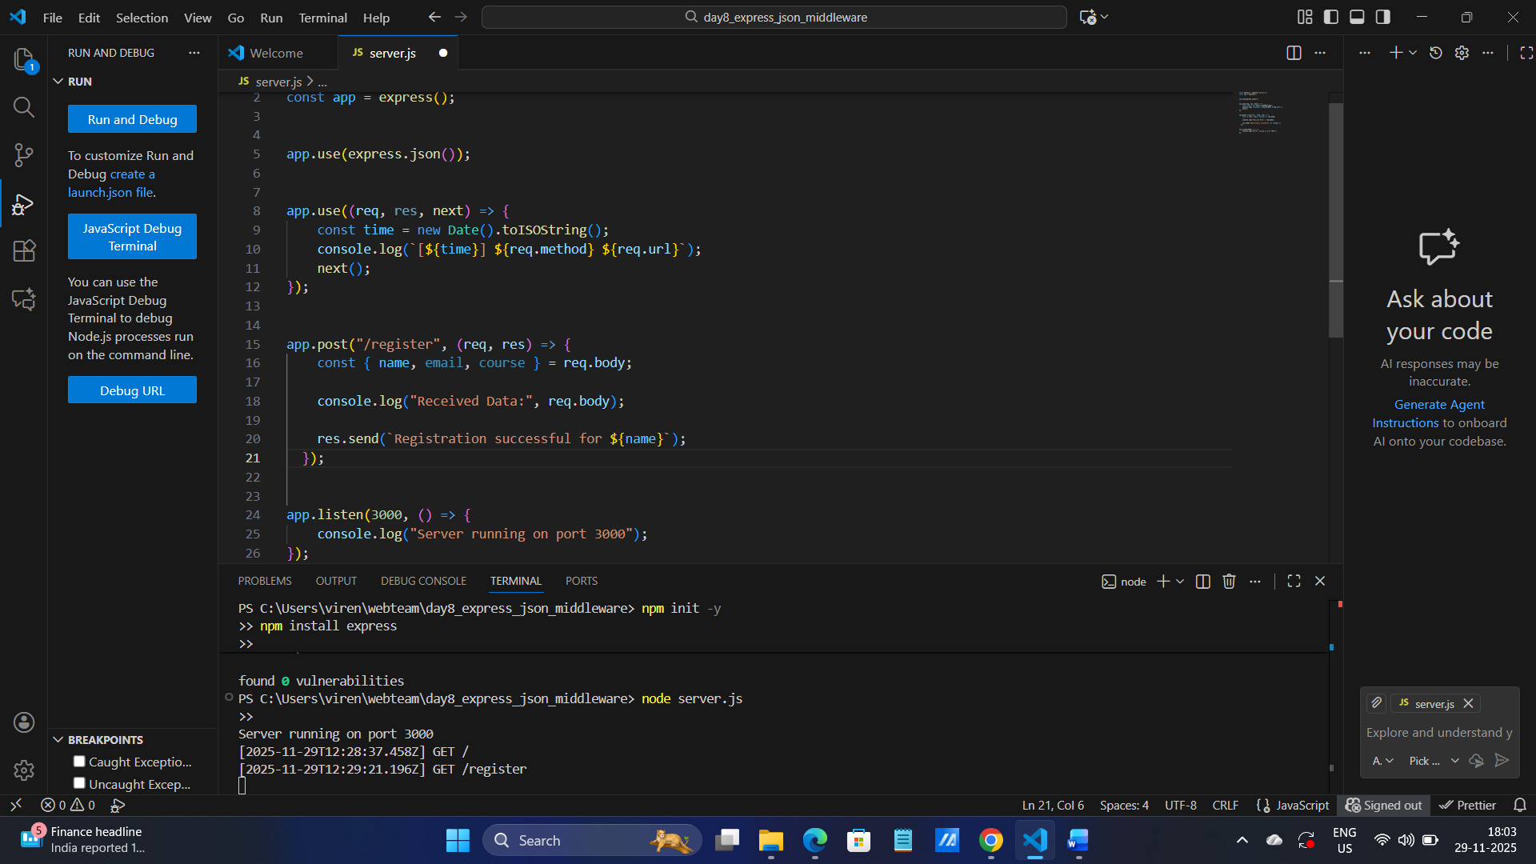

4. Use express.json() middleware to parse incoming JSON data

5. Create a POST route /register that:
• Accepts JSON body with fields: name, email, course
• Logs the data in the console
• Responds with: "Registration successful for [name]"
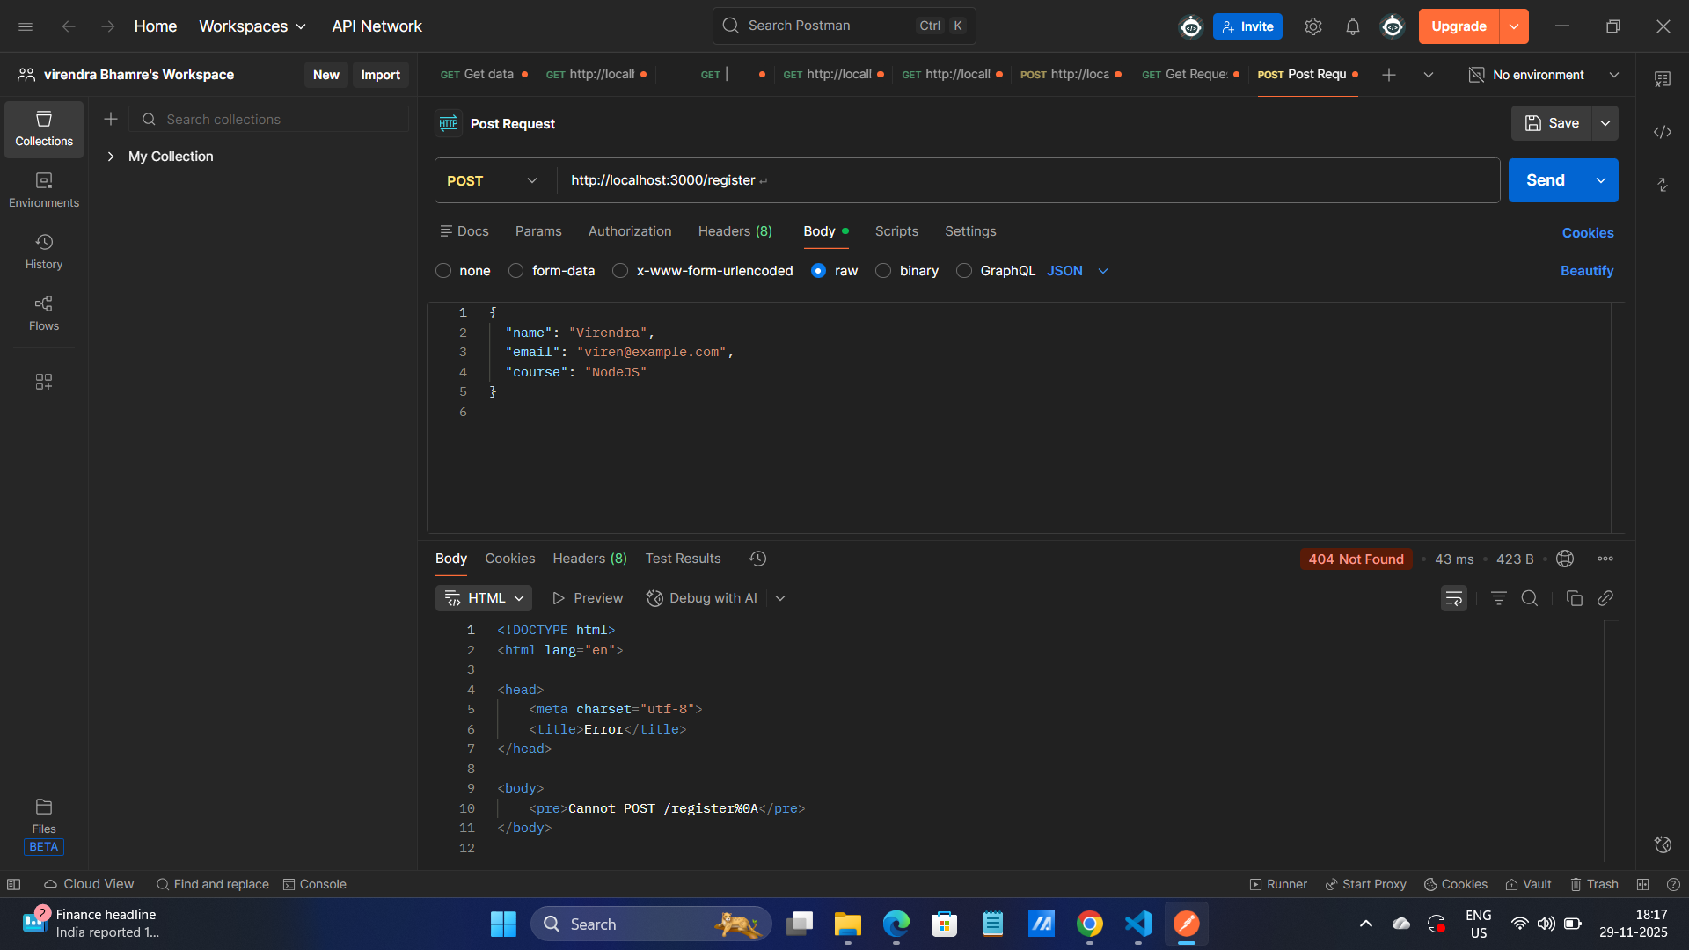

6. Add a custom middleware that logs:
• Request URL, method, and timestamp for every request
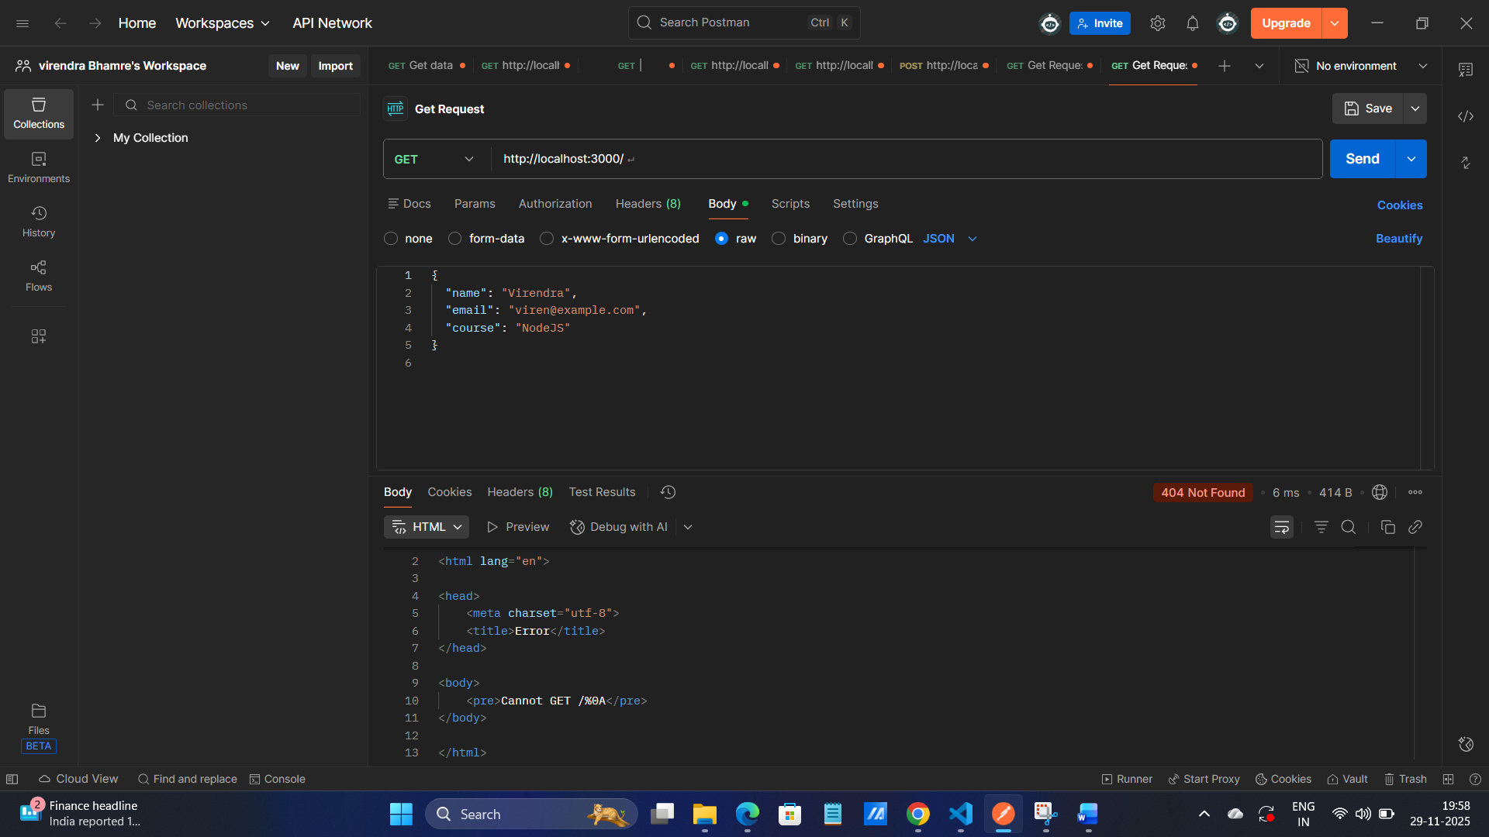
7. Test the POST route using Postman

