1. Create a new folder named day4_node_url_query
2. Write a short explanation of:
• What are query parameters in URLs?

Query parameters are key–value pairs added to a URL after a ? to send extra data to the server.
Example:
?name=John&course=NodeJS
They help pass information in a GET request.

• How Node.js handles URL parsing
Node.js uses the built-in url module.
url.parse(req.url, true) converts the URL into an object and stores query parameters in parsedUrl.query, making them easy to access.

3. Create a file server.js
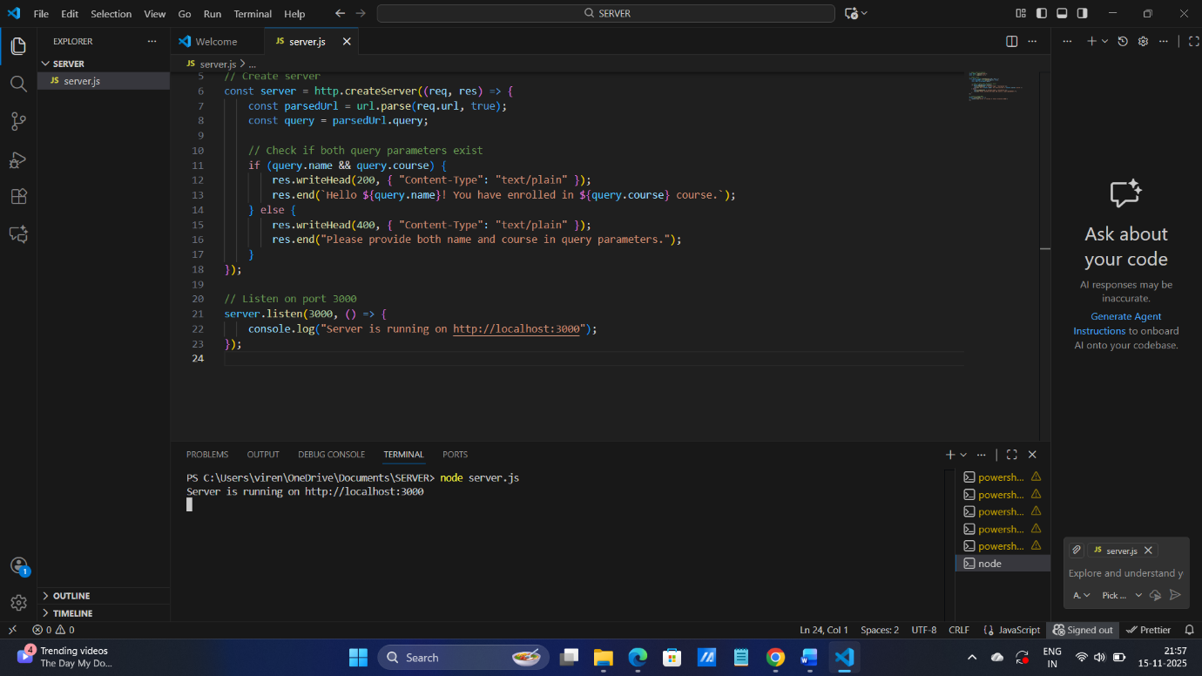

4. Using the built-in http and url modules:
• Create a server that listens on port 3000
• Accept requests like: http://localhost:3000/?name=John&course=NodeJS
• Respond with: Hello John! You have enrolled in NodeJS course.
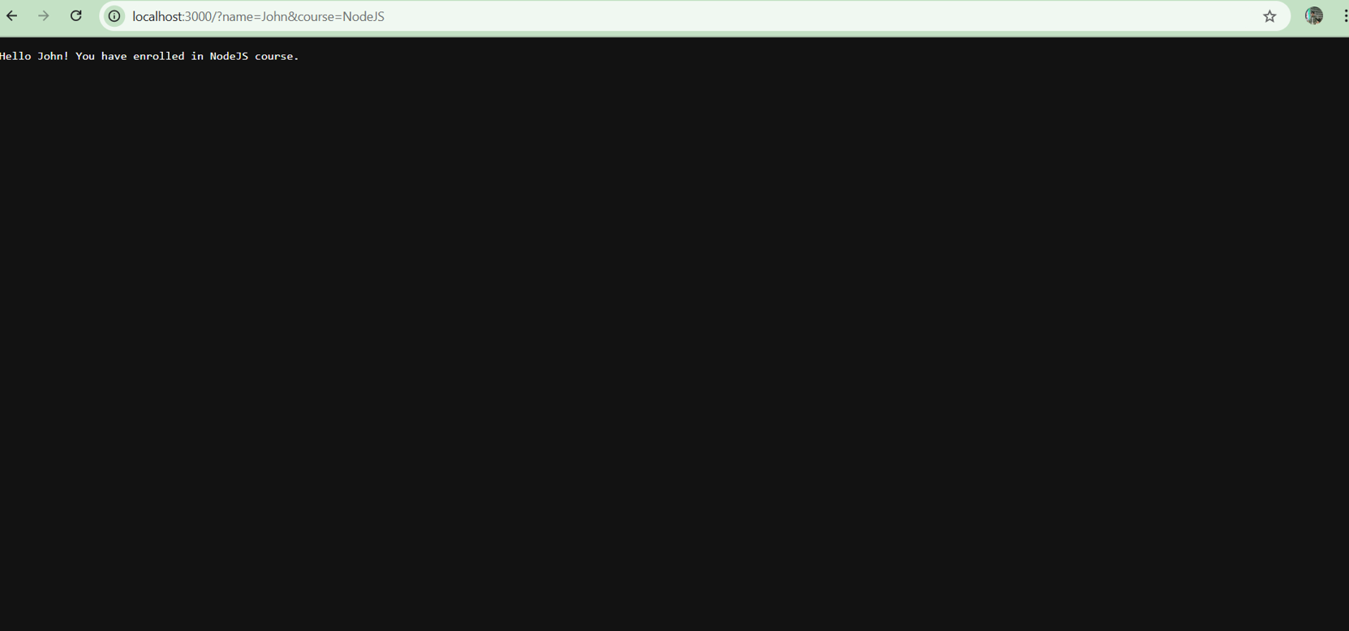

5. Display a message if query parameters are missing:
Please provide both name and course in query parameters.

