# Cancel_to_Trade_SD

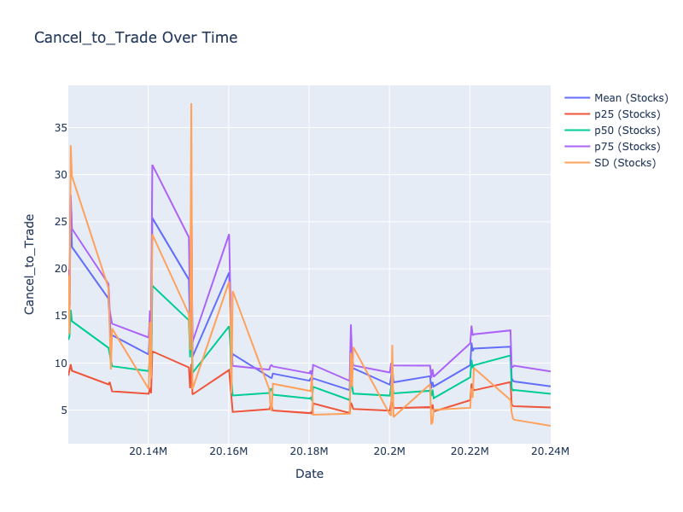

# Trade_to_Order_SD

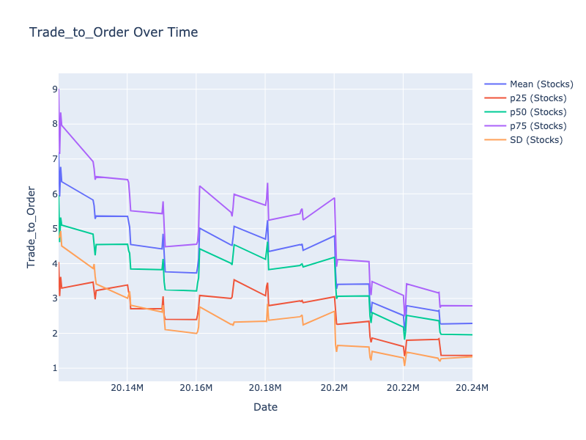

# Hidden_Rate_SD

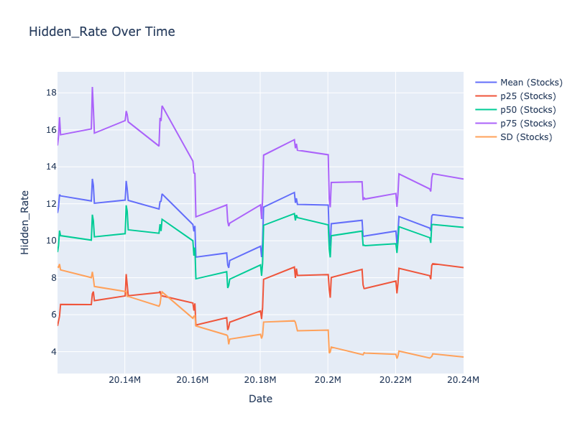

# Hidden_Vol_SD

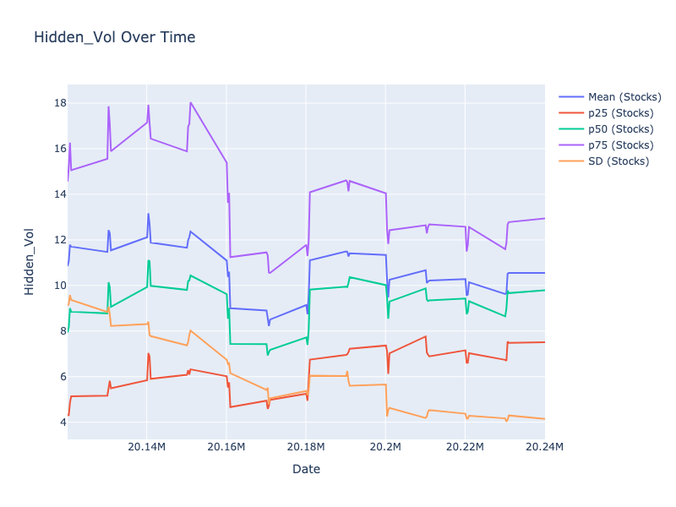

# Oddlot_Rate_SD

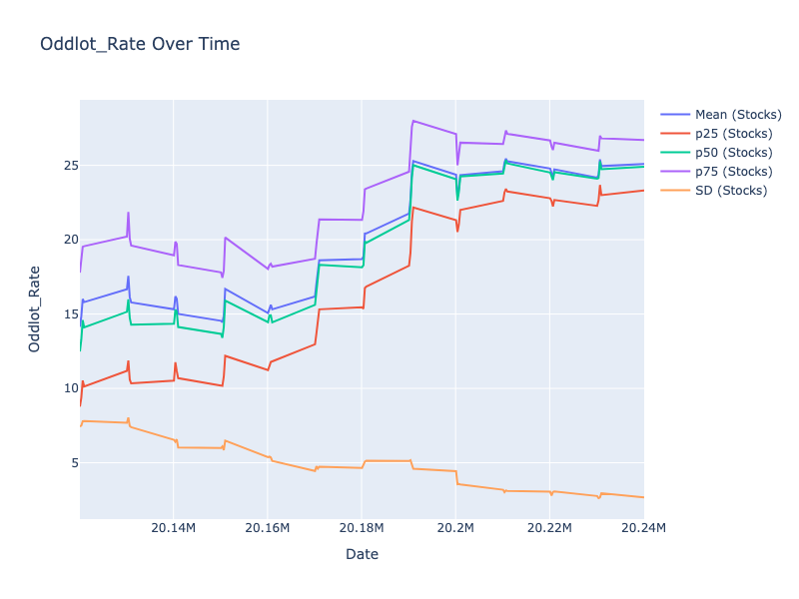

# Oddlot_Vol_SD

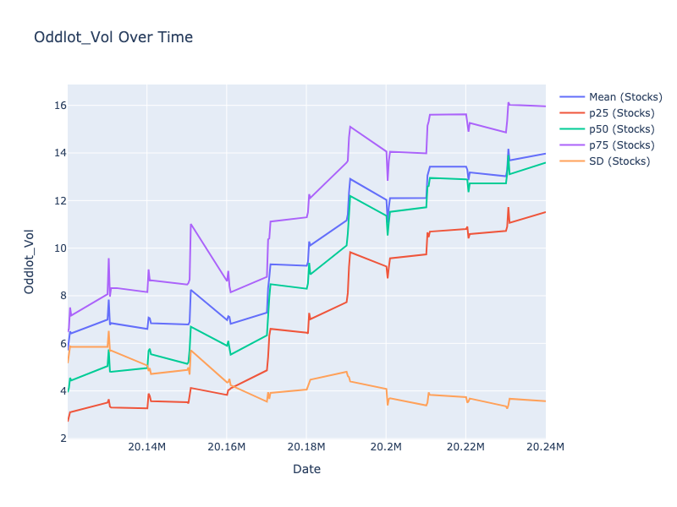

# Cancel_to_Trade_SD

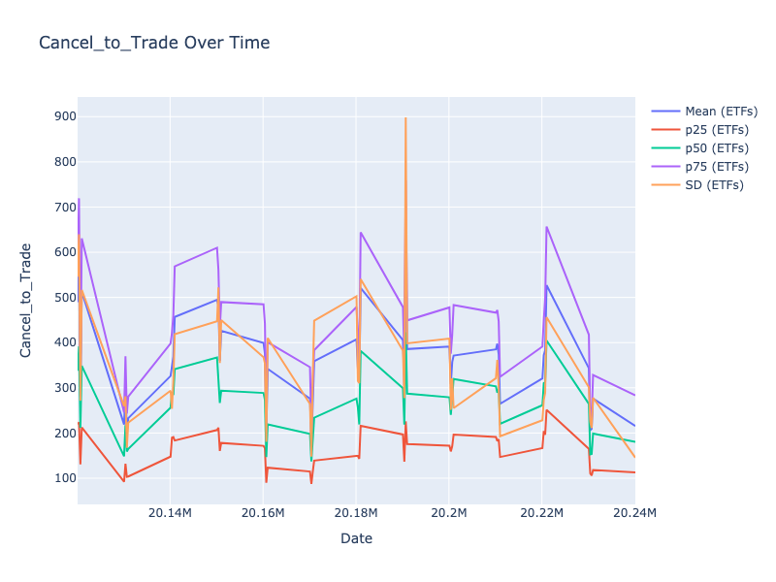

# Trade_to_Order_SD

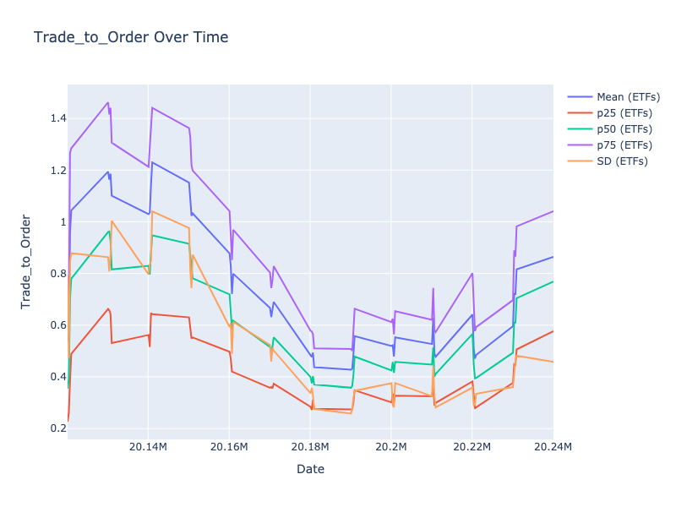

# Hidden_Rate_SD

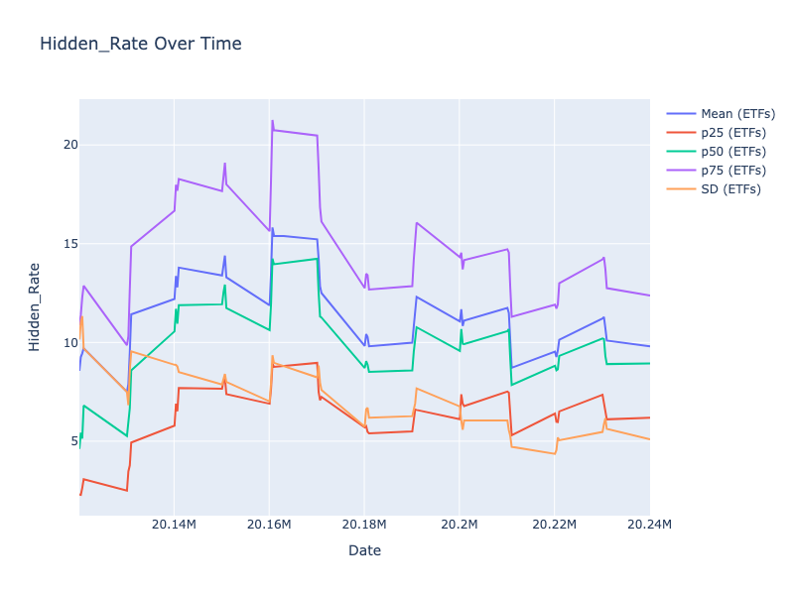

# Hidden_Vol_SD

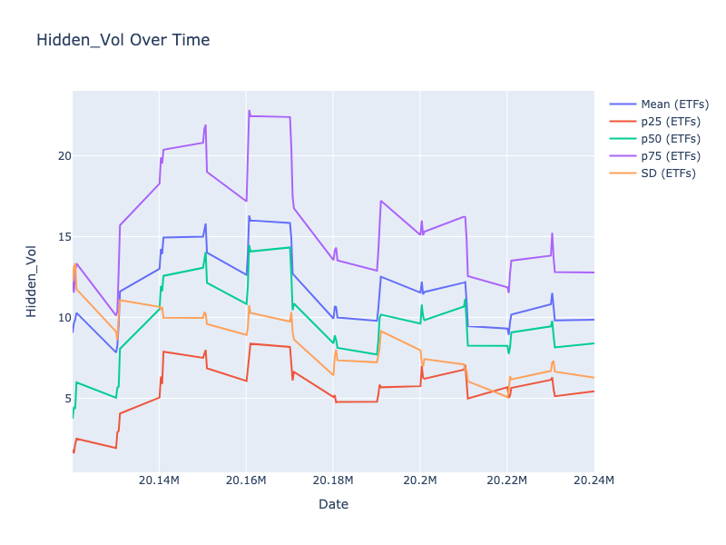

# Oddlot_Rate_SD

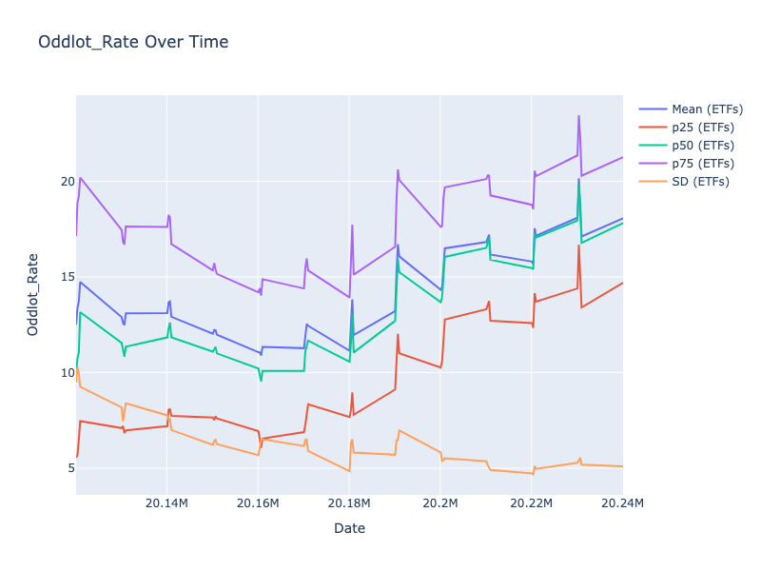

# Oddlot_Vol_SD

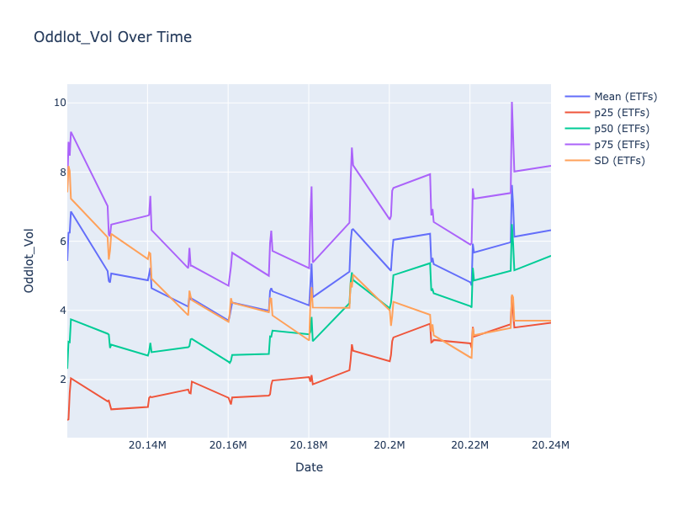

# Cancel_to_Trade_Mean

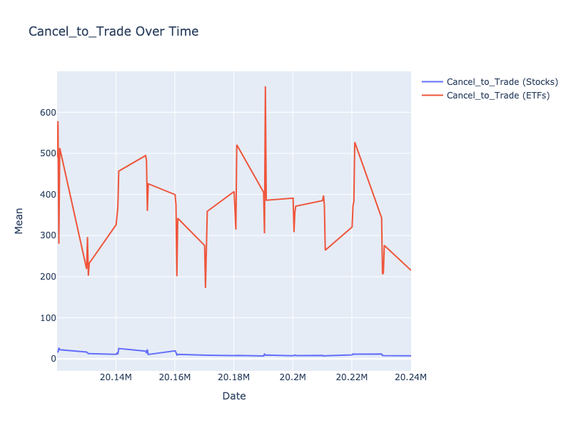

# Cancel_to_Trade_p25

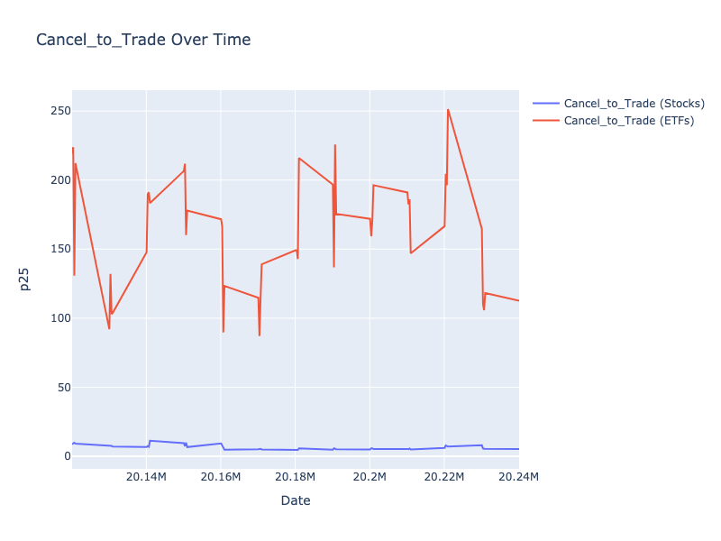

# Cancel_to_Trade_p50

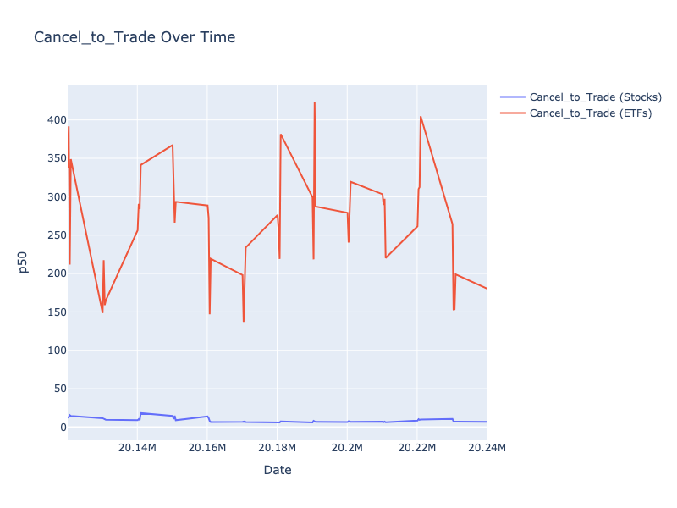

# Cancel_to_Trade_p75

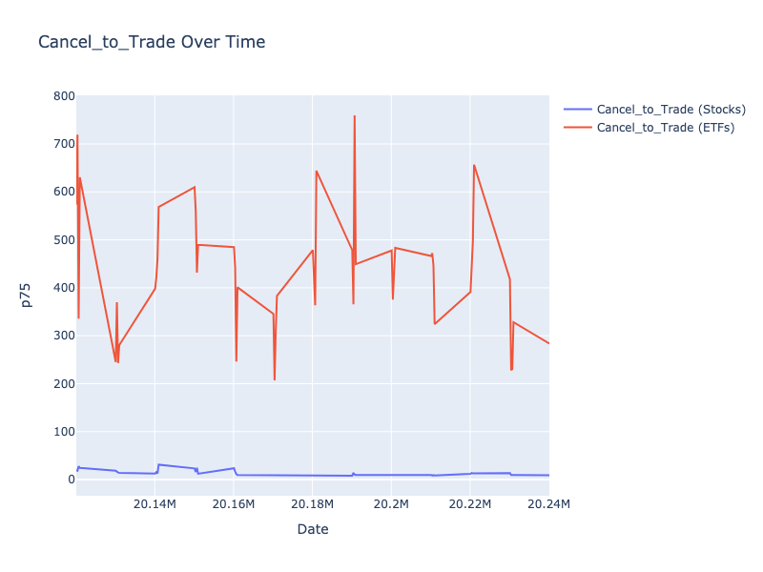

# Cancel_to_Trade_SD

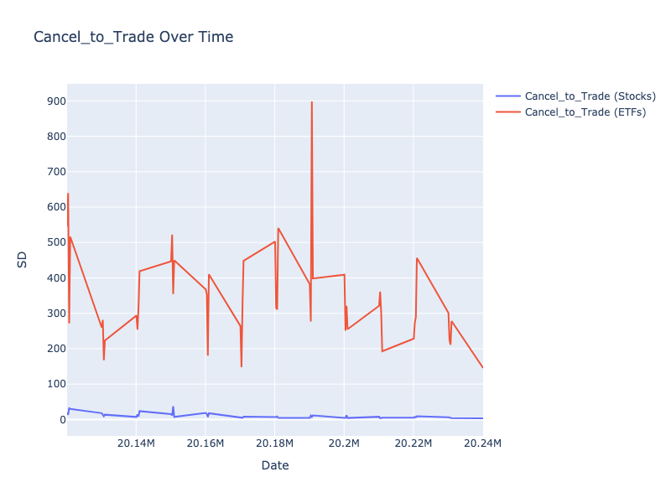

# Trade_to_Order_Mean

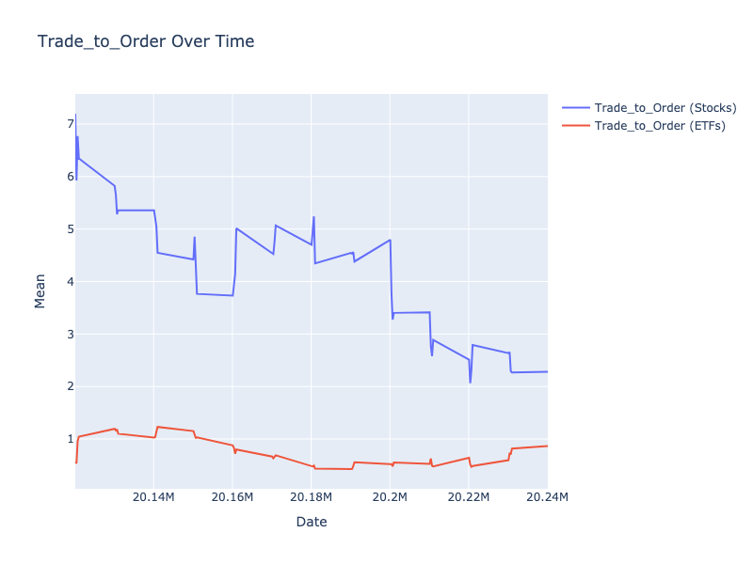

# Trade_to_Order_p25

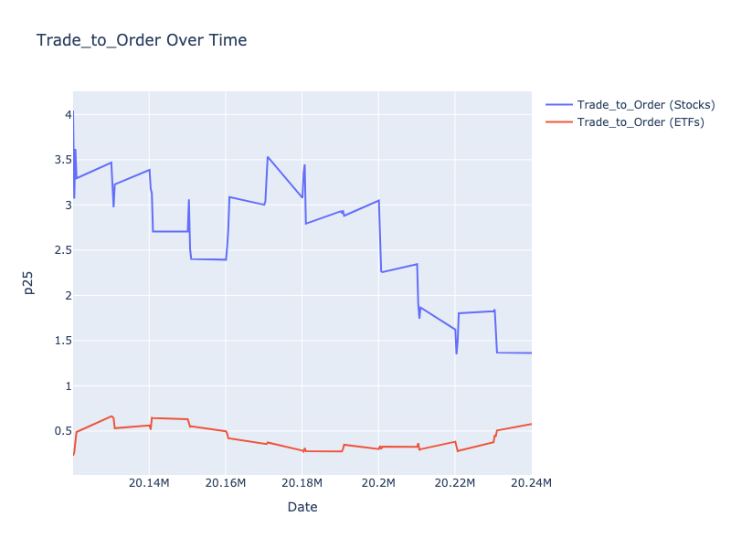

# Trade_to_Order_p50

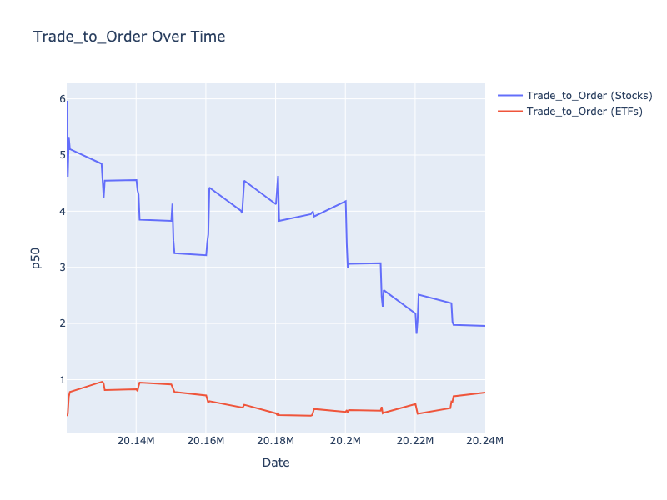

# Trade_to_Order_p75

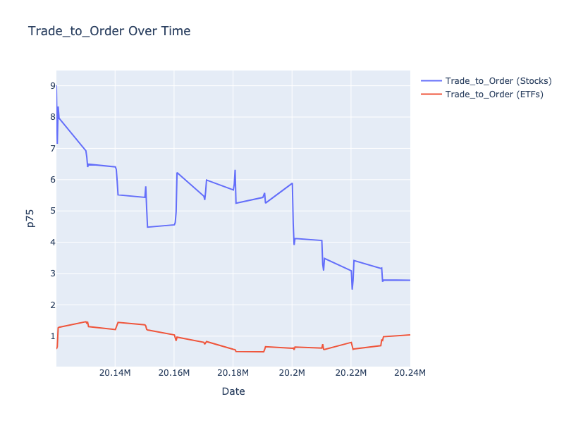

# Trade_to_Order_SD

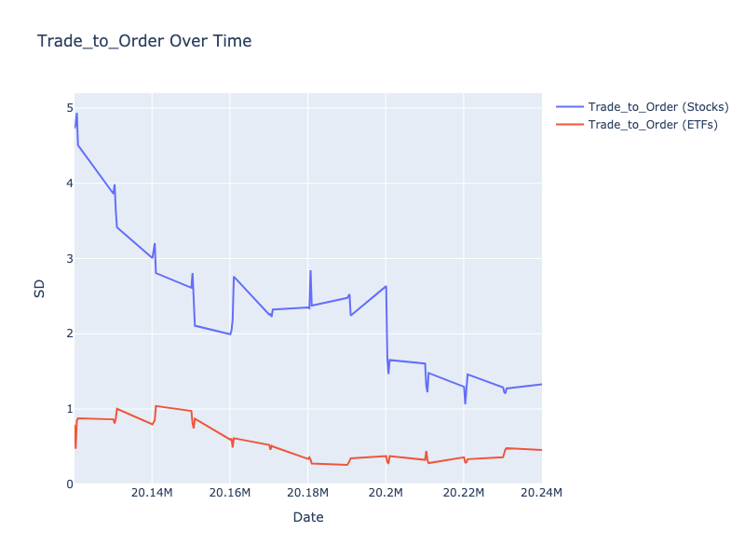

# Hidden_Rate_Mean

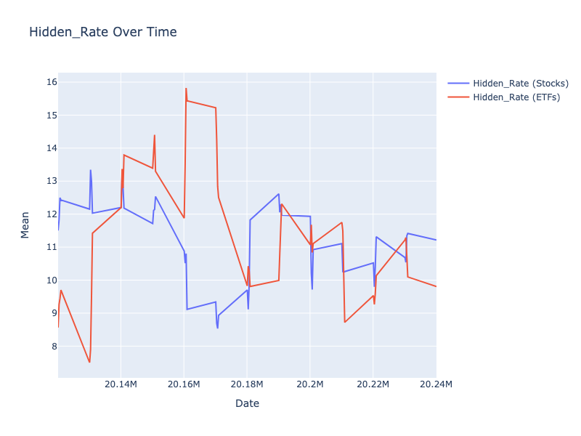

# Hidden_Rate_p25

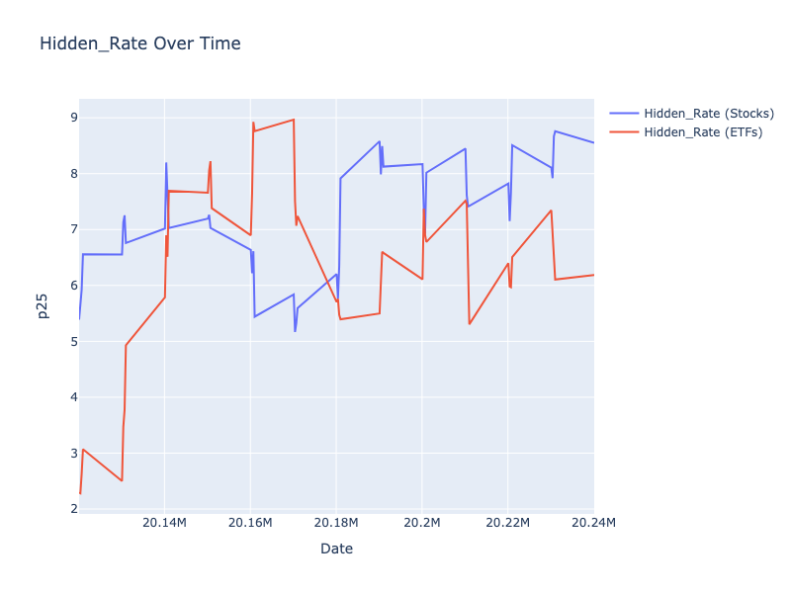

# Hidden_Rate_p50

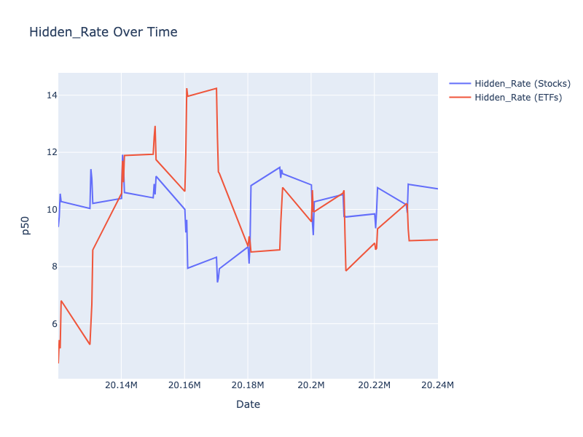

# Hidden_Rate_p75

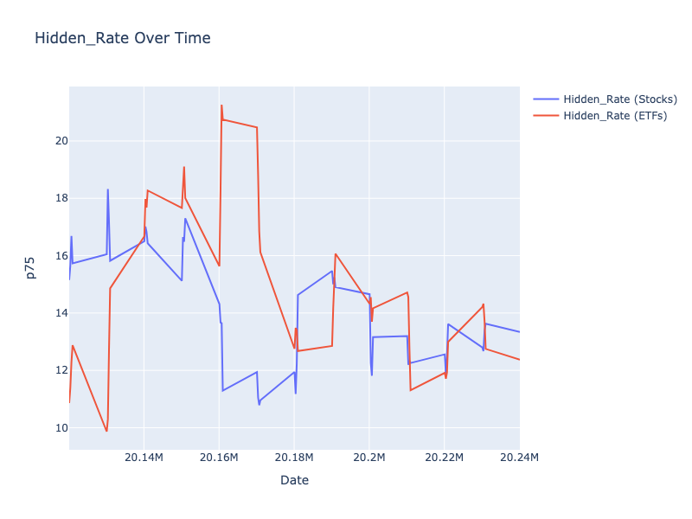

# Hidden_Rate_SD

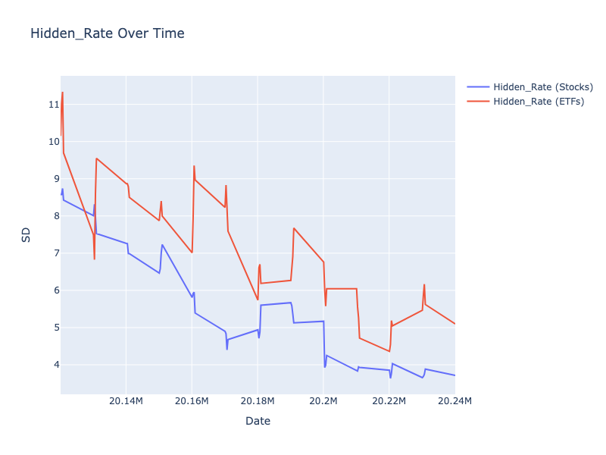

# Hidden_Vol_Mean

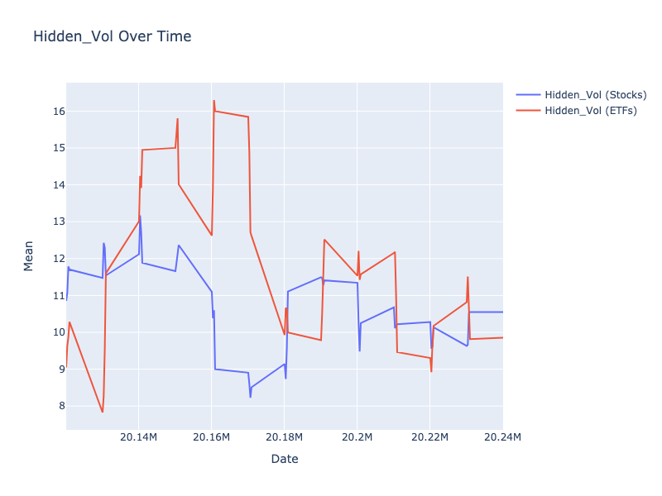

# Hidden_Vol_p25

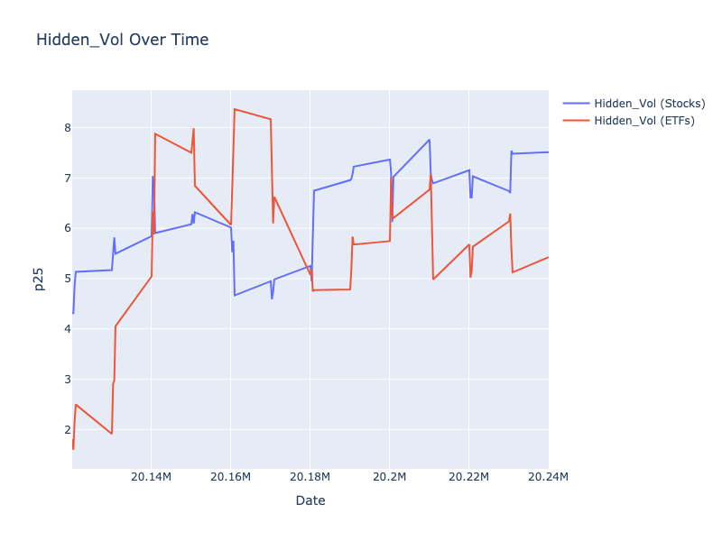

# Hidden_Vol_p50

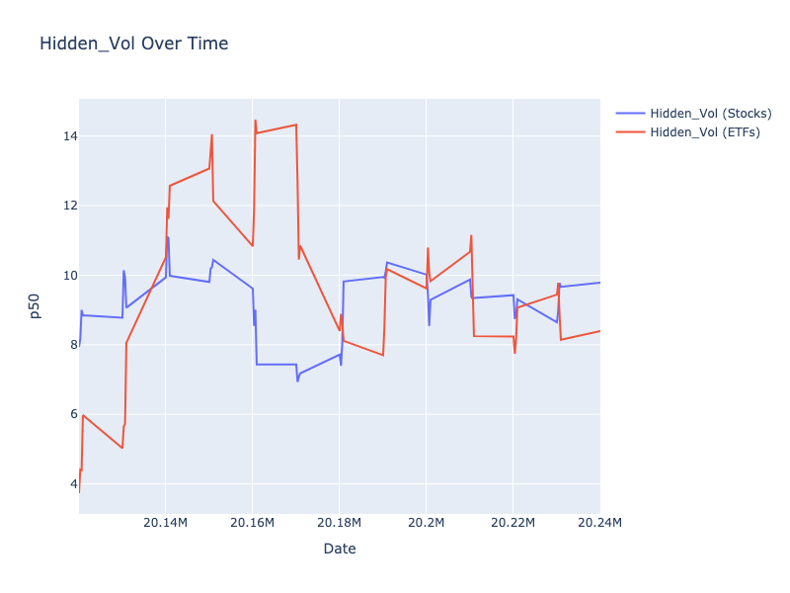

# Hidden_Vol_p75

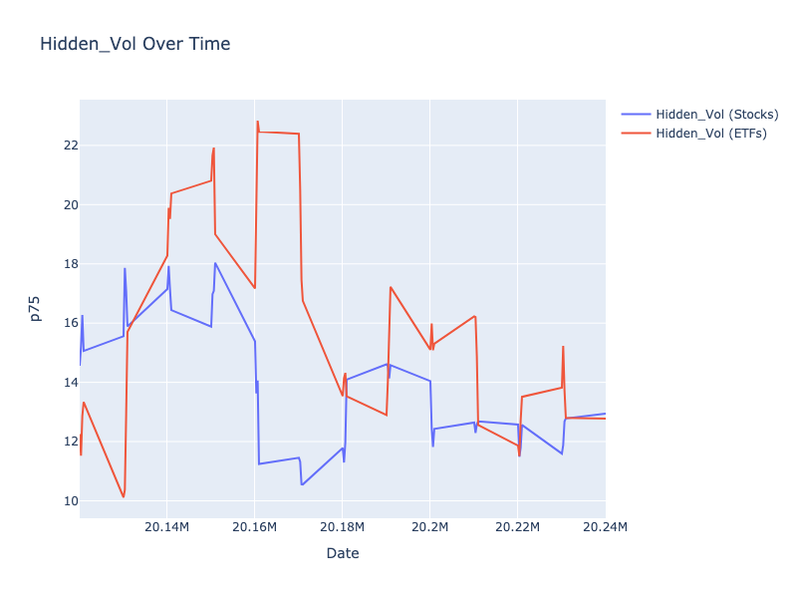

# Hidden_Vol_SD

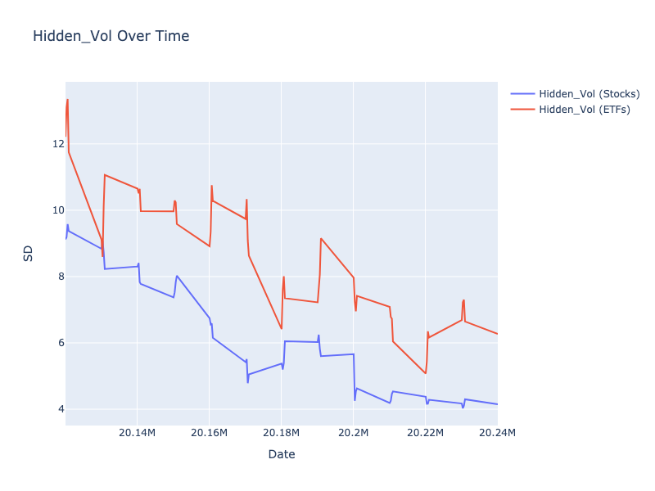

# Oddlot_Rate_Mean

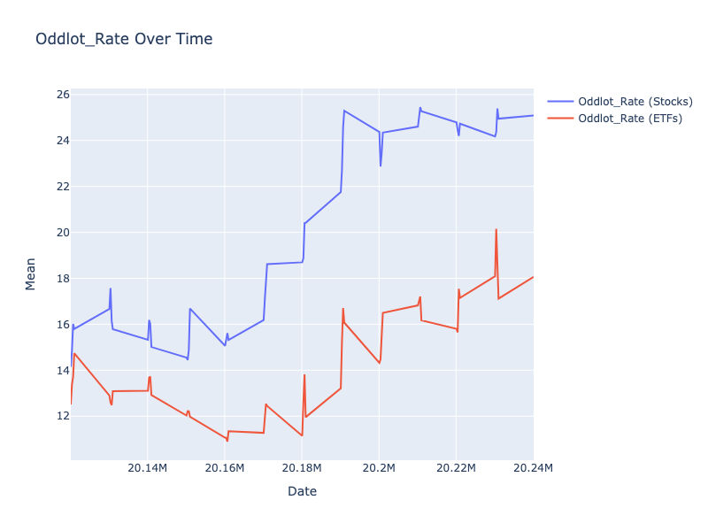

# Oddlot_Rate_p25

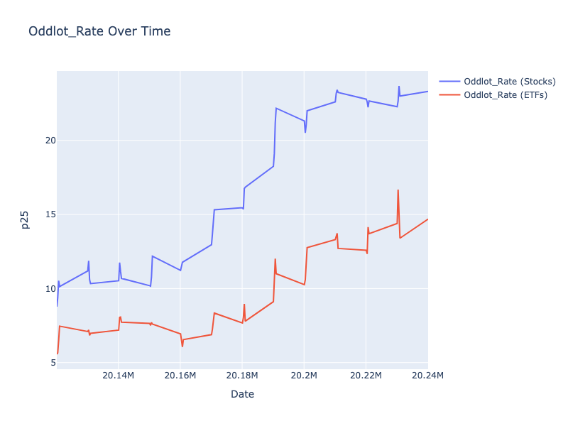

# Oddlot_Rate_p50

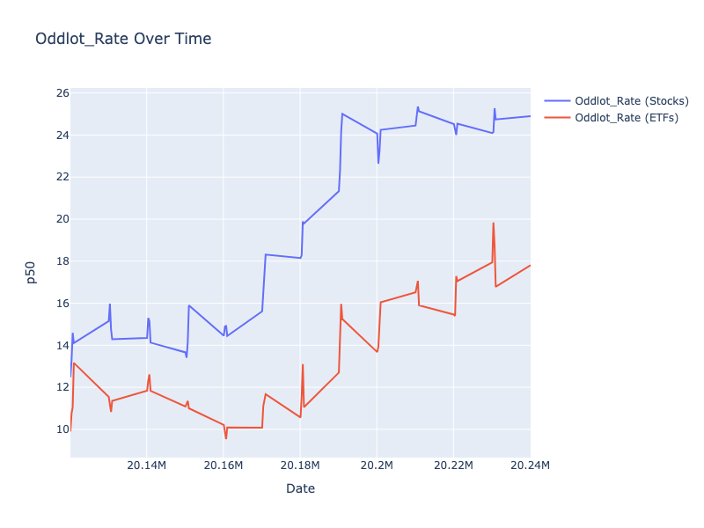

# Oddlot_Rate_p75

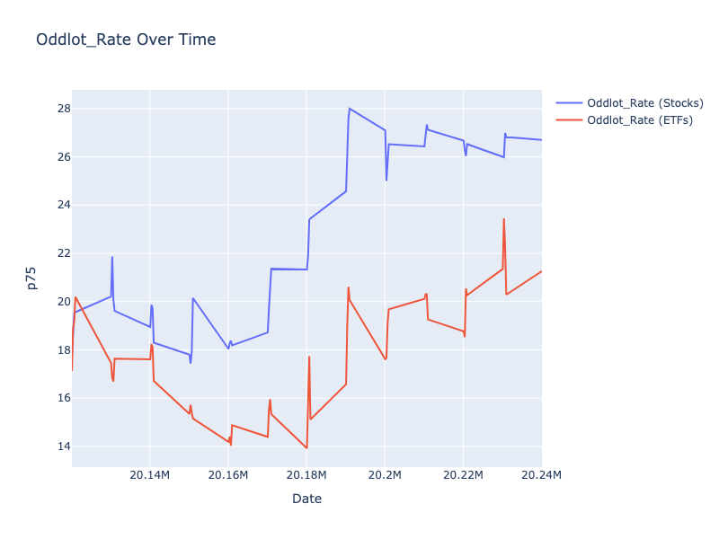

# Oddlot_Rate_SD

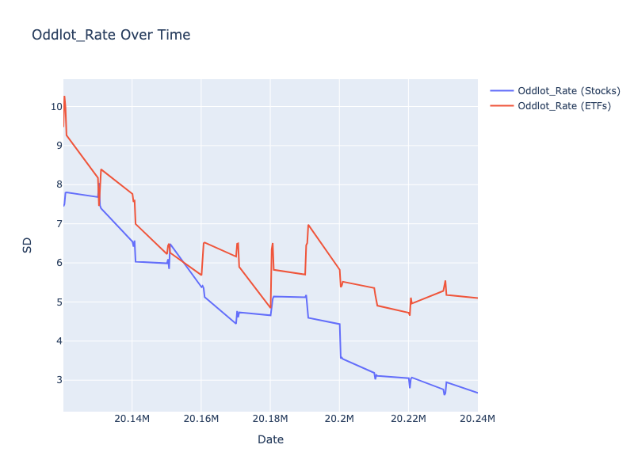

# Oddlot_Vol_Mean

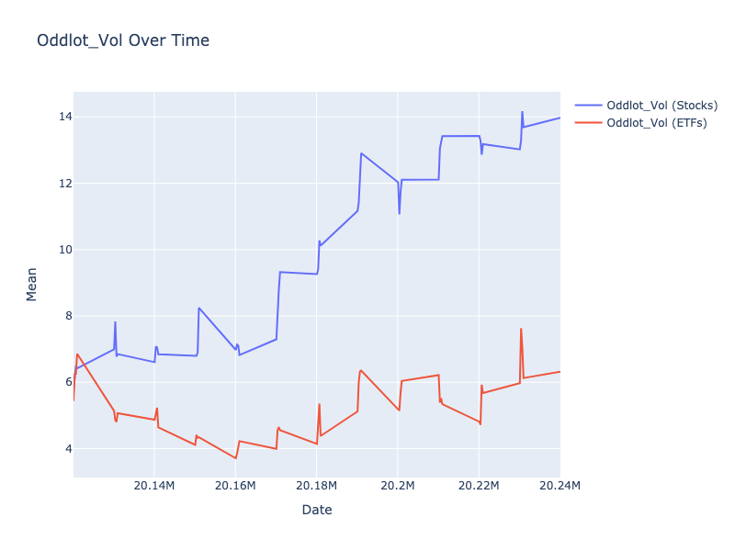

# Oddlot_Vol_p25

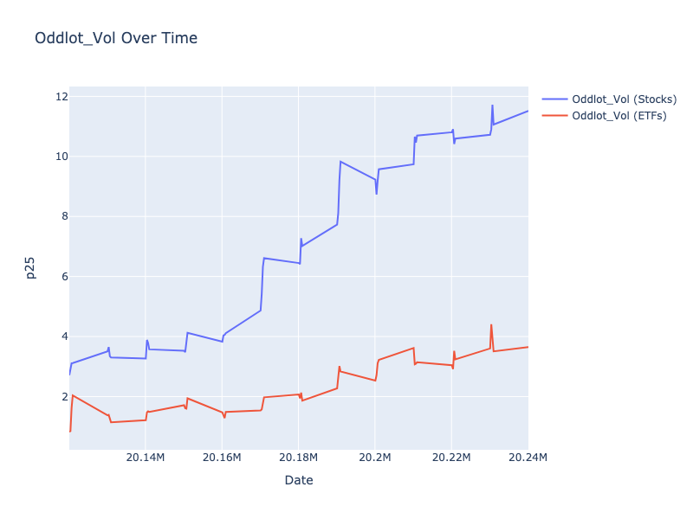

# Oddlot_Vol_p50

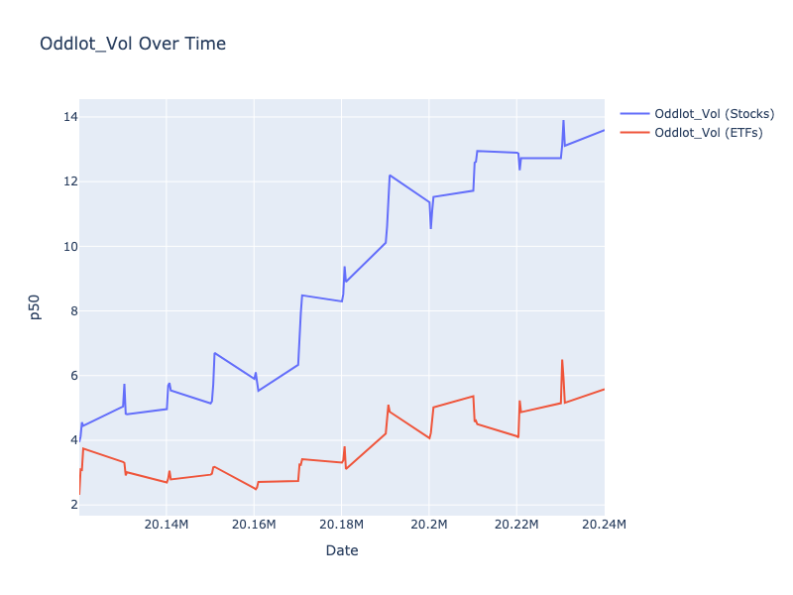

# Oddlot_Vol_p75

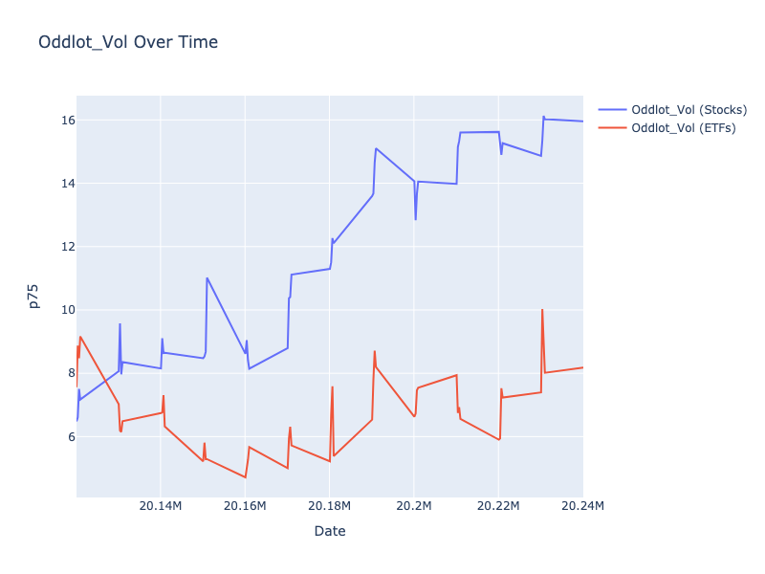

# Oddlot_Vol_SD

