GM University
Course Code: UE26CS1103
Course Title: C Programming with Practice
Project-Based Learning (PBL) Report
Student Academic Record and Performance Management System using C
Assigned PBL title (same project for all teams)
Team Members
S.No | Name | Roll Number | Role in the project
1 | [Member 1 name] | [roll no.] | [e.g. input handling and program flow]
2 | [Member 2 name] | [roll no.] | [e.g. records, display and search]
3 | [Member 3 name] | [roll no.] | [e.g. calculations and analysis]
4 | [Member 4 name] | [roll no.] | [e.g. testing and documentation]

Faculty / Course instructor | Semester / Section | Date of submission
[faculty name] | [semester / section] | [dd/mm/yyyy] (within Week 14)
Maximum marks: 40 | Duration: 14 weeks | Group size: at most 4 students
Report: one per group, maximum 12 A4 pages

1. Abstract
Academic departments constantly record marks, compute results and look for weak areas; doing this by hand is slow and error-prone. This project develops a menu-driven console program in C that stores student academic records, validates every input, calculates total, average, percentage and a pass/fail decision, searches by identifier or name, and reports highest/lowest performance, mark-band frequencies and pass/fail counts. Identity data is held in an array of structures and the marks in a separate two-dimensional student-by-subject table; 58 user-defined functions in five source modules implement the operations. Keyboard input is read with fgets and converted with strtol, so invalid, over-long and out-of-range input is rejected without corrupting stored data. Six optional menu options were added: update marks, ranking, partial-name search, save, load and CSV export. The system was verified with 139 unit checks and 45 scripted integration cases covering normal, boundary and invalid input; all pass, including under AddressSanitizer and UndefinedBehaviorSanitizer. Records live in memory unless saved, and capacity is fixed at 100 students.

2. Introduction
Every institution keeps academic records: who a student is, what they scored in each subject, whether they passed, and how the class performed. Even a small system for this task needs decisions (does the student pass?), repetition (every student, every subject), tables (marks by subject), text handling (names and identifiers) and careful input checking. That makes it a good vehicle for applying the first six units of the course, C Programming with Practice, in one coherent program.
The purpose of this project is to design, implement, test and demonstrate such a system in standard C (C11), as a terminal application. Records are kept in memory, with optional text-file persistence added as an enhancement. The program is about 1835 lines of commented C across five modules and compiles without warnings under -Wall -Wextra -Wpedantic. This report follows the prescribed structure: problem statement, objectives and requirements, algorithms and flowcharts, system design, implementation, testing and results, conclusion, references and the individual contribution table.

3. Problem Statement
Design and develop a menu-driven C programming system to maintain student academic records and perform useful computations and searches. The system should integrate iterative programming, arrays, strings, two-dimensional arrays, structures and user-defined functions.
The system therefore has to hold for each student an identifier, a name and one mark per subject; accept and validate that data; display it in readable form; calculate the total, average and percentage; decide pass or fail; search by identifier or name; and analyse the class (highest and lowest results, frequency of mark bands, pass/fail counts). The assignment does not fix the numbers and rules involved, so the following design choices were made and are used consistently in the code, tests and this report:
Design choice | Value used | Design choice | Value used
Maximum records | 100 students | Pass rule | every subject mark ≥ 40
Subjects | 5 (Maths, Physics, Chemistry, English, Computing) | Frequency bands | 0–39, 40–59, 60–79, 80–100 per subject
Marks | whole numbers 0–100 | ID | unique, 1–19 characters, no spaces, case-sensitive
Name | 1–79 characters, spaces allowed, duplicates allowed | Search | exact ID; exact (case-sensitive) name, all matches

4. Objectives and Functional Requirements
Objectives. (1) Apply problem-solving and programming fundamentals (Units 1–2). (2) Use decision-making and user-defined functions (Unit 3). (3) Implement iterative algorithms and number processing (Unit 4). (4) Use arrays and strings for collections and text (Unit 5). (5) Use two-dimensional arrays and structures for tables and records (Unit 6).
Functional requirements and how each is met (menu options 1–8 are the required features; 9–14 are enhancements):
Requirement | Implementation | Test evidence
Data entry and validation | Option 1 add_student; read_int_in_range, read_nonempty_text, duplicate-ID check, capacity check | TC01, TC11–TC12, TC20–TC28
Formatted display | Option 2 aligned table; display_student detailed view | TC02
Total, average, percentage | calculate_total, calculate_average, calculate_percentage (floating-point) | TC01, TC02, unit tests
Pass/fail decision | is_pass: every subject ≥ 40 | TC13, TC14
Search by ID or name | Option 3 (find_student_by_id), option 4 (search_by_name) | TC03–TC05
Maximum/minimum and frequency | Option 6 show_extremes (ties listed), option 7 show_frequency, option 8 pass/fail | TC07–TC09, TC16–TC19
Subject-wise marks | Two-dimensional marks[100][5]; option 5 table with class averages | TC06
Structures | Student (id, name) and Records (students, marks, count) | Section 6
Reusable functions | 58 functions, prototypes in student.h; main only dispatches | Section 7
Testing | Normal, boundary and invalid cases | Section 8, tests/test-cases.md
Enhancements (options 9–14) | Update marks, ranking, partial-name search, save, load, CSV export | TC35–TC45

5. Algorithm / Flowchart

5.1 Overall program flow
The program initialises an empty record table and then repeats: show the menu, read a valid choice, run the chosen operation through its function, and return to the menu, until Exit is chosen or the input ends (Figure 1).
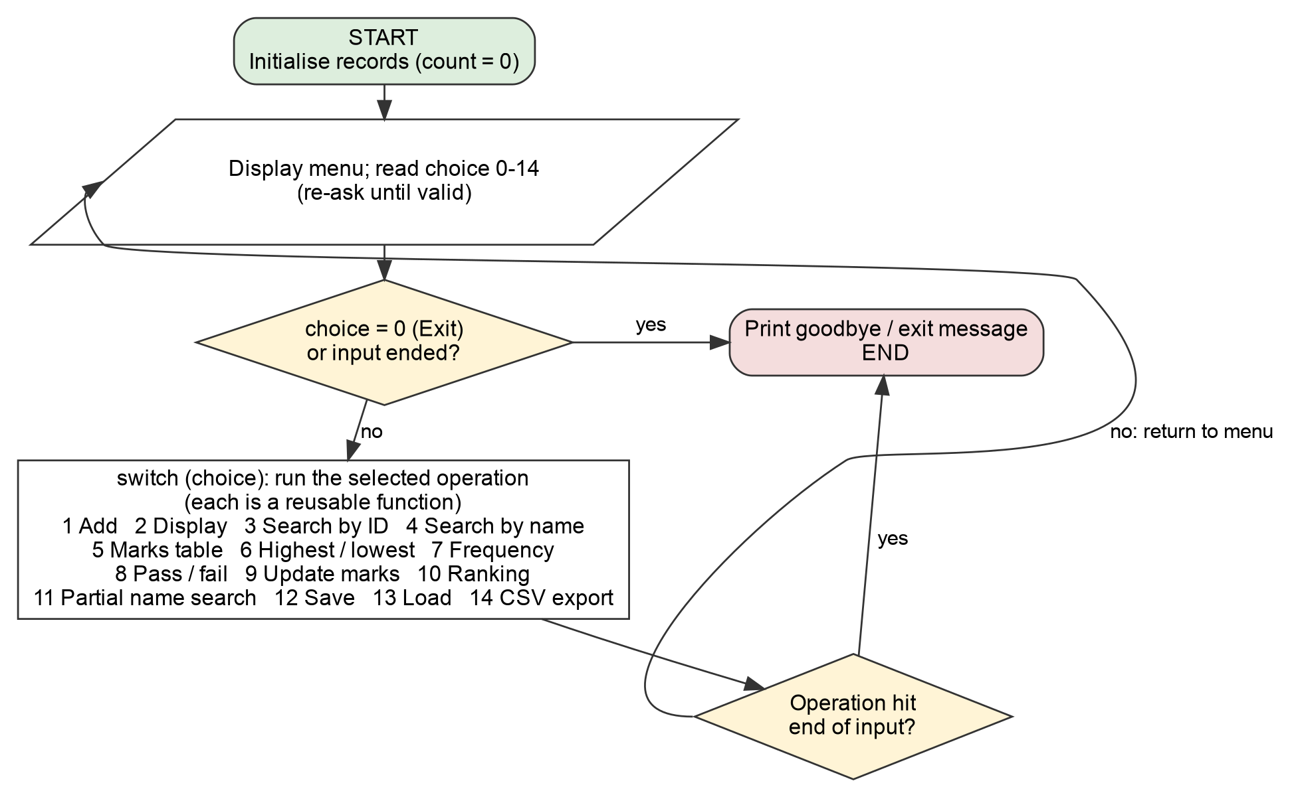
Figure 1: Main program flow (menu loop)

5.2 Entry validation and result calculation
Algorithm: add one student  - If the table already holds 100 students, report it and return.  - Read the ID; re-ask if blank, over 19 characters or containing spaces.  - If the ID is already stored (linear search with strcmp), reject it and return.  - Read the name; re-ask if blank or over 79 characters.  - For each of the 5 subjects read a mark with strtol; re-ask for text, trailing characters, overflow, below 0 or above 100.  - If the input ends at any prompt, discard the temporary data and return.  - Only now copy the temporary identity and marks into row count and increase count by one.  - Display the saved record with its calculated result.  The new data stays in temporary variables until step 7, so rejecting a duplicate or cancelling can never leave a half-written record or a wrong count. | 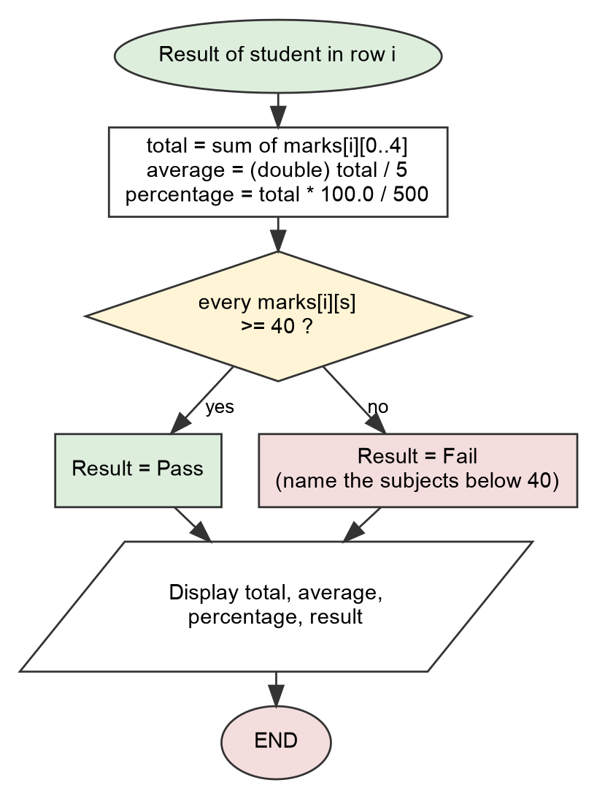  Figure 2: Calculation of total, average, percentage and result

5.3 Key operation logic
- Search. By ID: compare the wanted ID with students[0].id, students[1].id, … using strcmp until a match or the end (linear search). By name: the same, but the whole table is always traversed because names are not unique.
- Highest/lowest. Stop if there are no records; start both from the first real record, then compare the remaining rows; finally list every student that holds the extreme value (ties). The same is done for each subject column.
- Frequency. Zero a counts[subject][band] table; for every mark add one to exactly one band (80+ → 3, 60+ → 2, 40+ → 1, else 0); every subject row must add up to the number of students.
- Pass/fail. Count students for whom is_pass is true or false; pass percentage = passes × 100 / students.

6. System Design / Methodology
Approach. The system was designed top-down and built incrementally in the order: constants and data model, validated input and menu, entry and display, calculations, search, analysis, integration, then testing. Hand-calculated expected results (for example S001: 80+70+60+90+50 = 350, 350 ÷ 5 = 70.00, 350 × 100 ÷ 500 = 70.00 %) were written down before the code and every function was checked against them.
Data model. One Records structure holds an array of Student structures (id, name), a separate two-dimensional marks table and the number of occupied rows. Row i of both arrays describes the same person (Figure 3). Marks are stored once; total, average, percentage and result are recalculated whenever they are needed, so they can never be stale after an update.
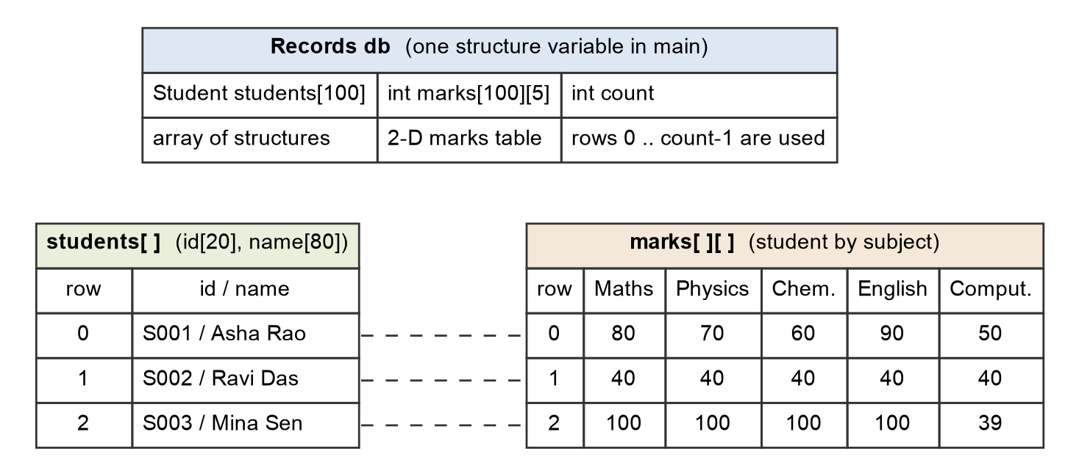
Figure 3: Data model — identity structures and the two-dimensional marks table share a row index
Module | Responsibility | Main functions
main.c | Menu, dispatch with switch, clean exit on end of input | main, print_menu
student.h | Constants, Student and Records types, all prototypes | —
student.c | Entry, display, search, marks table, update marks | add_student, display_student, find_student_by_id, search_by_name, display_marks_table
analysis.c | Calculations, decisions, extremes, frequency, summary, ranking | calculate_total, is_pass, mark_band, show_extremes, show_frequency
input.c | Safe bounded input | read_int_in_range, read_nonempty_text, parse_int_in_range
storage.c | Optional save/load and CSV export | save_records, load_records, export_csv

Academic rules and formulas. With S = 5 subjects and a maximum of M = 100 per subject: total = sum of the marks; average = total / S; percentage = total × 100 / (S × M), both in floating point; pass = every subject mark ≥ 40. A student with 100, 100, 100, 100, 39 has 87.80 % but fails, and the program names the subject responsible.
Design decisions.
- Input policy. Every keyboard read goes through input.c: read a line with fgets, discard the rest of an over-long line, trim spaces, convert with strtol (clearing errno first) and reject empty text, letters, 42abc, 4.5, overflow and out-of-range values; end of input cancels the current operation cleanly. scanf is never used.
- Atomic changes. Adding builds the record in temporaries and commits it last; updating edits a temporary copy of the marks; loading parses into a scratch table and replaces memory only if the whole file is valid.
- Const-correct data. Marks and students are wrapped in Records so read-only functions take const Records *. Passing a bare int[][5] to a const int (*)[5] parameter is rejected by GCC under -std=c11 -Wpedantic (“pointers to arrays with different qualifiers”), which the wrapper avoids.
- Ranking without moving data. Ranking sorts an array of row indices, so the student and marks rows can never get out of step.

7. Implementation
The program consists of 58 functions, 69 for loops, 7 while loops and 2 switch statements. The excerpts below are copied from the source files.
Data types (student.h): an array of structures and a two-dimensional array inside one structure.
typedef struct {
Student students[MAX_STUDENTS];
int marks[MAX_STUDENTS][SUBJECT_COUNT];
int count;
} Records;

Pass rule (analysis.c): iteration with an early exit and a decision; the function is reused by every report.
/* Academic rule: pass only when EVERY subject mark is at least PASS_MARK. */
bool is_pass(const int row[SUBJECT_COUNT])
{
int s;

for (s = 0; s < SUBJECT_COUNT; s++) {
if (row[s] < PASS_MARK) {
return false;
}
}
return true;
}

Safe numeric input (input.c): errno is cleared, strtol is used, and a partial match such as 42abc is rejected.
/*
* Convert text to an int in [min, max] without accepting partial matches.
* errno is cleared first because strtol never clears it (see C library docs).
*/
ParseResult parse_int_in_range(const char *text, int min, int max, int *value)
{
char *end;
long parsed;

if (text == NULL || text[0] == '\0' || isspace((unsigned char)text[0])) {
return PARSE_NOT_NUMBER;
}

errno = 0;
parsed = strtol(text, &end, 10);

if (end == text || *end != '\0') {
return PARSE_NOT_NUMBER; /* nothing converted, or "42abc" */
}
if (errno == ERANGE || parsed < min || parsed > max) {
return PARSE_OUT_OF_RANGE; /* overflow or outside the range */
}
*value = (int)parsed;
return PARSE_OK;
}

Committing a record last (student.c, end of add_student): reached only after every field has been validated.
/* Everything is valid: commit the whole record, then count it once. */
db->students[db->count] = fresh;
for (s = 0; s < SUBJECT_COUNT; s++) {
db->marks[db->count][s] = fresh_marks[s];
}
db->count++;

Frequency analysis (analysis.c): a two-dimensional counter table is zeroed and then filled by nested loops.
/* counts[s][b] = number of students whose mark in subject s is in band b. */
void compute_band_counts(const Records *db, int counts[SUBJECT_COUNT][BAND_COUNT])
{
int s;
int b;
int i;

for (s = 0; s < SUBJECT_COUNT; s++) {
for (b = 0; b < BAND_COUNT; b++) {
counts[s][b] = 0; /* initialise every counter */
}
}
for (i = 0; i < db->count; i++) {
for (s = 0; s < SUBJECT_COUNT; s++) {
counts[s][mark_band(db->marks[i][s])]++;
}
}
}

Course-unit coverage in the code:
Unit | Where it appears
1–2 Fundamentals, problem solving | Data types, expressions, formatted I/O, algorithms in Section 5, compilation with warnings enabled
3 Decisions and functions | Menu switch, validation, is_pass, if/else chains; every operation is a function with a prototype
4 Iteration, number processing | Totals, minimum/maximum, counting, frequency bands, insertion sort in show_ranking
5 Arrays and strings | id and name arrays, strcmp/strlen/snprintf, band counters, case-insensitive substring search
6 2-D arrays and structures | marks[100][5], Student, Records, column sums for class averages

8. Testing, Results & Discussion
Method. Expected values were hand-calculated first (five students S001–S005; Section 6). Testing has three layers: (1) 139 unit checks (tests/unit_tests.c) on calculations, band edges, parsing, validators, search, entry, update and file handling; (2) 45 scripted integration cases that type a fixed keystroke script into the real program and compare the transcript with the expected text — each also fails on a non-zero exit code or any output on stderr; (3) robustness runs. Table 1 lists representative cases; the “Actual output” column quotes lines from the transcripts of the run (spacing condensed). All 45 cases and their full transcripts are in tests/test-cases.md and tests/transcripts/.
ID | Category | Input / action | Expected | Actual output (from the run) | Result
TC01 | Normal | Add S001: 80 70 60 90 50 | Total 350/500, average 70.00, 70.00 %, Pass | Total : 350 / 500  Average : 70.00  Percentage : 70.00%  Result : Pass | Pass
TC03 | Normal | Search ID S004 | Omar Ali’s record, total 0, Fail | Name : Omar Ali  Total : 0 / 500  Result : Fail | Pass
TC04 | Normal | Search name “Asha Rao” | Two records (S001, S005) | Found 2 record(s) named "Asha Rao". | Pass
TC05 | Normal | Search missing ID S999 and name “Nobody Here” | Clear “not found” messages | No student found with ID "S999".  No student found with the name "Nobody Here". | Pass
TC07 | Normal | Highest / lowest performance | S005 highest (500), S004 lowest (0) | Highest total: 500 / 500 (100.00%)  Lowest total: 0 / 500 (0.00%) | Pass
TC08 | Normal | Frequency analysis | Maths bands 1, 1, 0, 3 (total 5) | Maths 1 1 0 3 5 | Pass
TC09 | Normal | Pass/fail summary | 3 pass, 2 fail, 60.00 % | Passed : 3  Failed : 2  Pass percentage : 60.00% | Pass
TC13 | Boundary | All marks exactly 40 | Pass (40 ≥ 40) | Average : 40.00  Result : Pass | Pass
TC14 | Boundary | Marks 100 100 100 100 39 | Fail although 87.80 % | Percentage : 87.80%  Result : Fail | Pass
TC15 | Boundary | Options 2–11 and 14 with no records | Safe message each time, no crash | No student records available yet. Use option 1 to add students.  (shown 11 times) | Pass
TC17 | Boundary | Two students tied for highest | Both listed, tie noted | Highest total: 450 / 500 (90.00%) - 2 students tied | Pass
TC18 | Boundary | 100th record, then a 101st attempt | 100th accepted; 101st rejected, count stays 100 | Student added successfully (100 of 100 records used).  Capacity reached: the table already holds 100 students. Nothing was added.  100 student record(s) shown. Pass rule: every subject >= 40. | Pass
TC19 | Boundary | Maths 39, 40, 59, 60, 79, 80 | Bands 1, 2, 2, 1 (total 6) | Maths 1 2 2 1 6 | Pass
TC20 | Invalid | Mark −1, then 101 | Rejected and asked again | -1 is out of range. Enter a whole number from 0 to 100.  101 is out of range. Enter a whole number from 0 to 100. | Pass
TC21 | Invalid | Mark abc, 42abc, 4.5, blank | All rejected; 42abc is not read as 42 | "abc" is not a valid whole number. Enter a whole number from 0 to 100.  "42abc" is not a valid whole number. Enter a whole number from 0 to 100.  "4.5" is not a valid whole number. Enter a whole number from 0 to 100.  input cannot be blank. Enter a whole number from 0 to 100. | Pass
TC22 | Invalid | Mark 99999999999999999999 | Rejected as out of range | 99999999999999999999 is out of range. Enter a whole number from 0 to 100. | Pass
TC23 | Invalid | Duplicate ID S001 | Rejected; original record and count kept | ID "S001" already exists. The record was not added.  Records stored: 1 / 100 | Pass
TC25 | Invalid | ID of 25 and 300 characters, name of 90 | Length errors; later input not corrupted | input is too long (maximum 19 characters, you typed 25).  input is too long (maximum 79 characters, you typed 90).  Student added successfully (1 of 100 records used). | Pass
TC26 | Invalid | Menu choices 99, −1, abc, 3.5, blank | Message, prompt returns, normal exit | 99 is out of range. Enter a whole number from 0 to 14.  Thank you for using the system. Records held in memory are lost on exit | Pass
TC27 | Invalid | Input ends in the middle of an entry | No partial record; clean exit | Input ended. The record was not added.  Exiting the program. | Pass
Table 1: Representative test cases (normal, boundary, invalid)
Sample output. Menu option 2 for the hand-calculated dataset (S003 fails with 87.80 %, S002 passes on the boundary), and option 8:
=== All Student Records ===
ID Name Math Phys Chem Engl Comp Total Average Percent Result
-----------------------------------------------------------------------------
S001 Asha Rao 80 70 60 90 50 350 70.00 70.00% Pass
S002 Ravi Das 40 40 40 40 40 200 40.00 40.00% Pass
S003 Mina Sen 100 100 100 100 39 439 87.80 87.80% Fail
S004 Omar Ali 0 0 0 0 0 0 0.00 0.00% Fail
S005 Asha Rao 100 100 100 100 100 500 100.00 100.00% Pass

=== Pass / Fail Summary ===
Pass rule : every subject mark must be at least 40
Total students : 5
Passed : 3
Failed : 2
Pass percentage : 60.00%

Failed students (with the subjects below 40):
S003 Mina Sen 87.80% below pass mark in: Computing (39)
S004 Omar Ali 0.00% below pass mark in: Maths (0), Physics (0), Chemistry (0), English (0), Computing (0)

Figure 4: Captured console output (tests TC02 and TC09)
Verification summary.
Check | Result
Unit tests | 139 checks, 0 failed
Integration tests | 45 cases, 45 passed, 0 failed (normal, boundary, invalid and enhancement cases)
Compiler warnings | None with -std=c11 -Wall -Wextra -Wpedantic; also clean with -Wshadow -Wconversion -Wformat=2
Memory/undefined behaviour | All unit and integration tests pass under AddressSanitizer and UndefinedBehaviorSanitizer
Randomised input | 500 random sessions (400 random menu/text sessions and 100 raw random byte streams) against the sanitizer build: no crash, no sanitizer report
Do the tests detect bugs? | Two mutation-testing rounds of 13 deliberately injected bugs each (for example <= instead of < in the pass rule, integer division for the average, removed duplicate check, removed capacity check, 42abc accepted): the unit suite caught 12 of 13 (the remaining mutant is equivalent on 64-bit systems) and the integration suite caught 13 of 13 after test TC25 was strengthened

Discussion. The program reproduced every hand-calculated value, including the key distinction that a student can have a high percentage and still fail (S003: 87.80 %, Fail) and that a mark exactly on the boundary passes (S002). Boundary behaviour — empty data, a single record, ties, the 100th and 101st record and the band edges 39/40, 59/60, 79/80 — matched the expected results, and no invalid input caused a crash, an endless loop or a changed record count. Checking the tests themselves found two test-side issues, both fixed: a column-spacing mistake in the expected text of one enhancement test (the program was right), and a gap that let a missing “discard the rest of an over-long line” step go unnoticed (TC25 now detects it); reviewing the output also led to removing trailing spaces from table rows. No functional defect was found in the final program by any of these checks. Limitations observed: records are lost on exit unless saved, capacity (100) and subject count (5) are fixed at compile time, exact searches are case-sensitive, and table columns are aligned by bytes, so non-ASCII names may look misaligned.

9. Conclusion & Future Scope
The project delivers a complete menu-driven C system that meets every functional requirement: validated entry, formatted display, total/average/percentage, a pass/fail rule, search by identifier and name, extremes and frequency analysis, subject-wise marks in a two-dimensional table, structures for records, reusable functions, and documented normal/boundary/invalid testing. It demonstrates all six course units in one program, and the safety-first input handling and “commit last” updates keep the data consistent even when the user makes mistakes or the input ends unexpectedly.
Future scope: dynamic memory (malloc) for an unlimited number of students; configurable subjects and per-subject maximum marks; grade bands and CGPA; sorting by any column and richer search (by range of marks); a binary or database back end with backups; separate teacher/student views with authentication; and a graphical or web front end reusing the same calculation modules.

10. References
- GM University, C Programming with Practice (UE26CS1103): Project-Based Learning (PBL) guidelines, deliverables, report format, rubrics and timeline, course document, pp. 15–19.
- cppreference.com, “strtol, strtoll” (C standard library reference), https://en.cppreference.com/w/c/string/byte/strtol — accessed 8 October 2026.
- cppreference.com, “fgets” (C standard library reference), https://en.cppreference.com/w/c/io/fgets — accessed 8 October 2026.
- Y. Shafranovich, “Common Format and MIME Type for CSV Files”, RFC 4180, IETF, October 2005, https://www.rfc-editor.org/rfc/rfc4180 — accessed 8 October 2026.

11. Individual Contribution Table
Individual contribution declaration. Use only real members; percentages must reflect the work actually done and total 100 %. Every member signs.
Name | Role | Contribution % | Signature
[Member 1 name] | [work actually performed] | [%]
[Member 2 name] | [work actually performed] | [%]
[Member 3 name] | [work actually performed] | [%]
[Member 4 name] | [work actually performed] | [%]
Total |  | 100 %

Suggested split of the work areas in the source: input handling and program flow (input.c, main.c); records and searching (student.c); calculations and analysis (analysis.c); testing, documentation and enhancements (tests/, storage.c, report). Replace this note with each member’s real contribution before submission.

