User perception on 3D stereoscopic cultural heritage ancient collection

Adri Gabriel Sooai
Universitas Katolik Wdya Mandira
Kupang Indonesia
adrigabriel@gmail.com
Graduate School of Electrical Engineering
Institut Teknologi Sepuluh Nopember
Surabaya, Indonesia
adri14@mhs.ee.its.ac.id
Surya Sumpeno, Mauridhi Hery Purnomo
Multimedia and Network Engineering Department
Graduate School of Electrical Engineering
Institut Teknologi Sepuluh Nopember
Surabaya, Indonesia
surya@ee.its.ac.id, hery@ee.its.ac.id

ABSTRACT
Cultural heritages are legacy and inherited from generation to generation, several sample of it are ancient artifacts. However, they are prone to damage and sometimes have limited access for observers to study in a museum. In supporting the younger generation to learn from cultural heritages, there are three-dimensional stereo technology which are able to support artifact exploration activities. The main goal of this study is to improve museum facilities. We presents the application development work-flow with user perception of wearing 3D stereoscopic visual aid to see cultural heritage collection. We develop the 3D stereoscopic application using UNITY3D and deploy it on cardboard android device. As an experimental setup, several artifacts are placed in the scenery of this application. We ask several colleagues to test the application, and ask them about their experiences and perception in observing the artifacts using the application. A depth perception in 3D environment when exploring the scenery adheres to one perceptual principle of human computer interaction, that is “make display legible”, the legibility of a visual device reach its best when it can give the most important information to the user. The application will help students, observers and researchers or any visitors made an exploration and study from ancient collections without damaging the original one. In this way, the young generation can learn the cultural heritages using their favorite devices.
Author keywords
User perception; User Experience; 3D Stereoscopic; Cultural Heritage; Ancient Artifact; Google Cardboard; Virtual Museum.

ACM Classification Keywords
Human Computer Interaction; Human Factor; Design.

INTRODUCTION
Cultural heritages are legacy and inherited from generation to generation. They are divided into several types: tangible culture such as monuments and artifacts, intangible like traditions and knowledge, natural heritage such like specific landscape, number of species and ecosystem [2].
Artifacts are one of many cultural heritages that can excite an observer’s curiosity. However, artifacts are prone to damage. That is why in a museum, where they are stored and preserved well, they have a limited access. They are untouchable. Museum as a center of education and nation cultural heritage, is a place to uphold national artifacts collection. It is source of references for knowing the culture and national history. However, in many cases, museum is a place full of restrictions, therefore it is unable to offer joy and pleasure to the visitor especially to younger generation.

Three-dimensional (3D) stereo technology brings new excitement for the museum, artifacts can be reconstructed into a virtual form [15]. Nowadays, the young generation ranging from teenage to young adults, are technology savvy. The technology has become prevalent within them. For instance, the uses of computer tablets, and smart-phone is inseparable from their daily activities. A variety of applications, using 3D technology, such as games, become a part of the younger generation’s life. They tend to learn about almost everything using smart-phone and computer tablet. That is why these devices are suitable to deliver kinds of information including cultural heritages [11]. In addition, to support museums with inexpensive cutting-edge technology on the learning cultural heritage, 3D technology comes as one solution.

Three-dimensional environment can accommodate the virtual artifacts, packed it into an application, and be installed inside smart-phone and be displayed using relatively inexpensive 3D Stereo visual aids, such as Google Cardboard. In this research, we try to create a three-dimensional stereoscopic environment, place numbers of virtual artifacts in it, and display it to the museum visitors. Users can explore this environment using their smart-phone and 3D Stereo visual utility: Google Cardboard. There are two question of this research, First: does camera movement increase observer's stereo perception? Second: what are movement controls in the 3D stereo virtual environment, and those that are needed to complete the exploration and observation?

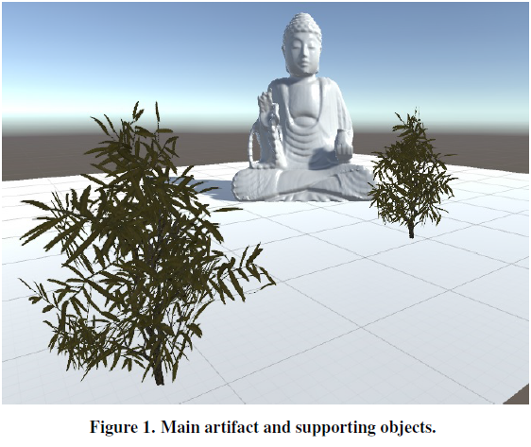
Figure 1. Main artifact and supporting objects

RELATED WORKS

Museum Limitation
Limitations in exploring a museum are obstacles often experienced by visitors [16]. In artifact study, sometimes it requires detailed observation, repeated process and a longer time to study, in other words to be immersed in the observations [3]. With the dawn of three-dimensional computer generated modeled museum space, a 3D stereo environment allows artifact’s observers to get more time to make virtual visit [4]. Several Museums try to present its content in a digital form and make it available in virtual environment [5]. A breakthrough to overcome museum limitation done by providing a 360 panoramic view for a virtual tour [9].

Virtual objects preparation
Initial preparations for displaying various artifacts into stereo 3D environment done by reconstructing them to virtual form through the acquisition process. The process varies, i.e. structure from motion [10], deformation graph-based processing [17] and other methods. One way to acquire 3D model of artifact is using calibrated 3D scanner, a point cloud created as a result of scanning process. These points bond together to form a mesh. The mesh covered by texture, to give a real impression of how the 3D model looks in real form. Mesh collection need extra finishing touch to cover up cracks and holes using specific algorithm. Finally, all of them are uploaded to the cloud computing server which provides 3D model generator [15].

Avoiding simulator sickness
Developing a 3D stereo application for Google Cardboard, if not carried out by specific provisions, the application as a result from this process, can lead to impaired balance in the brain. Several signs are: headache, pain in the eye, and could even lead to vomit. Some of these have been studied before and used as inputs for 3D stereo application developers [6, 8]. There are guidelines to create comfort for users of 3D stereo applications as follows: 1) not replace the lighting in the 3D stereo environment when the application is in use 2) not give a drastic movement of
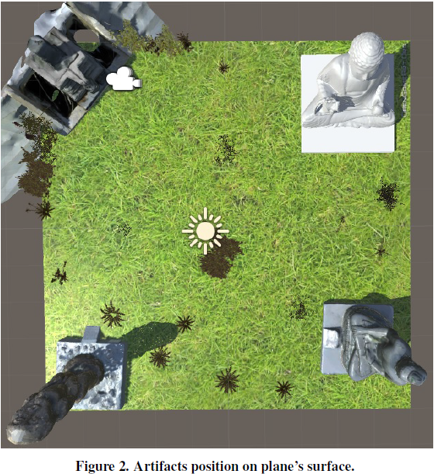
Figure 2. Artifacts positions on plane’s surface
turning in the virtual environment. 3) The user should be in a state of sitting while using 3D applications, 4) adjustment of the lens’ distance to the observer's eyes should be taken to prevent nausea (a feeling of sickness with an inclination to vomit). So the impairment to the brain is evaded.

Free tools
The development and use of 3D technology is supported by many free tools, for-example the use of UNITY3D, simplifying the game development process. The simplicities in this free tool motivate the young generation to increase their productivity in developing 3D games [7]. Another support in providing approach for game programming is offered to the educational world. It provides easier task to help the game developer [14].

Eyesight position
Stereoscopic camera must be at a perfect distance from the observed, because it will affect several things: comfort in view and stereoscopic effect. The correct position of both eyes (camera) is a crucial step to do a more natural human-computer interaction which diminishes visual fatigue [1].

User experience
Optimization of an application, either a 2D or 3D stereoscopic application, needs feedback from users. Feedbacks in shape of user experience and usability are important things to improve products. If we want to know whether the design of our product meets the need of end-user, then we can offer a prototype product test to them [12].

User perception
In an interactive exhibit, a model of a large city is presented in digital form. Curators, observers and visitors suggest some improvement. It varies from a simple suggestion to a complicated one. There are no limits of perception [13].

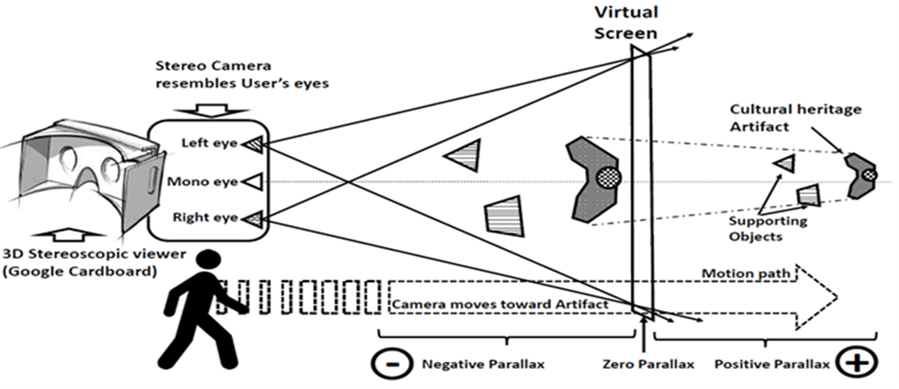
Figure 3. 3D Stereoscopic viewing mechanism of ‘walking” user wearing Google Cardboard

3D STEREOSCOPIC ENVIRONMENT PREPARATION

3D Technology and Head-Mounted Display
There are two categories of 3D viewer technology, active and passive. The first one using shutter system. This system works alternately, displaying the image for the left eye and shut the view to the right eye, and vice versa. This process is performed repeatedly at very high speed, thereby creating a 3D perception in the brain. The second one uses several systems such as: Polarization, interference filter, color anaglyph, chroma depth, pulfrich and over under system, both systems used Head-Mounted Display. There are many Head-Mounted Display (HMD) on the market. It varies based on technology and price. Google-cardboard is one of inexpensive HMD.

Stereoscopic Environment
There are several options to prepare a 3D virtual environment. The simplest way is preparing a flat plane, place several main artifacts and supporting objects to give depth impression. Second way is to imitate artifact placement inside museum building. In this situation, all rooms which are filled with artifacts should be arranged relatively more in detail compared to the first option. The main intention in creating this 3D stereoscopic environment is to bring visitors immersed in the environment. The first option is chosen because its simplicity.

3D Model placement
In this scenario, a plane with 10 unit width and 10 unit height is prepared. Four artifacts are ready to fill in the plane. Each artifact placed near each plane's corner. Several supporting objects such as bushes, shrubs, weeds and trees placed within plane's space. These objects are meant to give a depth impression for viewers while they are exploring the 3D stereoscopic environment.

Stereoscopic Sight and Camera movement
Stereo-camera is a pair of identical camera, it resembles the exact position of human eyes, and creates a side-by-side visualization from a scenery. Scenery sets in 3D environment are ready for stereoscopic exploration. A visual aide device needs to explore the scenery. There are many options of this visual aide available, one inexpensive choice is Google Cardboard. There are three modes which the viewer can enjoy the scenery: namely 3D movie, semi-interactive and fully interactive.
In a 3D Movie, viewers are in a passive state, sit down, relax and just enjoy the film. In Fully interactive mode, such as games, viewers or players have full control on when to act or where to go in the scenery. While in semi-interactive mode, the viewer flies through a predefined path, following camera's movements, and still has the ability to look around or backwards. Camera movement will mimic viewer's eyesight, traveling from a fixed position toward an artifact. On some points, the viewer will experience a depth perception state.

Parallax view
There are three parallax views which are created as a result of camera's movement along the path. First is positive parallax; a state where the observing object is behind virtual screen. This state means that the observer's eyes view all objects with no depth perception. The second is zero parallax. This is the border between positive and negative parallax, namely virtual screen. Virtual screen is a point where the observer's sight move from positive to negative parallax, as shown in Figure 3. The Third is negative parallax. This state means that the observer's eyes can see depth perception and get a strong impression of stereoscopic view. However, the negative parallax state should not be too long because they can result in eye fatigue.

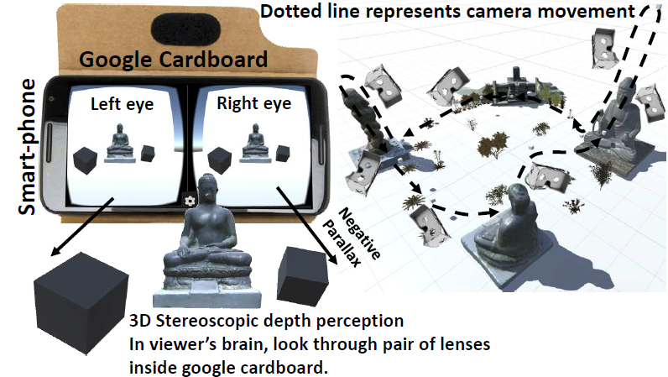
Figure 4. Depth perception and camera movements

Motion path
Motion path is created to give a fixed way for the viewer's virtual movement. This path starts from a position in front of an artifact. The path travels along the scenery, until all artifact are visited. On some prepared points, camera movement towards artifact turn extremely to give the viewer more impression. The extreme turn’s adjustment depends on artifact point of interest. There are parts of artifacts when seen from such an angle can give some impression to the viewers. Therefore, a specific extreme turn has to be made towards those parts.
Several cultural heritage ancient artifacts are prepared in 3D model. These are the main objects to explore. There are four artifacts namely: Primitive, First and second Buddha, and Linggageni(it is a symbol of fertility in Indonesian Cultural Heritage). All of these 3D model artifacts will be accompanied by supporting objects. These supporting objects are essential to add depth impression for viewers in observing the artifacts. These objects are placed in front of an artifact, a little bit to the left or to the right, and should not block the camera movement. It has been arranged in a specific way, so these objects will not look more interesting than the artifacts.

IMPLEMENTATION AND DISCUSSION

Application work-flow
This application development consists of six phases. In the first phase, several 3D model of artifacts prepared from a related research [15]. These main objects are placed orderly on a plane and facing the camera. All main objects are already rendered in advance, complete with their original textures. Therefore, they can give a nearly similar appearance to the real object in the museum.
In the second phase, we use Unity3D personal edition to setup the 3D environment. Equipped with lots of free assets, supporting objects are available. A little bit of the touch of nature resembling, several shrubs, weed, bushes and small trees are chosen as supporting objects.
In the third phase, a plane size 10 by 10 unit is placed as a ground floor for all main and supporting objects. The plane is then covered by a grassy texture and all four main objects are placed around each plane's corner as shown on Figure 2. The main object height varies from 3 to 4 unit, and width from 2 to 5 unit.
In the fourth phase, Google cardboard camera package imported from its official site; by using this package, developers can shorten the procedure in preparing stereo camera pair, side-by-side stereo rendering and many features come with this package. After importing the package, an asset called Cardboard-main placed on a start position, facing to one of the main objects, hover about one unit high from the ground.
In the fifth phase, a path consisting of thirteen points, start from one unit in front of the camera, to the first main object, climbing up and down leaving it and moving to another main object, traveling along the scenery.
In the sixth phase, a container (invisible object) which will be a host for the camera is created. This container embedded with an auto-move script using C#, and all thirteen points sequentially added to it, creates a movement path for the camera, as show in Figure 4. Finally, several test are taken to make adjustments on how fast the virtual tour take place. In this application we use 0.125 unit per second for turn speed and 0.25 unit per second for move speed.

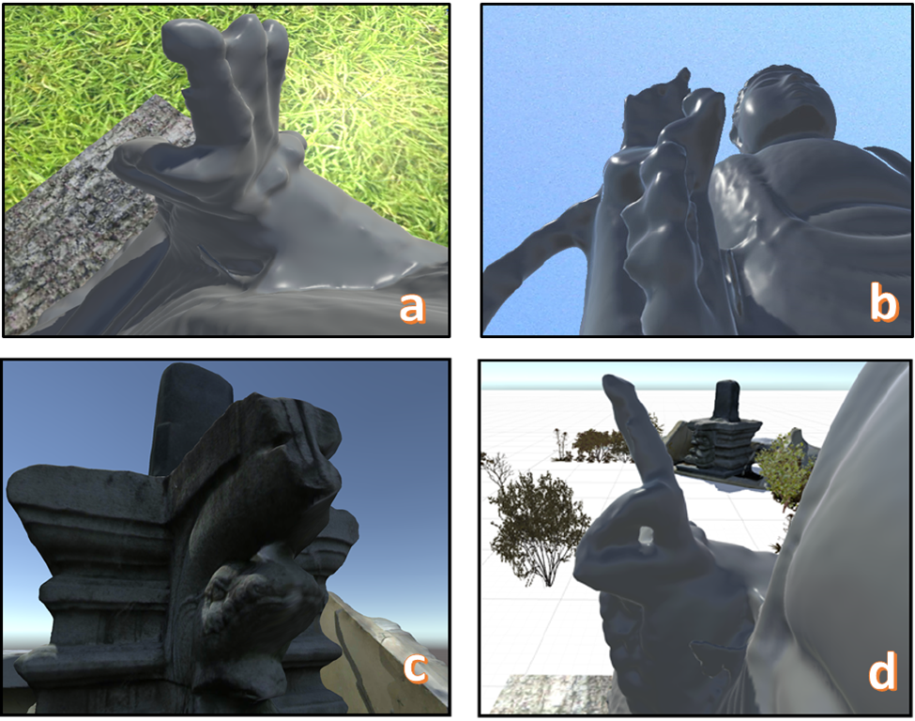
Figure 5. Depth perception

Deploying to smart-phone
When the application is ready, deploying to smart-phone is the next step. Smart-phone must have a gyroscope sensor, allows the user or viewer to look around to all direction while the camera moves along the path. It will make viewer feels like flying in the air and sees what left behind, scenery on their left or right or down below, and still move forward to next main object. Before deploying process there are smart-phone screen size selections i.e. 4.5" or 5" or 5.5" or 6" available, developer can make a selection suitable for specific smart-phone. An Android SDK is also needed for the build process. There are three types of Google cardboard that are worn by several users to test the application. First is Google cardboard bought from local computer accessories store, it cost Rp. 22.900, (it's about \$US 1.63), the second one cost Rp. 29.600, (it's about \$US 2.11), the third one not from cardboard but hard plastic with adjustable lens to widen or tighten the distance within the lens. We differ the term cardboard and plastic-board, because the head-mounted display made from plastic has an adjustable lens position. The lens position is for screen size 3.5" - 4.7", 4.7"- 5.5", 5.5" - 6" and it is cheap, about Rp.112.000 ($US 8).

User evaluation and perception
We collect some suggestions from several colleagues who tested the application using Google cardboard. Eye fatigue and nausea happened within 10 seconds while watching or viewing the application using first two cardboard. They are more convenient in using the plastic-board viewer, because it has the adjustment switches for widen the lenses, and the lid where smart-phone are clamped into is also adjustable. It gives a good focus to the user’s eyes and prevents eye fatigue. Nevertheless, it was also noticed that they were interested in the experience on how they feel like flying through from one main object to another in the 3D environment. Using the third plastic-board viewer, they can enjoy the virtual journey.

Exploring the scenery
Depth perception refers to the viewer's eyes ability to focus-in on artifacts and calculate about how far it is. Before reaching a main artifact, viewers will pass by several supporting objects such as shrubs, bushes or small trees. There are at least two supporting objects stand before the artifact. Camera's default moving speed, which is 0.125 unit per second, increases the user’s depth perception.
On some point, there is a sub path designed to climb up a statue. It is prepared to give viewer a sense of freedom in exploring an imaginary huge surface. The flying path moves over the top of the statue, facing the empty sky, and suddenly turns back toward the statue, sliding down on its surface. For a couple of seconds, viewer will see the statue's right hand closer and getting bigger as shown on Figure 5a. Within this moment, they can look around or backward and see the head of the statue shrink down as shown on Figure 5b. The exploration continues, approaching the next statue, while viewer fly through predefined path. Several depth perceptions appear on their left or right side as shown on Figure 5c and Figure 5d. These experiences correlate with one perceptual principle of human computer interaction that is make display legible, the legibility of a visual device reaches its best when it can give the most important information to the user.

Focus adjustment
When using the plastic-board viewer, the lid where the smart-phone is attached needs adjustment by the user, they can push it for about 2cm away from the lenses to get a perfect focus. The adjustment varies among the users. By default, with a closed lid, the user gets a blurred image from the screen and make the user dizzy. Users with glasses do not need to adjust the lid, possibly the mix of their glasses with Google-cardboard lenses and the distance to the smart-phone screen give’s a perfect focus.

Additional features
After exploring the scenery, users are asking for several changes to be added in the application. They need a control of which they can start over from specific point and not wait until the path is explored. Users also wants wider scenery, not only 10 by 10 but wider. It needs to add another 3D model of cultural heritage, it can be done by using terrain to replace the plane and adding wind to make the vegetation look alive. A description near the artifact is also important, so it helps them to know a brief story about the artifact they are gazing at. One additional feature is also requested; it is a background of a soft instrumental music or natural sound that can give comfort in immersing the environment.

CONCLUSION AND FURTHER WORKS
The main goal of 3D stereoscopic cultural heritage ancient collection application is to improve museum facilities. With the existing of this application, the museum will be no longer a sacred place, it can offer joy and pleasure to the younger generation, and it becomes real with the support of 3D Stereoscopic technology and Google-cardboard. The application will help students, observers and researcher or any visitors make a detailed observation and study from ancient collections without damaging the original one. In this way, the young generation can learn the cultural heritage using their favorite equipment. Hopefully, this will increase the enthusiasm and interest in learning, especially culture heritage through the museum. This application is just the beginning of improvement of learning facilities at the museum. In the foreseeable future, we are planning to develop more applications which is more interactive, spacious and more artifacts are included. This will offer a new learning experience, where museum visitors can walk in the virtual world containing cultural heritage.

ACKNOWLEDGMENTS
This study is supported by Human Centric Computation and Visualization Laboratory in Multimedia Network Engineering Department - Institut Teknologi Sepuluh Nopember, Surabaya Indonesia. Special thanks to Ir. IGN Made Soetedja.MM for providing several books about museum design.

REFERENCES
- M. Chessa, M. Garibotti, G. Maiello, L. Caroggio, H. Huang, S. Sabatini, and F. Solari. 2014. Detection of 3D position of eyes through a consumer RGB-D camera for stereoscopic mixed reality environments. In 3D Imaging (IC3D), 2014 International Conference on. 1–8. DOI: http://dx.doi.org/10.1109/IC3D.2014.7032592
- R. Damiano, V. Lombardo, and A. Lieto. 2015. Visual metaphors for semantic cultural heritage. In Intelligent Technologies for Interactive Entertainment (INTETAIN), 2015 7th International Conference on. 100–109.
- F. Gabellone, I. Ferrari, M.T. Giannotta, and A.Dell’Aglio. 2013. From museum to original site: A 3d environment for virtual visits to finds re-contextualized in their original setting. In Digital Heritage International Congress (DigitalHeritage), 2013, Vol. 2. 215–222. DOI: http://dx.doi.org/10.1109/DigitalHeritage.2013.6744757
- M. Hayashi, S. Bachelder, M. Nakajima, and A. Iguchi. 2014. A New Virtual Museum Equipped with Automatic Video Content Generator. In Cyberworlds (CW), 2014 International Conference on. 377–383. DOI: http://dx.doi.org/10.1109/CW.2014.59
- B. Hemminger, G. Bolas, and D. Schiff. 2004. Visiting virtual reality museum exhibits. In Digital Libraries, 2004. Proceedings of the 2004 Joint ACM/IEEE Conference on. 423–. DOI: http://dx.doi.org/10.1109/JCDL.2004.1336227
- B Keshavarz and H Hecht. 2012. Stereoscopic Viewing Enhances Visually Induced Motion Sickness but Sound Does Not. Presence 21, 2 (May 2012), 213–228. DOI: http://dx.doi.org/10.1162/PRES_a_00102
- Sung Lae Kim, Hae Jung Suk, Jeong Hwa Kang, Jun Mo Jung, T.H. Laine, and J. Westlin. 2014. Using Unity 3D to facilitate mobile augmented reality game development. In Internet of Things (WF-IoT), 2014 IEEE World Forum on. 21–26. DOI: http://dx.doi.org/10.1109/WF-IoT.2014.6803110
- J.P. McIntire, S.T. Wright, L.K. Harrington, P.R. Havig, S.N.J. Watamaniuk, and E.L. Heft. 2015. Binocular Fusion Ranges and Stereoacuity Predict Positional and Rotational Spatial Task Performance on a Stereoscopic 3D Display. Display Technology, Journal of 11, 11 (Nov 2015), 959–966. DOI: http://dx.doi.org/10.1109/JDT.2014.2367161
- Muhdatin, I Ketut Eddy Purnama, Ahmad Zaini, Surya Sumpeno, and Dyah Kartikawati. 2014. Implementation of panorama 360 for virtual touring at Tugu Pahlawan Museum Surabaya. Theoretical and Applied Information Technology, Journal of 62, 3 (Apr 2014), 959–966. 10. M. Nabil and F. Saleh. 2014. 3D reconstruction from images for museum artefacts: A comparative study. In Virtual Systems Multimedia (VSMM), 2014 International Conference on. 257–260. DOI: http://dx.doi.org/10.1109/VSMM.2014.7136681
- N.F.M. Nusran and N.A.M. Zin. 2010. Popularizing folk stories among young generation through mobile game approach. In Computer Sciences and Convergence Information Technology (ICCIT), 2010 5th International Conference on. 244–248. DOI:http://dx.doi.org/10.1109/ICCIT.2010.5711065
- N.F.M. Nusran and N.A.M. Zin. 2010. Popularizing folk stories among young generation through mobile game approach. In Computer Sciences and Convergence Information Technology (ICCIT), 2010 5th International Conference on. 244–248. DOI:http
- Maria Rauschenberger, Martin Schrepp, Manuel PÃl’rezCota, Siegfried Olschner, and JÃ˝urg Thomaschewski.2013. Efficient Measurement of the User Experience of Interactive Products. How to use the User Experience Questionnaire (UEQ).Example: Spanish LanguageVersion. Artificial Intelligence and Interactive Multimedia, International Journal of 2, 1 (Mar 2013), 39–45. DOI:http://dx.doi.org/10.9781/ijimai.2013.215
- Selma Rizvic, Daniel Pletinckx, and Vensada Okanovic.2015. Enhancing museum exhibitions with interactive digital content: Sarajevo city model interactive. In Information, Communication and Automation Technologies (ICAT), 2015 XXV International Conference on. 1–5. DOI: http://dx.doi.org/10.1109/ICAT.2015.7340510
- P. Smith, T.P. Hartley, and Q.H. Mehdi. 2013. C SHARP interpreter and unity 3D for educational programming games. In Computer Games: AI, Animation, Mobile, Interactive Multimedia, Educational Serious Games (CGAMES), 2013 18th International Conference on. 41–47. DOI: http://dx.doi.org/10.1109/CGames.2013.6632602
- Surya Sumpeno, Moch Muhtadin, and Ahmad Zaini. 2015. Ragam Teknologi Infomrasi untuk REvitalisasi Museum. In Seminar Nasional Otomasi Industri dan Teknologi Informasi, Institut Teknologi Sepuluh Nopember ITS. 1–7.
- Ning Wang and Xukun Shen. 2013. The Research onInteractive Exhibition Technology of Digital Museum Resources. In Green Computing and Communications (GreenCom), 2013 IEEE and Internet of Things (iThings/CPSCom), IEEE International Conference on and IEEE Cyber, Physical and Social Computing.2067–2070. DOI:http://dx.doi.org/10.1109/GreenCom-iThings-CPSCom.2013.387
- M. Zollhofer, C. Siegl, B. Riffelmacher, M. Vetter, B.Dreyer, M. Stamminger, and F. Bauer. 2014. Low-Cost Real-Time 3D Reconstruction of Large-Scale Excavation Sites using an RGB-D Camera. In EUROGRAPHICS Workshops on Graphics and Cultural Heritage (2014). 1–10.

