Test management tools
Maven Tutorial

- Create New Maven Project
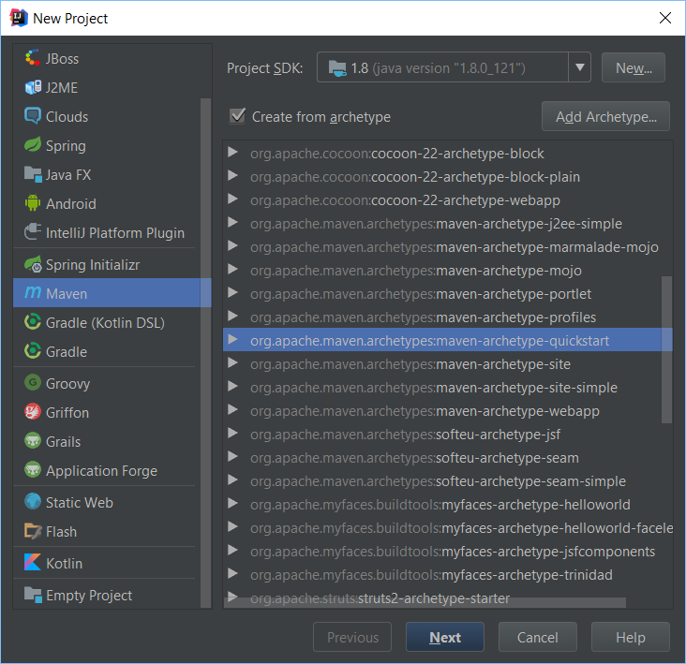

  - Add info: GroupId/ArtefactID

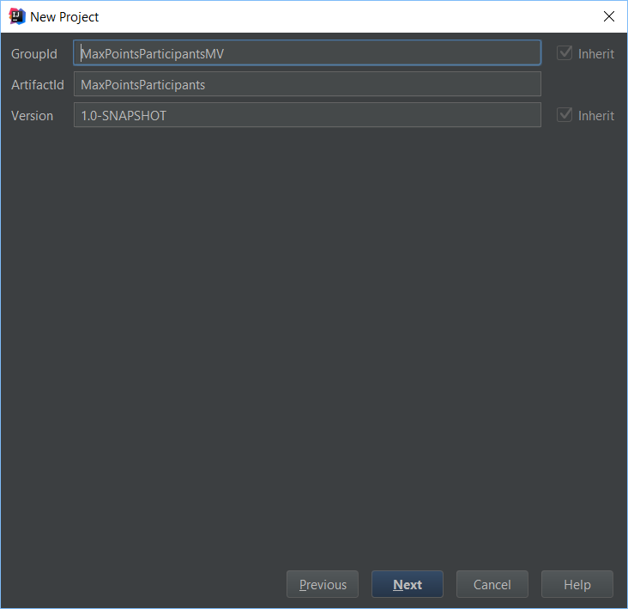

  - Add location
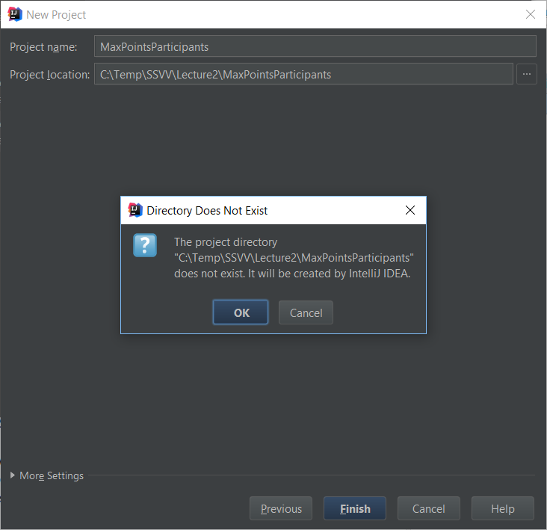

- The Maven project is created
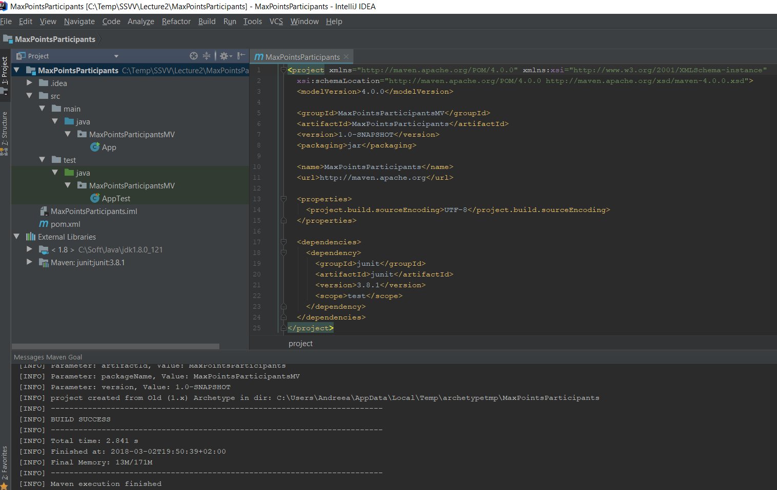

- Install the required plugins
  - Maven 2 Integration
  - Maven Test Support Plugin

- Add the required plugins to the created Maven project
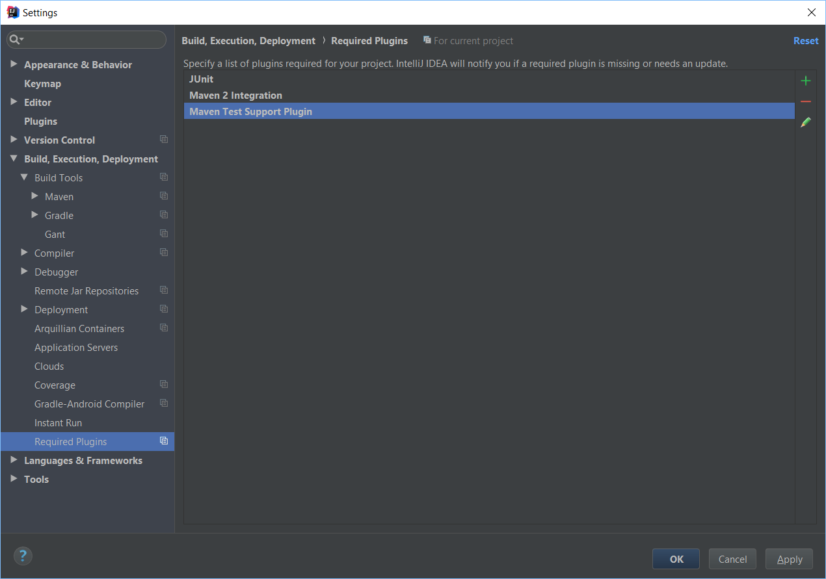

- Import automatically to the Maven project
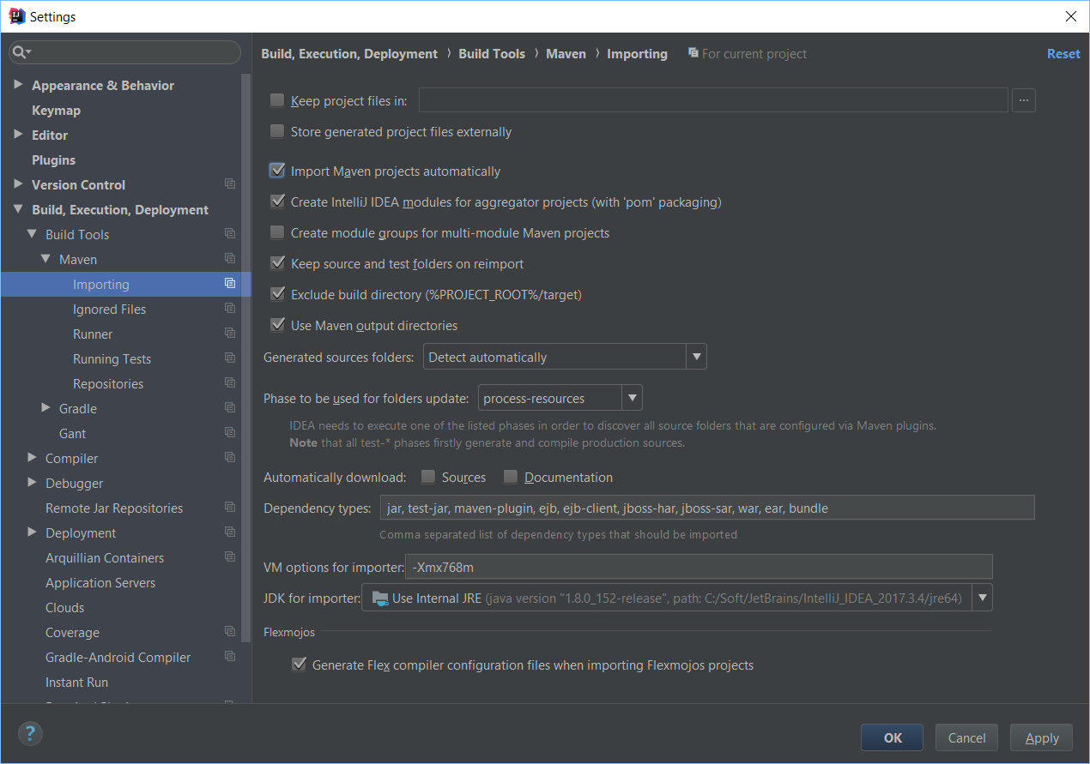

- Modify pom file by adding

<properties>
<project.build.sourceEncoding>UTF-8</project.build.sourceEncoding>
<maven.compiler.source>1.6</maven.compiler.source>
<maven.compiler.target>1.6</maven.compiler.target>
</properties>
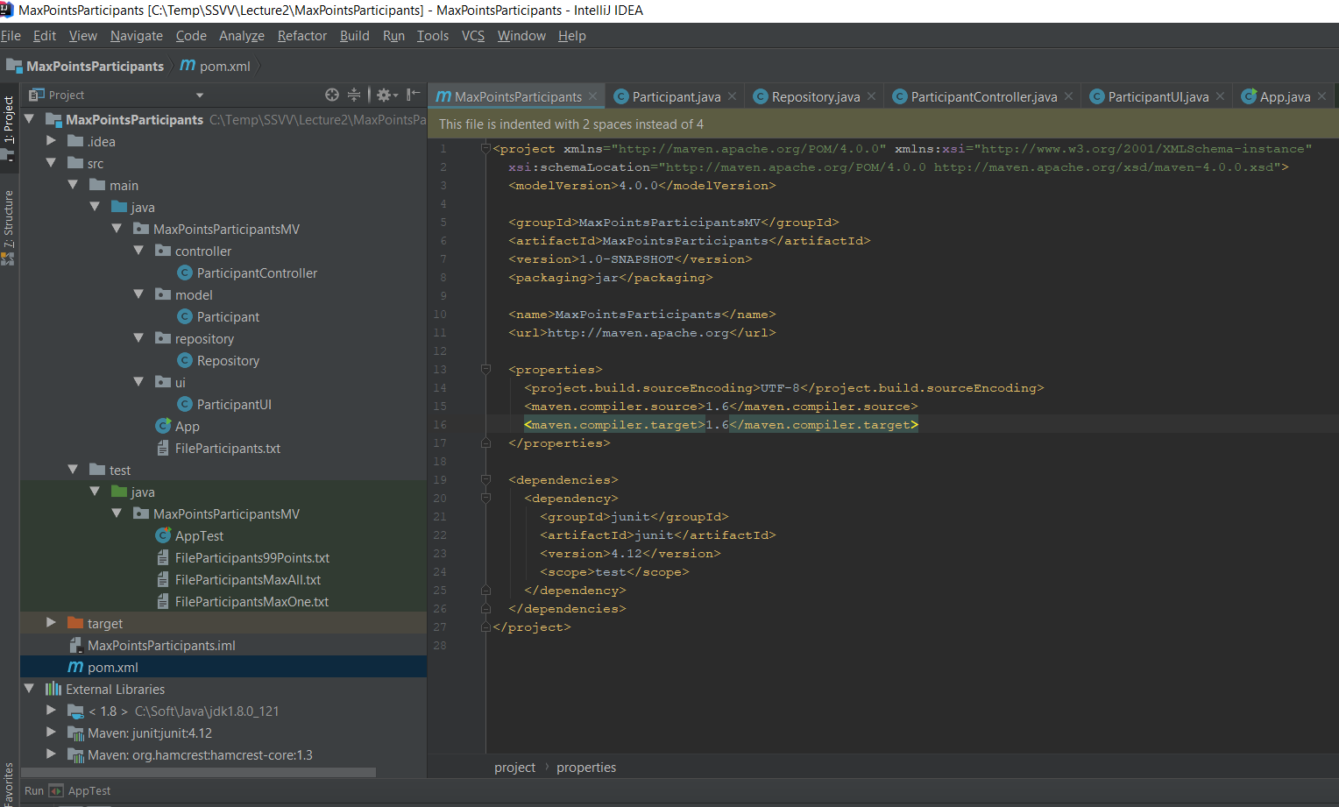

- Maven project to Github
