**ECM User Manual**

The User Manual for the Electronic Conference application. The User starts with the Login System interface where it either uses its existing account

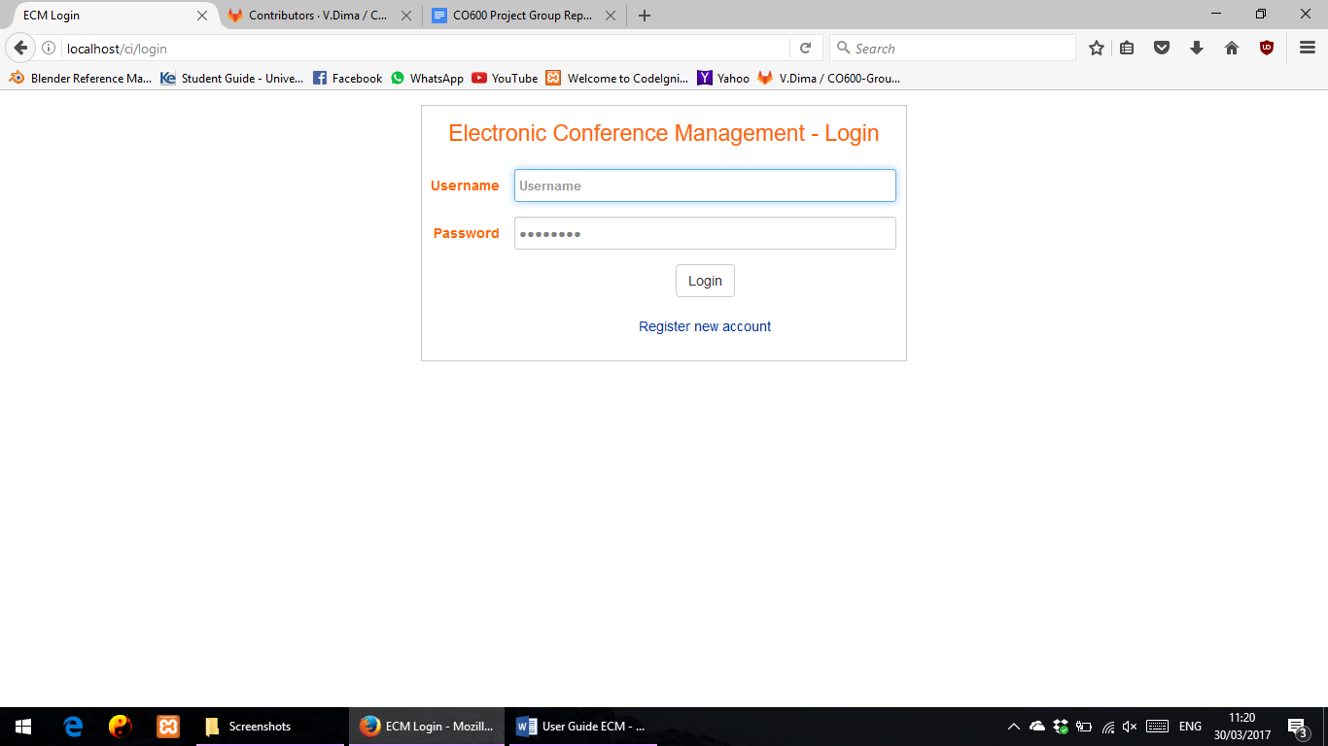

Or he can register a new account by clicking Register new account

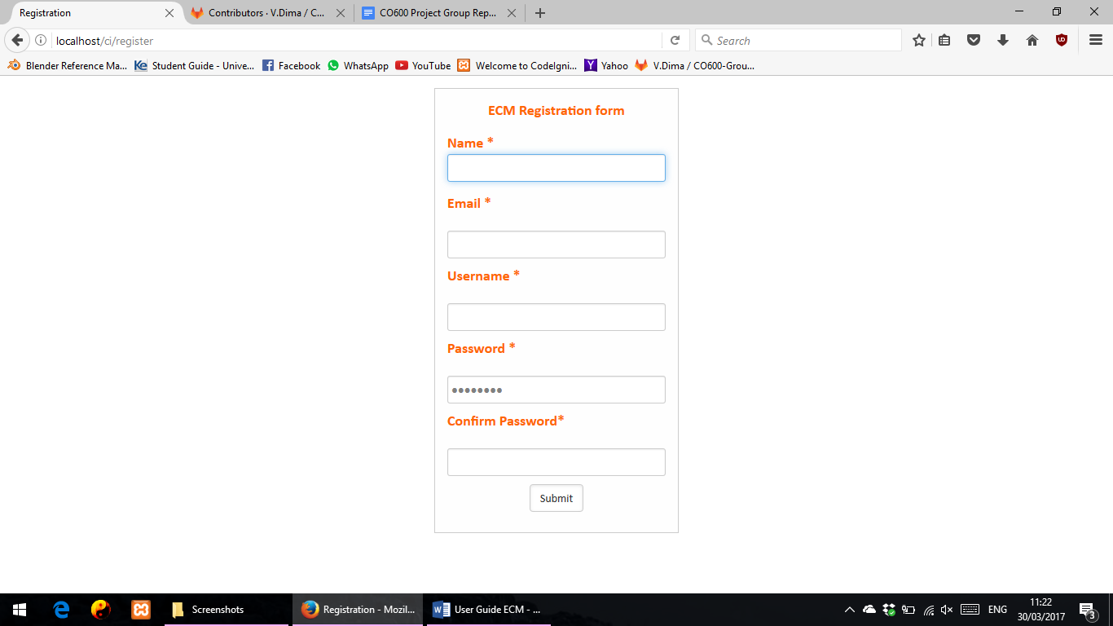

After the user credentials are met, he will reach the homepage

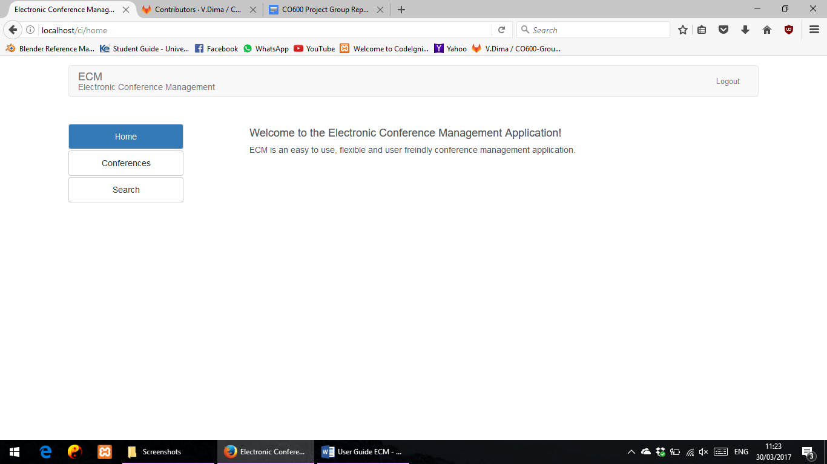

Where he will have the option of Creating a new Conference from the sidebar or manage a Conflict

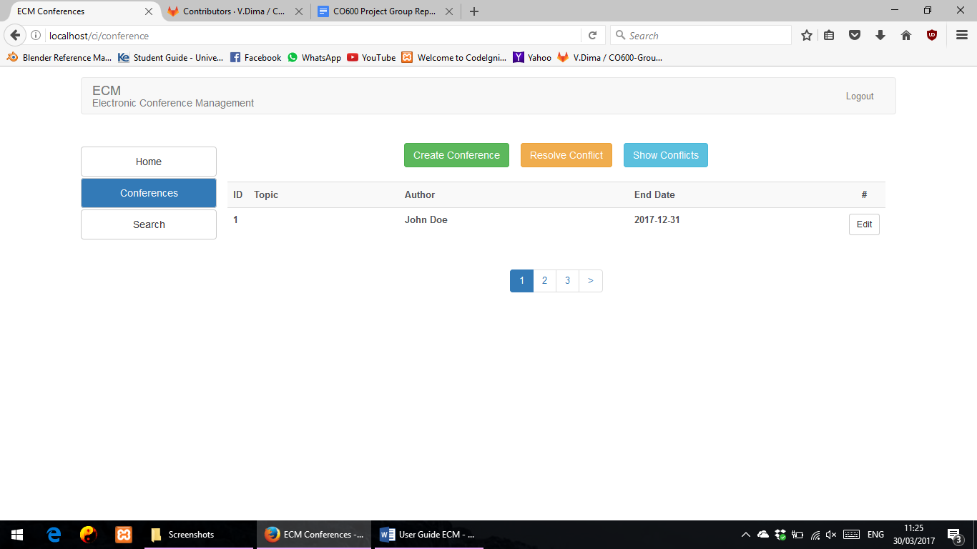

Once Create Conference is selected, the user will have to imput a Conference name and a end date for it

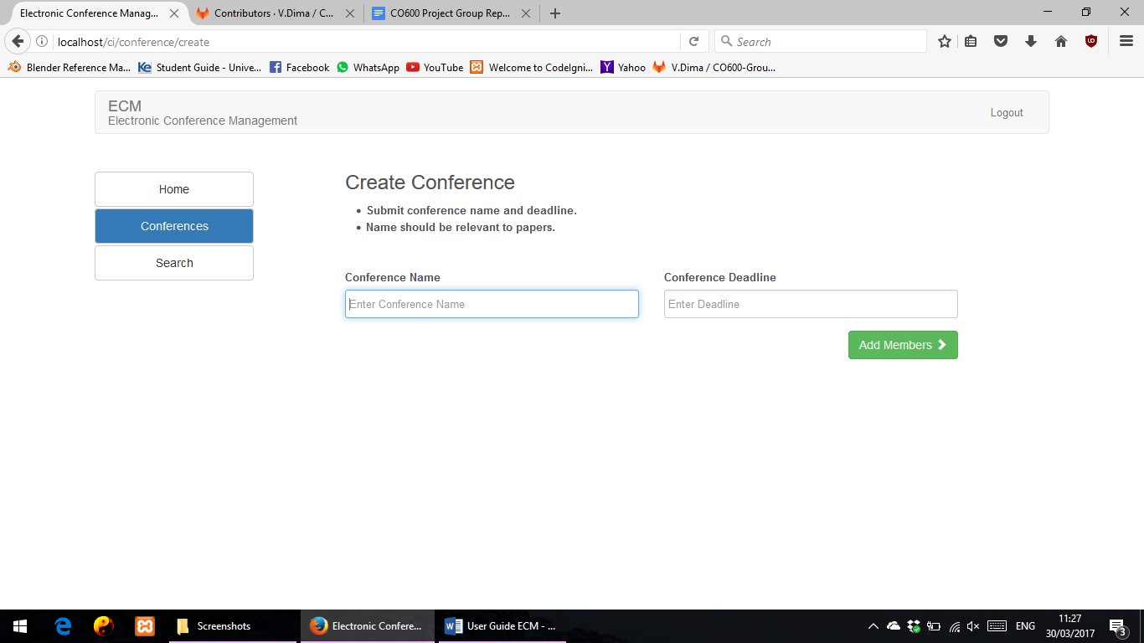

And then moves on to adding members to the conference and adding a Topic, submission deadline

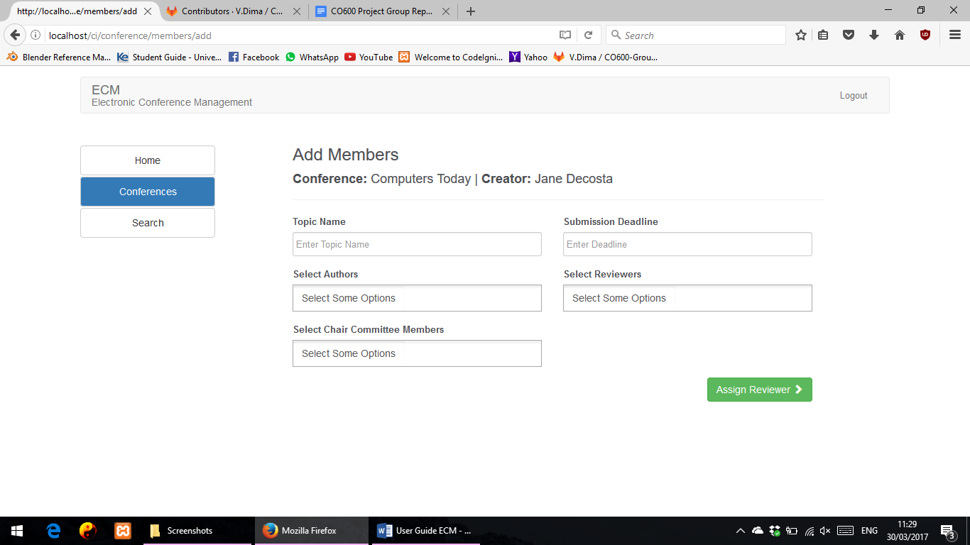

And moving on to assigning papers to the reviewers if papers have been submitted already

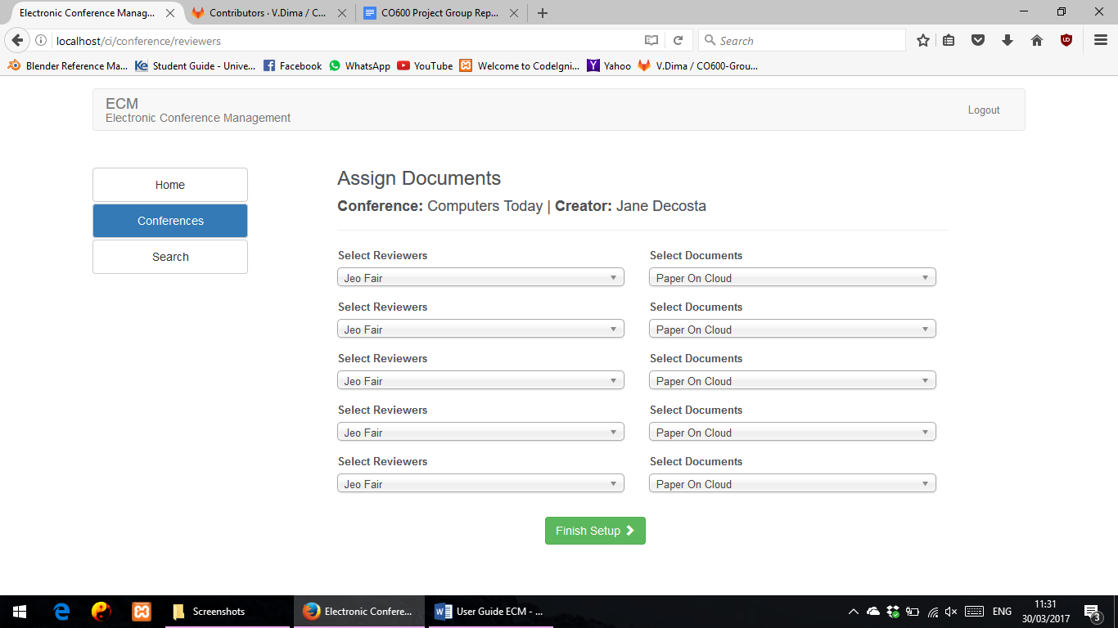

Another option would be to create or manage a Conflict

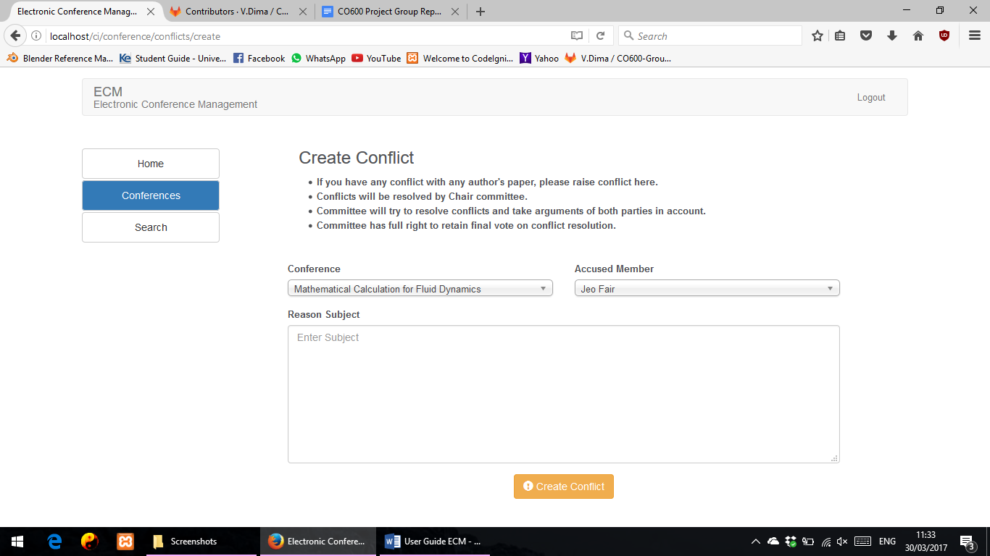

Or just see a list of the existing conflicts and try to solve them (chair role)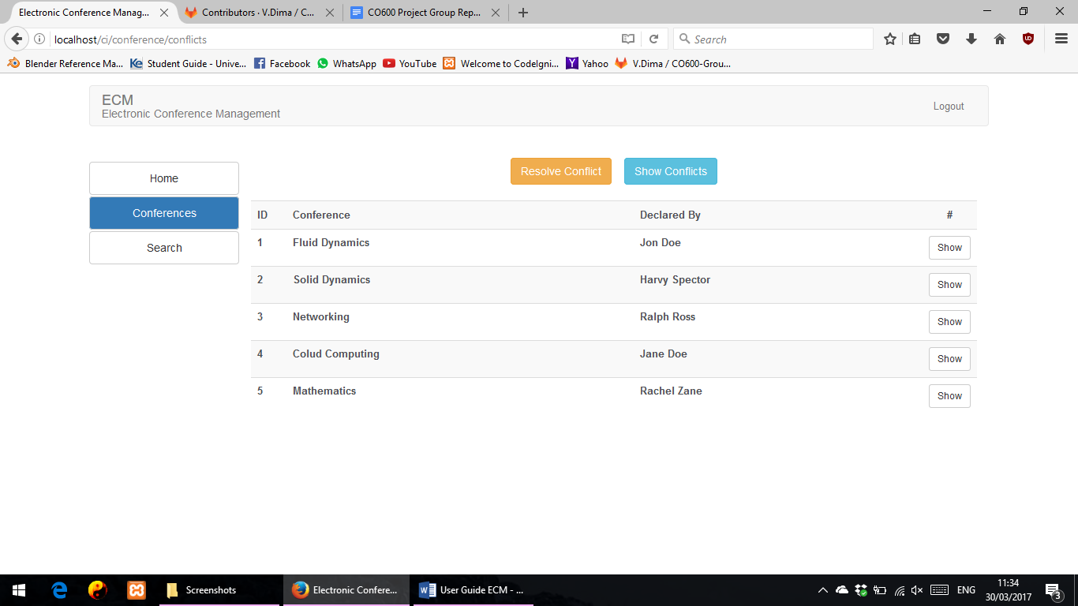

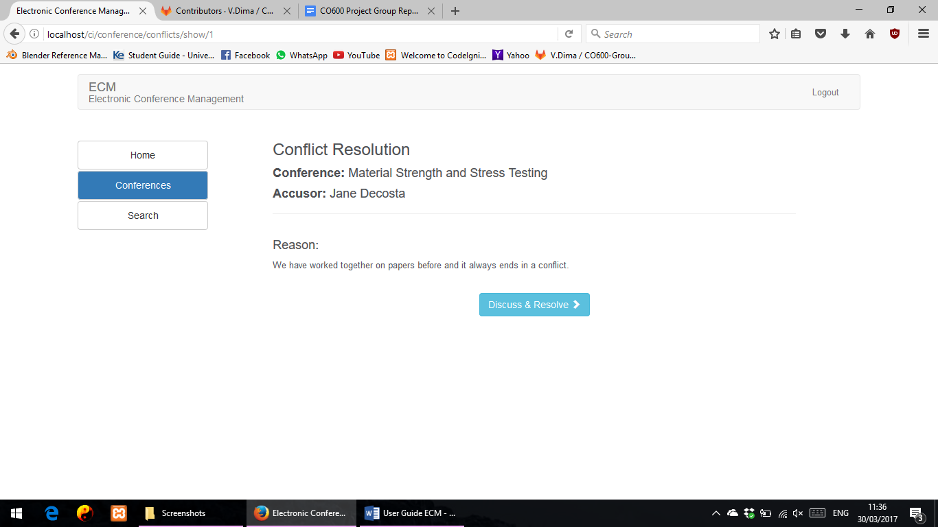

Another option from the sidebar would be to search the database for a list of usernames

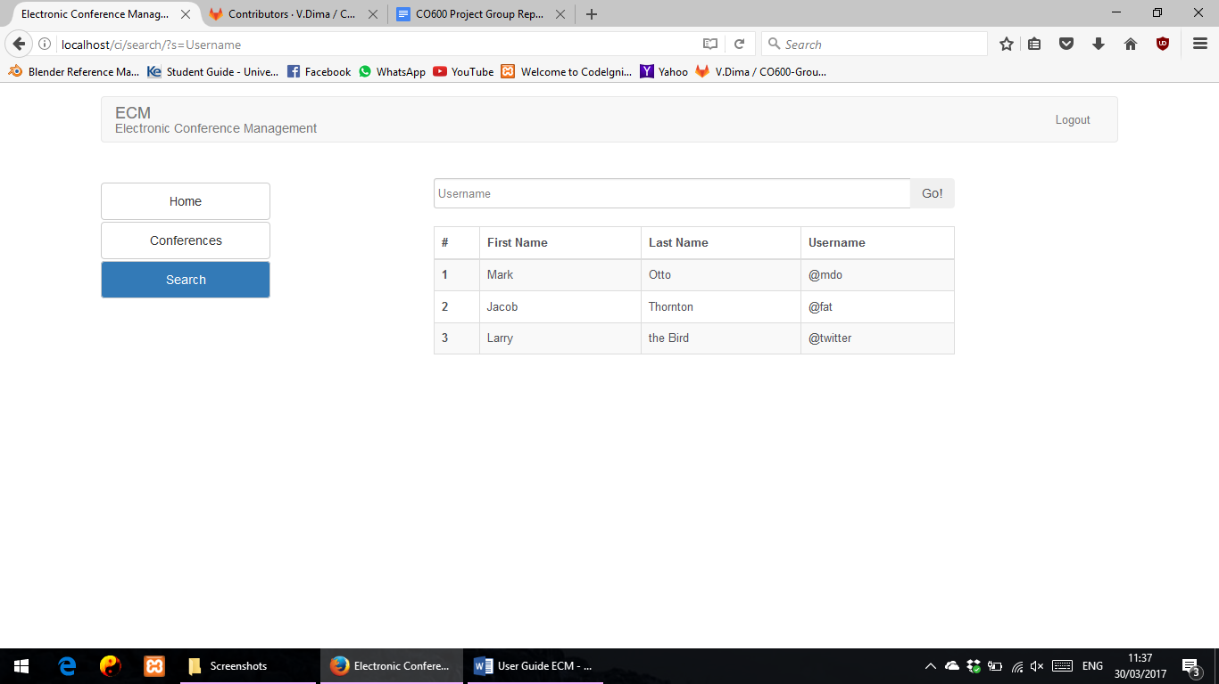

And once you have finished you work simply click Logout to keep your work safe.

