Configuration Management & Bug Reporting

The tool set for our management configuration and Bug Reporting will be GitLab. GitLab has several features that will enable us to create and develop quality software engineering projects.

Version control system with git will allow us to record changes of the file or set of files over time so that we can recall specific versions later, It allows us to revert files back to a previous state, revert the entire project back to a previous state, compare changes over time, see who last modified something that might be causing a problem, who introduced an issue and when, and more. Using a VCS also generally means that if we lose files, we can easily recover. In addition, we get all this for very little overhead. It also allows to view the file structure of repository with commit message, making it easier to browse through the files.

As communication on different topics, project related, if essential, we will be able to make use of the Wiki feature of the GitLab. This will allow us to create pages on multiple topics and give each other feedback on the work done step by step. The pages are linked with one 30/01/2016another and they are even linked with the commit messages and the issue tracking system, helping us discuss problems and finding solutions easier.

Just like any project, there will be different bugs along the way, in order to help on that topic, GitLab has a Bug Tracking System that will allow us to create a report about the bug and send it to the developer alongside with a tag that will keep the user informed about the progress of the report, as well as keeping other users informed about the problem being raised again. The bug reports are stored on the server classified with a status and severity.

Whenever there will be an issue within the project, we will be making use of the Issue Tracking System. Whether the issue is a bug report, a task, a feature request or support problem, any user can create an issue and assign it to a user, reassign it if needed and anybody can add comments to it, thus helping us organise our work more efficiently.

Here is an example of the Issue view from our project: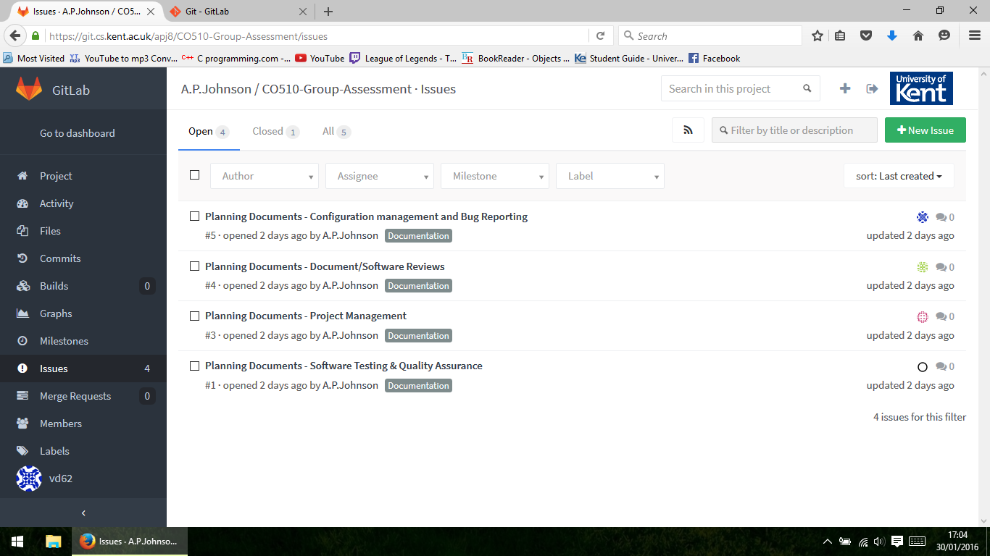

Update Stage 3

Since we had to start coding the app we decided to use the GitLab Merge feature to help us put everything together once everyone finished his work. This will allow us to divide our group work to all the project members and once we are done, upload the files into the repository and perform a merge request. There will still be issues to be fixed once the merge is done, but fixing them would be easier then reading each other’s code and deciding how to put it all together.

We continued making use of the Issues feature by assigning the new tasks to each of the group members and also closing the ones we finished in the previous stage.