1. npm init –y

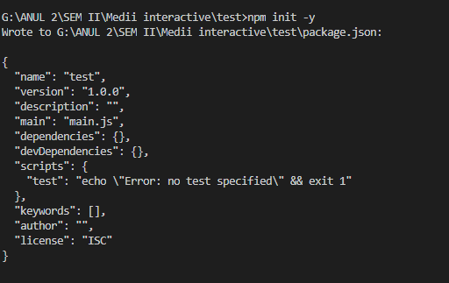

1. npm install bootstrap

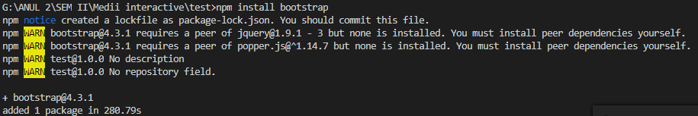

1. npm install ts-dependency-injection –save



4. git init

Echo “node_modules/” >> .gitignor

git add *

git commit – m “first commit”

5. npm install -g json-server

json-server –watch db.json

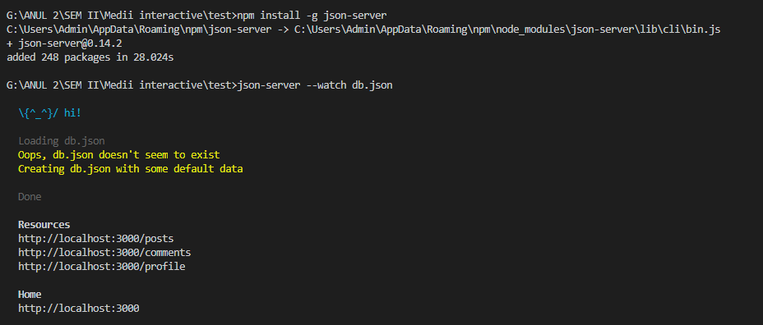

6.npm install –save-dev webpack

7. npm install --save-dev webpack-livereload-plugin

8. npm install --save-dev webpack-merge

9. uglifyjs --compress --mangle -- main.js

npm install --save-dev mini-css-extract-plugin