Orange Dot 6.0 - Regional Microdata

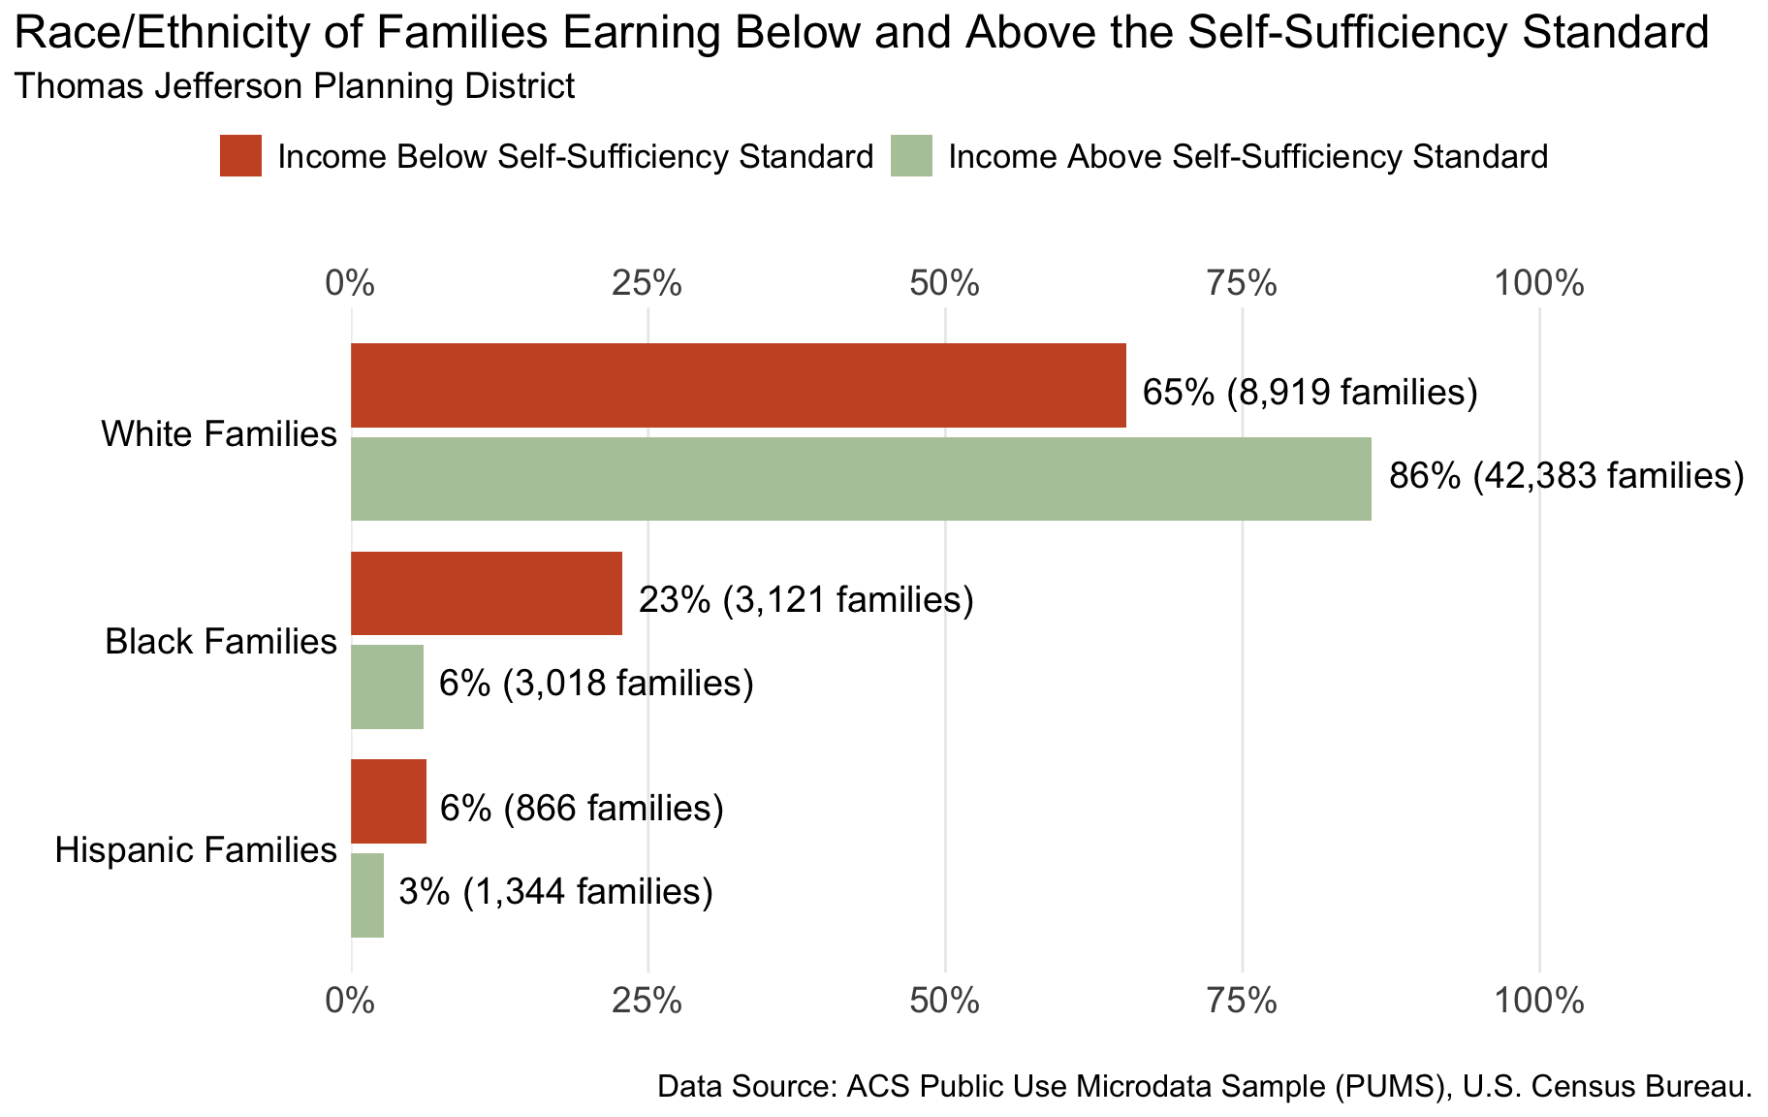

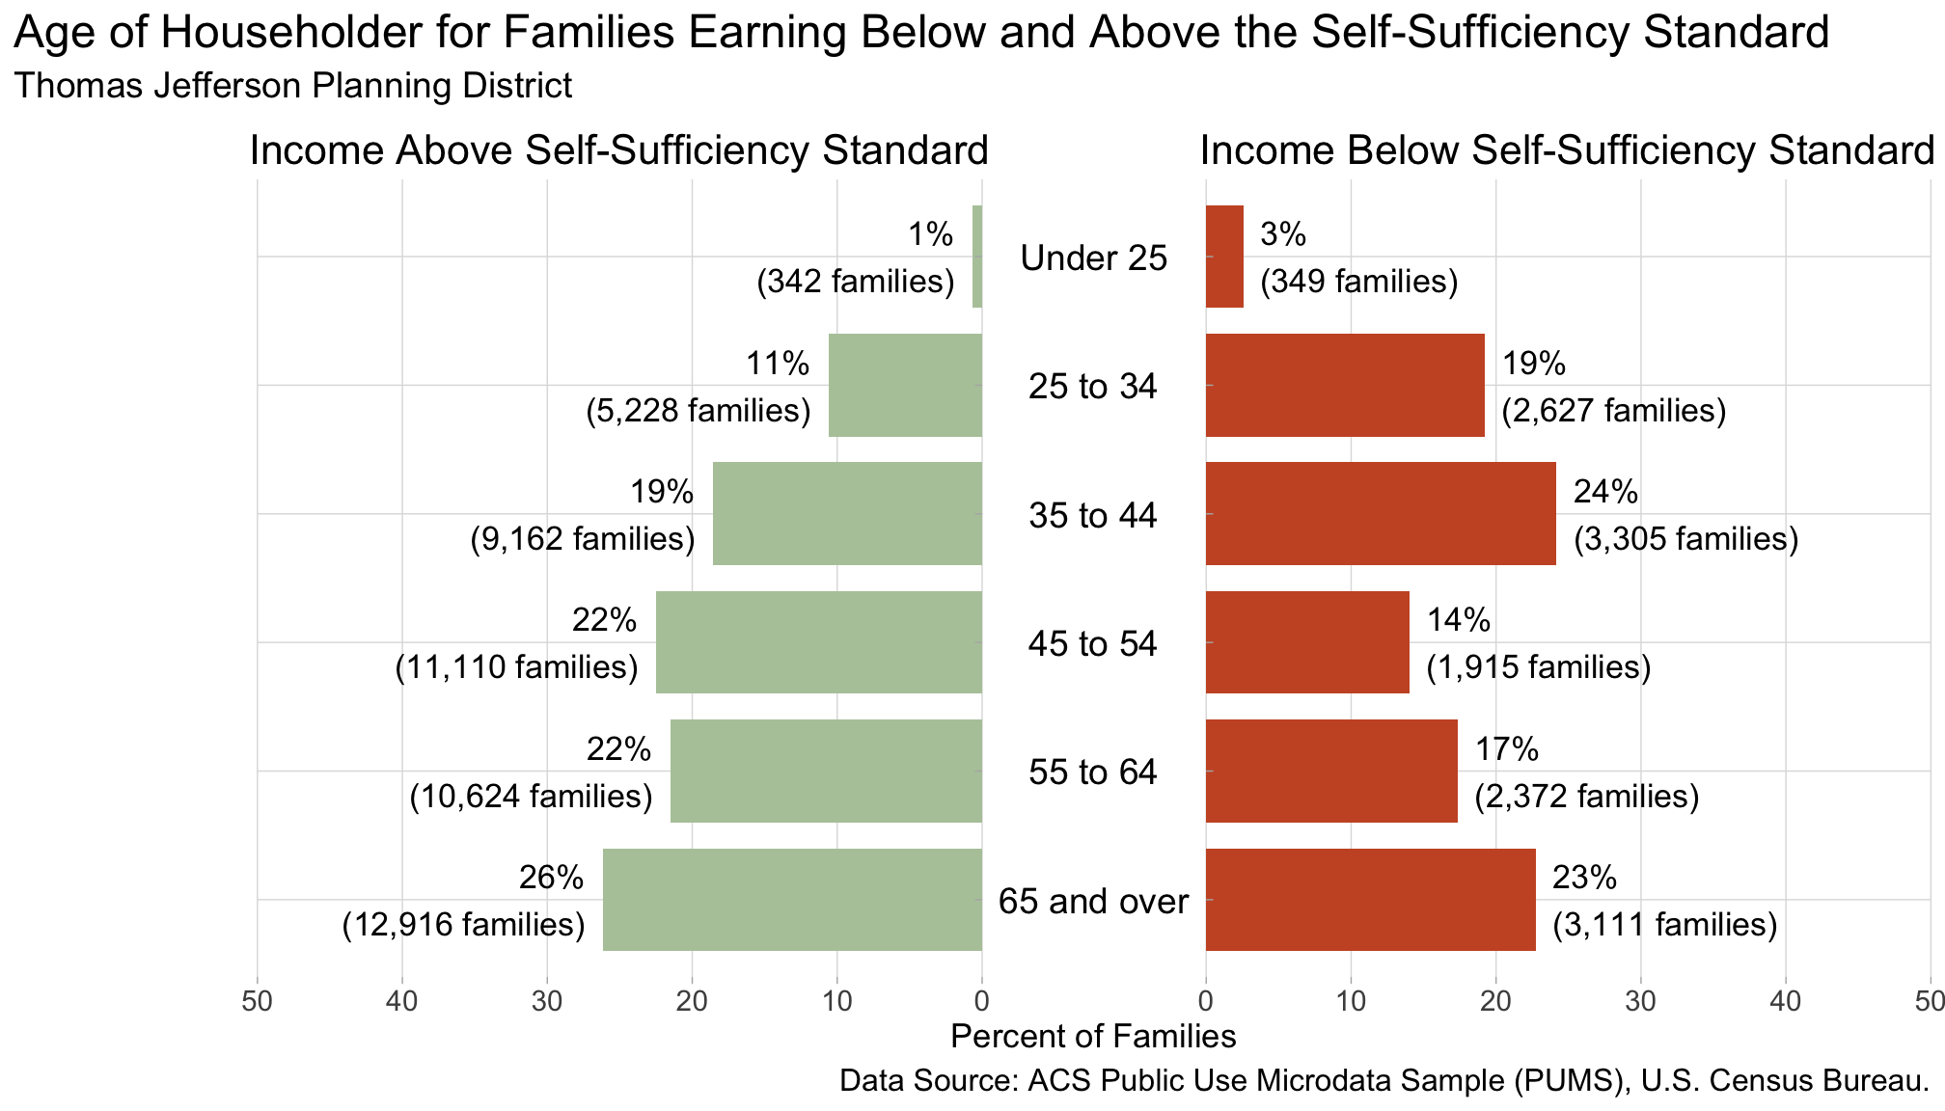

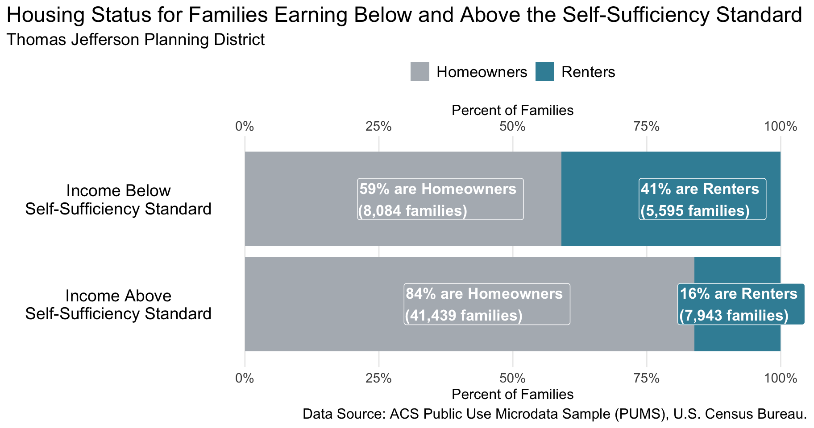

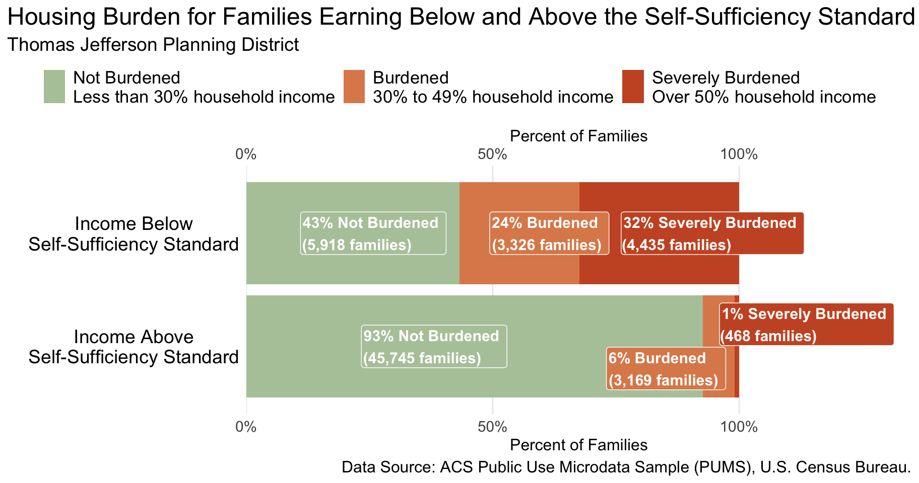

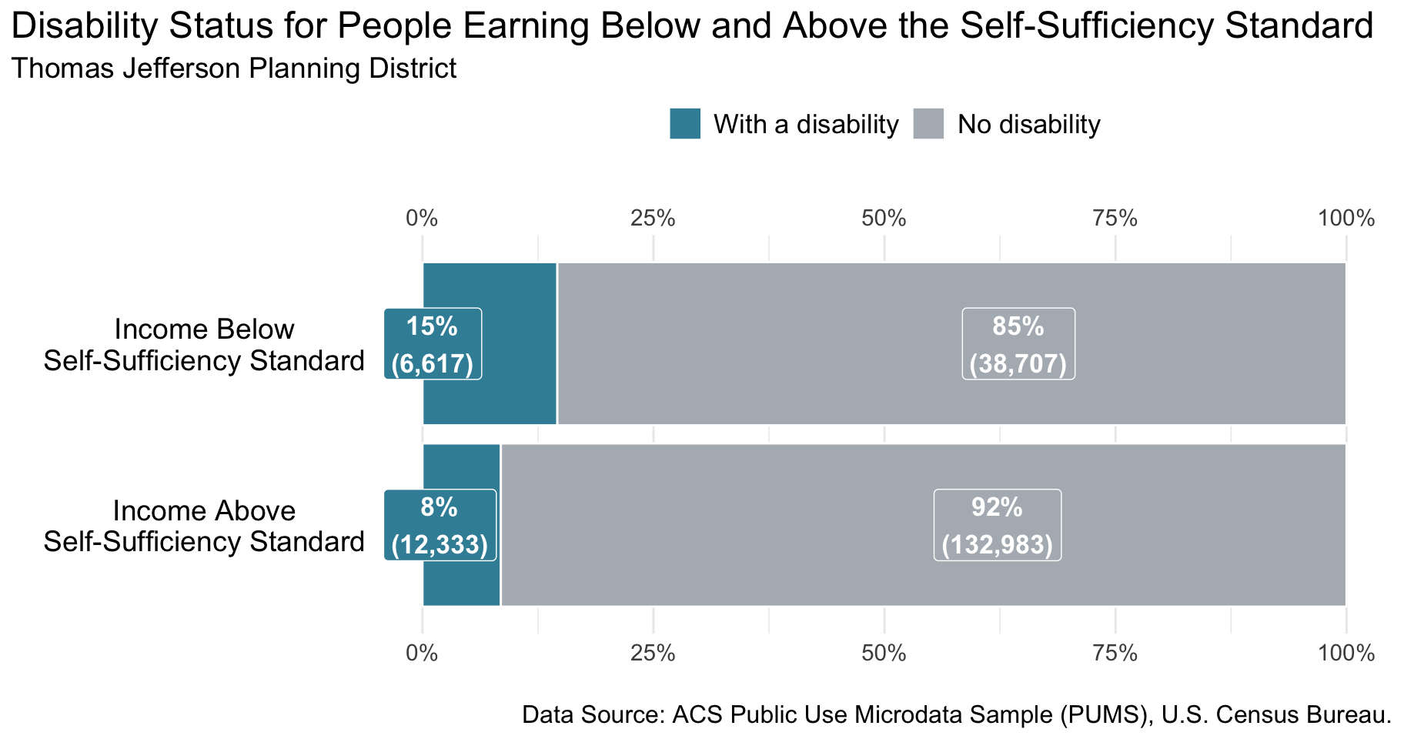

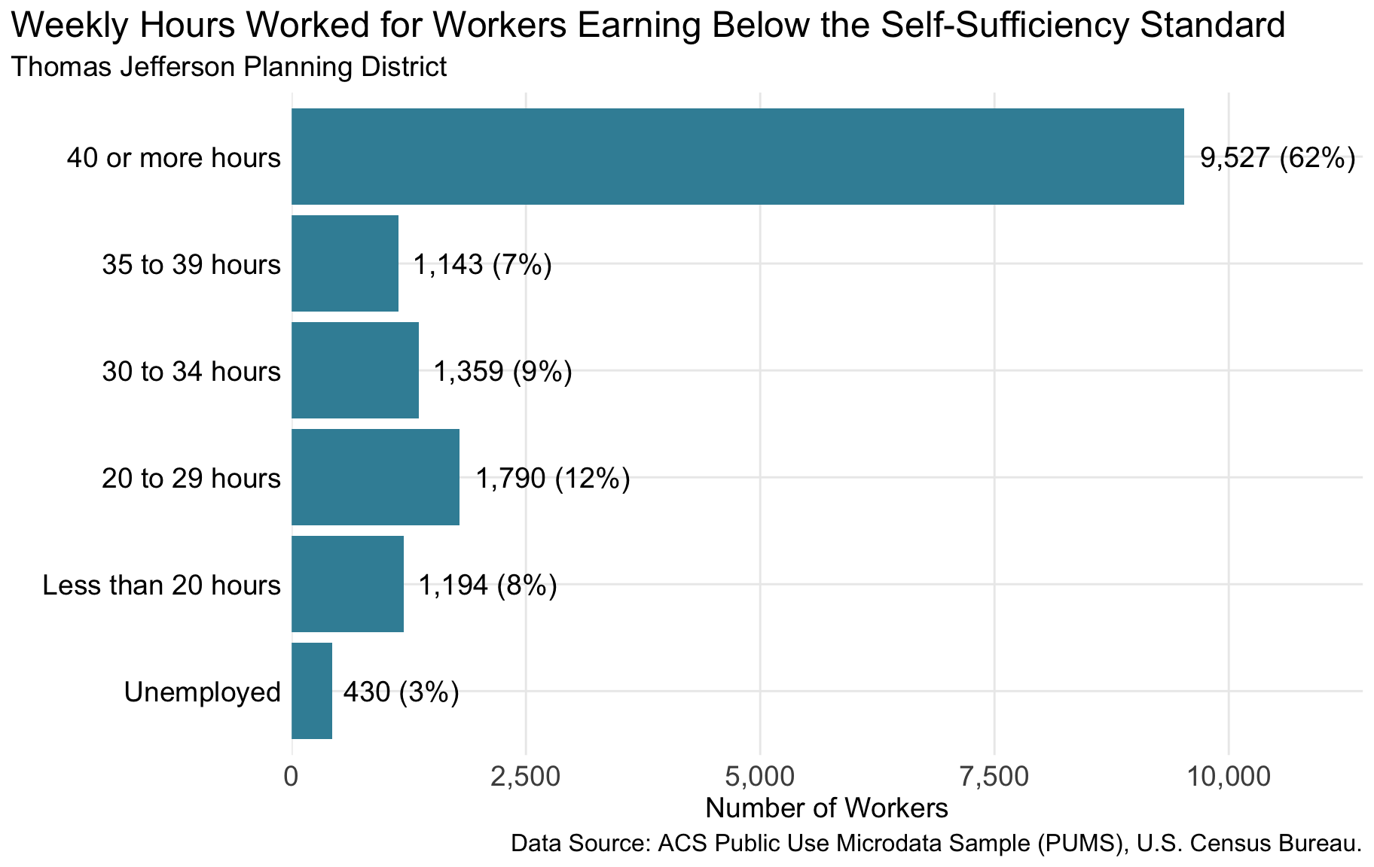

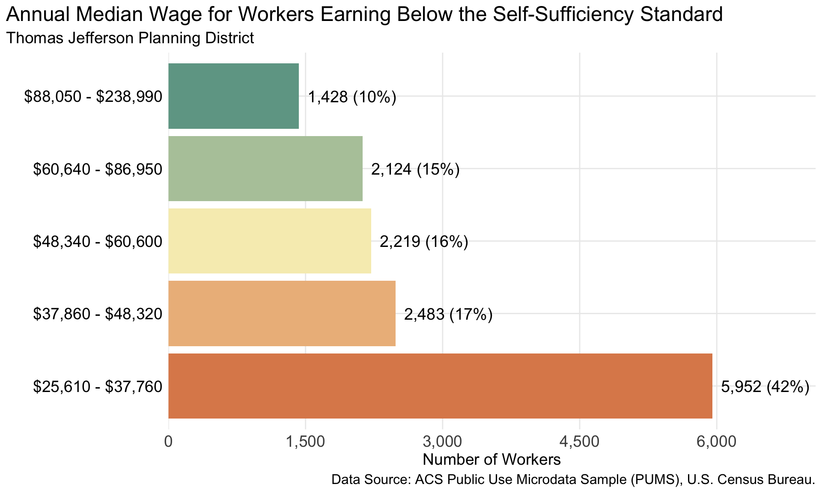

Table 1: Common Occupations for Job Seekers by Annual Median Wage*1*

| Occupation | Annual Median Wage |  | Employment Rate*2* |
| --- | --- | --- | --- |
| Home Health and Personal Care Aides | $26,720.00 |  | 16% |
| Cashiers | $28,580.00 |  | 21% |
| Fast Food and Counter Workers | $29,190.00 |  | 24% |
| Customer Service Representatives | $36,710.00 |  | 13% |
| Construction Laborers | $38,290.00 |  | 6% |
| Light Truck Drivers | $41,390.00 |  | 4% |
| Maintenance and Repair Workers, General | $44,210.00 |  | 10% |
| Office and Administrative Support Workers, All Other | $48,900.00 |  | 3% |
| Medical Records Specialists | $54,390.00 |  | 2% |
| Electricians | $58,630.00 |  | 7% |
| Computer User Support Specialists | $60,700.00 |  | 4% |
| Radiologic Technologists and Technicians | $74,140.00 |  | 1% |
| Registered Nurses | $81,510.00 |  | 28% |
| Dental Hygienists | $92,000.00 |  | 1% |
| Construction Managers | $101,490.00 |  | 2% |
| General and Operations Managers | $105,030.00 |  | 19% |
| *1*See Appendix for more occupations | | | |
| *2*Employment rate per 1,000 jobs | | | |
| Data Source: ACS Public Use Microdata Sample (PUMS), U.S. Census Bureau. | | | |