Orange Dot 7 DRAFT
September 2026
Table of Contents

Families Struggling in Our Region
Table 1: Summary of Struggling Families in the Region
 | Number of Struggling Families | Percent of Struggling Families
Albemarle County, Virginia | 7,552 | 27%
Buckingham County, Virginia | 1,656 | 41%
Charlottesville city, Virginia | 3,135 | 35%
Fluvanna County, Virginia | 2,585 | 34%
Greene County, Virginia | 2,338 | 41%
Louisa County, Virginia | 3,769 | 33%
Nelson County, Virginia | 1,433 | 37%
Total for Region | 22,467 | 32%
Note: Values are approximate based on the U.S. Census Bureau, American Community Survey 5-year estimates (2020-2024)
Table 1: Summary of Struggling Families With and Without Children Under 18 in the Region
 | Struggling Families With Children Under 18 yrs. |  | Struggling Families With No Children Under 18 yrs.
 | Number | Percent | Number | Percent
Albemarle County, Virginia | 3,530 | 29% | 2,678 | 17%
Buckingham County, Virginia | 527 | 35% | 685 | 27%
Charlottesville city, Virginia | 1,701 | 39% | 938 | 21%
Fluvanna County, Virginia | 753 | 28% | 1,212 | 25%
Greene County, Virginia | 1,178 | 49% | 760 | 23%
Louisa County, Virginia | 1,607 | 39% | 1,418 | 20%
Nelson County, Virginia | 446 | 43% | 639 | 23%
Total for Region | 9,742 | 34% | 8,331 | 20%
Note: Values are approximate based on the U.S. Census Bureau, American Community Survey 5-year estimates (2020-2024)

Locality Profiles

Albemarle County
Table 1: Average Survival Budget for Families in Albemarle County
 | Monthly | Annual
Housing | $1,778.62 | $21,343.44
Child Care | $1,019.08 | $12,228.96
Food | $1,179.23 | $14,150.76
Transportation | $637.69 | $7,652.28
Health Care | $674.77 | $8,097.24
Technology | $122.92 | $1,475.04
Miscellaneous | $541.23 | $6,494.76
Taxes | $851.46 | $10,217.52
Total Income Needed to Meet Budget | $6,805.00 | $81,660.00
ALICE 2024 Survival Budget by Family Composition
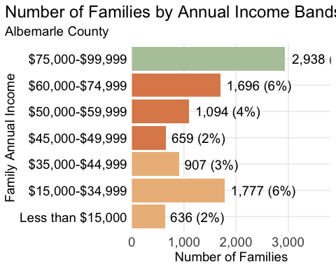
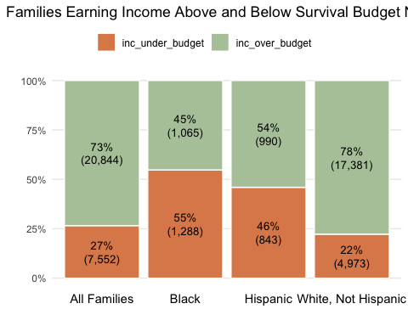
Census Tract |  | Percent
Hydraulic |  | 73
Commonwealth-Townwood-Berkmar |  | 71
Oak Hill, Southwood |  | 63
Old Ivy-Darden School (UVA) |  | 59
Albemarle High School |  | 55
Carr's Hill-McCormick Road (UVA) |  | 52
Crozet-Beaver Creek Southern Albemarle-Scottsville |  | 38
Pantops |  | 35
Barracks-Hessian Hills |  | 29
Western Ridge-Westhall |  | 27
Village of Rivanna |  | 26
Berkmar Drive Yancey Mills, Batesville |  | 25
Free Union Monticello, Carters Mountain Woodbrook-Carrsbrook |  | 24
Hollymead |  | 22
Avon Street Ext.-Mill Creek |  | 21
Earlysville |  | 19
Charlottesville-Albemarle Airport North Garden |  | 18
Stony Point-Keswick |  | 17
Branchland |  | 16
Darden-Key West Dunlora-Stone Henge Old Trail |  | 13
Ivy |  | 12
Polo Grounds Road |  | 3
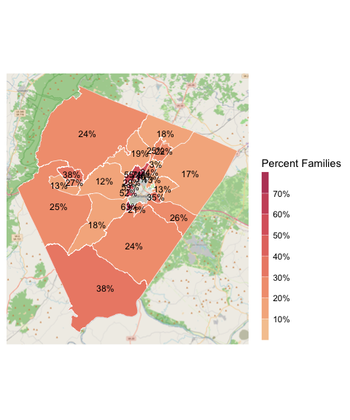
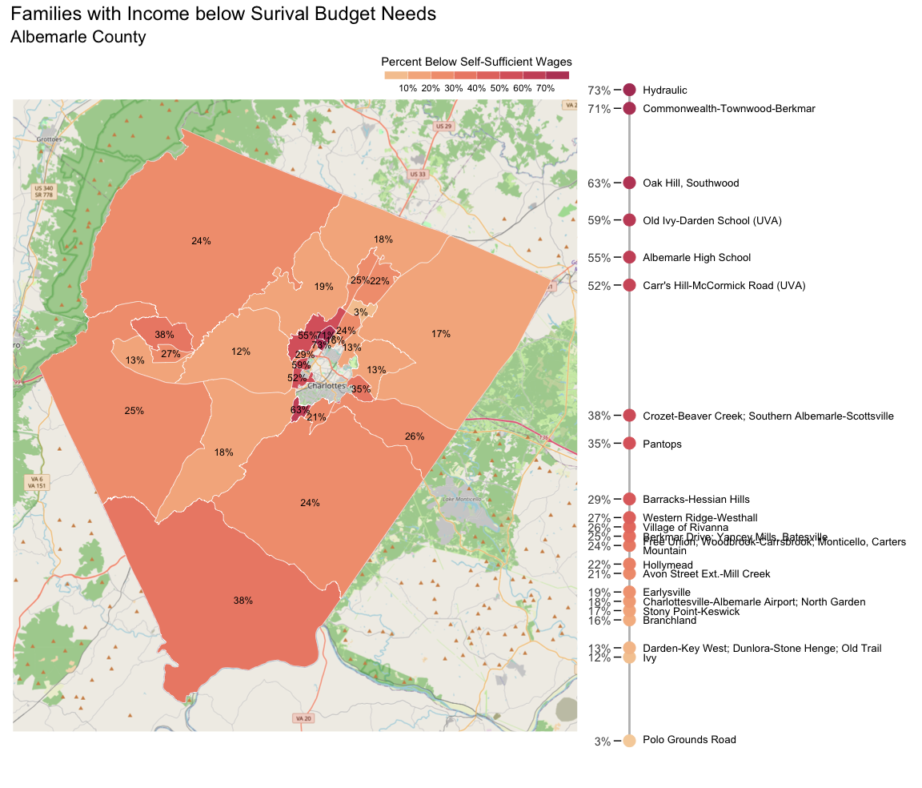
Figure 1: Percent of families with annual income below the survival budget by census tract, 2024, for Albemarle County.

