Orange Dot Report 7.0: Realizing Our Potential
Family Self-Sufficiency in the Charlottesville Region: Albemarle, Buckingham, Fluvanna, Greene, Louisa, Nelson Counties & the City of Charlottesville, Virginia
Elizabeth Mitchell, Michele Claibourn, and Ridge Schuyler
October 2026

Table of Contents
Executive Summary 2
Introduction 3
Defining Self-Sufficiency 4
Families Struggling in Our Region 4
Undervalued Labor 6
Locality Profiles 11
Albemarle County 11
Buckingham County 21
Charlottesville 28
Fluvanna County 35
Greene County 42
Louisa County 49
Nelson County 56
Credits 63
Project Repository 63
Citation 63
Appendix 64
Family Survival Budgets by Locality 64
List of Occupations by Employment Rate 71

Executive Summary
In the larger Charlottesville region, 22,467 families (32%) do not make enough money to meet their basic needs, including the cost of housing, child care, food, transportation, health care, phone, internet, and taxes. Rising costs and inflation combined with stagnant wages and undervalued labor has made it increasingly difficult for families to be self-sufficient.
The goal of the Orange Dot Report is to provide an overview of the families in our region that struggle to afford the basic necessities. To determine what annual income is required for a family in our region to be considered self-sufficient, this year’s report uses household budget data from the national research project, United for ALICE. United for ALICE provides household survival budgets that reflect the minimum cost of living in today’s economy and vary by location and family size.
The Orange Dot Report focuses on families living in the City of Charlottesville and the surrounding counties of Albemarle, Buckingham, Fluvanna, Greene, Louisa, and Nelson. The average annual survival budget for families in our region ranges from around $66,000 in Buckingham to $87,000 in the City of Charlottesville. A detailed breakdown of these costs and wages are provided in this report for each locality.
While families facing economic insecurity live throughout our region, the struggle is not equally shared. For families with children under 18 years old, the financial burden is larger: 1 in 3 (34%) do not earn enough to meet their basic needs, compared to 1 in 5 (20%) families without children under 18 years. Additionally, 56% of Black families and 47% of Hispanic families do not earn enough to meet their basic needs, compared to 28% of white families. This reflects a persistent gap resulting from past and ongoing policies that suppress investment, opportunity, and wealth creation in minoritized communities.
The percent of families struggling overall is highest in Buckingham and Greene counties at 41%, and lowest in Albemarle County, at 27%. The variation within localities is even greater. Most localities in our region have areas where over half (50%) of families have less than family-sufficient incomes. Albemarle, Fluvanna, and the City of Charlottesville each have neighborhoods where 3 in 4 families (75%) do not earn enough to meet the local cost of living.
In addition to presenting survival budgets and income data for families, the Locality Profiles in this year’s Orange Dot Report also include information on households aged 65 years and over. There are many areas in our region where those 65 years and over, who may no longer be in the workforce and living on fixed incomes, do not have enough to meet their basic needs.
Despite more than a decade of attention and the dedicated efforts of many valuable organizations and programs, there are still too many struggling families. For a region as prosperous as ours, we have the means to build programs and enact policy that helps more families become self-sufficient.

Introduction
We seek to build “a world of constantly accelerating economic progress—not material welfare as an end in itself, but as a means to liberate the capacity of every human being to pursue his talents and to pursue his hopes.”
— Robert F. Kennedy, Remarks delivered June 6, 1966, Cape Town, South Africa
A community thrives when its residents thrive. Residents thrive when their capacity as human beings is unleashed. And their capacity as human beings can only be unleashed when their basic needs are met.
As illustrated in the pages that follow, there are too many families in our community who do not earn enough to meet their basic needs. When you worry every month about paying the landlord, every week about buying groceries, every day about whether your car will start, it is difficult to be the parent you want to be, the worker you know you could be, or the person you were meant to be.
There are thousands in our community who dream of being their better selves, but their daily reality causes that dream to fade. Too often, that reality involves working long hours for low wages. These neighbors have a lack of income, but not a lack of value. They want to do better for themselves and their families, but the pathway that could lead them there is unmarked. They recognize the potential they have within them but can’t find the way to realize that potential.
In his I Have A Dream speech, Dr. Martin Luther King, Jr. lamented that there were too many Americans living “on a lonely island of poverty in the midst of a vast ocean of material prosperity.”
Today, we remain surrounded by a vast ocean of material prosperity. Yet, here in our community there are too many families currently stranded on that island. Too many who do not make enough to meet the costs of survival—food, shelter, clothing and utilities—and the added costs related to working—childcare and transportation. Too many left behind.
“Only when we know where we are will we know where we can go and how we can get there.” — Robert F. Kennedy, in a 1968 address, paraphrasing from Abraham Lincoln’s “House Divided” speech.
We cannot begin to realize the potential of those being left behind, however, without understanding their circumstances.

Defining Self-Sufficiency
The goal of the Orange Dot Report is to provide an overview of the families in our region that struggle to afford the basic necessities, to describe where we are. This year’s report uses household budget data from the national research project, United for ALICE, to estimate the annual income required for a family in our region to be self-sufficient.
United for ALICE provides household budgets that are specific to location and household composition, taking into account different sized households, ages of children and local cost of living. The Household Survival Budgets, used to determine family self-sufficiency in this report, reflect the minimum cost to live and work in today’s economy and include housing, child care, food, transportation, health care, and technology, plus taxes and a contingency fund for one-time unanticipated costs. The data sources used by United for ALICE in determining household expenses are comparable to those used in past Orange Dot Reports, and their methods are replicable, updated annually, and sensitive to local context. For more information on the sources used in determining household budgets, see more at United for ALICE: https://www.unitedforalice.org/the-cost-of-basics/virginia.
The Orange Dot Report differs from the work of United for ALICE in one fundamental respect: Orange Dot focuses on family households while ALICE focuses on all households. Family households are defined by the U.S. Census as households where two or more people are related by birth, marriage, or adoption. By centering families, the Orange Dot Report focuses on households in our community who are more likely to be pooling resources and sharing in financial hardship. To more clearly understand the impact of rising costs, this year’s Orange Dot Report also provides data for both families with and without children under 18 years old. Families with dependents, in particular, face higher barriers to mobility, education, and other investments to improve work and wage prospects.

Families Struggling in Our Region
There are approximately 70,000 families living in the Charlottesville region, defined in this report as the City of Charlottesville and the surrounding counties of Albemarle, Buckingham, Fluvanna, Greene, Louisa, and Nelson. Of these families, over 22,000 (32%) do not earn enough to provide for their family’s basic needs. This is nearly one in three families struggling to keep up with the rising cost of living in our region.
The summary tables below show the breakdown of struggling families in the Charlottesville region. In each locality, nearly 30% of families or more are struggling, with the highest percentages in Buckingham and Fluvanna, at 41%. Localities in our region vary in population, so that even though Albemarle has the lowest percent (27%), it has the highest number of families struggling to meet their basic minimum needs, at over 7,500.
While families facing economic insecurity live throughout our region, the struggle is not equally shared. For families with children under 18 years old, the financial burden is larger: 34% struggle to meet their basic needs compared to 20% for families without children under 18. Additionally, 56% of Black families and 47% of Hispanic families do not earn enough to meet their basic needs, compared to 28% of white families. This reflects a persistent gap resulting from past and ongoing policies that suppress investment, opportunity, and wealth creation in minoritized communities.
Table 1: Summary of Struggling Families in the Region
 | Number of Struggling Families | Percent of Struggling Families
Albemarle County | 7,552 | 27%
Buckingham County | 1,656 | 41%
Charlottesville City | 3,135 | 35%
Fluvanna County | 2,585 | 34%
Greene County | 2,338 | 41%
Louisa County | 3,769 | 33%
Nelson County | 1,433 | 37%
Total for Region | 22,467 | 32%
Note: Values are approximate based on the U.S. Census Bureau, American Community Survey 5-year estimates (2020-2024)

Table 2: Summary of Struggling Families With and Without Children Under 18 in the Region
 | Struggling Families With Children Under 18 yrs. |  | Struggling Families With No Children Under 18 yrs.
 | Number | Percent | Number | Percent
Albemarle County | 3,530 | 29% | 2,678 | 17%
Buckingham County | 527 | 35% | 685 | 27%
Charlottesville City | 1,701 | 39% | 938 | 21%
Fluvanna County | 753 | 28% | 1,212 | 25%
Greene County | 1,178 | 49% | 760 | 23%
Louisa County | 1,607 | 39% | 1,418 | 20%
Nelson County | 446 | 43% | 639 | 23%
Total for Region | 9,742 | 34% | 8,331 | 20%
Note: Values are approximate based on the U.S. Census Bureau, American Community Survey 5-year estimates (2020-2024)
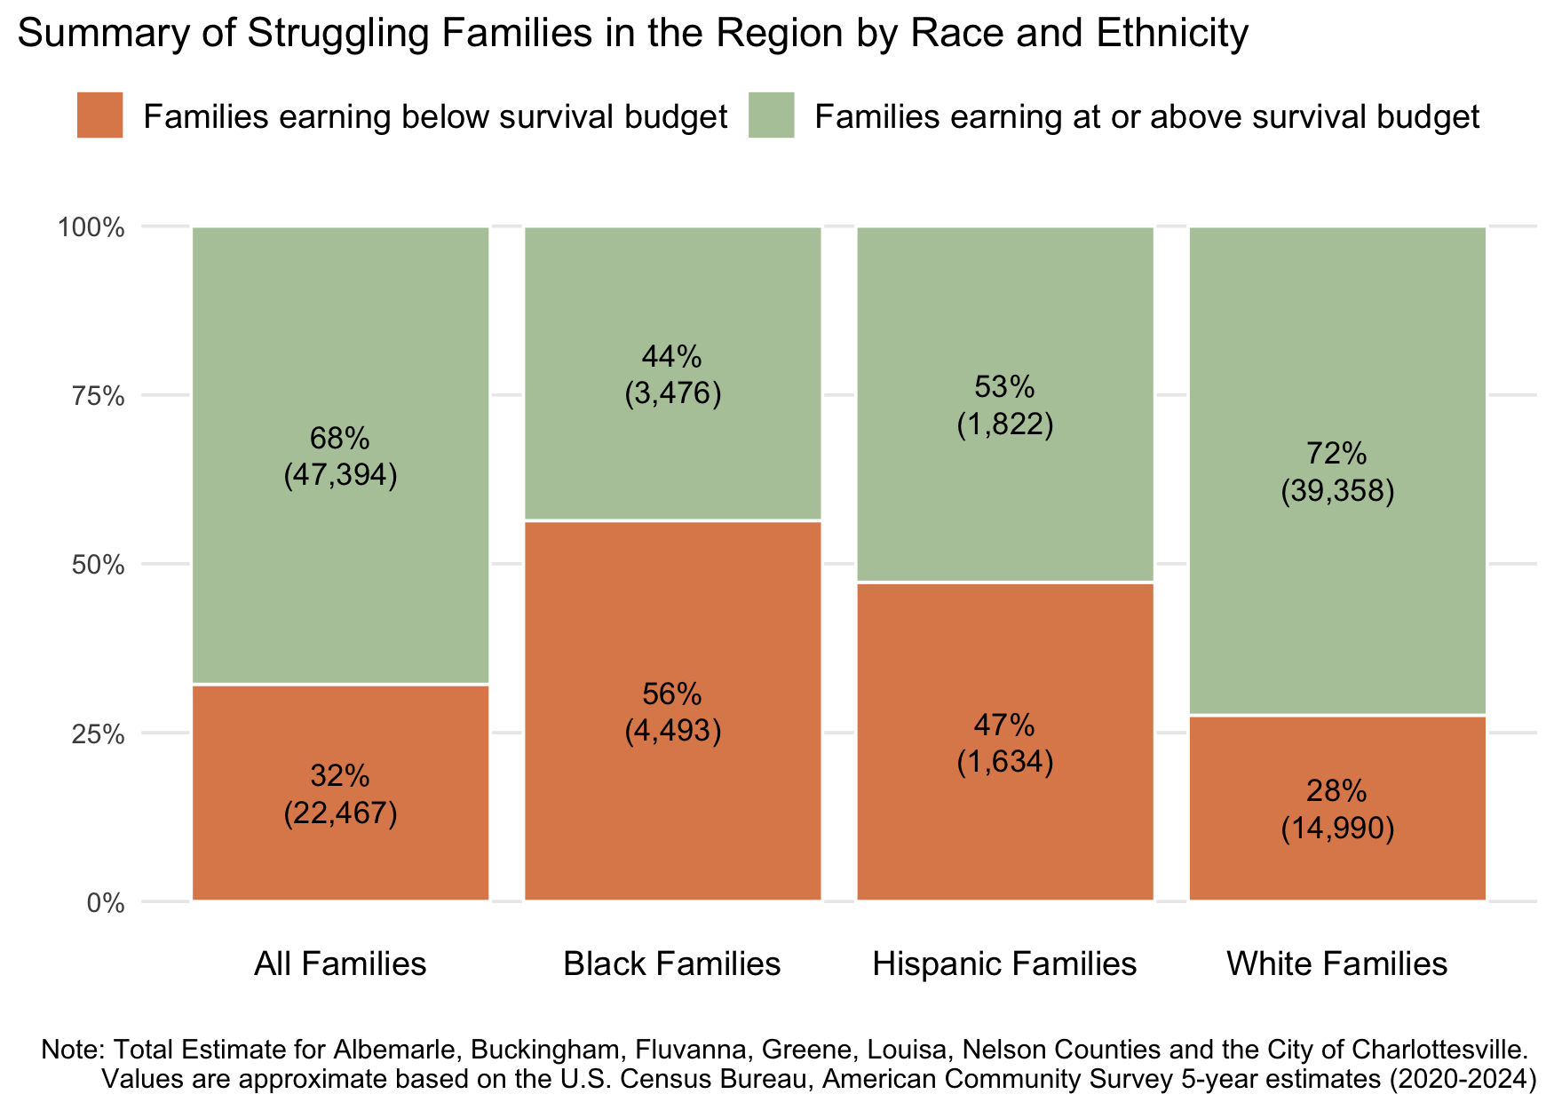
Figure 1: Percent and number of struggling families by race and ethinicity for the Charlottesville region, including Albemarle, Buckingham, Fluvanna, Greene, Louisa, Nelson Counties and the City of Charlottesville. 56% of Black families and 47% of Hispanic families do not earn enough to meet their basic needs, compared to 28% of white families.

Undervalued Labor
A majority (64%) of workers in struggling families are working at least 40 hours per week, the equivalent of a full-time job. Many of those who are working less than full time would like to work more. These workers are also in low-waged employment. Half of workers in struggling families are earning less than $30,000 a year—making it difficult to impossible to meet their household’s survival budget for single or two-parent households. This deeper understanding about people in the workforce who are in families earning below what they need is drawn from the ACS Public Use Microdata Sample provided by the U.S. Census Bureau for our region.
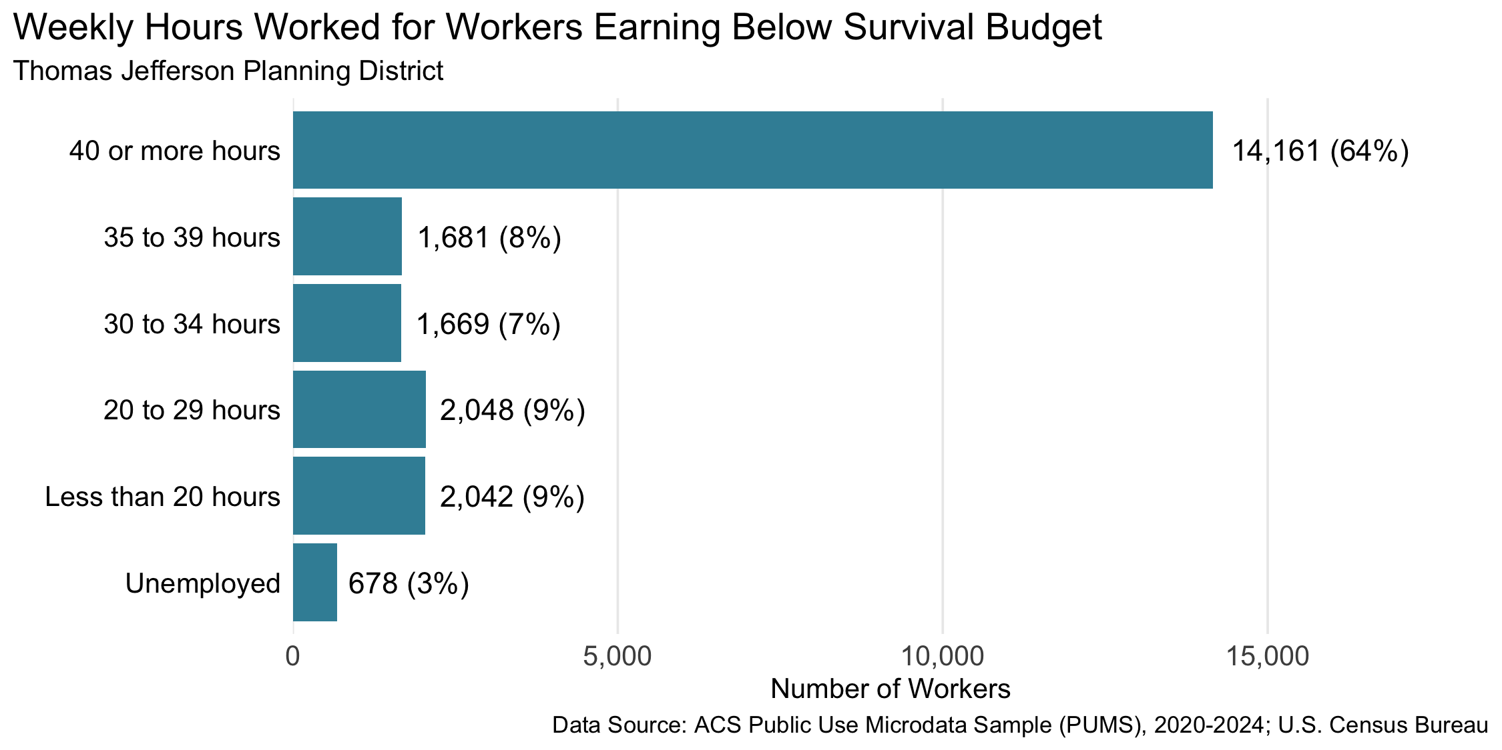
Figure 2: Estimated number and percent of workers in the TJ Planning District in families with income less than the household survival budget by weekly hours worked. 64% of these workers worked 40 or more hours a week; 88% worked 20 or more hours a week. The Thomas Jefferson Planning District includes the City of Charlottesville, and Albemarle, Fluvanna, Greene, Louisa, and Nelson counties. Buckingham County is not included in the microdata sample.

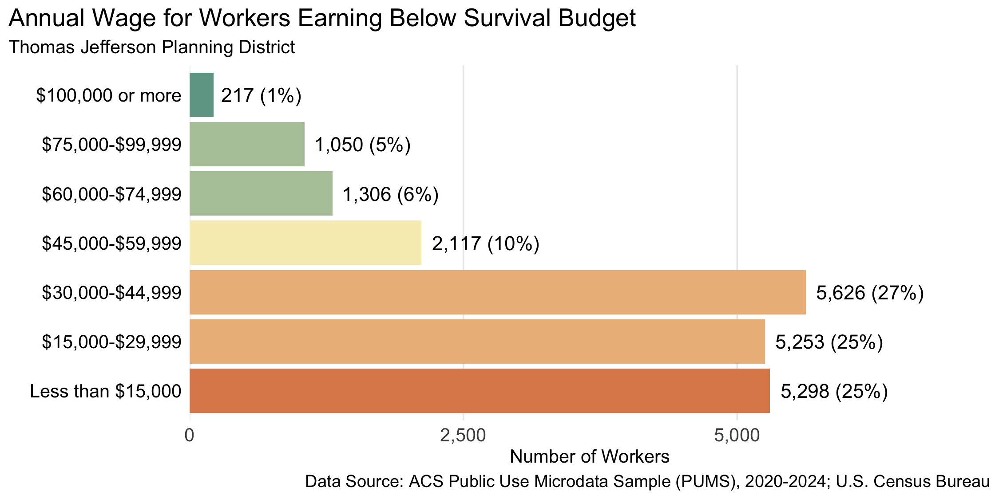
Figure 3: Estimated number and percent of workers in the TJ Planning District in families with income less than the household survival budget by their annual wage. 77% of these workers earned less than $45,000 a year. The Thomas Jefferson Planning District includes the City of Charlottesville, and Albemarle, Fluvanna, Greene, Louisa, and Nelson counties. Buckingham County is not included in the microdata sample.
As the data suggests, for most families, low-incomeness is not a constant that must be worked around, but a variable that must be changed. For a family experiencing economic struggle, the first question should be: What do they need to increase their income?
Some families are on fixed incomes or have otherwise reached a more constrained earning potential due to illness, caregiving responsibilities, and other circumstances. The vast majority of workers, however, have the capacity to earn a wage that can support their families. They are working, but their labor is not sufficiently valued.
The undervaluing of labor has far-reaching consequences. The myth of the American Dream promotes the idea that those who work hard and play by the rules will get ahead. The flipside of that myth—if you haven’t gotten ahead, it must be because you don’t work hard enough or play by the rules—leads to negative beliefs about the poor in our society and, subsequently, to reduced support for resources and programs meant to reduce the burdens of poverty. Working hard, however, does not guarantee that individuals will get ahead. Take the formulas below:
Hard Work × High Wages = High Income
Hard Work × Low Wages = Low Income
It’s not the hard work that makes the difference—it’s the low wage. The full-time worker making Virginia’s minimum wage will have a gross income of $26,500 per year. To reduce the number of struggling families, therefore, requires an increase in their wages. We need a system that identifies the hard-working families whose labor is not sufficiently valued and help them increase their value in the marketplace.
To get ahead, those workers need jobs and careers that pay enough to support their families. The table below provides information on the types of jobs and the corresponding wages that fall into different earning bands. Note that a number of the lowest paying jobs provide some of the highest value for our society: caring for our children when they’re young and our parents when they’re old. These jobs require them to sacrifice for our benefit by working for less pay than they can live on.
Table 3: Selection of Occupations by Annual Median Wage Earned in the Charlottesville Metro Area¹
Occupation | Annual Median Wage² |  | Employment Rate (per 1,000 jobs)³ | Occupation Group⁴
Home Health and Personal Care Aides | $29,700.00 |  | 17.2 | Healthcare Support
Fast Food and Counter Workers | $30,150.00 |  | 24.4 | Food Preparation and Serving Related
Cashiers | $30,930.00 |  | 18.4 | Sales and Related
Childcare Workers | $34,130.00 |  | 3.1 | Personal Care and Service
Emergency Medical Technicians | $39,760.00 |  | 1.1 | Healthcare Practitioners and Technical
Customer Service Representatives | $40,240.00 |  | 9.8 | Office and Administrative Support
Healthcare Support Workers, All Other | $41,460.00 |  | 2.5 | Healthcare Support
Medical Assistants | $42,140.00 |  | 3.1 | Healthcare Support
Nursing Assistants | $44,140.00 |  | 14.1 | Healthcare Support
Dental Assistants | $45,040.00 |  | 2.4 | Healthcare Support
Construction Laborers | $45,080.00 |  | 4.9 | Construction and Extraction
Bus Drivers, School | $46,260.00 |  | 3.0 | Transportation and Material Moving
Bus Drivers, Transit and Intercity | $47,950.00 |  | 2.1 | Transportation and Material Moving
Maintenance and Repair Workers, General | $48,170.00 |  | 9.2 | Installation, Maintenance, and Repair
Secretaries and Administrative Assistants, Except Legal, Medical, and Executive | $53,100.00 |  | 10.1 | Office and Administrative Support
Office and Administrative Support Workers, All Other | $53,170.00 |  | 3.3 | Office and Administrative Support
Heavy and Tractor-Trailer Truck Drivers | $54,970.00 |  | 5.5 | Transportation and Material Moving
Carpenters | $56,090.00 |  | 5.5 | Construction and Extraction
Plumbers, Pipefitters, and Steamfitters | $56,510.00 |  | 2.1 | Construction and Extraction
Installation, Maintenance, and Repair Occupations | $57,660.00 |  | 31.5 | Installation, Maintenance, and Repair
Community and Social Service Occupations | $58,070.00 |  | 22.3 | Community and Social Service
Automotive Service Technicians and Mechanics | $59,130.00 |  | 3.8 | Installation, Maintenance, and Repair
Heating, Air Conditioning, and Refrigeration Mechanics and Installers | $59,540.00 |  | 3.6 | Installation, Maintenance, and Repair
Elementary School Teachers, Except Special Education | $60,770.00 |  | 9.0 | Educational Instruction and Library
Police and Sheriff's Patrol Officers | $60,880.00 |  | 3.6 | Protective Service
Graphic Designers | $61,700.00 |  | 1.4 | Arts, Design, Entertainment, Sports, and Media
Medical Records Specialists | $62,600.00 |  | 1.9 | Healthcare Practitioners and Technical
Electricians | $62,980.00 |  | 4.0 | Construction and Extraction
Secondary School Teachers, Except Special and Career/Technical Education | $63,200.00 |  | 7.9 | Educational Instruction and Library
Computer User Support Specialists | $63,530.00 |  | 3.5 | Computer and Mathematical
Clinical Laboratory Technologists and Technicians | $66,700.00 |  | 1.5 | Healthcare Practitioners and Technical
Licensed Practical and Licensed Vocational Nurses | $67,120.00 |  | 3.0 | Healthcare Practitioners and Technical
Electrical and Electronic Engineering Technologists and Technicians | $74,100.00 |  | 0.9 | Architecture and Engineering
Radiologic Technologists and Technicians | $79,560.00 |  | 1.7 | Healthcare Practitioners and Technical
Accountants and Auditors | $81,530.00 |  | 9.6 | Business and Financial Operations
Registered Nurses | $99,320.00 |  | 26.5 | Healthcare Practitioners and Technical
General and Operations Managers | $107,200.00 |  | 22.1 | Management
Dental Hygienists | $107,690.00 |  | 1.1 | Healthcare Practitioners and Technical
¹A full list of occupations and wages is available here: https://github.com/virginiaequitycenter/orange-dot/blob/main/OrangeDot7_2026/data/bls_occupations_by_wagebin.csv
²The annual median wage is the boundary between the highest and lowest paid workers in a given occupation. Half of the workers in a given occupation earn more than the median wage, and half the workers earn less than the median wage.
³Employment rate is the number of jobs (employment) in the given occupation per 1,000 jobs in the Charlottesville Metro Area
⁴Major occupation groups defined by the Standard Occupational Classification (SOC) system, used by Federal statistical agencies to classify workers and jobs into occupational categories for the purpose of collecting, calculating, analyzing, or disseminating data.
Data Source: U.S. Bureau of Labor Statistics, Occupational Employment and Wage Statistics; May 2025; https://www.bls.gov/oes/tables.htm

Locality Profiles

Albemarle County
There are 28,396 families living in Albemarle County. Of these families, 7,552 (27%) do not earn enough to provide for their family’s basic needs.

Albemarle County at a glance:
- The annual household survival budget for an average family in Albemarle County is $81,660. This is the approximate income working families need to meet their basic necessities. The household survival budget includes: housing, child care, food, transportation, health care, and technology (phone and internet), plus taxes and a 10% contingency fund for one-time unanticipated costs.
- Approximately 7,552 families, or 27% of families, in Albemarle County earn below their household’s survival budget.
- The percent of Black families not earning enough to meet their basic needs is 55%. The percent of Hispanic families not earning enough to meet their basic needs is 46%. These are 32% and 24% higher than the percent of white families earning below the survival budget (22%).
- The median family income for Albemarle County is $137,355. The tract with the lowest median family income is Oak Hill, Southwood at $50,000. The tract with the highest median family income is Ivy at $222,000.
- The tract with the highest percent of families with income below the average survival budget is Hydraulic with 73% of families. The tract with the lowest percent of families not earning enough to meet their basic needs is Polo Grounds Road with 3% of families. That is a difference of 70%.
- The annual survival budget for an average household 65 years and over in Albemarle County is $54,510. The tract with the highest percent of households 65 years and over with income below the average survival budget is Hydraulic with 71%. The tract with the lowest percent of households 65 years and over not earning enough to meet their basic needs is Darden-Key West and Western Ridge-Westhall with 13%.

Families
Table 4: Average Survival Budget for Families in Albemarle
 | Monthly | Annual
Housing | $1,778.62 | $21,343.44
Child Care | $1,019.08 | $12,228.96
Food | $1,179.23 | $14,150.76
Transportation | $637.69 | $7,652.28
Health Care | $674.77 | $8,097.24
Technology | $122.92 | $1,475.04
Miscellaneous | $541.23 | $6,494.76
Taxes | $851.46 | $10,217.52
Total Income Needed to Meet Budget | $6,805.00 | $81,660.00
Note: The Average Family Survival Budget is calculated using the ALICE 2024 Household Survival Budgets. The average budget is calculated for each locality based on families with one or two adults and one or two children. Family compositions include children ages 0-2 years (infant), 3-4 years (preschooler), and 5-17 years (school-aged). See the Appendix for detailed budgets for specific family compositions.
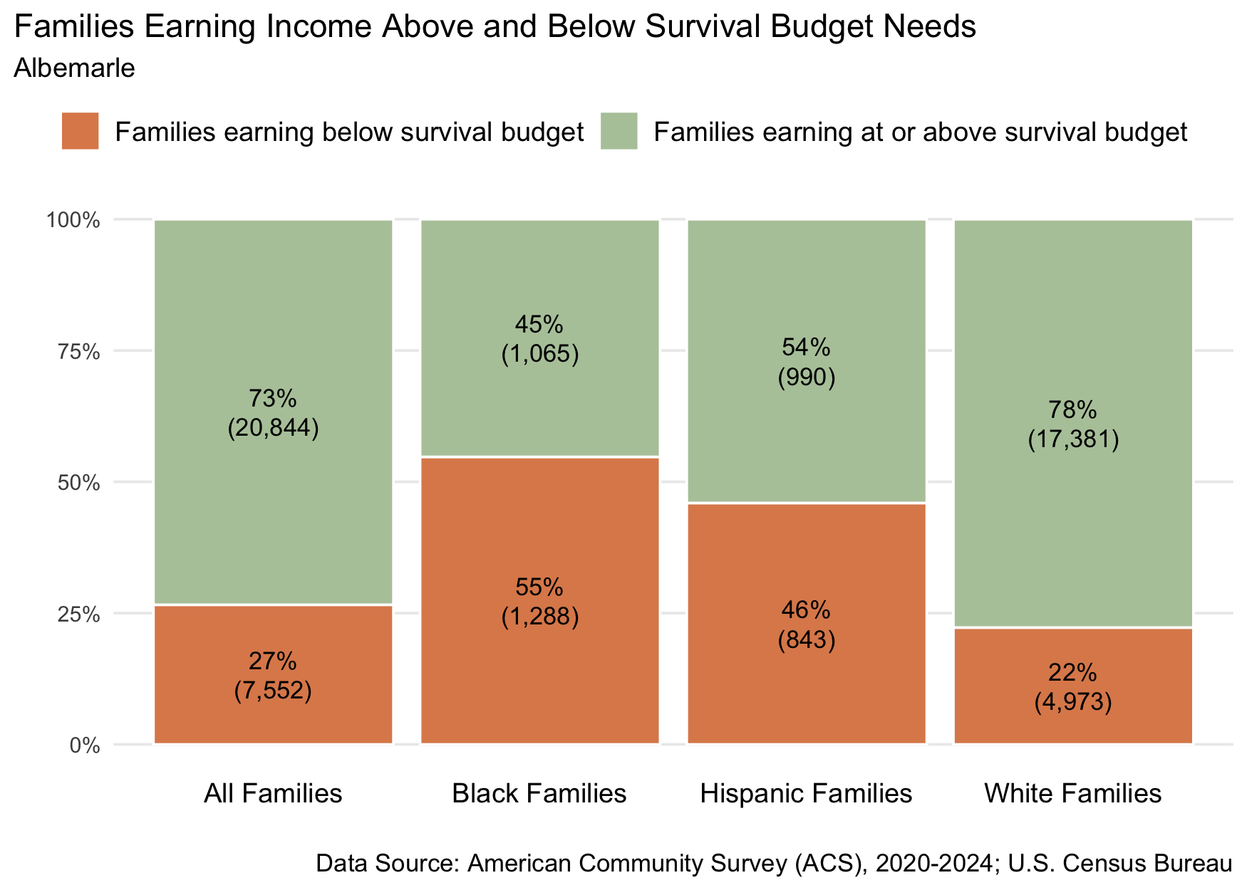
Figure 4: Percent and number of families earning above and below the average family survival budget, 2024 for Albemarle County
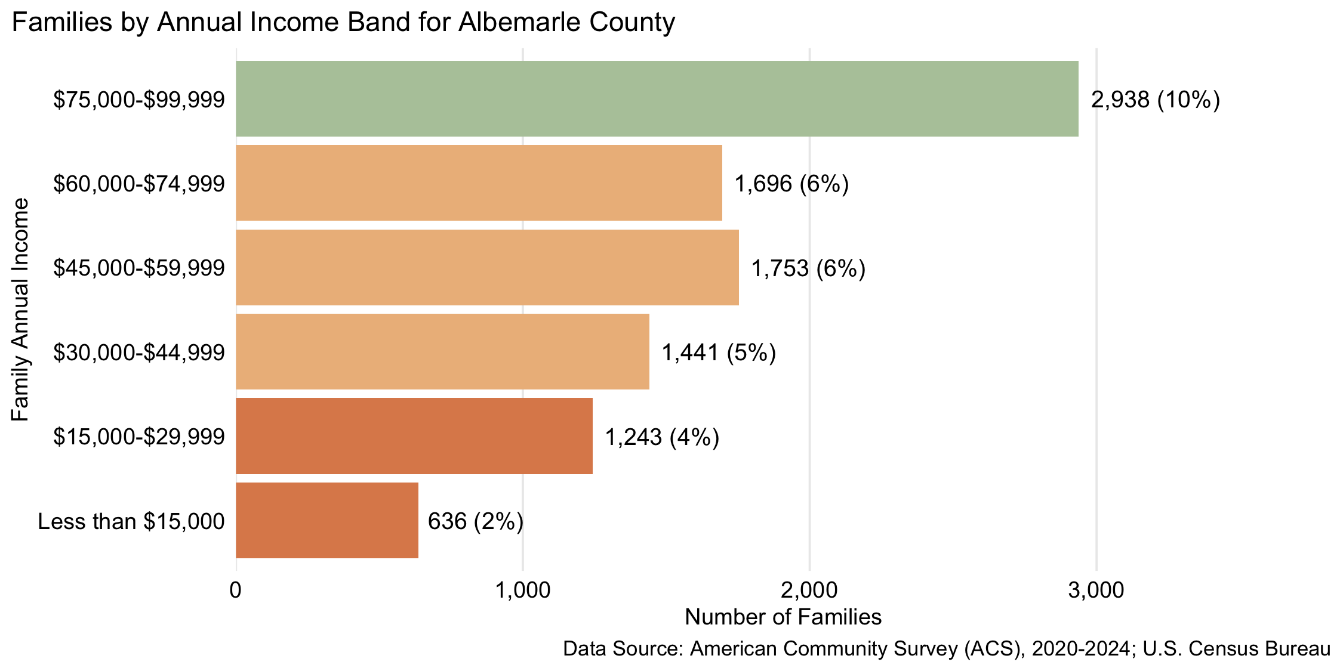
Figure 5: Number and percent of families by family annual income, for family incomes below $100,000, 2024, for Albemarle County

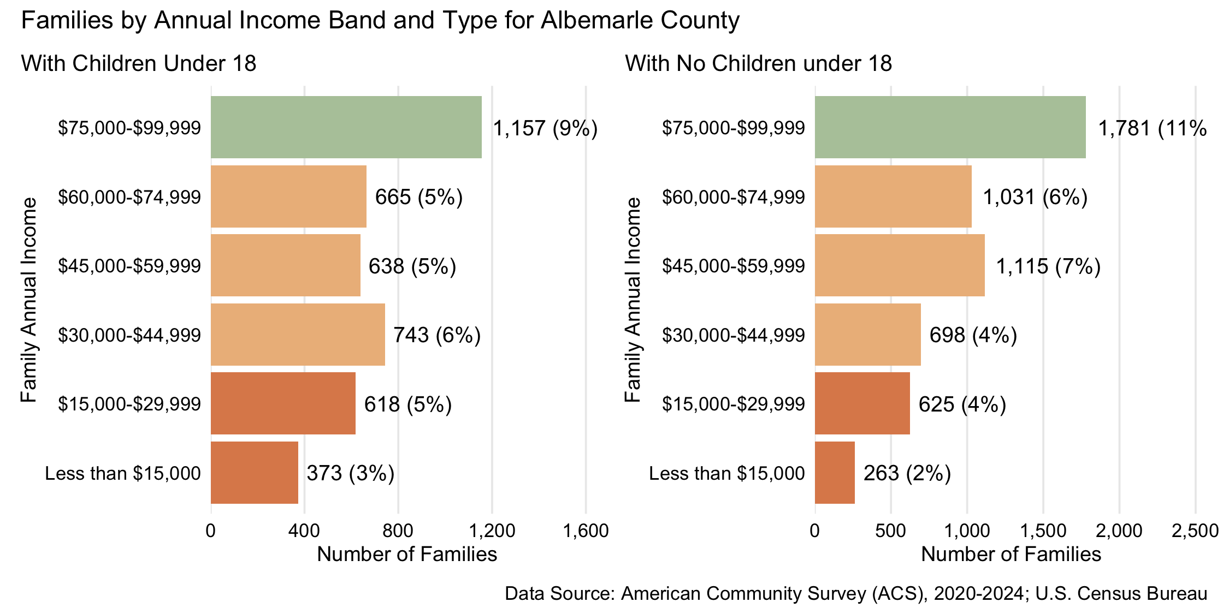
Figure 6: Number and percent of families with and without children under 18 years old by family annual income, for family incomes below $100,000, 2024, for Albemarle County

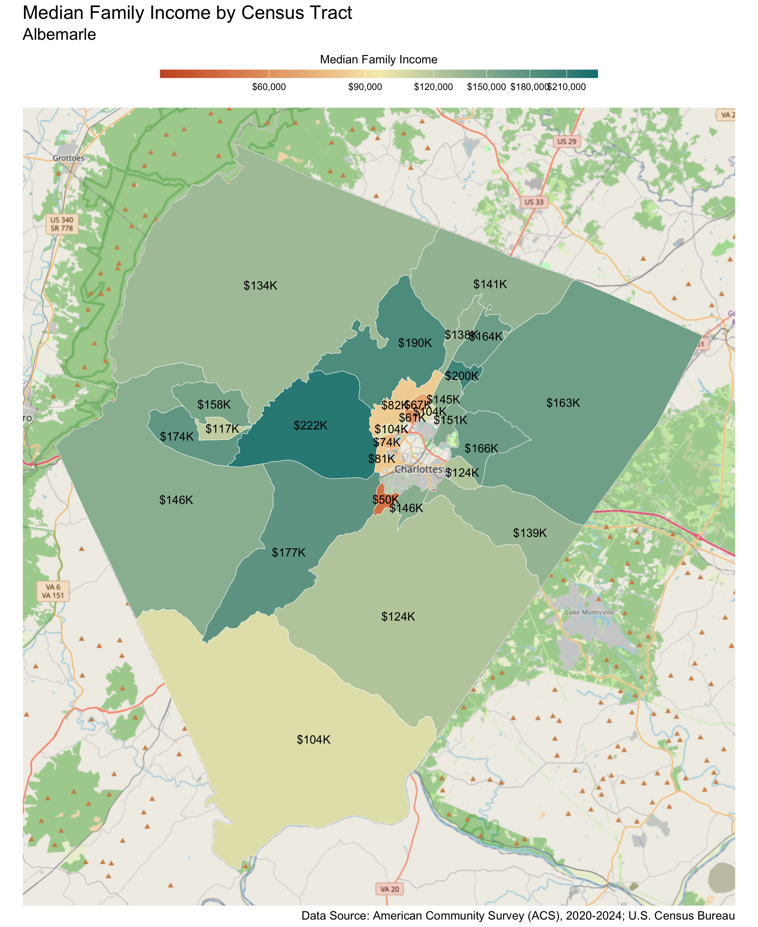
Census Tract |  | Median Family Income
Oak Hill, Southwood* |  | $50,000
Hydraulic* |  | $61,000
Commonwealth-Townwood-Berkmar* |  | $67,000
Old Ivy-Darden School (UVA)* |  | $74,000
Carr's Hill-McCormick Road (UVA)* |  | $81,000
Albemarle High School |  | $82,000
Barracks-Hessian Hills |  | $104,000
Branchland |  | $104,000
Southern Albemarle-Scottsville |  | $104,000
Western Ridge-Westhall |  | $117,000
Monticello, Carters Mountain |  | $124,000
Pantops |  | $124,000
Free Union |  | $134,000
Berkmar Drive |  | $138,000
Village of Rivanna |  | $139,000
Charlottesville-Albemarle Airport |  | $141,000
Woodbrook-Carrsbrook |  | $145,000
Avon Street Ext.-Mill Creek |  | $146,000
Yancey Mills, Batesville |  | $146,000
Dunlora-Stone Henge |  | $151,000
Crozet-Beaver Creek |  | $158,000
Stony Point-Keswick |  | $163,000
Hollymead |  | $164,000
Darden-Key West |  | $166,000
Old Trail |  | $174,000
North Garden |  | $177,000
Earlysville |  | $190,000
Polo Grounds Road |  | $200,000
Ivy |  | $222,000
* Census tracts listed in bold have a median family income below the locality's average family survival budget.
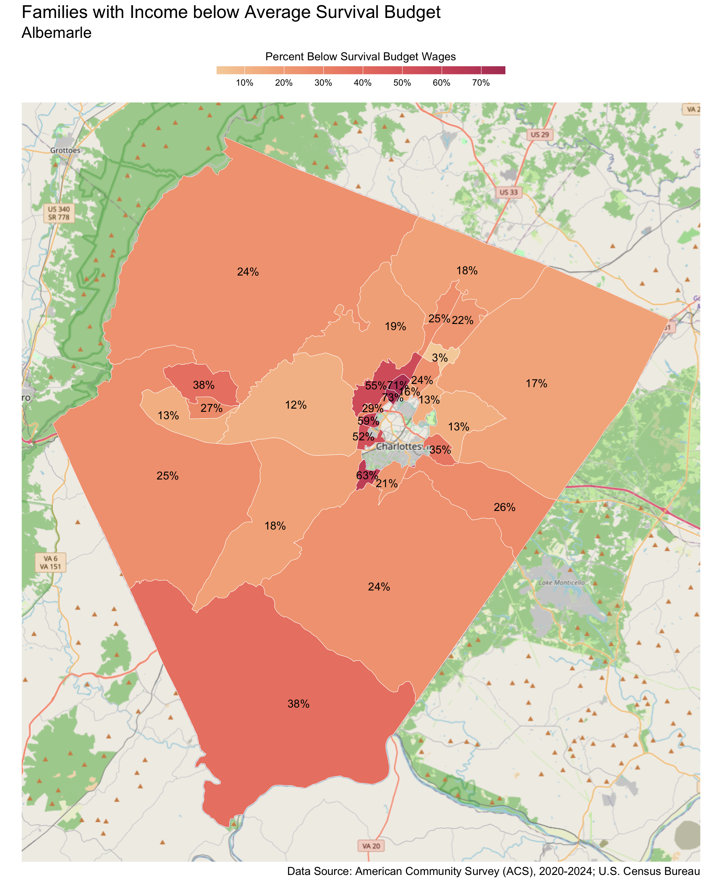
Census Tract |  | Percent
Hydraulic |  | 73%
Commonwealth-Townwood-Berkmar |  | 71%
Oak Hill, Southwood |  | 63%
Old Ivy-Darden School (UVA) |  | 59%
Albemarle High School |  | 55%
Carr's Hill-McCormick Road (UVA) |  | 52%
Crozet-Beaver Creek |  | 38%
Southern Albemarle-Scottsville |  | 38%
Pantops |  | 35%
Barracks-Hessian Hills |  | 29%
Western Ridge-Westhall |  | 27%
Village of Rivanna |  | 26%
Berkmar Drive |  | 25%
Yancey Mills, Batesville |  | 25%
Free Union |  | 24%
Monticello, Carters Mountain |  | 24%
Woodbrook-Carrsbrook |  | 24%
Hollymead |  | 22%
Avon Street Ext.-Mill Creek |  | 21%
Earlysville |  | 19%
Charlottesville-Albemarle Airport |  | 18%
North Garden |  | 18%
Stony Point-Keswick |  | 17%
Branchland |  | 16%
Darden-Key West |  | 13%
Dunlora-Stone Henge |  | 13%
Old Trail |  | 13%
Ivy |  | 12%
Polo Grounds Road |  | 3%

Households 65 years and over
Table 5: Average Survival Budget for Households 65 years and over in Albemarle
 | Monthly | Annual
Housing | $1,562.00 | $18,744.00
Child Care | $0.00 | $0.00
Food | $688.50 | $8,262.00
Transportation | $363.00 | $4,356.00
Health Care | $727.00 | $8,724.00
Technology | $119.00 | $1,428.00
Miscellaneous | $346.00 | $4,152.00
Taxes | $737.00 | $8,844.00
Total Income Needed to Meet Budget | $4,542.50 | $54,510.00
Note: The Average Household Survival Budget is calculated using the ALICE 2024 Household Survival Budgets. The average budget for households 65 years and over is calculated for each locality based on households with one or two adults aged 65 years and over. See the Appendix for detailed budgets for specific family compositions.
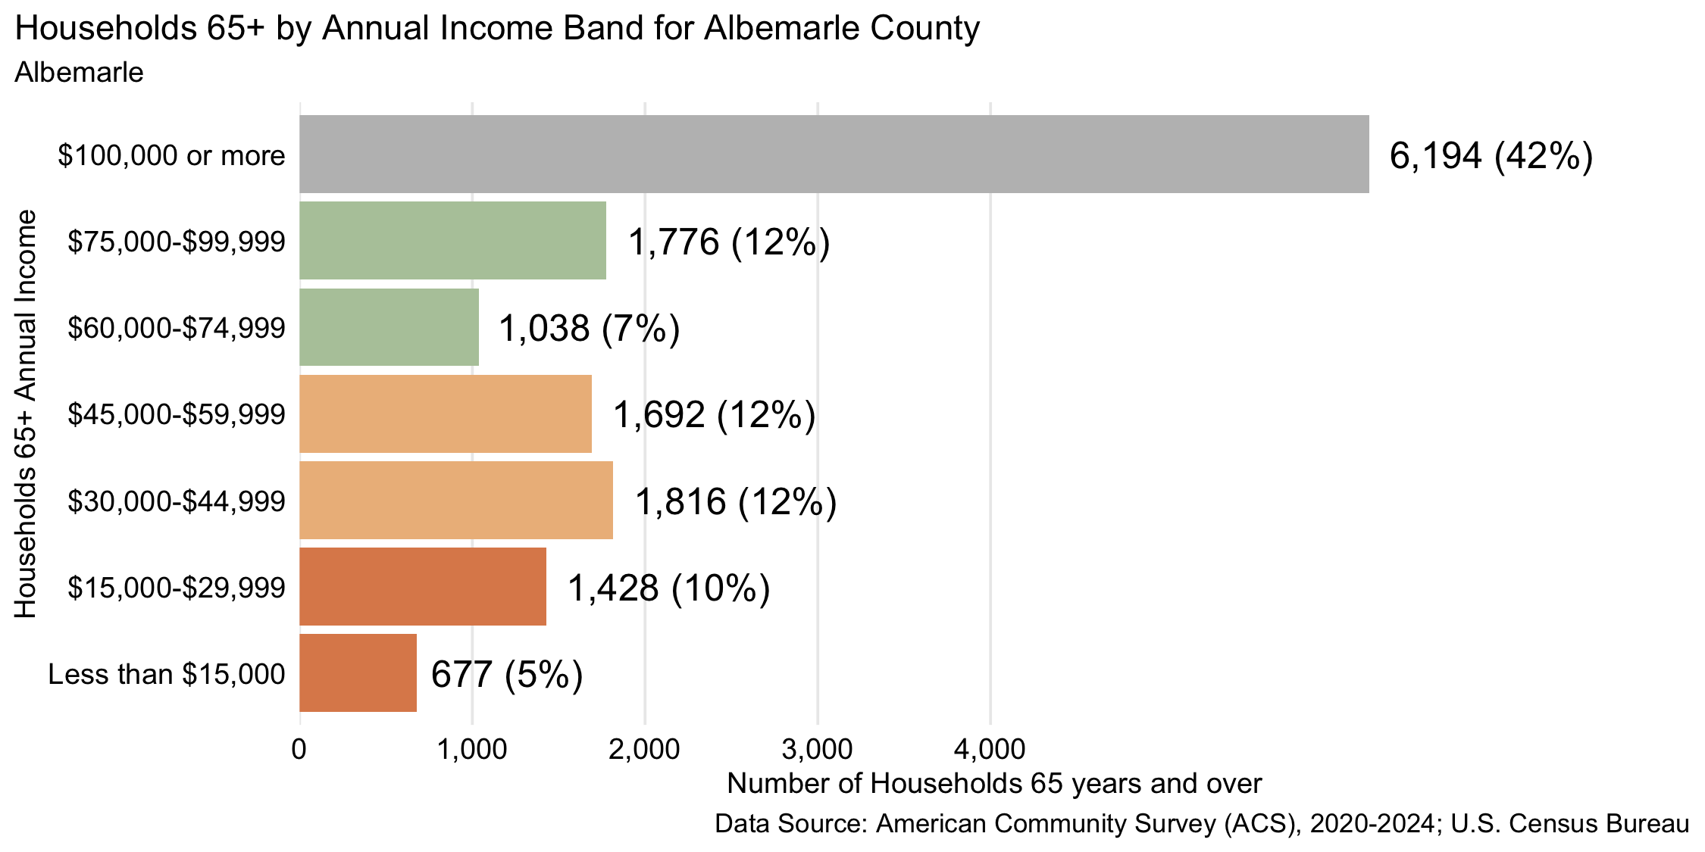
Figure 7: Number and percent of households 65 years and over by annual household income, 2024, for Albemarle County
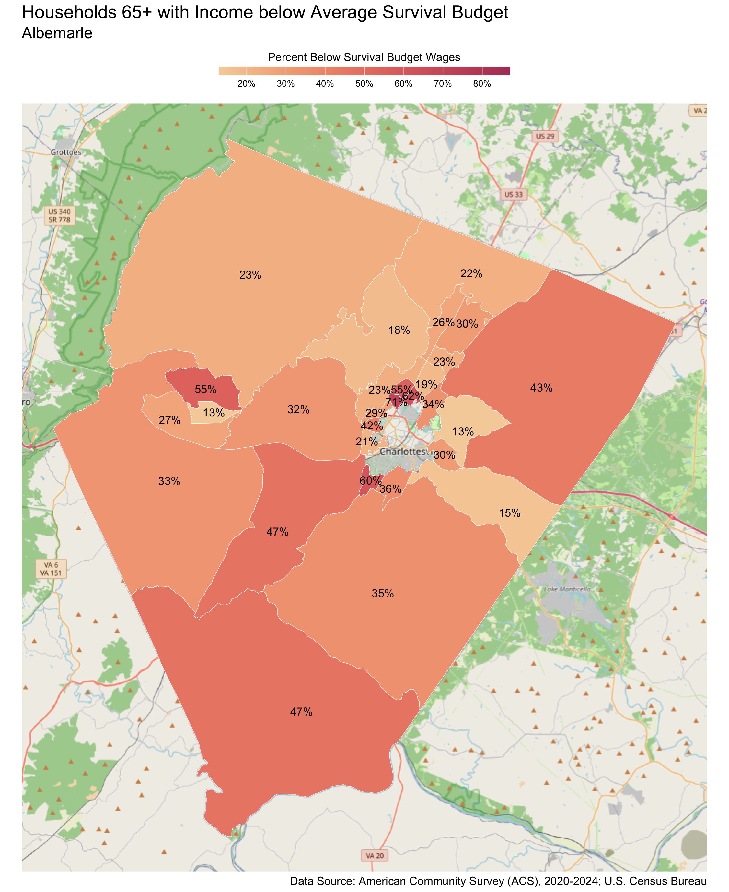
Census Tract |  | Percent
Hydraulic |  | 71%
Branchland |  | 62%
Oak Hill, Southwood |  | 60%
Commonwealth-Townwood-Berkmar |  | 55%
Crozet-Beaver Creek |  | 55%
North Garden |  | 47%
Southern Albemarle-Scottsville |  | 47%
Stony Point-Keswick |  | 43%
Old Ivy-Darden School (UVA) |  | 42%
Avon Street Ext.-Mill Creek |  | 36%
Monticello, Carters Mountain |  | 35%
Dunlora-Stone Henge |  | 34%
Yancey Mills, Batesville |  | 33%
Ivy |  | 32%
Hollymead |  | 30%
Pantops |  | 30%
Barracks-Hessian Hills |  | 29%
Old Trail |  | 27%
Berkmar Drive |  | 26%
Albemarle High School |  | 23%
Free Union |  | 23%
Polo Grounds Road |  | 23%
Charlottesville-Albemarle Airport |  | 22%
Carr's Hill-McCormick Road (UVA) |  | 21%
Woodbrook-Carrsbrook |  | 19%
Earlysville |  | 18%
Village of Rivanna |  | 15%
Darden-Key West |  | 13%
Western Ridge-Westhall |  | 13%

Buckingham County
There are 4,074 families living in Buckingham County. Of these families, 1,656 (41%) do not earn enough to provide for their family’s basic needs.

Buckingham County at a glance:
- The annual survival budget for an average family in Buckingham County is $66,639.72. This is the income working families need to meet their basic necessities. The survival budget include: housing, child care, food, transportation, health care, and technology (phone and internet), plus taxes and a 10% contingency fund for one-time unanticipated costs.
- Approximately 1,656 families, or 41% of families, in Buckingham County earn below their household’s survival budget.
- The percent of Black families not earning enough to meet their basic needs is 46%. This is 7% higher than the percent of white families earning below the survival budget (38%).
- The median family income for Buckingham County is $80,505. The tract with the lowest median family income is New Canton at $70,000. The tract with the highest median family income is Dillwyn and James River at $82,000.
- The tract with the highest percent of families with income below the average survival budget is New Canton with 45% of families. The tract with the lowest percent of families not earning enough to meet their basic needs is Mount Rush with 38% of families. That is a difference of 7%.
- The annual survival budget for an average household 65 years and over in Buckingham County is $42,558. The tract with the highest percent of households 65 years and over with income below the average survival budget is New Canton with 52%. The tract with the lowest percent of households 65 years and over not earning enough to meet their basic needs is James River with 37%.

Families
Table 6: Average Survival Budget for Families in Buckingham
 | Monthly | Annual
Housing | $1,059.00 | $12,708.00
Child Care | $1,019.08 | $12,228.96
Food | $988.23 | $11,858.76
Transportation | $637.69 | $7,652.28
Health Care | $677.46 | $8,129.52
Technology | $122.92 | $1,475.04
Miscellaneous | $450.46 | $5,405.52
Taxes | $598.46 | $7,181.52
Total Income Needed to Meet Budget | $5,553.31 | $66,639.72
Note: The Average Family Survival Budget is calculated using the ALICE 2024 Household Survival Budgets. The average budget is calculated for each locality based on families with one or two adults and one or two children. Family compositions include children ages 0-2 years (infant), 3-4 years (preschooler), and 5-17 years (school-aged). See the Appendix for detailed budgets for specific family compositions.
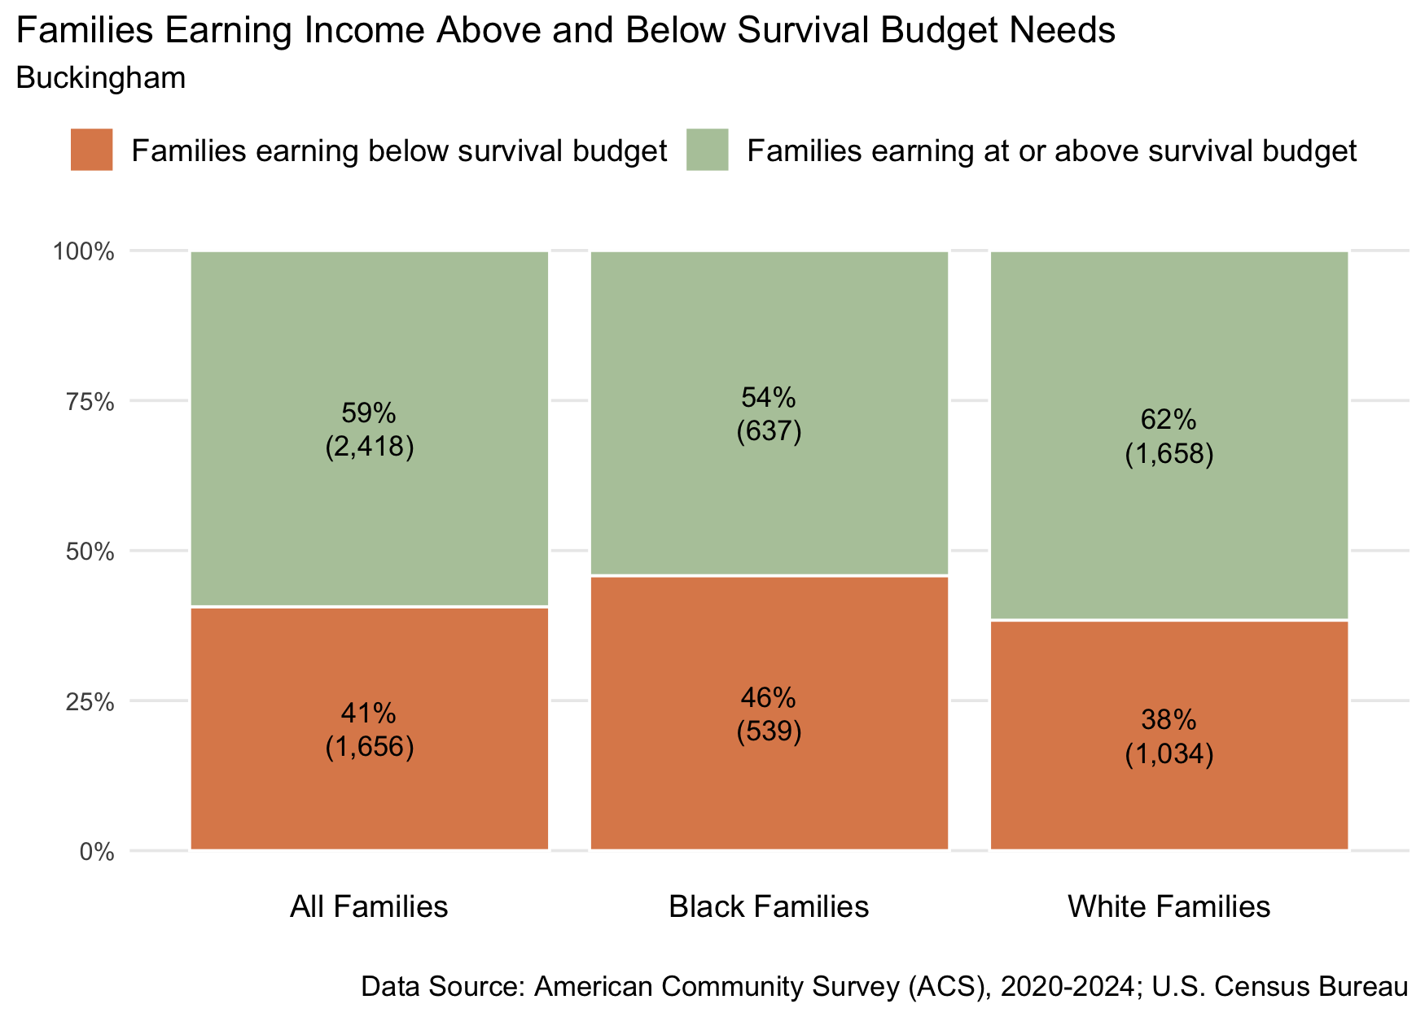
Figure 8: Percent and number of families earning above and below the average family survival budget, 2024 for Buckingham County
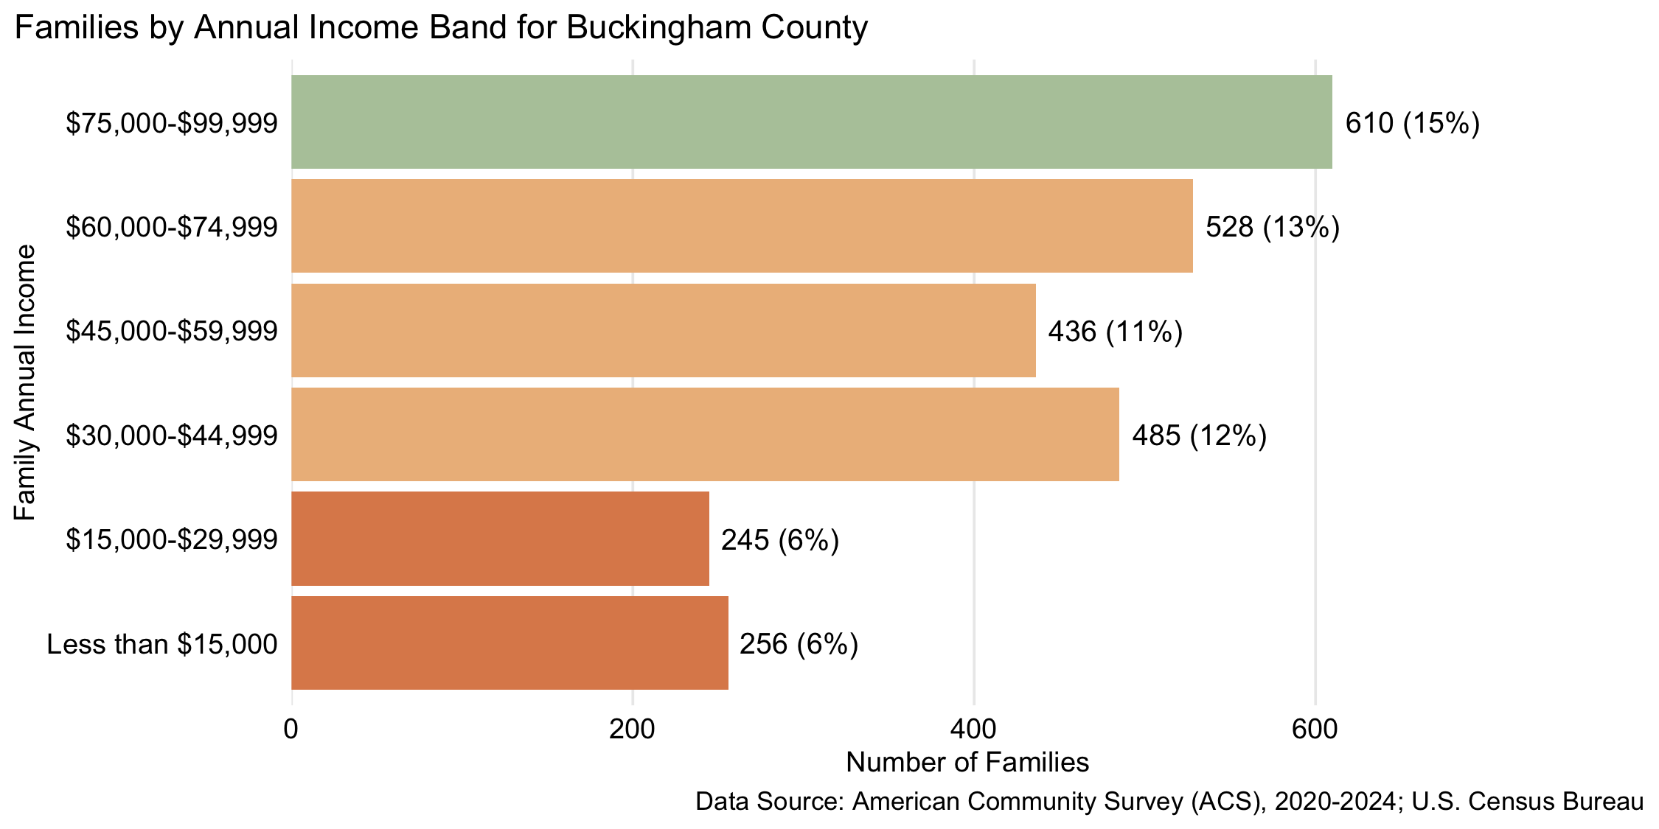
Figure 9: Number and percent of families by family annual income, for family incomes below $100,000, 2024, for Buckingham County

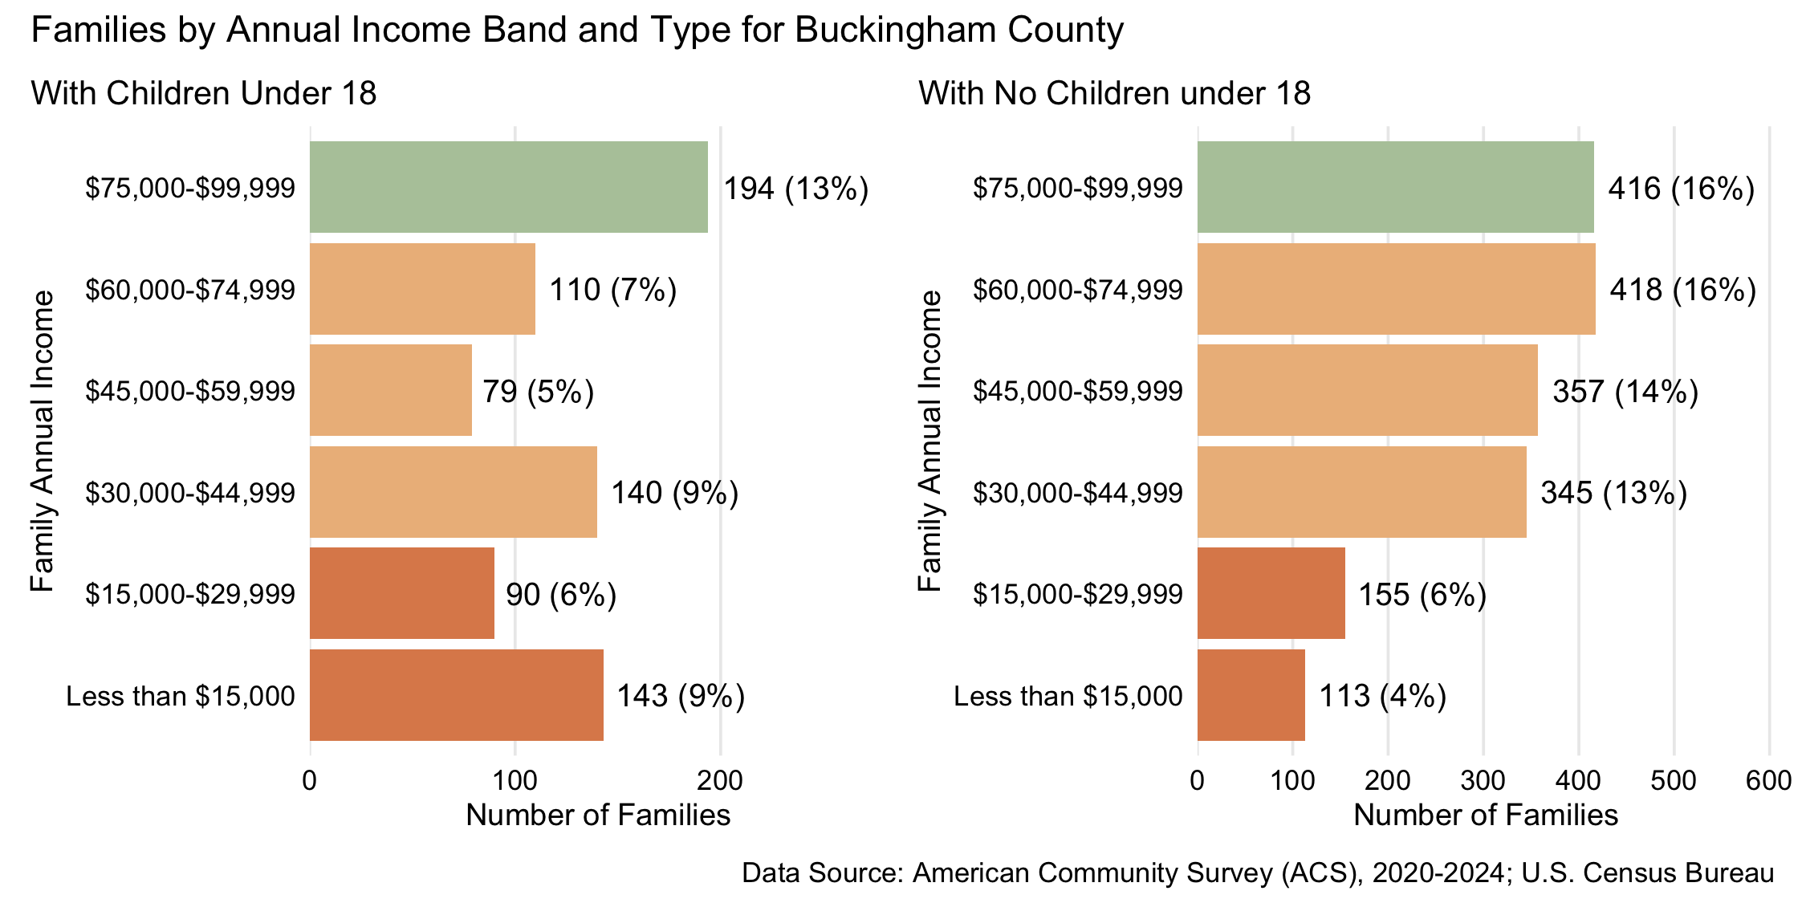
Figure 10: Number and percent of families with and without children under 18 years old by family annual income, for family incomes below $100,000, 2024, for Buckingham County
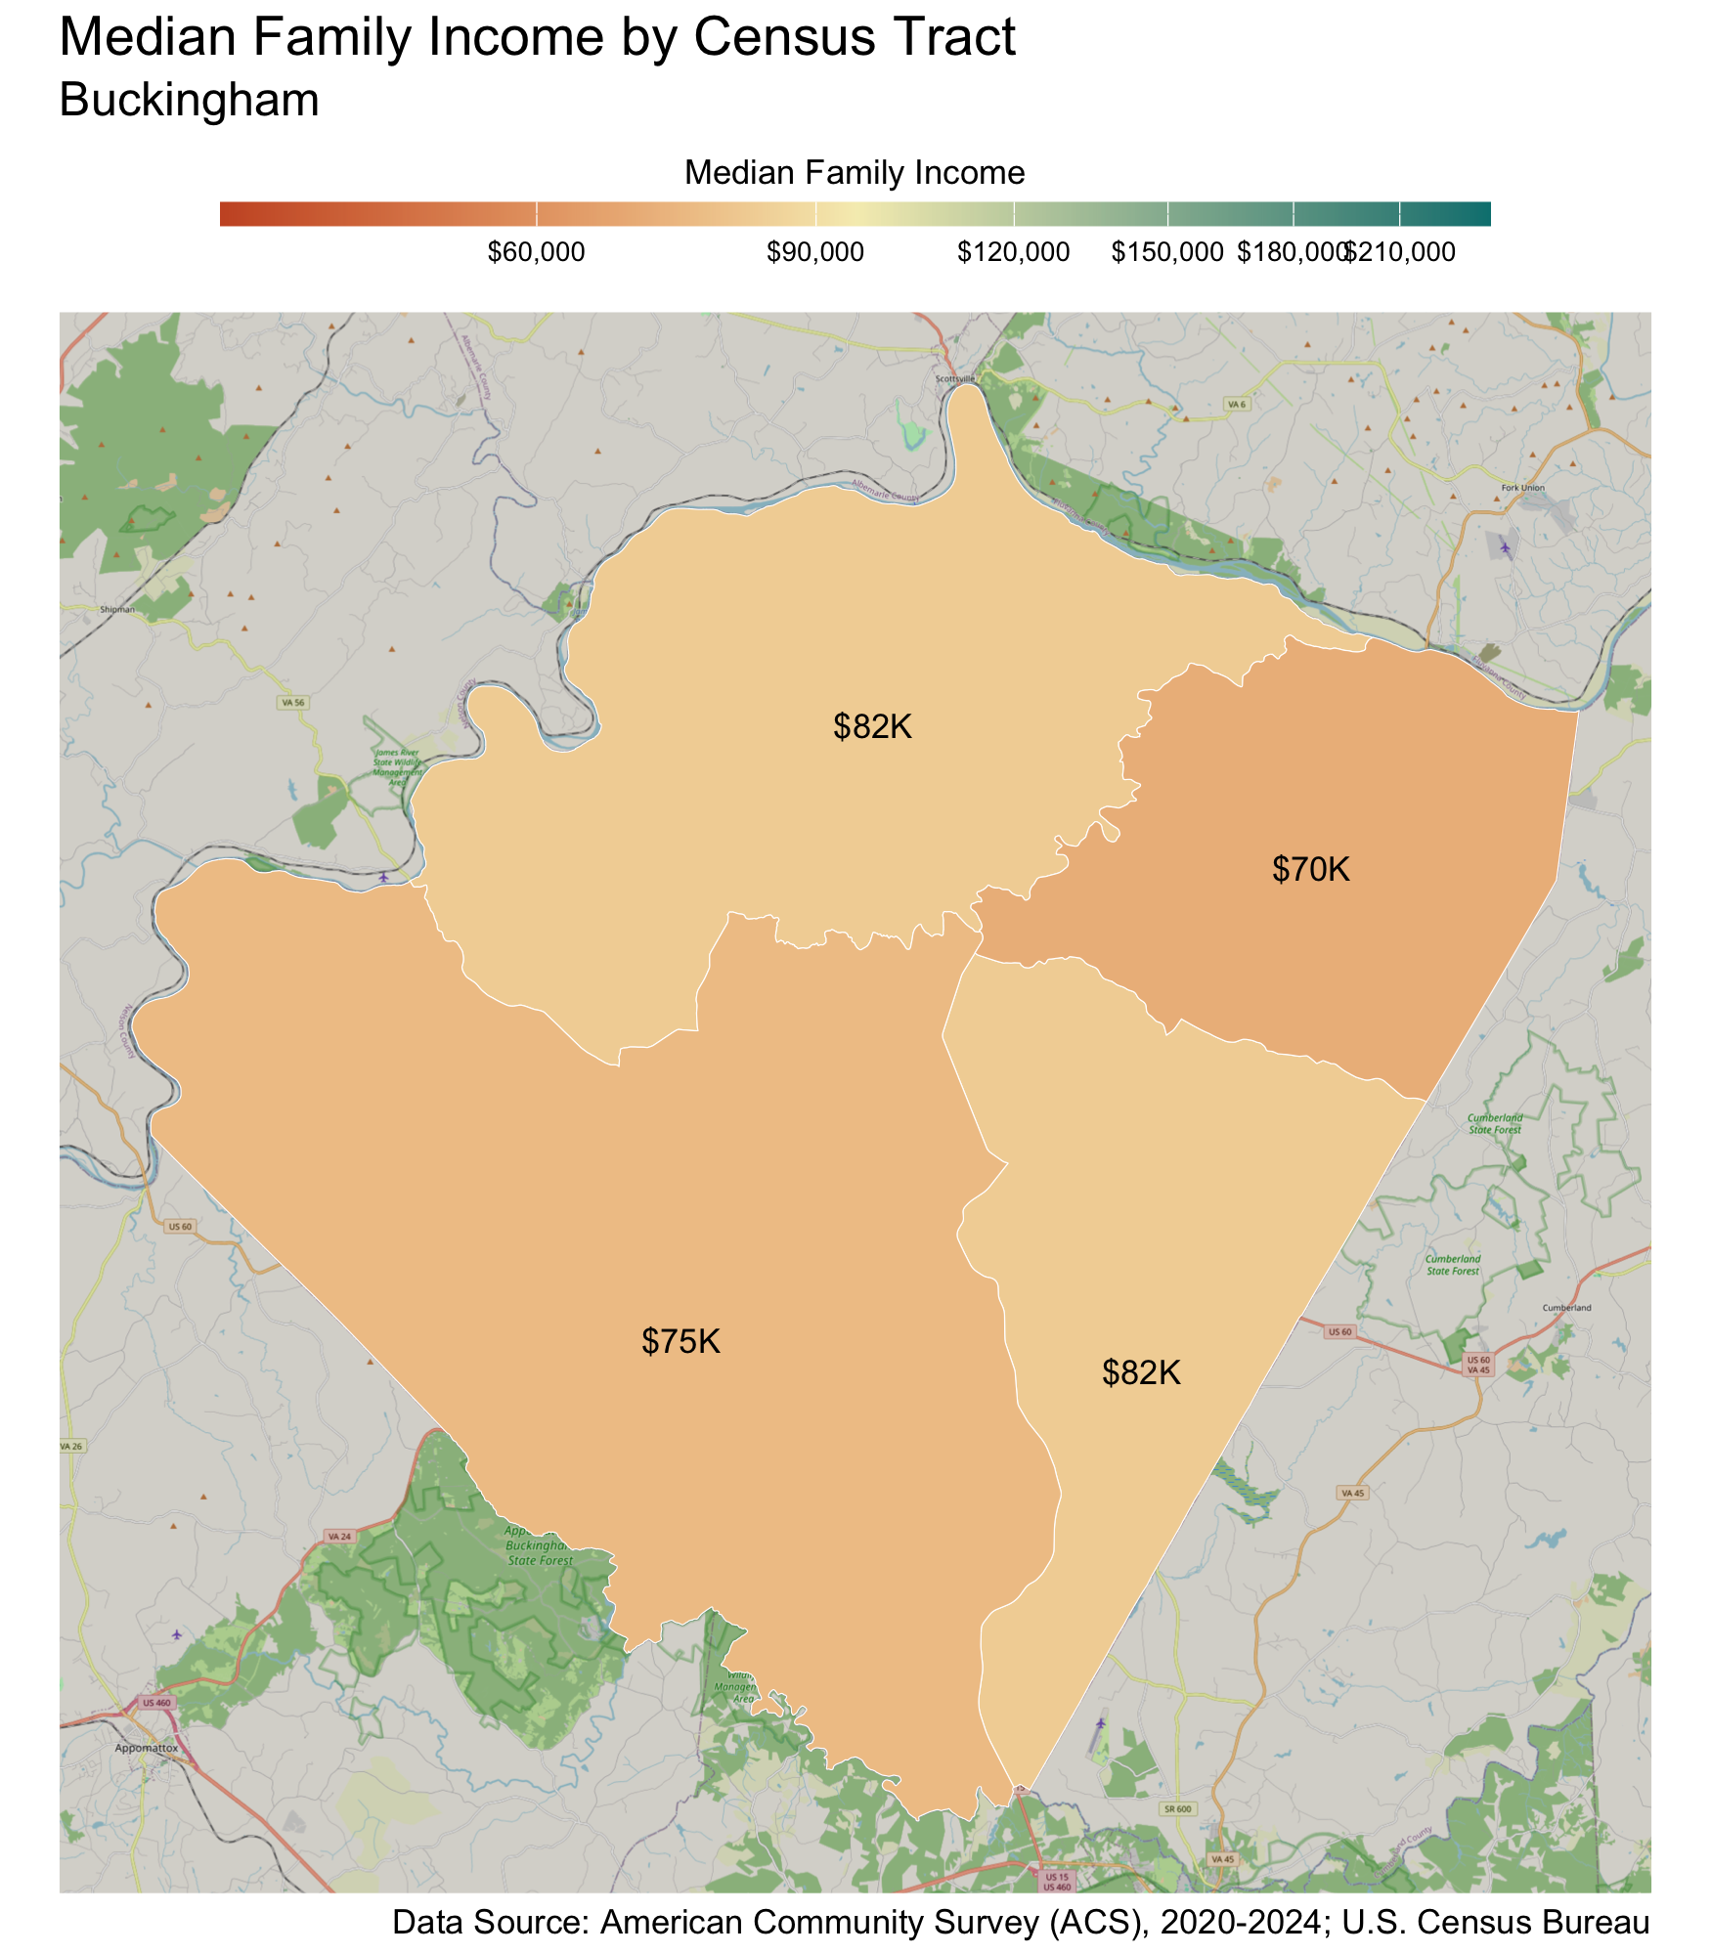
Census Tract |  | Median Family Income
New Canton |  | $70,000
Mount Rush |  | $75,000
Dillwyn |  | $82,000
James River |  | $82,000
* Census tracts listed in bold have a median family income below the locality's average family survival budget.
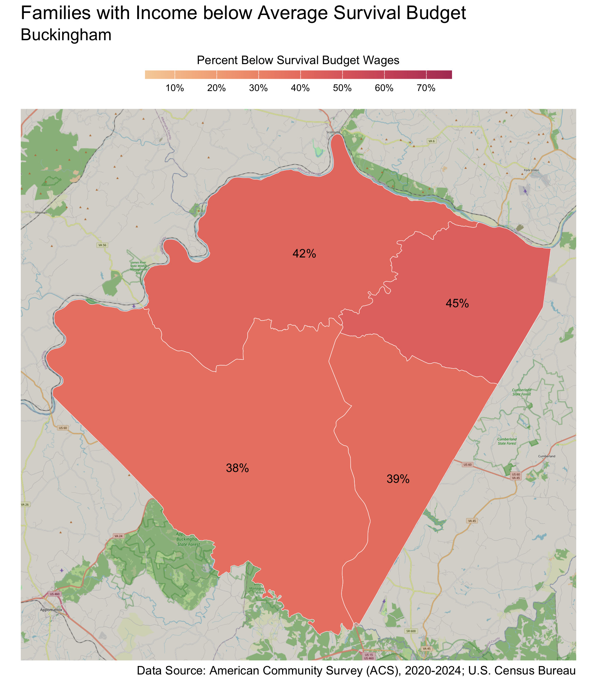
Census Tract |  | Percent
New Canton |  | 45%
James River |  | 42%
Dillwyn |  | 39%
Mount Rush |  | 38%

Households 65 years and over
Table 7: Average Survival Budget for Households 65 years and over in Buckingham
 | Monthly | Annual
Housing | $925.00 | $11,100.00
Child Care | $0.00 | $0.00
Food | $577.50 | $6,930.00
Transportation | $363.00 | $4,356.00
Health Care | $753.00 | $9,036.00
Technology | $119.00 | $1,428.00
Miscellaneous | $274.00 | $3,288.00
Taxes | $535.00 | $6,420.00
Total Income Needed to Meet Budget | $3,546.50 | $42,558.00
Note: The Average Household Survival Budget is calculated using the ALICE 2024 Household Survival Budgets. The average budget for households 65 years and over is calculated for each locality based on households with one or two adults aged 65 years and over. See the Appendix for detailed budgets for specific family compositions.
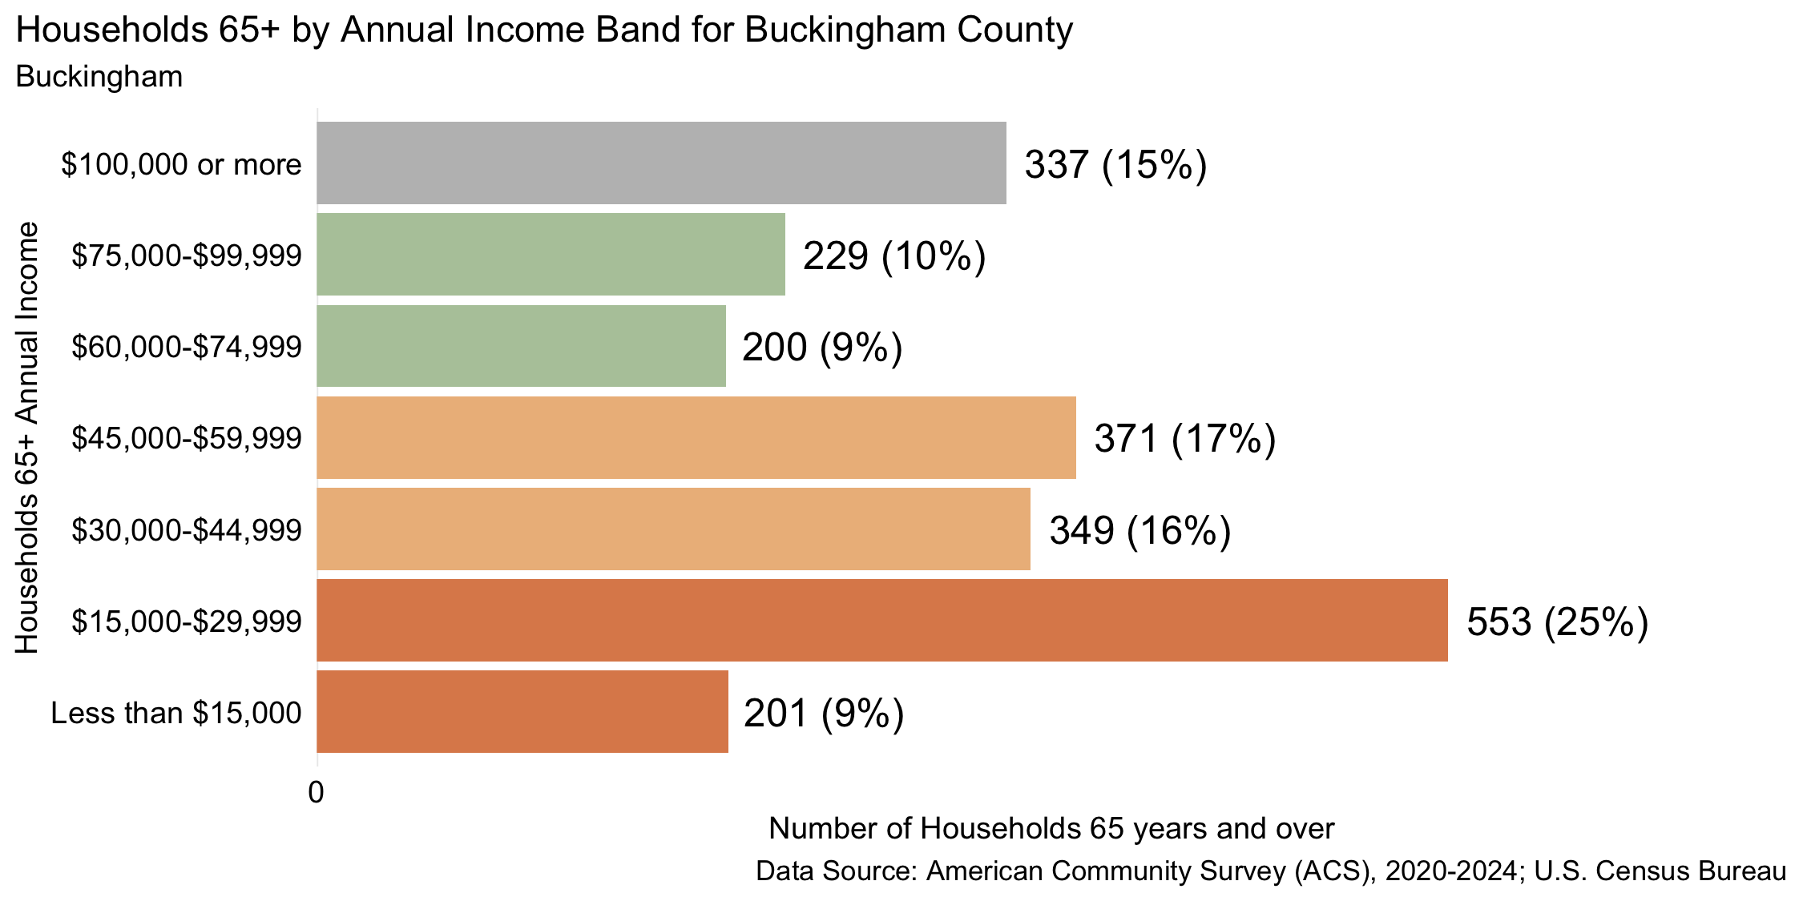
Figure 11: Number and percent of households 65 years and over by annual household income, 2024, for Buckingham County
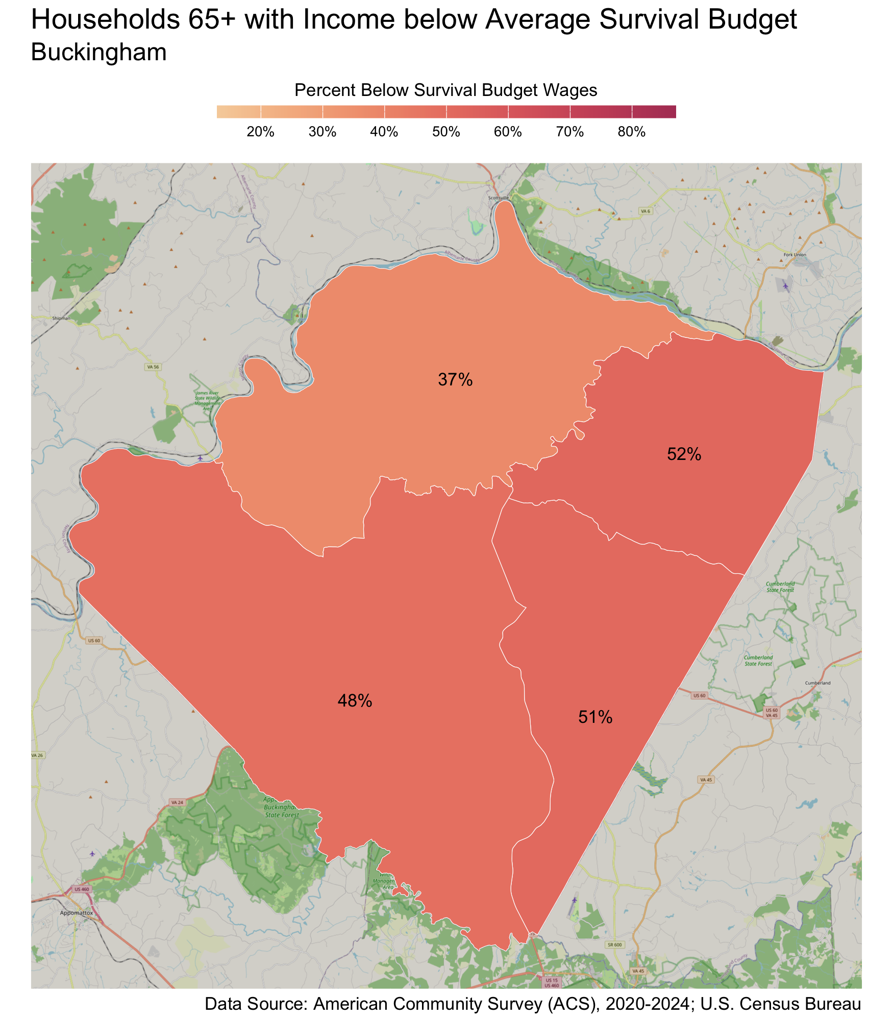
Census Tract |  | Percent
New Canton |  | 52%
Dillwyn |  | 51%
Mount Rush |  | 48%
James River |  | 37%

Charlottesville
There are 8,903 families living in Charlottesville City. Of these families, 3,135 (35%) do not earn enough to provide for their family’s basic needs.

Charlottesville City at a glance:
- The annual household survival budget for an average family in Charlottesville City is $87,017.52. This is the approximate income working families need to meet their basic necessities. The household survival budget includes: housing, child care, food, transportation, health care, and technology (phone and internet), plus taxes and a 10% contingency fund for one-time unanticipated costs.
- Approximately 3,135 families, or 35% of families, in Charlottesville City earn below their household’s survival budget.
- The percent of Black families not earning enough to meet their basic needs is 81%. The percent of Hispanic families not earning enough to meet their basic needs is 59%. These are 61% and 39% higher than the percent of white families earning below the survival budget (20%).
- The median family income for Charlottesville City is $119,149. The tract with the lowest median family income is 10th & Page-Venable at $38,000. The tract with the highest median family income is Barracks-Rugby at $239,000.
- The tract with the highest percent of families with income below the average survival budget is 10th & Page-Venable with 76% of families. The tract with the lowest percent of families not earning enough to meet their basic needs is Downtown Area with 8% of families. That is a difference of 68%.
- The annual survival budget for an average household 65 years and over in Charlottesville City is $57,966. The tract with the highest percent of households 65 years and over with income below the average survival budget is Ridge St. with 63%. The tract with the lowest percent of households 65 years and over not earning enough to meet their basic needs is Fifeville-Cherry Avenue with 29%.

Families
Table 8: Average Survival Budget for Families in Charlottesville
 | Monthly | Annual
Housing | $1,837.08 | $22,044.96
Child Care | $1,019.08 | $12,228.96
Food | $1,442.69 | $17,312.28
Transportation | $637.69 | $7,652.28
Health Care | $675.08 | $8,100.96
Technology | $122.92 | $1,475.04
Miscellaneous | $573.46 | $6,881.52
Taxes | $943.46 | $11,321.52
Total Income Needed to Meet Budget | $7,251.46 | $87,017.52
Note: The Average Family Survival Budget is calculated using the ALICE 2024 Household Survival Budgets. The average budget is calculated for each locality based on families with one or two adults and one or two children. Family compositions include children ages 0-2 years (infant), 3-4 years (preschooler), and 5-17 years (school-aged). See the Appendix for detailed budgets for specific family compositions.
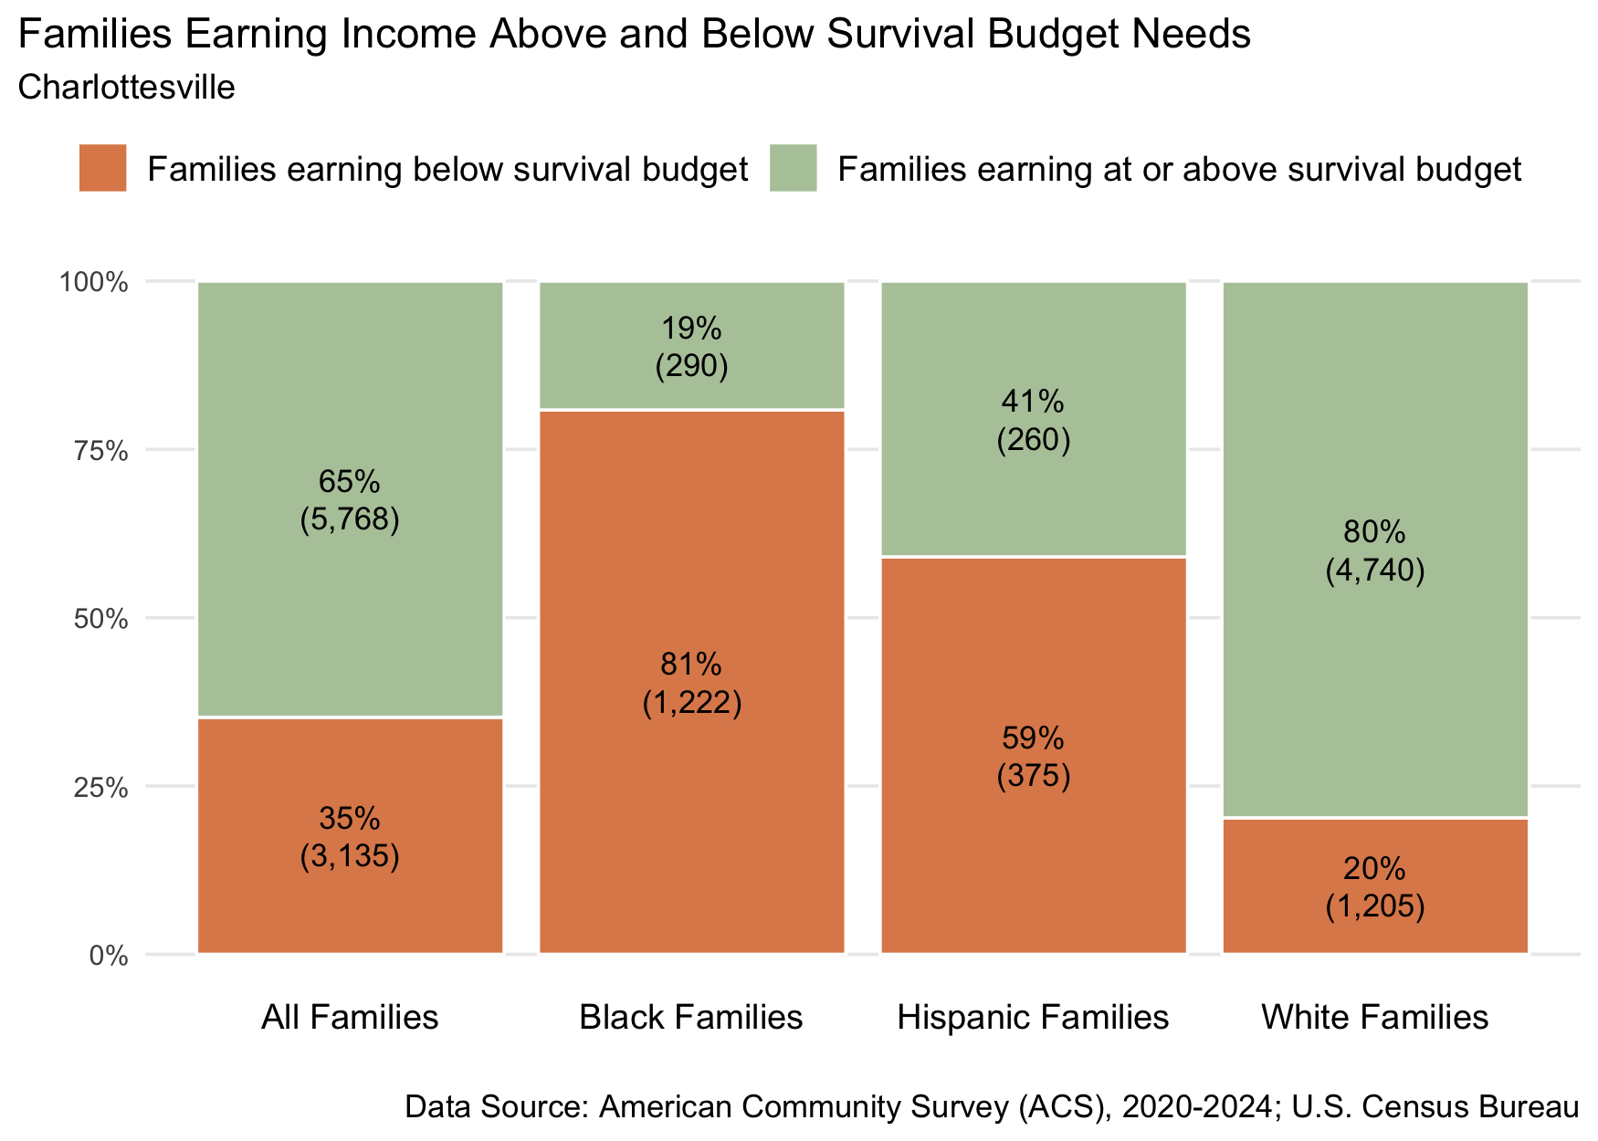
Figure 12: Percent and number of families earning above and below the average family survival budget, 2024 for Charlottesville City
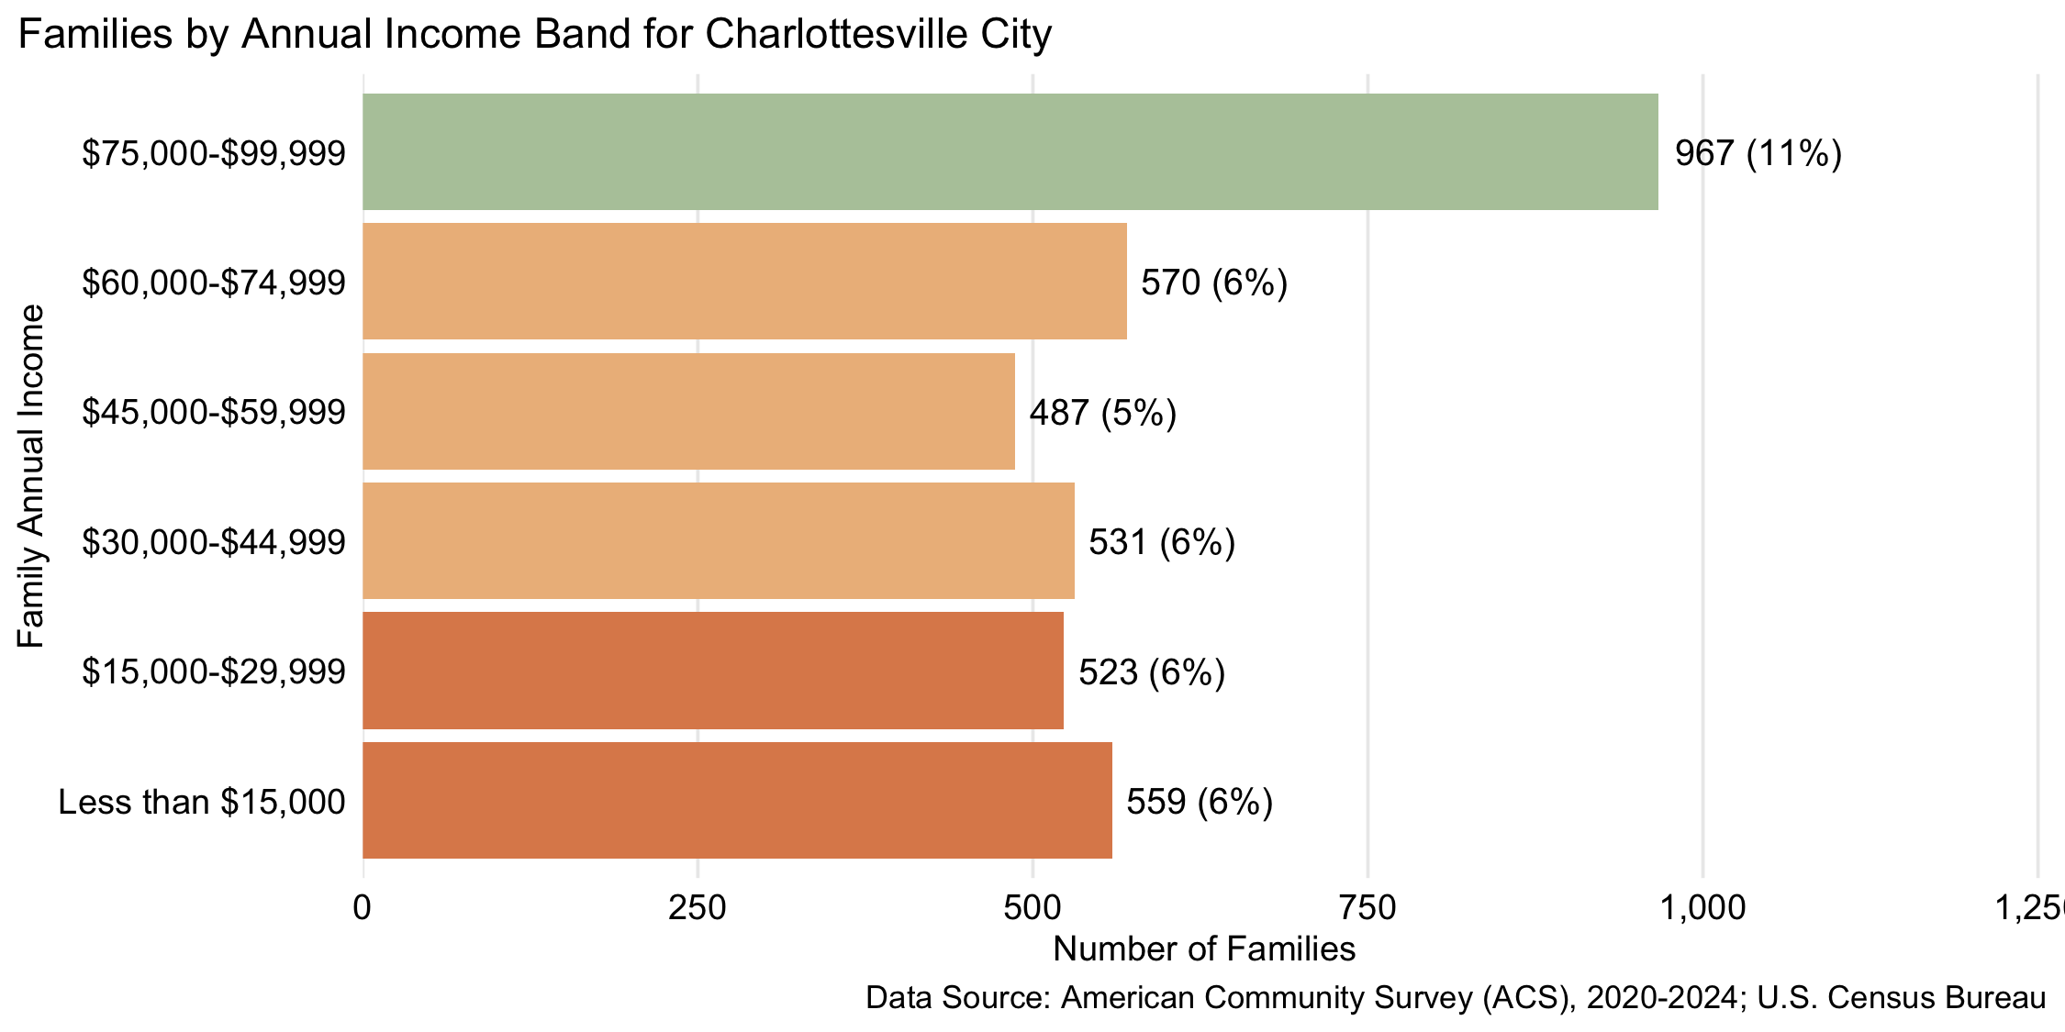
Figure 13: Number and percent of families by family annual income, for family incomes below $100,000, 2024, for Charlottesville City

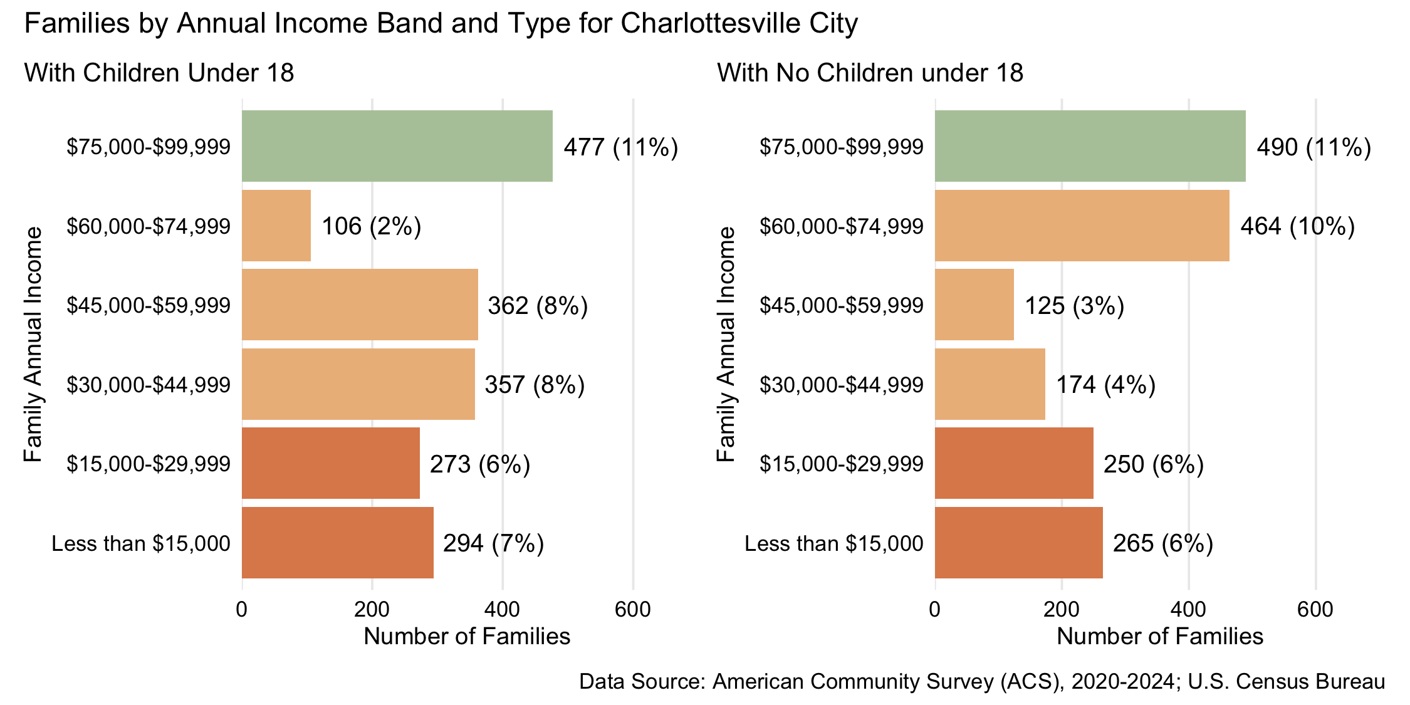
Figure 14: Number and percent of families with and without children under 18 years old by family annual income, for family incomes below $100,000, 2024, for Charlottesville City
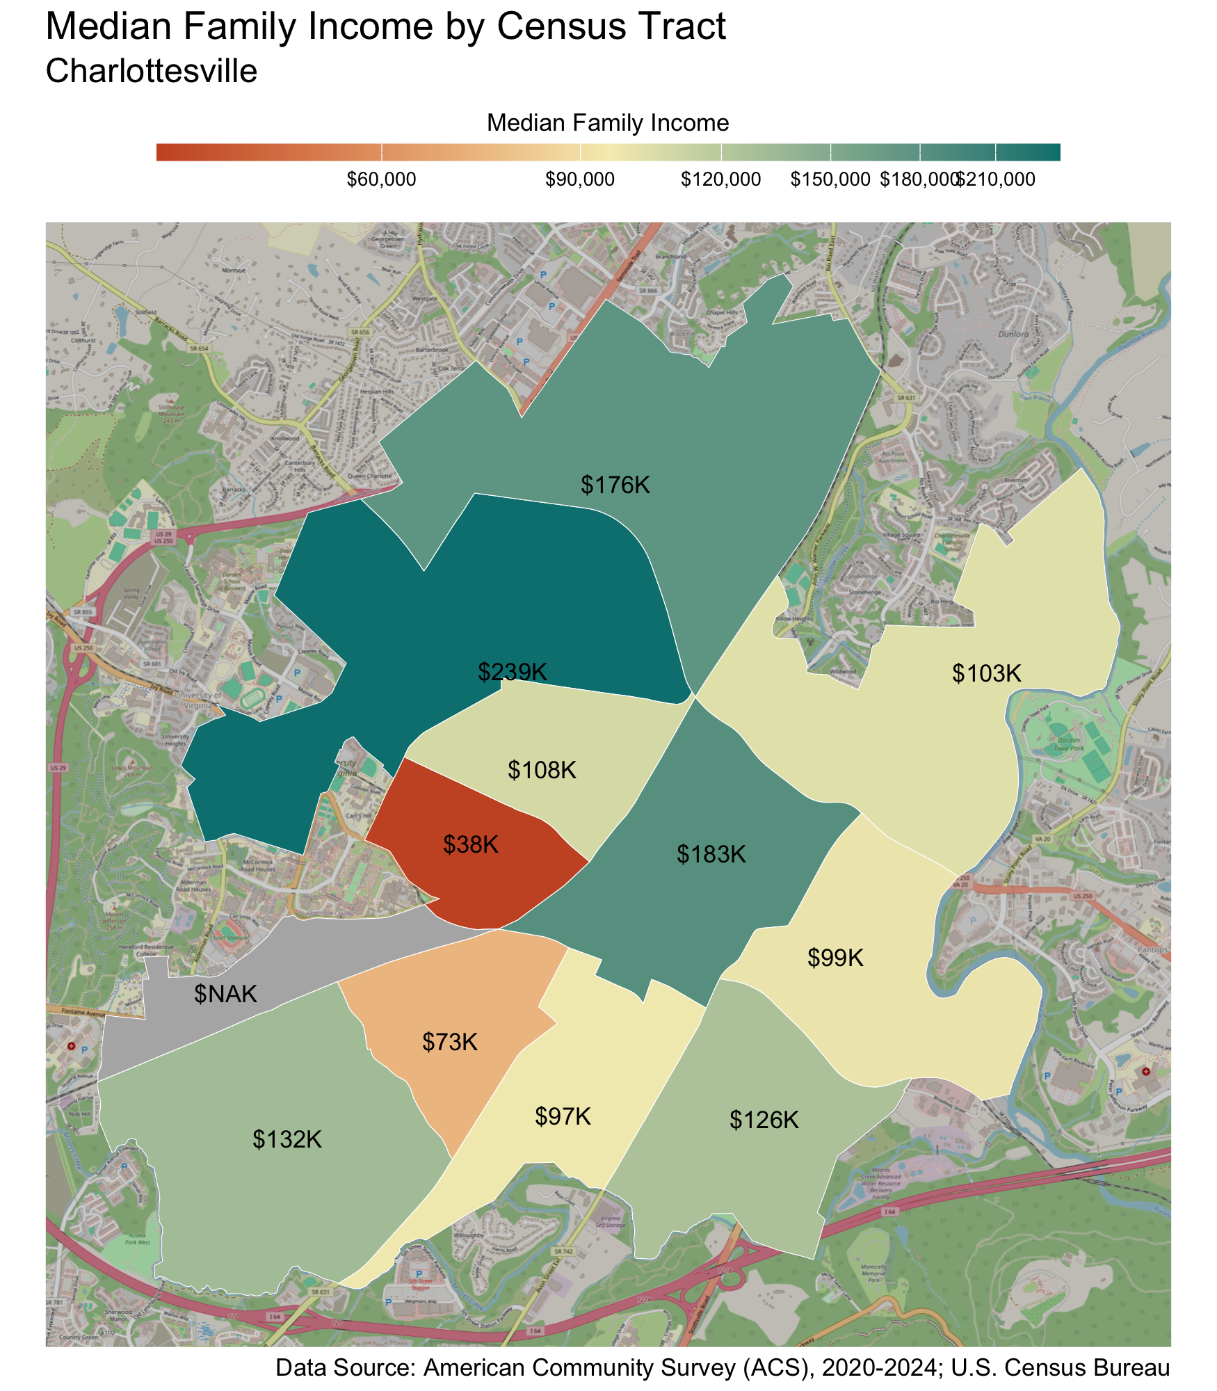
Census Tract |  | Median Family Income
10th & Page-Venable* |  | $38,000
Fifeville-Cherry Avenue* |  | $73,000
Ridge St. |  | $97,000
Woolen Mills |  | $99,000
Locust Grove |  | $103,000
Rose Hill-Harris-Venable |  | $108,000
Belmont |  | $126,000
Fry's Springs |  | $132,000
Greenbrier-Meadows |  | $176,000
Downtown Area |  | $183,000
Barracks-Rugby |  | $239,000
JPA-Fontaine |  | NA
* Census tracts listed in bold have a median family income below the locality's average family survival budget.
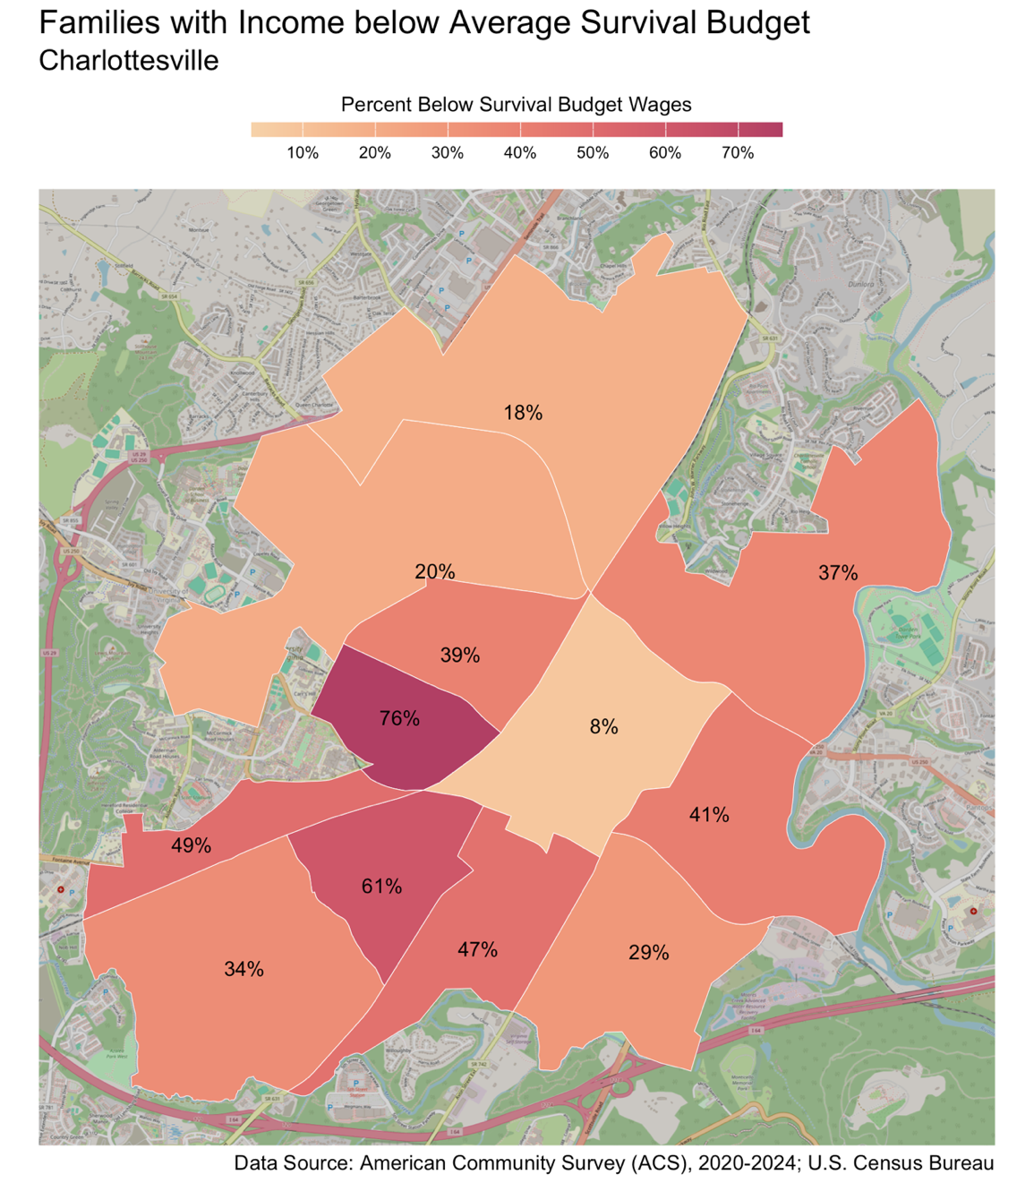
Census Tract |  | Percent
10th & Page-Venable |  | 76%
Fifeville-Cherry Avenue |  | 61%
JPA-Fontaine |  | 49%
Ridge St. |  | 47%
Woolen Mills |  | 41%
Rose Hill-Harris-Venable |  | 39%
Locust Grove |  | 37%
Fry's Springs |  | 34%
Belmont |  | 29%
Barracks-Rugby |  | 20%
Greenbrier-Meadows |  | 18%
Downtown Area |  | 8%

Households 65 years and over
Table 9: Average Survival Budget for Households 65 years and over in Charlottesville
 | Monthly | Annual
Housing | $1,614.00 | $19,368.00
Child Care | $0.00 | $0.00
Food | $842.50 | $10,110.00
Transportation | $363.00 | $4,356.00
Health Care | $729.50 | $8,754.00
Technology | $119.00 | $1,428.00
Miscellaneous | $367.00 | $4,404.00
Taxes | $795.50 | $9,546.00
Total Income Needed to Meet Budget | $4,830.50 | $57,966.00
Note: The Average Household Survival Budget is calculated using the ALICE 2024 Household Survival Budgets. The average budget for households 65 years and over is calculated for each locality based on households with one or two adults aged 65 years and over. See the Appendix for detailed budgets for specific family compositions.
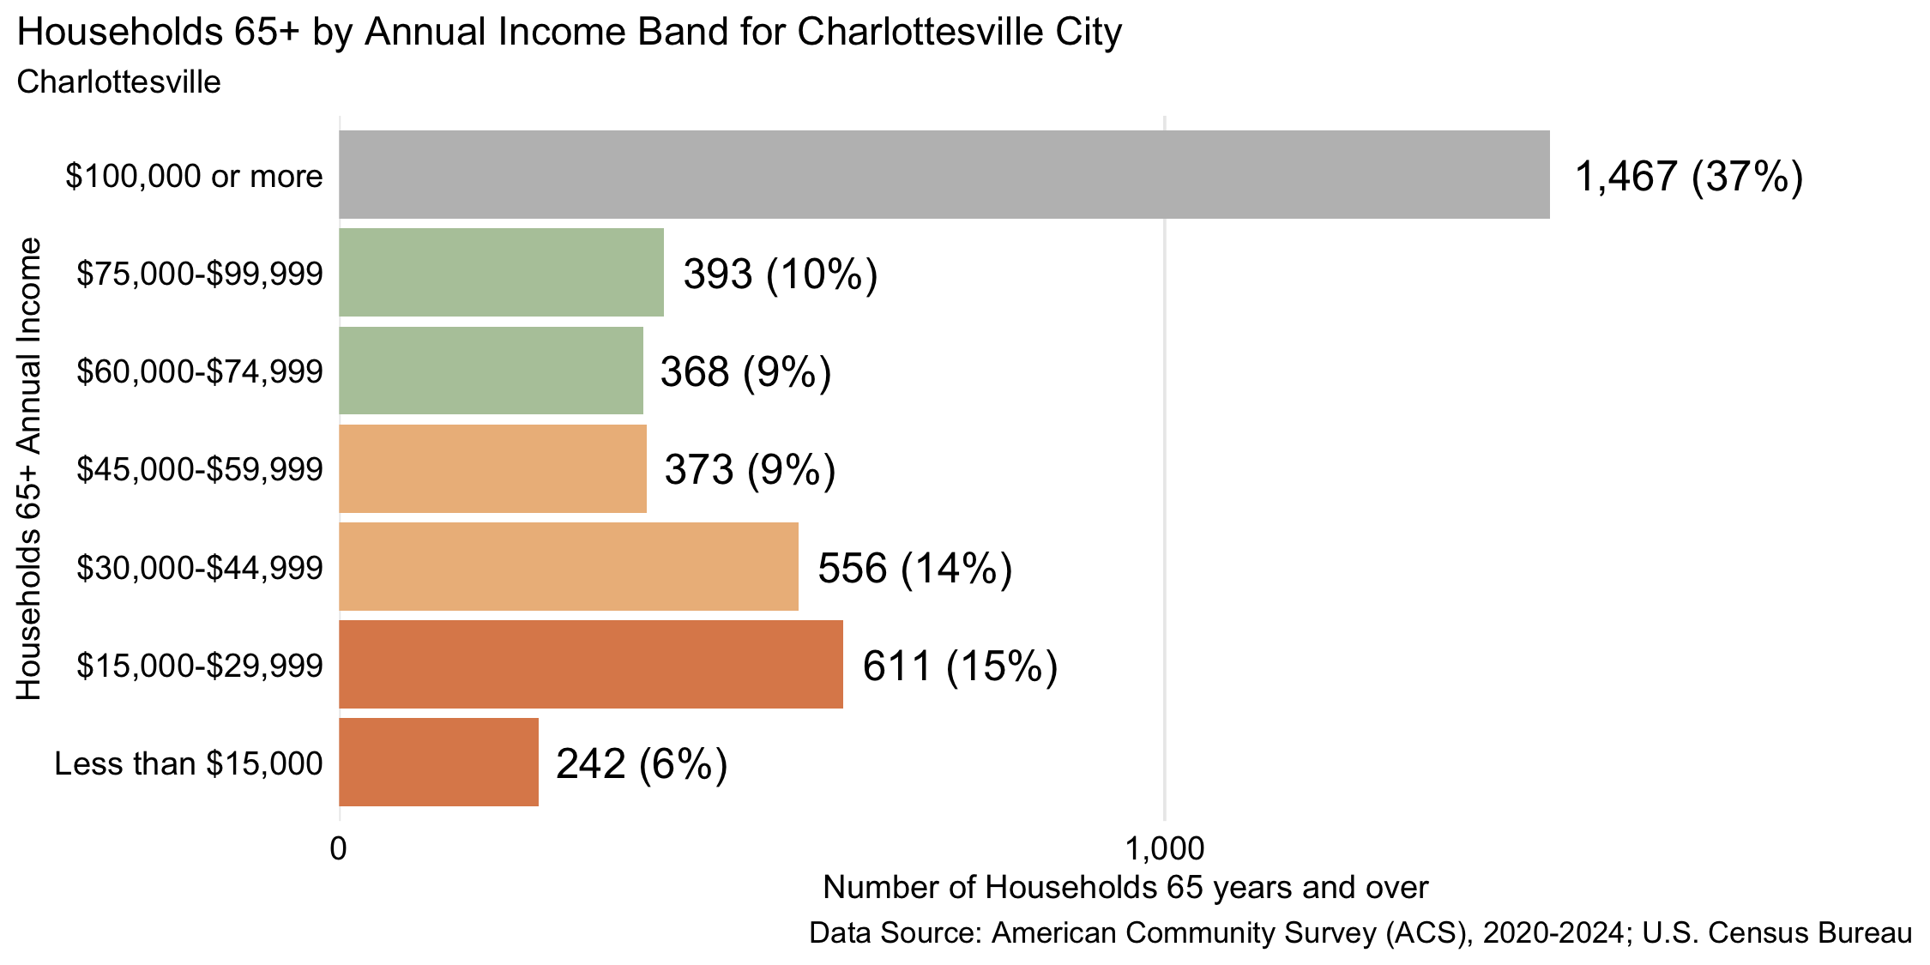
Figure 15: Number and percent of households 65 years and over by annual household income, 2024, for Charlottesville City
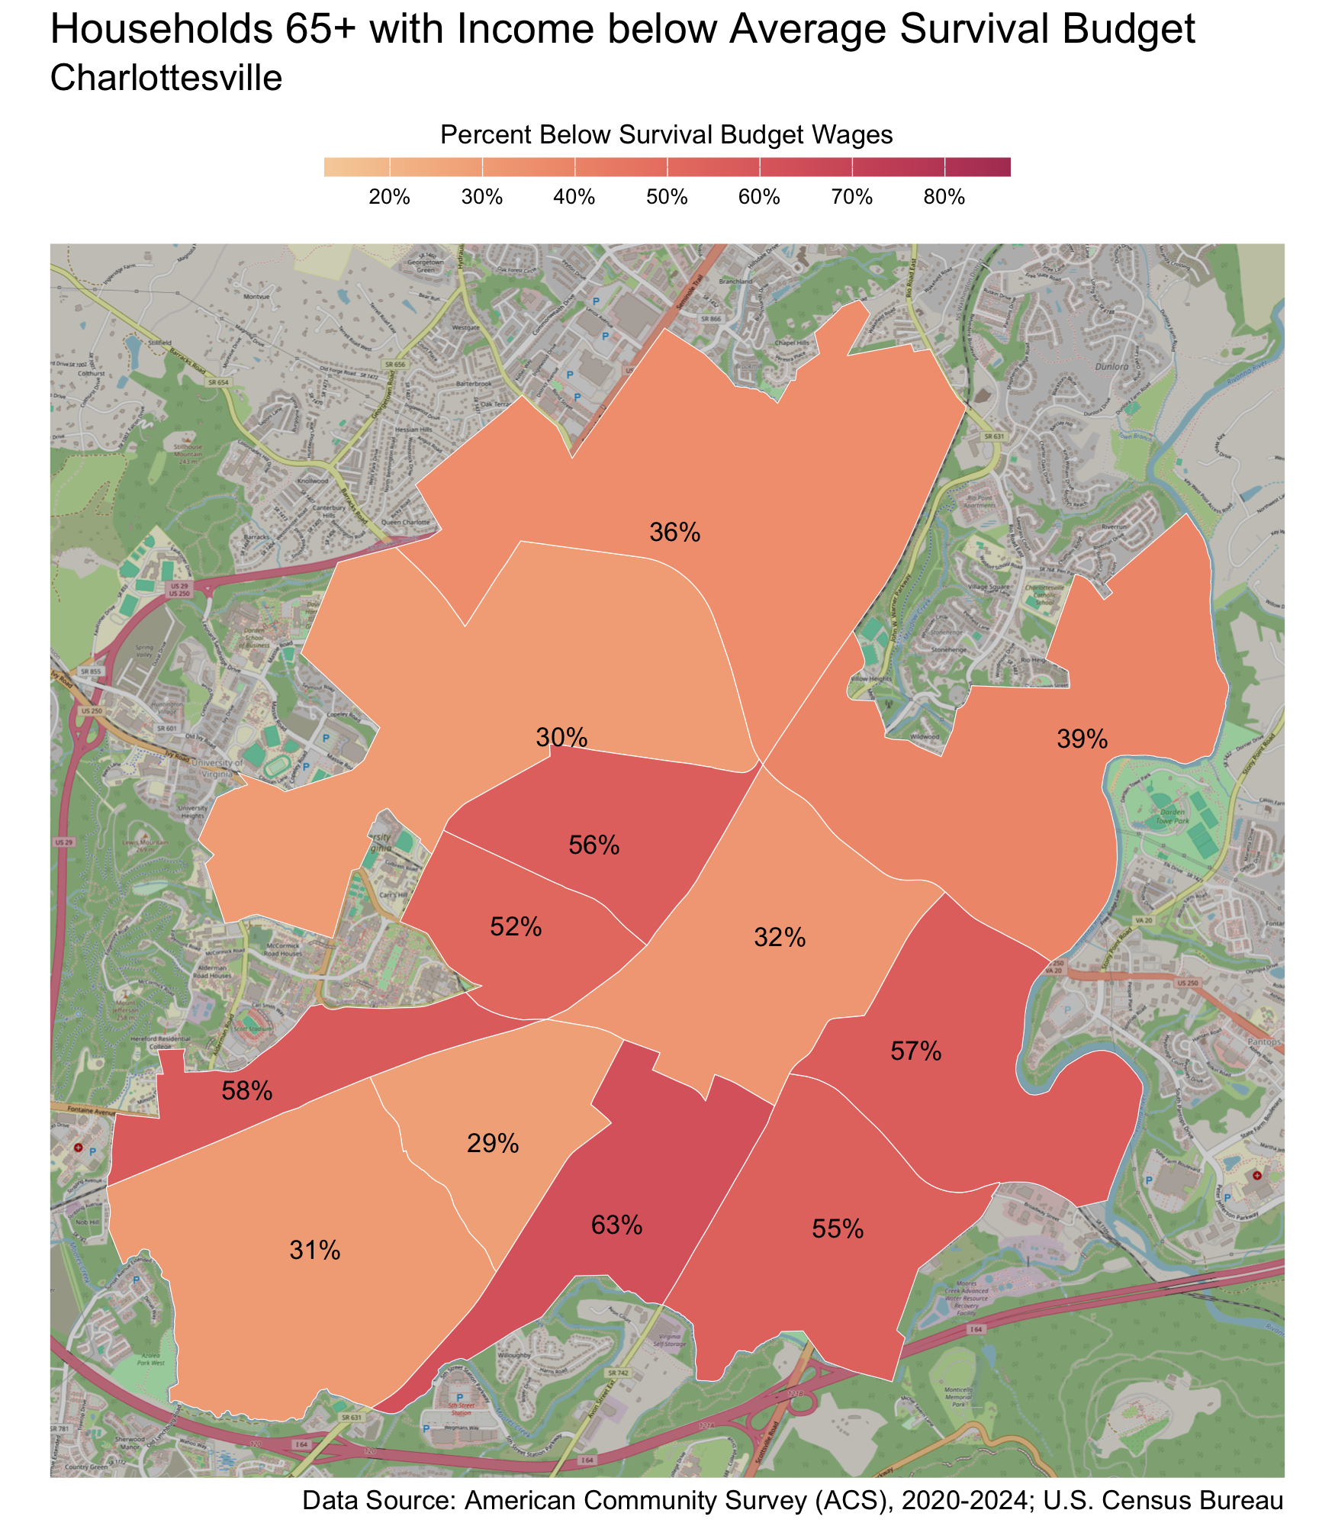
Census Tract |  | Percent
Ridge St. |  | 63%
JPA-Fontaine |  | 58%
Woolen Mills |  | 57%
Rose Hill-Harris-Venable |  | 56%
Belmont |  | 55%
10th & Page-Venable |  | 52%
Locust Grove |  | 39%
Greenbrier-Meadows |  | 36%
Downtown Area |  | 32%
Fry's Springs |  | 31%
Barracks-Rugby |  | 30%
Fifeville-Cherry Avenue |  | 29%

Fluvanna County
There are 7,549 families living in Fluvanna County. Of these families, 2,585 (34%) do not earn enough to provide for their family’s basic needs.

Fluvanna County at a glance:
- The annual survival budget for an average family in Fluvanna County is $81,257.52. This is the income working families need to meet their basic necessities. The survival budget include: housing, child care, food, transportation, health care, and technology (phone and internet), plus taxes and a 10% contingency fund for one-time unanticipated costs.
- Approximately 2,585 families, or 34% of families, in Fluvanna County earn below their household’s survival budget.
- The percent of Black families not earning enough to meet their basic needs is 55%. This is 24% higher than the percent of white families earning below the survival budget (31%).
- The median family income for Fluvanna County is $104,986. The tract with the lowest median family income is Columbia/Fork Union at $54,000. The tract with the highest median family income is Lake Monticello and Palmyra at $123,000.
- The tract with the highest percent of families with income below the average survival budget is Columbia/Fork Union with 75% of families. The tract with the lowest percent of families not earning enough to meet their basic needs is Cunningham and Palmyra with 25% of families. That is a difference of 50%.
- The annual survival budget for an average household 65 years and over in Fluvanna County is $53,754. The tract with the highest percent of households 65 years and over with income below the average survival budget is Columbia/Fork Union with 69%. The tract with the lowest percent of households 65 years and over not earning enough to meet their basic needs is Lake Monticello and Palmyra with 22%.

Families
Table 10: Average Survival Budget for Families in Fluvanna
 | Monthly | Annual
Housing | $1,757.08 | $21,084.96
Child Care | $1,019.08 | $12,228.96
Food | $1,179.23 | $14,150.76
Transportation | $637.69 | $7,652.28
Health Care | $672.00 | $8,064.00
Technology | $122.92 | $1,475.04
Miscellaneous | $538.92 | $6,467.04
Taxes | $844.54 | $10,134.48
Total Income Needed to Meet Budget | $6,771.46 | $81,257.52
Note: The Average Family Survival Budget is calculated using the ALICE 2024 Household Survival Budgets. The average budget is calculated for each locality based on families with one or two adults and one or two children. Family compositions include children ages 0-2 years (infant), 3-4 years (preschooler), and 5-17 years (school-aged). See the Appendix for detailed budgets for specific family compositions.
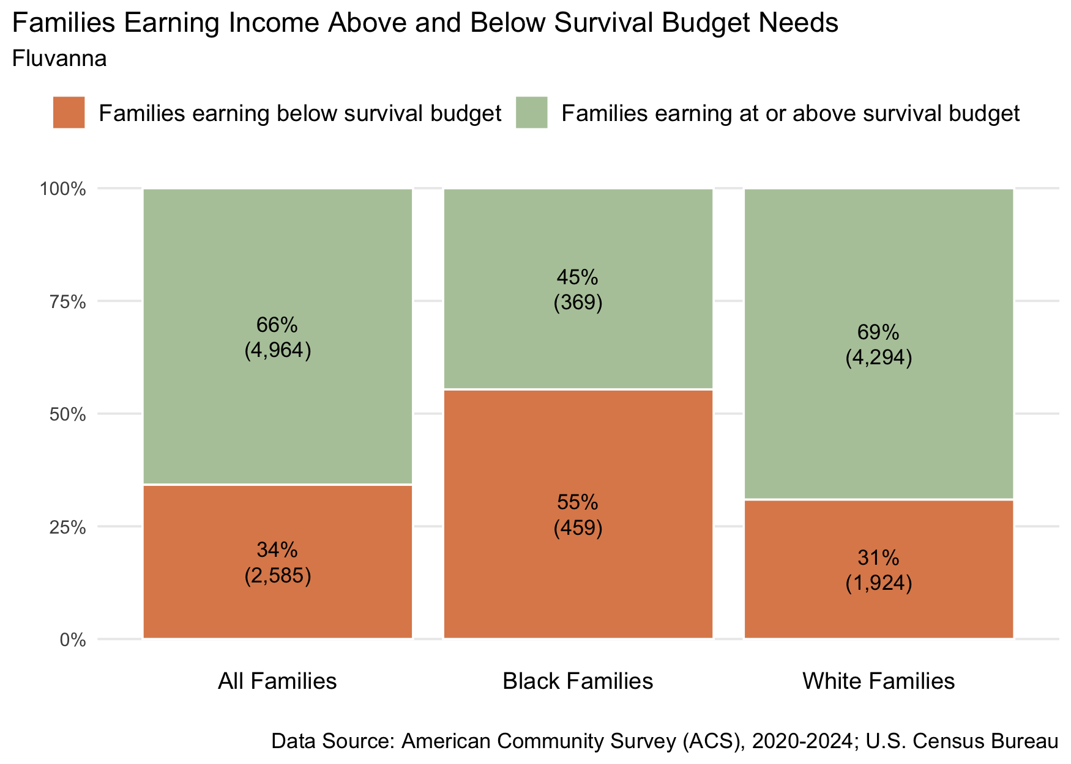
Figure 16: Percent and number of families earning above and below the average family survival budget, 2024 for Fluvanna County
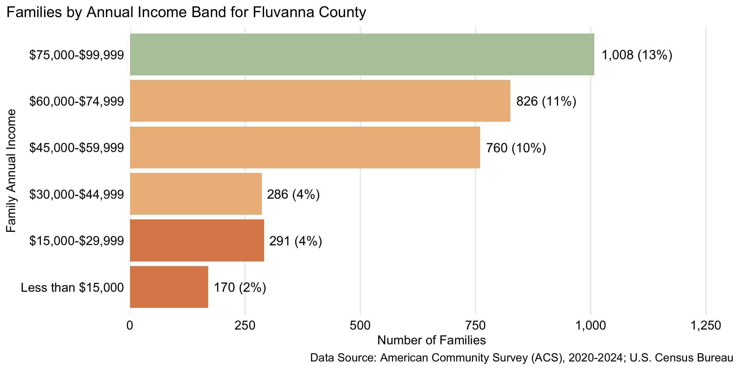
Figure 17: Number and percent of families by family annual income, for family incomes below $100,000, 2024, for Fluvanna County

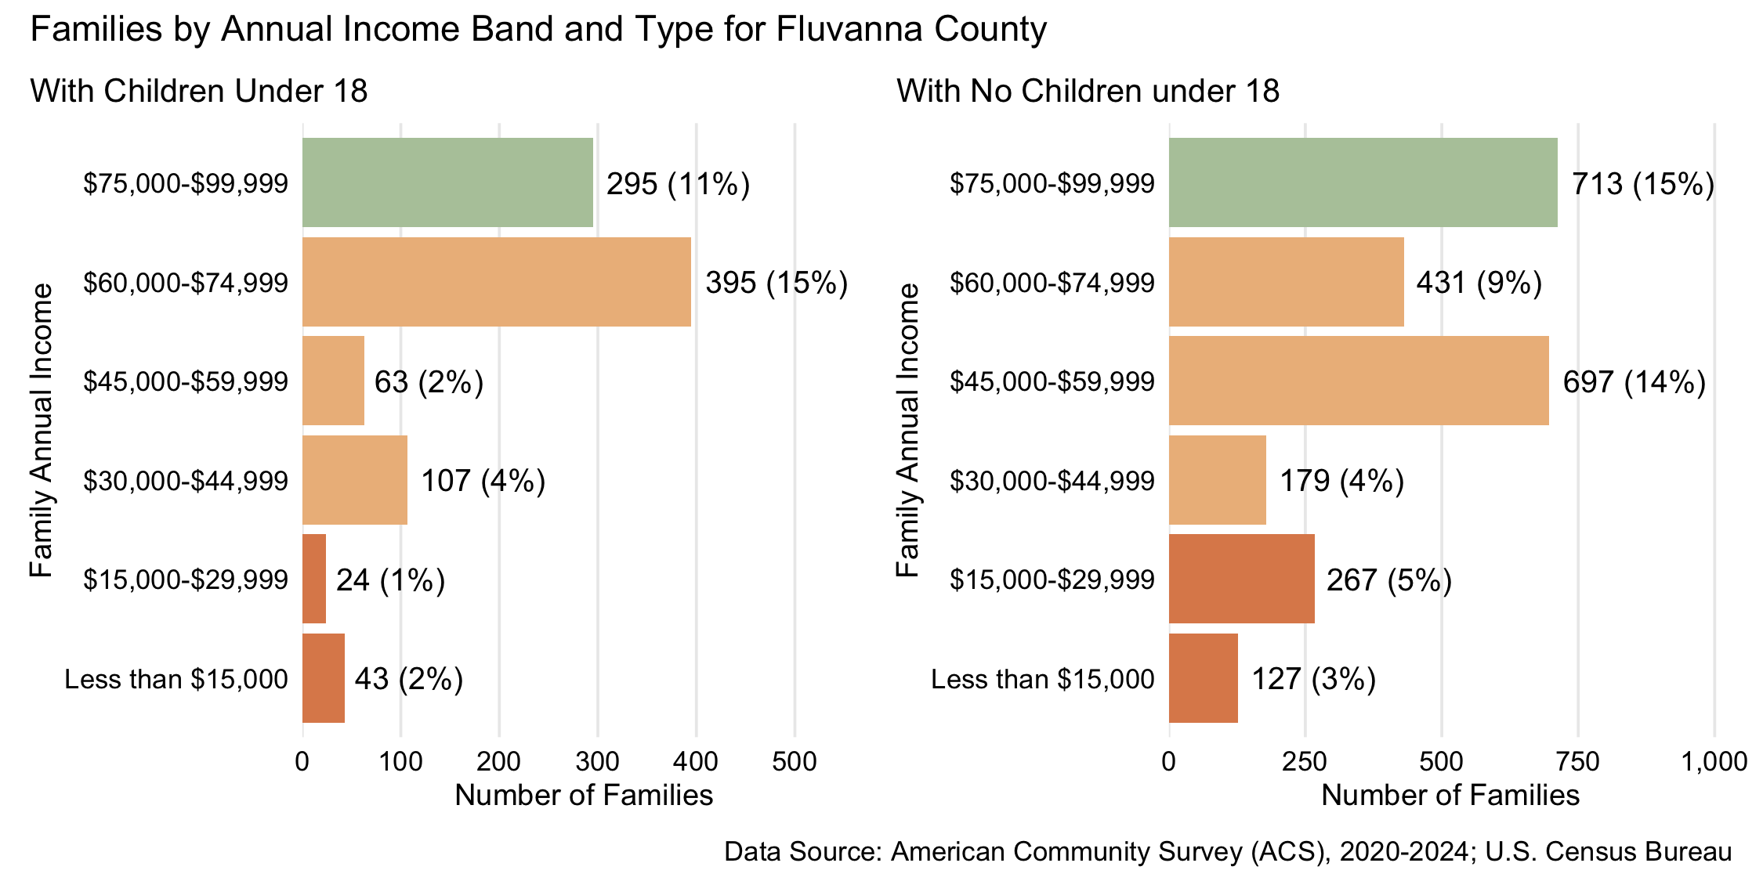
Figure 18: Number and percent of families with and without children under 18 years old by family annual income, for family incomes below $100,000, 2024, for Fluvanna County
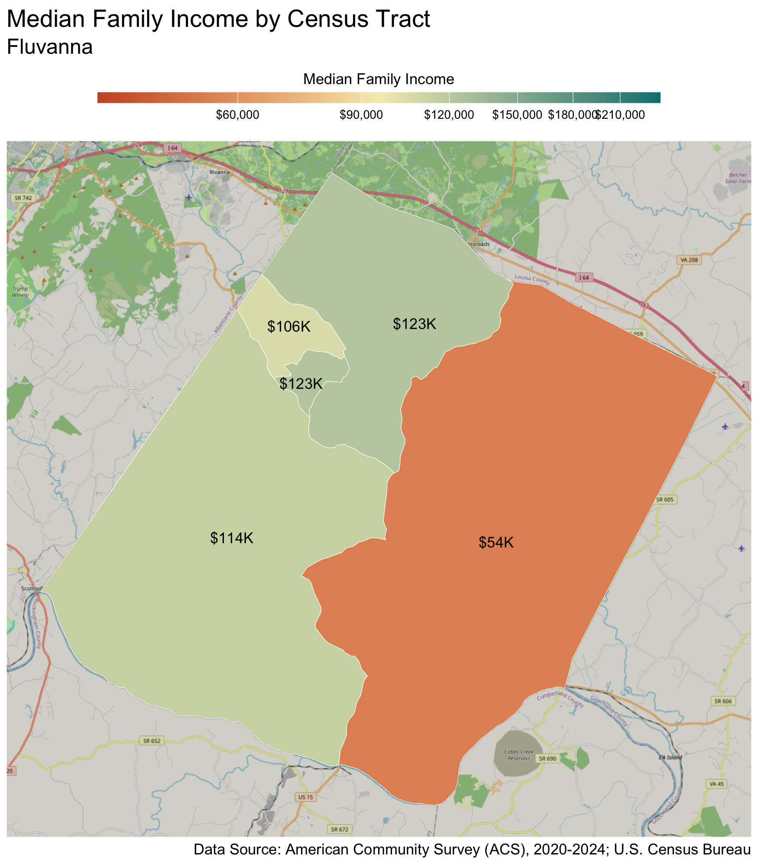
Census Tract |  | Median Family Income
Columbia/Fork Union* |  | $54,000
Rivanna |  | $106,000
Cunningham |  | $114,000
Lake Monticello |  | $123,000
Palmyra |  | $123,000
* Census tracts listed in bold have a median family income below the locality's average family survival budget.
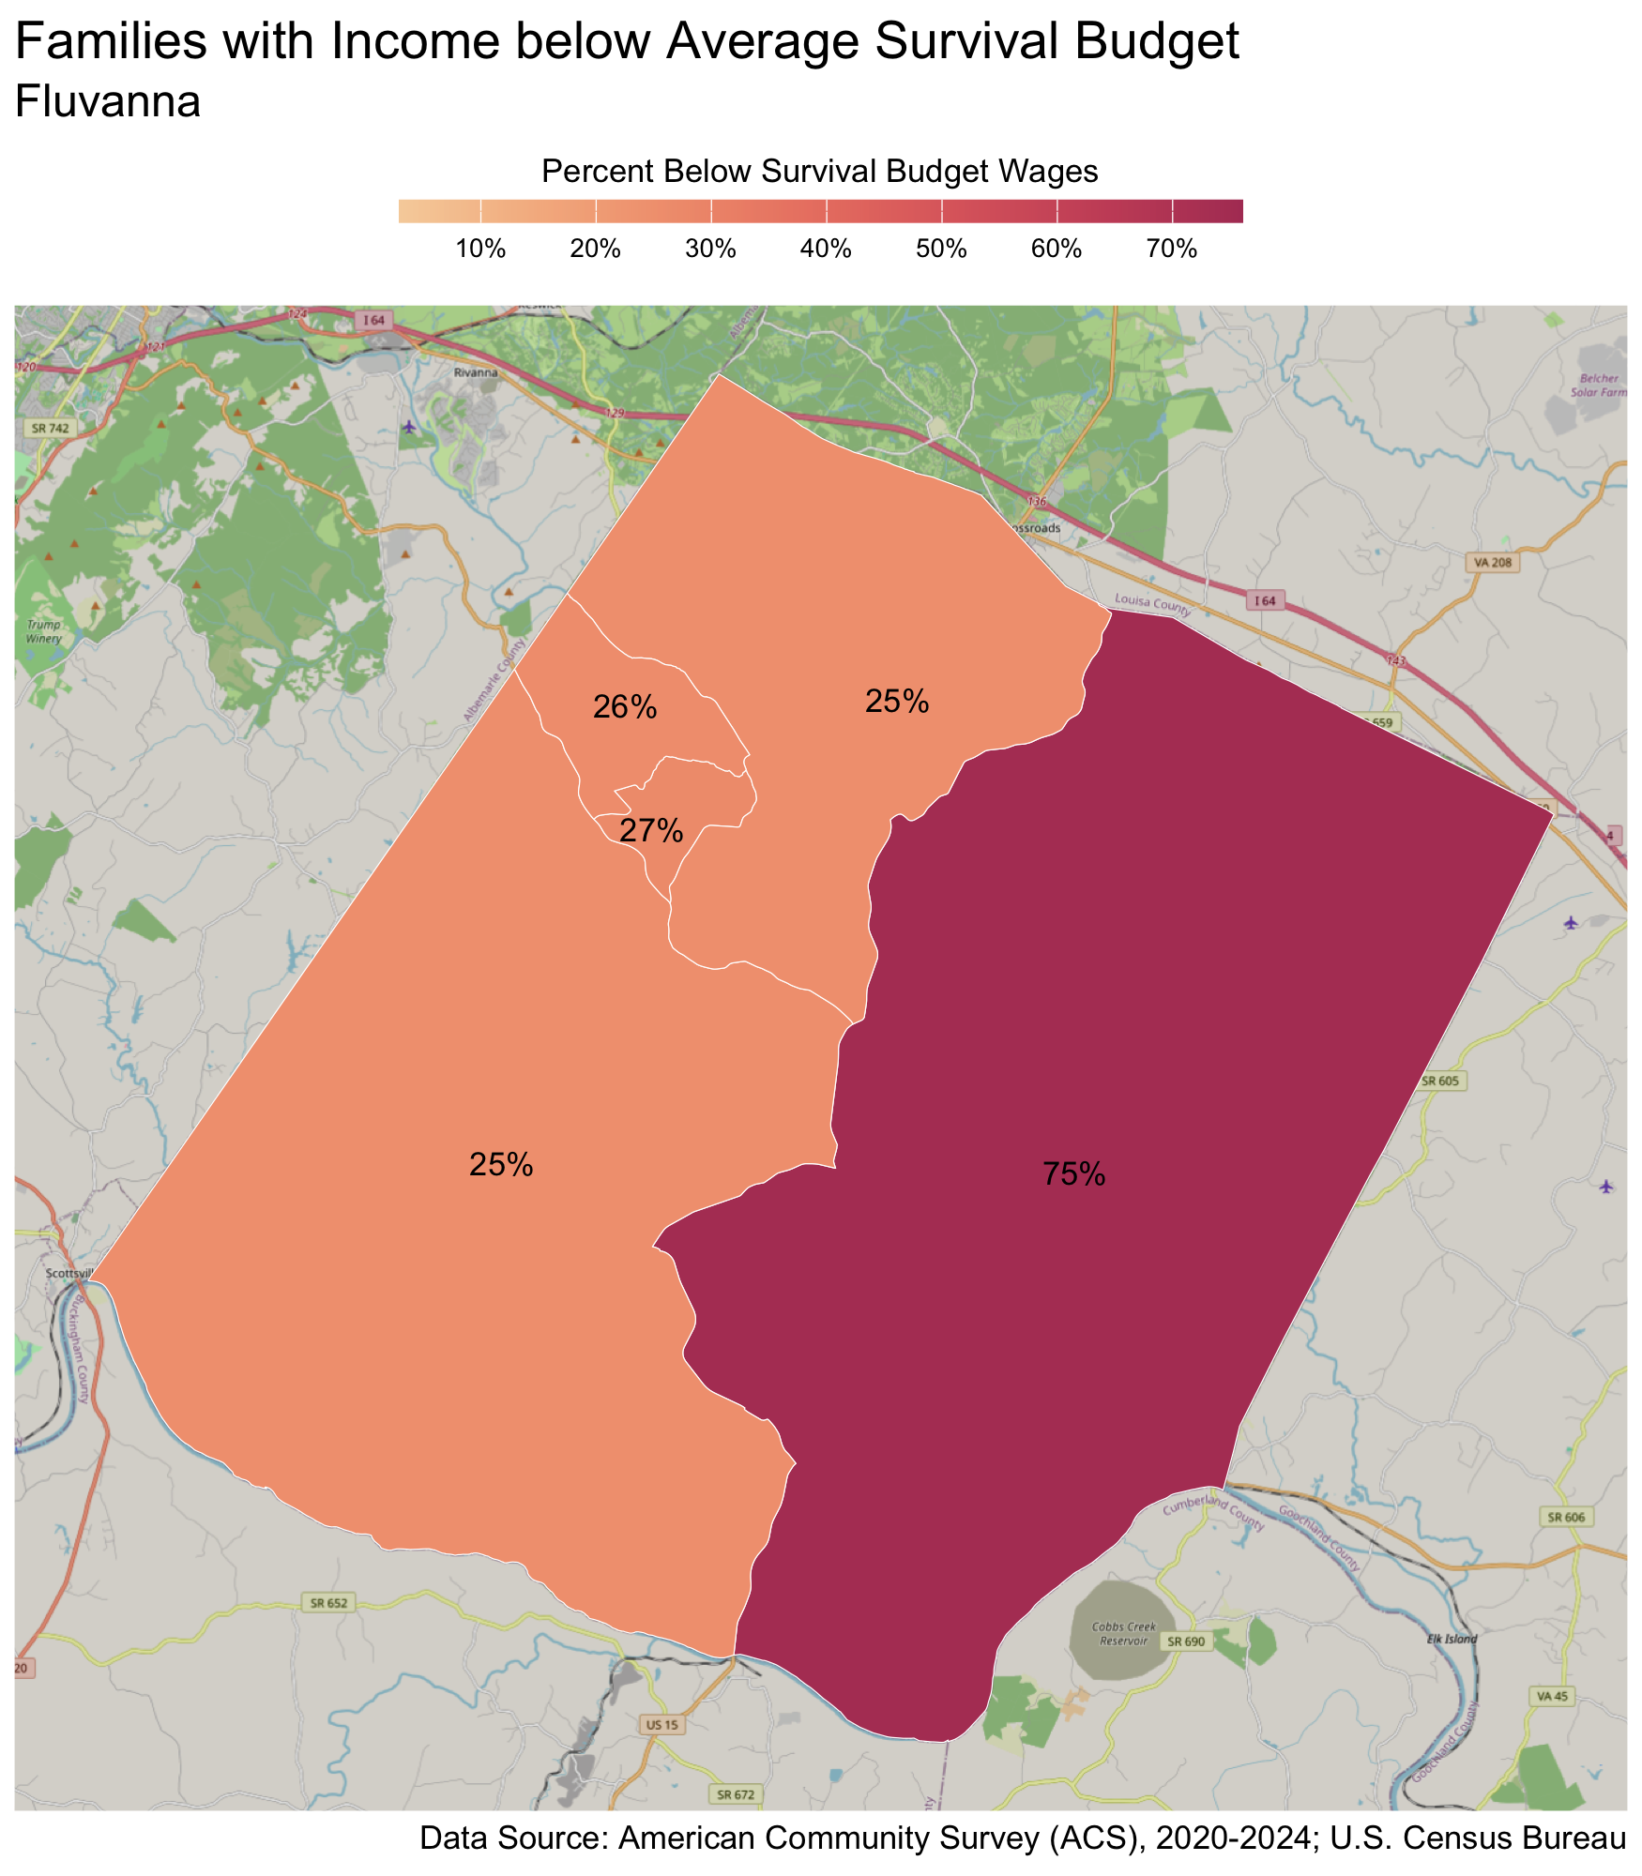
Census Tract |  | Percent
Columbia/Fork Union |  | 75%
Lake Monticello |  | 27%
Rivanna |  | 26%
Cunningham |  | 25%
Palmyra |  | 25%

Households 65 years and over
Table 11: Average Survival Budget for Households 65 years and over in Fluvanna
 | Monthly | Annual
Housing | $1,544.00 | $18,528.00
Child Care | $0.00 | $0.00
Food | $688.50 | $8,262.00
Transportation | $363.00 | $4,356.00
Health Care | $699.50 | $8,394.00
Technology | $119.00 | $1,428.00
Miscellaneous | $341.50 | $4,098.00
Taxes | $724.00 | $8,688.00
Total Income Needed to Meet Budget | $4,479.50 | $53,754.00
Note: The Average Household Survival Budget is calculated using the ALICE 2024 Household Survival Budgets. The average budget for households 65 years and over is calculated for each locality based on households with one or two adults aged 65 years and over. See the Appendix for detailed budgets for specific family compositions.
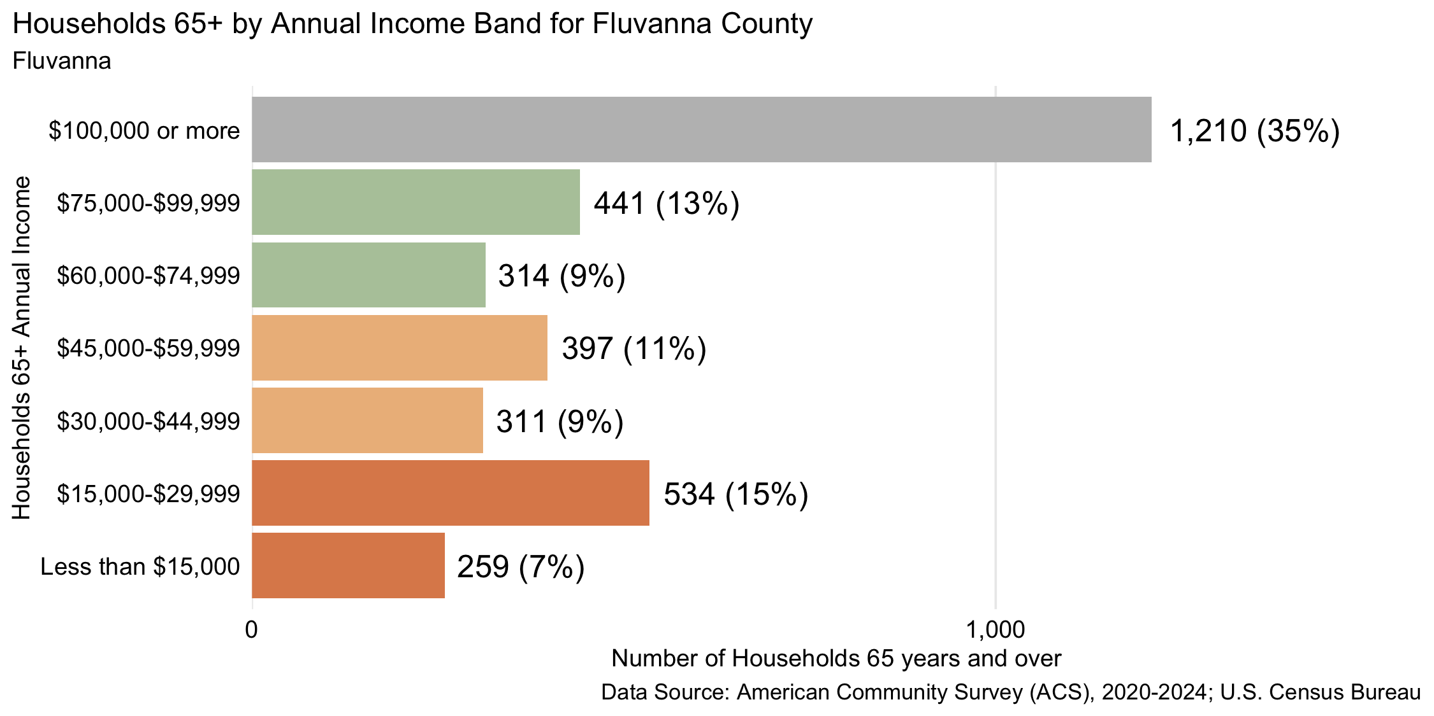
Figure 19: Number and percent of households 65 years and over by annual household income, 2024, for Fluvanna County
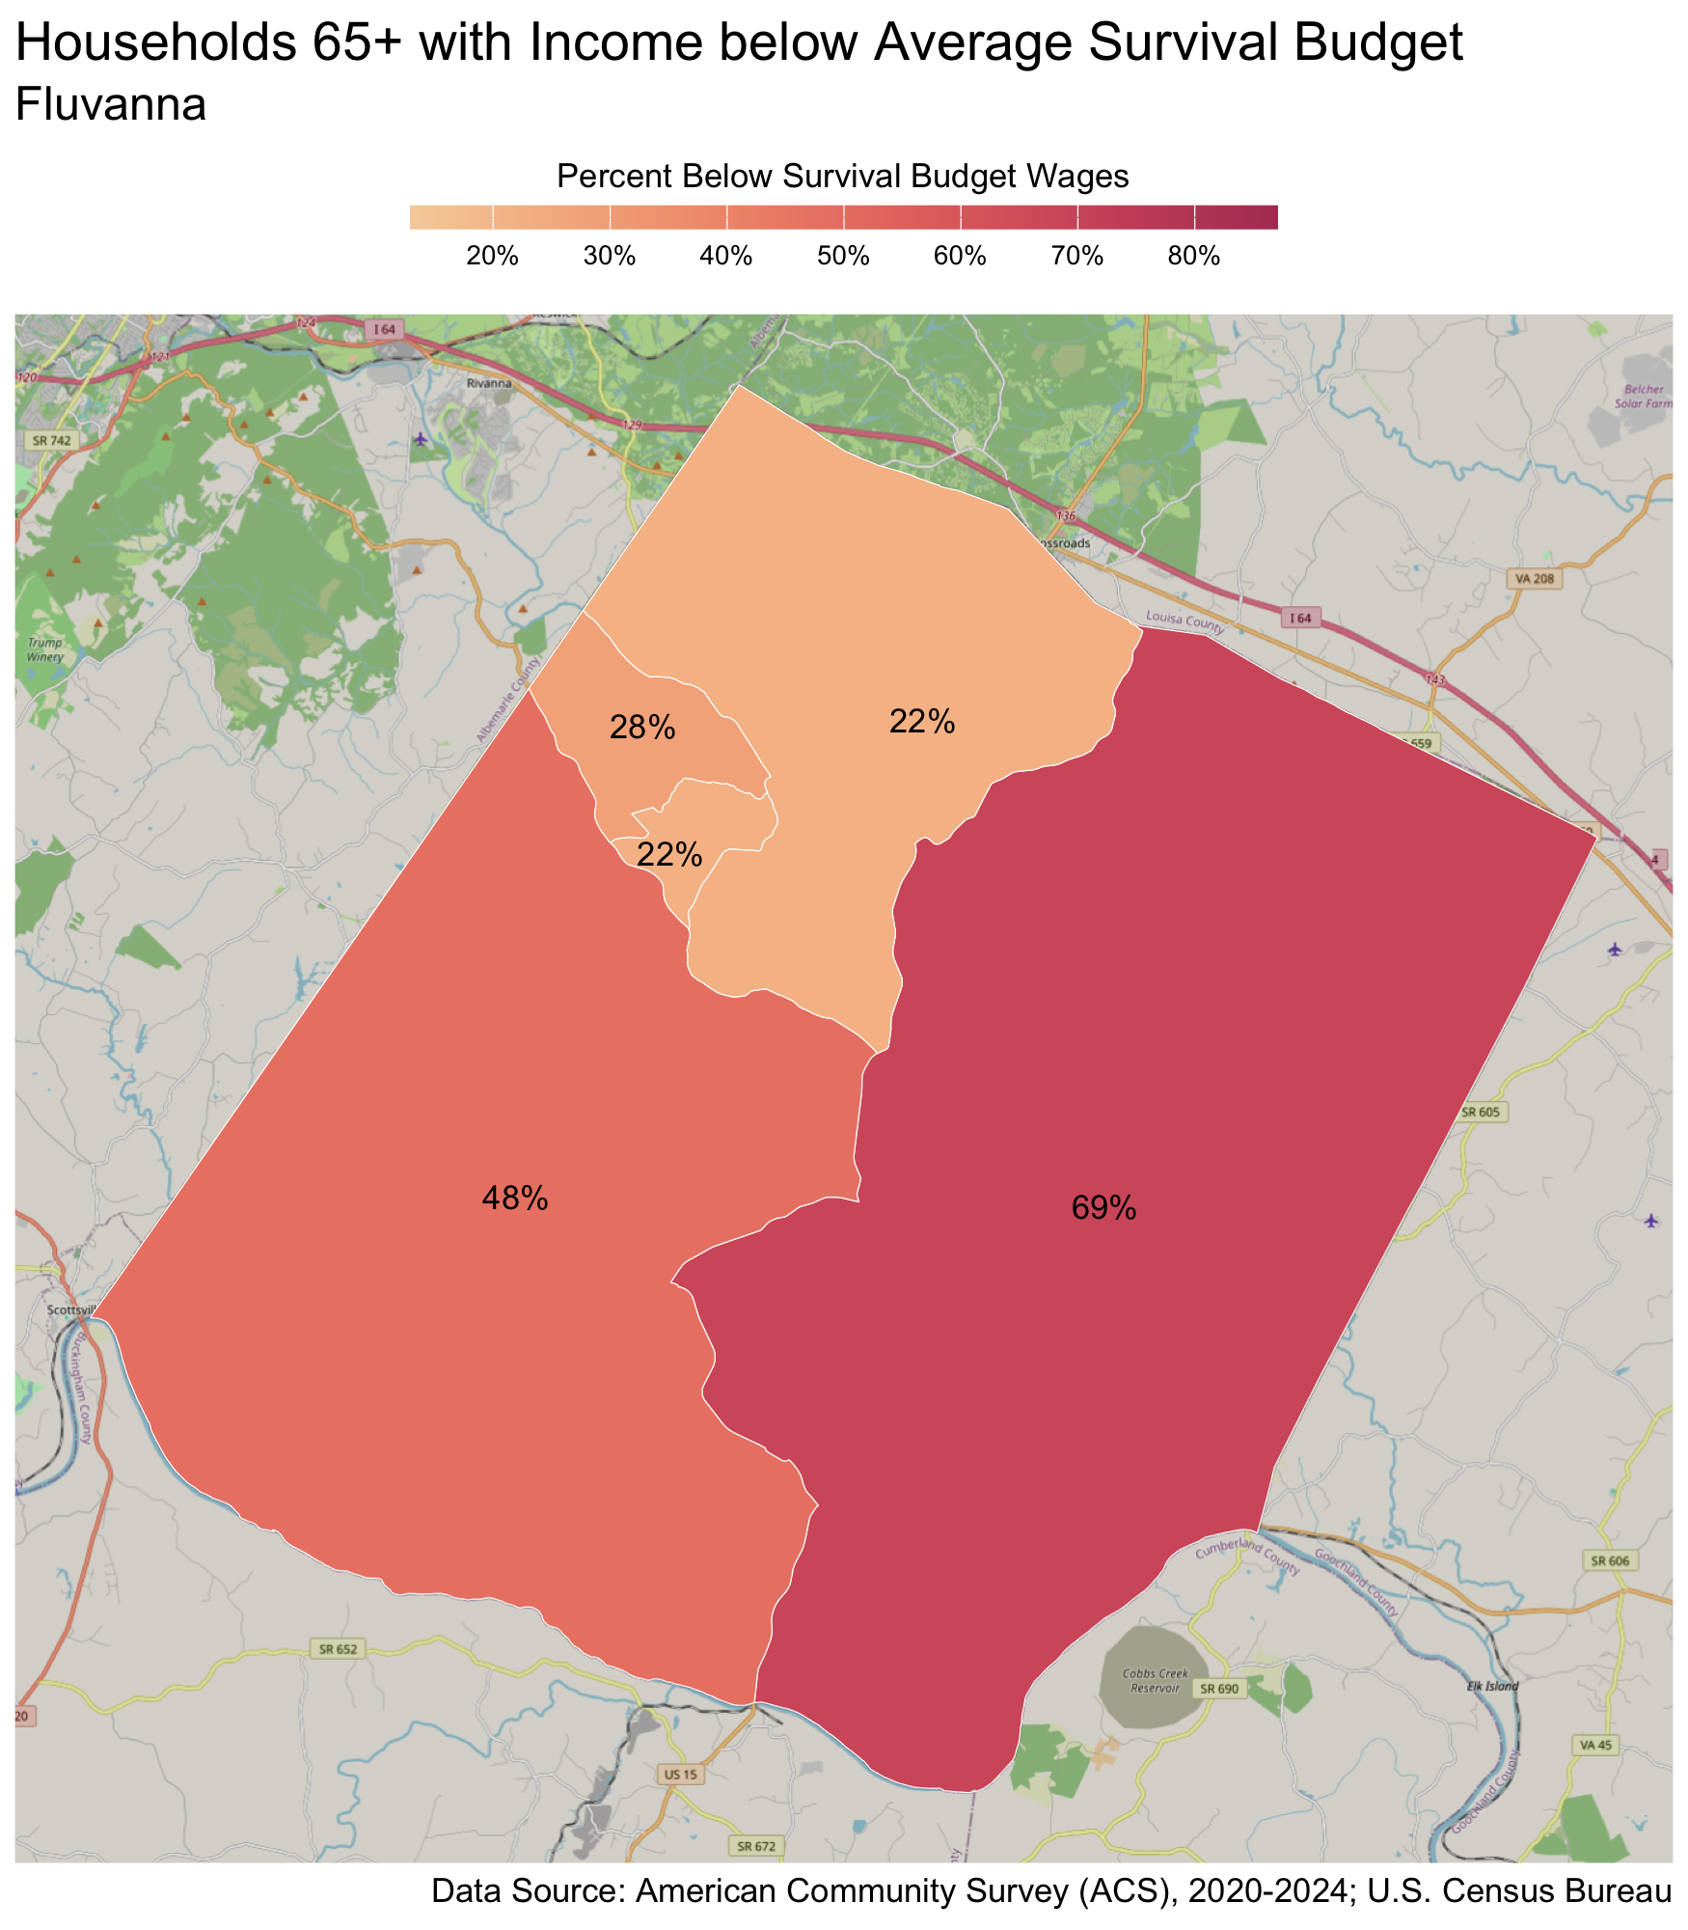
Census Tract |  | Percent
Columbia/Fork Union |  | 69%
Cunningham |  | 48%
Rivanna |  | 28%
Lake Monticello |  | 22%
Palmyra |  | 22%

Greene County
There are 5,762 families living in Greene County. Of these families, 2,338 (41%) do not earn enough to provide for their family’s basic needs.

Greene County at a glance:
- The annual survival budget for an average family in Greene County is $85,715.04. This is the income working families need to meet their basic necessities. The survival budget include: housing, child care, food, transportation, health care, and technology (phone and internet), plus taxes and a 10% contingency fund for one-time unanticipated costs.
- Approximately 2,338 families, or 41% of families, in Greene County earn below their household’s survival budget.
- The percent of Black families not earning enough to meet their basic needs is 76%. This is 40% higher than the percent of white families earning below the survival budget (36%).
- The median family income for Greene County is $104,643. The tract with the lowest median family income is Stanardsville at $82,000. The tract with the highest median family income is Midway at $127,000.
- The tract with the highest percent of families with income below the average survival budget is Ruckersville with 50% of families. The tract with the lowest percent of families not earning enough to meet their basic needs is Midway with 30% of families. That is a difference of 20%.
- The annual survival budget for an average household 65 years and over in Greene County is $57,102. The tract with the highest percent of households 65 years and over with income below the average survival budget is Stanardsville with 54%. The tract with the lowest percent of households 65 years and over not earning enough to meet their basic needs is Ruckersville with 31%.

Families
Table 12: Average Survival Budget for Families in Greene
 | Monthly | Annual
Housing | $1,757.08 | $21,084.96
Child Care | $1,019.08 | $12,228.96
Food | $1,442.69 | $17,312.28
Transportation | $637.69 | $7,652.28
Health Care | $676.92 | $8,123.04
Technology | $122.92 | $1,475.04
Miscellaneous | $565.62 | $6,787.44
Taxes | $920.92 | $11,051.04
Total Income Needed to Meet Budget | $7,142.92 | $85,715.04
Note: The Average Family Survival Budget is calculated using the ALICE 2024 Household Survival Budgets. The average budget is calculated for each locality based on families with one or two adults and one or two children. Family compositions include children ages 0-2 years (infant), 3-4 years (preschooler), and 5-17 years (school-aged). See the Appendix for detailed budgets for specific family compositions.
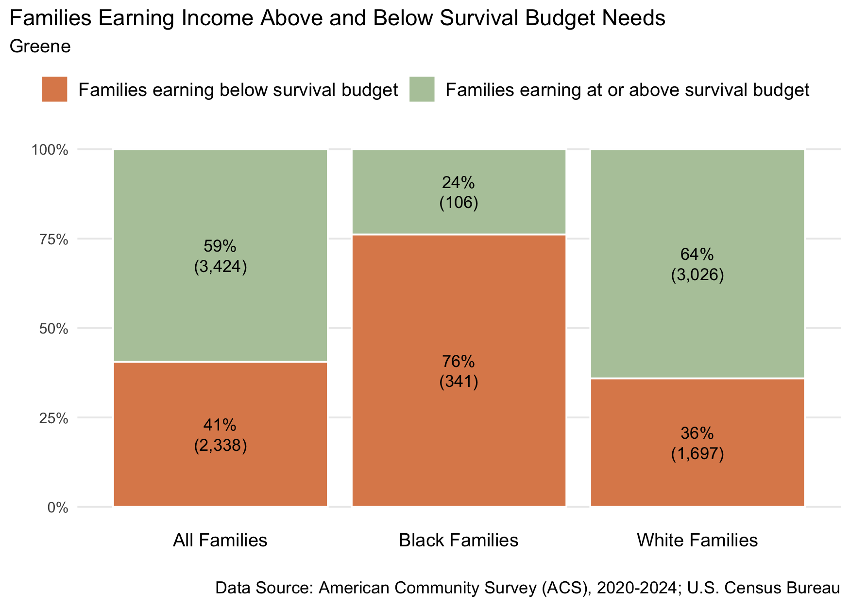
Figure 20: Percent and number of families earning above and below the average family survival budget, 2024 for Greene County
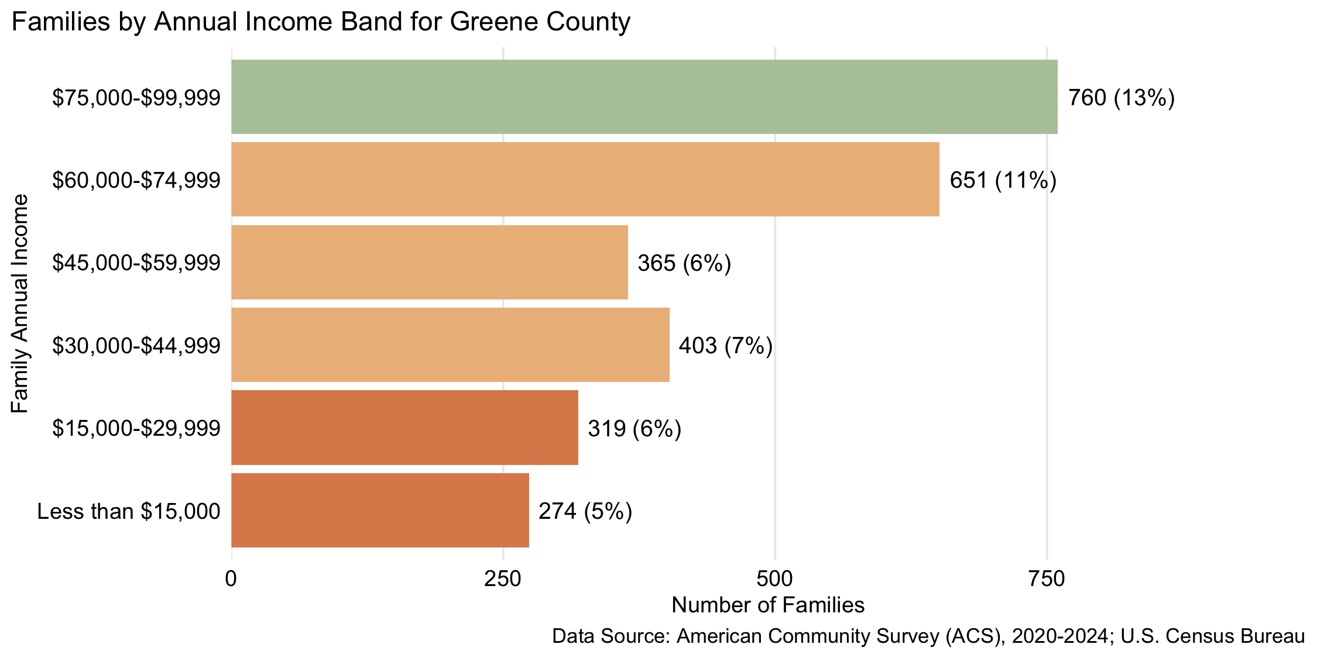
Figure 21: Number and percent of families by family annual income, for family incomes below $100,000, 2024, for Greene County

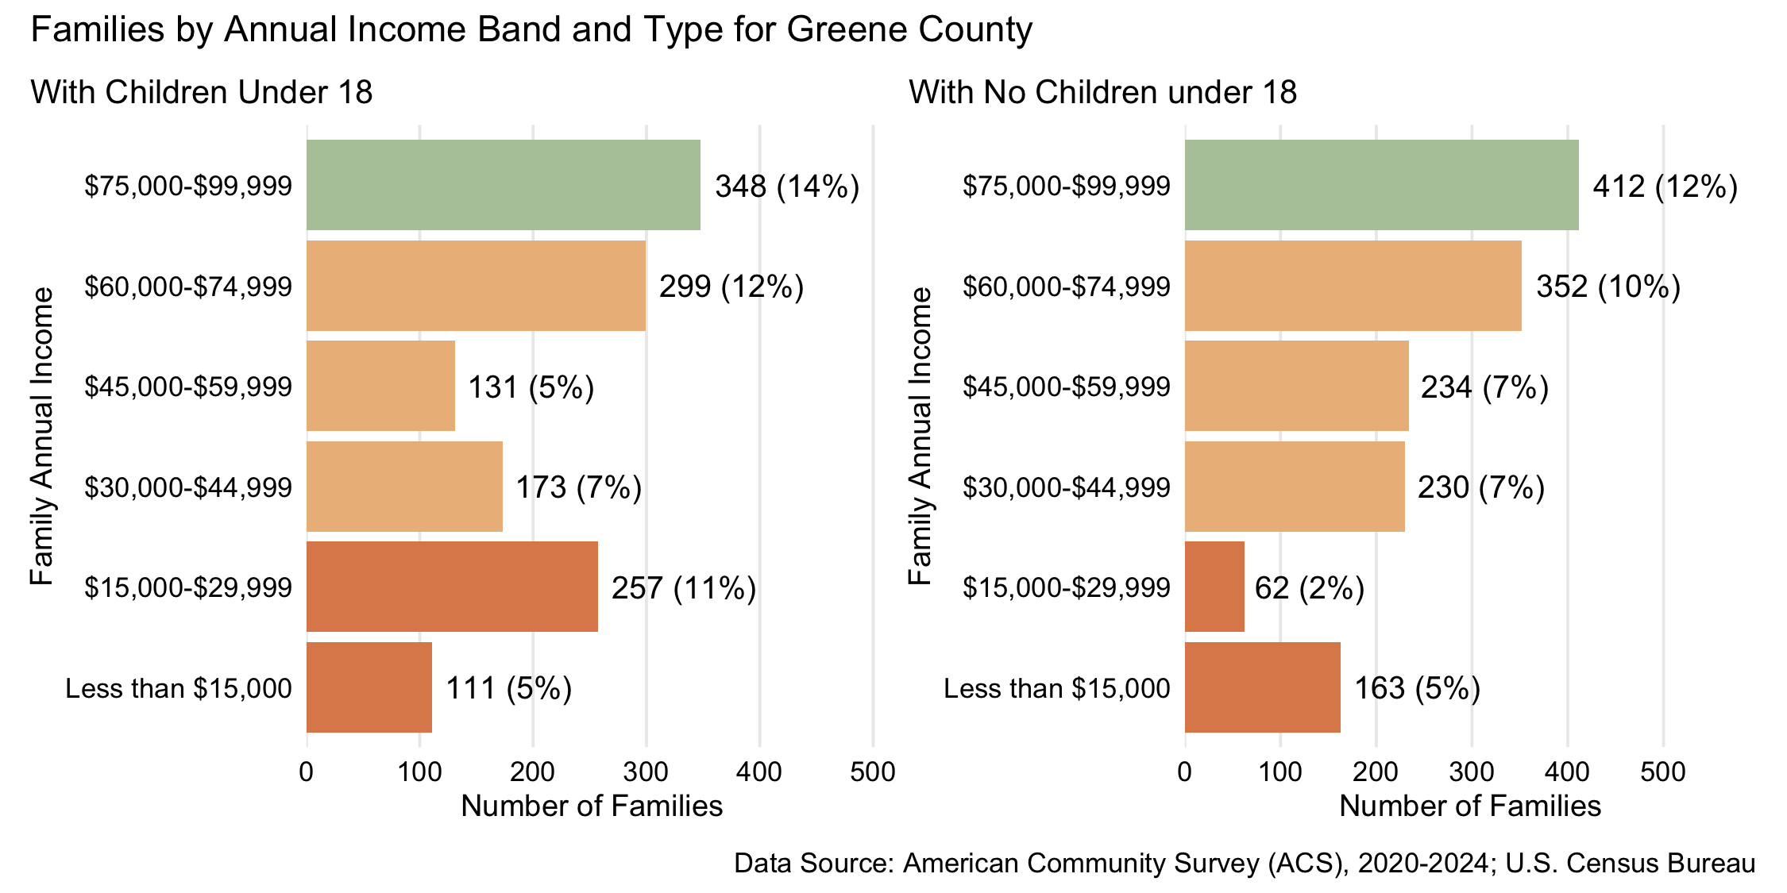
Figure 22: Number and percent of families with and without children under 18 years old by family annual income, for family incomes below $100,000, 2024, for Greene County
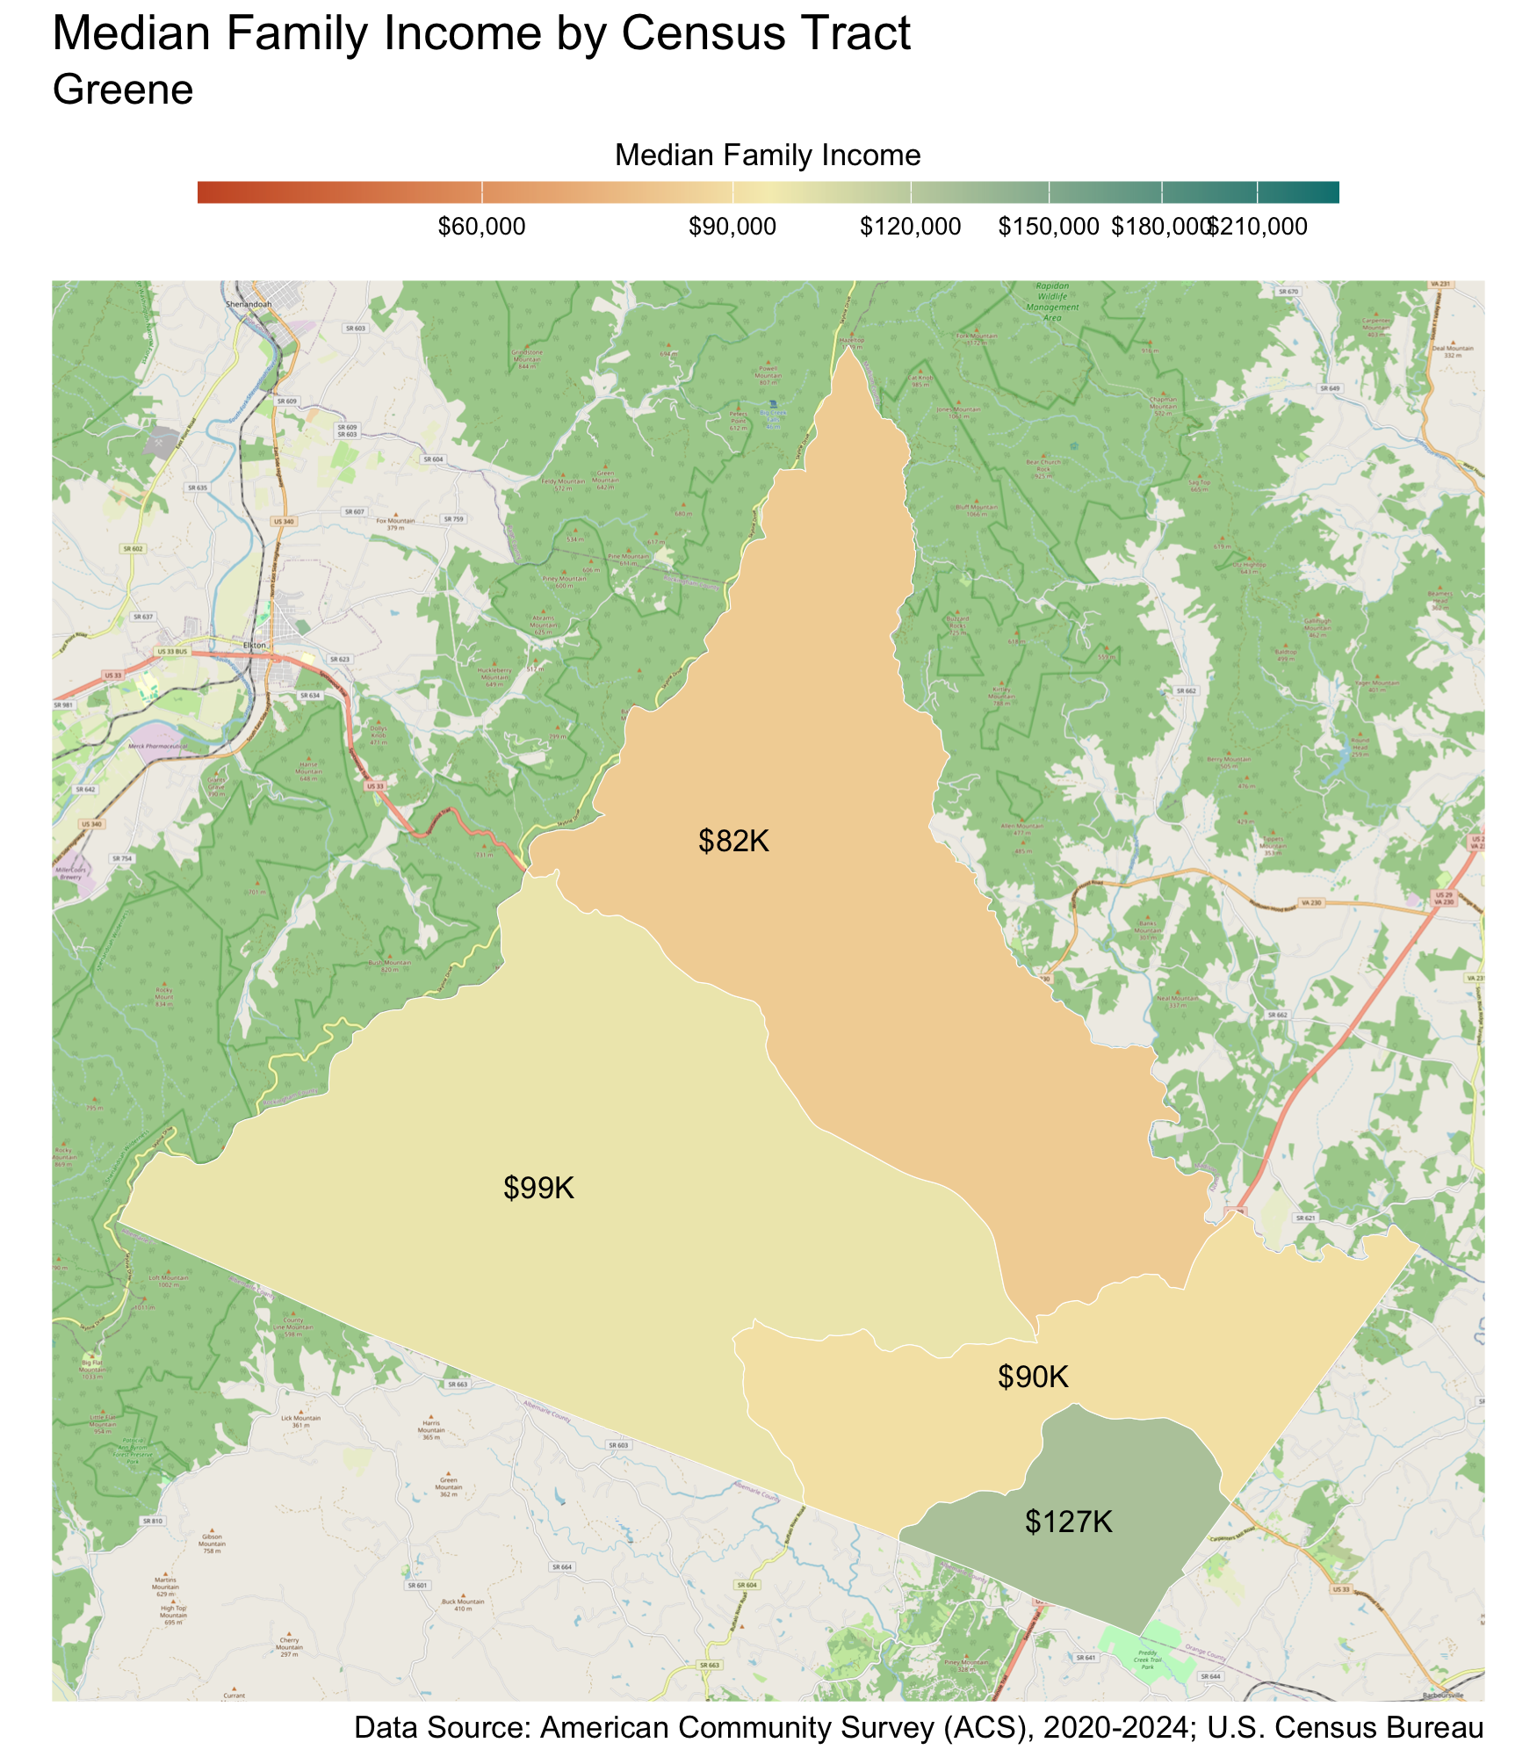
Census Tract |  | Median Family Income
Stanardsville* |  | $82,000
Ruckersville |  | $90,000
Monroe |  | $99,000
Midway |  | $127,000
* Census tracts listed in bold have a median family income below the locality's average family survival budget.
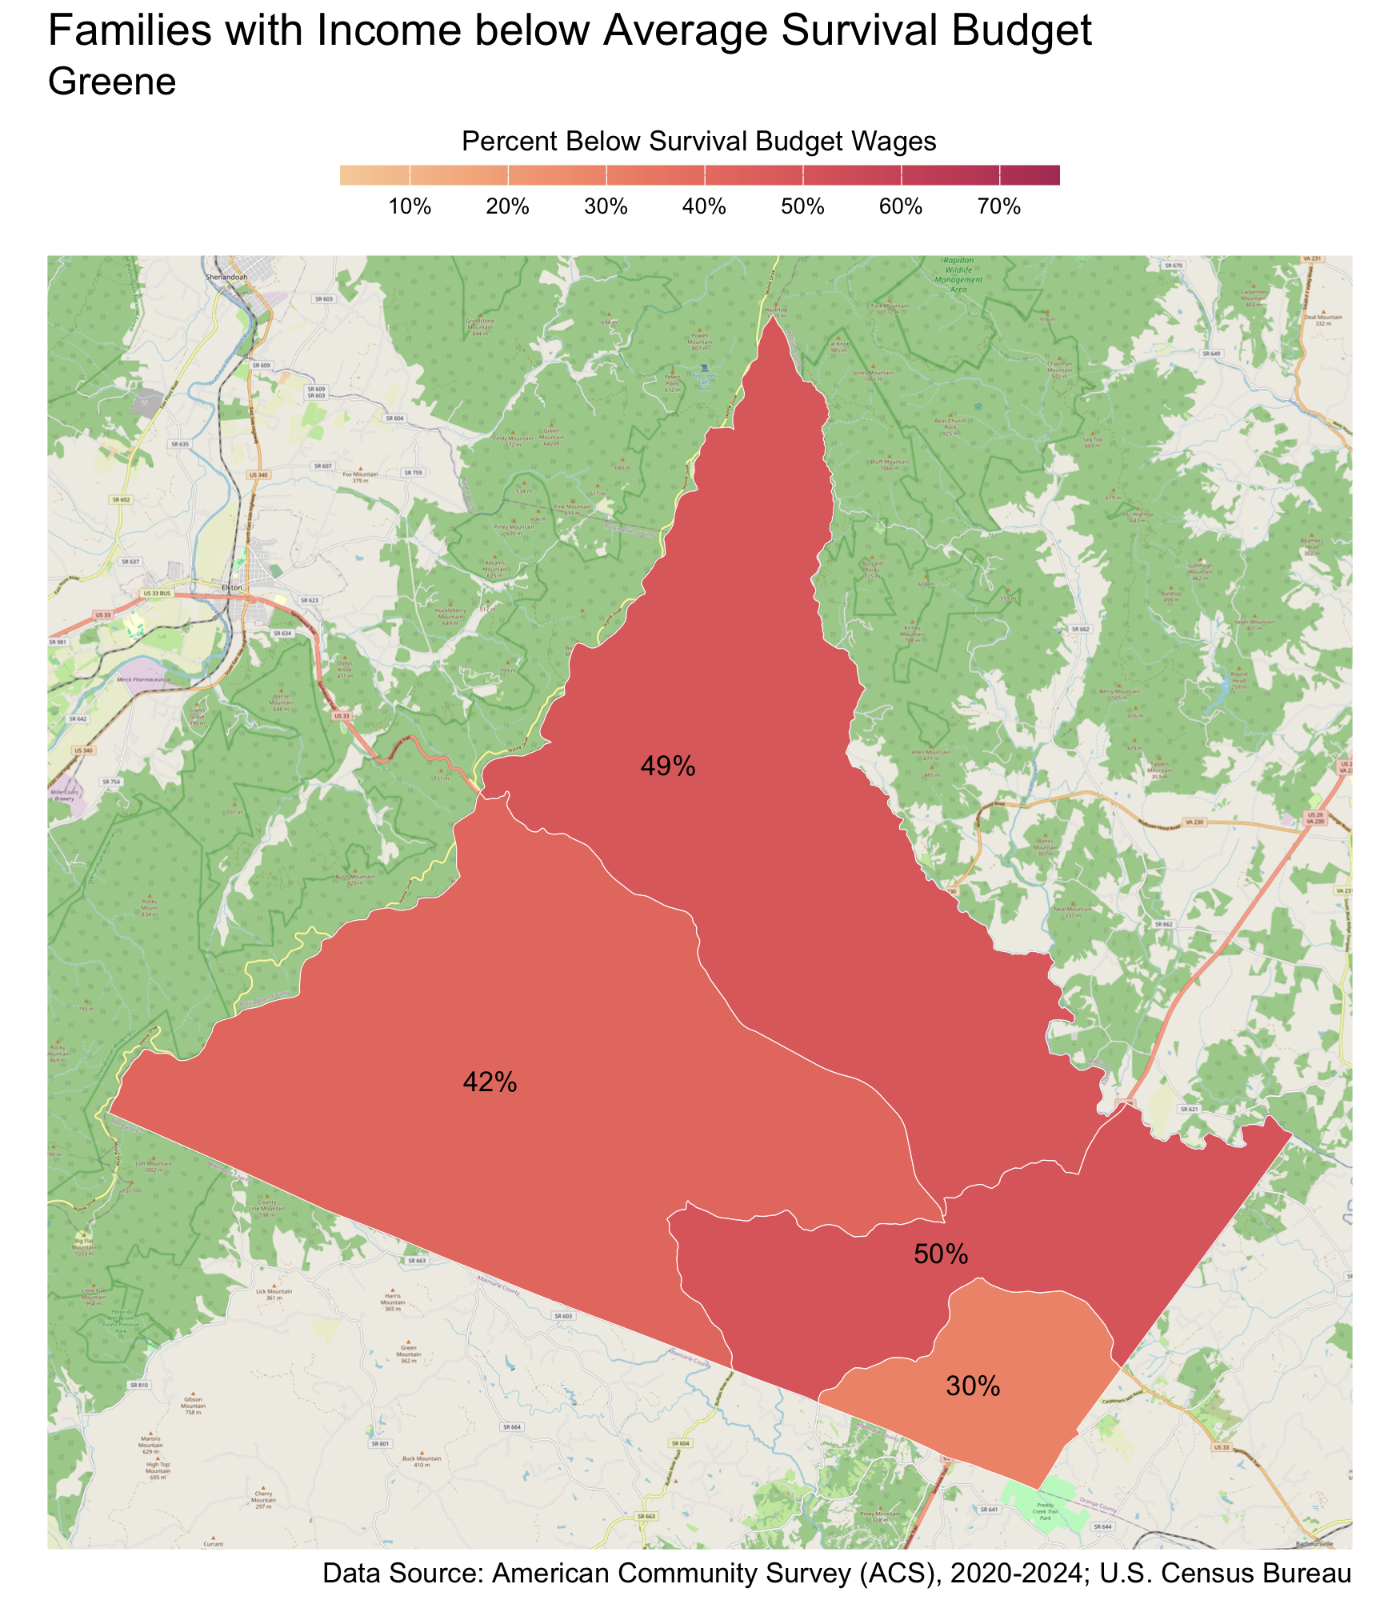
Census Tract |  | Percent
Ruckersville |  | 50%
Stanardsville |  | 49%
Monroe |  | 42%
Midway |  | 30%

Households 65 years and over
Table 13: Average Survival Budget for Households 65 years and over in Greene
 | Monthly | Annual
Housing | $1,544.00 | $18,528.00
Child Care | $0.00 | $0.00
Food | $842.50 | $10,110.00
Transportation | $363.00 | $4,356.00
Health Care | $747.50 | $8,970.00
Technology | $119.00 | $1,428.00
Miscellaneous | $361.50 | $4,338.00
Taxes | $781.00 | $9,372.00
Total Income Needed to Meet Budget | $4,758.50 | $57,102.00
Note: The Average Household Survival Budget is calculated using the ALICE 2024 Household Survival Budgets. The average budget for households 65 years and over is calculated for each locality based on households with one or two adults aged 65 years and over. See the Appendix for detailed budgets for specific family compositions.
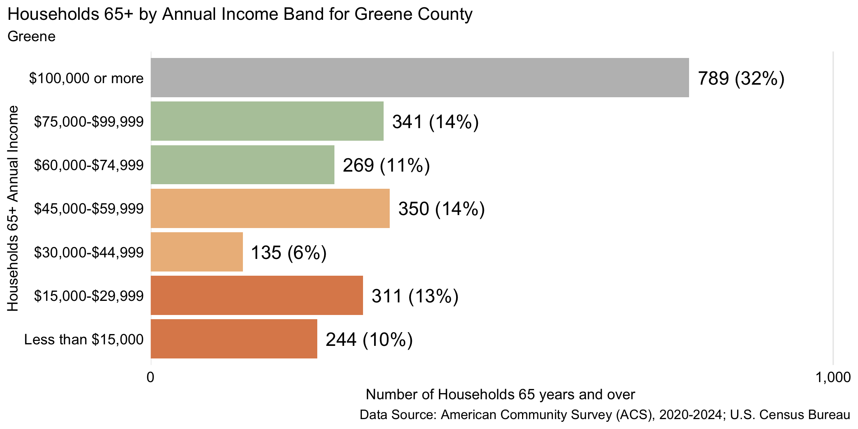
Figure 23: Number and percent of households 65 years and over by annual household income, 2024, for Greene County
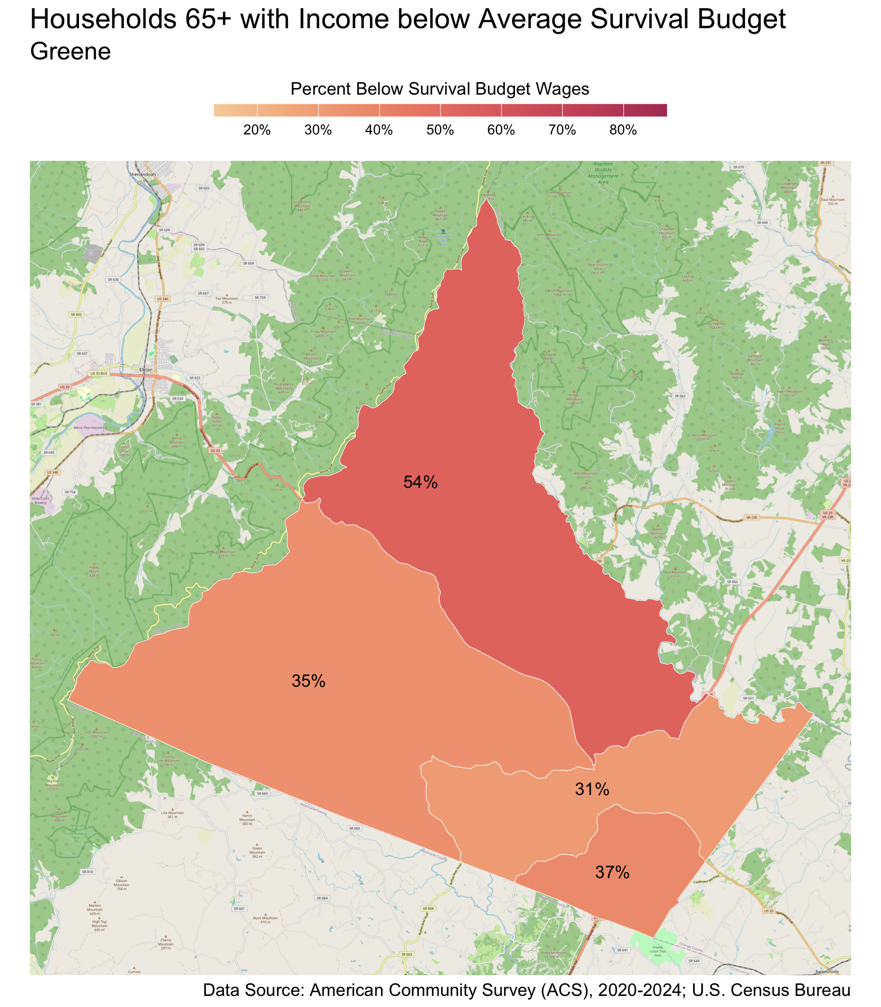
Census Tract |  | Percent
Stanardsville |  | 54%
Midway |  | 37%
Monroe |  | 35%
Ruckersville |  | 31%

Louisa County
There are 11,351 families living in Louisa County. Of these families, 3,769 (33%) do not earn enough to provide for their family’s basic needs.

Louisa County at a glance:
- The annual survival budget for an average family in Louisa County is $70,373.52. This is the income working families need to meet their basic necessities. The survival budget include: housing, child care, food, transportation, health care, and technology (phone and internet), plus taxes and a 10% contingency fund for one-time unanticipated costs.
- Approximately 3,769 families, or 33% of families, in Louisa County earn below their household’s survival budget.
- The percent of Black families not earning enough to meet their basic needs is 39%. This is 8% higher than the percent of white families earning below the survival budget (32%).
- The median family income for Louisa County is $101,472. The tract with the lowest median family income is Trevillians at $63,000. The tract with the highest median family income is Green Springs at $154,000.
- The tract with the highest percent of families with income below the average survival budget is Trevillians with 49% of families. The tract with the lowest percent of families not earning enough to meet their basic needs is Green Springs with 15% of families. That is a difference of 34%.
- The annual survival budget for an average household 65 years and over in Louisa County is $46,272. The tract with the highest percent of households 65 years and over with income below the average survival budget is Trevillians with 48%. The tract with the lowest percent of households 65 years and over not earning enough to meet their basic needs is Bumpus-Mountain Road District-Buckner with 21%.

Families
Table 14: Average Survival Budget for Families in Louisa
 | Monthly | Annual
Housing | $1,205.15 | $14,461.80
Child Care | $1,019.08 | $12,228.96
Food | $1,067.23 | $12,806.76
Transportation | $637.69 | $7,652.28
Health Care | $678.15 | $8,137.80
Technology | $122.92 | $1,475.04
Miscellaneous | $473.08 | $5,676.96
Taxes | $661.15 | $7,933.80
Total Income Needed to Meet Budget | $5,864.46 | $70,373.52
Note: The Average Family Survival Budget is calculated using the ALICE 2024 Household Survival Budgets. The average budget is calculated for each locality based on families with one or two adults and one or two children. Family compositions include children ages 0-2 years (infant), 3-4 years (preschooler), and 5-17 years (school-aged). See the Appendix for detailed budgets for specific family compositions.
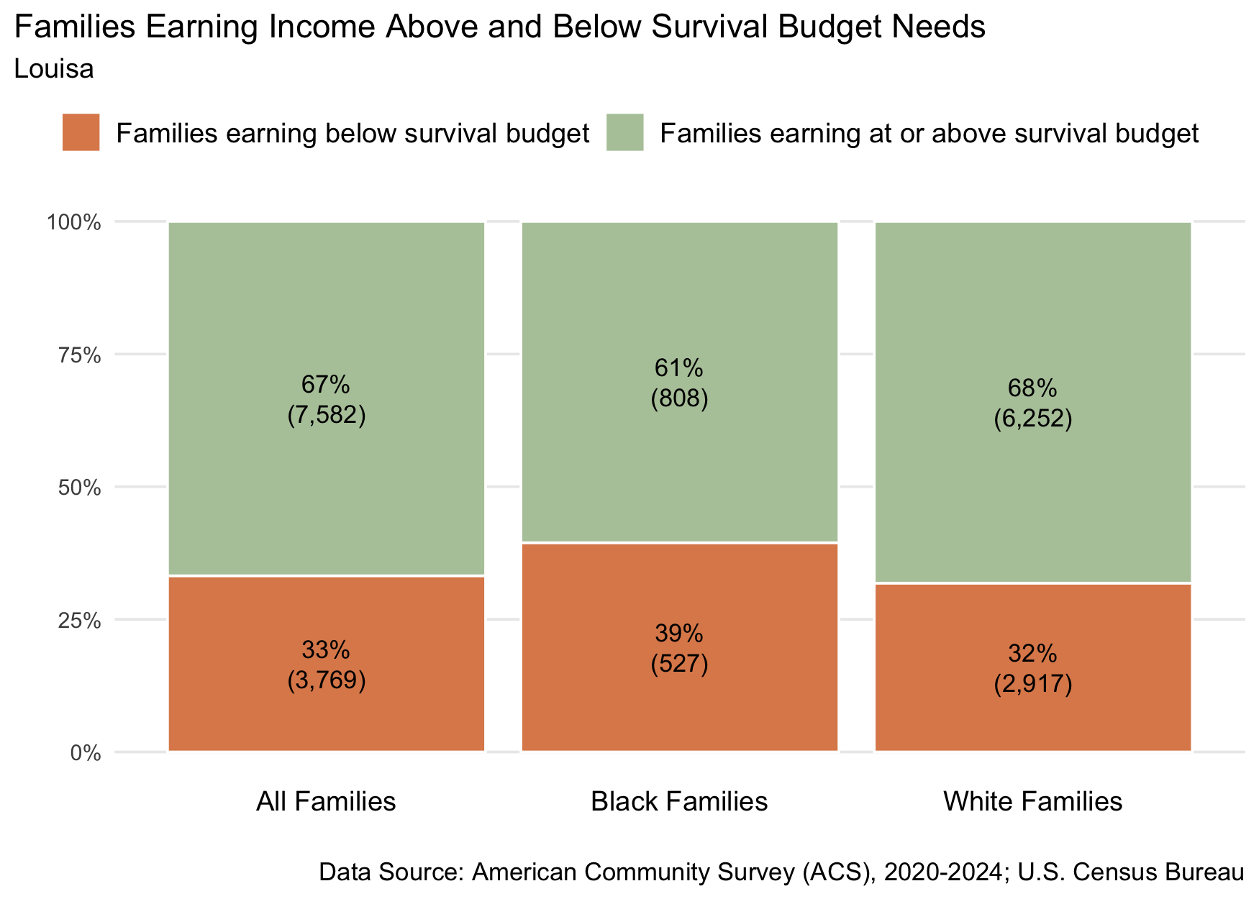
Figure 24: Percent and number of families earning above and below the average family survival budget, 2024 for Louisa County
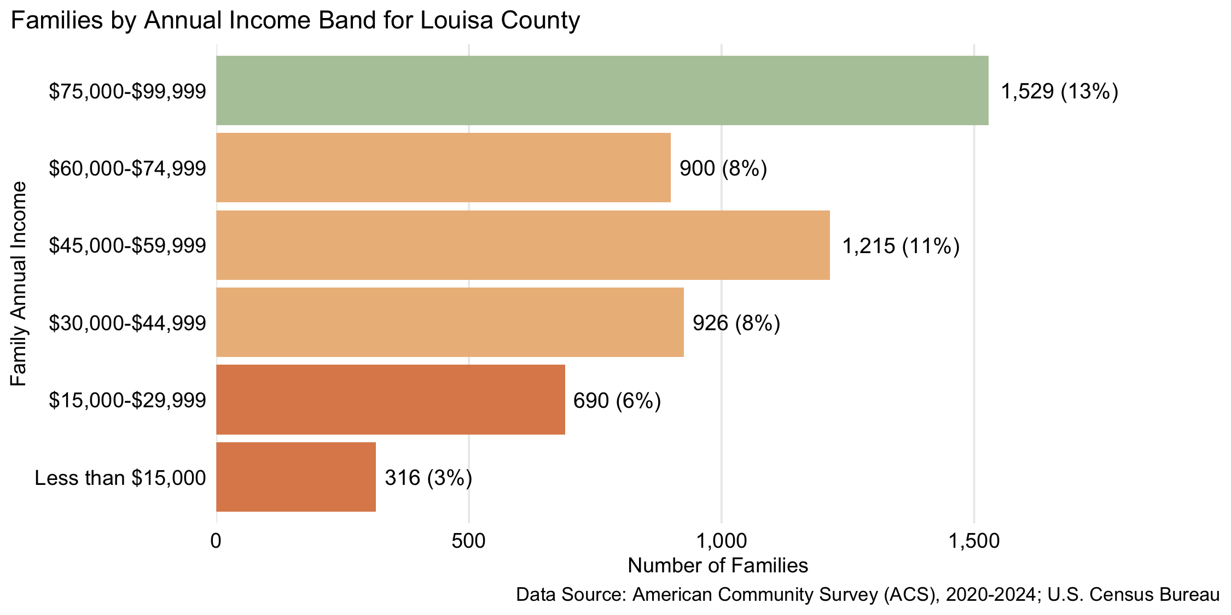
Figure 25: Number and percent of families by family annual income, for family incomes below $100,000, 2024, for Louisa County

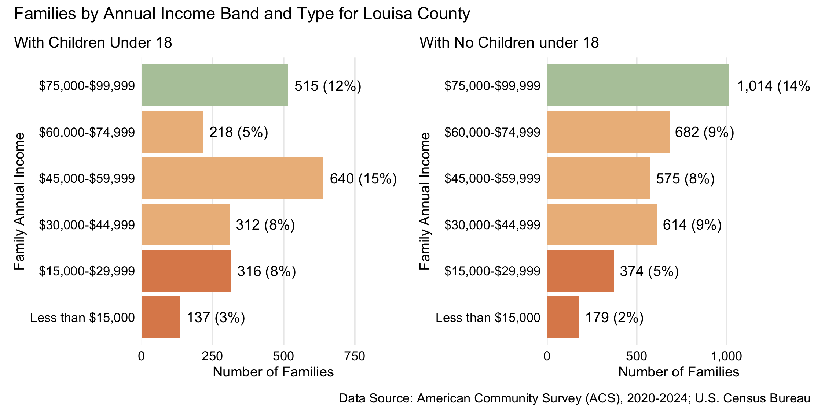
Figure 26: Number and percent of families with and without children under 18 years old by family annual income, for family incomes below $100,000, 2024, for Louisa County
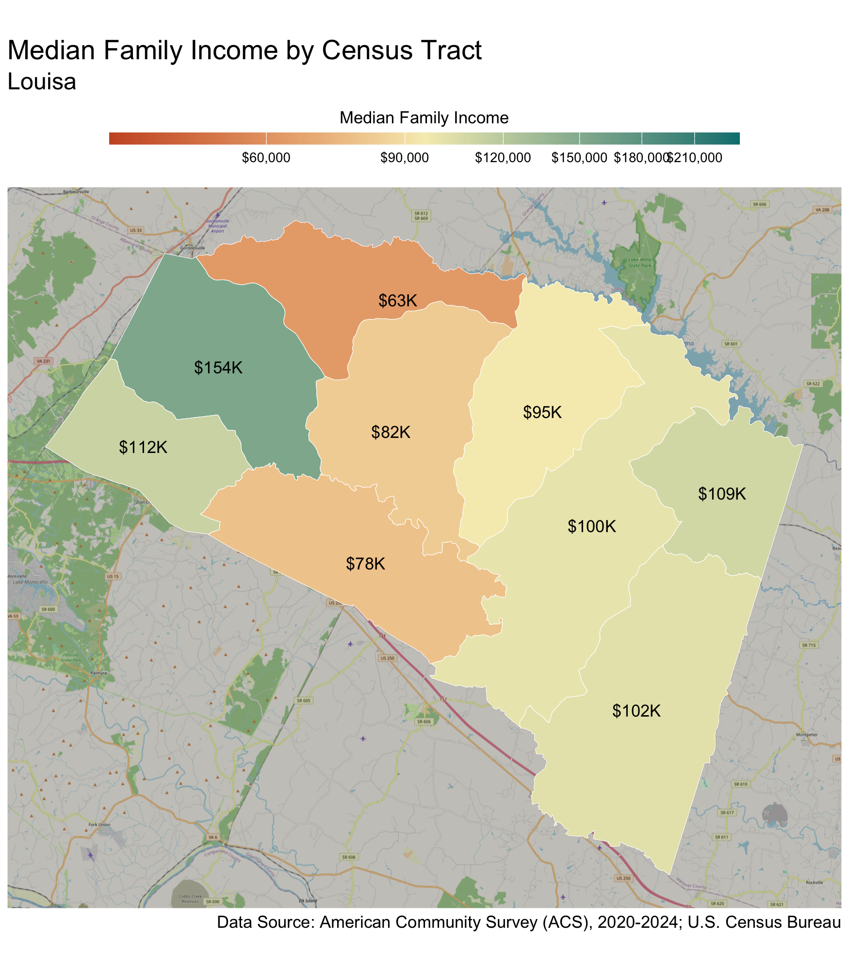
Census Tract |  | Median Family Income
Trevillians* |  | $63,000
Ferncliff-Shannon Hill (Yanceyville) |  | $78,000
Town of Louisa |  | $82,000
Mineral |  | $95,000
Cuckoo District |  | $100,000
Gum Springs-Holly Grove |  | $102,000
Bumpus-Mountain Road District-Buckner |  | $109,000
Zion Crossroads |  | $112,000
Green Springs |  | $154,000
* Census tracts listed in bold have a median family income below the locality's average family survival budget.
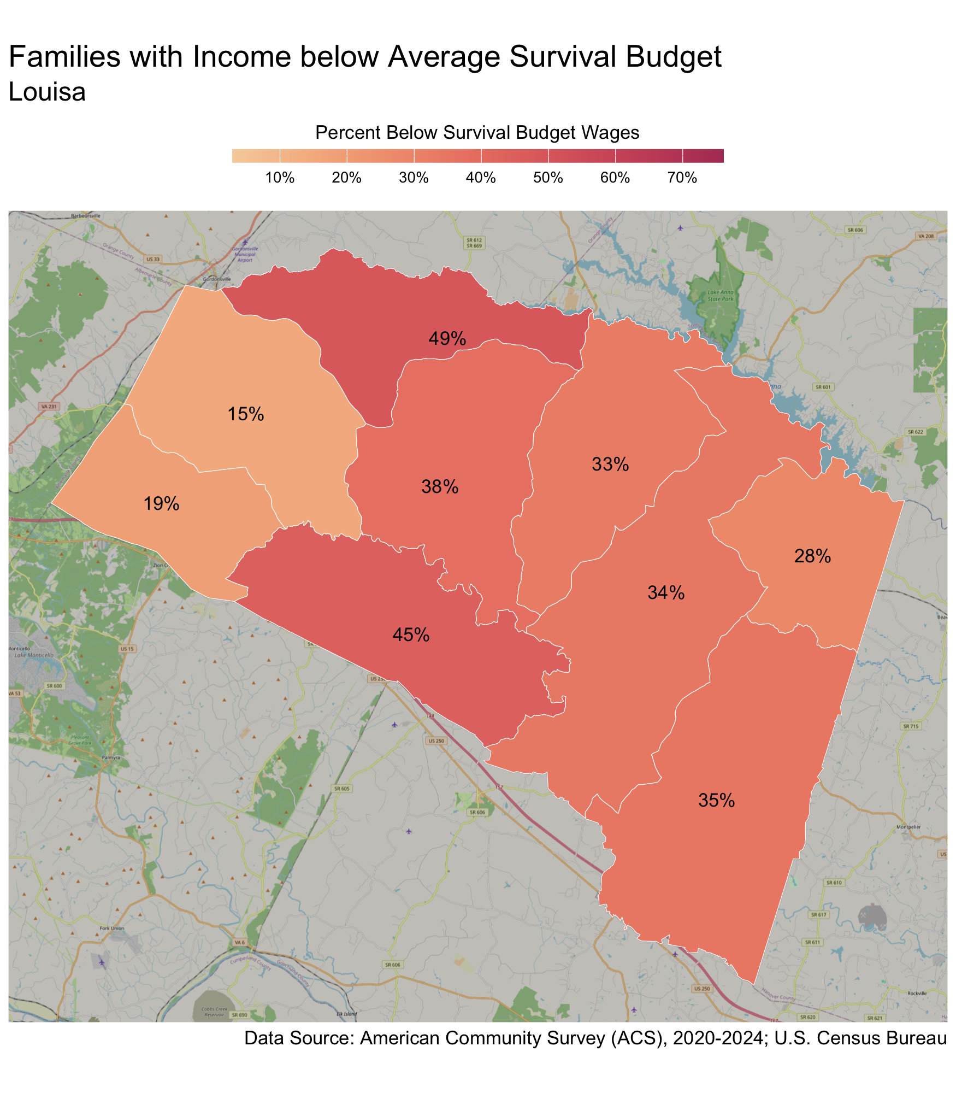
Census Tract |  | Percent
Trevillians |  | 49%
Ferncliff-Shannon Hill (Yanceyville) |  | 45%
Town of Louisa |  | 38%
Gum Springs-Holly Grove |  | 35%
Cuckoo District |  | 34%
Mineral |  | 33%
Bumpus-Mountain Road District-Buckner |  | 28%
Zion Crossroads |  | 19%
Green Springs |  | 15%

Households 65 years and over
Table 15: Average Survival Budget for Households 65 years and over in Louisa
 | Monthly | Annual
Housing | $1,096.00 | $13,152.00
Child Care | $0.00 | $0.00
Food | $623.50 | $7,482.00
Transportation | $363.00 | $4,356.00
Health Care | $760.00 | $9,120.00
Technology | $119.00 | $1,428.00
Miscellaneous | $296.50 | $3,558.00
Taxes | $598.00 | $7,176.00
Total Income Needed to Meet Budget | $3,856.00 | $46,272.00
Note: The Average Household Survival Budget is calculated using the ALICE 2024 Household Survival Budgets. The average budget for households 65 years and over is calculated for each locality based on households with one or two adults aged 65 years and over. See the Appendix for detailed budgets for specific family compositions.
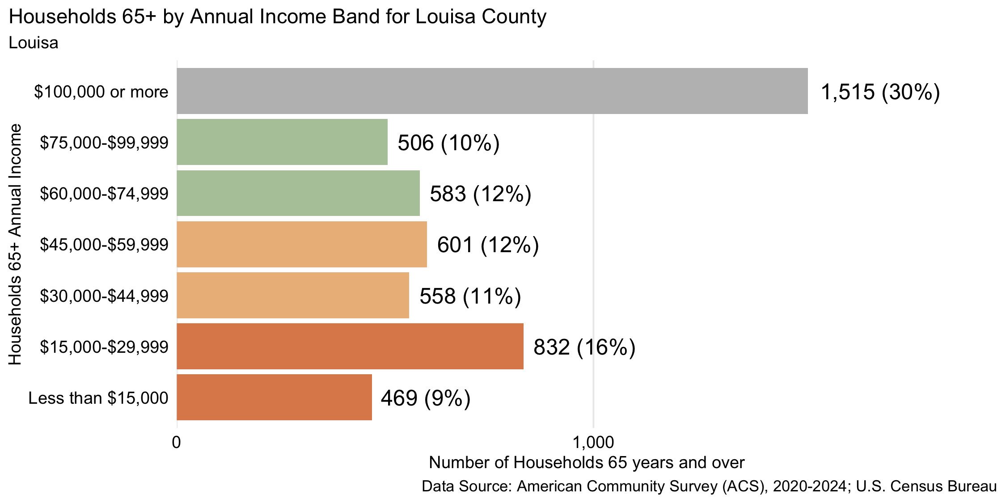
Figure 27: Number and percent of households 65 years and over by annual household income, 2024, for Louisa County
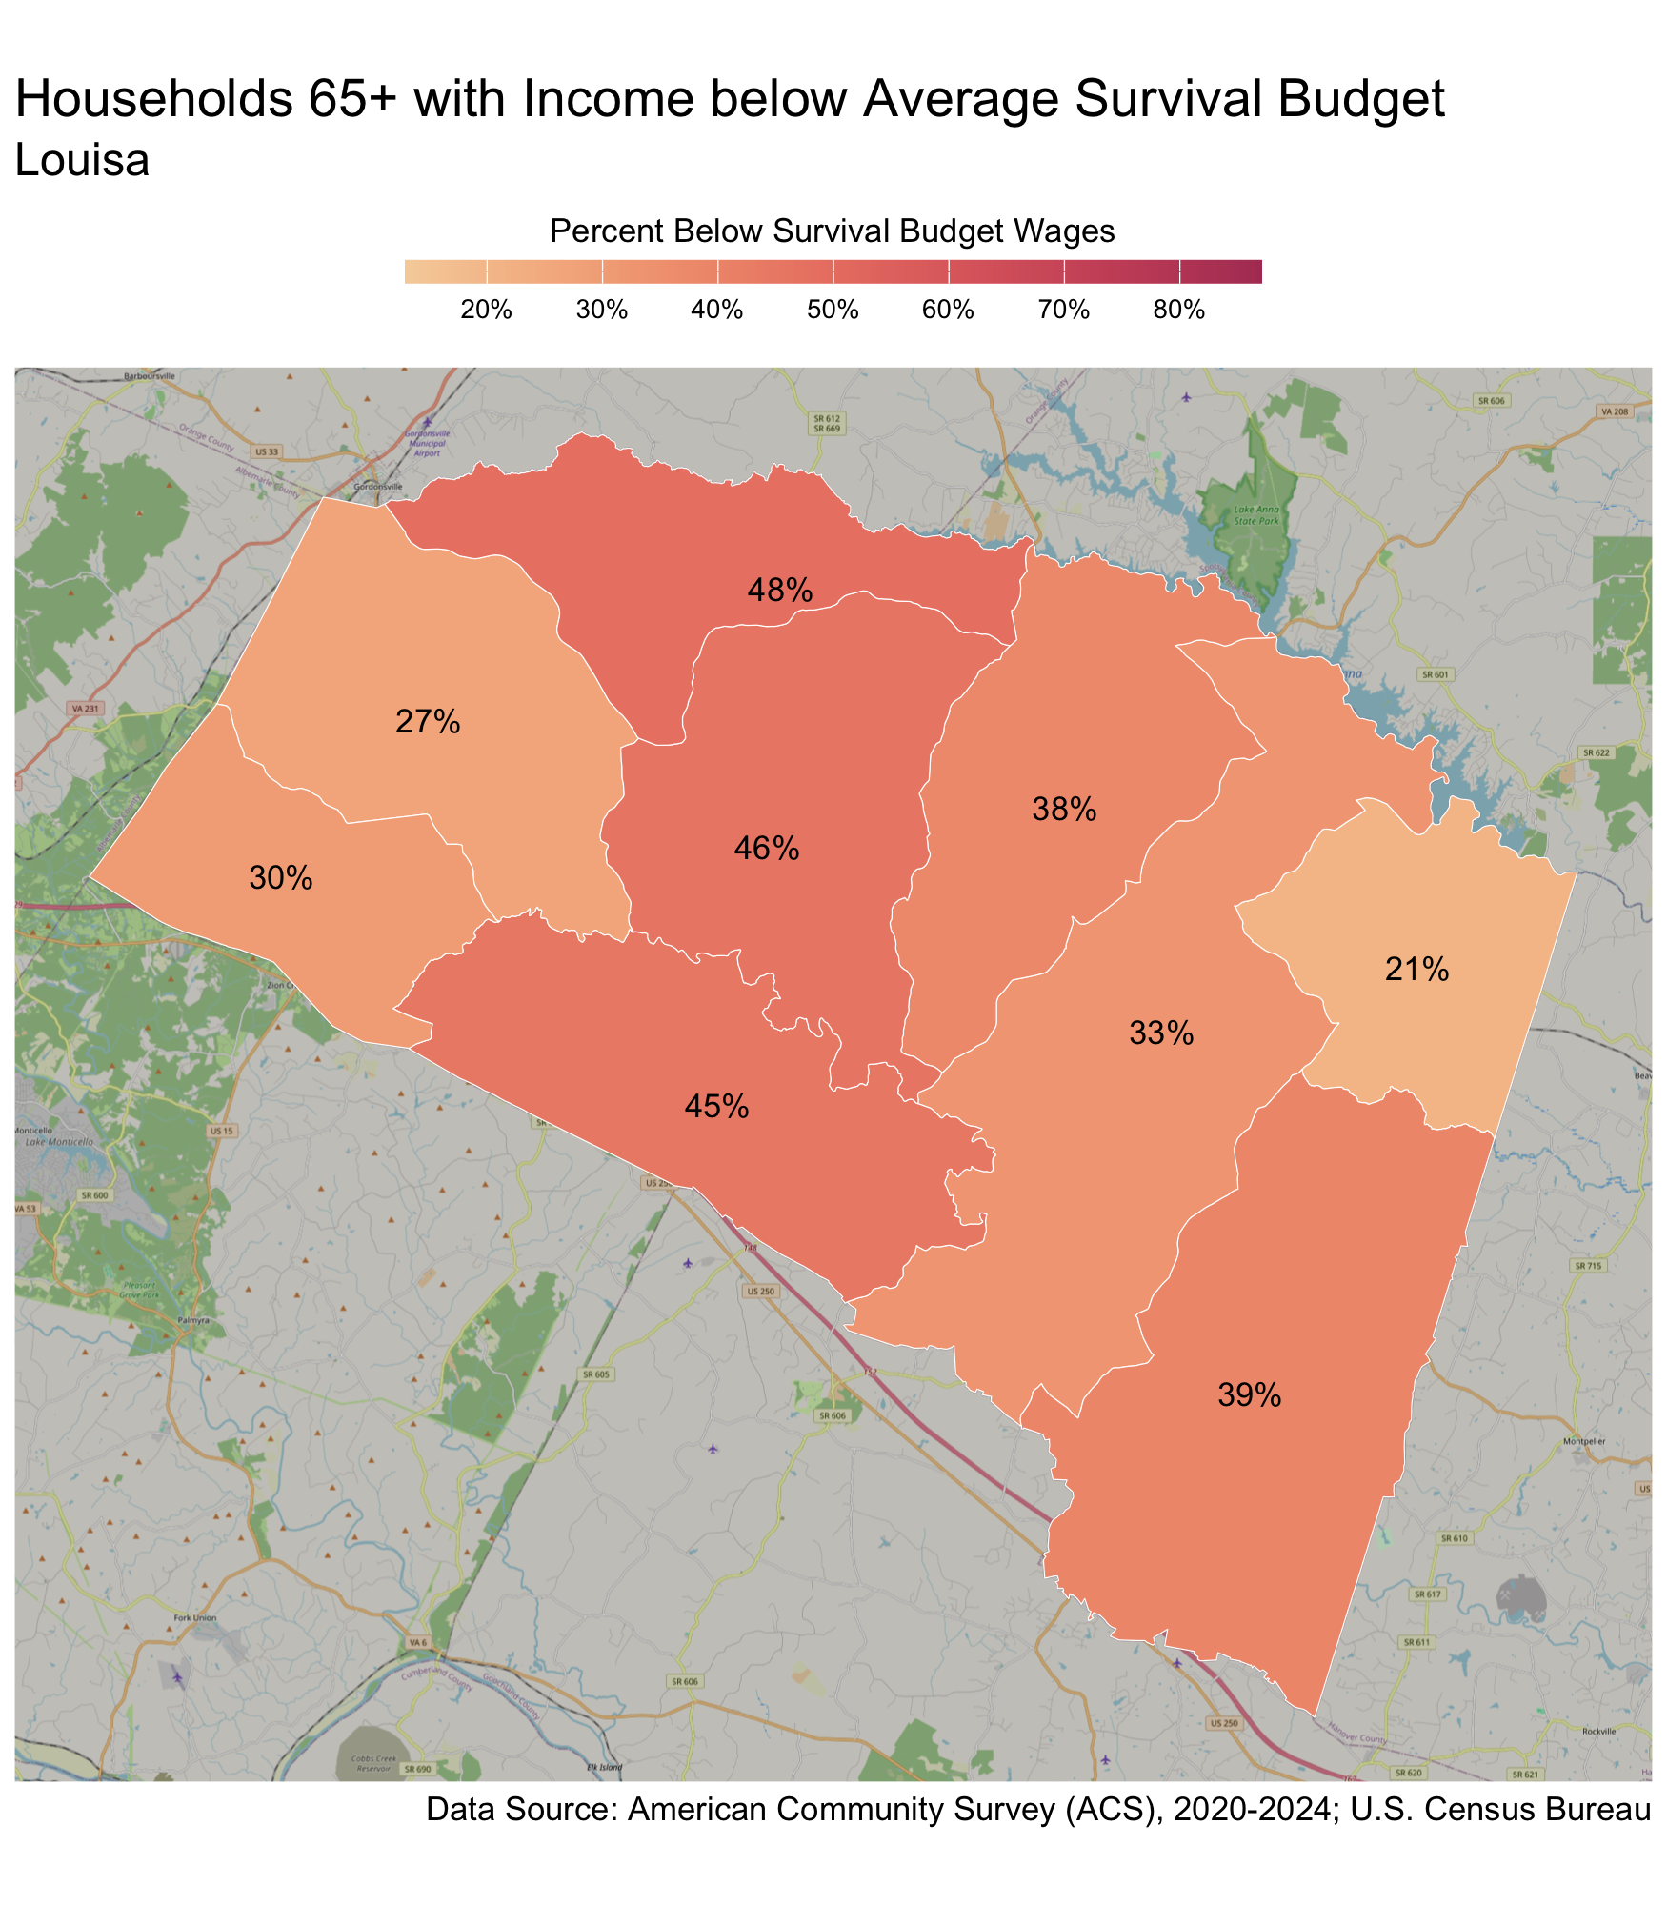
Census Tract |  | Percent
Trevillians |  | 48%
Town of Louisa |  | 46%
Ferncliff-Shannon Hill (Yanceyville) |  | 45%
Gum Springs-Holly Grove |  | 39%
Mineral |  | 38%
Cuckoo District |  | 33%
Zion Crossroads |  | 30%
Green Springs |  | 27%
Bumpus-Mountain Road District-Buckner |  | 21%

Nelson County
There are 3,826 families living in Nelson County. Of these families, 1,433 (37%) do not earn enough to provide for their family’s basic needs.

Nelson County at a glance:
- The annual survival budget for an average family in Nelson County is $78,245.52. This is the income working families need to meet their basic necessities. The survival budget include: housing, child care, food, transportation, health care, and technology (phone and internet), plus taxes and a 10% contingency fund for one-time unanticipated costs.
- Approximately 1,433 families, or 37% of families, in Nelson County earn below their household’s survival budget.
- The percent of Black families not earning enough to meet their basic needs is 37%. This is -1% higher than the percent of white families earning below the survival budget (38%).
- The median family income for Nelson County is $102,872. The tract with the lowest median family income is Wintergreen-Wingina at $78,000. The tract with the highest median family income is Wintergreen-Rockfish Valley at $148,000.
- The tract with the highest percent of families with income below the average survival budget is Wintergreen-Wingina with 49% of families. The tract with the lowest percent of families not earning enough to meet their basic needs is Wintergreen-Rockfish Valley with 27% of families. That is a difference of 22%.
- The annual survival budget for an average household 65 years and over in Nelson County is $52,614. The tract with the highest percent of households 65 years and over with income below the average survival budget is Wintergreen-Wingina with 55%. The tract with the lowest percent of households 65 years and over not earning enough to meet their basic needs is Wintergreen-Rockfish Valley with 14%.

Families
Table 16: Average Survival Budget for Families in Nelson
 | Monthly | Annual
Housing | $1,722.77 | $20,673.24
Child Care | $1,019.08 | $12,228.96
Food | $1,030.08 | $12,360.96
Transportation | $637.69 | $7,652.28
Health Care | $673.92 | $8,087.04
Technology | $122.92 | $1,475.04
Miscellaneous | $520.69 | $6,248.28
Taxes | $793.31 | $9,519.72
Total Income Needed to Meet Budget | $6,520.46 | $78,245.52
Note: The Average Family Survival Budget is calculated using the ALICE 2024 Household Survival Budgets. The average budget is calculated for each locality based on families with one or two adults and one or two children. Family compositions include children ages 0-2 years (infant), 3-4 years (preschooler), and 5-17 years (school-aged). See the Appendix for detailed budgets for specific family compositions.
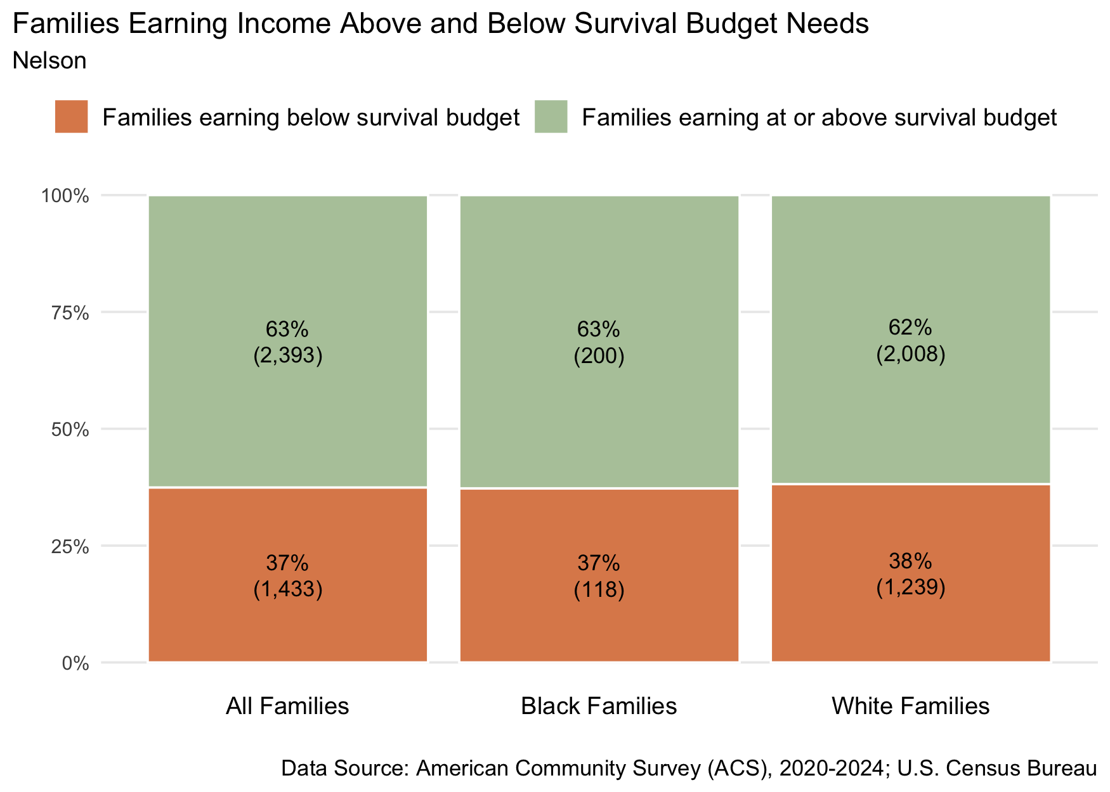
Figure 28: Percent and number of families earning above and below the average family survival budget, 2024 for Nelson County
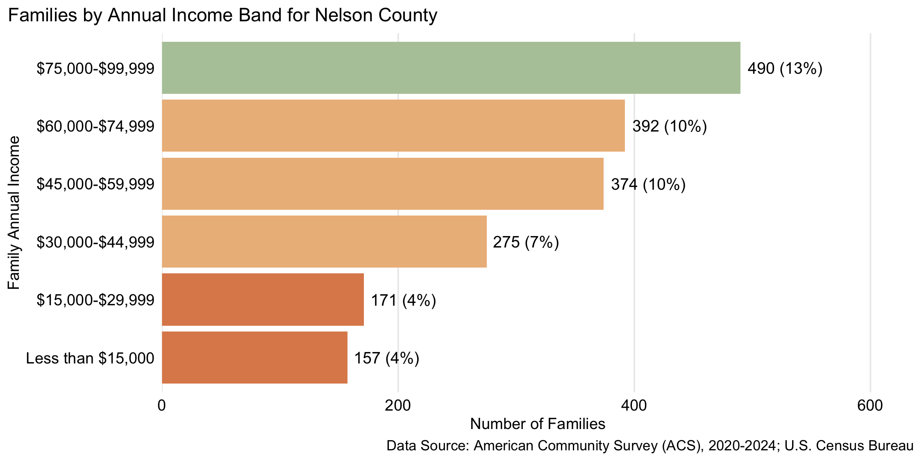
Figure 29: Number and percent of families by family annual income, for family incomes below $100,000, 2024, for Nelson County

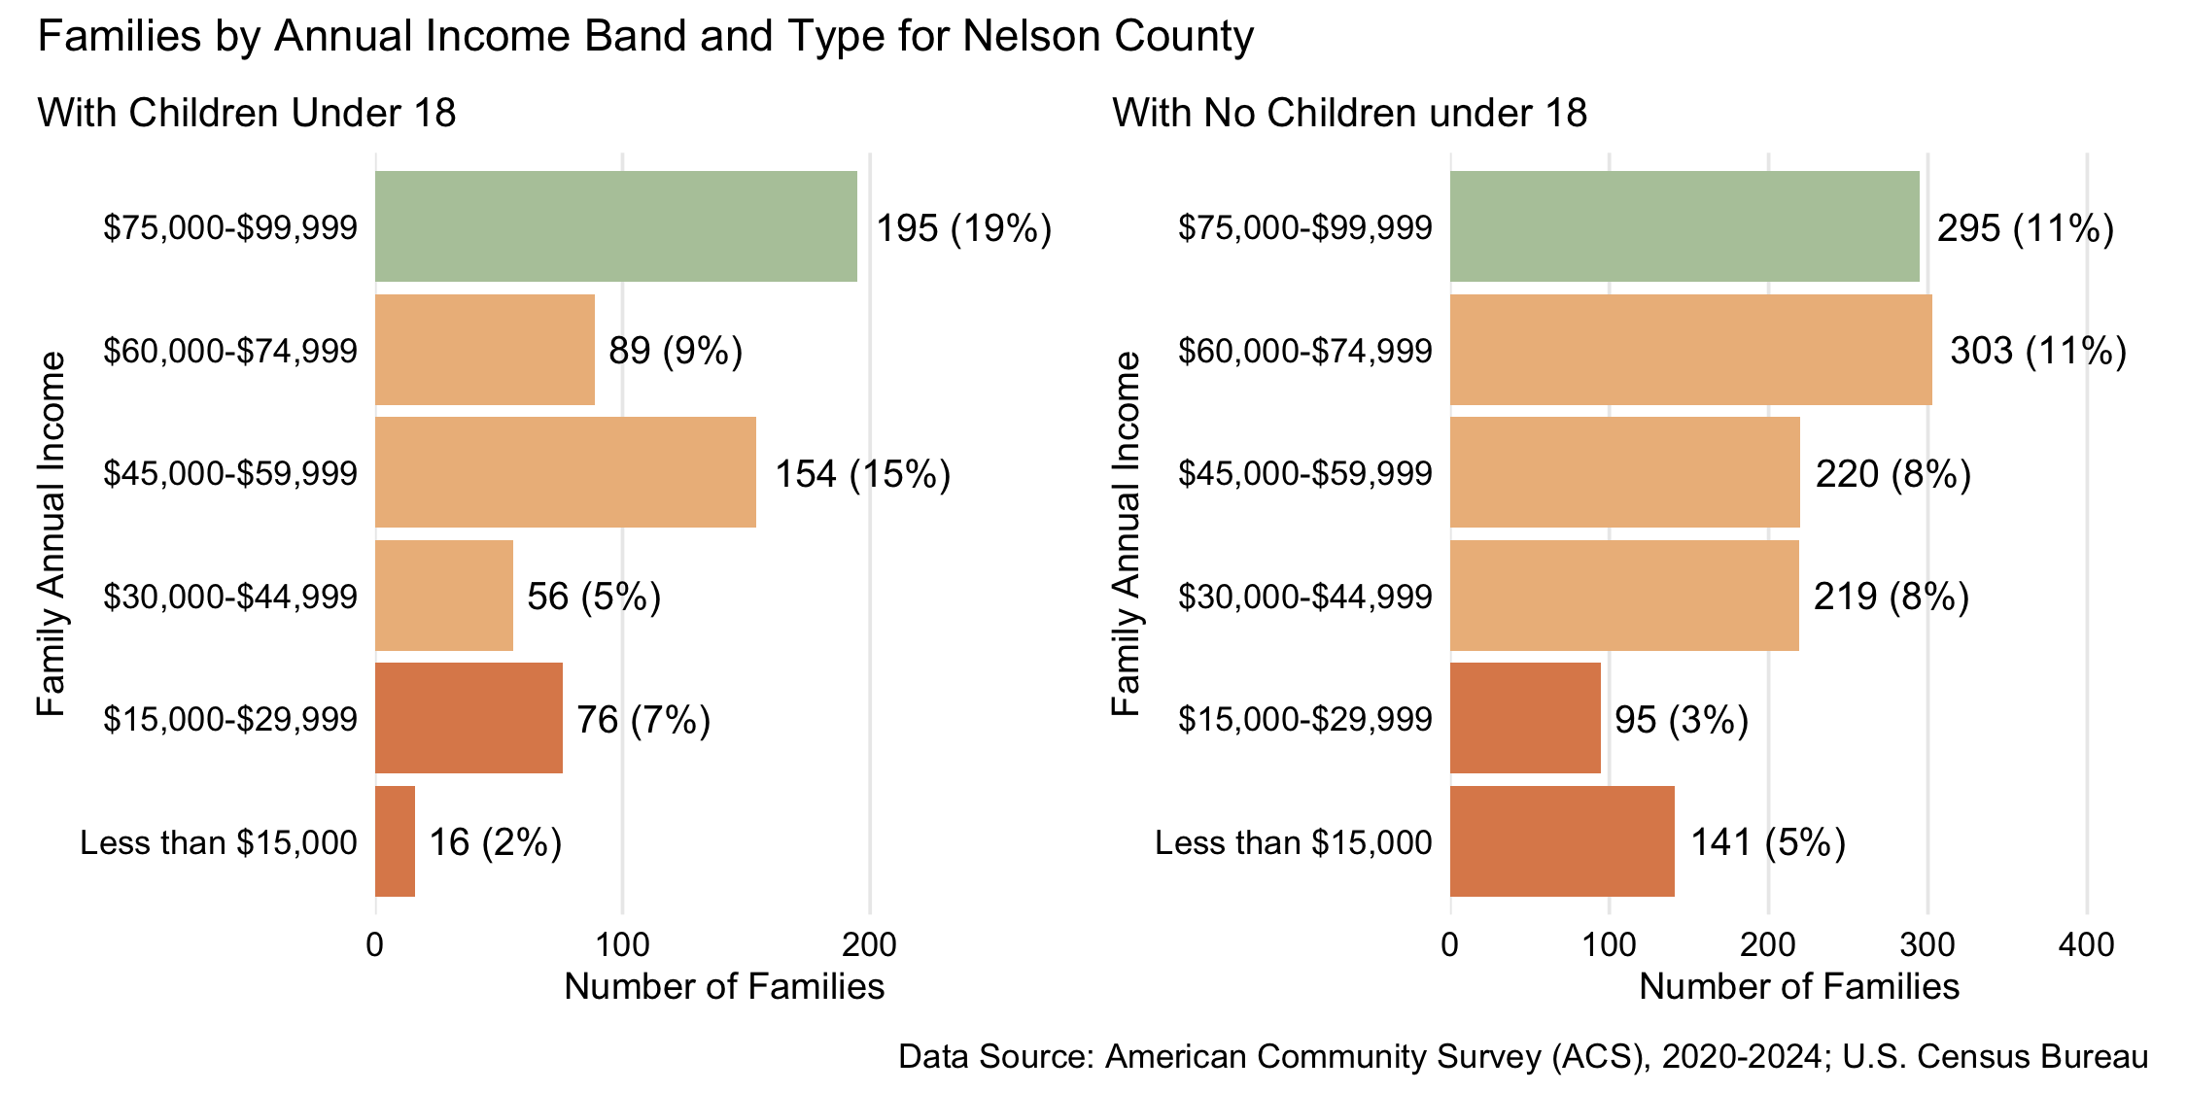
Figure 30: Number and percent of families with and without children under 18 years old by family annual income, for family incomes below $100,000, 2024, for Nelson County
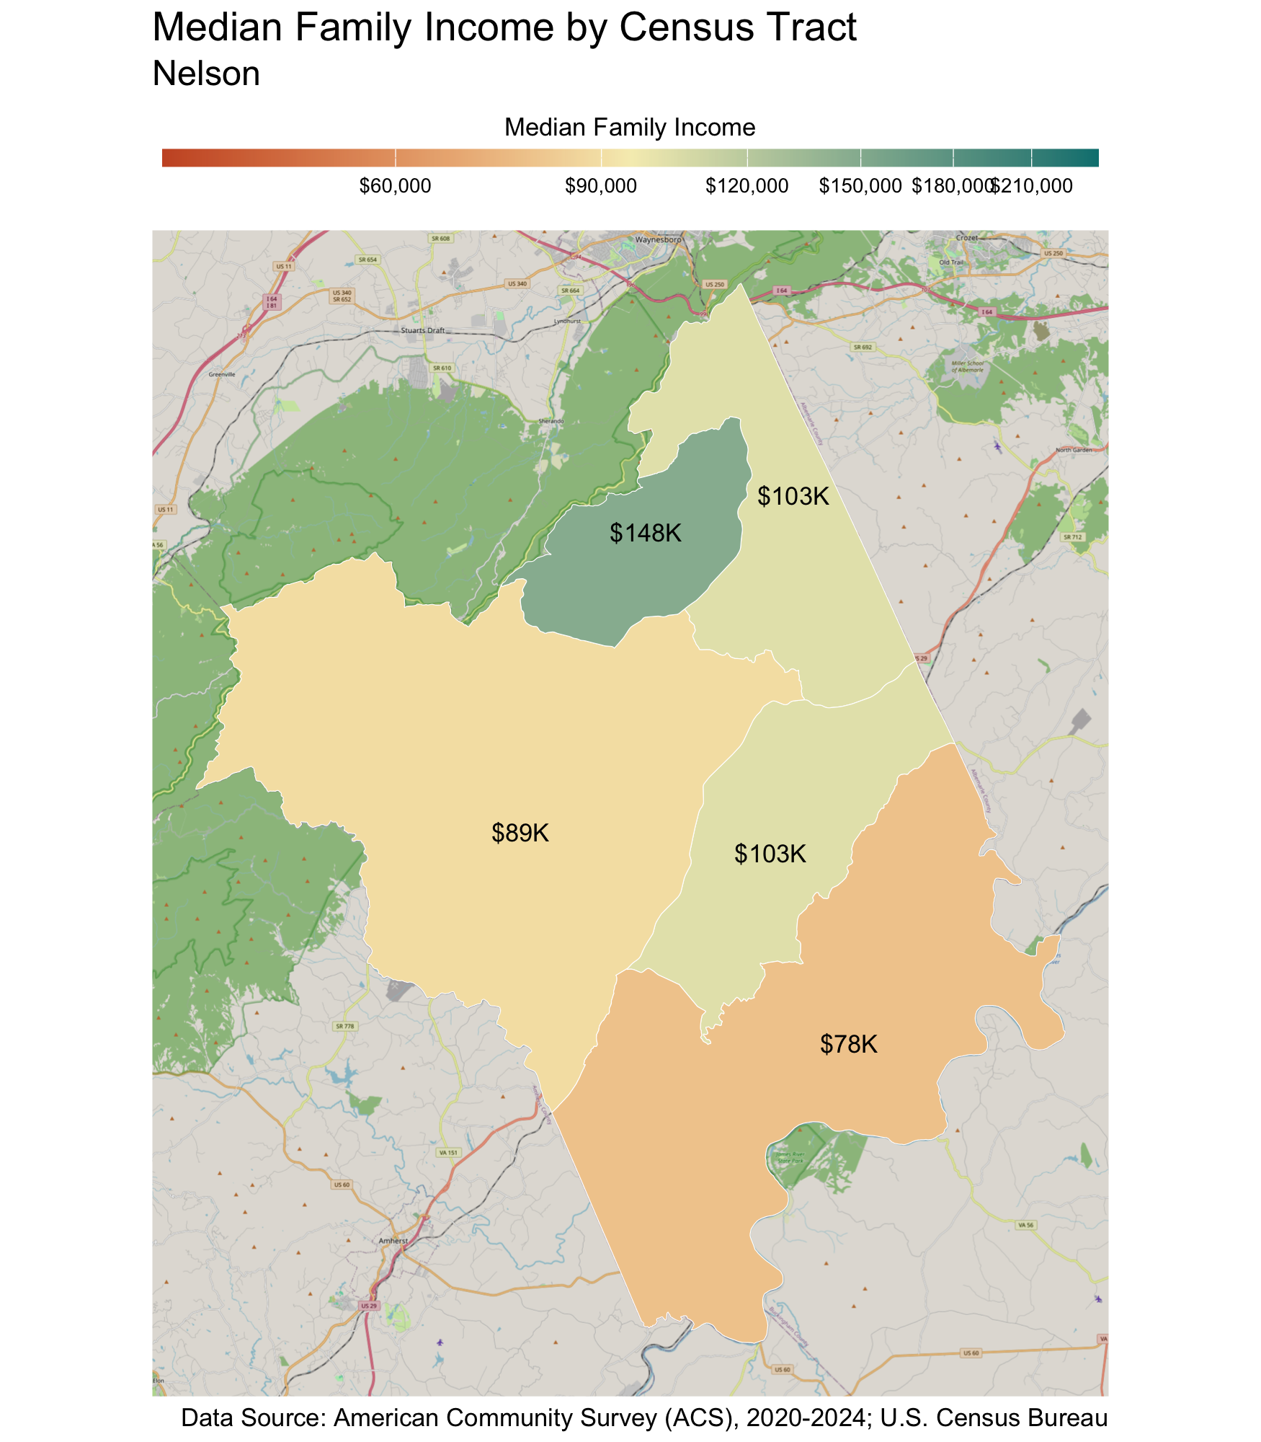
Census Tract |  | Median Family Income
Wintergreen-Wingina* |  | $78,000
Roseland |  | $89,000
Afton-Schuyler |  | $103,000
Lovingston |  | $103,000
Wintergreen-Rockfish Valley |  | $148,000
* Census tracts listed in bold have a median family income below the locality's average family survival budget.
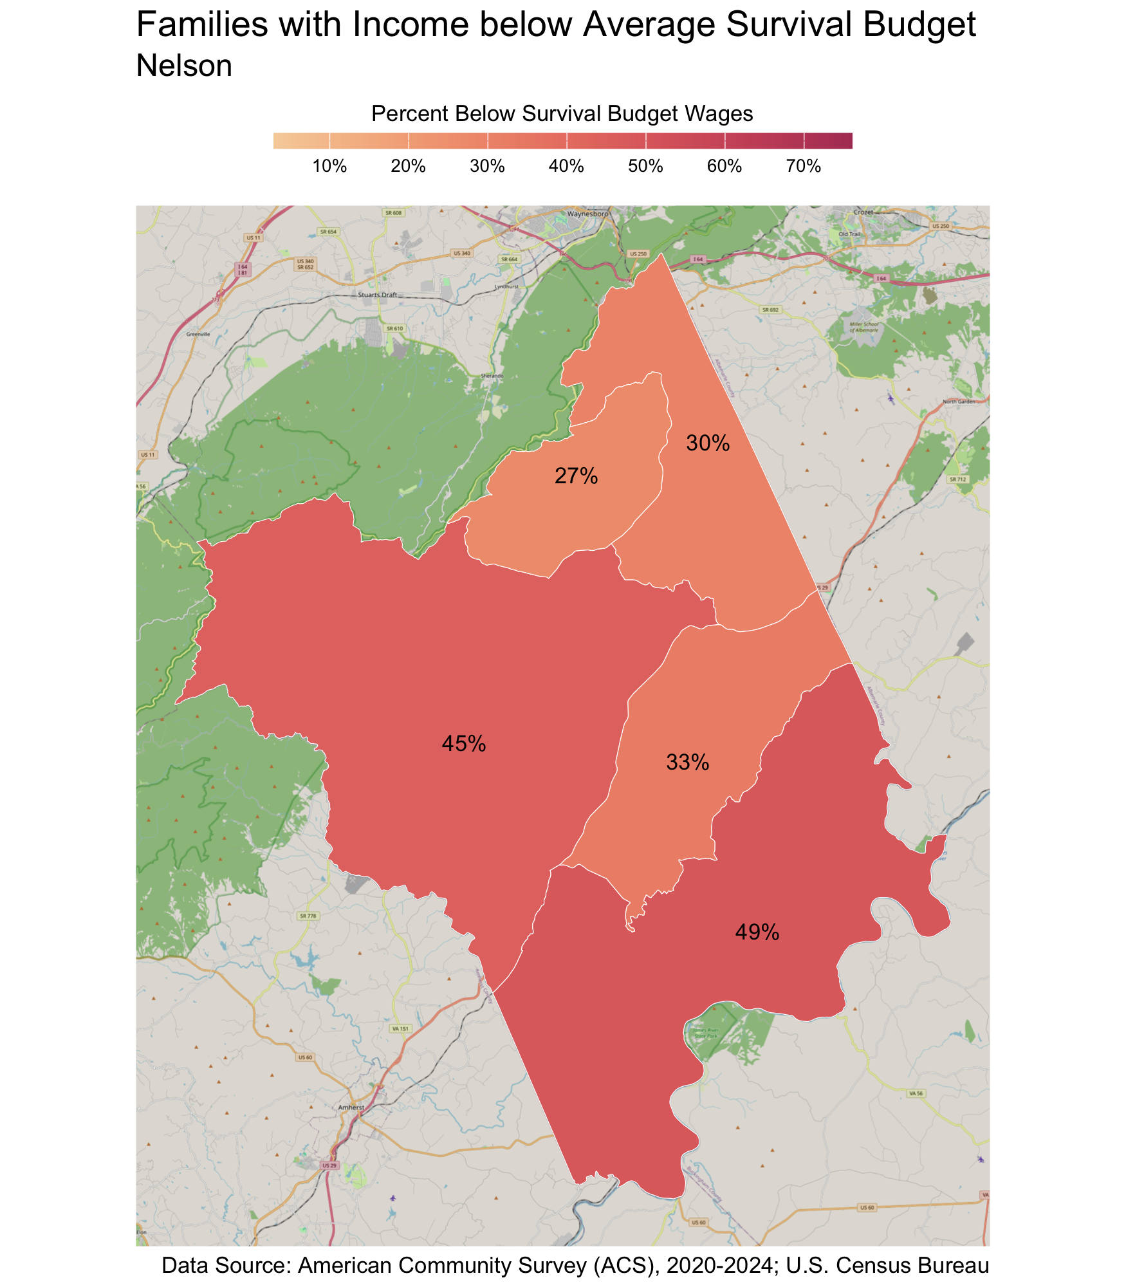
Census Tract |  | Percent
Wintergreen-Wingina |  | 49%
Roseland |  | 45%
Lovingston |  | 33%
Afton-Schuyler |  | 30%
Wintergreen-Rockfish Valley |  | 27%

Households 65 years and over
Table 17: Average Survival Budget for Households 65 years and over in Nelson
 | Monthly | Annual
Housing | $1,544.00 | $18,528.00
Child Care | $0.00 | $0.00
Food | $600.50 | $7,206.00
Transportation | $363.00 | $4,356.00
Health Care | $718.50 | $8,622.00
Technology | $119.00 | $1,428.00
Miscellaneous | $334.50 | $4,014.00
Taxes | $705.00 | $8,460.00
Total Income Needed to Meet Budget | $4,384.50 | $52,614.00
Note: The Average Household Survival Budget is calculated using the ALICE 2024 Household Survival Budgets. The average budget for households 65 years and over is calculated for each locality based on households with one or two adults aged 65 years and over. See the Appendix for detailed budgets for specific family compositions.
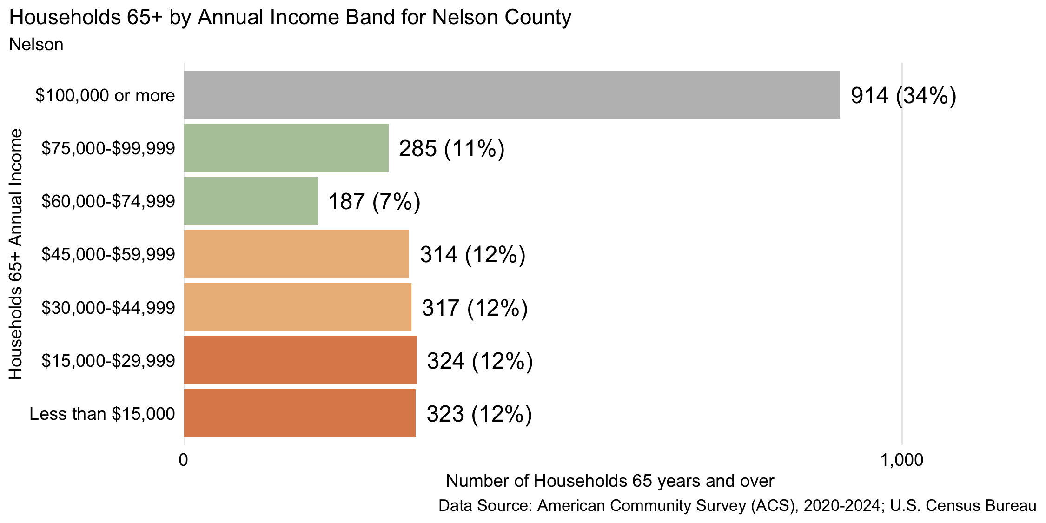
Figure 31: Number and percent of households 65 years and over by annual household income, 2024, for Nelson County
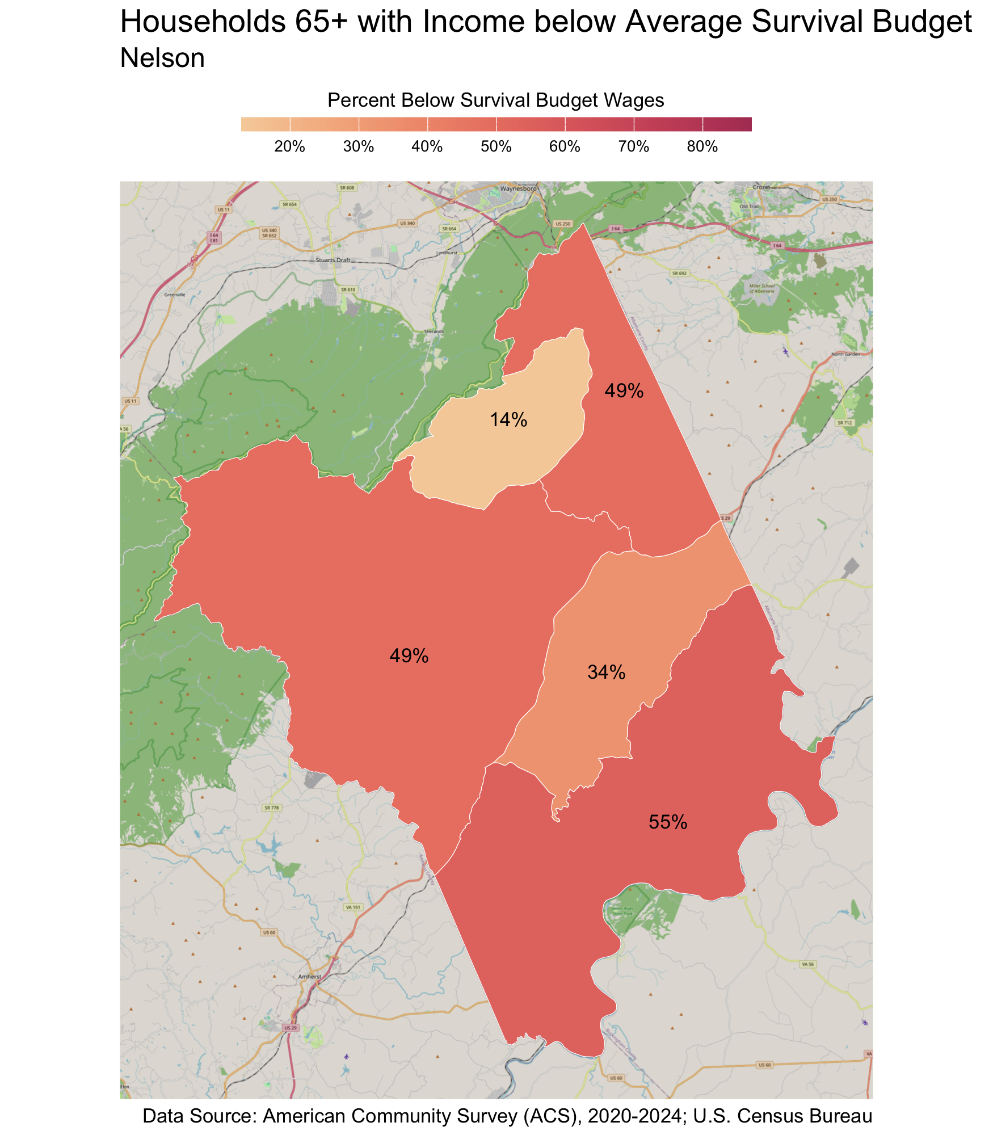
Census Tract |  | Percent
Wintergreen-Wingina |  | 55%
Afton-Schuyler |  | 49%
Roseland |  | 49%
Lovingston |  | 34%
Wintergreen-Rockfish Valley |  | 14%

Credits
This report was done in partnership between Network2Work USA and the UVA Center for Community Partnerships.
The authors of this report are:
- Elizabeth Mitchell, Senior Research Specialist, Center for Community Partnerships, University of Virginia
- Michele Claibourn, Director of Community-Centered Analysis, Center for Community Partnerships, University of Virginia and Assistant Professor, Batten School of Leadership and Public Policy, University of Virginia
- Ridge Schuyler, Founding Director and CEO of Network2Work USA, originated the Orange Dot Report in 2011

Project Repository
The work supporting the Orange Dot Report 7.0, including our data collection documentation and the corresponding data, is publicly available on Github at https://github.com/virginiaequitycenter/orange-dot/tree/main

Citation
Elizabeth Mitchell, Michele Claibourn, Ridge Schuyler. UVA Center for Community Partnerships and Network2Work USA. Orange Dot Report 7.0: Family Self-Sufficiency in the Charlottesville Region: Albemarle, Buckingham, Fluvanna, Greene, Louisa, Nelson Counties & the City of Charlottesville, Virginia. Published October 2026.
This work is licensed under a Creative Commons Attribution 4.0 International License.

Appendix

Family Survival Budgets by Locality
Albemarle County: Survival Budgets by Family Composition
Categories | Single Adult | One Adult One Infant One Preschooler |  | One Adult One Preschooler |  | One Adult One Preschooler One School-Age |  | One Adult One School-Age |  | One Adult Two School-Age |  |  |  |  |  | Two Adults |  |  |  | Two Adults One Infant
Housing | $1,551 | $1,870 |  | $1,573 |  | $1,870 |  | $1,573 |  | $1,870 |  |  |  |  |  | $1,573 |  |  |  | $1,870
Child Care | $0 | $2,208 |  | $1,104 |  | $1,518 |  | $414 |  | $828 |  |  |  |  |  | $0 |  |  |  | $1,104
Food | $528 | $1,042 |  | $801 |  | $1,155 |  | $893 |  | $1,242 |  |  |  |  |  | $968 |  |  |  | $1,202
Transportation | $368 | $614 |  | $461 |  | $614 |  | $461 |  | $614 |  |  |  |  |  | $543 |  |  |  | $708
Health Care | $196 | $694 |  | $478 |  | $694 |  | $478 |  | $694 |  |  |  |  |  | $478 |  |  |  | $694
Technology | $102 | $102 |  | $102 |  | $102 |  | $102 |  | $102 |  |  |  |  |  | $136 |  |  |  | $136
Miscellaneous | $275 | $653 |  | $452 |  | $595 |  | $392 |  | $535 |  |  |  |  |  | $370 |  |  |  | $571
Taxes | $538 | $1,082 |  | $730 |  | $911 |  | $563 |  | $742 |  |  |  |  |  | $602 |  |  |  | $937
Monthly Total | $3,558 | $8,265 |  | $5,701 |  | $7,459 |  | $4,876 |  | $6,627 |  |  |  |  |  | $4,670 |  |  |  | $7,222
ANNUAL TOTAL | $42,696 | $99,180 |  | $68,412 |  | $89,508 |  | $58,512 |  | $79,524 |  |  |  |  |  | $56,040 |  |  |  | $86,664
Hourly Wage | $21.35 | $49.59 |  | $34.21 |  | $44.75 |  | $29.26 |  | $39.76 |  |  |  |  |  | $28.02 |  |  |  | $43.33
Categories | Two Adults One Infant One Preschooler | Two Adults One Preschooler |  | Two Adults One Preschooler One School-Age |  | Two Adults One School-Age |  | Two Adults Two School-Age |  | Two Adults Three School-Age |  |  |  |  |  | Single Senior |  |  |  | Two Seniors
Housing | $1,551 | $1,870 |  | $1,573 |  | $1,870 |  | $1,573 |  | $1,870 |  |  |  |  |  | $1,573 |  |  |  | $1,870
Child Care | $0 | $2,208 |  | $1,104 |  | $1,518 |  | $414 |  | $828 |  |  |  |  |  | $0 |  |  |  | $1,104
Food | $528 | $1,042 |  | $801 |  | $1,155 |  | $893 |  | $1,242 |  |  |  |  |  | $968 |  |  |  | $1,202
Transportation | $368 | $614 |  | $461 |  | $614 |  | $461 |  | $614 |  |  |  |  |  | $543 |  |  |  | $708
Health Care | $196 | $694 |  | $478 |  | $694 |  | $478 |  | $694 |  |  |  |  |  | $478 |  |  |  | $694
Technology | $102 | $102 |  | $102 |  | $102 |  | $102 |  | $102 |  |  |  |  |  | $136 |  |  |  | $136
Miscellaneous | $275 | $653 |  | $452 |  | $595 |  | $392 |  | $535 |  |  |  |  |  | $370 |  |  |  | $571
Taxes | $538 | $1,082 |  | $730 |  | $911 |  | $563 |  | $742 |  |  |  |  |  | $602 |  |  |  | $937
Monthly Total | $3,558 | $8,265 |  | $5,701 |  | $7,459 |  | $4,876 |  | $6,627 |  |  |  |  |  | $4,670 |  |  |  | $7,222
ANNUAL TOTAL | $42,696 | $99,180 |  | $68,412 |  | $89,508 |  | $58,512 |  | $79,524 |  |  |  |  |  | $56,040 |  |  |  | $86,664
Hourly Wage | $21.35 | $49.59 |  | $34.21 |  | $44.75 |  | $29.26 |  | $39.76 |  |  |  |  |  | $28.02 |  |  |  | $43.33
Data Source: ALICE Household Survival Budgets, https://www.unitedforalice.org/the-cost-of-basics/virginia.
Buckingham County: Survival Budgets by Family Composition
Categories | Single Adult |  | One Adult One Infant One Preschooler |  | One Adult One Preschooler |  | One Adult One Preschooler One School-Age |  |  |  | One Adult One School-Age |  |  | One Adult Two School-Age |  |  |  | Two Adults |  |  |  | Two Adults One Infant
Housing | $908 |  | $1,111 |  | $942 |  | $1,111 |  |  |  | $942 |  |  | $1,111 |  |  |  | $942 |  |  |  | $1,111
Child Care | $0 |  | $2,208 |  | $1,104 |  | $1,518 |  |  |  | $414 |  |  | $828 |  |  |  | $0 |  |  |  | $1,104
Food | $443 |  | $873 |  | $671 |  | $968 |  |  |  | $748 |  |  | $1,041 |  |  |  | $812 |  |  |  | $1,007
Transportation | $368 |  | $614 |  | $461 |  | $614 |  |  |  | $461 |  |  | $614 |  |  |  | $543 |  |  |  | $708
Health Care | $196 |  | $694 |  | $478 |  | $694 |  |  |  | $478 |  |  | $694 |  |  |  | $478 |  |  |  | $694
Technology | $102 |  | $102 |  | $102 |  | $102 |  |  |  | $102 |  |  | $102 |  |  |  | $136 |  |  |  | $136
Miscellaneous | $202 |  | $560 |  | $376 |  | $501 |  |  |  | $315 |  |  | $439 |  |  |  | $291 |  |  |  | $476
Taxes | $334 |  | $813 |  | $518 |  | $646 |  |  |  | $347 |  |  | $474 |  |  |  | $399 |  |  |  | $671
Monthly Total | $2,553 |  | $6,975 |  | $4,652 |  | $6,154 |  |  |  | $3,807 |  |  | $5,303 |  |  |  | $3,601 |  |  |  | $5,907
ANNUAL TOTAL | $30,636 |  | $83,700 |  | $55,824 |  | $73,848 |  |  |  | $45,684 |  |  | $63,636 |  |  |  | $43,212 |  |  |  | $70,884
Hourly Wage | $15.32 |  | $41.85 |  | $27.91 |  | $36.92 |  |  |  | $22.84 |  |  | $31.82 |  |  |  | $21.61 |  |  |  | $35.44
Categories | Two Adults One Infant One Preschooler |  | Two Adults One Preschooler |  | Two Adults One Preschooler One School-Age |  | Two Adults One School-Age |  |  |  | Two Adults Two School-Age |  |  | Two Adults Three School-Age |  |  |  | Single Senior |  |  |  | Two Seniors
Housing | $1,111 |  | $1,111 |  | $1,111 |  | $1,111 |  |  |  | $1,111 |  |  | $1,370 |  |  |  | $908 |  |  |  | $942
Child Care | $2,208 |  | $1,104 |  | $1,518 |  | $414 |  |  |  | $828 |  |  | $1,242 |  |  |  | $0 |  |  |  | $0
Food | $1,200 |  | $1,028 |  | $1,290 |  | $1,102 |  |  |  | $1,360 |  |  | $1,588 |  |  |  | $408 |  |  |  | $747
Transportation | $813 |  | $708 |  | $813 |  | $708 |  |  |  | $813 |  |  | $919 |  |  |  | $306 |  |  |  | $420
Health Care | $735 |  | $694 |  | $735 |  | $694 |  |  |  | $735 |  |  | $776 |  |  |  | $502 |  |  |  | $1,004
Technology | $136 |  | $136 |  | $136 |  | $136 |  |  |  | $136 |  |  | $136 |  |  |  | $102 |  |  |  | $136
Miscellaneous | $620 |  | $478 |  | $560 |  | $417 |  |  |  | $498 |  |  | $603 |  |  |  | $223 |  |  |  | $325
Taxes | $854 |  | $677 |  | $686 |  | $504 |  |  |  | $513 |  |  | $634 |  |  |  | $392 |  |  |  | $678
Monthly Total | $7,677 |  | $5,936 |  | $6,849 |  | $5,086 |  |  |  | $5,994 |  |  | $7,268 |  |  |  | $2,841 |  |  |  | $4,252
ANNUAL TOTAL | $92,124 |  | $71,232 |  | $82,188 |  | $61,032 |  |  |  | $71,928 |  |  | $87,216 |  |  |  | $34,092 |  |  |  | $51,024
Hourly Wage | $46.06 |  | $35.62 |  | $41.09 |  | $30.52 |  |  |  | $35.96 |  |  | $43.61 |  |  |  | $17.05 |  |  |  | $25.51
Data Source: ALICE Household Survival Budgets, https://www.unitedforalice.org/the-cost-of-basics/virginia.

Charlottesville City: Survival Budgets by Family Composition
Categories | Single Adult | One Adult One Infant One Preschooler | One Adult One Preschooler | One Adult One Preschooler One School-Age | One Adult One School-Age | One Adult Two School-Age | Two Adults | Two Adults One Infant
Housing | $1,600 | $1,930 | $1,628 | $1,930 | $1,628 | $1,930 | $1,628 | $1,930
Child Care | $0 | $2,208 | $1,104 | $1,518 | $414 | $828 | $0 | $1,104
Food | $646 | $1,275 | $980 | $1,413 | $1,092 | $1,520 | $1,184 | $1,470
Transportation | $368 | $614 | $461 | $614 | $461 | $614 | $543 | $708
Health Care | $196 | $694 | $478 | $694 | $478 | $694 | $478 | $694
Technology | $102 | $102 | $102 | $102 | $102 | $102 | $136 | $136
Miscellaneous | $291 | $682 | $475 | $627 | $418 | $569 | $397 | $604
Taxes | $584 | $1,196 | $796 | $999 | $634 | $837 | $671 | $1,029
Monthly Total | $3,787 | $8,701 | $6,024 | $7,897 | $5,227 | $7,094 | $5,037 | $7,675
ANNUAL TOTAL | $45,444 | $104,412 | $72,288 | $94,764 | $62,724 | $85,128 | $60,444 | $92,100
Hourly Wage | $22.72 | $52.21 | $36.14 | $47.38 | $31.36 | $42.56 | $30.22 | $46.05
Categories | Two Adults One Infant One Preschooler | Two Adults One Preschooler | Two Adults One Preschooler One School-Age | Two Adults One School-Age | Two Adults Two School-Age | Two Adults Three School-Age | Single Senior | Two Seniors
Housing | $1,930 | $1,930 | $1,930 | $1,930 | $1,930 | $2,431 | $1,600 | $1,628
Child Care | $2,208 | $1,104 | $1,518 | $414 | $828 | $1,242 | $0 | $0
Food | $1,752 | $1,501 | $1,884 | $1,608 | $1,986 | $2,318 | $595 | $1,090
Transportation | $813 | $708 | $813 | $708 | $813 | $919 | $306 | $420
Health Care | $735 | $694 | $735 | $694 | $735 | $776 | $486 | $973
Technology | $136 | $136 | $136 | $136 | $136 | $136 | $102 | $136
Miscellaneous | $757 | $607 | $702 | $549 | $643 | $782 | $309 | $425
Taxes | $1,237 | $1,037 | $1,081 | $875 | $916 | $1,134 | $634 | $957
Monthly Total | $9,568 | $7,717 | $8,799 | $6,914 | $7,987 | $9,738 | $4,032 | $5,629
ANNUAL TOTAL | $114,816 | $92,604 | $105,588 | $82,968 | $95,844 | $116,856 | $48,384 | $67,548
Hourly Wage | $57.41 | $46.30 | $52.79 | $41.48 | $47.92 | $58.43 | $24.19 | $33.77
Data Source: ALICE Household Survival Budgets, https://www.unitedforalice.org/the-cost-of-basics/virginia.

Fluvanna County: Survival Budgets by Family Composition
Categories | Single Adult | One Adult One Infant One Preschooler | One Adult One Preschooler | One Adult One Preschooler One School-Age | One Adult One School-Age | One Adult Two School-Age | Two Adults | Two Adults One Infant
Housing | $1,531 | $1,846 | $1,557 | $1,846 | $1,557 | $1,846 | $1,557 | $1,846
Child Care | $0 | $2,208 | $1,104 | $1,518 | $414 | $828 | $0 | $1,104
Food | $528 | $1,042 | $801 | $1,155 | $893 | $1,242 | $968 | $1,202
Transportation | $368 | $614 | $461 | $614 | $461 | $614 | $543 | $708
Health Care | $196 | $694 | $478 | $694 | $478 | $694 | $478 | $694
Technology | $102 | $102 | $102 | $102 | $102 | $102 | $136 | $136
Miscellaneous | $273 | $651 | $450 | $593 | $391 | $533 | $368 | $569
Taxes | $532 | $1,073 | $726 | $904 | $559 | $735 | $598 | $930
Monthly Total | $3,530 | $8,230 | $5,679 | $7,426 | $4,855 | $6,594 | $4,648 | $7,189
ANNUAL TOTAL | $42,360 | $98,760 | $68,148 | $89,112 | $58,260 | $79,128 | $55,776 | $86,268
Hourly Wage | $21.18 | $49.38 | $34.07 | $44.56 | $29.13 | $39.56 | $27.89 | $43.13
Categories | Two Adults One Infant One Preschooler | Two Adults One Preschooler | Two Adults One Preschooler One School-Age | Two Adults One School-Age | Two Adults Two School-Age | Two Adults Three School-Age | Single Senior | Two Seniors
Housing | $1,846 | $1,846 | $1,846 | $1,846 | $1,846 | $2,325 | $1,531 | $1,557
Child Care | $2,208 | $1,104 | $1,518 | $414 | $828 | $1,242 | $0 | $0
Food | $1,432 | $1,227 | $1,540 | $1,314 | $1,623 | $1,895 | $486 | $891
Transportation | $813 | $708 | $813 | $708 | $813 | $919 | $306 | $420
Health Care | $735 | $694 | $735 | $694 | $735 | $776 | $466 | $933
Technology | $136 | $136 | $136 | $136 | $136 | $136 | $102 | $136
Miscellaneous | $717 | $572 | $659 | $511 | $598 | $729 | $289 | $394
Taxes | $1,124 | $938 | $961 | $769 | $792 | $987 | $578 | $870
Monthly Total | $9,011 | $7,225 | $8,208 | $6,392 | $7,371 | $9,009 | $3,758 | $5,201
ANNUAL TOTAL | $108,132 | $86,700 | $98,496 | $76,704 | $88,452 | $108,108 | $45,096 | $62,412
Hourly Wage | $54.07 | $43.35 | $49.25 | $38.35 | $44.23 | $54.05 | $22.55 | $31.21
Data Source: ALICE Household Survival Budgets, https://www.unitedforalice.org/the-cost-of-basics/virginia.

Greene County: Survival Budgets by Family Composition
Categories | Single Adult | One Adult One Infant One Preschooler | One Adult One Preschooler | One Adult One Preschooler One School-Age | One Adult One School-Age | One Adult Two School-Age | Two Adults | Two Adults One Infant
Housing | $1,531 | $1,846 | $1,557 | $1,846 | $1,557 | $1,846 | $1,557 | $1,846
Child Care | $0 | $2,208 | $1,104 | $1,518 | $414 | $828 | $0 | $1,104
Food | $646 | $1,275 | $980 | $1,413 | $1,092 | $1,520 | $1,184 | $1,470
Transportation | $368 | $614 | $461 | $614 | $461 | $614 | $543 | $708
Health Care | $196 | $694 | $478 | $694 | $478 | $694 | $478 | $694
Technology | $102 | $102 | $102 | $102 | $102 | $102 | $136 | $136
Miscellaneous | $284 | $674 | $468 | $619 | $410 | $560 | $390 | $596
Taxes | $565 | $1,163 | $776 | $976 | $614 | $813 | $653 | $1,005
Monthly Total | $3,692 | $8,576 | $5,926 | $7,782 | $5,128 | $6,977 | $4,941 | $7,559
ANNUAL TOTAL | $44,304 | $102,912 | $71,112 | $93,384 | $61,536 | $83,724 | $59,292 | $90,708
Hourly Wage | $22.15 | $51.46 | $35.56 | $46.69 | $30.77 | $41.86 | $29.65 | $45.35
Categories | Two Adults One Infant One Preschooler | Two Adults One Preschooler | Two Adults One Preschooler One School-Age | Two Adults One School-Age | Two Adults Two School-Age | Two Adults Three School-Age | Single Senior | Two Seniors
Housing | $1,846 | $1,846 | $1,846 | $1,846 | $1,846 | $2,325 | $1,531 | $1,557
Child Care | $2,208 | $1,104 | $1,518 | $414 | $828 | $1,242 | $0 | $0
Food | $1,752 | $1,501 | $1,884 | $1,608 | $1,986 | $2,318 | $595 | $1,090
Transportation | $813 | $708 | $813 | $708 | $813 | $919 | $306 | $420
Health Care | $735 | $694 | $735 | $694 | $735 | $776 | $498 | $997
Technology | $136 | $136 | $136 | $136 | $136 | $136 | $102 | $136
Miscellaneous | $749 | $599 | $693 | $541 | $634 | $772 | $303 | $420
Taxes | $1,213 | $1,014 | $1,057 | $851 | $893 | $1,105 | $618 | $944
Monthly Total | $9,452 | $7,602 | $8,682 | $6,798 | $7,871 | $9,593 | $3,953 | $5,564
ANNUAL TOTAL | $113,424 | $91,224 | $104,184 | $81,576 | $94,452 | $115,116 | $47,436 | $66,768
Hourly Wage | $56.71 | $45.61 | $52.09 | $40.79 | $47.23 | $57.56 | $23.72 | $33.38
Data Source: ALICE Household Survival Budgets, https://www.unitedforalice.org/the-cost-of-basics/virginia.

Louisa County: Survival Budgets by Family Composition
Categories | Single Adult | One Adult One Infant One Preschooler | One Adult One Preschooler | One Adult One Preschooler One School-Age | One Adult One School-Age | One Adult Two School-Age | Two Adults | Two Adults One Infant
Housing | $1,081 | $1,247 | $1,111 | $1,247 | $1,111 | $1,247 | $1,111 | $1,247
Child Care | $0 | $2,208 | $1,104 | $1,518 | $414 | $828 | $0 | $1,104
Food | $478 | $943 | $725 | $1,045 | $808 | $1,124 | $876 | $1,087
Transportation | $368 | $614 | $461 | $614 | $461 | $614 | $543 | $708
Health Care | $196 | $694 | $478 | $694 | $478 | $694 | $478 | $694
Technology | $102 | $102 | $102 | $102 | $102 | $102 | $136 | $136
Miscellaneous | $223 | $581 | $398 | $522 | $337 | $461 | $314 | $498
Taxes | $392 | $870 | $580 | $706 | $411 | $535 | $459 | $731
Monthly Total | $2,840 | $7,259 | $4,959 | $6,448 | $4,122 | $5,605 | $3,917 | $6,205
ANNUAL TOTAL | $34,080 | $87,108 | $59,508 | $77,376 | $49,464 | $67,260 | $47,004 | $74,460
Hourly Wage | $17.04 | $43.55 | $29.75 | $38.69 | $24.73 | $33.63 | $23.50 | $37.23
Categories | Two Adults One Infant One Preschooler | Two Adults One Preschooler | Two Adults One Preschooler One School-Age | Two Adults One School-Age | Two Adults Two School-Age | Two Adults Three School-Age | Single Senior | Two Seniors
Housing | $1,247 | $1,247 | $1,247 | $1,247 | $1,247 | $1,739 | $1,081 | $1,111
Child Care | $2,208 | $1,104 | $1,518 | $414 | $828 | $1,242 | $0 | $0
Food | $1,296 | $1,110 | $1,394 | $1,190 | $1,469 | $1,715 | $440 | $807
Transportation | $813 | $708 | $813 | $708 | $813 | $919 | $306 | $420
Health Care | $735 | $694 | $735 | $694 | $735 | $776 | $507 | $1,013
Technology | $136 | $136 | $136 | $136 | $136 | $136 | $102 | $136
Miscellaneous | $644 | $500 | $584 | $439 | $523 | $653 | $244 | $349
Taxes | $919 | $738 | $753 | $567 | $581 | $773 | $451 | $745
Monthly Total | $7,998 | $6,237 | $7,180 | $5,395 | $6,332 | $7,953 | $3,131 | $4,581
ANNUAL TOTAL | $95,976 | $74,844 | $86,160 | $64,740 | $75,984 | $95,436 | $37,572 | $54,972
Hourly Wage | $47.99 | $37.42 | $43.08 | $32.37 | $37.99 | $47.72 | $18.79 | $27.49
Data Source: ALICE Household Survival Budgets, https://www.unitedforalice.org/the-cost-of-basics/virginia.

Nelson County: Survival Budgets by Family Composition
Categories | Single Adult | One Adult One Infant One Preschooler | One Adult One Preschooler | One Adult One Preschooler One School-Age | One Adult One School-Age | One Adult Two School-Age | Two Adults | Two Adults One Infant
Housing | $1,531 | $1,846 | $1,557 | $1,846 | $1,111 | $1,846 | $1,557 | $1,846
Child Care | $0 | $2,208 | $1,104 | $1,518 | $414 | $828 | $0 | $1,104
Food | $460 | $908 | $698 | $1,006 | $808 | $1,083 | $844 | $1,047
Transportation | $368 | $614 | $461 | $614 | $461 | $614 | $543 | $708
Health Care | $196 | $694 | $478 | $694 | $478 | $694 | $478 | $694
Technology | $102 | $102 | $102 | $102 | $102 | $102 | $136 | $136
Miscellaneous | $266 | $637 | $440 | $578 | $337 | $517 | $356 | $554
Taxes | $513 | $1,028 | $697 | $862 | $411 | $691 | $566 | $887
Monthly Total | $3,436 | $8,037 | $5,537 | $7,220 | $4,122 | $6,375 | $4,480 | $6,976
ANNUAL TOTAL | $41,232 | $96,444 | $66,444 | $86,640 | $49,464 | $76,500 | $53,760 | $83,712
Hourly Wage | $20.62 | $48.22 | $33.22 | $43.32 | $24.73 | $38.25 | $26.88 | $41.86
Categories | Two Adults One Infant One Preschooler | Two Adults One Preschooler | Two Adults One Preschooler One School-Age | Two Adults One School-Age | Two Adults Two School-Age | Two Adults Three School-Age | Single Senior | Two Seniors
Housing | $1,846 | $1,846 | $1,846 | $1,846 | $1,846 | $2,325 | $1,531 | $1,557
Child Care | $2,208 | $1,104 | $1,518 | $414 | $828 | $1,242 | $0 | $0
Food | $1,248 | $1,069 | $1,342 | $1,146 | $1,415 | $1,652 | $424 | $777
Transportation | $813 | $708 | $813 | $708 | $813 | $919 | $306 | $420
Health Care | $735 | $694 | $735 | $694 | $735 | $776 | $479 | $958
Technology | $136 | $136 | $136 | $136 | $136 | $136 | $102 | $136
Miscellaneous | $699 | $556 | $639 | $494 | $577 | $705 | $284 | $385
Taxes | $1,072 | $893 | $906 | $722 | $733 | $919 | $565 | $845
Monthly Total | $8,757 | $7,006 | $7,935 | $6,160 | $7,083 | $8,674 | $3,691 | $5,078
ANNUAL TOTAL | $105,084 | $84,072 | $95,220 | $73,920 | $84,996 | $104,088 | $44,292 | $60,936
Hourly Wage | $52.54 | $42.04 | $47.61 | $36.96 | $42.50 | $52.04 | $22.15 | $30.47
Data Source: ALICE Household Survival Budgets, https://www.unitedforalice.org/the-cost-of-basics/virginia.

List of Occupations by Employment Rate
Table 18: Occupations with the highest Employment Rate in the Charlottesville Metro Area¹
List of occupations with employment rate of 10 per 1,000 jobs or higher, with annual median wage
Occupation | Annual Median Wage² | Employment Rate (per 1,000 jobs)³ | Occupation Group⁴
Educational Instruction and Library Occupations | $73,840.00 | 106.2 | Educational Instruction and Library
Office and Administrative Support Occupations | $47,380.00 | 96.1 | Office and Administrative Support
Food Preparation and Serving Related Occupations | $36,010.00 | 94.4 | Food Preparation and Serving Related
Healthcare Practitioners and Technical Occupations | $99,530.00 | 78.3 | Healthcare Practitioners and Technical
Sales and Related Occupations | $37,030.00 | 76.5 | Sales and Related
Business and Financial Operations Occupations | $80,180.00 | 71.8 | Business and Financial Operations
Transportation and Material Moving Occupations | $38,100.00 | 49.6 | Transportation and Material Moving
Healthcare Support Occupations | $38,320.00 | 47.8 | Healthcare Support
Life, Physical, and Social Science Occupations | $67,240.00 | 36.7 | Life, Physical, and Social Science
Construction and Extraction Occupations | $55,580.00 | 35.9 | Construction and Extraction
Computer and Mathematical Occupations | $109,620.00 | 35.2 | Computer and Mathematical
Building and Grounds Cleaning and Maintenance Occupations | $36,170.00 | 34.3 | Building and Grounds Cleaning and Maintenance
Installation, Maintenance, and Repair Occupations | $57,660.00 | 31.5 | Installation, Maintenance, and Repair
Registered Nurses | $99,320.00 | 26.5 | Healthcare Practitioners and Technical
Personal Care and Service Occupations | $35,740.00 | 25.6 | Personal Care and Service
Fast Food and Counter Workers | $30,150.00 | 24.4 | Food Preparation and Serving Related
Community and Social Service Occupations | $58,070.00 | 22.3 | Community and Social Service
Retail Salespersons | $34,210.00 | 22.2 | Sales and Related
Protective Service Occupations | $48,430.00 | 22.1 | Protective Service
General and Operations Managers | $107,200.00 | 22.1 | Management
Production Occupations | $46,640.00 | 21.7 | Production
Waiters and Waitresses | $44,030.00 | 18.6 | Food Preparation and Serving Related
Cashiers | $30,930.00 | 18.4 | Sales and Related
Office Clerks, General | $45,620.00 | 18.1 | Office and Administrative Support
Home Health and Personal Care Aides | $29,700.00 | 17.2 | Healthcare Support
Arts, Design, Entertainment, Sports, and Media Occupations | $61,410.00 | 15.7 | Arts, Design, Entertainment, Sports, and Media
Architecture and Engineering Occupations | $87,080.00 | 14.2 | Architecture and Engineering
Nursing Assistants | $44,140.00 | 14.1 | Healthcare Support
Stockers and Order Fillers | $35,710.00 | 13.4 | Transportation and Material Moving
Maids and Housekeeping Cleaners | $34,940.00 | 12.8 | Building and Grounds Cleaning and Maintenance
Software Developers | $128,520.00 | 12.2 | Computer and Mathematical
Cooks, Restaurant | $36,960.00 | 12.0 | Food Preparation and Serving Related
Janitors and Cleaners, Except Maids and Housekeeping Cleaners | $36,090.00 | 10.5 | Building and Grounds Cleaning and Maintenance
Secretaries and Administrative Assistants, Except Legal, Medical, and Executive | $53,100.00 | 10.1 | Office and Administrative Support
¹A full list of occupations and wages is available here: https://github.com/virginiaequitycenter/orange-dot/blob/main/OrangeDot7_2026/data/bls_occupations_by_wagebin.csv
²The annual median wage is the boundary between the highest and lowest paid workers in a given occupation. Half of the workers in a given occupation earn more than the median wage, and half the workers earn less than the median wage.
³Employment rate is the number of jobs (employment) in the given occupation per 1,000 jobs in the Charlottesville Metro Area
⁴Major occupation groups defined by the Standard Occupational Classification (SOC) system, used by Federal statistical agencies to classify workers and jobs into occupational categories for the purpose of collecting, calculating, analyzing, or disseminating data.
Data Source: U.S. Bureau of Labor Statistics, Occupational Employment and Wage Statistics; May 2025; https://www.bls.gov/oes/tables.htm

Family households, by definition, exclude households composed of single adults. Thus, college students are not counted in this analysis unless they reside with a relative. As this definition can also exclude older adults living alone, who may face higher risk of economic instability, we include separate estimates of the economic self-sufficiency of households aged 65 and over to provide a more complete picture of this growing population.
The Thomas Jefferson Planning District includes the City of Charlottesville, and Albemarle, Fluvanna, Greene, Louisa, and Nelson counties. Buckingham County is not included in the microdata sample.
Based on the 2026 minimum wage of $12.77 per hour. In 2027, the Virginia minimum wage will increase to $13.75, and subsequently increase to $15.00 per in 2028. https://www.governor.virginia.gov/newsroom/news-releases/2026/april-releases/name-1116004-en.html

