Report Title
Report Subtitle
Date
Table of Contents
Heading 2 0
Heading 3 0

Heading 2
First Paragraph

Heading 3
Stepping Stones 2026 Executive Summary
Body Text
- Normal + Bold: Normal

Heading 4

Heading 5

Heading 6

Heading 7
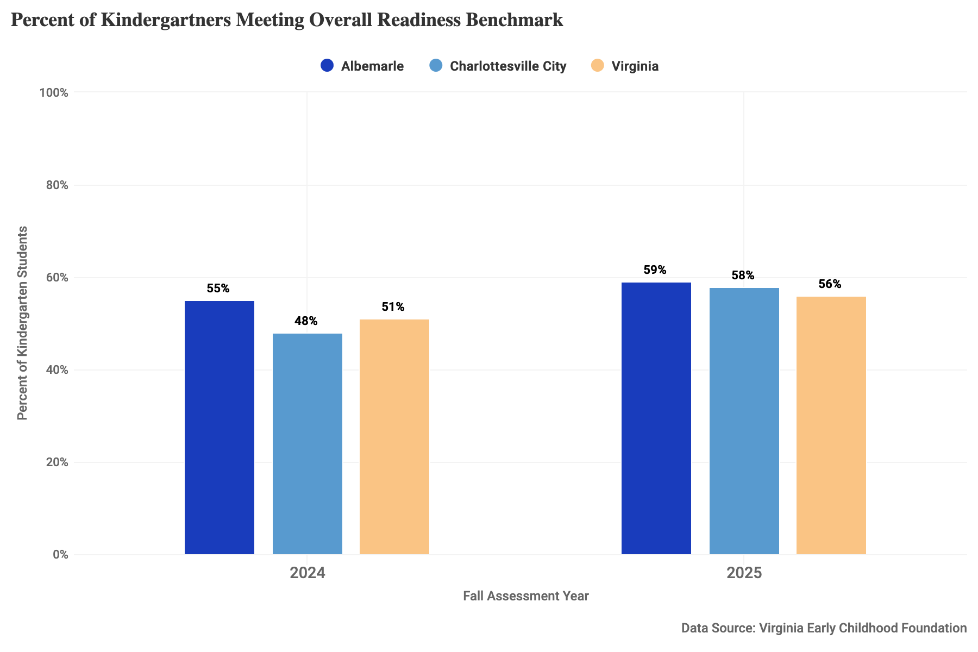
Figure 1: Image Caption

Figure | Source
Figure 1: Percent of kindergartners meeting overall readiness benchmark in the 2024 and 2025 fall assessments for Albemarle County, Charlottesville City, and Virginia. | "School Readiness," Ready Region ECCE Supply/Demand Dashboard, Virginia Early Childhood Foundation. https://vecf.org/supply-and-demand-data/
Figure 2: Percent of students who pass the 3rd grade math SOL test, 2009-10 through 2024-25 school years at ACPS, CCS and Virginia public schools. SOL tests were not conducted for the 2019-20 school year due to the COVID-19 pandemic. | Virginia Department of Education (VDOE). “Test Results Build-A-Table.” 2009-2025. https://p1pe.doe.virginia.gov/buildatable/testresults
Figure 3: Percent of students who pass the 5th grade math SOL test, 2009-10 through 2024-25 school years at ACPS, CCS and Virginia public schools. SOL tests were not conducted for the 2019-20 school year due to the COVID-19 pandemic. | Virginia Department of Education (VDOE). “Test Results Build-A-Table.” 2009-2025. https://p1pe.doe.virginia.gov/buildatable/testresults
Figure 4: Percent of students who pass the 3rd grade reading SOL test, 2009-10 through 2024-25 school years at ACPS, CCS and Virginia public schools. SOL tests were not conducted for the 2019-20 school year due to the COVID-19 pandemic. | Virginia Department of Education (VDOE). “Test Results Build-A-Table.” 2009-2025. https://p1pe.doe.virginia.gov/buildatable/testresults

