Albemarle County Community Wellbeing Profile: Summary

UVA Center for Community Partnerships in partnership with Albemarle County

The Albemarle County Community Wellbeing Profile provides current data for measures related to well-being, building on the 2021 Albemarle County Equity Profile. The American Human Development Index (AHDI)—calculated from metrics on health, access to knowledge, and living standards and scored on a scale from 0 to 10—is used as a framework to assess and advocate for increased and inclusive well-being.

|  |  | Health | Access to Knowledge | | | | Living Standards |
| --- | --- | --- | --- | --- | --- | --- | --- |
| **American HD Index** | Life Expectancy (years) | At Least High School Diploma | At Least Bachelor’s Degree | Graduate Degree | School Enrollment | Median Earnings |
| Local | | | | | | | |
| Albemarle (2023) | **7.3** | 82 | 94% | 61% | 31% | 85% | $51,922 |
| Albemarle (2019) | **7.4** | 83 | 95% | 61% | 30% | 87% | $44,030 |
| State | | | | | | | |
| Virginia (2023) | **5.8** | 78 | 91% | 41% | 18% | 76% | $49,405 |
| Virginia (2019) | **5.8** | 79 | 90% | 40% | 17% | 78% | $40,405 |
| Data Sources: *Life Expectancy:* County Health Rankings, 2024. *Education and Earnings:* U.S. Census Bureau, American Community Survey 5-year estimates, 2023. | | | | | | | |

Census tract-level AHDI values provided in this profile show that there are wide disparities in outcomes related to health, education, and economic success within Albemarle County.

Life expectancy at birth is high in Albemarle, at 82 years, however, there are major demographic disparities: a 5-year difference between Black and white residents. The percent of residents without health insurance ranges, with most census tracts falling below 10% and others as high as 20% and 31%. There are also stark disparities by racial and ethnic identity, with 3% of white residents, 8% of Black residents, and 27% of Hispanic residents lacking coverage.

## Health

Educational attainment is high in Albemarle County: 61% of residents overall have a bachelor’s degree or higher. Among county census tracts, this value ranges from 37% 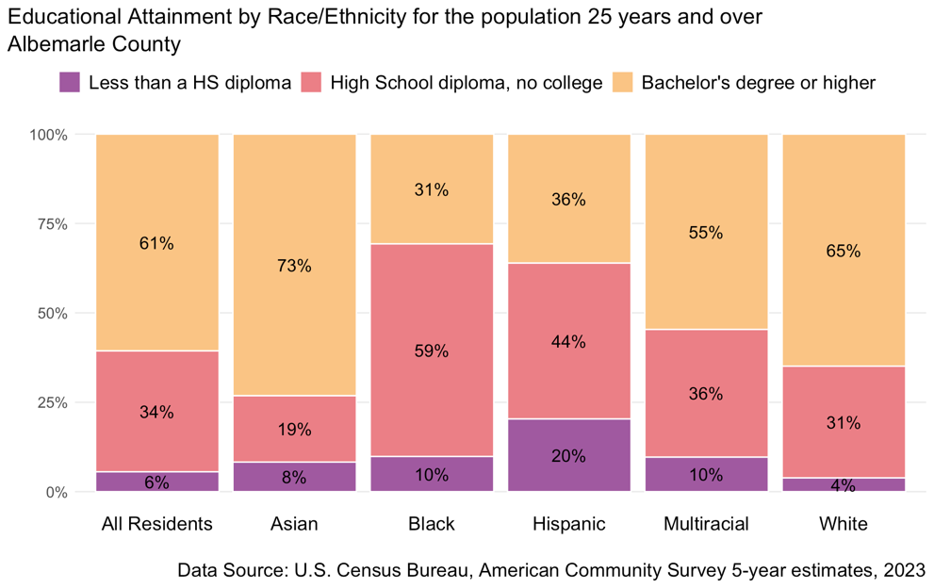to 86%. Additionally, there are differences in degree attainment by race and ethnicity: 31% of Black residents, 36% of Hispanic residents, and 65% of white residents have BA’s or higher.

## Education

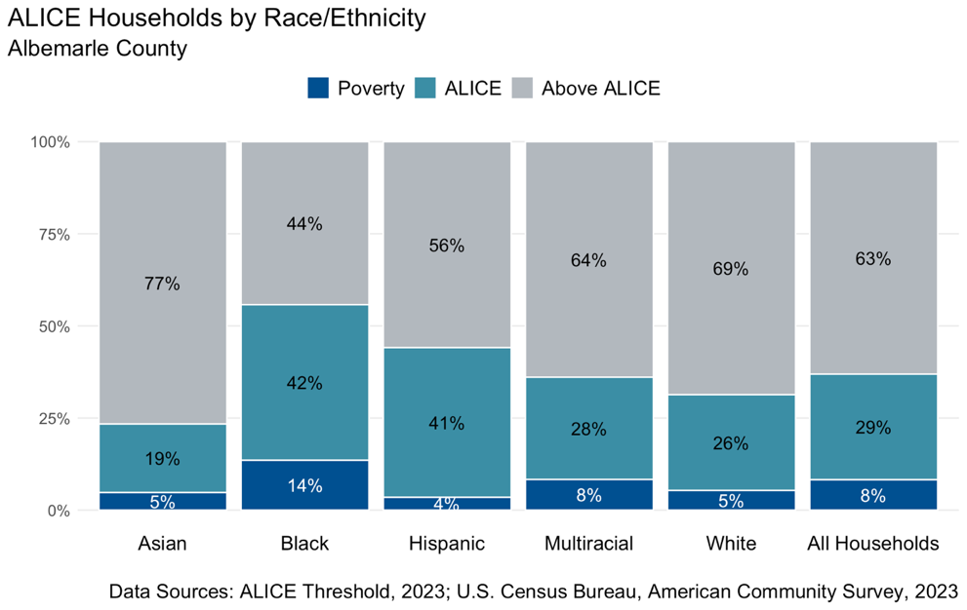The median household income for Albemarle is high, around $102,600 a year—the value for which half of households bring in more and half bring in less. Across the county, median household income ranges from a low of $41,000, to a high of $183,000.

## Living Standards

Many households with incomes below the local cost of living threshold, but above the federal poverty line may not be traditionally thought of as financially burdened. Overall, 8% of households in Albemarle are earning incomes below the federal poverty line and 29% of families earn above this amount but below cost of living threshold, meaning they struggle to afford their basic needs.

These and other measures and outcomes presented in the Albemarle County Community Wellbeing Profile are a resource for residents and leaders to support understanding of our collective well-being and point to challenges we can address together. Each section of the report—Demographic Profile, Health Profile, Education Profile, and Economic Security and Housing Profile—also include key policy connections, highlighting research and policy choices that support universal well-being.