City of Charlottesville Community Wellbeing Profile: Summary

UVA Center for Community Partnerships in partnership with the City of Charlottesville Office of Social Equity

The Charlottesville City Community Wellbeing Profile provides current data for measures related to the well-being of Charlottesville residents. The American Human Development Index (AHDI)—calculated from metrics on health, access to knowledge, and living standards and scored on a scale from 0 to 10—is used as a framework to assess and advocate for increased and inclusive well-being.

|  |  | Health | Access to Knowledge | | | | Living Standards |
| --- | --- | --- | --- | --- | --- | --- | --- |
| **American HD Index** | Life Expectancy (years) | At Least High School Diploma | At Least Bachelor’s Degree | Graduate Degree | School Enrollment | Median Earnings (2023 $) |
| Local | | | | | | | |
| Charlottesville | **6.2** | 79 | 93% | 61% | 33% | 87% | $38,285 |
| Albemarle | **7.3** | 82 | 94% | 61% | 31% | 85% | $51,922 |
| State | | | | | | | |
| Virginia | **5.8** | 78 | 91% | 41% | 18% | 76% | $49,405 |
| Data Sources: *Life Expectancy:* County Health Rankings, 2024. *Education and Earnings:* U.S. Census Bureau, American Community Survey 5-year estimates, 2023. | | | | | | | |

Census tract-level AHDI values provided in this profile show that there are wide disparities in outcomes related to health, education, and economic success within the City of Charlottesville.

Life expectancy at birth in Charlottesville is 79 years, however, there are major demographic disparities: a 9-year difference between Black and white residents. The percent of residents without health insurance ranges within the city, from a low of 1% to a high of 14%. There are also stark disparities by racial and ethnic identity, with 3% of white residents, 11% of Black residents, and 16% of Hispanic residents lacking coverage.

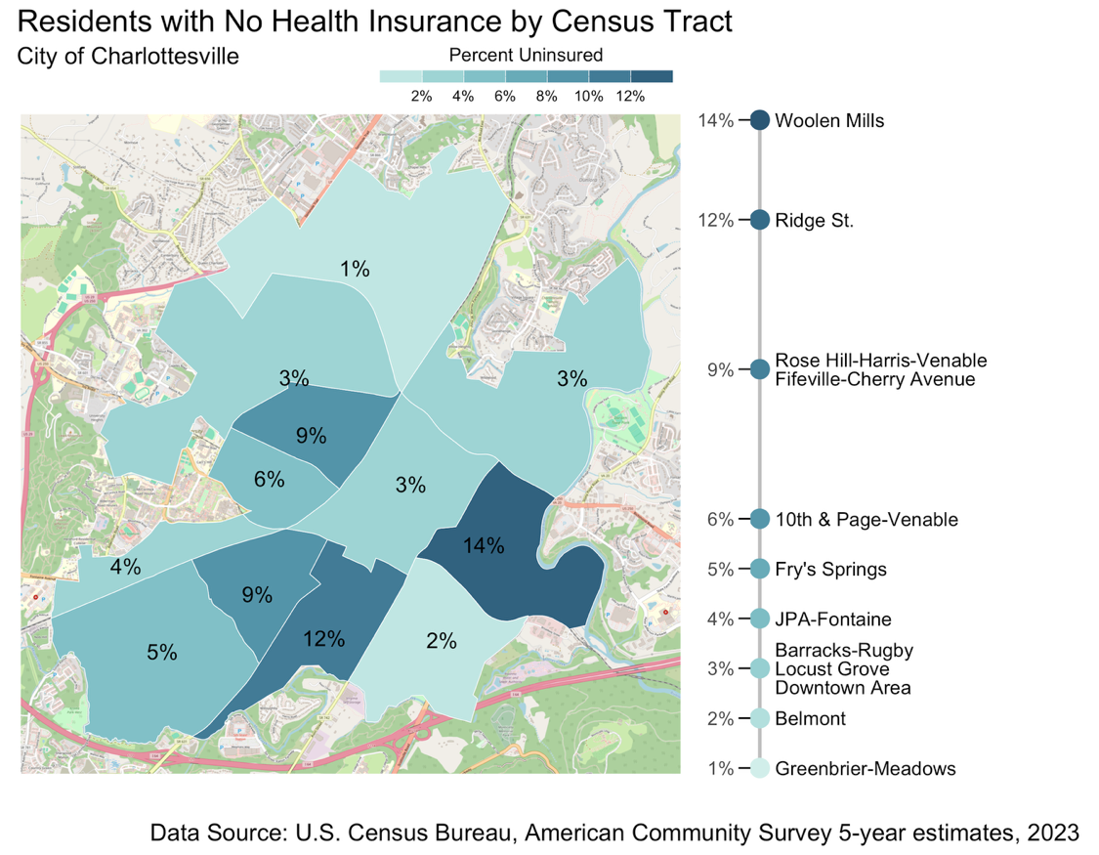

## Health

Overall, educational attainment is high in Charlottesville: 61% of residents overall have a bachelor’s degree or higher. Among city census tracts, this value ranges from 36% to 78%. Additionally, there are differences in degree attainment by race: 21% 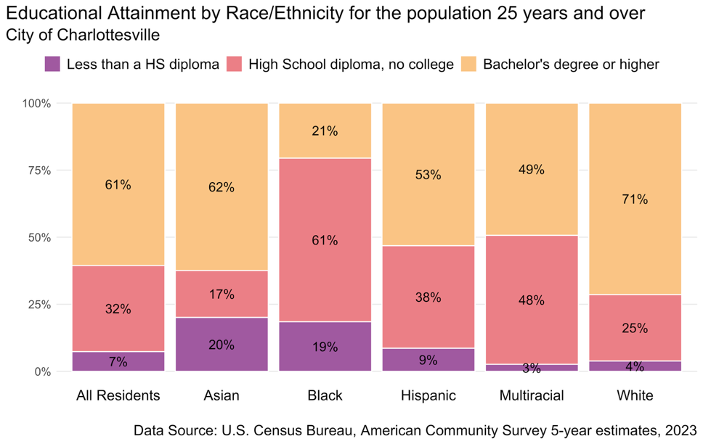of Black residents compared to 71% of white residents have BA’s or higher.

## Education

## Living Standards

The median household income for Charlottesville is around $69,800 a year—across the city, median household income ranges from a low of around $20,000, to a high of $113,700.

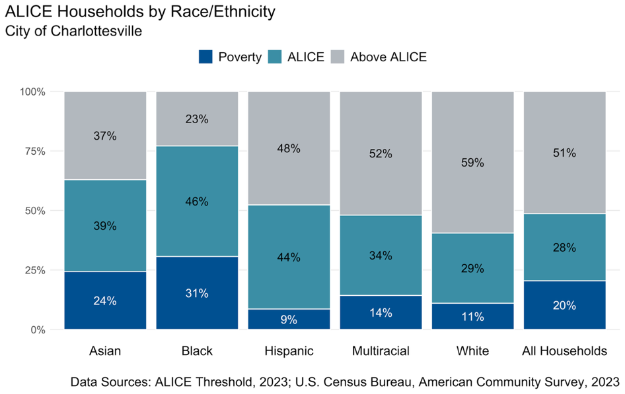Many households with incomes below the local cost of living threshold, but above the federal poverty line may not be traditionally thought of as financially burdened. Overall, 20% of households in Charlottesville are earning incomes below the federal poverty line and 28% of families earn above this amount but below the cost of living threshold, meaning they struggle to afford their basic needs.

The impact of high rental costs on economic security is evident in how much of a household’s income goes towards housing. In many city census tracts over half of renters are burdened by housing costs, including a significant number of households considered severely burdened, spending over 50% of their monthly income on housing.

The measures presented in the Charlottesville City Community Wellbeing Profile are a resource to support understanding of our collective well-being and point to challenges we can address together. Each section of the report—Demographic Profile, Health Profile, Education Profile, and Economic Security and Housing Profile—also include key policy connections, highlighting research and policy choices that support universal well-being.