Albemarle & Charlottesville Area Community Wellbeing Profile: Summary

UVA Center for Community Partnerships in partnership with Albemarle County and the City of Charlottesville

The Charlottesville and Albemarle Area Community Wellbeing Profile provides current and trend data for measures related to the well-being of the collective population, expanding on the individual locality profiles for the city and county. The American Human Development Index (AHDI)—calculated from metrics on health, access to knowledge, and living standards and scored on a scale from 0 to 10—is used as a framework to assess and advocate for increased and inclusive well-being. Metrics on the combined area of the city and county can highlight outcomes and support decisions that cross geographical boundaries.

**American Human Development Index: Local and State-wide Comparison**

|  |  | Health | Access to Knowledge | | | | Living Standards |
| --- | --- | --- | --- | --- | --- | --- | --- |
| American HD Index | Life Expectancy (years) | At Least High School Diploma | At Least Bachelor’s Degree | Graduate Degree | School Enrollment | Median Earnings  (2023 $) |
| Charlottesville & Albemarle Combined | 7.0 | 81 | 94% | 61% | 31% | 86% | $48,041 |
| Albemarle | 7.3 | 82 | 94% | 61% | 31% | 85% | $51,922 |
| Charlottesville | 6.2 | 79 | 93% | 61% | 33% | 87% | $38,285 |
| Virginia | 5.8 | 78 | 91% | 41% | 18% | 76% | $49,405 |
| Data Sources: *Life Expectancy:* County Health Rankings, 2024. *Education and Earnings:* U.S. Census Bureau, American Community Survey 5-year estimates, 2023. | | | | | | | |

While the rate of residents lacking health insurance has declined, with 6% of residents overall without coverage, there are stark disparities by racial and ethnic identity, with 3% of white residents, 9% of Black residents, and 24% of Hispanic residents lacking coverage. 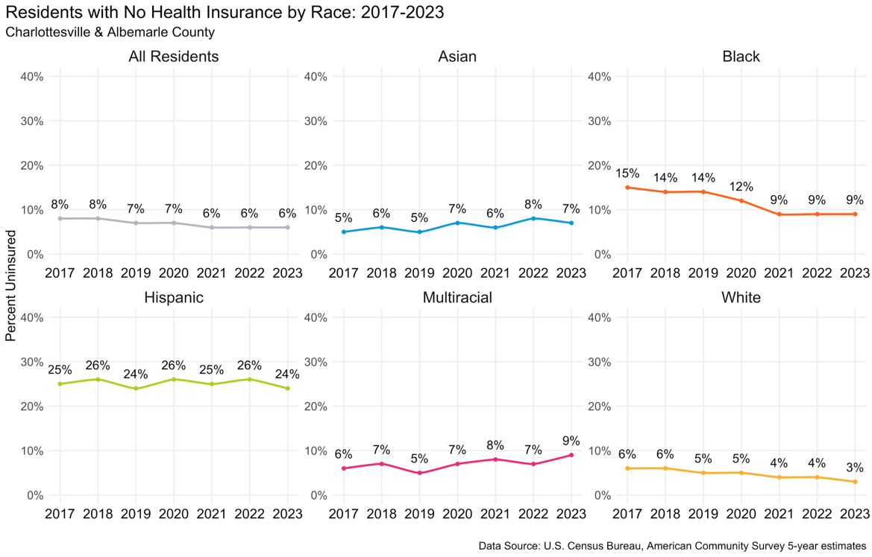

## Health

In Charlottesville and Albemarle County, school enrollment for young people ages 3 to 24 years, has remained steady, from 84% in 2018 to 86% in 2023. Enrollment rates for 2023 by age group show: 3- to 4-year-olds at 69% and 20- to 24-year-olds at 67%, with age groups in between ranging from 96% to 99%.

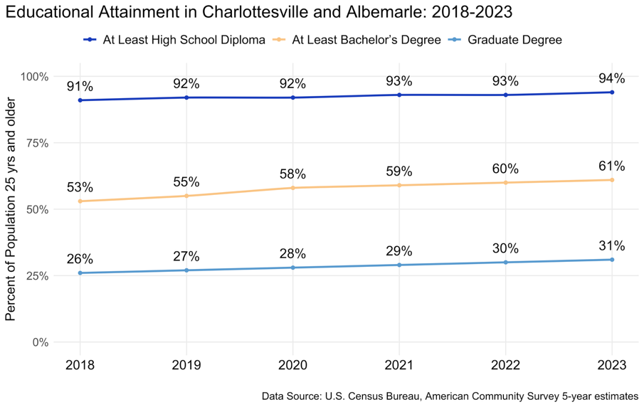Educational attainment has increased in Charlottesville and Albemarle over time, with 61% of residents having a four-year college degree, up from 53% in 2018. Residents haven't benefited equally from this rise, with 26% of Black residents and 40% of Hispanic residents earning a bachelor’s degree or higher compared to 66% of white residents.

## Education

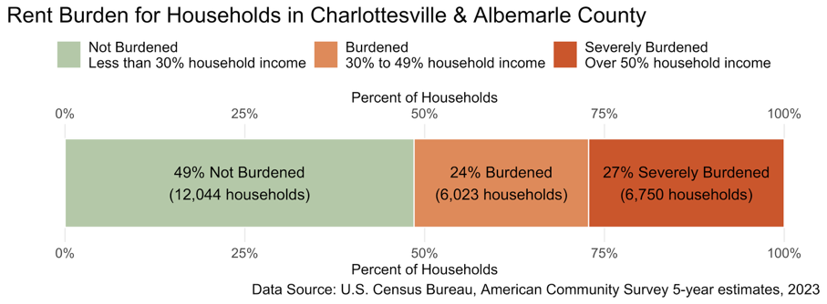While median earnings rose steadily in the last decade, the housing capacity did not keep pace, and many city and county residents struggled to pay rent. More than half of all renters—nearly 12,800 households—were considered rent-burdened, spending over 30% of their income on housing, and local courts saw both eviction filings and judgments increase to pre-pandemic levels.

## Living Standards

The Albemarle and Charlottesville Combined Area profile is complement to two additional locality focused Community Wellbeing Profiles.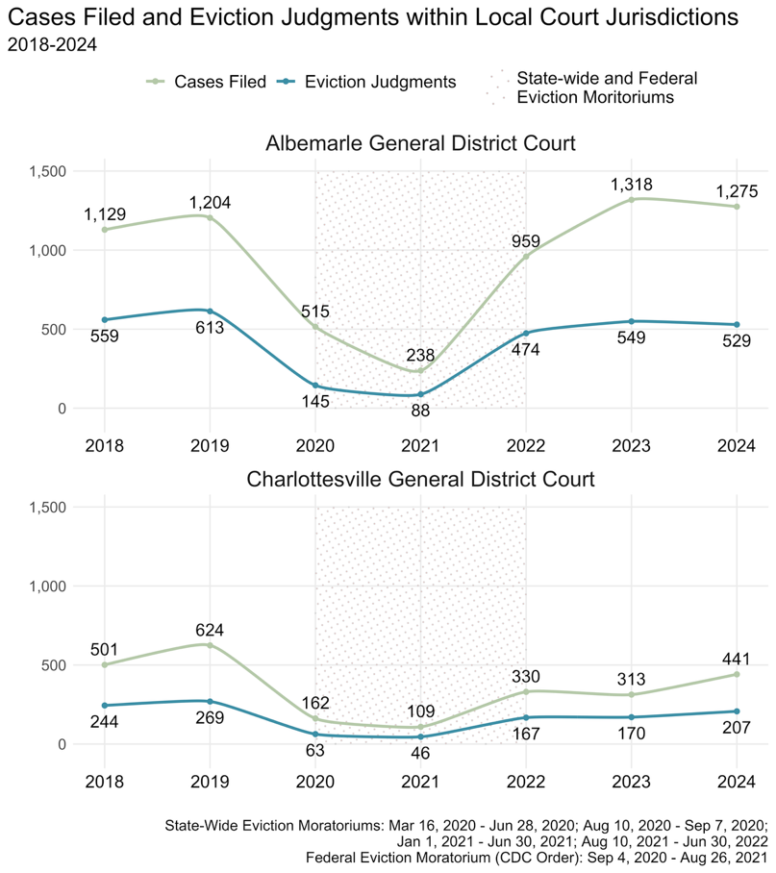 The measures and outcomes presented in these reports are a resource to support understanding of our collective well-being and point to challenges we can address together.