Stepping Stones 2026 Supplement Report
Disaggregated Measures of Well-Being of Children and Families in in Charlottesville and Albemarle
July 2026
Table of Contents

Education

Students Eligible for Special Education Services

Albemarle County Public Schools
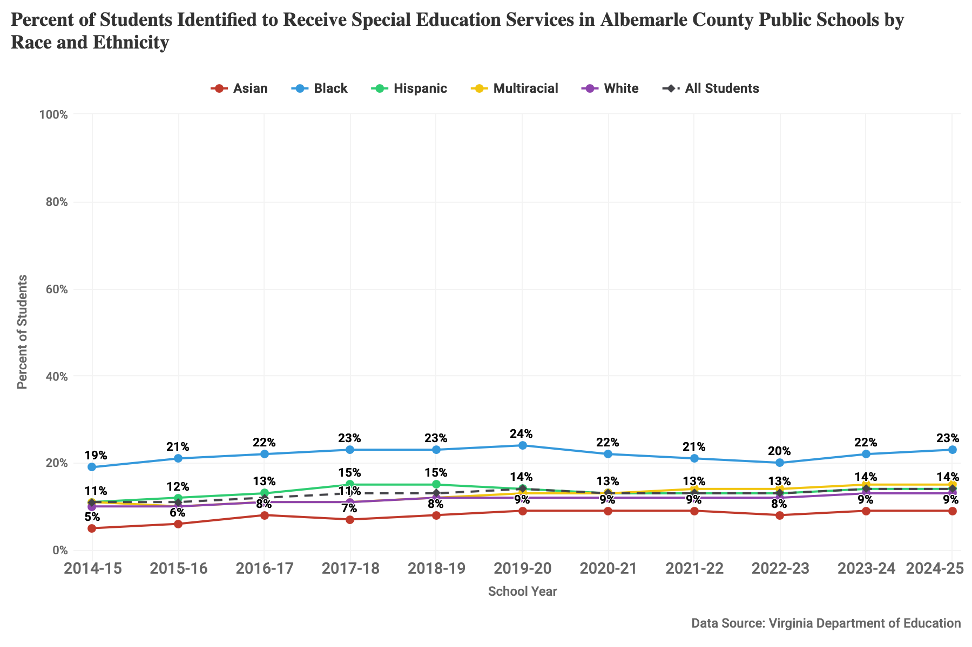
Figure 1: Percent of students identified to receive special education services by race and ethnicity for the 2014-15 through 2024-25 school years at ACPS.

Charlottesville City Schools
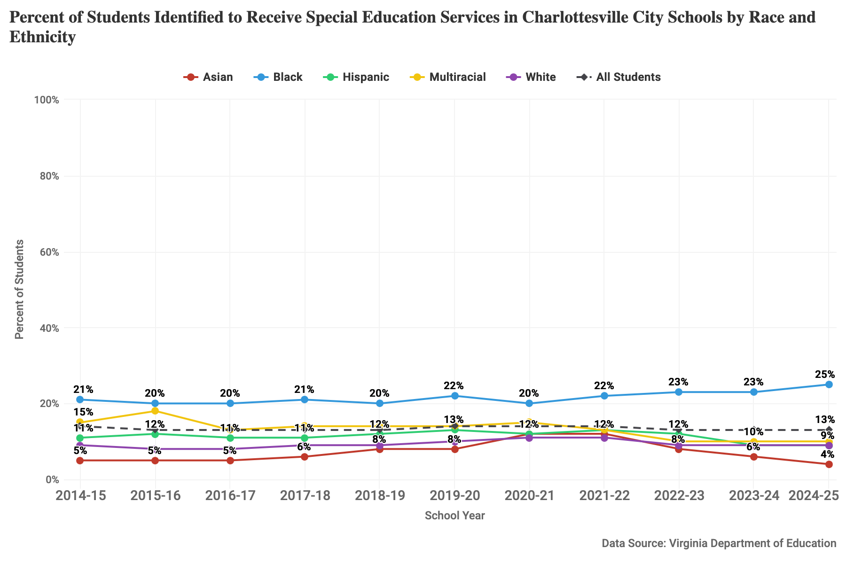
Figure 2: Percent of students identified to receive special education services by race and ethnicity for the 2014-15 through 2024-25 school years at CCS.

Virginia Public Schools
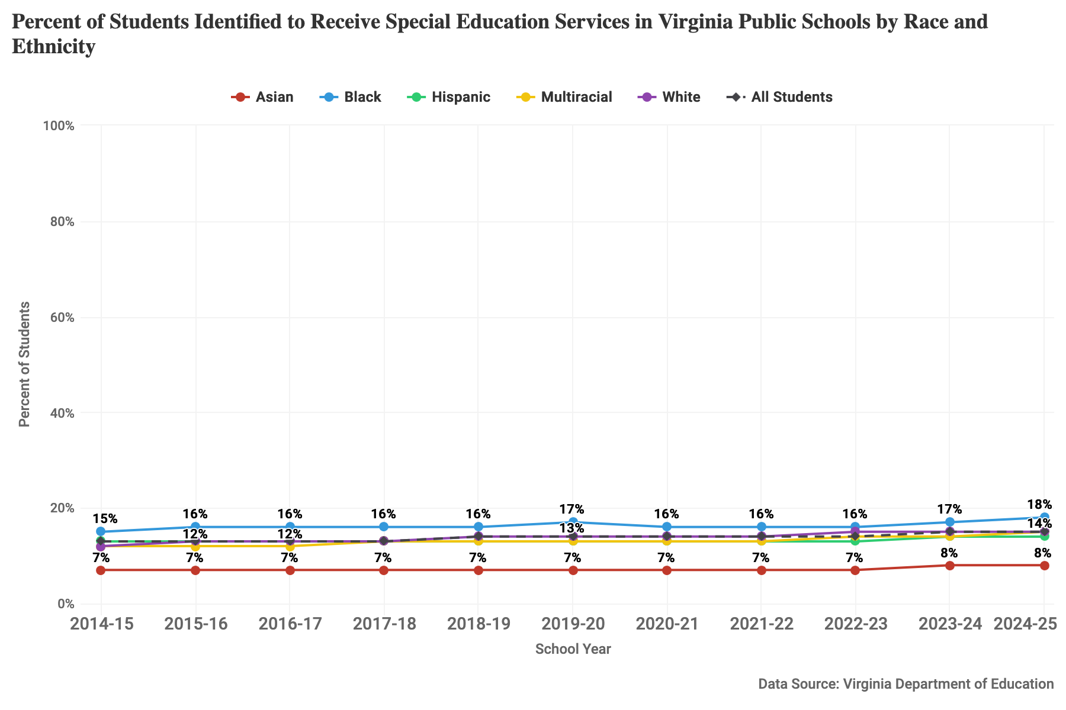
Figure 3: Percent of students identified to receive special education services by race and ethnicity for the 2014-15 through 2024-25 school years at Virginia public schools.

High School Graduation Rate

Albemarle County Public Schools
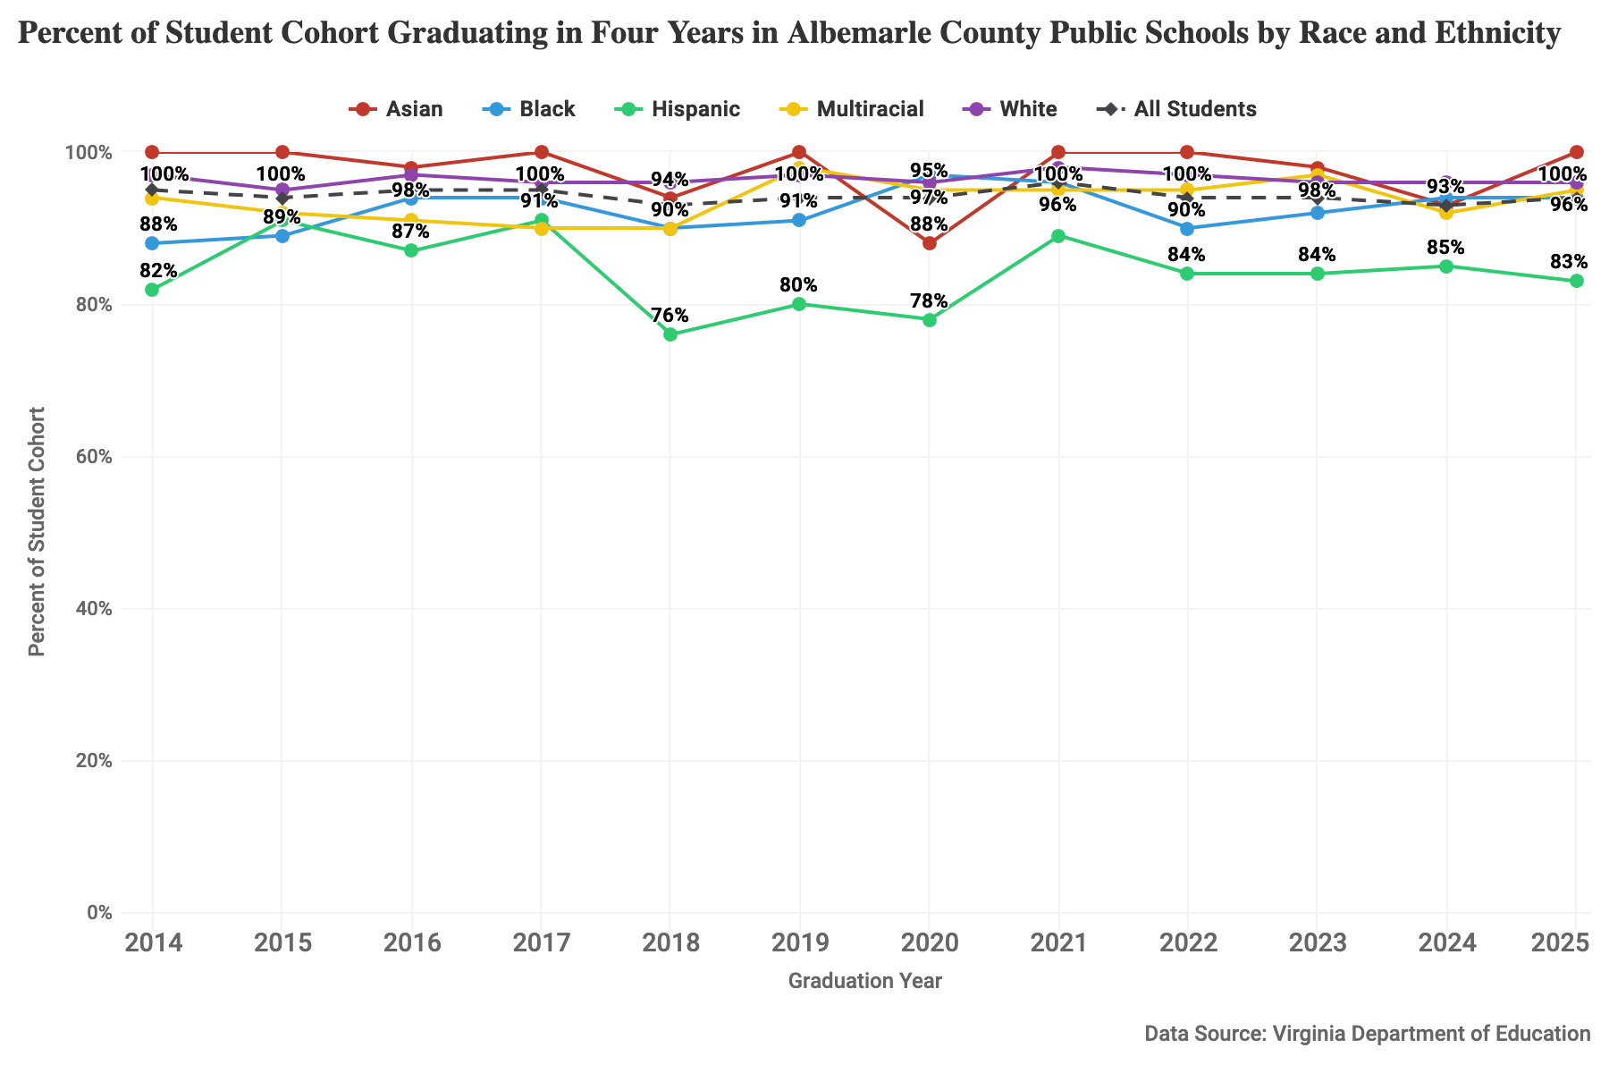
Figure 4: Percent of student cohort graduating in four years by race and ethnicity, and economically disadvantaged students for 2014-2025 at ACPS.
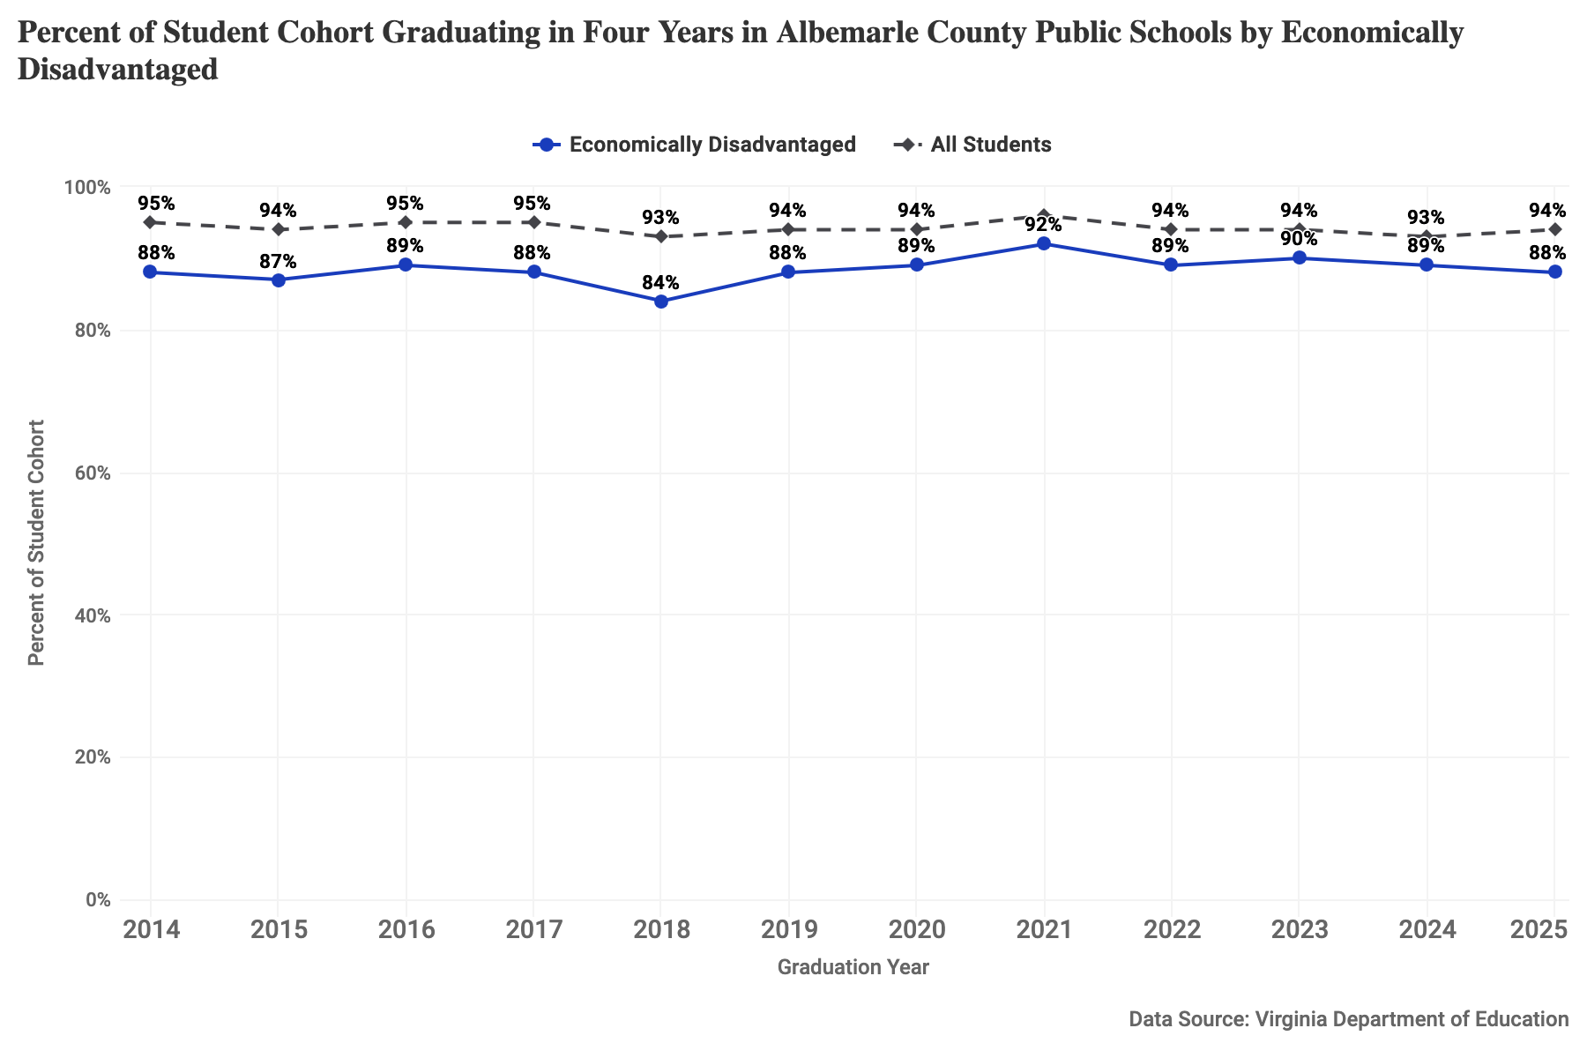
Figure 5: Percent of student cohort graduating in four years by race and ethnicity, and economically disadvantaged students for 2014-2025 at ACPS.

Charlottesville City Schools
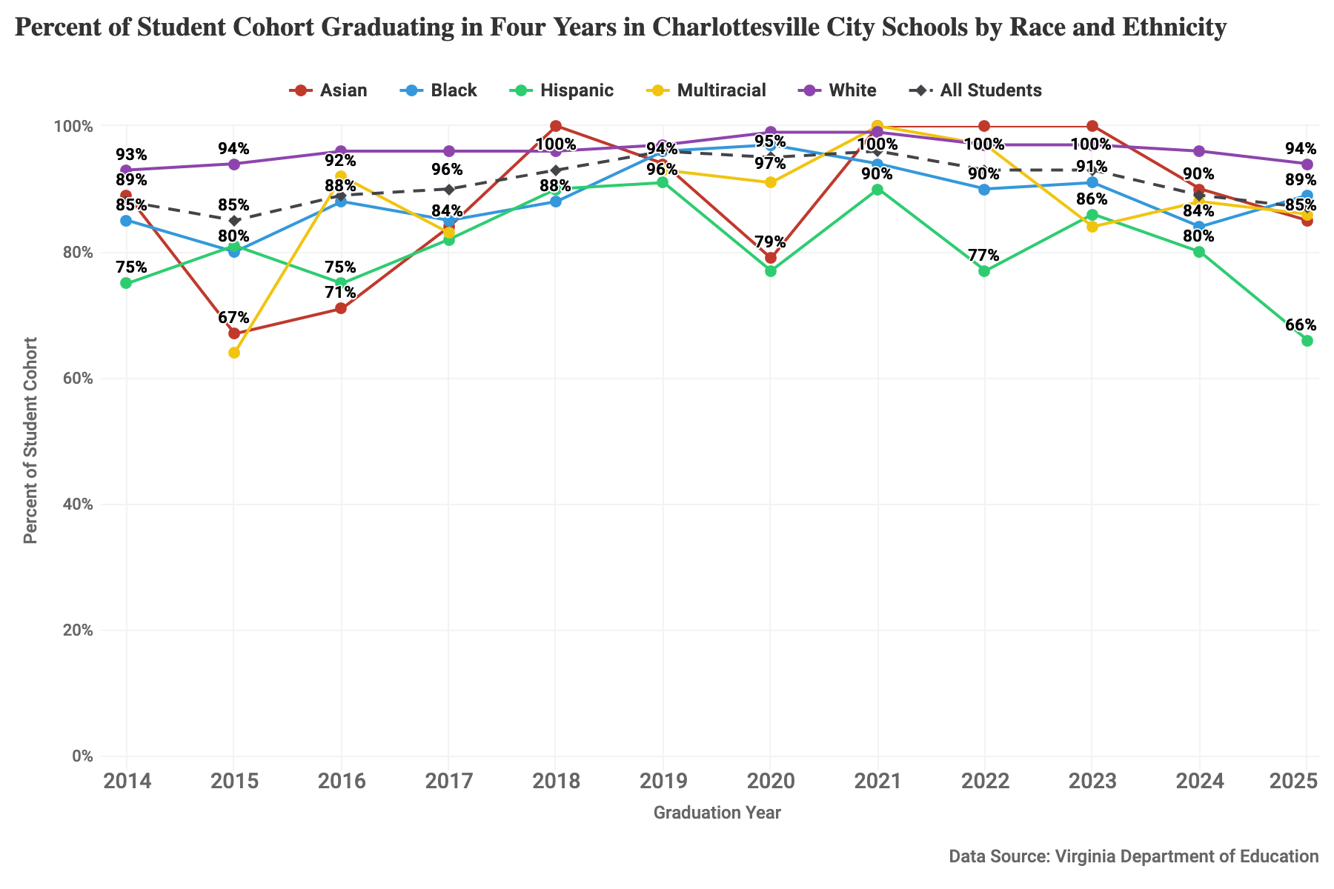
Figure 6: Percent of student cohort graduating in four years by race and ethnicity, and economically disadvantaged students for 2014-2025 at CCS.
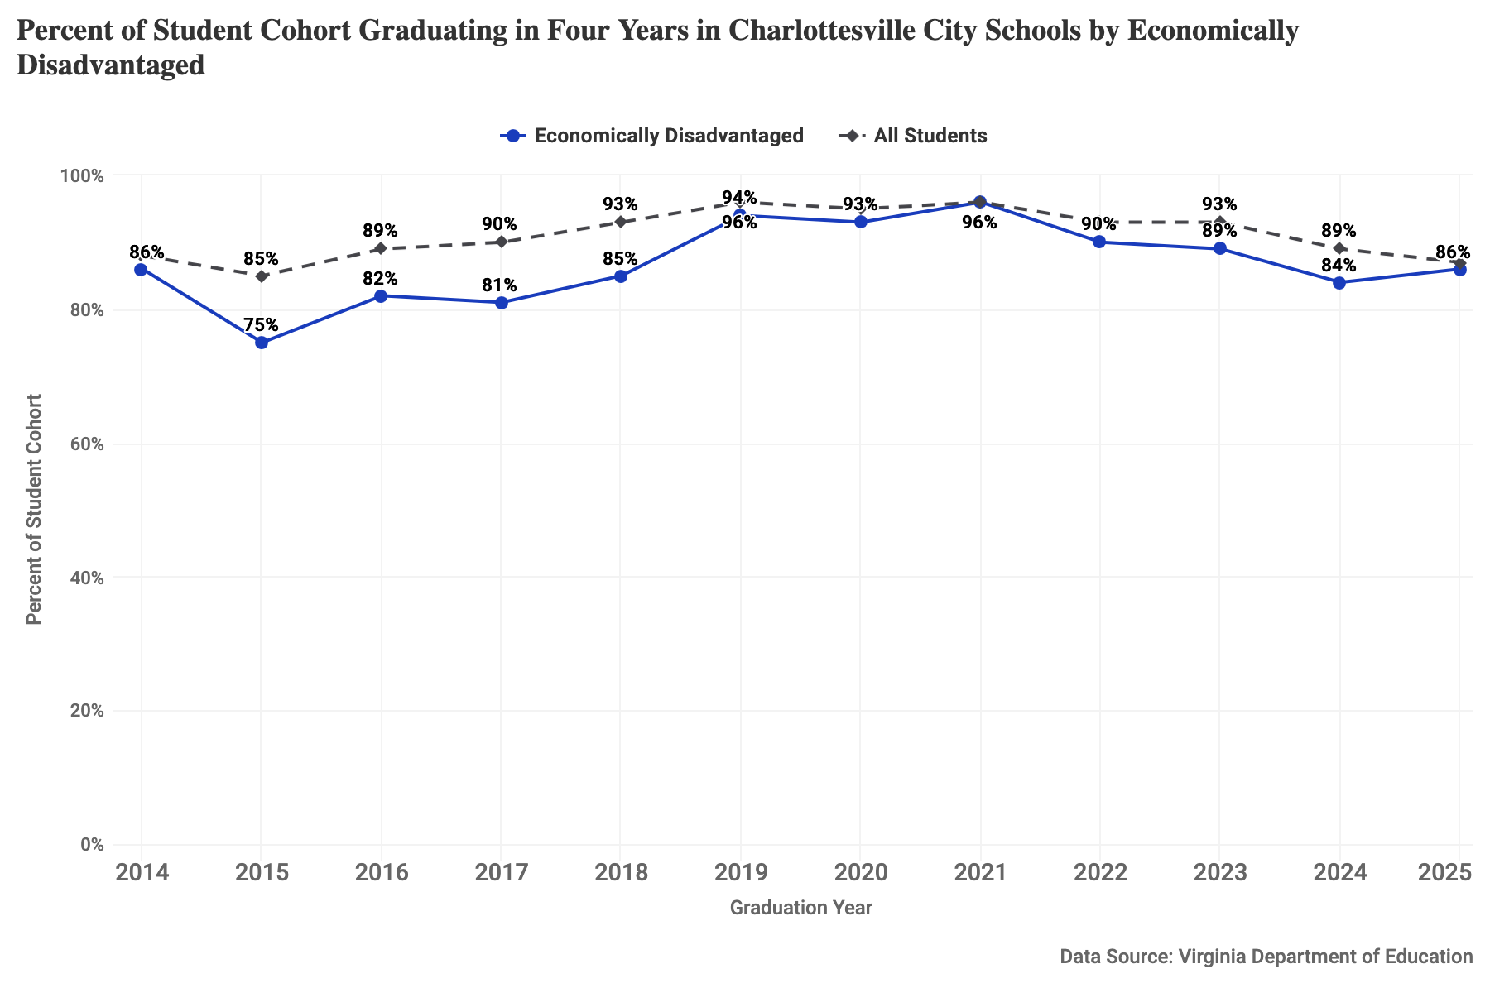
Figure 7: Percent of student cohort graduating in four years by race and ethnicity, and economically disadvantaged students for 2014-2025 at CCS.

Virginia Public Schools
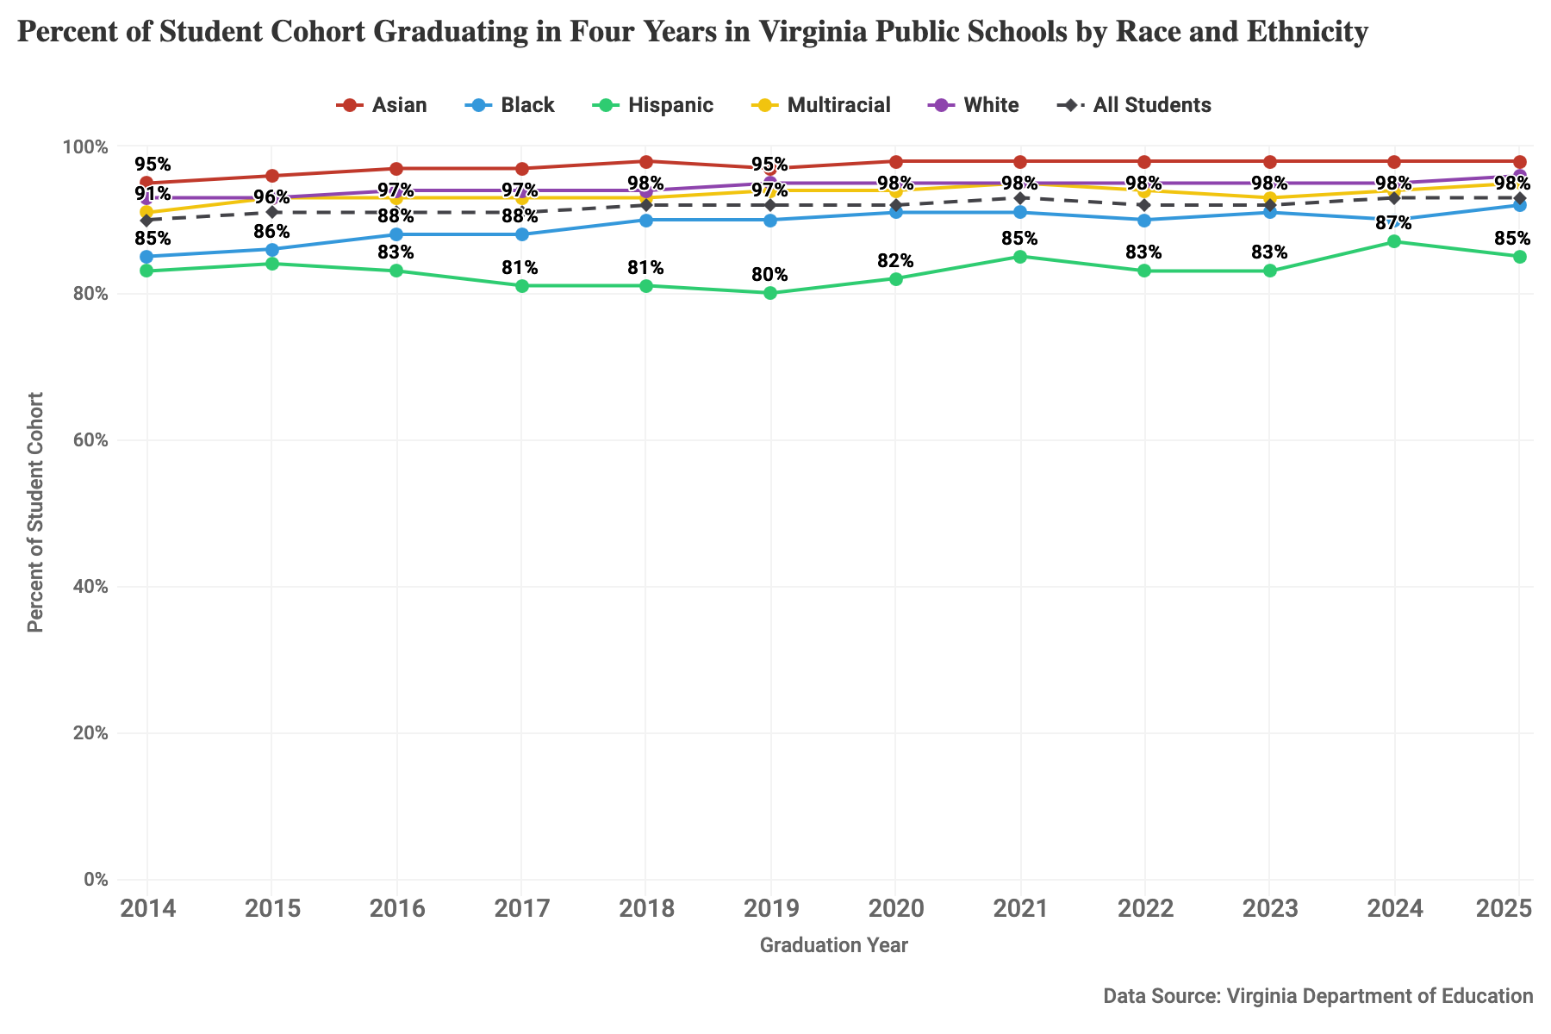
Figure 8: Percent of student cohort graduating in four years by race and ethnicity, and economically disadvantaged students for 2014-2025 at Virginia public schools.
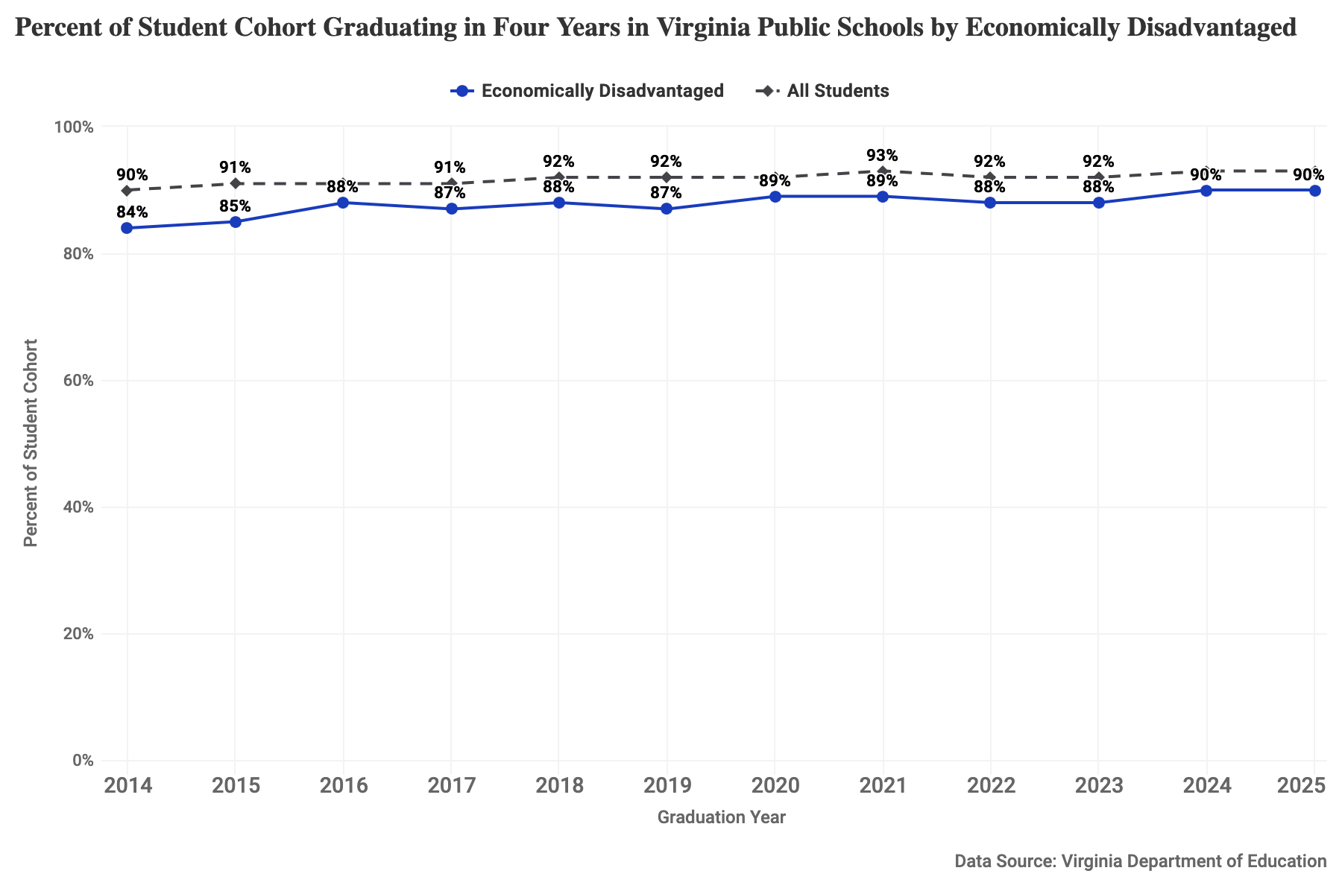
Figure 9: Percent of student cohort graduating in four years by race and ethnicity, and economically disadvantaged students for 2014-2025 at Virginia public schools.

Post-Secondary Enrollment

Albemarle County Public Schools
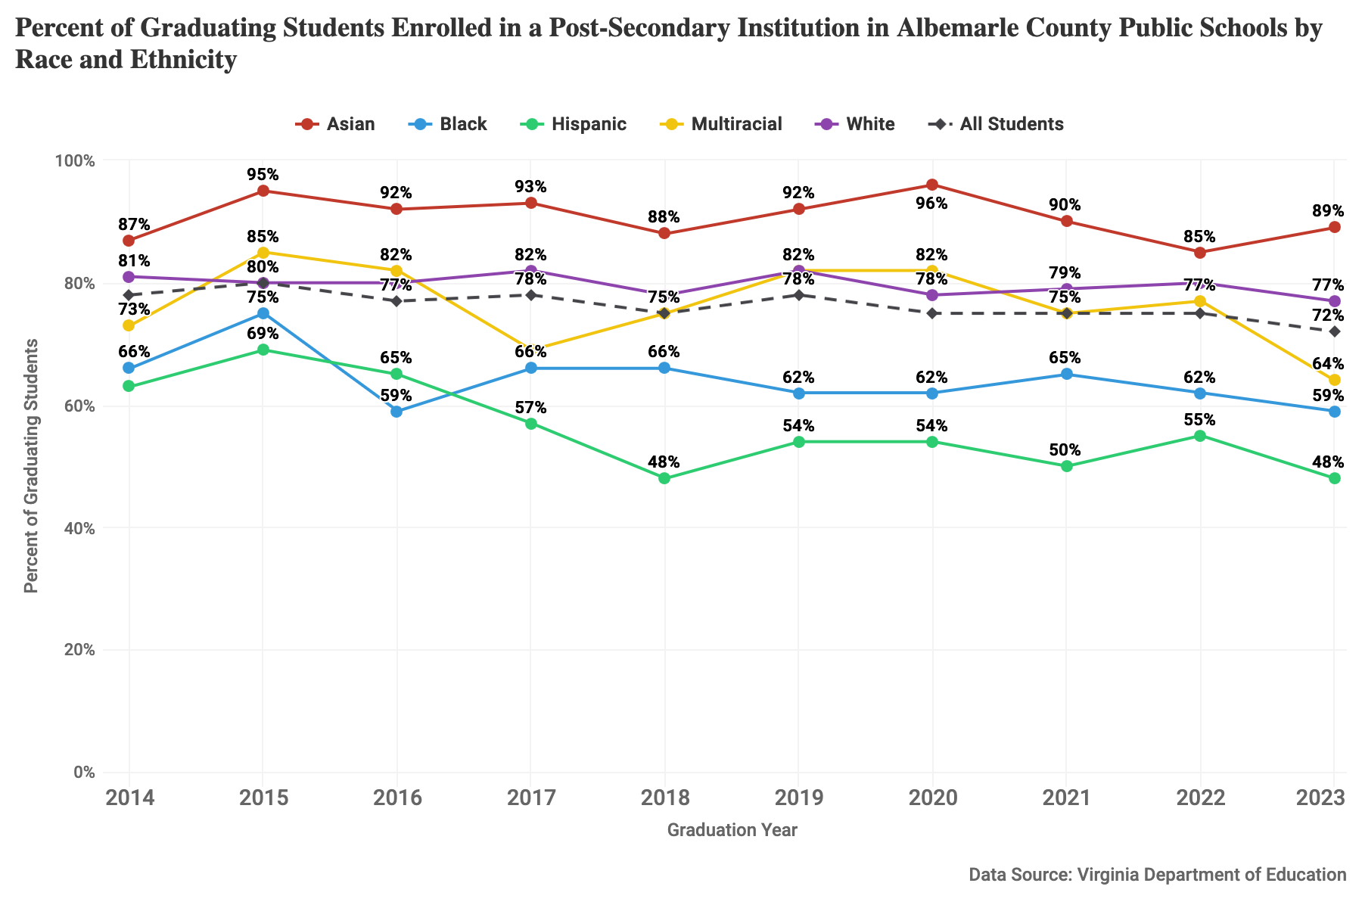
Figure 10: Percent of graduating students enrolled in a post-secondary institution by race and ethnicity, and economically disadvantaged students for 2014-2023 at ACPS.
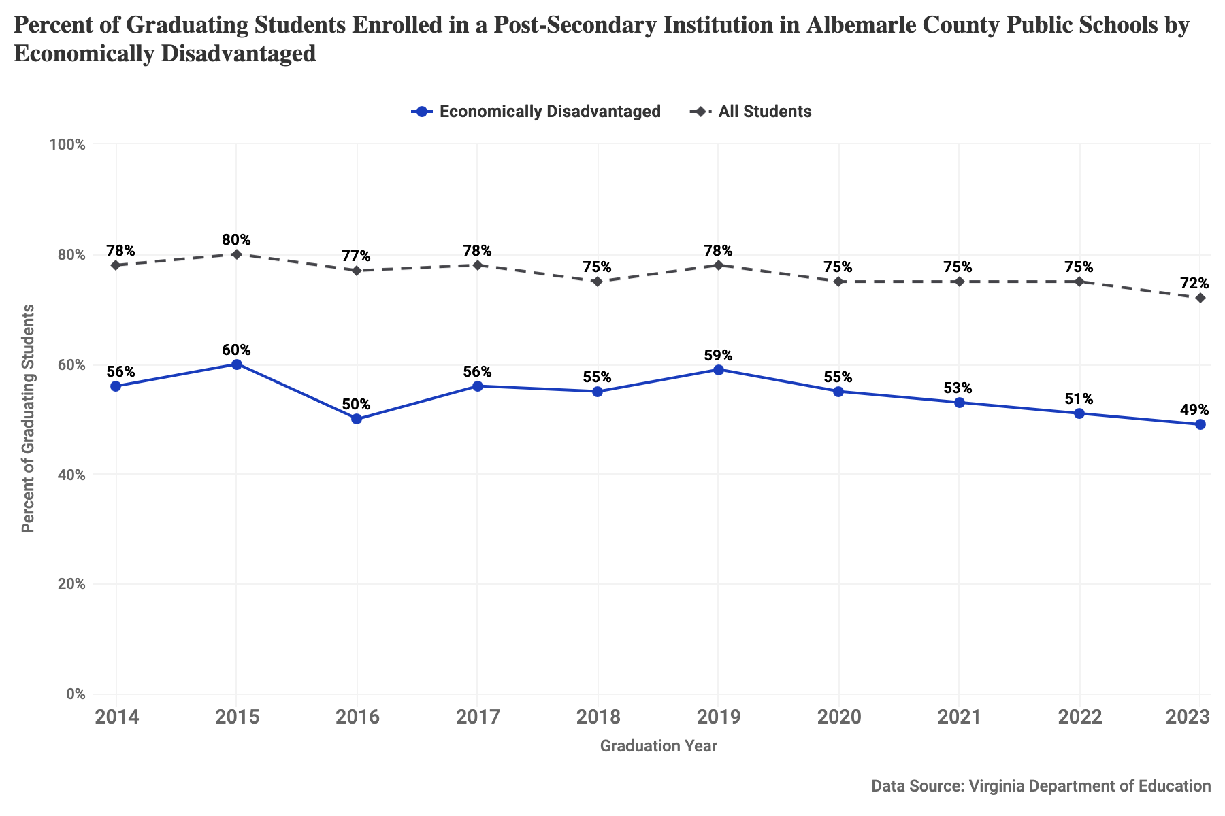
Figure 11: Percent of graduating students enrolled in a post-secondary institution by race and ethnicity, and economically disadvantaged students for 2014-2023 at ACPS.

Charlottesville City Schools
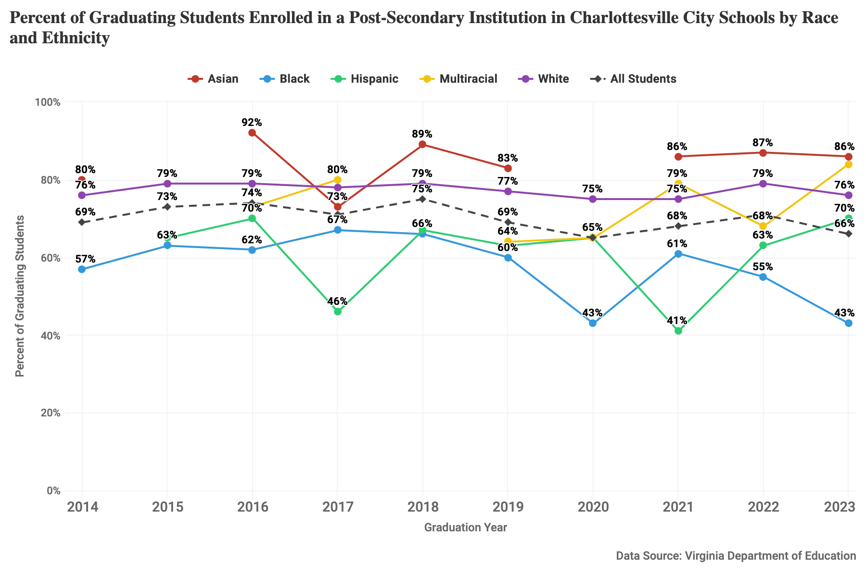
Figure 12: Percent of graduating students enrolled in a post-secondary institution by race and ethnicity, and economically disadvantaged students for 2014-2023 at CCS.
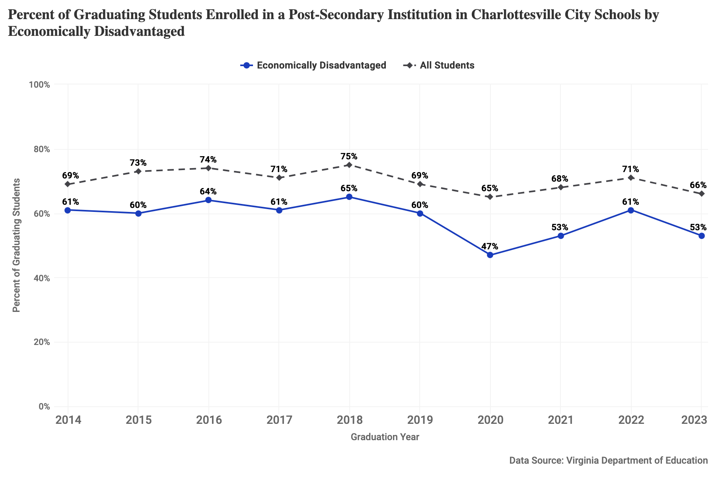
Figure 13: Percent of graduating students enrolled in a post-secondary institution by race and ethnicity, and economically disadvantaged students for 2014-2023 at CCS.

Virginia Public Schools
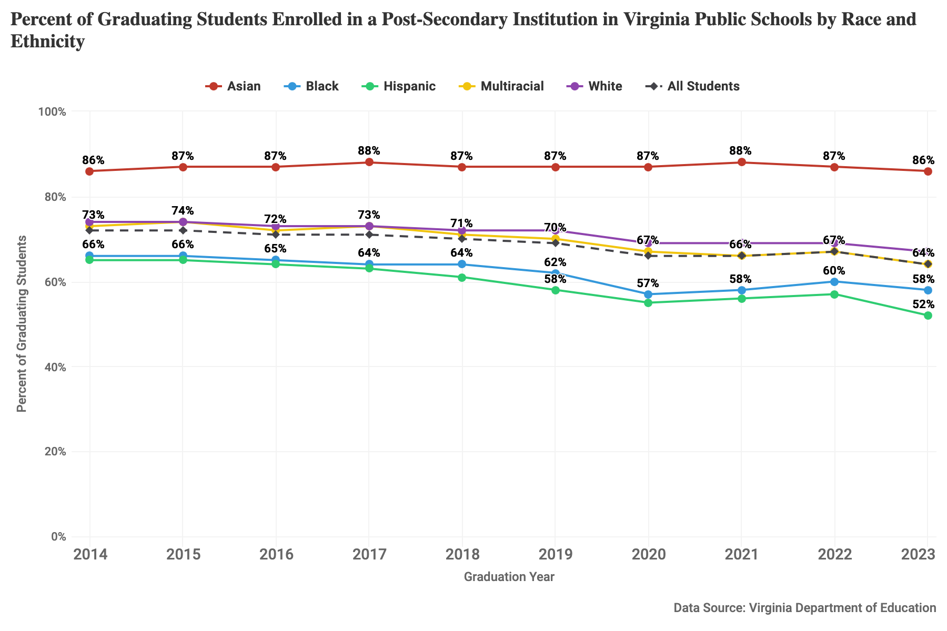
Figure 14: Percent of graduating students enrolled in a post-secondary institution by race and ethnicity, and economically disadvantaged students for 2014-2023 at Virginia public schools.
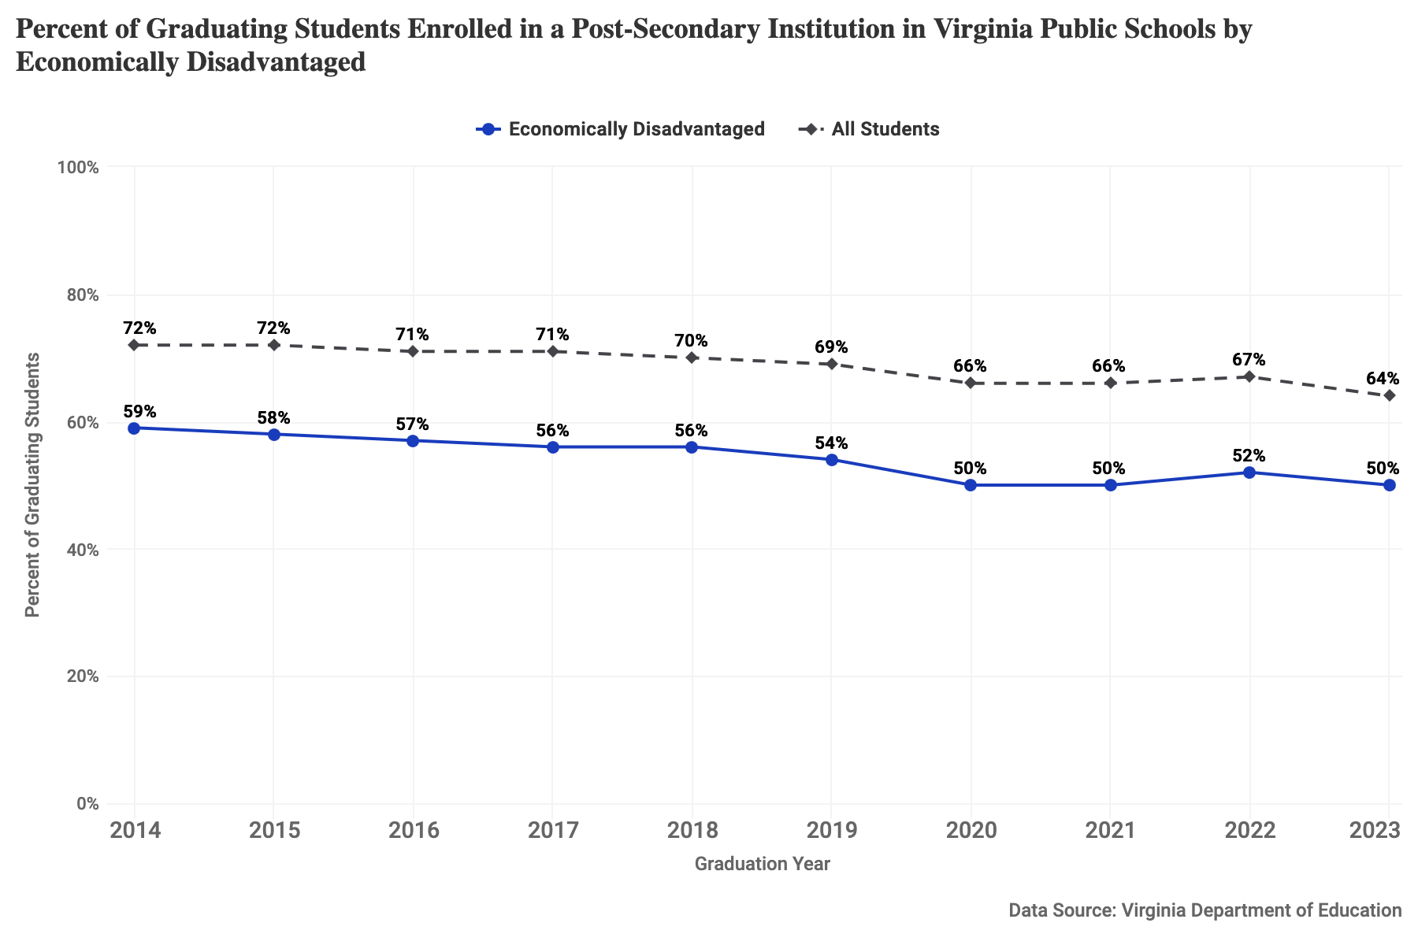
Figure 15: Percent of graduating students enrolled in a post-secondary institution by race and ethnicity, and economically disadvantaged students for 2014-2023 at Virginia public schools.

Economic and Family Stability

Youth Labor Force Participation and Unemployment

Albemarle County Census Tracts
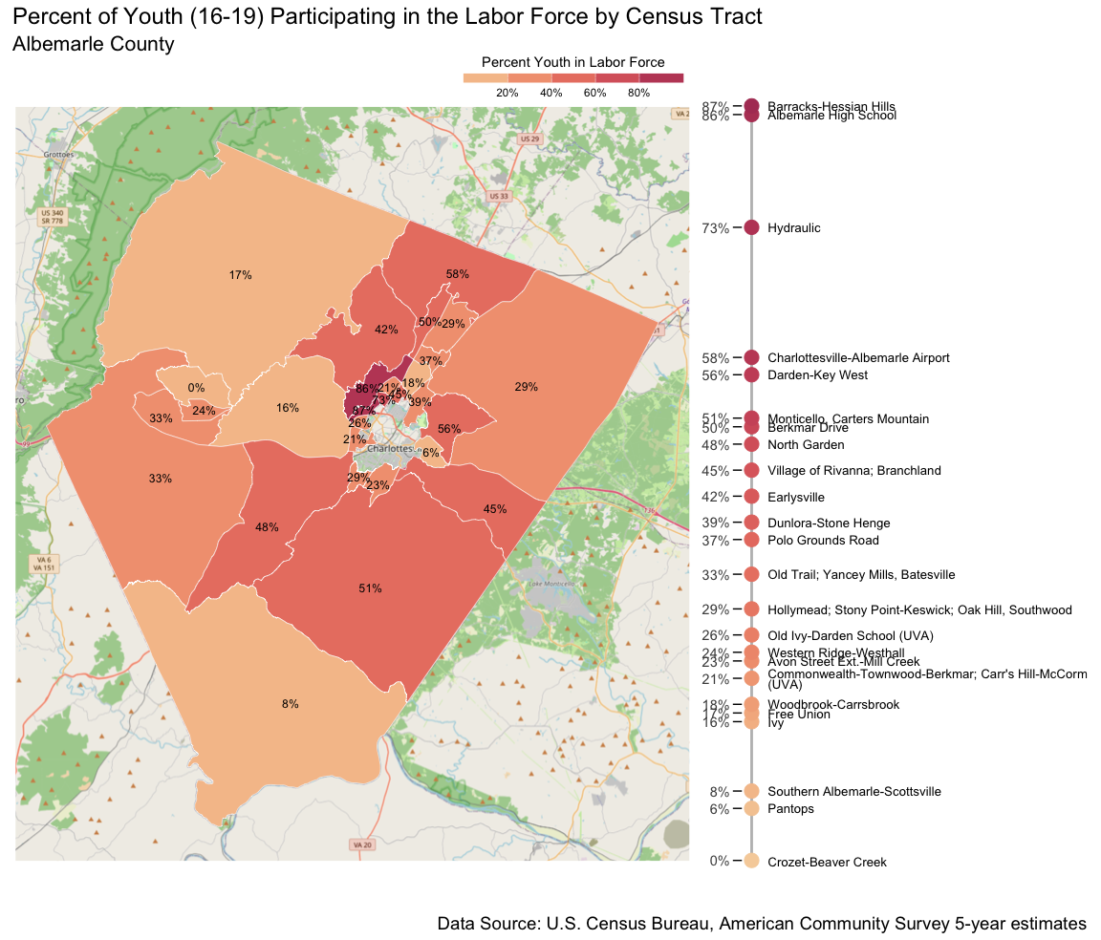
Figure 16: Percent of youth (16-19) participating in the labor force by census tract, 2024, for Albemarle County.
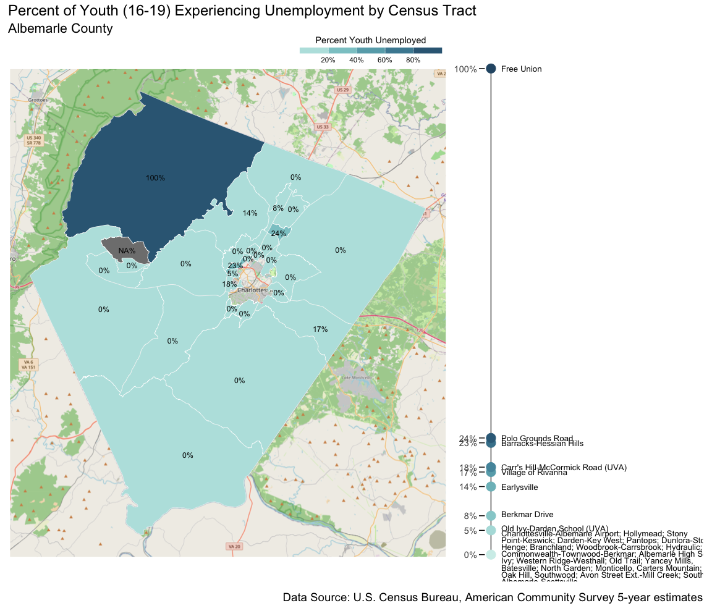
Figure 17: Percent of youth (16-19) in the labor force experiencing unemployment by census tract, 2024, for Albemarle County.

Charlottesville Census Tracts
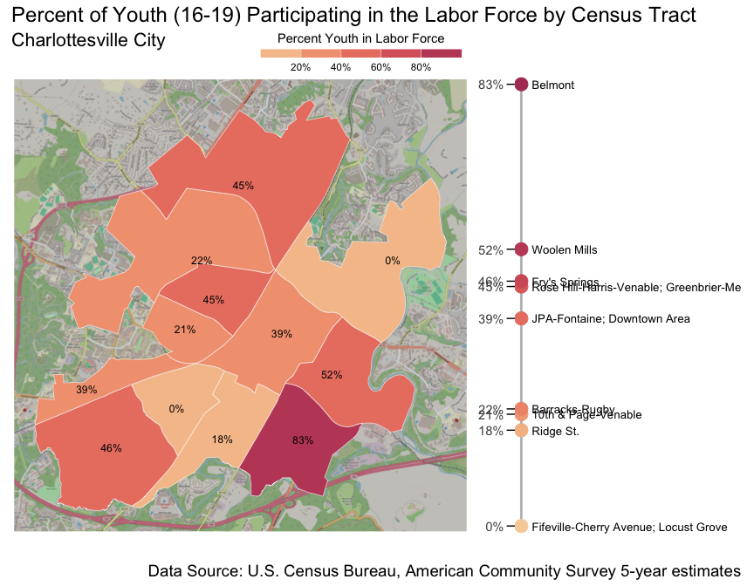
Figure 18: Percent of youth (16-19) participating in the labor force by census tract, 2024, for Charlottesville City.
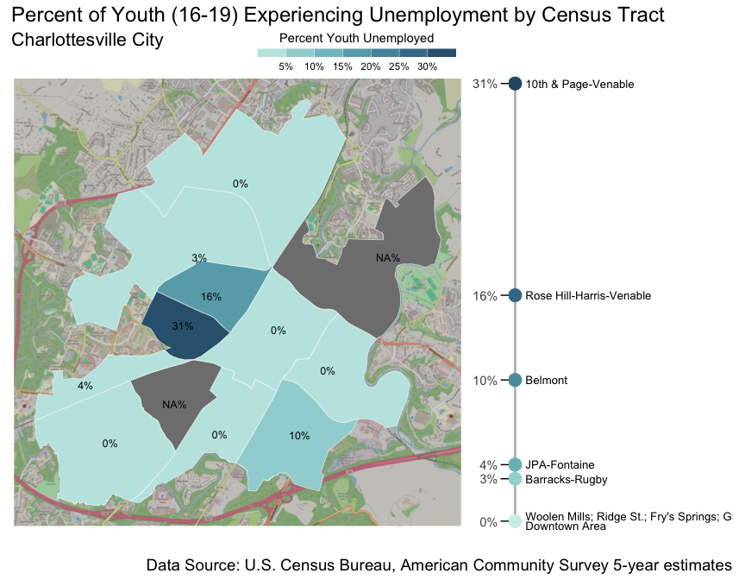
Figure 19: Percent of youth (16-19) in the labor force experiencing unemployment by census tract, 2024, for Charlottesville City.

Children Living below Poverty Threshold

Albemarle County
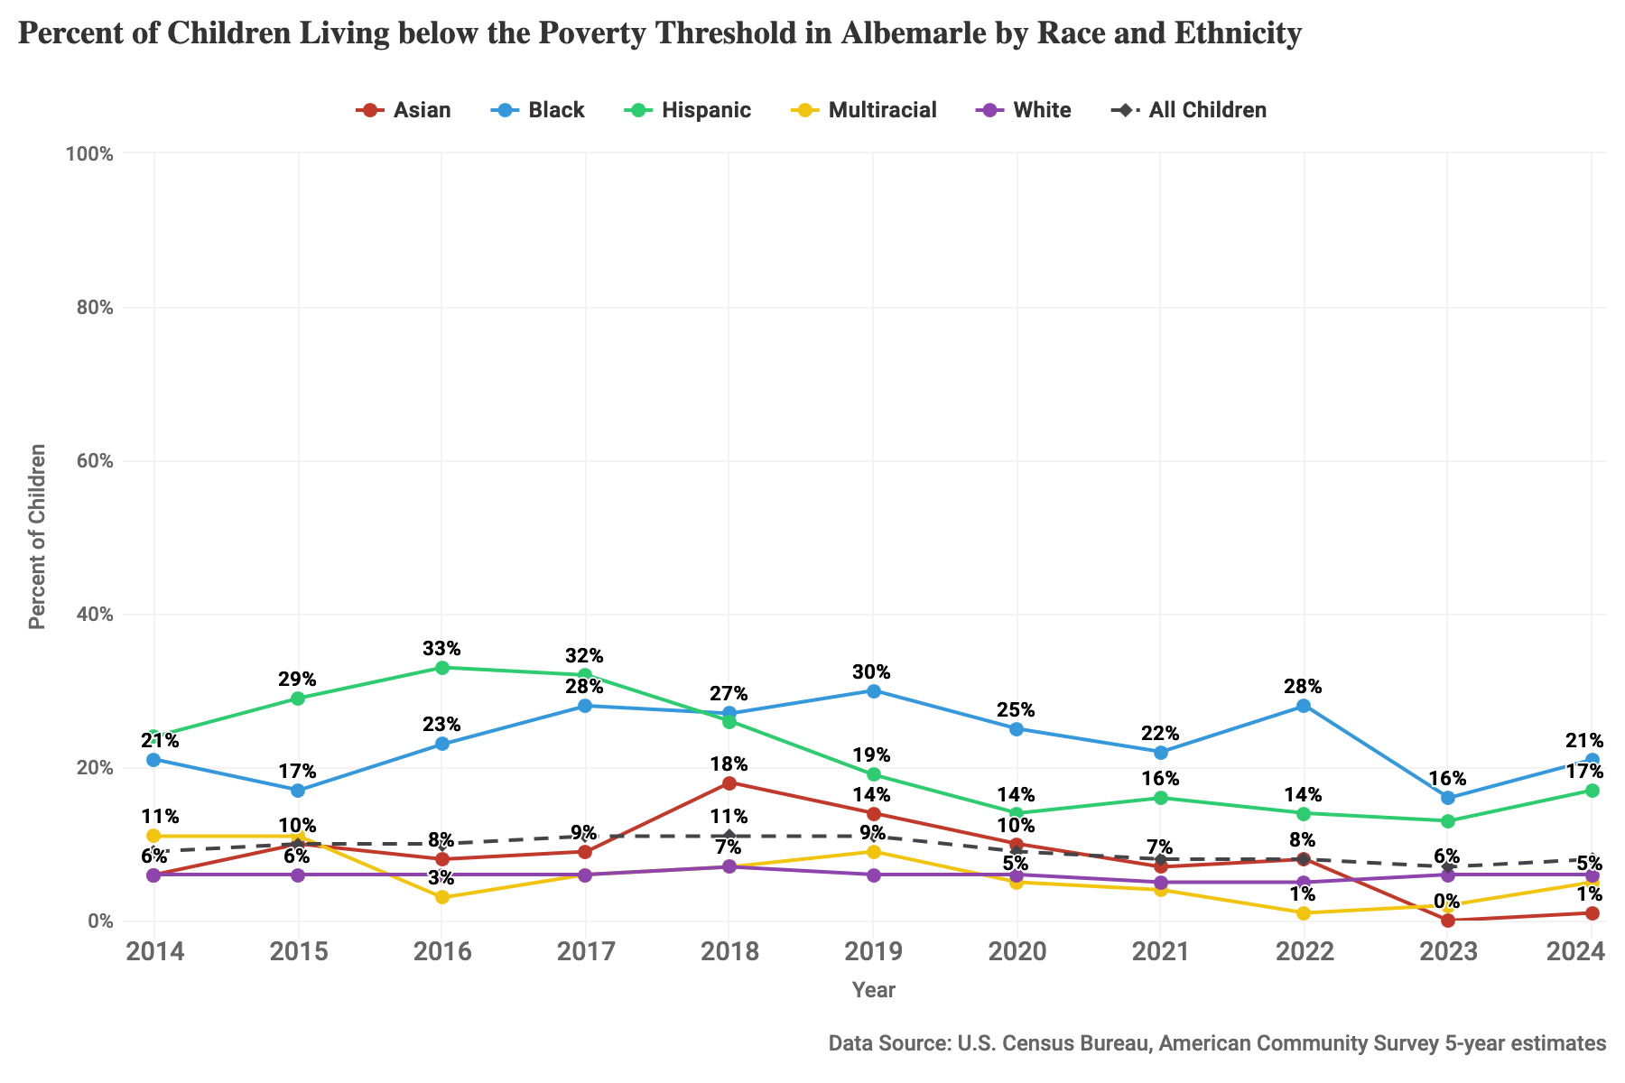
Figure 20: Percent of children living below the poverty threshold by race and ethnicity, 2014-2024, for Albemarle County.

Charlottesville City
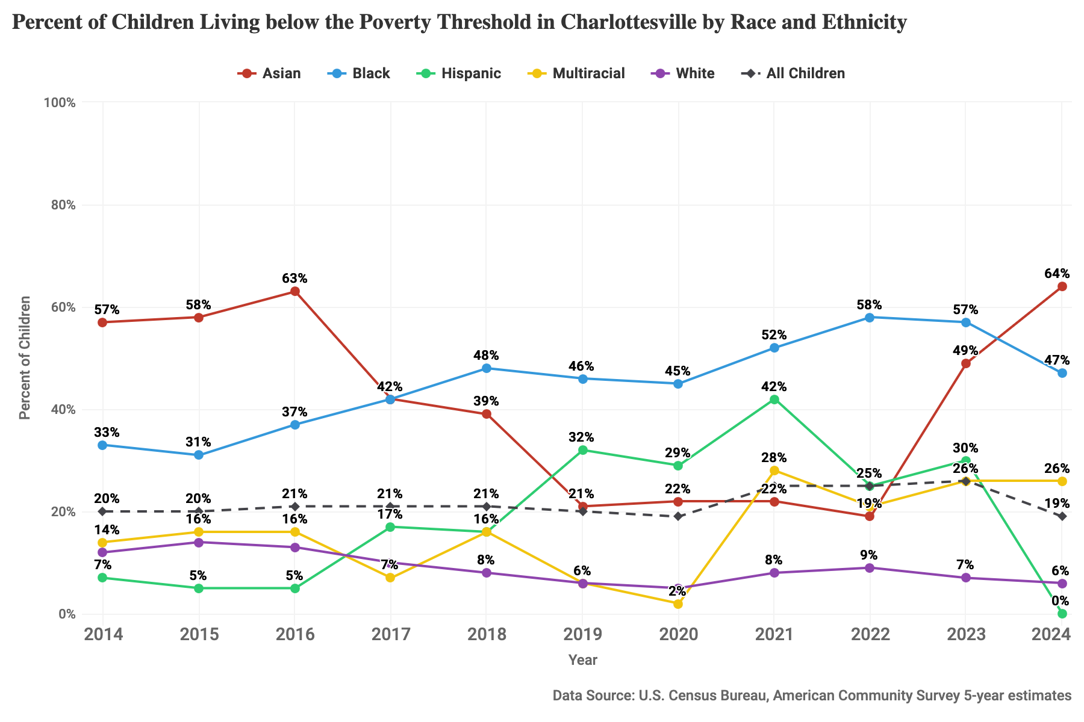
Figure 21: Percent of children living below the poverty threshold by race and ethnicity, 2014-2024, for Charlottesville City.

Virginia
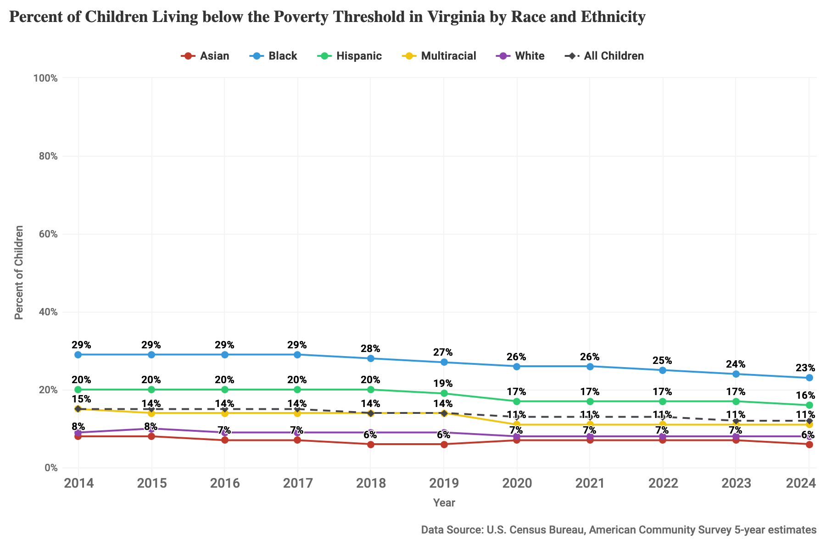
Figure 22: Percent of children living below the poverty threshold by race and ethnicity, 2014-2024, for Virginia.

Students Identified as Economically Disadvantaged

Albemarle County Public Schools
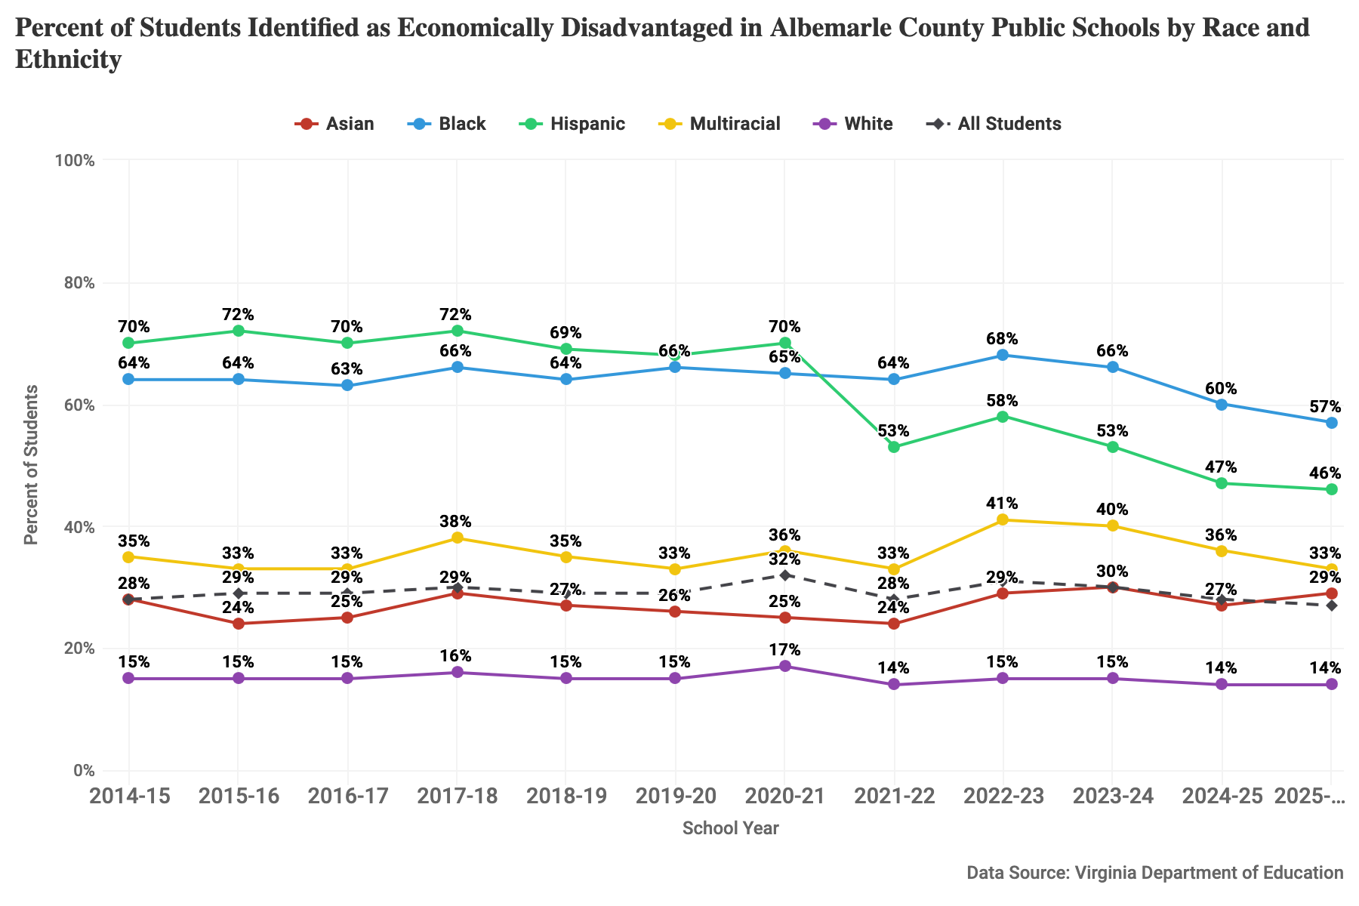
Figure 23: Percent of students identified as economically disadvantaged by race and ethnicity for the 20014-15 through 2025-26 school years in ACPS.

Charlottesville City Schools
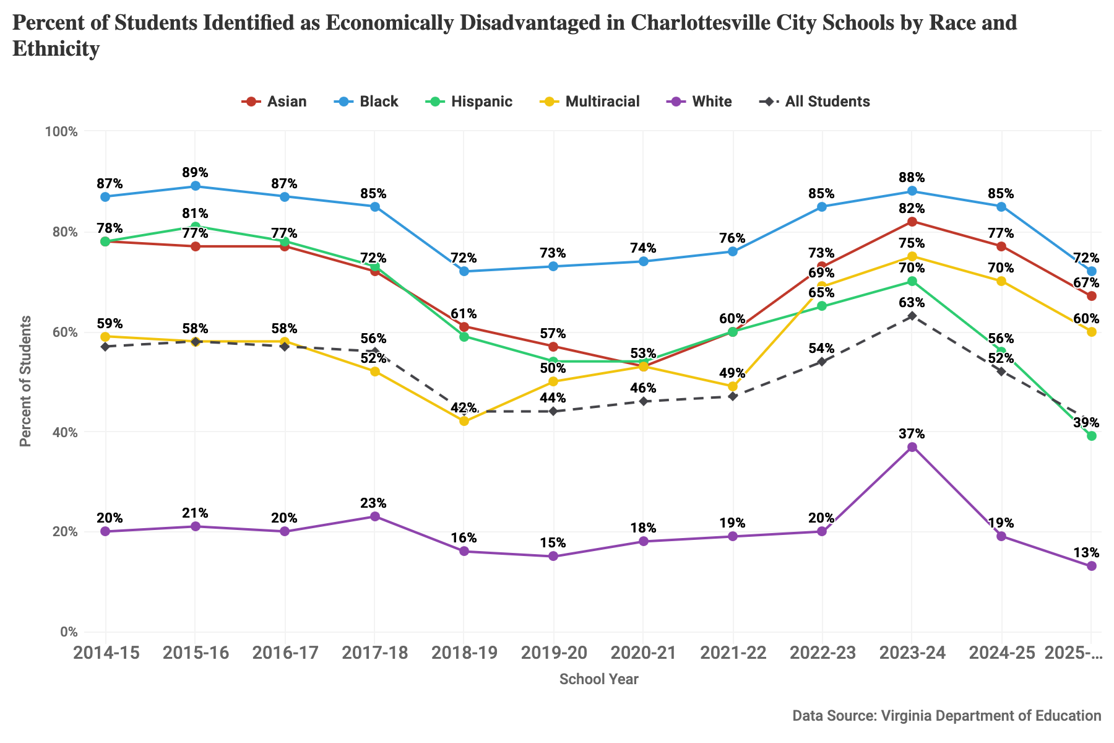
Figure 24: Percent of students identified as economically disadvantaged by race and ethnicity for the 20014-15 through 2025-26 school years in CCS.

Virginia Public Schools
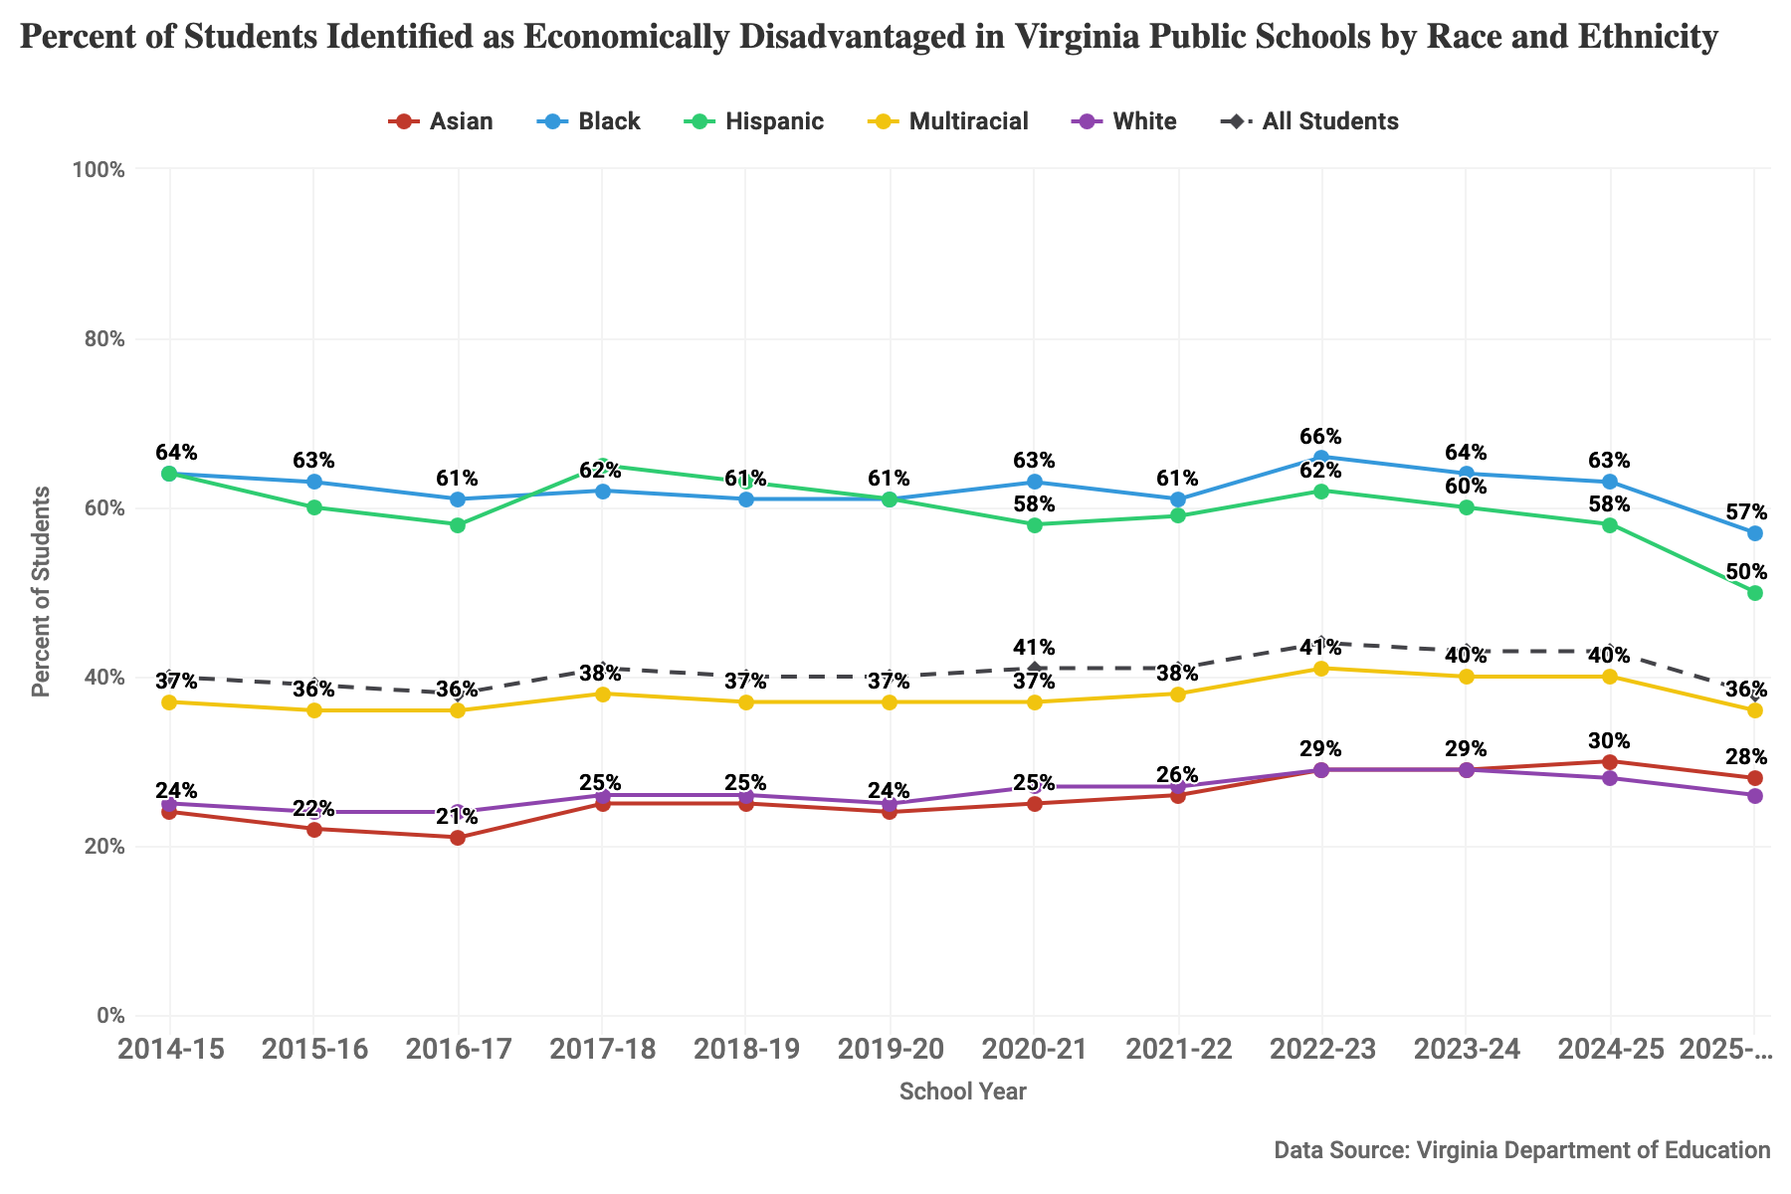
Figure 25: Percent of students identified as economically disadvantaged by race and ethnicity for the 20014-15 through 2025-26 school years in Virginia public schools.

Assessments and Investigations by Child Protective Services

Albemarle County
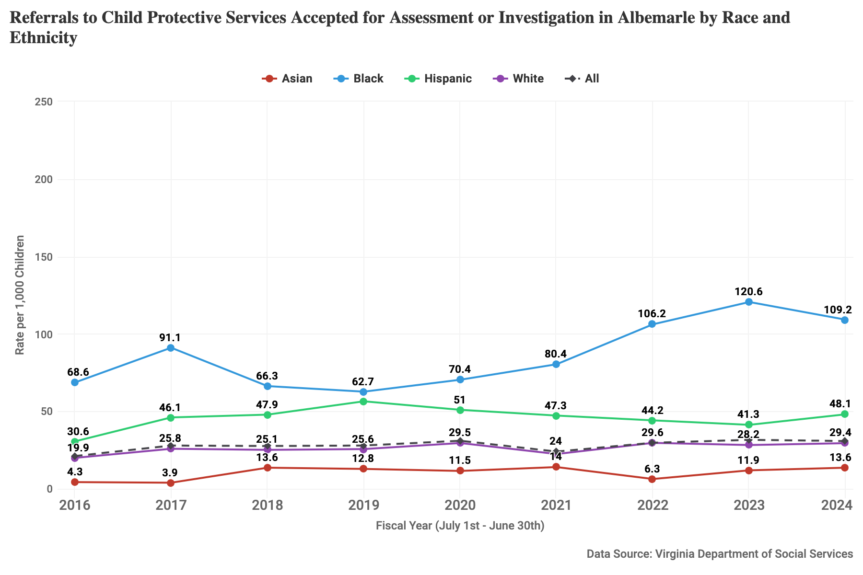
Figure 26: Referrals to child protective services accepted for assessment or investigation by race and ethnicity, rate per 1,000 children, for fiscal years 2016-2024 for Albemarle County.

Charlottesville City
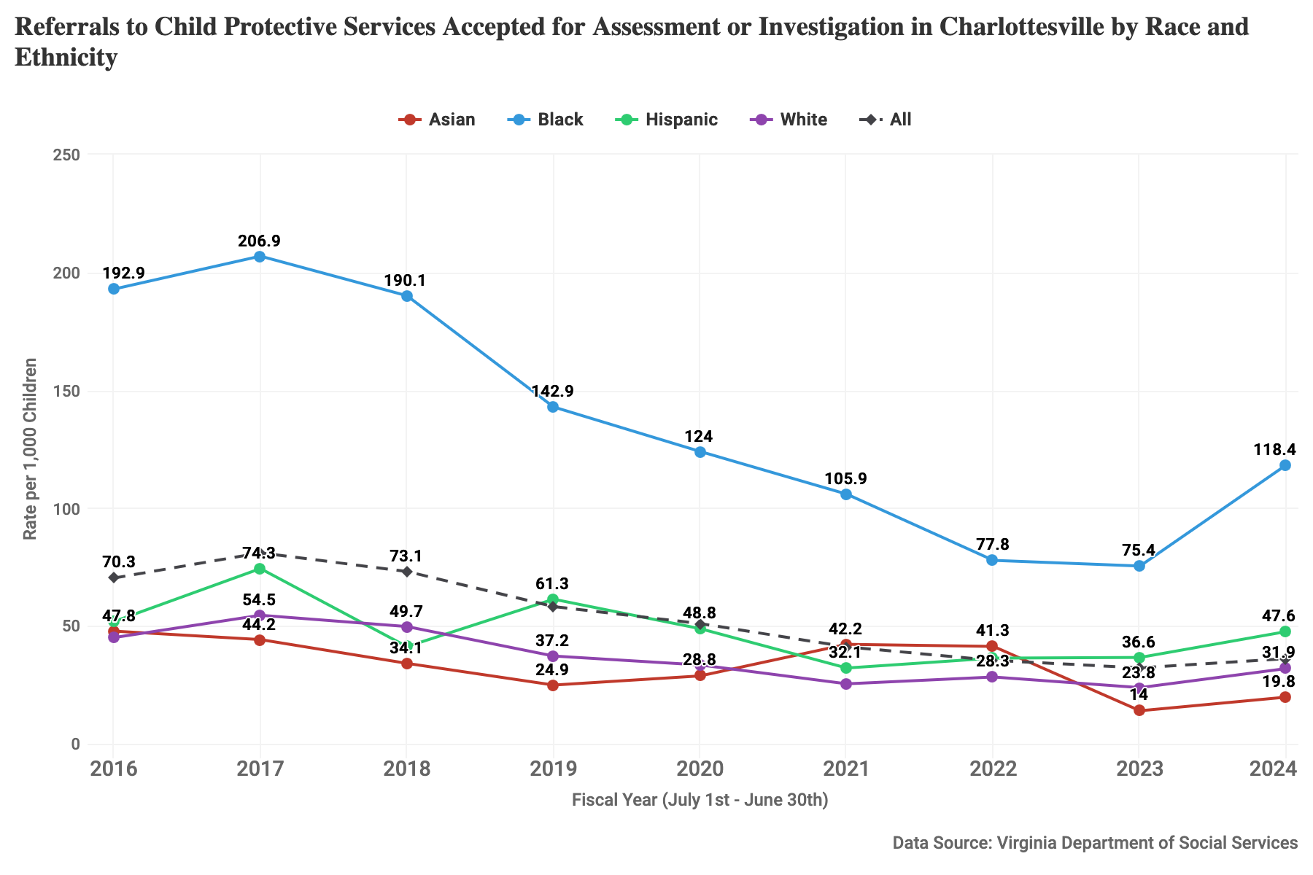
Figure 27: Referrals to child protective services accepted for assessment or investigation by race and ethnicity, rate per 1,000 children, for fiscal years 2016-2024 for Charlottesville City.

Virginia
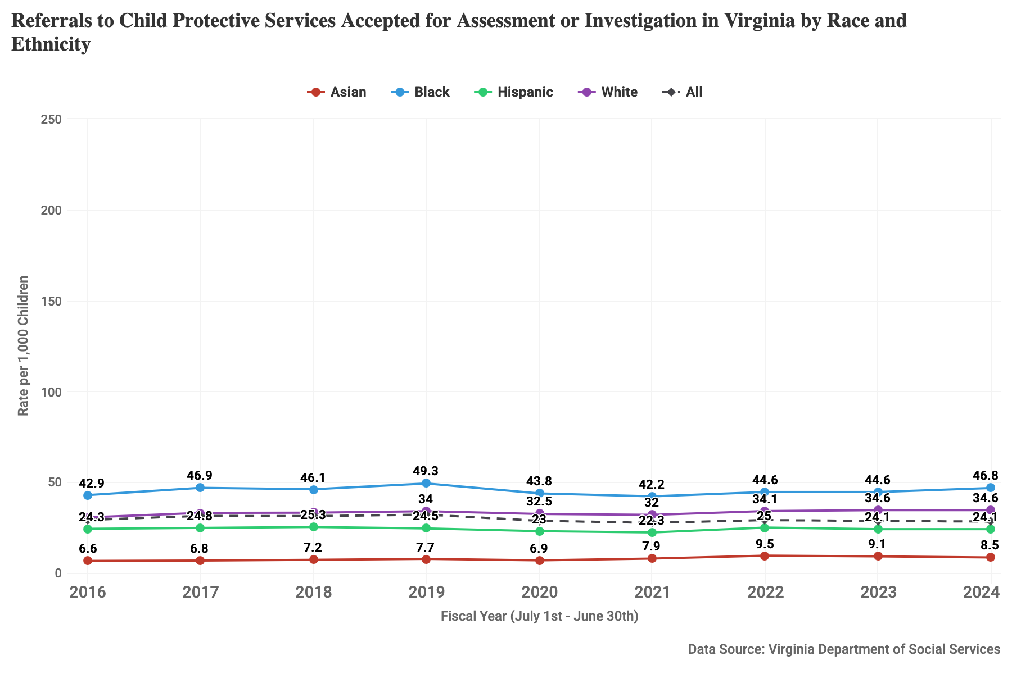
Figure 28: Referrals to child protective services accepted for assessment or investigation by race and ethnicity, rate per 1,000 children, for fiscal years 2016-2024 for Virginia.

Children in Foster Care

Albemarle County
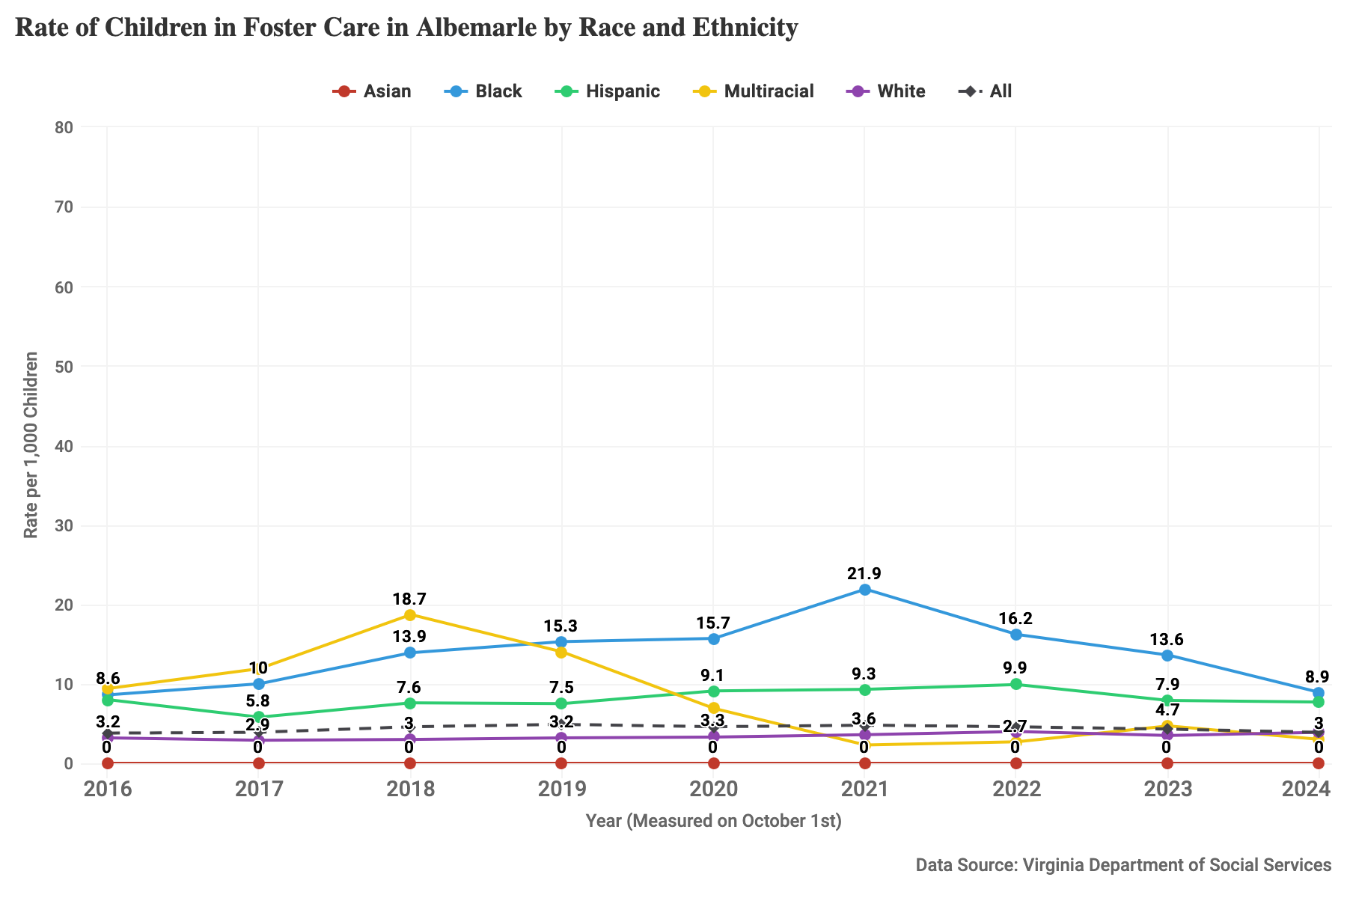
Figure 29: Children in foster care by race and ethnicity, rate per 1,000 children in Albemarle County for 2016-2024, measured in October of each year.

Charlottesville City
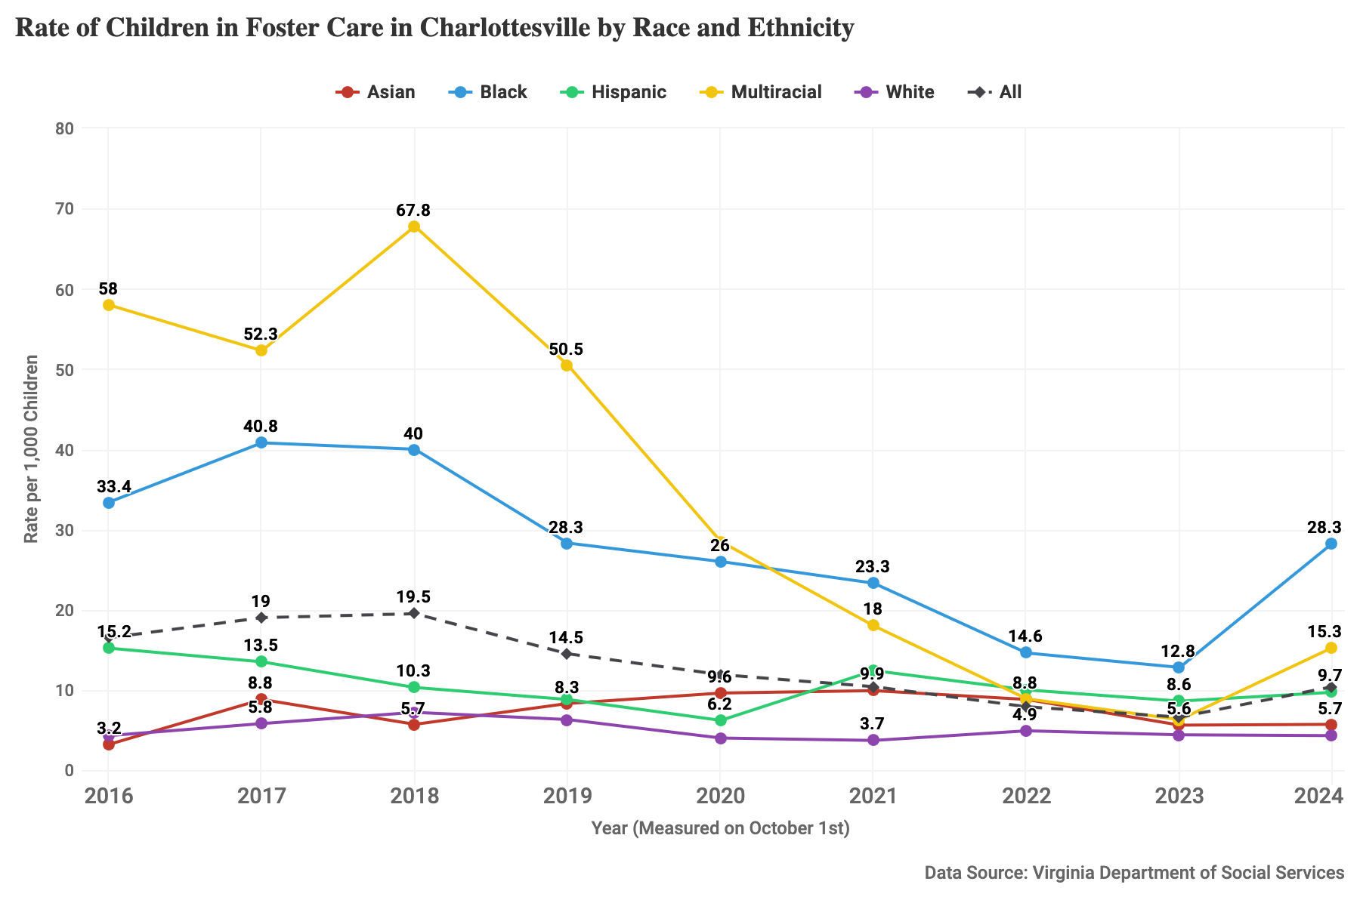
Figure 30: Children in foster care by race and ethnicity, rate per 1,000 children in Charlottesville City for 2016-2024, measured in October of each year.

Virginia
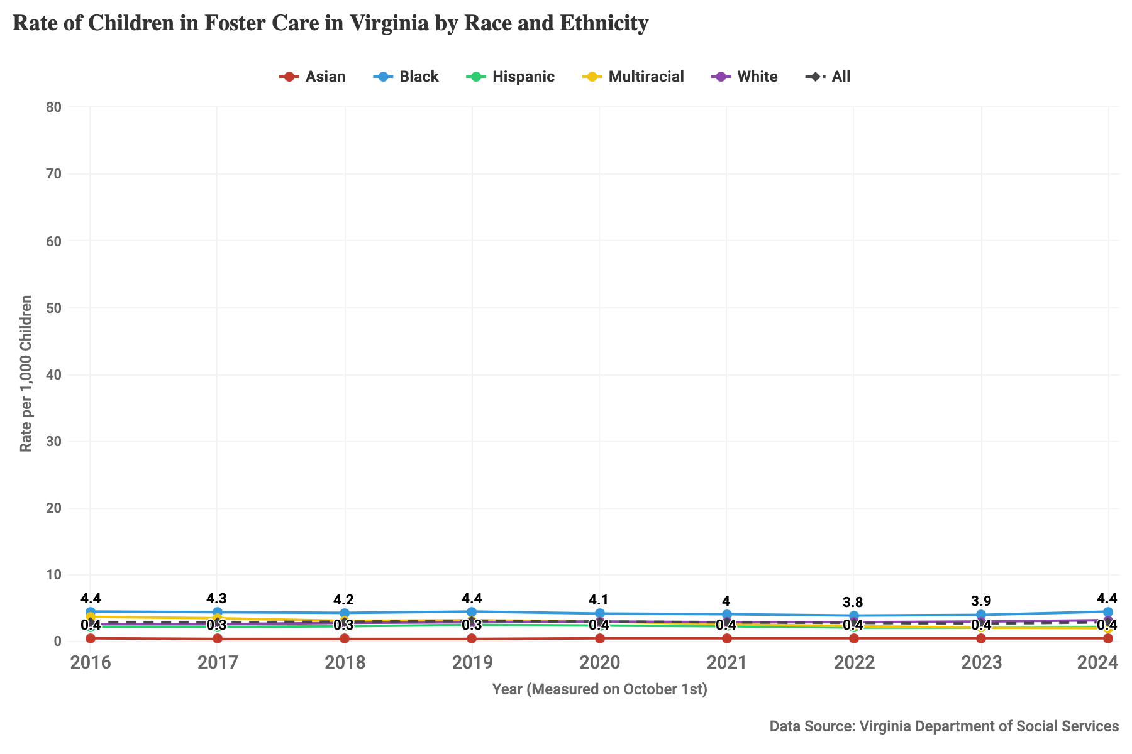
Figure 31: Children in foster care by race and ethnicity, rate per 1,000 children in Virginia for 2016-2024, measured in October of each year.

Health

Low Birth-Weight Infants

Albemarle County
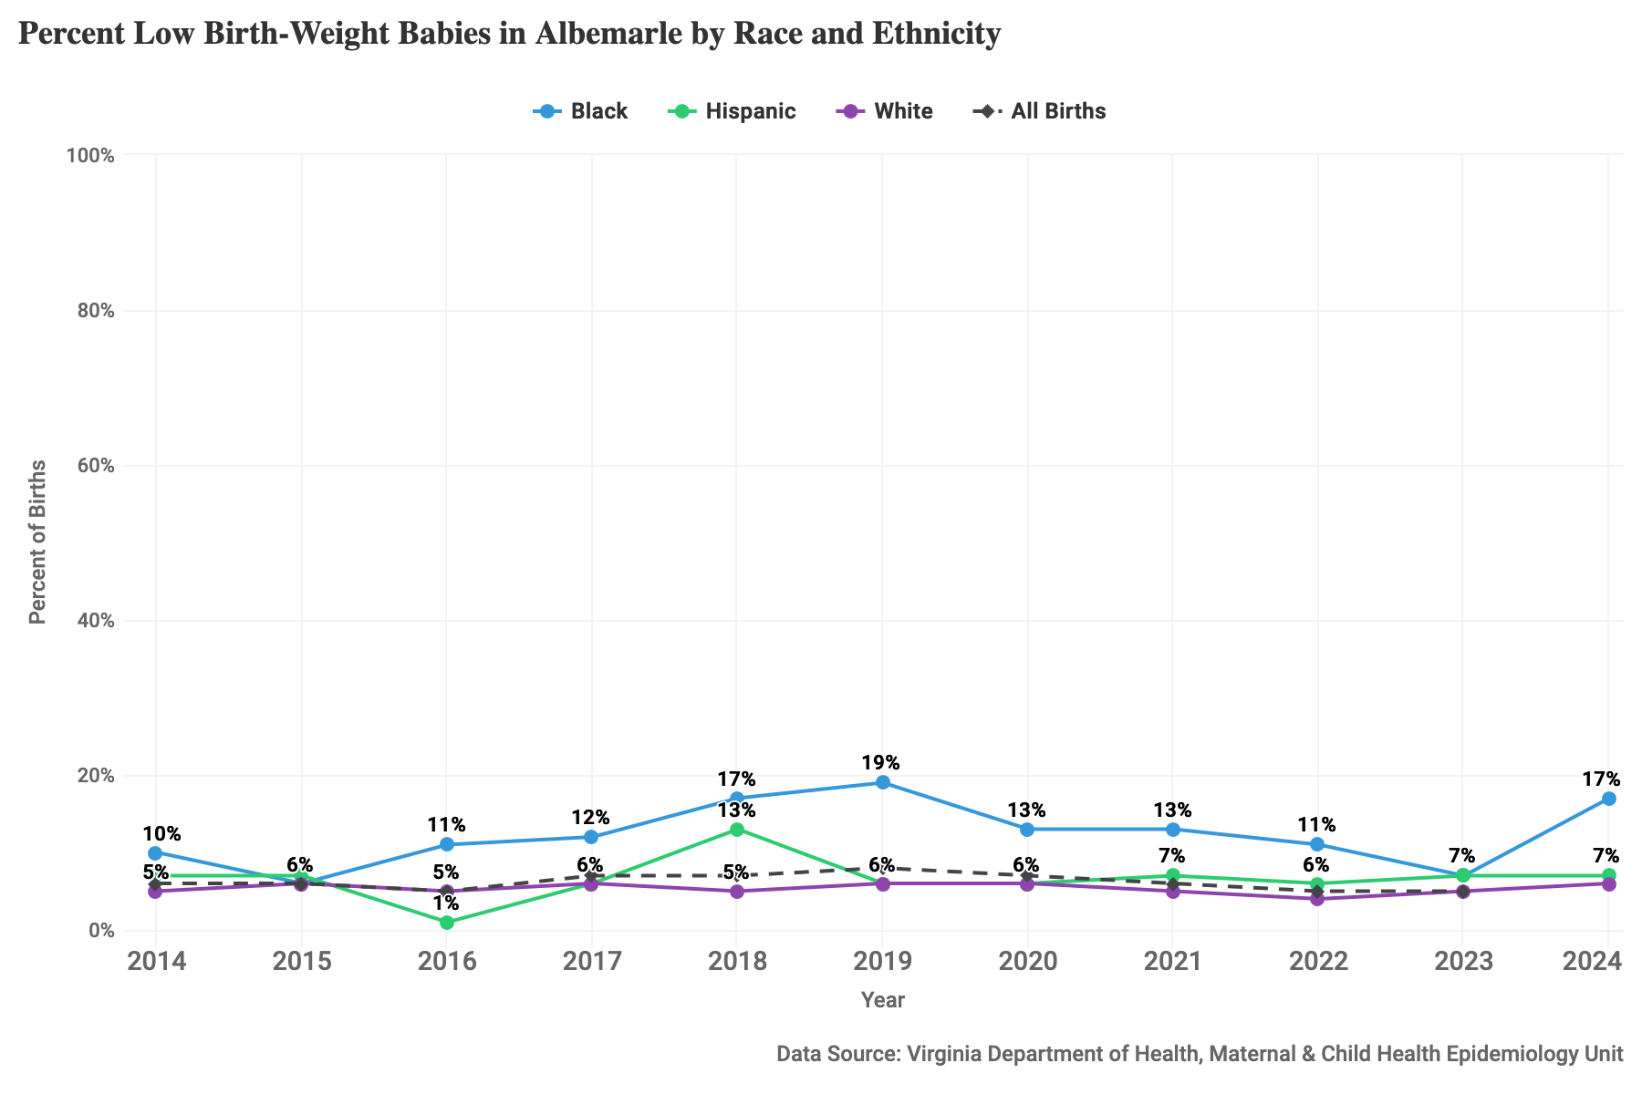
Figure 32: Percent of babies born weighing under 2,500 grams (5.5 lbs) by race and ethnicity, 2014-2024, for Albemarle County.

Charlottesville City
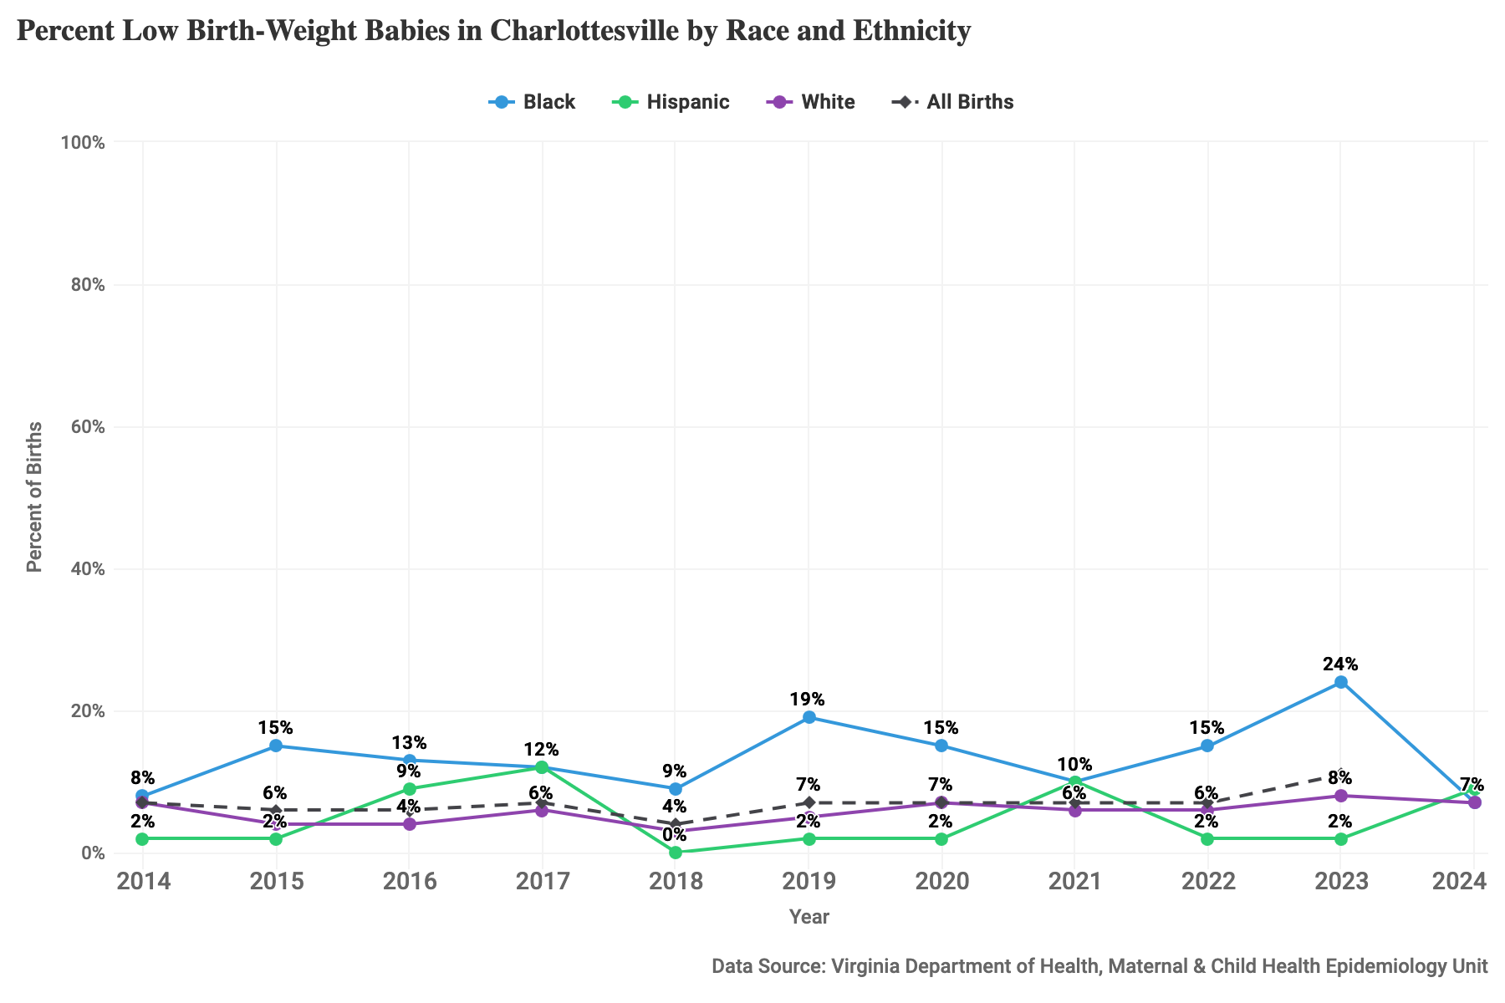
Figure 33: Percent of babies born weighing under 2,500 grams (5.5 lbs) by race and ethnicity, 2014-2024, for Charlottesville City.

Virginia
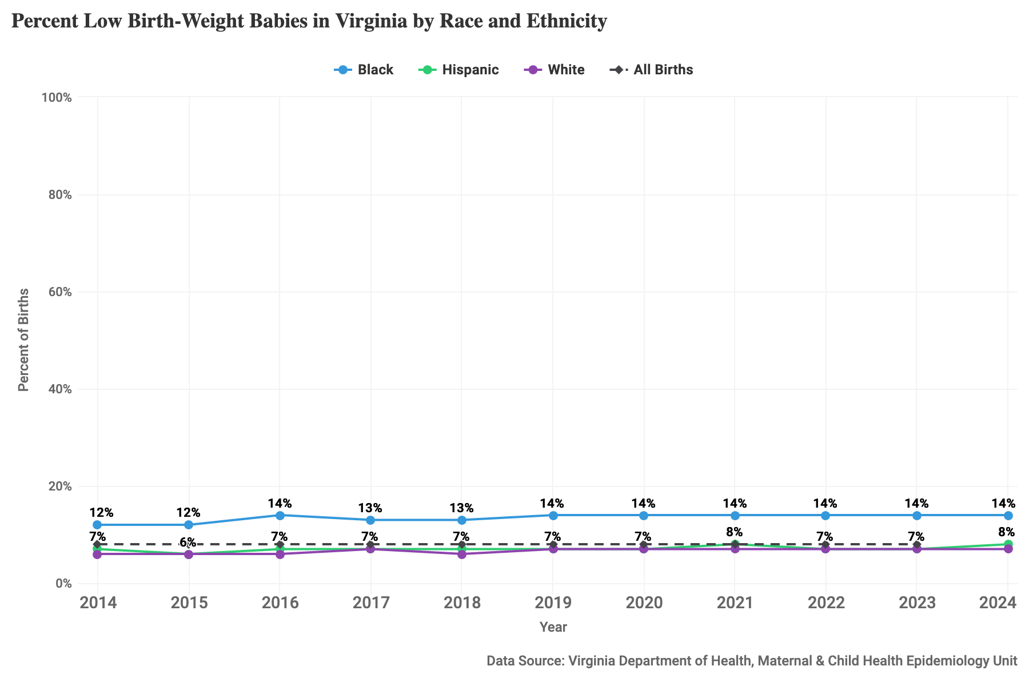
Figure 34: Percent of babies born weighing under 2,500 grams (5.5 lbs) by race and ethnicity, 2014-2024, for Virginia.

Infant Mortality

Albemarle County
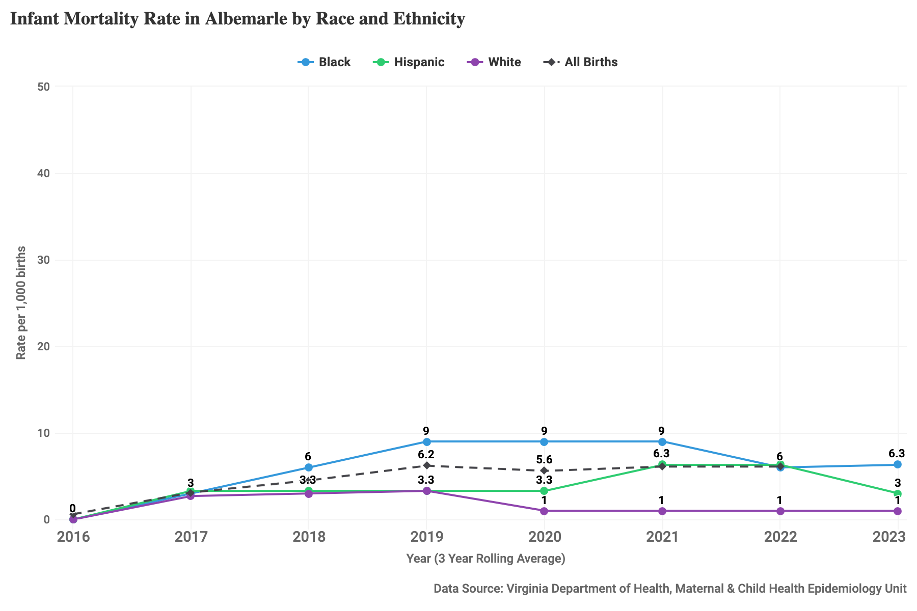
Figure 35: Rate per 1,000 births of infants who died before their 1st birthday by race and ethnicity, 2016-2023, for Albemarle.

Charlottesville City
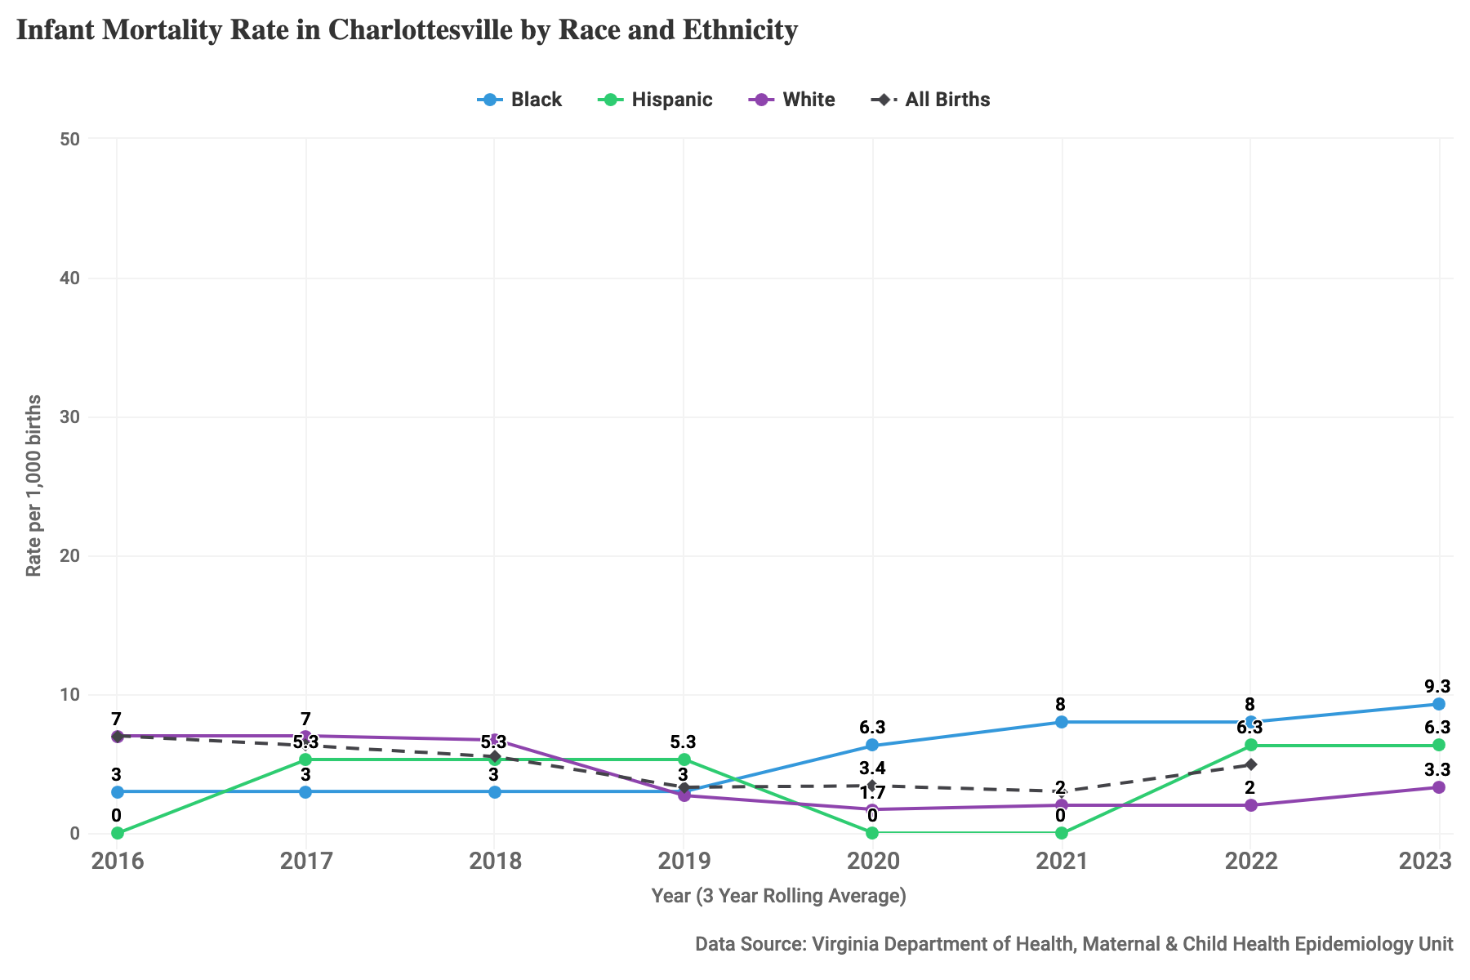
Figure 36: Rate per 1,000 births of infants who died before their 1st birthday by race and ethnicity, 2016-2023, for Charlottesville City.

Virginia
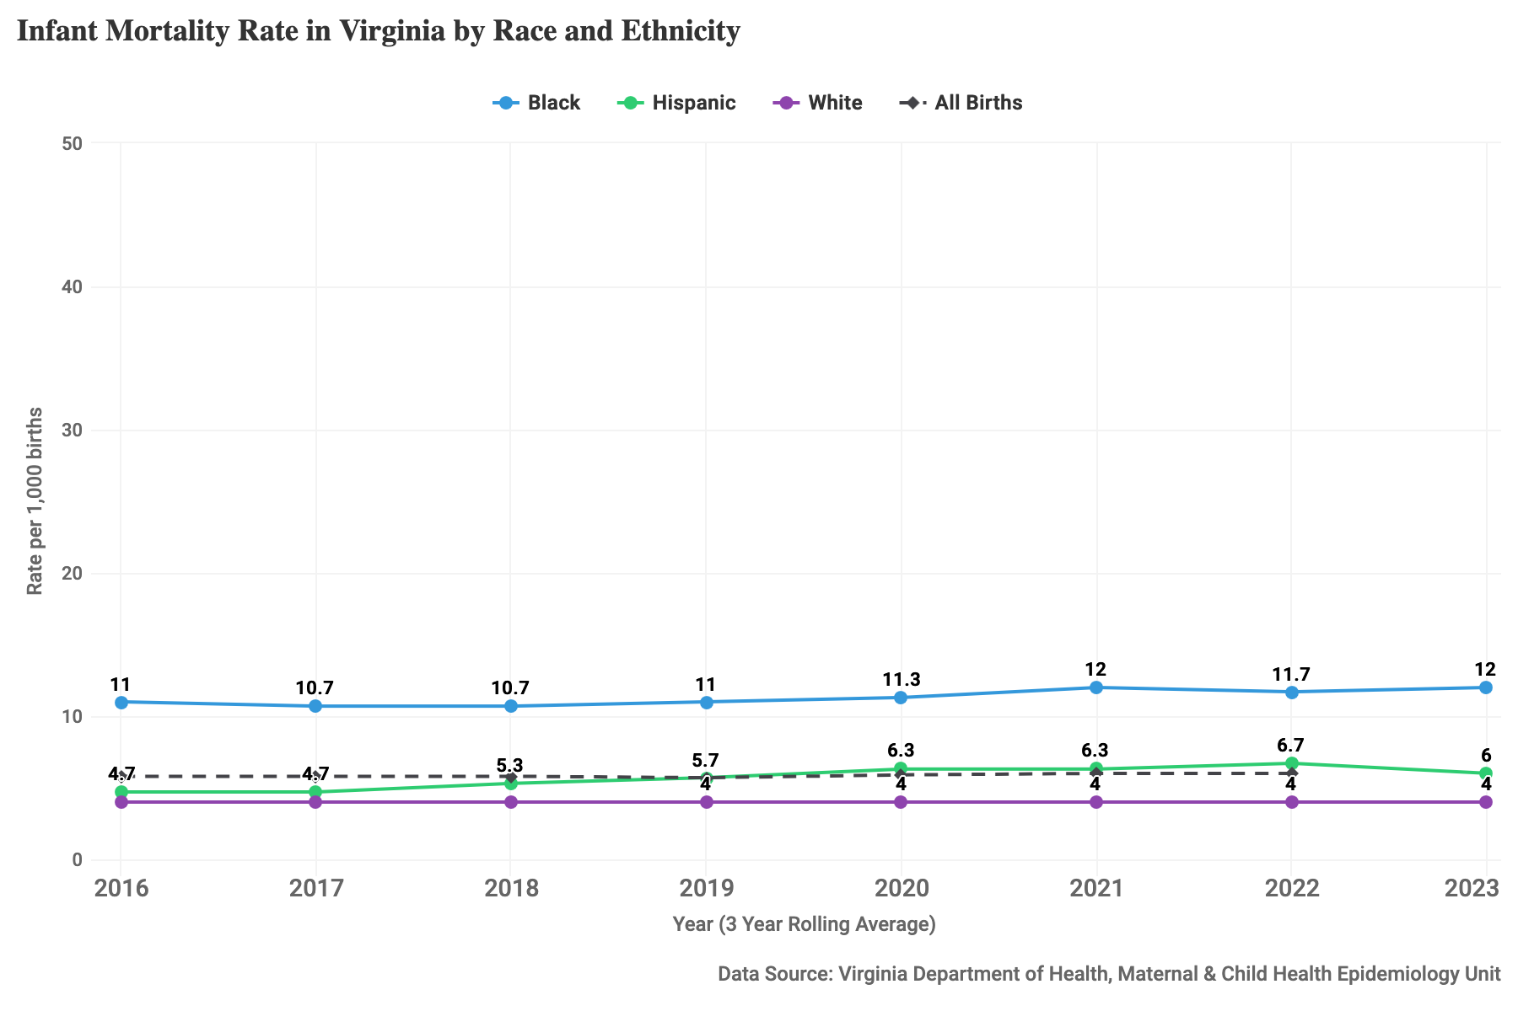
Figure 37: Rate per 1,000 births of infants who died before their 1st birthday by race and ethnicity, 2016-2023, for Virginia.

