Stepping Stones 2026
Table of Contents

List of Figures

1 Education

1.1 Kindergarteners At or Above Reading Levels

1.2 Standards of Learning

Math: Grades 3, and 5
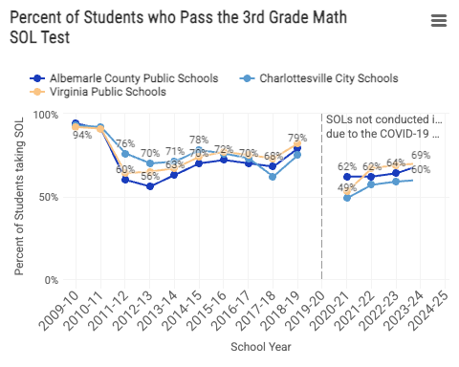
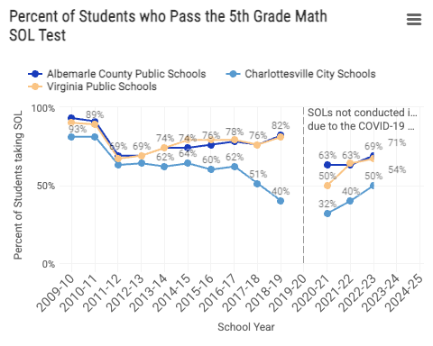

Reading: Grades 3, and 5
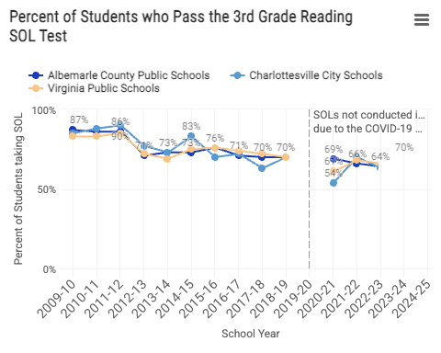
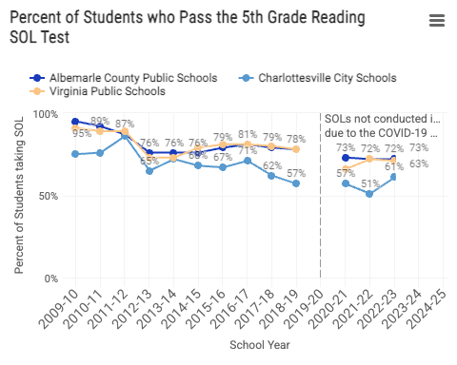

1.3 Students Eligible for Special Education Services
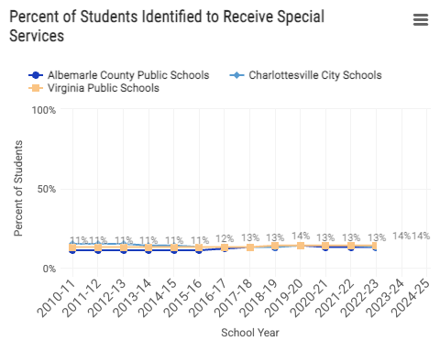

1.4 English Learners
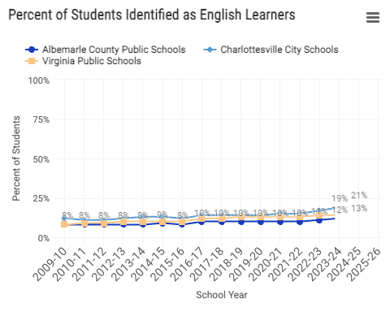

1.5 Absenteeism
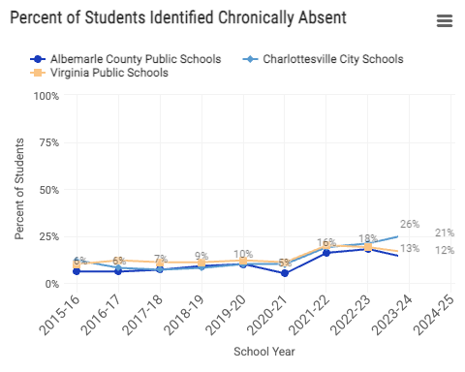

1.6 On-Time Graduation Rates
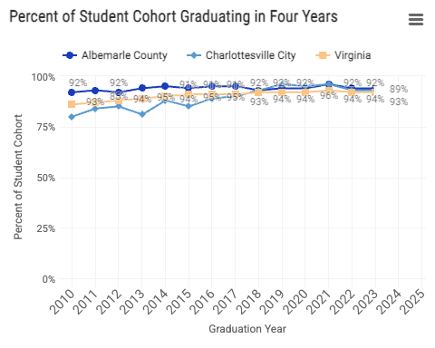

1.7 Post-Secondary Enrollment
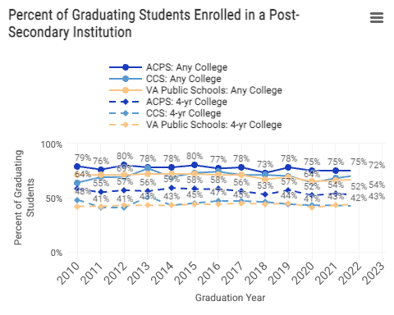

1.8 High School Degree Attainment
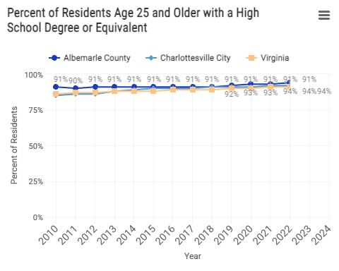

2 Economic and Family Stability

2.1 Income for Famlies with Children
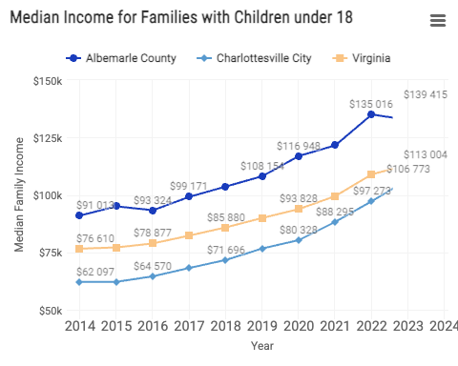

2.2 Youth Labor Force Participation and Unemployment
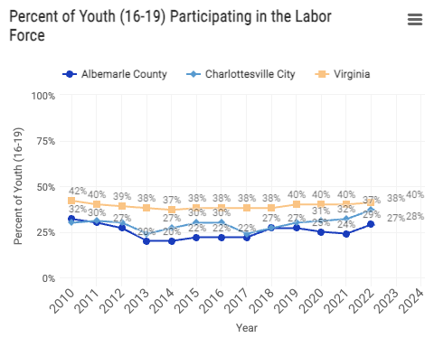
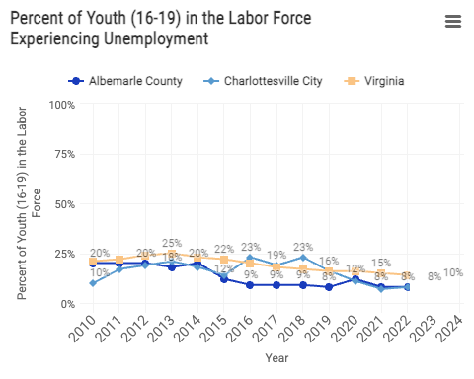

2.3 Children Living below Poverty Threshold
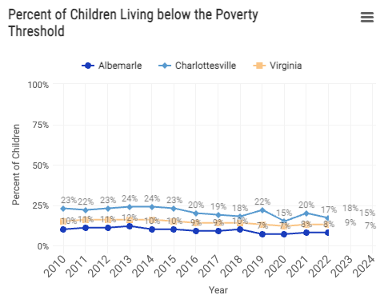

2.4 Students Identified as Economically Disadvantaged
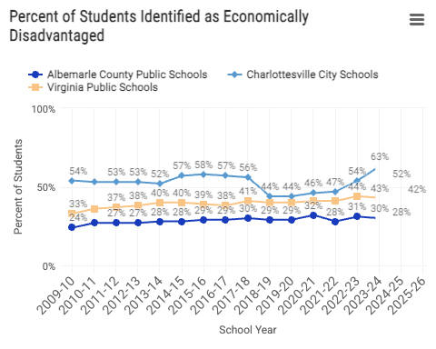

2.5 Children in Two-Parent Households
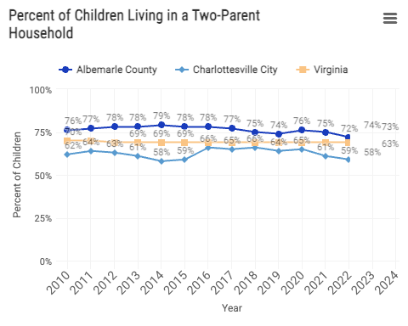

2.6 Assessments and Investigations by Child Protective Services
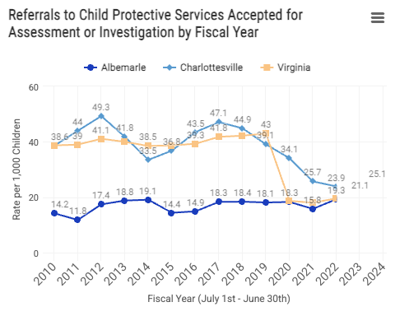

2.7 Children in Foster Care
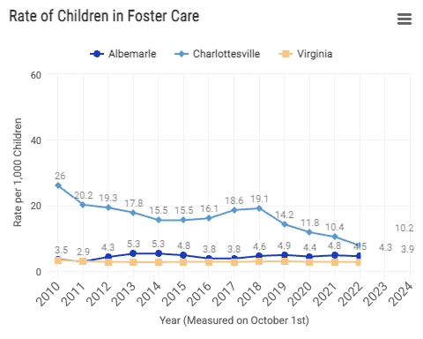

2.8 Students Experiencing Homelessness
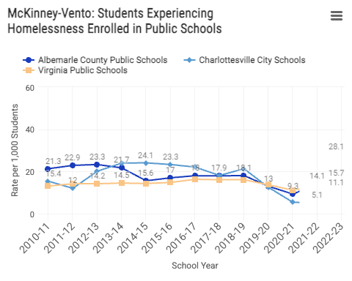

3 Health

3.1 Sexually Transmitted Infections in Youth
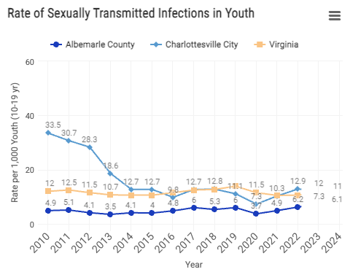

4 School and Community Disciplinary Actions

4.1 Student Behavior and Administrative Response
BESO: Behaviors that Endanger Self or Others (BESO). These behaviors endanger the health, safety, or welfare of either the student or others in the school community.
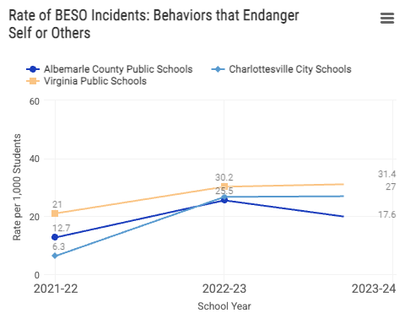
Persistently Dangerous (PD): Behaviors described in Virginia’s Unsafe School Choice Option Policy required by the federal Every Student Succeeds Act of 2015.
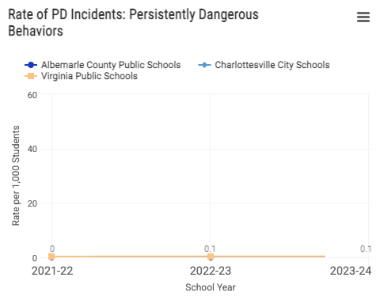
Figure 1: SBAR data

4.2 In-School Suspensions
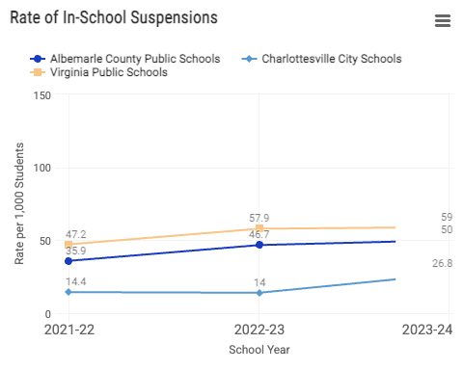

4.3 Out-of-School Suspensions
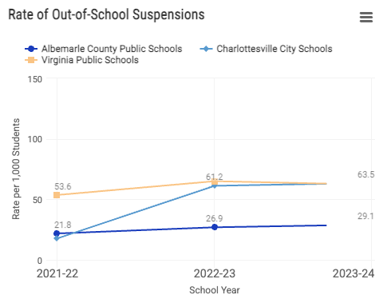

4.4 Children in Need of Services or Supervision
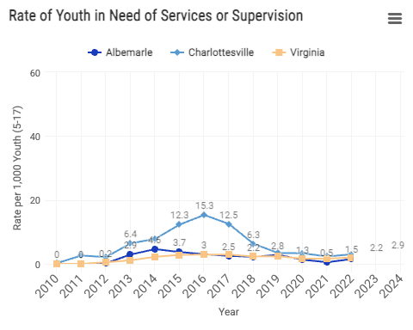

4.5 Juvenile Delinquency Judgments
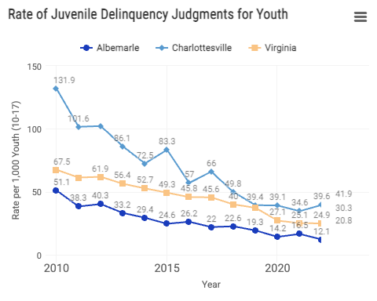

4.6 Arrests for Violent Crimes
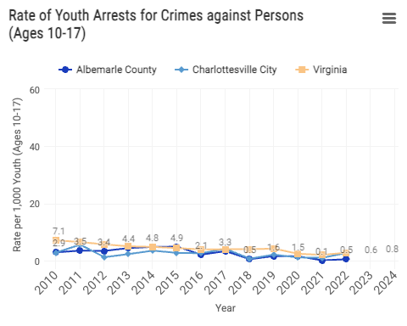

4.7 Arrests for Crimes involving Firearms
