Stepping Stones 2026
Table of Contents
1 Education
1.1 Kindergarteners At or Above Reading Levels i
1.2 Standards of Learning i
1.3 Students Eligible for Special Education Services v
1.4 English Learners vi
1.5 Absenteeism vii
1.6 On-Time Graduation Rates viii
1.7 Post-Secondary Enrollment ix
1.8 High School Degree Attainment x
2 Economic and Family Stability x
2.1 Income for Famlies with Children xi
2.2 Youth Labor Force Participation and Unemployment xii
2.3 Children Living below Poverty Threshold xiv
2.4 Students Identified as Economically Disadvantaged xiv
2.5 Children in Two-Parent Households xvi
2.6 Assessments and Investigations by Child Protective Services xvi
2.7 Children in Foster Care xviii
2.8 Students Experiencing Homelessness xix
3 Health xix
3.1 Sexually Transmitted Infections in Youth xx
4 School and Community Disciplinary Actions xx
4.1 Student Behavior and Administrative Response xx
4.2 In-School Suspensions xxiii
4.3 Out-of-School Suspensions xxiv
4.4 Children in Need of Services or Supervision xxv
4.5 Juvenile Delinquency Judgments xxvi
4.6 Arrests for Violent Crimes xxvii
4.7 Arrests for Crimes involving Firearms xxviii

List of Figures
Figure 1: SBAR data xxii

1 Education

1.1 Kindergarteners At or Above Reading Levels

1.2 Standards of Learning

Math: Grades 3, and 5
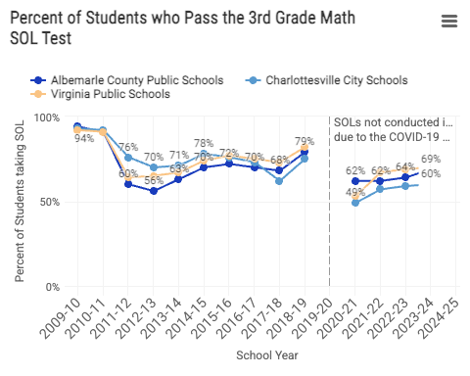
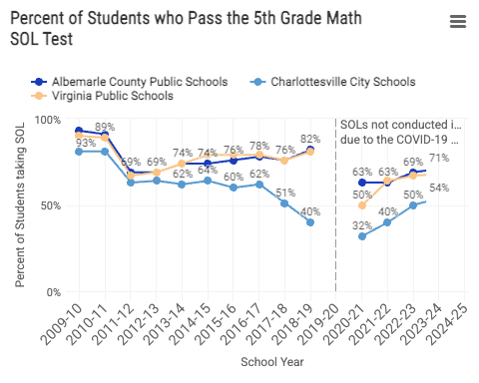

Reading: Grades 3, and 5
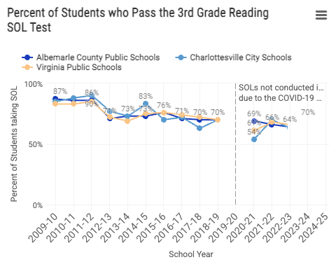
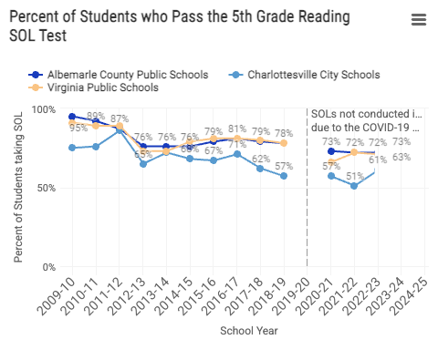

1.3 Students Eligible for Special Education Services
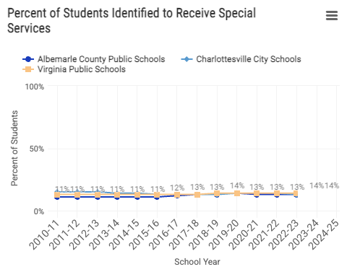

1.4 English Learners
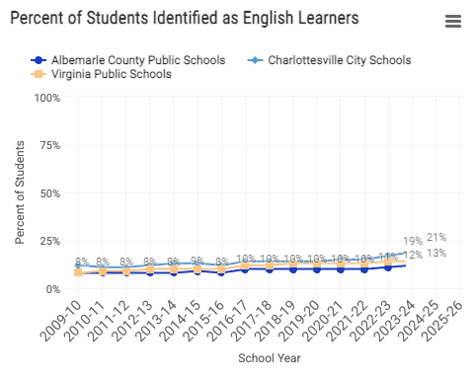

1.5 Absenteeism
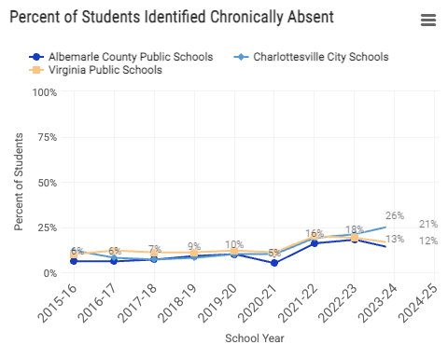

1.6 On-Time Graduation Rates
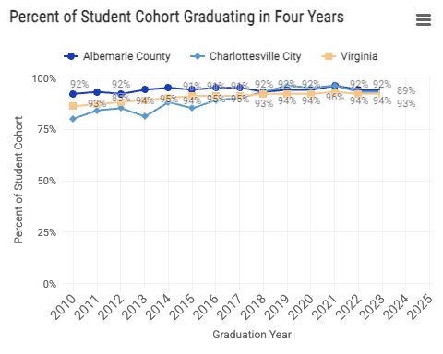

1.7 Post-Secondary Enrollment
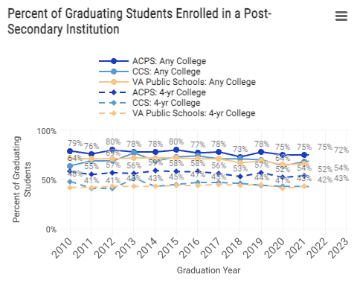

1.8 High School Degree Attainment
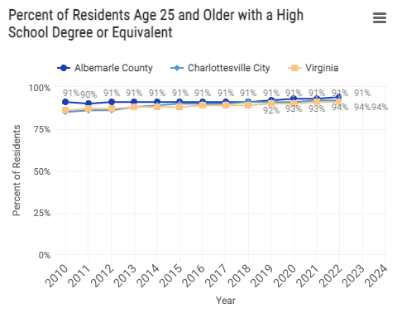

2 Economic and Family Stability

2.1 Income for Famlies with Children
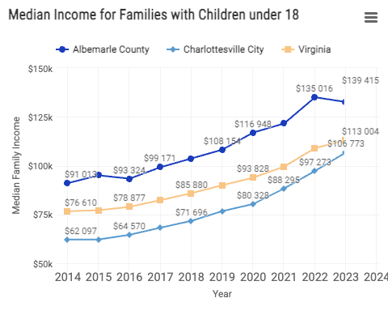

2.2 Youth Labor Force Participation and Unemployment
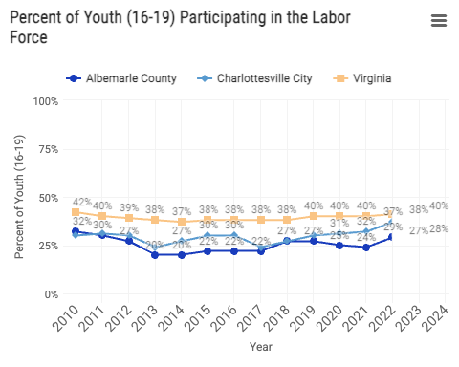
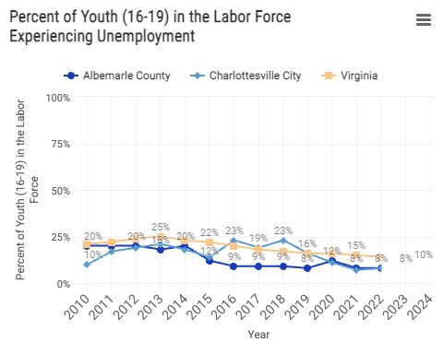

2.3 Children Living below Poverty Threshold
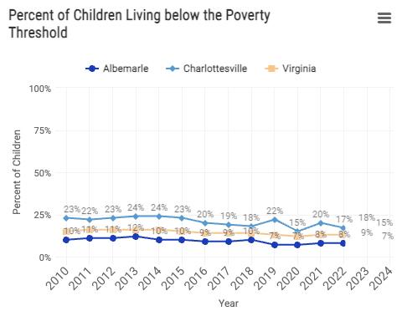

2.4 Students Identified as Economically Disadvantaged
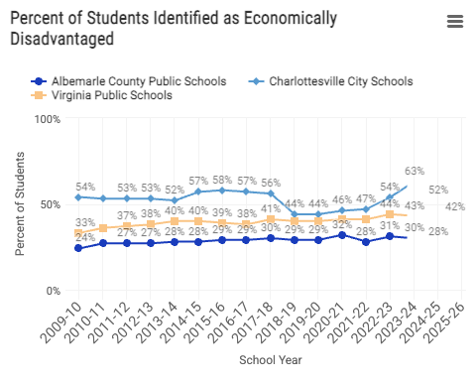

2.5 Children in Two-Parent Households
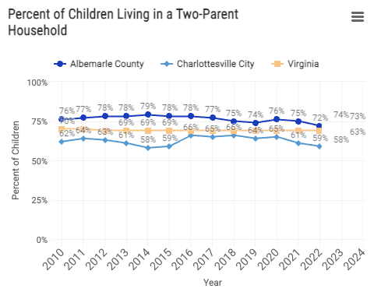

2.6 Assessments and Investigations by Child Protective Services
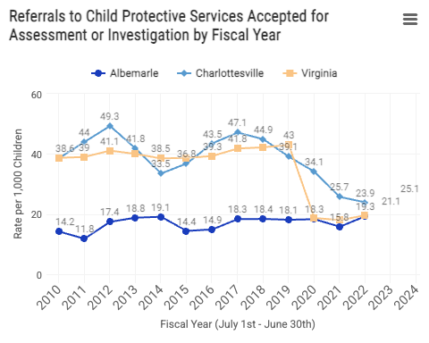

2.7 Children in Foster Care
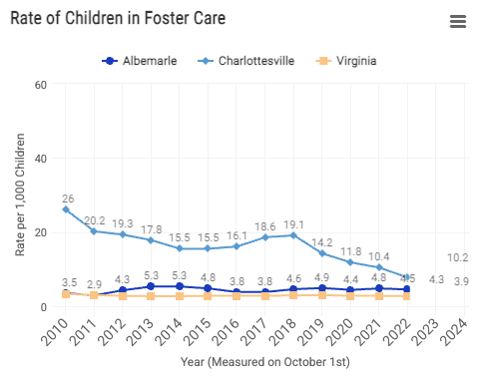

2.8 Students Experiencing Homelessness
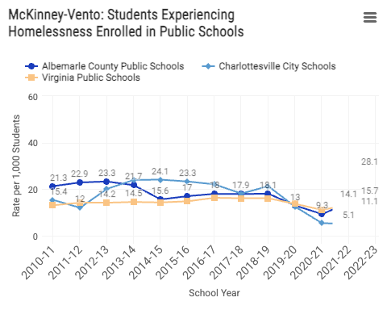

3 Health

3.1 Sexually Transmitted Infections in Youth
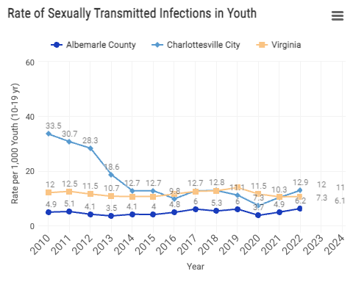

4 School and Community Disciplinary Actions

4.1 Student Behavior and Administrative Response
BESO: Behaviors that Endanger Self or Others (BESO). These behaviors endanger the health, safety, or welfare of either the student or others in the school community.
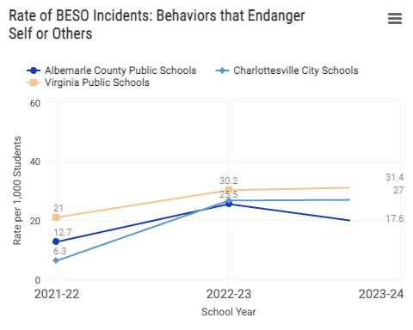
Persistently Dangerous (PD): Behaviors described in Virginia’s Unsafe School Choice Option Policy required by the federal Every Student Succeeds Act of 2015.
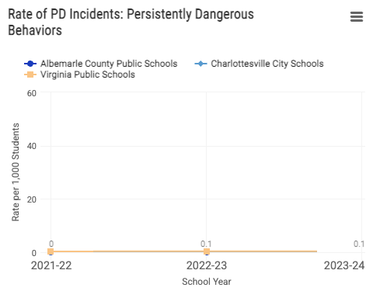
Figure 1: SBAR data

4.2 In-School Suspensions
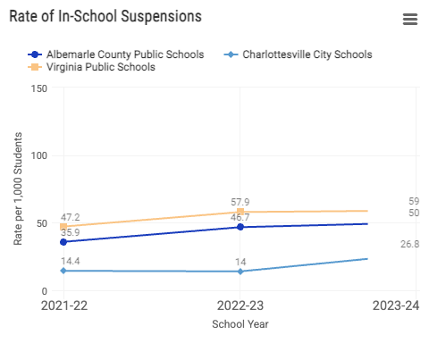

4.3 Out-of-School Suspensions
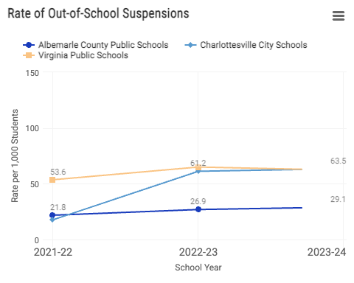

4.4 Children in Need of Services or Supervision
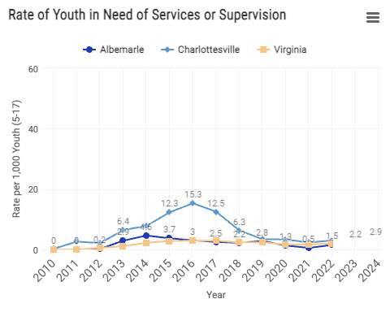

4.5 Juvenile Delinquency Judgments
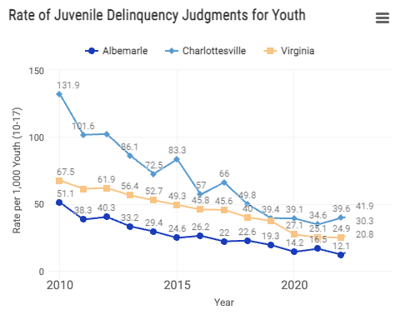

4.6 Arrests for Violent Crimes
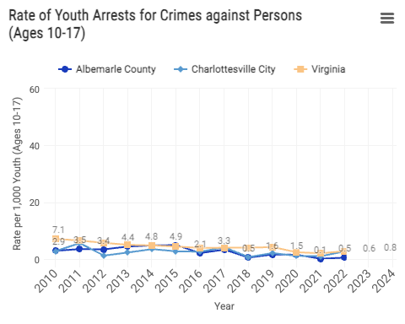

4.7 Arrests for Crimes involving Firearms
