### *\* I added screenshots of the code I inputted during my data exploration so you have a better idea of what I did, it’s available at the very end of the doc. If you would like to see any of the outputs or want me to look in a different direction for the future, please let me know! Honestly also completely forgot the Jupyter notebook was a thing until last Saturday when AG shared her notes with me, definitely gonna move to that for next week!*

### Khalila

Data sources, measures to understand flood hazard, storm risks (over space; is data available over time?)

**FEMA sources**

* Flood insurance claims: <https://www.fema.gov/openfema-data-page/fima-nfip-redacted-claims>
  + Can be easily accessed and read in python by downloading the csv file; pretty big file (605.9mb; over 2.5million claims)
  + FIPS Date Ranges: Cville area flood insurance claims begin in 1978 end in 2020; Eastern Shore begins 1977 ends in 2021; both updated monthly
  + Over 40 different variables available (screenshot below): latitude/longitude (smallest spatial scale), year of loss, amount paid on building/contents claims are examples; this could be really helpful as it shows the nfip claims reported by city (ie. when/where floods tend to happen; the extent of the damage)
  + They’ve been used in related work to “broaden understanding of the nation’s flood insurance program” and to “promote transparency, reduce complexity [of] public data requests, and improve how the agency’s stakeholders interact with and understand the NFIP; all without compromising consumer privacy”
  + Derived from the NFIP system of records
  + Code book available describing each variable and what they are measuring in the link (column list below)
  + **Data Exploration:**
    - Did it in Spyder, screenshots below!
* Flood maps: <https://www.fema.gov/flood-maps>
  + Flood maps themselves don’t seem to be very helpful. Dynamic maps available online and static maps can be downloaded, but doesn’t seem like either can be really be used in R/Python
* The **National Risk Index** might be helpful though? : <https://hazards.geoplatform.gov/portal/apps/MapSeries/index.html?appid=ddf915a24fb24dc8863eed96bc3345f8>
  + Can be easily downloaded as a csv file and measures expected annual loss, social vulnerability, community resilience, national risk index percentiles, area, population and 18 disaster specific rankings: more broad than just flood damages
    - Avalanche, coastal flooding, cold wave, drought, earthquake, hail, heat wave, hurricane, ice storm, landslide, lightning, riverine flooding, strong wind, tornado, tsunami, volcanic activity, wildfire, winter weather
  + Smallest available spatial scale seems to be the county level
  + Only most recent data available (archives may be available if we wanted to see differences over time, not exactly sure how these would be accessed though)
  + Has been used in other initiatives of making data accessible to communities: “Intended users include planners and emergency managers at the local, regional, state, and federal levels, as well as other decision makers and interested members of the general public.” (possible uses listed and include Updating emergency operations plans and Educating homeowners and renters)
  + The hazard selection was determined by reviewing 50 state hazard mitigation plans and developing an initial list based on the rate of occurrence in each state plan (profiled by at least 50% of plans) or a regionally significant event, like a hurricane, tsunami or volcano.
  + **Data Exploration:**
    - Cville area missing data: miscellaneous Tsunami, Avalanche, Volcano, Coastal flooding, and Wildfire events
    - Eastern Shore missing data: miscellaneous Tsunami, Avalanche; wildfire events; earthquake events
    - Lotsss of columns: copy/pasted them at the very bottom
    - Same code as NFIP exploration but for this data set instead
* Flood hazard layer: <https://www.fema.gov/flood-maps/national-flood-hazard-layer>
  + **Preliminary** flood hazard data not available for counties of interest (honestly seems like it's mostly bigger/richer counties where prelim data is available but this just conjecture)
  + NFHL viewer creates a FIRM (Flood Insurance Rate Map) and provides the public a look into their home or community’s projected risk to flood hazards.
  + Can be readily accessed as a PDF but not easily called into R/Python; It can be used in most GIS applications though to perform spatial analyses and for integration into custom maps and reports and to do so, we’ll need GIS or mapping software that can read data in shapefile format (I don't know much about GIS or how much this team uses it)
  + NFHL viewer (online) can view down to towns and streets: so small spatial scale (1in = 1000ft); PDF/ArcGIS shows only most recent data, but again archives might be available
  + “Variables” in the FIRM included areas of flood hazard, coastal transects, “a line called the Limit of Moderate Wave Action (LiMWA) [which] marks the inland limit of the Coastal A Zone— the part of the coastal SFHA referenced by building codes and standards where wave heights can be between 1.5 and 3 feet during a base flood event,” and other general structures (basic map legend stuff)
  + “The flood risk information presented on the Flood Insurance Rate Map is based on historic, meteorological, hydrologic, and hydraulic data, as well as open-space conditions, flood- control works, and development.”
  + This could be used for our project, but I think other measures like the NRI or the NFIP claims would be much more helpful
  + Fact Sheet and FAQ on flood mapping: <https://msc.fema.gov/msccontent/Flood_Hazard_Mapping_Updates_Overview_Fact_Sheet.pdf>
  + **Data Exploration:**
    - Rotunda FIRMette (not too interesting unfortunately)
    - Accomack Full FIRM (pretty interesting)
    - Both pdfs
* Flood risk data: <https://firststreet.org/>
  + CSV files of flood statistics for the 48 contiguous states at the congressional district, county, and zip code level (spatial scale). Includes statistics on the amount of properties at risk according to FEMA, the number of properties at risk according to First Street Foundation, and the difference between the two: <https://registry.opendata.aws/fsf-flood-risk/>
  + Lots of different resources/attributes; currently doing research with a lot of other universities like UCDavis, UMiami, VTech, etc; we could also join but they said it takes a while to get approval
  + Most recent CSV (v1.3) has risk data for 2020 and projected data for 2050, v1.0 has 2020, 2035, and 2050 risk data
  + Can be used in ArcMaps and QGIS (gives tutorials)
  + Website has more information than csv files tbh, they seem to focus more on the differences between them and FEMA but maybe I’m just interpreting the data wrong
  + Has a 78pg technical document with methodology: quick summary is they used a “flood frequency analysis of river gauge records to characterize extreme river flows and generate boundary conditions of the hydraulic model”
  + **Data Exploration:**
    - No missing data
    - Almost every column for each county has a unique value: no repeats
    - Same code as NFIP exploration

### *\* Data in order: code from NFIP claims exploration (used the same code for the three datasets I found), NFIP claim variables (ie. column names), First Street Foundation variables, NRI data variables;*

### *\* PDFs for the Flood Hazard data are in my repo folder!*

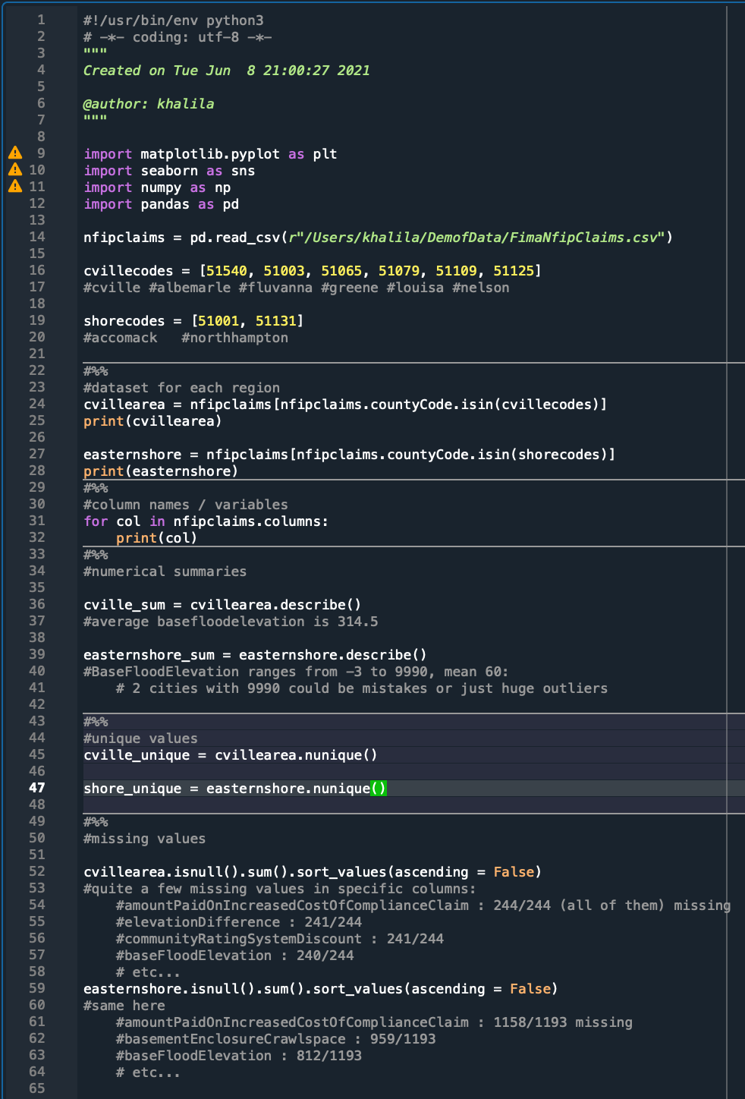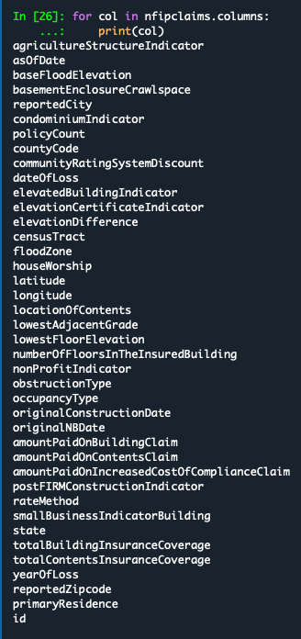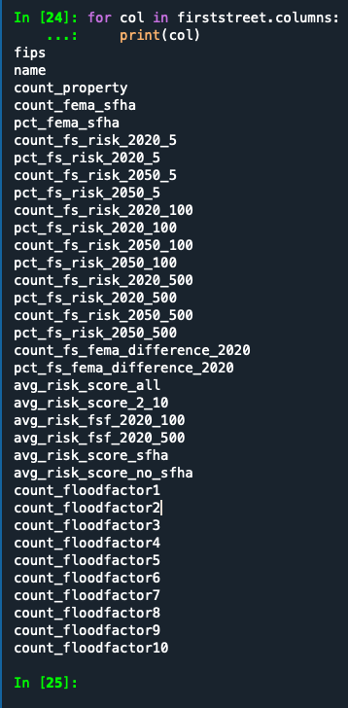

for col in NRIdata.columns:

print(col)

OBJECTID

NRI_ID

State Name

State Name Abbreviation

State FIPS Code

County Name

County Type

County FIPS Code

State-County FIPS Code

Population (2016)

Building Value ($)

Agricultural Value ($)

Area (sq mi)

National Risk Index - Score

National Risk Index

National Risk Index - National Percentile

National Risk Index - State Percentile

Expected Annual Loss - Score

Expected Annual Loss

Expected Annual Loss - National Percentile

Expected Annual Loss - State Percentile

Expected Annual Loss - Total

Expected Annual Loss - Building Value

Expected Annual Loss - Population

Expected Annual Loss - Population Equivalence

Expected Annual Loss - Agricultural Value

Social Vulnerability - Score

Social Vulnerability

Social Vulnerability - National Percentile

Social Vulnerability - State Percentile

Social Vulnerability - Value

Community Resilience - Score

Community Resilience

Community Resilience - National Percentile

Community Resilience - State Percentile

Community Resilience - Value

Avalanche - Number of Events

Avalanche - Annualized Frequency

Avalanche - Exposure - Building Value

Avalanche - Exposure - Population

Avalanche - Exposure - Population Equivalence

Avalanche - Exposure - Total

Avalanche - Historic Loss Ratio - Buildings

Avalanche - Historic Loss Ratio - Population

Avalanche - Historic Loss Ratio - Overall Rating

Avalanche - Expected Annual Loss - Building Value

Avalanche - Expected Annual Loss - Population

Avalanche - Expected Annual Loss - Population Equivalence

Avalanche - Expected Annual Loss - Total

Avalanche - Expected Annual Loss Score

Avalanche - Expected Annual Loss Rating

Avalanche - Individual Hazard Risk Score

Avalanche - Individual Hazard Risk Rating

Coastal Flooding - Number of Events

Coastal Flooding - Annualized Frequency

Coastal Flooding - Exposure - Building Value

Coastal Flooding - Exposure - Population

Coastal Flooding - Exposure - Population Equivalence

Coastal Flooding - Exposure - Total

Coastal Flooding - Historic Loss Ratio - Buildings

Coastal Flooding - Historic Loss Ratio - Population

Coastal Flooding - Historic Loss Ratio - Overall Rating

Coastal Flooding - Expected Annual Loss - Building Value

Coastal Flooding - Expected Annual Loss - Population

Coastal Flooding - Expected Annual Loss - Population Equivalence

Coastal Flooding - Expected Annual Loss - Total

Coastal Flooding - Expected Annual Loss Score

Coastal Flooding - Expected Annual Loss Rating

Coastal Flooding - Individual Hazard Risk Score

Coastal Flooding - Individual Hazard Risk Rating

Cold Wave - Number of Events

Cold Wave - Annualized Frequency

Cold Wave - Exposure - Building Value

Cold Wave - Exposure - Population

Cold Wave - Exposure - Population Equivalence

cwav_expa

Cold Wave - Exposure - Total

Cold Wave - Historic Loss Ratio - Buildings

Cold Wave - Historic Loss Ratio - Population

cwav_hslras

Cold Wave - Historic Loss Ratio - Overall Rating

Cold Wave - Expected Annual Loss - Building Value

Cold Wave - Expected Annual Loss - Population

Cold Wave - Expected Annual Loss - Population Equivalence

cwav_eala

Cold Wave - Expected Annual Loss - Total

Cold Wave - Expected Annual Loss Score

Cold Wave - Expected Annual Loss Rating

Cold Wave - Individual Hazard Risk Score

Cold Wave - Individual Hazard Risk Rating

Drought - Number of Events

Drought - Annualized Frequency

Drought - Exposure - Agricultural Value

Drought - Exposure - Total

Drought - Historic Loss Ratio - Agriculture

Drought - Historic Loss Ratio - Overall Rating

Drought - Expected Annual Loss - Agricultural Value

Drought - Expected Annual Loss - Total

Drought - Expected Annual Loss Score

Drought - Expected Annual Loss Rating

Drought - Individual Hazard Risk Score

Drought - Individual Hazard Risk Rating

Earthquake - Number of Events

Earthquake - Annualized Frequency

Earthquake - Exposure - Building Value

Earthquake - Exposure - Population

Earthquake - Exposure - Population Equivalence

Earthquake - Exposure - Total

Earthquake - Historic Loss Ratio - Buildings

Earthquake - Historic Loss Ratio - Population

Earthquake - Historic Loss Ratio - Overall Rating

Earthquake - Expected Annual Loss - Building Value

Earthquake - Expected Annual Loss - Population

Earthquake - Expected Annual Loss - Population Equivalence

Earthquake - Expected Annual Loss - Total

Earthquake - Expected Annual Loss Score

Earthquake - Expected Annual Loss Rating

Earthquake - Individual Hazard Risk Score

Earthquake - Individual Hazard Risk Rating

Hail - Number of Events

Hail - Annualized Frequency

Hail - Exposure - Building Value

Hail - Exposure - Population

Hail - Exposure - Population Equivalence

Hail - Exposure - Agricultural Value

Hail - Exposure - Total

Hail - Historic Loss Ratio - Buildings

Hail - Historic Loss Ratio - Population

Hail - Historic Loss Ratio - Agriculture

Hail - Historic Loss Ratio - Overall Rating

Hail - Expected Annual Loss - Building Value

Hail - Expected Annual Loss - Population

Hail - Expected Annual Loss - Population Equivalence

Hail - Expected Annual Loss - Agricultural Value

Hail - Expected Annual Loss - Total

Hail - Expected Annual Loss Score

Hail - Expected Annual Loss Rating

Hail - Individual Hazard Risk Score

Hail - Individual Hazard Risk Rating

Heat Wave - Number of Events

Heat Wave - Annualized Frequency

Heat Wave - Exposure - Building Value

Heat Wave - Exposure - Population

Heat Wave - Exposure - Population Equivalence

Heat Wave - Exposure - Total

Heat Wave - Historic Loss Ratio - Buildings

Heat Wave - Historic Loss Ratio - Population

Heat Wave - Historic Loss Ratio - Overall Rating

Heat Wave - Expected Annual Loss - Building Value

Heat Wave - Expected Annual Loss - Population

Heat Wave - Expected Annual Loss - Population Equivalence

Heat Wave - Expected Annual Loss - Total

Heat Wave - Expected Annual Loss Score

Heat Wave - Expected Annual Loss Rating

Heat Wave - Individual Hazard Risk Score

Heat Wave - Individual Hazard Risk Rating

Hurricane - Number of Events

Hurricane - Annualized Frequency

Hurricane - Exposure - Building Value

Hurricane - Exposure - Population

Hurricane - Exposure - Population Equivalence

Hurricane - Exposure - Total

Hurricane - Historic Loss Ratio - Buildings

Hurricane - Historic Loss Ratio - Population

Hurricane - Historic Loss Ratio - Overall Rating

Hurricane - Expected Annual Loss - Building Value

Hurricane - Expected Annual Loss - Population

Hurricane - Expected Annual Loss - Population Equivalence

Hurricane - Expected Annual Loss - Total

Hurricane - Expected Annual Loss Score

Hurricane - Expected Annual Loss Rating

Hurricane - Individual Hazard Risk Score

Hurricane - Individual Hazard Risk Rating

Ice Storm - Number of Events

Ice Storm - Annualized Frequency

Ice Storm - Exposure - Building Value

Ice Storm - Exposure - Population

Ice Storm - Exposure - Population Equivalence

Ice Storm - Exposure - Total

Ice Storm - Historic Loss Ratio - Buildings

Ice Storm - Historic Loss Ratio - Population

Ice Storm - Historic Loss Ratio - Overall Rating

Ice Storm - Expected Annual Loss - Building Value

Ice Storm - Expected Annual Loss - Population

Ice Storm - Expected Annual Loss - Population Equivalence

Ice Storm - Expected Annual Loss - Total

Ice Storm - Expected Annual Loss Score

Ice Storm - Expected Annual Loss Rating

Ice Storm - Individual Hazard Risk Score

Ice Storm - Individual Hazard Risk Rating

Landslide - Number of Events

Landslide - Annualized Frequency

Landslide - Exposure - Building Value

Landslide - Exposure - Population

Landslide - Exposure - Population Equivalence

Landslide - Exposure - Total

Landslide - Historic Loss Ratio - Buildings

Landslide - Historic Loss Ratio - Population

Landslide - Historic Loss Ratio - Overall Rating

Landslide - Expected Annual Loss - Building Value

Landslide - Expected Annual Loss - Population

Landslide - Expected Annual Loss - Population Equivalence

Landslide - Expected Annual Loss - Total

Landslide - Expected Annual Loss Score

Landslide - Expected Annual Loss Rating

Landslide - Individual Hazard Risk Score

Landslide - Individual Hazard Risk Rating

Lightning - Number of Events

Lightning - Annualized Frequency

Lightning - Exposure - Building Value

Lightning - Exposure - Population

Lightning - Exposure - Population Equivalence

Lightning - Exposure - Total

Lightning - Historic Loss Ratio - Buildings

Lightning - Historic Loss Ratio - Population

Lightning - Historic Loss Ratio - Overall Rating

Lightning - Expected Annual Loss - Building Value

Lightning - Expected Annual Loss - Population

Lightning - Expected Annual Loss - Population Equivalence

Lightning - Expected Annual Loss - Total

Lightning - Expected Annual Loss Score

Lightning - Expected Annual Loss Rating

Lightning - Individual Hazard Risk Score

Lightning - Individual Hazard Risk Rating

Riverine Flooding - Number of Events

Riverine Flooding - Annualized Frequency

Riverine Flooding - Exposure - Building Value

Riverine Flooding - Exposure - Population

Riverine Flooding - Exposure - Population Equivalence

Riverine Flooding - Exposure - Agricultural Value

Riverine Flooding - Exposure - Total

Riverine Flooding - Historic Loss Ratio - Buildings

Riverine Flooding - Historic Loss Ratio - Population

Riverine Flooding - Historic Loss Ratio - Agriculture

Riverine Flooding - Historic Loss Ratio - Overall Rating

Riverine Flooding - Expected Annual Loss - Building Value

Riverine Flooding - Expected Annual Loss - Population

Riverine Flooding - Expected Annual Loss - Population Equivalence

Riverine Flooding - Expected Annual Loss - Agricultural Value

Riverine Flooding - Expected Annual Loss - Total

Riverine Flooding - Expected Annual Loss Score

Riverine Flooding - Expected Annual Loss Rating

Riverine Flooding - Individual Hazard Risk Score

Riverine Flooding - Individual Hazard Risk Rating

Strong Wind - Number of Events

Strong Wind - Annualized Frequency

Strong Wind - Exposure - Building Value

Strong Wind - Exposure - Population

Strong Wind - Exposure - Population Equivalence

Strong Wind - Exposure - Agricultural Value

Strong Wind - Exposure - Total

Strong Wind - Historic Loss Ratio - Buildings

Strong Wind - Historic Loss Ratio - Population

Strong Wind - Historic Loss Ratio - Agriculture

Strong Wind - Historic Loss Ratio - Overall Rating

Strong Wind - Expected Annual Loss - Building Value

Strong Wind - Expected Annual Loss - Population

Strong Wind - Expected Annual Loss - Population Equivalence

Strong Wind - Expected Annual Loss - Agricultural Value

Strong Wind - Expected Annual Loss - Total

Strong Wind - Expected Annual Loss Score

Strong Wind - Expected Annual Loss Rating

Strong Wind - Individual Hazard Risk Score

Strong Wind - Individual Hazard Risk Rating

Tornado - Number of Events

Tornado - Annualized Frequency

Tornado - Exposure - Building Value

Tornado - Exposure - Population

Tornado - Exposure - Population Equivalence

Tornado - Exposure - Total

Tornado - Historic Loss Ratio - Buildings

Tornado - Historic Loss Ratio - Population

Tornado - Historic Loss Ratio - Overall Rating

Tornado - Expected Annual Loss - Building Value

Tornado - Expected Annual Loss - Population

Tornado - Expected Annual Loss - Population Equivalence

Tornado - Expected Annual Loss - Total

Tornado - Expected Annual Loss Score

Tornado - Expected Annual Loss Rating

Tornado - Individual Hazard Risk Score

Tornado - Individual Hazard Risk Rating

Tsunami - Number of Events

Tsunami - Annualized Frequency

Tsunami - Exposure - Building Value

Tsunami - Exposure - Population

Tsunami - Exposure - Population Equivalence

Tsunami - Exposure - Total

Tsunami - Historic Loss Ratio - Buildings

Tsunami - Historic Loss Ratio - Population

Tsunami - Historic Loss Ratio - Overall Rating

Tsunami - Expected Annual Loss - Building Value

Tsunami - Expected Annual Loss - Population

Tsunami - Expected Annual Loss - Population Equivalence

Tsunami - Expected Annual Loss - Total

Tsunami - Expected Annual Loss Score

Tsunami - Expected Annual Loss Rating

Tsunami - Individual Hazard Risk Score

Tsunami - Individual Hazard Risk Rating

Volcanic Activity - Number of Events

Volcanic Activity - Annualized Frequency

Volcanic Activity - Exposure - Building Value

Volcanic Activity - Exposure - Population

Volcanic Activity - Exposure - Population Equivalence

Volcanic Activity - Exposure - Total

Volcanic Activity - Historic Loss Ratio - Buildings

Volcanic Activity - Historic Loss Ratio - Population

Volcanic Activity - Historic Loss Ratio - Overall Rating

Volcanic Activity - Expected Annual Loss - Building Value

Volcanic Activity - Expected Annual Loss - Population

Volcanic Activity - Expected Annual Loss - Population Equivalence

Volcanic Activity - Expected Annual Loss - Total

Volcanic Activity - Expected Annual Loss Score

Volcanic Activity - Expected Annual Loss Rating

Volcanic Activity - Individual Hazard Risk Score

Volcanic Activity - Individual Hazard Risk Rating

Wildfire - Number of Events

Wildfire - Annualized Frequency

Wildfire - Exposure - Building Value

Wildfire - Exposure - Population

Wildfire - Exposure - Population Equivalence

Wildfire - Exposure - Total

Wildfire - Historic Loss Ratio - Buildings

Wildfire - Historic Loss Ratio - Population

Wildfire - Historic Loss Ratio - Overall Rating

Wildfire - Expected Annual Loss - Building Value

Wildfire - Expected Annual Loss - Population

Wildfire - Expected Annual Loss - Population Equivalence

Wildfire - Expected Annual Loss - Total

Wildfire - Expected Annual Loss Score

Wildfire - Expected Annual Loss Rating

Wildfire - Individual Hazard Risk Score

Wildfire - Individual Hazard Risk Rating

Winter Weather - Number of Events

Winter Weather - Annualized Frequency

Winter Weather - Exposure - Building Value

Winter Weather - Exposure - Population

Winter Weather - Exposure - Population Equivalence

Winter Weather - Exposure - Total

Winter Weather - Historic Loss Ratio - Buildings

Winter Weather - Historic Loss Ratio - Population

Winter Weather - Historic Loss Ratio - Overall Rating

Winter Weather - Expected Annual Loss - Building Value

Winter Weather - Expected Annual Loss - Population

Winter Weather - Expected Annual Loss - Population Equivalence

Winter Weather - Expected Annual Loss - Total

Winter Weather - Expected Annual Loss Score

Winter Weather - Expected Annual Loss Rating

Winter Weather - Individual Hazard Risk Score

Winter Weather - Individual Hazard Risk Rating

nri_ver