 | PollyApp2  Documentation



GITHUB REPOSITORY LINK

https://github.com/virginianegri/PollyApp

1 Abstract
The project aims to extend the PollyApp1 project developed by Ali Emre Soyluçiçek and Laura Schiatti Sisó.
The motive is to use the PollyApp1 to convert the footer notes in the slides, converting them to audios and then embedding them into slides.

A Nodejs based application that exploits Text-to-Speech service provided by Amazon Polly to perform the following transformations-
- Convert text file (.txt format) to audio file (.mp3) and multiple text files simultaneously present in a folder to multiple audio files.
- Read the footer notes in the Microsoft PowerPoint Presentation (.pptx format), converting them to audios using Amazon Polly and then inserting those audios in the corresponding slides in the deck.

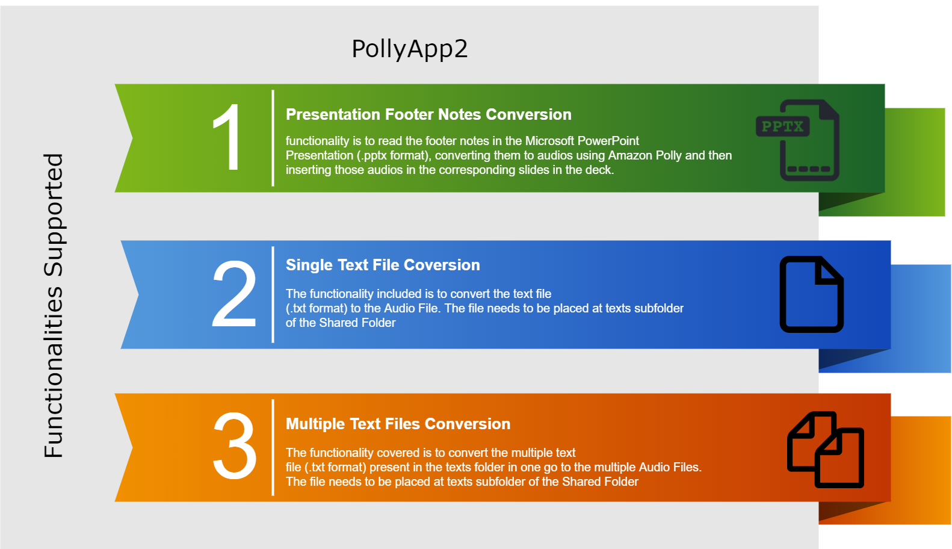

2 Contents
0.1 Abstract 2
1 Contents 3
2 Amazon Web Services(AWS) 4
2.1 Introduction to Amazon Polly 4
2.2 Authentication with Amazon Cognito 4
3 Project File Structure 5
3.1 Shared Folder Structure. 5
3.2 Modules 5
4 Prerequisites to run the Application 6
4.1 Other Standard Libraries 6
4.2 Steps to use Cognito Service 6
5 Project Functionality 8
5.1 Converting the footer notes in pptx and embed as audio file in the slide 8
5.2 Single Text File into Audio File 9
5.3 Converting Multiple Text files into Multiple Audio files 9
6 Project Usage 10
6.1 Input via Command Line Interface(CLI) 10
6.2 Input via Graphical User Interface (GUI) 12
7 Bibliography 14
Contact Persons 14
8 Appendix 15
A.1 Guidelines for writing PPTX notes for Amazon Polly 15

3 Amazon Web Services(AWS)

2.1 Introduction to Amazon Polly
Amazon Polly converts input text into life-like speech. Provide parameters and Amazon Polly then synthesizes the provided text into a high-quality speech audio stream.
The main flow can be described as follows
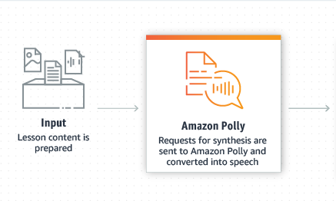

More details about SynthesizeSpeech method
https://docs.aws.amazon.com/polly/latest/dg/API_SynthesizeSpeech.html

2.2 Authentication with Amazon Cognito

Use Amazon Cognito to deliver temporary, limited-privilege credentials to your application, so that your users can access AWS resources.
Amazon identity pool

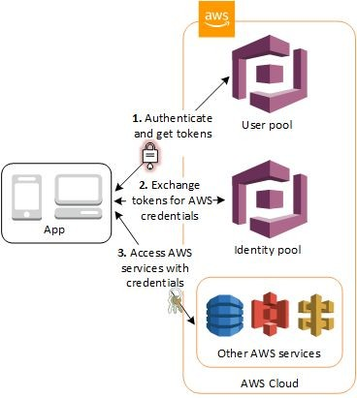

3 Project File Structure

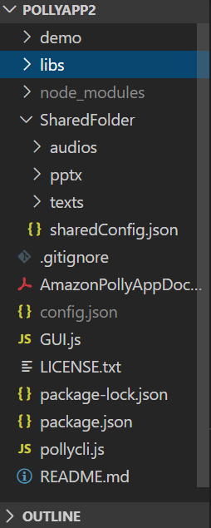
3.1 Shared Folder Structure.
Some of the configuration has to be present in the shared folder for the application to be able to perform properly. This shared folder will be provided by the Professor. The folder includes:

- sharedConfig.json
- Folder that includes the text files (.\PollyApp2\SharedFolder\texts)
- Folder that audio files will be saved to (.\PollyApp2\SsharedFolder\audios)
- Folder which includes the pptx files (.\PollyApp2\SharedFolder\pptx)

sharedConfig.js file will include several configuration parameters:

- aws_pool_id: Identity pool id for the AWS Cognito Service
- text_folder: Name of the text folder
- audio_folder: Name of the audio folder
- default_voice: Default name of the voice id for the speech
- extra_voice_character: Character to be used to identify if there is an extra voice parameter within the text file.

3.2 Modules
To make the project more readable, we exploited the functionality of the “Modules” so that the program has independent, interchangeable modules; each contains all the necessary to execute only one aspect of the desired functionality. A module interface expresses the elements that are provided and required by the module.
Slno | Library Name | Functionality
1 | getNotes.js | The module supports fetching the notes from the xml file contained in the zip folder.
2 | compress.js | The module supports compressing the PPTX into the Zip File.
3 | generateAllAudios.js | The module supports feeding multiple text files to Amazon Polly
4 | getPollyParams.js | This is utility function that generate pollyParams for AWS Polly service call
5 | manageConfig.js | Other relevant configuration calls for the file system
6 | polly.js | The module to instantiate Polly and to feed single text file and to generate audio
7 | processPPTXAudioHelper.js | The module helps perform audio conversion for processPPTXFile
8 | processPPTXFile.js | Perform functions on PPTX like zip conversion, extraction, Fetching Configs, unzipping etc
9 | questions.js | Handles the question asked to user while using GUI interface
10 | readFile.js | Module to read the contents of the file
11 | removeDir.js | Module to remove the directoty
12 | addAudioToFiles.js | Add audio metadata in order to match Polly audios with corresponding slides

4 Prerequisites to run the Application

4.1 Other Standard Libraries
- Inquirer.js
A collection of common interactive command line user interfaces. Inquirer ease the process of asking end user questions , parsing, validating answers, managing hierarchical prompts and providing error feedback. Inquirer provide the user interface , and the inquiry session flow.

- cli_init (CLI handler)
The library is used to build the command line calls for the project.

4.2 Steps to use Cognito Service
- Create a Role from AWS IAM service and assign AWS Polly full access for that specific role.
- Create an Identity Pool from AWS Cognito Service.
- Copy the application to a desired folder.
- Open terminal/cmd in the same folder as the application
- Write npm install, wait for it to finish.
- Write node app.js, application will guide you.
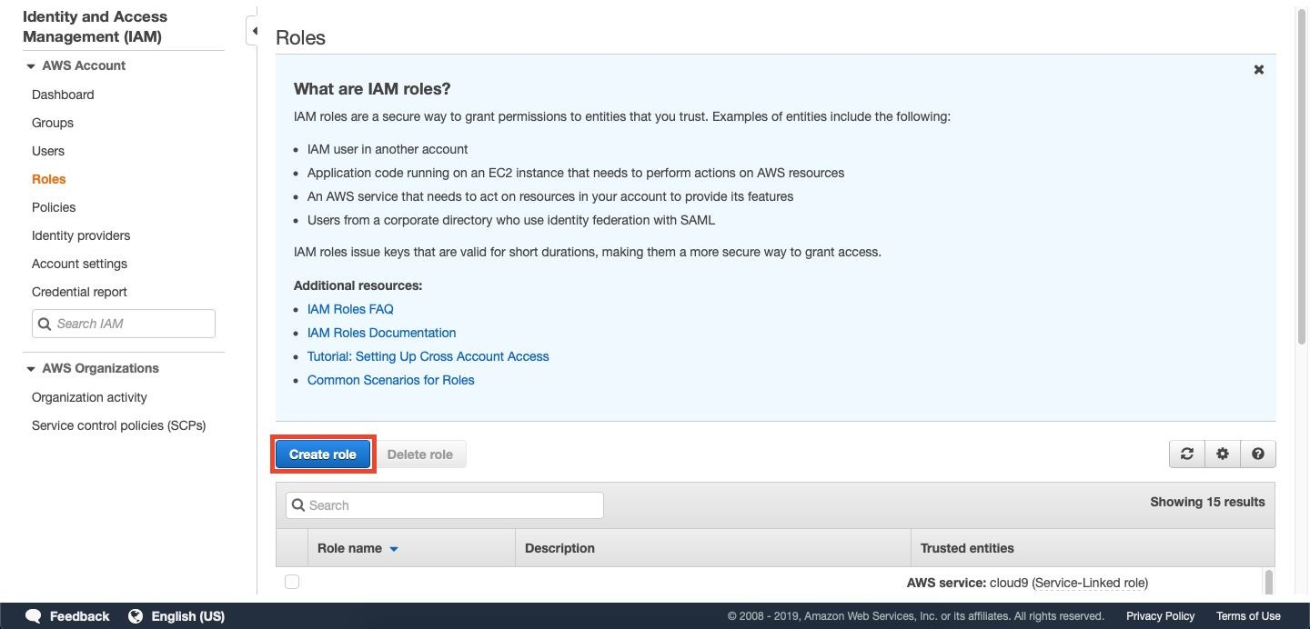
Creating a Role in IAM Service

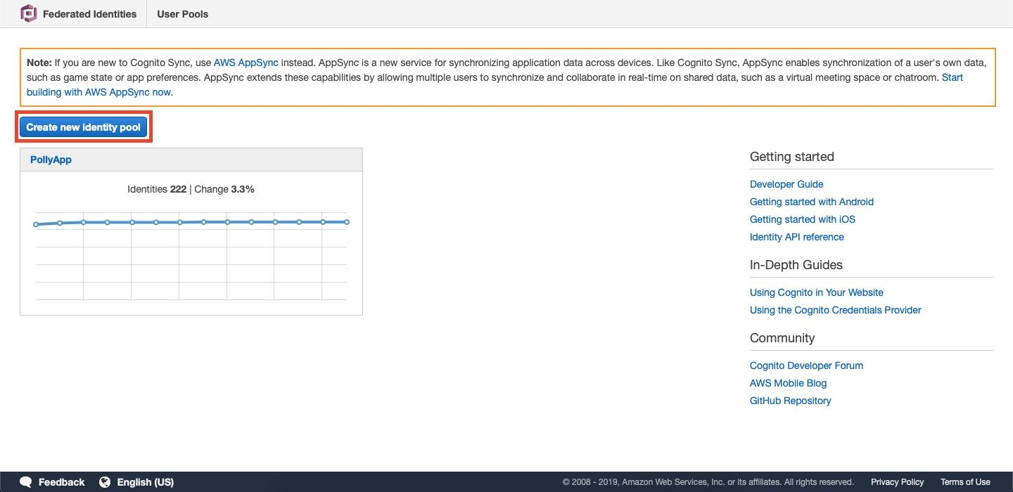
Creating an Identity Pool from Cognito Service

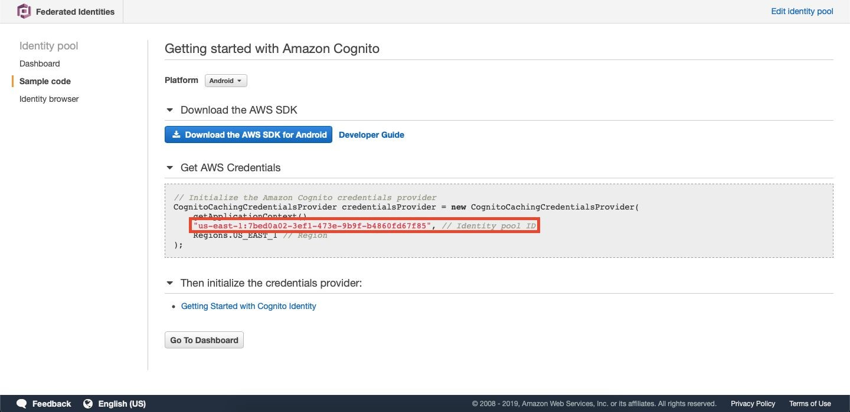
Identity Pool Id Location

5 Project Functionality

The core functionality involves handling three types of transformation scenarios
- Converting the footer notes in the pptx and embed as audio file in the slide
- Converting Multiple Text files into Multiple Audio files
- Single Text File into Audio File

5.1 Converting the footer notes in pptx and embed as audio file in the slide

The functionality is a follows
- First the pptx is converted into the zip folder. This is because zipped format of the pptx converts the PPT into a folder like structure with each slide having its own notation as per the formatting done in the slide.
- The footer notes of the respective slides can be easily fetched considering it to be a file structure using the predefined IO libraries.
- These notes are then fed to AWS Polly.
- The obtained audio files are matched with corresponding slides.
- The zipped format will be unzipped into .pptx structure again
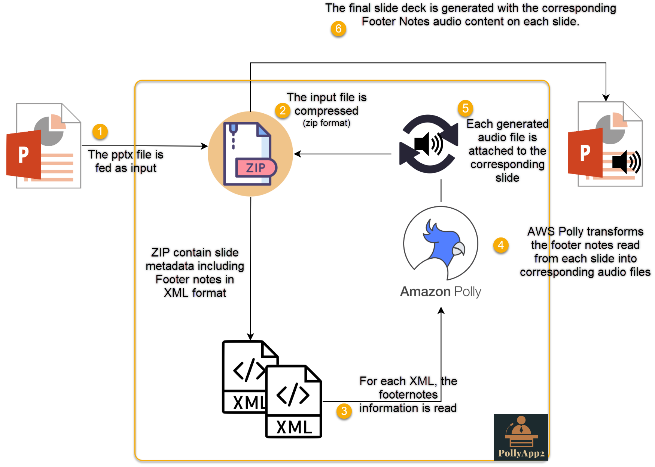

Single Text File into Audio File
The functionality included is to convert the text file (.txt format) to the Audio File. The file needs to be placed at texts subfolder of the Shared Folder (.\PollyApp2\SharedFolder\texts)

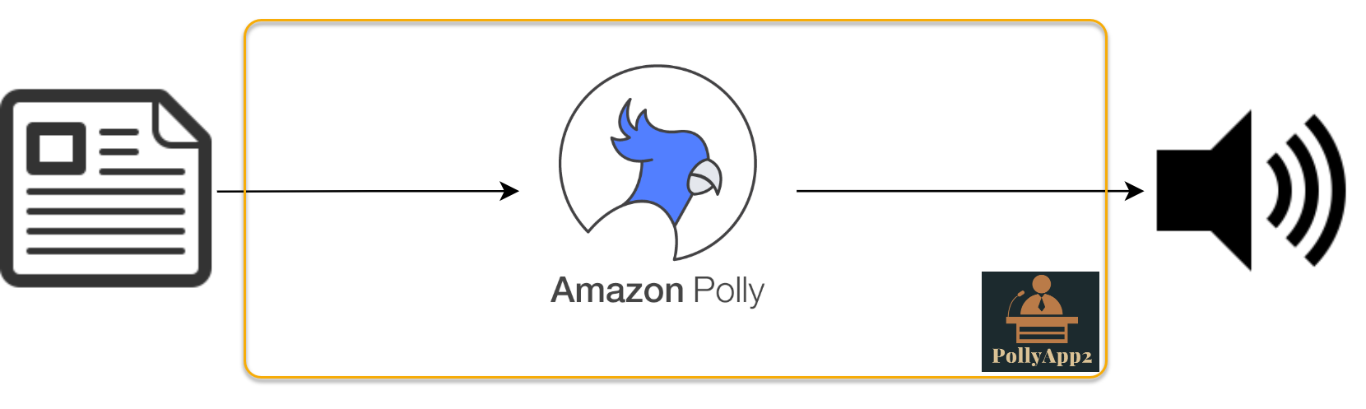

Converting Multiple Text files into Multiple Audio files

The functionality covered is to convert the multiple text file (.txt format) present in the texts folder in one go to the multiple Audio Files. The file needs to be placed at texts subfolder of the Shared Folder (.\PollyApp2\SharedFolder\texts)
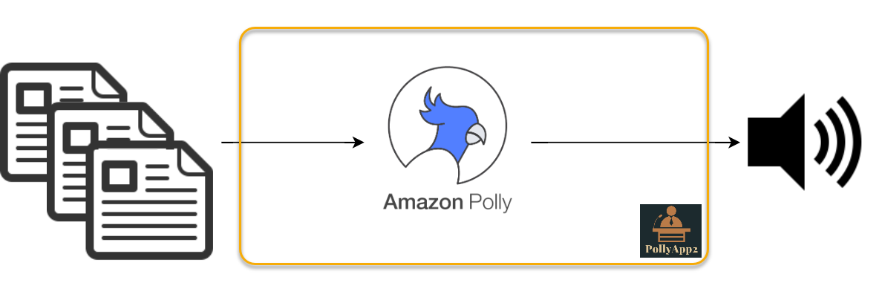

6 Project Usage
The input media can be fed to the PollyApp2 via two methods

- As a Command Line Interface(CLI)
- As a Graphical User Interface (GUI)

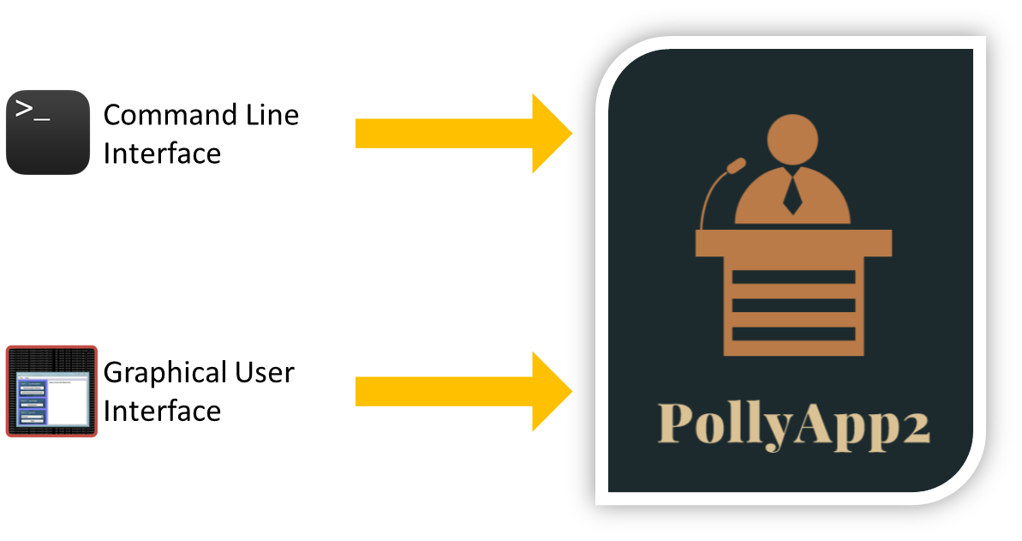

6.1 Input via Command Line Interface(CLI)

The command to access the CLI is
- node pollycli

To access the details about the functionality (HelpDoc), the user can use the command
- node pollycli --help

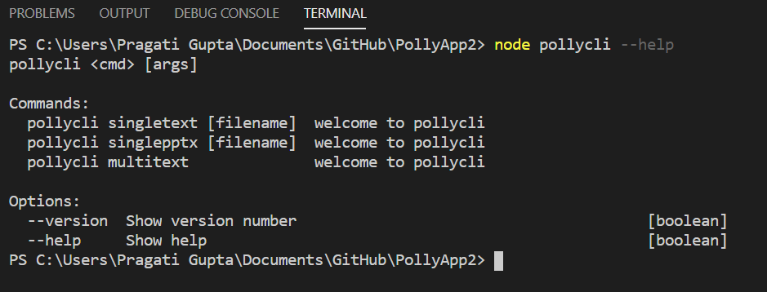

6.1.1 Single Text File Conversion
The first functionality covered in the command is to convert the text file (.txt format) to the Audio File.

The command is

- node pollycli singletext --filename “<<file_name.pptx>>”

The “—filename” is optional for the case the name of the file contains spaces.
The file is fetched from the texts folder and is fed to AWS Polly. The Polly service reads the text and converts it to an audio file. The configurations are being fetched from the sharedConfig.json like the speed, the voice etc. The converted file is stored in the audios folder present in the Shared Folder only.

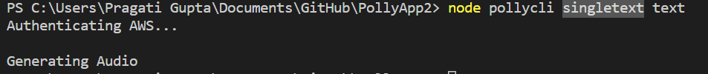

6.1.2 Multiple Text File Conversion

The functionality covered in the command is to convert the multiple text file (.txt format) present in the texts folder in one go to the multiple Audio Files. The file needs to be placed at texts subfolder of the Shared Folder (.\PollyApp2\SharedFolder\texts)

The command is

- node pollycli multitext

The text folder is fetched and then all the audio files are fed to AWS Polly in an iterative way. The Polly service reads the text and converts it to audio files and store them into the location (.\PollyApp2\SharedFolder\audios).
The configurations are again being fetched from the sharedConfig.json.

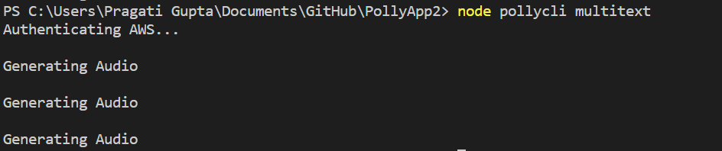

6.1.3 Converting Footer notes into Audios in Presentation

The pptx file is placed int the pptx folder under the SharedFolder. The command used
- node pollycli singlepptx --filename "<<file_name>>"
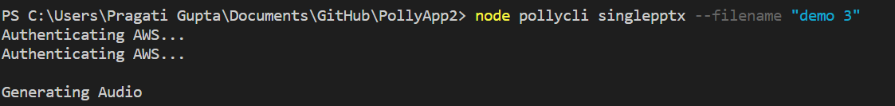

6.2 Input via Graphical User Interface (GUI)

The command to access the CLI is
- node GUI

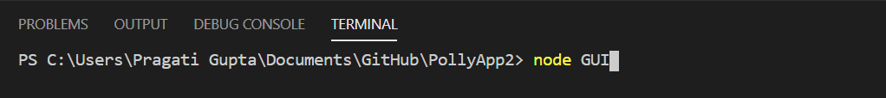
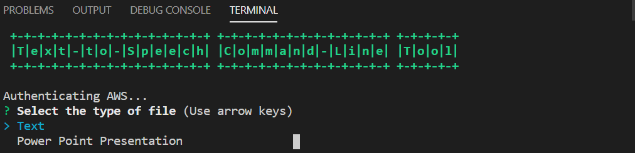

6.2.1 Single Text File Conversion
The first functionality covered in the command is to convert the text file (.txt format) to the Audio File. The file needs to be placed at texts subfolder of the Shared Folder (.\PollyApp2\SharedFolder\texts). The user can mention the name of the file which is there in the SharedFolder. No need to maintain the extension of the file. The system implicitly checks the file format.

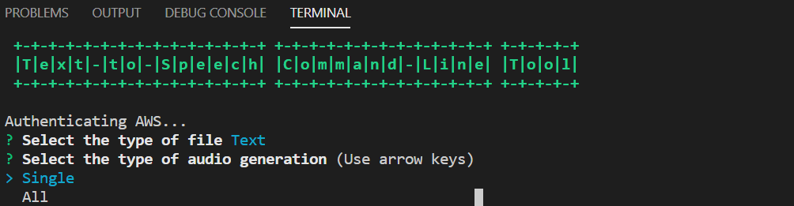
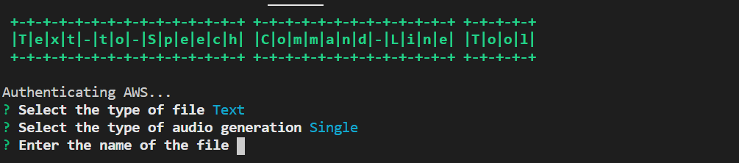

6.2.2 Multiple Text File Conversion

The functionality covered in the command is to convert the multiple text file (.txt format) present in the texts folder in one go to the multiple Audio Files. The file needs to be placed at texts subfolder of the Shared Folder (.\PollyApp2\SharedFolder\texts).
The use can select text and then can select “ALL” option in the menu.
The text folder is fetched and then all the audio files are fed to AWS Polly in an iterative way. The Polly service reads the text and converts it to audio files and store them into the location (.\PollyApp2\SharedFolder\audios).

6.2.3 Converting Footer notes into Audios in Presentation

The pptx file is placed int the pptx folder under the SharedFolder. The use can select the PowerPoint Presentation shown in the menu. It then asks for the name of the PPTX file. The user just need to mention the file name.

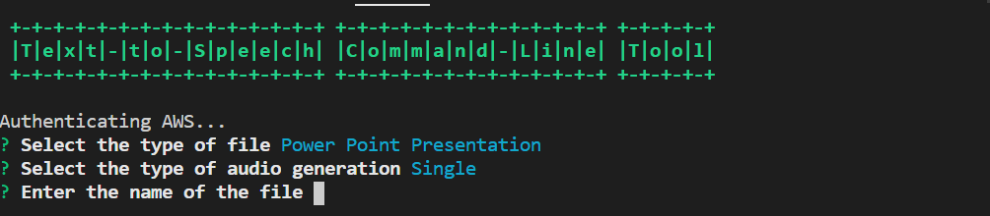

7 Bibliography
Tutorials
- https://medium.com/@anaptfox/getting-started-with-amazon-polly-using-node-js-345e84dbd23d
- https://medium.com/@smcelhinney/building-a-greeting-app-using-amazon-polly-and-nodejs-a605f29c20f5
- https://trevorsullivan.net/2016/12/01/amazon-aws-cloud-polly-nodejs/

Amazon Cognito:
- https://docs.aws.amazon.com/cognito/latest/developerguide/what-is-amazon-cognito.html

Contact Persons
Role | Name | Occupation | E-Mail
Manager | Paolo Cremonesi | Faculty, Polimi | paolo.cremonesi@polimi.it
Coordinator | Riccardo Medana | Faculty, Polimi | riccardo.medana@polimi.it
Coordinator | Federico Schiepatti | Faculty, Polimi | federico.schiepatti@polimi.it
Developer | Pragati Gupta | Student, Polimi | pragatigupta.97@gmail.com
Developer | Mohsin Khan | Student, Polimi | mohsin.j.khan310@gmail.com
Developer | Virgina Negri | Student, Polimi | virginia.negri20@gmail.com
Developer | Loris Rossi | Student, Polimi | loris1.rossi@mail.polimi.it

8 Appendix

A.1 Guidelines for writing PPTX notes for Amazon Polly
These are some tips to write nice pptx notes to be translated into audio with Amazon Polly and to export the PowerPoint presentation correctly to obtain a high quality video.

A.1.1 PPTX notes
- Do not enclose notes in tags, this is automatically done by code. (If you include the tags Polly will launch an exception)
- When writing the value of a tag’s attribute between double quotes (such as <break time=”5ms”/>, be sure to use straight quotes instead of smart quotes (you can set this automatically in PowerPoint by going to Preferences>AutoCorrect>Autoformat as You Type and uncheck “Straight quotes with smart quotes” If Polly eats some words simply rewrite them (rewrite that word, the preceding and following one to be sure)
- If Polly pronounces a . as “dot” rewrite it (as above). It works also to add another dot (“. .”).
- To emphasises words use commas (e.g. “A recommender system , is a system that...”, the comma here is used to emphasize the preceding words “recommender system”)
- An alternative to commas are breaks (<break time=”10ms”/>) with few ms. The two methods are identical
- When doing a new line, always make two new lines, otherwise Polly will read the final . as ‘dot’ before going to the next line
- It is safe to write ‘e.g.’, Polly automatically reads it as ‘For example’
- For a better pause between two sentences, you can end the 1st sentence with two dots like ‘. .’, or use the tag <p></p> (it’s much faster to use two dots). The methods are exactly equivalent
- Put notes in pptx in English (if you see all words underlined), otherwise some words are mispronounced

A.1.2 Working tags
- Supported SSML tags

A.1.2 Exporting video
- Ensure that all transitions have the effect Fade and duration of 1,00 s
  - If a sentence continues in the other slide reduce transition (maybe 0,5)
- Export to high quality

