CHAPTER 9

ARCTIC OCEAN
AND ITS SUB-DIVISIONS

CHARTLET-INDEX

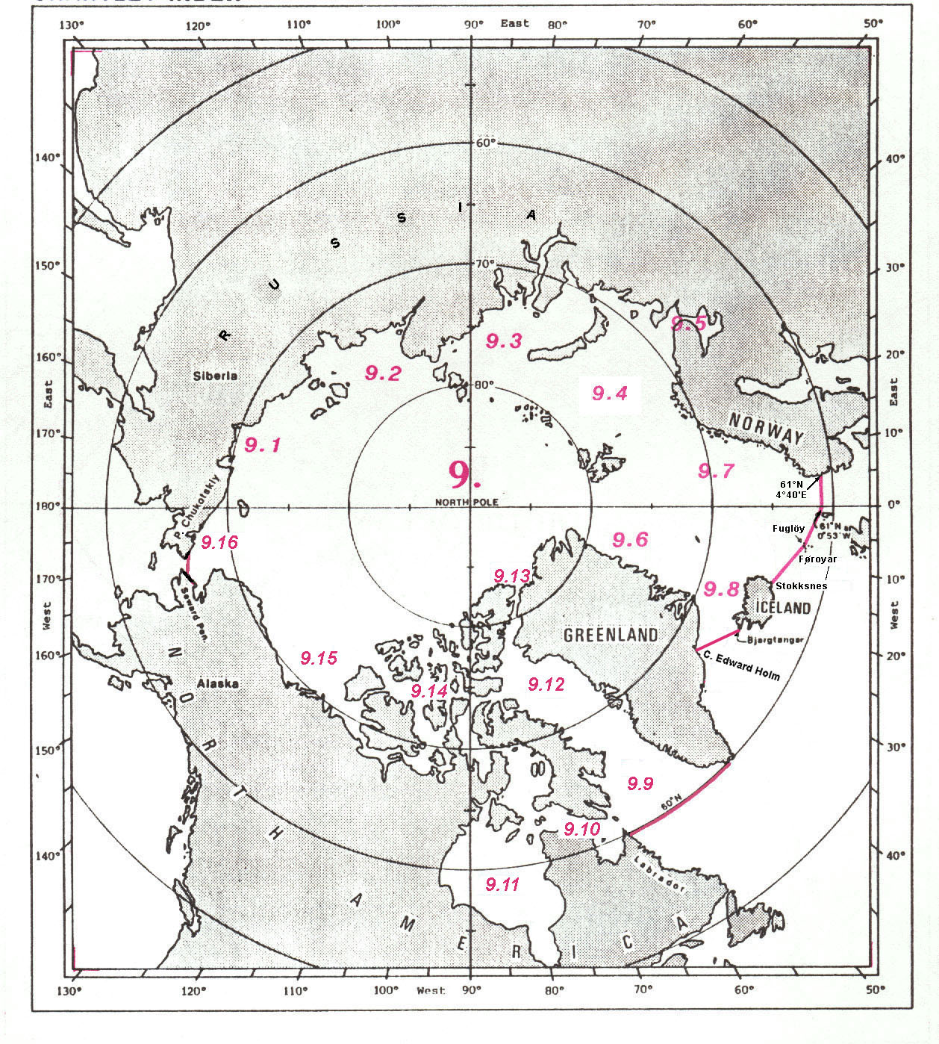
ARCTIC OCEAN

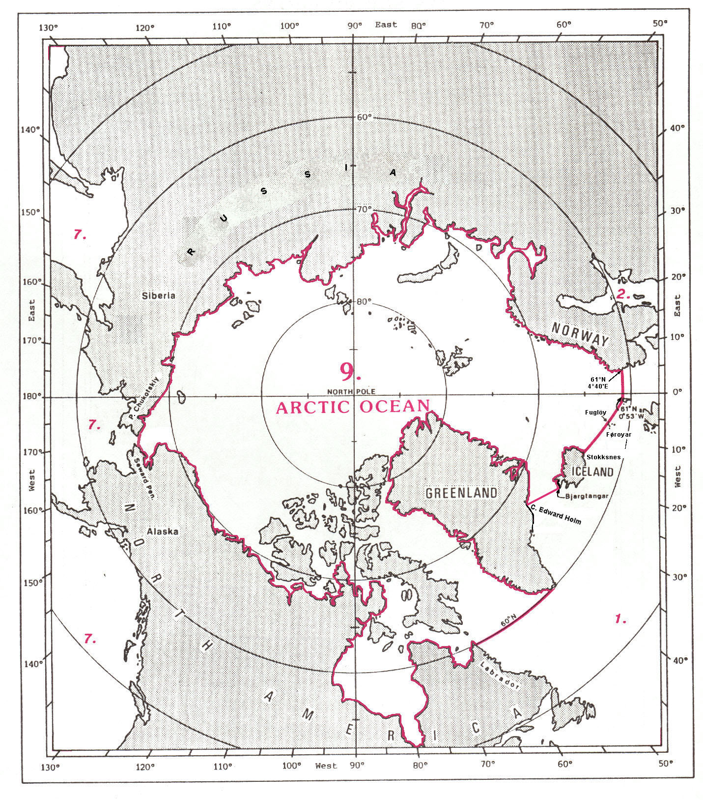
9. ARCTIC OCEAN¹

The Arctic Ocean is situated round the North Pole. Its southern limit is the following:

From the coast of Poluostrov² Chukotskiy at position 66°22'N – 170°35'W, in Siberia, westward, along the coasts of Russia and Norway, to the southwestern coast of Norway, at position 60°51'N - 4°40'E;
thence from position 60°51'N - 4°40'E, on the coast of Norway, westward, along the parallel of 60°51'N, to Muckle Flugga (60°51'N – 0°53'W);
thence from Muckle Flugga northwestward, a line to the northern extremity of Fuglöy (62°21'N – 6°15'W), in the Føroyar3, and to Stokksnes (64°14'N – 14°58'W), on the eastern coast of Iceland;
thence from Stokksnes northwestward, along the eastern and northern coasts of Iceland, to Bjargtangar (65°30'N – 24°32'W), the western extremity of this island;
thence a line joining Bjargtangar westward to Kap⁴ Edward Holm (67°51'N – 32°11'W), an island close off the southeastern coast of Greenland;
thence from Kap Edward Holm southwestward, along the coast of Greenland to its southwestern coast, at position 60°00'- 44°50'W;
thence from this position, on the coast of Greenland, westward, a line along the parallel of 60°N, to the coast of Labrador, Canada, at position 60°00’N - 64°10'W;
(From the southwestern coast of Norway to the coast of Labrador: the common limit with the North Atlantic Ocean, see 1.)
thence from this position, on the coast of Labrador, westward, along the northern mainland coast of North America, to the coast of the Seward Peninsula in Alaska, at position 66°11'N – 164°14'W;
and thence a line joining position 66°11'N – 164°14'W, on the coast of Seward Peninsula, westward, to the coast of Poluostrov Chukotskiy at position 66°22'N – 170°35'W) (the common limit with the North Pacific Ocean, see 7.).
EAST SIBERIAN SEA

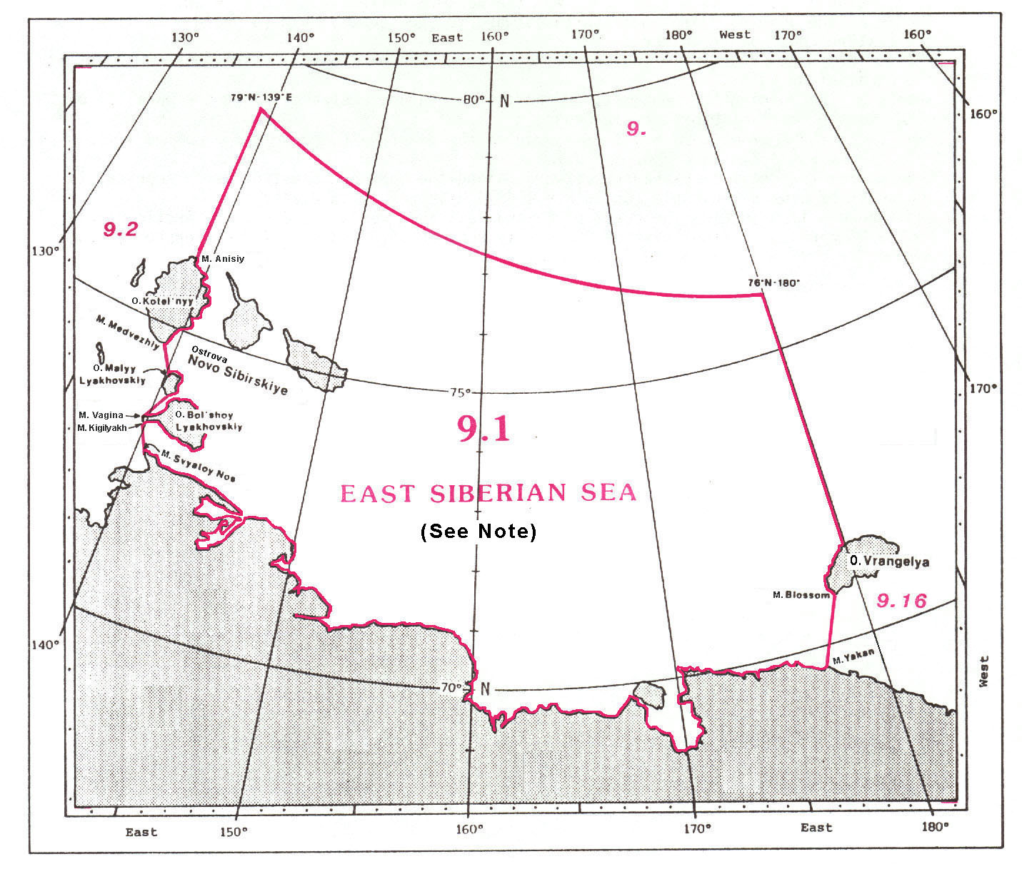

9.1 EAST SIBERIAN SEA

The limits of the East Siberian Sea, situated off the northeastern coast of Russia, between Ostrova¹ Novo Sibirskiye and Ostrov² Vrangelya, are the following:

On the North:
A line joining, on the shelf edge, position 79°00'N – 139°00'E southeastward to position 76°00'N – 180°00'E.

On the East:
A line joining position 76°00'N – 180°00'E southward, along the meridian of 180°, to the northern coast of Ostrov Vrangelya at position 71°32'N – 180°00'E;
thence from position 71°32'N – 180°E southwestward, along the western coast of this island, to Mys³ Blossom (70°47'N – 178°45'E), the southern extremity thereof;
and thence a line joining Mys Blossom southwestward to Mys Yakan (69°35'N - 177°30'E), on the northeastern coast of Russia (the common limit with the Chukchi Sea, see 9.17).

On the South:
From Mys Yakan westward, along the northeastern coast of Russia, to Mys Svyatoy Nos (72°53'N – 140°40'E).

On the West:
A line joining Mys Svyatoy Nos northwestward to Mys Kigilyakh (73°21'N – 139°50'E), the southwestern extremity of Ostrov Bol'shoy Lyakhovskiy;
thence from Mys Kigilyakh northward, along the western coast of this island, to Mys Vagina (73°26'N – 139°50'E), the northwestern extremity thereof;
thence a line joining Mys Vagina northward, through Ostrov Malyy Lyakhovskiy (74°10'N – 140°30"E), to Mys Medveshiy (74°37'N – 139°05'E), the southern extremity of Ostrov Kotel'nyy;
thence from Mys Medvezhiy northward, along the eastern coast of this island, to Mys Anisiy (76°12'N – 139°00'E), the northern extremity thereof;
and thence a line joining Mys Anisiy northward, along the meridian of 139°E, to position 79°00'N - 139°00'E, on the shelf edge (the common limit with the Laptev Sea, see 9.2).

Note: See reservation by the USA in Appendix A.
LAPTEV SEA
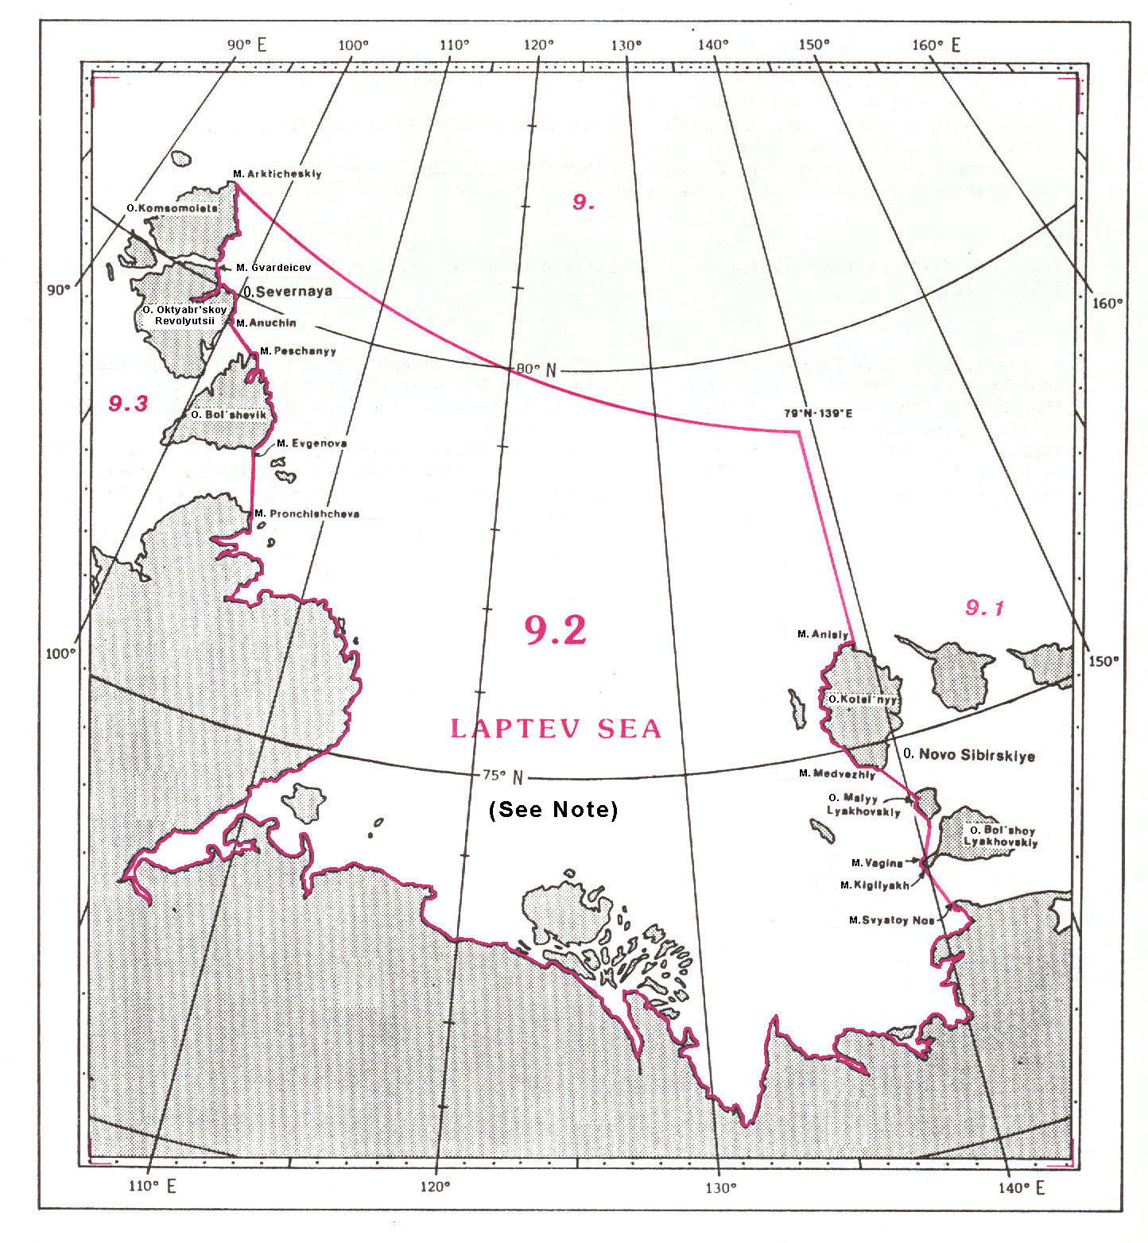
9.2 LAPTEV SEA

The limits of the Laptev Sea, situated off the northern coast of Russia, between Ostrova¹ Severnaya Zemlya Islands and Ostrova Novo Sibirskiye, are the following:

On the North:
A line joining Mys² Arktichesky (81°16'N – 95°45'E), the northern extremity of Ostrov³ Komsomolets, southeastward to position 79°00'N - 139°00'E, on the shelf edge.

On the East:
A line joining position 79°00'N – 139°00'E southward, along the meridian of 139°E, to Mys Anisiy (76°12'N – 139°00'E), the northern extremity of Ostrov Kotel'nyy;
thence from Mys Anisiy southward, along the western coast of this island, to Mys Medvezhiy, the southern extremity thereof;
thence a line joining Mys Medvezhiy southeastward, to the northwestern extremity of Ostrov Malyy Lyakhovskiy (74°10'N – 140°30'E);
thence a line joining this position southward to Mys Vagina (73°26'N – 139°50'E), the northwestern extremity of Poluostrov⁴ Kigilyakh, on Ostrov Bol'shoy Lyakhovskiy;
thence from Mys Vagina southward, along the western coast of this peninsula, to Mys Kigilyakh (73°21'N – 139°50'E), the southwestern extremity thereof;
and thence a line joining Mys Kigilyakh southeastward to Mys Svyatoy Nos (72°53'N – 140°40'E), on the northern coast of Russia (the common limit with the East Siberian Sea, see 9.1).

On the South:
From Mys Svyatoy Nos westward, along the northern coast of Russia, to Mys Pronchishcheva (77°32'N – 105°55'E).

On the West:
A line joining Mys Pronchishcheva northward to Mys Evgenova (78°18'N – 104°50'E), the southeastern extremity of Ostrov Bol'shevik;
thence from Mys Evgenova northwestward, along the eastern coast of this island, to Mys Peschanyy (79°25'N – 102°25'E), the northern extremity thereof;
thence a line joining Mys Peschanyy northwestward to Mys Anuchin (79°40'N – 100°20'E), the eastern extremity of Ostrov Oktyabr'skoy Revolyutsii;
thence from Mys Anuchin northwestward, along the eastern coast of this island, to Mys Gvardeicev (80°10'N – 97°40'E), the northern extremity thereof;
thence a line joining Mys Gvardeicev northwestward to the southeastern extremity of Ostrov Komsomolets (80°13'N – 97°20'E);
and thence from the southeastern extremity of Ostrov Komsomolets northwestward, along the eastern coast of this island, to Mys Arkticheskiy (81°16'N – 95°45'E), the northern extremity thereof (the common limit with the Kara Sea, see 9.3).

Note: See reservation by the USA in Appendix A.
KARA SEA

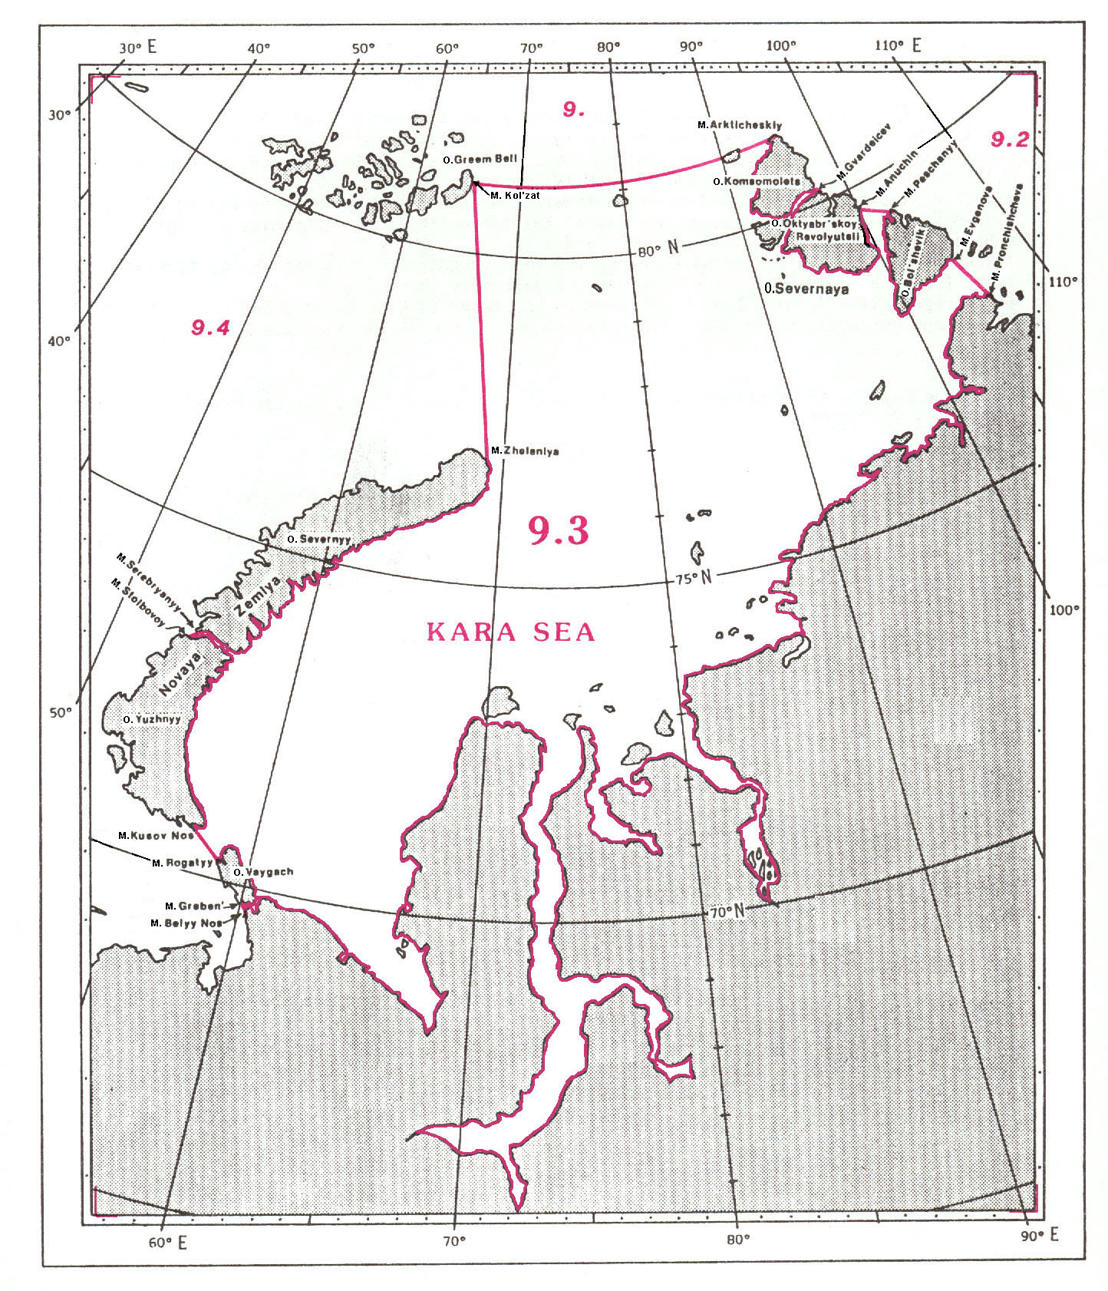
9.3 KARA SEA

The limits of the Kara Sea, situated off the northern coast of Russia, between Ostrova¹ Novaya Zemlya and Ostrova Severnaya, are the following:

On the North:
A line joining Mys² Kol'zat (81°00'N – 65°20'E), on the eastern coast of Ostrov³ Greem Bell, eastward to Mys Arkticheskiy (81°16'N – 95°45'E), the northern extremity of Ostrov Komsomolets.

On the East:
From Mys Arkticheskiy southeastward, along the western coast of Ostrov Komsomolets, to the southeastern extremity of this island (80°13'N – 97°20'E);
thence a line joining the southeastern extremity of Ostrov Komsomolets southeastward to Mys Gvardeicev (80°10'N – 97°40'E), the northern extremity of Ostrov Oktyabr'skoy Revolyutsii;
thence from Mys Gvardeicev southeastward, along the western coast of this island, to Mys Anuchin (79°40'N – 100°20'E), the eastern extremity thereof;
thence a line joining Mys Anuchin southeastward to Mys Peschanyy (79°25'N – 102°25'E), the northern extremity of Ostrov Bol'shevik;
thence from Mys Peschanyy southeastward, along the western coast of this island, to Mys Evgenova (78°18'N – 104°50'E), the southeastern extremity thereof;
and thence a line joining Mys Evgenova southward to Mys Pronchishcheva (77°32'N – 105°55'E) on the northern coast of mainland Russia (the common limit with the Laptev Sea, see 9.2).

On the South:
From Mys Pronchishcheva southwestward, along the northern coast of Russia, to Mys Belyy Nos (69°36'N – 60°12'E).

On the West:
A line joining Mys Belyy Nos northwestward to Mys Greben' (69°40'N – 59°59'E), the southern extremity of Ostrov Vaygach;
thence from Mys Greben' northwestward, along the western coast of this island, to Mys Rogatyy (70°15'N – 58°26'E), the western extremity thereof;
thence a line joining Mys Rogatyy northwestward to Mys Kusov Nos (70°28'N – 57°07'E) the southern extremity of Ostrov Yuzhnyy (Novaya Zemlya);
thence from Mys Kusov Nos northwestward, along the eastern coast of this island, to Mys Stolbovoy (73°17'N – 53°53'E), on the northwestern coast thereof;
thence a line joining Mys Stolbovoy northeastward to Mys Serebryanyy (73°21'N – 54°05'E), the southwestern extremity of Ostrov Severnyy (Novaya Zemlya);
thence from Mys Serebryanyy northeastward, along the eastern coast of this island, to Mys Zhelaniya (76°57'N – 68°35'E), on the northern coast thereof;
and thence a line joining Mys Zhelaniya northward to Mys Kol'zat (81°00'N – 65°20'E), on the eastern coast of Ostrov Greem Bell (the common limit with the Barents Sea, see 9.4)

BARENTS SEA and WHITE SEA

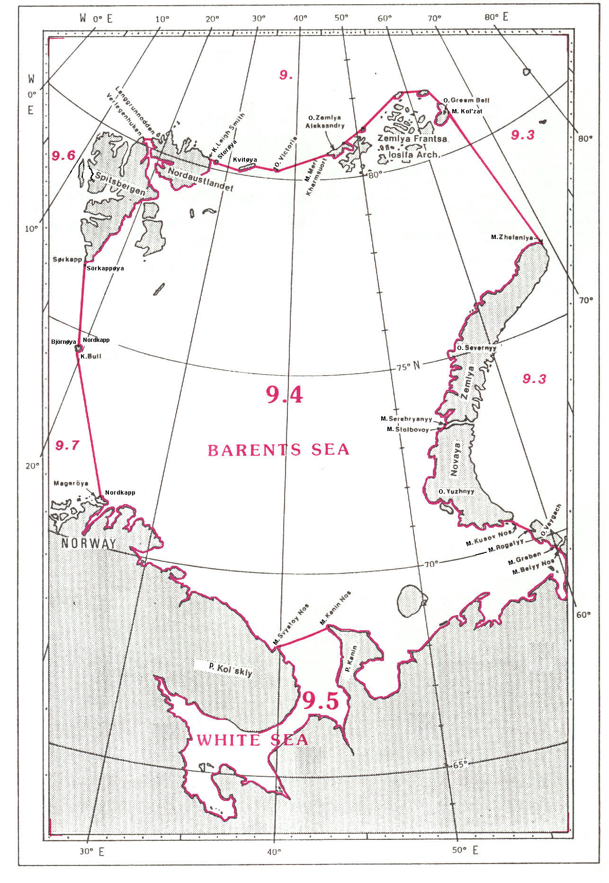

9.4 BARENTS SEA

The Barents Sea, situated off the northeastern coast of Norway and the northwestern coast of Russia, is bounded by Svalbard (Spitsbergen and Nordaustlandet) on the Northwest, by Zemlya Frantsa Iosifa Archipelago on the Northeast, and by Novaya Zemlya on the East. Its limits are the following:

On the North:
A line joining Verlegenhuken (80°04'N – 16°16'E), the northern extremity of Spitsbergen, eastward to Langgrunnodden (80°08'N – 17°46'E), the western extremity of Nordaustlandet;
thence from Langgrunnodden eastward, along the southern coast of Nordaustlendet, to Kapp¹ Leigh Smith (80°10'N – 26°50'E), on the northeastern coast thereof;
thence a line joining Kapp Leigh Smith eastward, through Storøya (80°08'N – 28°00'E), Kvitøya (80°10'N – 32°40'E), and Ostrov² Victoria (80°10'N – 36°45'E), to Mys³ Meri Kharmsuort (80°36'N – 44°55'E), the western extremity of Ostrov Zemlya Aleksandry, the western island of the Zemlya Frantsa Iosifa Archipelago;
and thence from Mys Meri Kharmsuort eastward, along the northern coasts of this archipelago, to Mys Kol'zat (81°00'N – 65°20'E), on the eastern coast of Ostrov Greem Bell.

On the East:
A line joining Mys Kol'zat southward to Mys Zhelaniya (76°57'N – 68°35'E), on the northern coast of Ostrov Severnyy (Novaya Zemlya);
thence from Mys Zhelaniya southwestward, along the western coast of this island, to Mys Serebryanyy (73°21'N – 54°05'E), the southwestern extremity thereof;
thence a line joining Mys Serebryanyy southwestward to Mys Stolbovoy (73°17'N – 53°53'E), on the northwestern coast of Ostrov Yuzhnyy (Novaya Zemlya);
thence from Mys Stolbovoy southward, along the western coast of this island, to Mys Kusov Nos (70°28'N – 57°07'E), the southern extremity thereof;
thence a line joining Mys Kusov Nos southeastward to Mys Rogatyy (70°15'N – 58°26'E), the western extremity of Ostrov Vaygach;
thence from Mys Rogatyy southeastward, along the western coast of this island, to Mys Greben' (69°40'N – 59°59'E), the southern extremity thereof;
and thence a line joining Mys Greben' southeastward to Mys Belyy Nos (69°36'N – 60°12'E), on the northwestern coast of Russia (the common limit with the Kara Sea, see 9.3).

On the South:
From Mys Belyy Nos westward, along the northwestern coast of Russia, to Mys Kanin Nos (68°39'N – 43°18'E), the northwestern extremity of Poluostrov⁴ Kanin;
thence a line joining Mys Kanin Nos southwestward to Mys Svyatoy Nos (68°08'N – 39°46'E), on the northeastern coast of Poluostrov Kol'skiy (the common limit with the White Sea, see 9.5);
and thence from Mys Svyatoy Nos northwestward, along the coasts of Russia and Norway, to Nordkapp (71°10'N – 25°47'E), on the northern coast of Mageröya, off the northern coast of Norway.

On the West:
A line joining Nordkapp, in Norway, northwestward to Kapp Bull (74°21'N – 19°05'E), the southern extremity of Björnøya;
thence from Kapp Bull northward, along the eastern coast of this island, to Nordkapp (74°31'N – 19°07'E), the northern extremity thereof;
thence a line joining Nordkapp, the northern extremity of Björnøya, northwestward to Sørkapp (76°28'N – 16°37'E), the southern extremity of Sörkappøya, off the southern coast of Spitsbergen (Svalbard) (the common limit with the Norwegian Sea, see 9.7);
and thence from Sørkapp northward, along the eastern coast of Spitsbergen, to Verlegenhuken (80°04'N – 16°16'E), the northern extremity of this island.

9.5 WHITE SEA

The White Sea is situated southward and adjacent to the Barents Sea and bounded by the northwestern coast of Russia. Its common limit with the Barents Sea (see 9.4) is the following:

On the North:
A line joining Mys¹ Svyatoy Nos (68°08'N – 39°46'E), on the northeastern coast of Poluostrov² Kol'skiy, northeastward to Mys Kanin Nos (68°39'N – 43°18'E), the northwestern extremity of Poluostrov Kanin.

GREENLAND SEA, NORWEGIAN SEA and ICELAND SEA

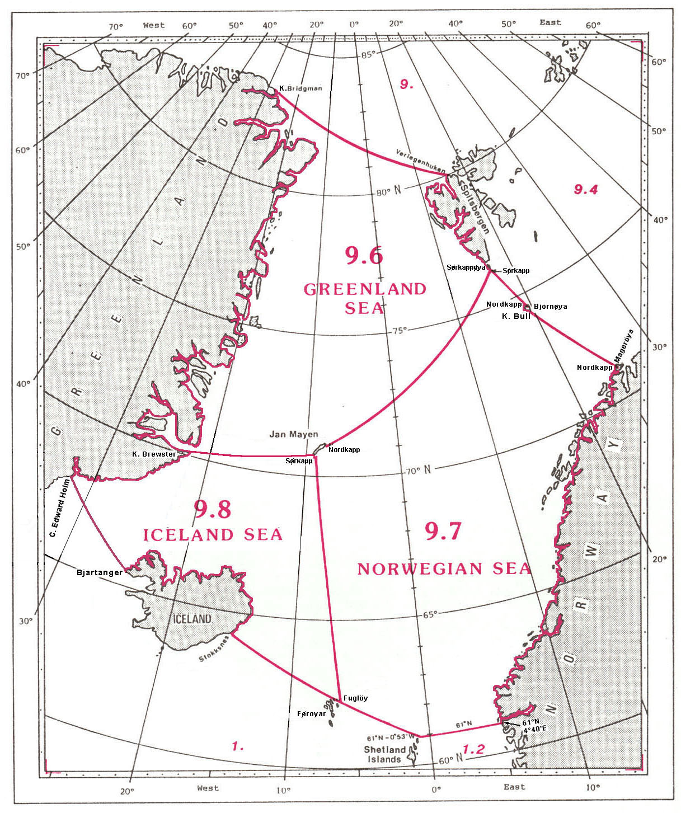

9.6 GREENLAND SEA

The limits of the Greenland Sea, situated off the northeastern coast of Greenland and bounded by the Svalbard on the Northeast, and by Jan Mayen on the South, are the following:

On the North:
A line joining Kap¹ Bridgman (83°23'N – 25°25'W), on the northern coast of Greenland, southeastward to Verlegenhuken (80°04'N – 16°16'E), the northern extremity of Svalbard.

On the East:
From Verlegenhuken southward, along the western coast of Spitsbergen, to Sørkapp (76°28'N – 16°37'E), the southern extremity of Sørkappøya, off the southern coast of Spitsbergen (Svalbard).

On the Southeast:
A line joining Sørkapp, the southern extremity of Sørkappøya, southwestward to Nordkapp (71°10'N – 7°58'W), the northern extremity of Jan Mayen;
and thence from Nordkapp southwestward, along the western coast of this island, to Sørkapp (70°50'N – 9°00'W), the southern extremity thereof (the common limit with the Norwegian Sea, see 9.7).

On the South:
A line joining Sørkapp, the southern extremity of Jan Mayen, westward to Kap Brewster (70°09'N – 22°04'W), on the eastern coast of Greenland. (the common limit with the Iceland Sea, see 9.8).

On the West:
The northeastern coast of Greenland, from Kap Brewster northward to Kap Bridgman (83°24'N – 25°25'W).

9.7 NORWEGIAN SEA

The limits of the Norwegian Sea, situated off the western coast of Norway and bounded by the southern extremity of the Svalbard on the North, by Jan Mayen on the West, and by Fuglöy (in Føroyar²) on the Southwest, are the following:

On the Northwest:
From Sørkapp (70°50'N – 9°00'W), the southern extremity of Jan Mayen, northeastward, along the eastern coast of this island, to Nordkapp (71°10'N – 7°58'W), the northern extremity thereof;
and thence a line joining Nordkapp, the northern extremity of Jan Mayen, northeastward to Sørkapp (76°28'N – 16°37'E), the southern extremity of Sørkappøya, off the southern coast of Spitsbergen (Svalbard) (the common limit with the North Greenland Sea, see 9.6).

On the Northeast:
A line joining Sørkapp, southeastward to Nordkapp (74°31'N – 19°07'E), the northern extremity of Björnøya;
thence from Nordkapp southward, along the western coast of Björnøya, to Kapp³ Bull (74°21'N – 19°05'E), the southern extremity of this island;
and thence a line joining Kapp Bull southeastward to Nordkapp (71°10'N – 25°47'E), on the northern coast of Mageröya, off the northern coast of Norway (the common limit with the Barents Sea, see 9.4).

On the East:
From Nordkapp southwestward, along the western coast of Norway, to position 61°00'N – 4°40'E.
On the South:
A line joining position 61°00N - 4°40'E, on the coast of Norway, westward, along the parallel of 61°N, to position 61°00'N – 0°53'W, on the Hebridean Shelf (the common limit with the North Sea, see 1.2);
and thence a line joining position 61°00'N – 0°53'W northwestward to the northeastern extremity of Fuglöy (62°21'N – 6°15'W), in Føroyar¹ (the common limit with the North Atlantic Ocean, see 1.).

On the West:
A line joining the northeastern extremity of Fuglöy northward to Sørkapp (70°50'N – 9°00'W), the southern extremity of Jan Mayen (the common limit with the Iceland Sea, see 9.8).

9.8 ICELAND SEA

The Iceland Sea is limited by the Greenland Sea to the north, the Norwegian Sea to the east, the Atlantic Ocean to the west and the coast of northern and eastern Iceland and further east by the Atlantic Ocean. Its limits are the following:

On the North:
A line joining Kap² Brewster (70°09'N – 22°04'W), on the eastern coast of Greenland, in an easterly direction to Sørkapp (70°50'N - 9°00'W), the southern extremity of Jan Mayen.

On the East:
A line joining Sørkapp, on Jan Mayen, southward to the northeastern extremity of Fuglöy (62°21'N – 6°15'W), in Føroyar

On the South:
A line joining the northeastern extremity of Fuglöy northwestward to Stokksnes (64°14'N – 14°58'W), on the eastern coast of Iceland (the common limit of the North Atlantic, see 1.)

On the West:
From Stokksnes, following the east and north east coasts of Iceland, to Bjartangar (65°30'N – 24°32'W), the western extremity of Iceland;
thence a line joining Bjartangar, in a northwesterly direction, to Kap Edward Holm (67°51'N – 32°11'W), on the southeastern coast of Greenland;
and thence from Kap Edward Holm, in a northeasterly direction, following the eastern coast of Greenland, to Kap Brewster (70°09'N – 22°04'W), the point of commencement.

DAVIS STRAIT

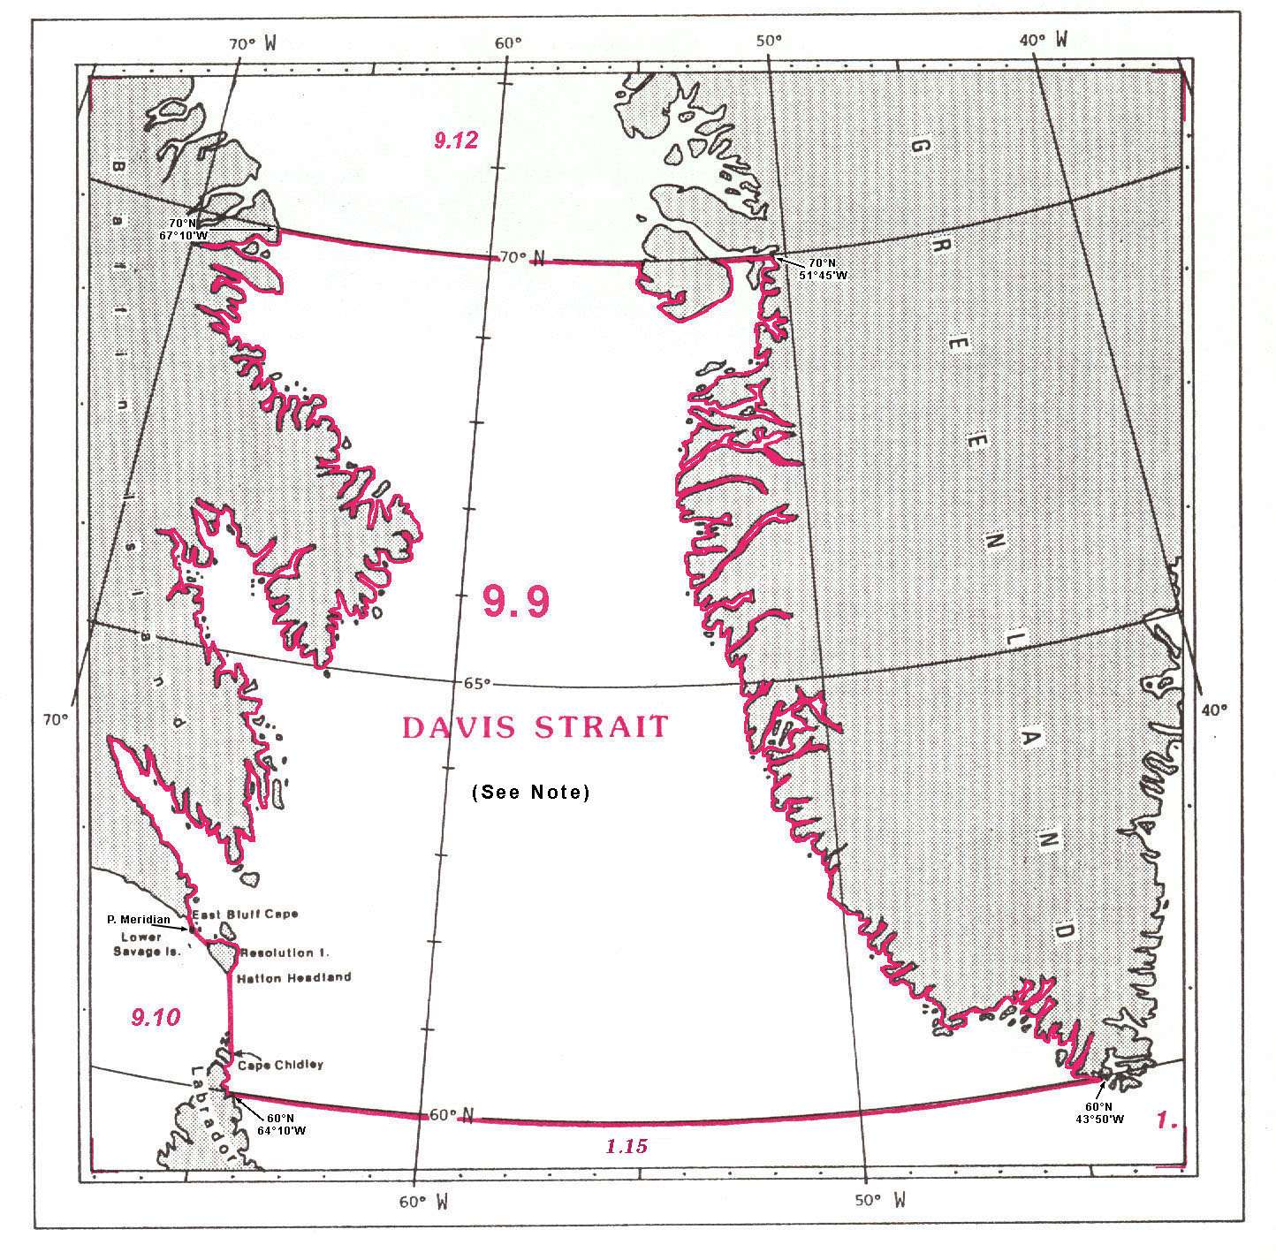
9.9 DAVIS STRAIT

The limits of the Davis Strait, situated between Baffin Island and Greenland, are the following:

On the North:
A line joining position 70°00'N - 67°10'W, on the eastern coast of Baffin Island, eastward, along the parallel of 70°N, to the western coast of Greenland at position 70°00'N – 51°45'W (the common limit with the Baffin Bay, see 9.12).

On the East:
The western coast of Greenland, from position 70°00'N - 51°45'W southward to position 60°00'N - 44°50'W.

On the South:
A line joining position 60°00'N - 44°50'W, on the southern coast of Greenland, westward, along the parallel of 60°N, to the northern coast of Labrador, in Canada, at position 60°00'N - 64°10'W (the common limit with the Labrador Sea, see 1.14).

On the West:
The northeastern coast of Labrador, from position 60°00'N - 64°10'W, northward to Cape Chidley (60°24'N – 64°26'W);
thence a line joining Cape Chidley northward to Hatton Headland (61°19'N – 64°47'W), the southeastern extremity of Resolution Island;
thence from Hatton Headland northwestward, along the western coast of this island, to the western extremity thereof (61°38'N – 65°29'W);
thence a line joining the western extremity of Resolution Island northwestward to the southeastern extremity of Lower Savage Islands (61°45'N – 65°40'W);
thence from the southeastern extremity of Lower Savage Islands northwestward, through these islands, to Point Meridian (61°47'N – 65°57'W), the western extremity thereof;
thence a line joining Point Meridian northerly to East Bluff Cape (61°53'N – 65°58'W), the southeastern extremity of Baffin Island (the common limit with the Hudson Strait, see 9.10);
and thence from East Bluff Cap northward, along the eastern coast of Baffin Island, to position 70°00'N - 67°10'W.

Note: See reservation by Russian Federation in Appendix A.

HUDSON STRAIT and HUDSON BAY

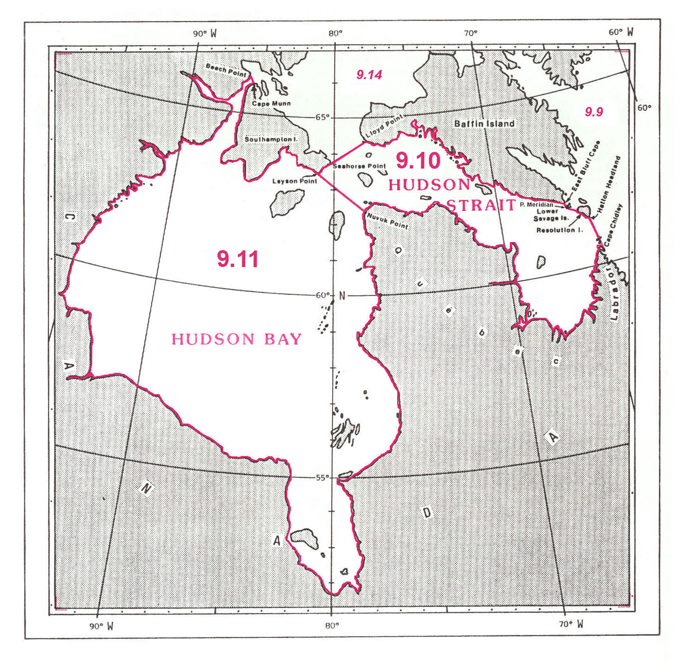
9.10 HUDSON STRAIT

The limits of Hudson Strait, situated between the northern coast of Quebec and the southern coast of Baffin Island, and linking Hudson Bay with Davis Strait, are the following:

On the North:
The southern coast of Baffin Island, from Lloyd Point (64°26'N – 78°02'W) southeastward to East Bluff Cape (61°53'N – 65°58'W), the southeastern extremity of this island.

On the East:
A line joining East Bluff Cape southeastward to Point Meridian (61°47'N – 65°57'W), the western extremity of Lower Savage Islands;
thence from Point Meridian southeastward, along the western coast of these islands, to the southeastern extremity thereof (61°45'N – 65°40'W);
thence a line joining the southeastern extremity of Lower Savage Islands southeastward to the western extremity of Resolution Island (61°38'N – 65°29'W);
thence from the western extremity of Resolution Island, along the western coast of this island, to Hatton Headland (61°19'N – 64°47'W), the southeastern extremity thereof;
and thence a line joining Hatton Headland southward to Cape Chidley (60°24'N – 64°26'W), on the northern coast of Labrador (the common limit with the Davis Strait, see 9.9).

On the South:
The northern coasts of Labrador and Quebec, from Cape Chidley, in Labrador, westward to Nuvuk Point (62°22'N – 78°06'W), the northwestern extremity of Quebec.

On the West:
A line joining Nuvuk Point northwestward to Leyson Point (63°27'N – 80°59'W), the southeastern extremity of Southampton Island (the common limit with Hudson Bay, see 9.11);
thence from Leyson Point northeastward, along the southeastern coast of this island, to Seahorse Point (63°47'N – 80°09'W), the eastern extremity thereof;
and thence a line joining Seahorse Point northeastward to Lloyd Point (64°26'N – 78°02'W), on the southwestern coast of Baffin Island (the common limit with the Northwestern Passages, see 9.14).

9.11 HUDSON BAY

Hudson Bay is a large enclosed sea situated off the northeastern part of the North American continent and bounded on the East, the South and the West by the northern coast of Canada. It is connected on the North with the Northwestern Passages and the Hudson Strait; this northern limit is the following:

On the North:
A line joining Beach Point (66°12'N – 85°52'W), on the coast of Canada, southeastward to Cape Munn (65°55'N – 85°32'W), the northern extremity of Southampton Island (the common limit with the Northwestern Passages, see 9.14);
thence from Cape Munn southward and eastward, along the western and southern coasts of Southampton Island, to Leyson Point (63°27'N – 80°59'W), the southeastern extremity of this island;
and thence a line joining Leyson Point southeastward to Nuvuk Point (62°22'N – 78°06'W), the northwestern extremity of Quebec, in Canada (the common limit with the Hudson Strait, see 9.10).
BAFFIN BAY and LINCOLN SEA

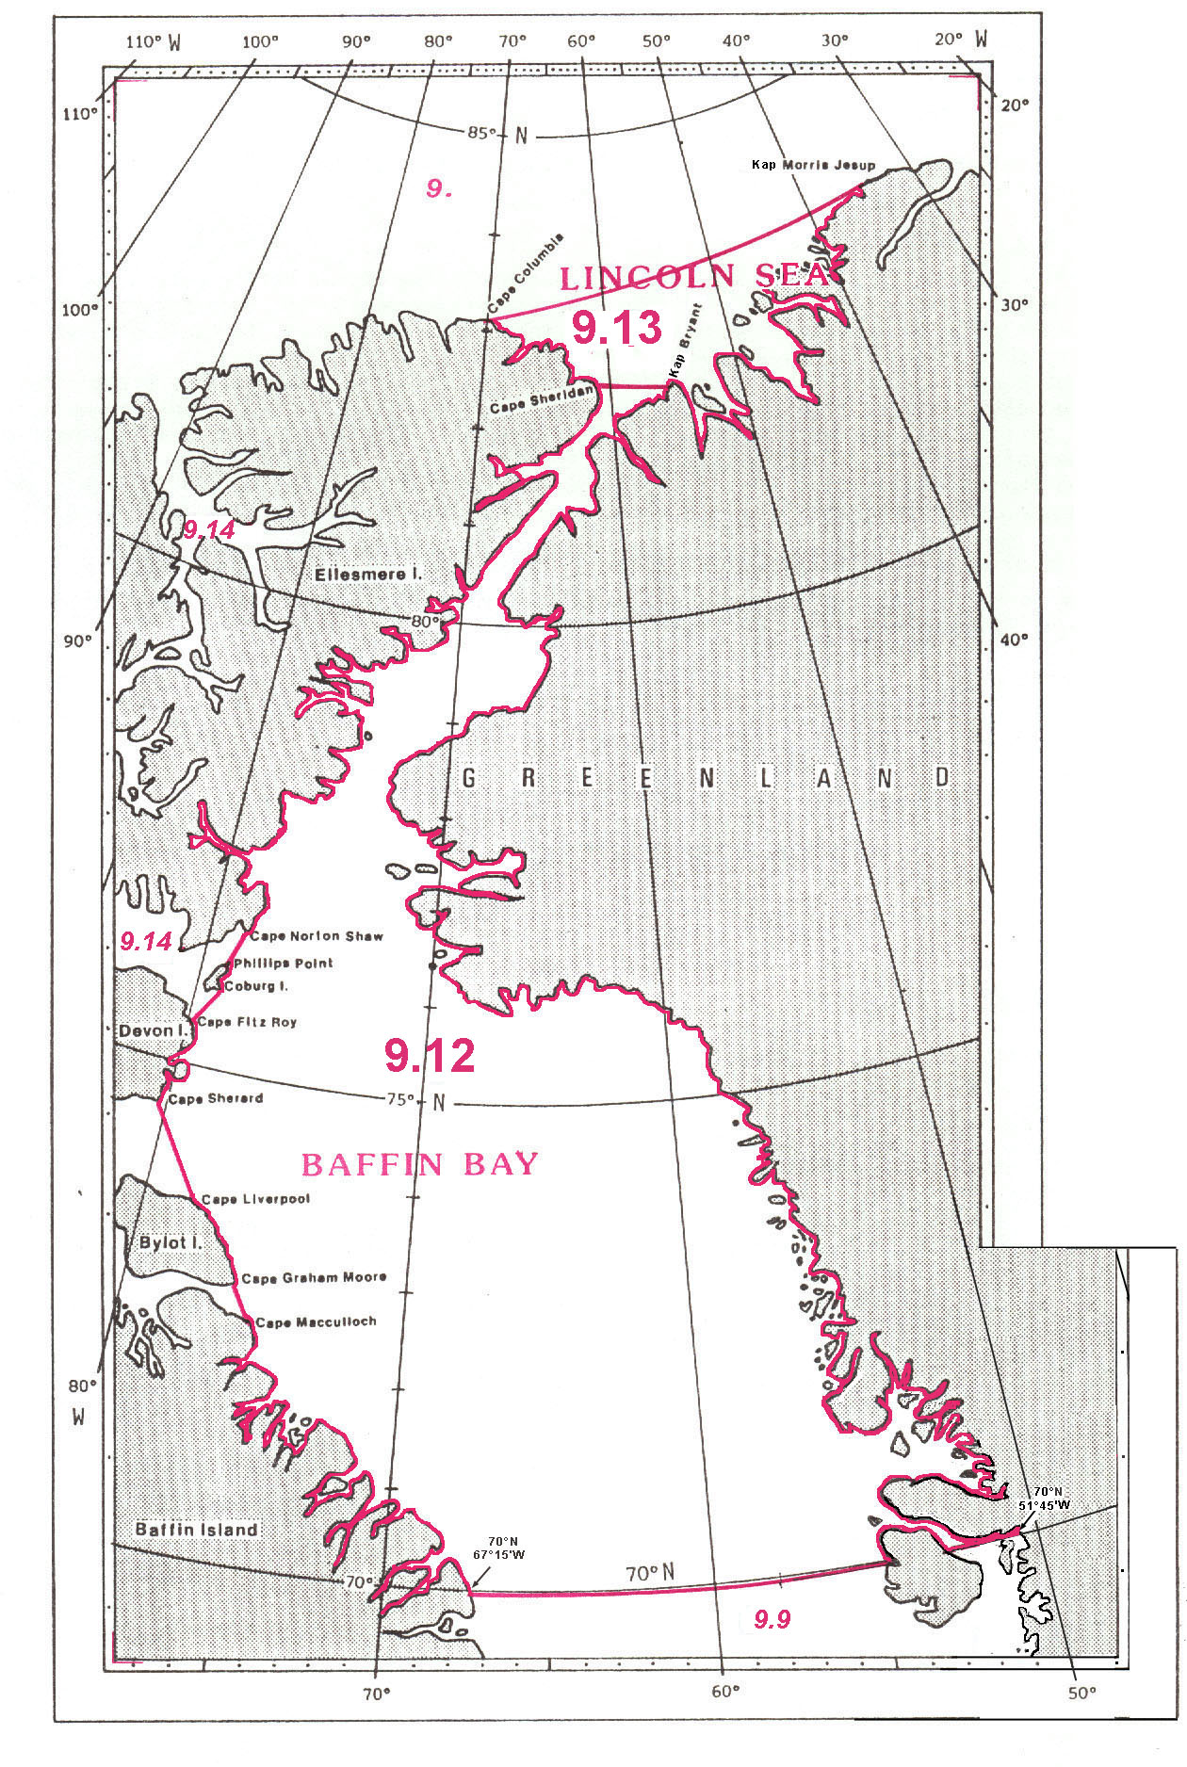
9.12 BAFFIN BAY¹

The limits of Baffin Bay, situated between the eastern coast of Ellesmere, Devon, Bylot and Baffin Islands on the West, and the western and northwestern coasts of Greenland on the East, are the following:

On the North:
A line joining Cape Sheridan (82°28'N – 61°31'W), on the northeastern coast of Ellesmere Island, eastward to Kap² Bryant (82°21'N – 55°10'W), on the northwestern coast of Greenland (the common limit with the Lincoln Sea, see 9.13).

On the East:
From Kap Bryant southward, along the western coast of Greenland, to position 70°00'N - 51°45'W.

On the South:
A line joining position 70°00'N - 51°45'W, on the western coast of Greenland, westward, along the parallel of 70°N, to the eastern coast of Baffin Island at position 70°00'N - 67°15'W (the common limit with the Davis Strait, see 9.9).

On the West:
The northeastern coast of Baffin Island, from position 70°00'N - 67°15'W northwestward to Cape Macculloch (72°30'N – 75°10'W);
thence a line joining Cape Macculloch northwestward to Cape Graham Moore (75°52'N – 76°04'W), the southeastern extremity of Bylot Island;
thence from Cape Graham Moore northwestward, along the eastern coast of this island, to Cape Liverpool (73°40'N – 78°05'W), the northeastern extremity thereof;
thence a line joining Cape Liverpool northwestward to Cape Sherard (74°36'N – 80°14'W), the southeastern extremity of Devon Island;
thence from Cape Sherard northward, along the eastern coast of this island, to Cape Fitz Roy (75°36'N – 80°07'W), on the northeastern coast thereof;
thence a line joining Cape Fitz Roy northeastward to the southeastern extremity of Coburg Island (75°51'N – 78°55'W);
thence from the southeastern extremity of Coburg Island northward, along the eastern coast of this island, to Phillips Point (76°06'N – 79°04'W), the northern extremity thereof;
thence a line joining Phillips Point northward to Cape Norton Shaw (76°24'N – 78°36'W), on the southeastern coast of Ellesmere Island (the common limit with the Northwestern Passages, see 9.14);
and thence from Cape Norton Shaw northeastward, along the eastern coast of Ellesmere Island, to Cape Sheridan (82°28'N – 61°31'W), on the northeastern coast of this island.

9.13 LINCOLN SEA

The limits of the Lincoln Sea, situated between the northern coasts of Ellesmere Island and Greenland, are the following:

On the North:
A line joining Cape Columbia (83°09'N – 71°15'W), the northern extremity of Ellesmere Island, eastward to Kap Morris Jesup (83°38'N – 33°56'W), the northern extremity of Greenland.

On the East:
From Kap Morris Jesup southwestward, along the northern coast of Greenland, to Kap Bryant (82°21'N – 55°13'W).

On the South:
A line joining Kap Bryant westward to Cape Sheridan (82°28'N – 61°31'W), on the northeastern coast of Ellesmere Island (the common limit with the Baffin Bay, see 9.12).

On the West:
From Cape Sheridan northwestward, along the northern coast of Ellesmere Island, to Cape Columbia (83°09'N – 71°15'W), the northern extremity of this island.
NORTHWESTERN PASSAGES

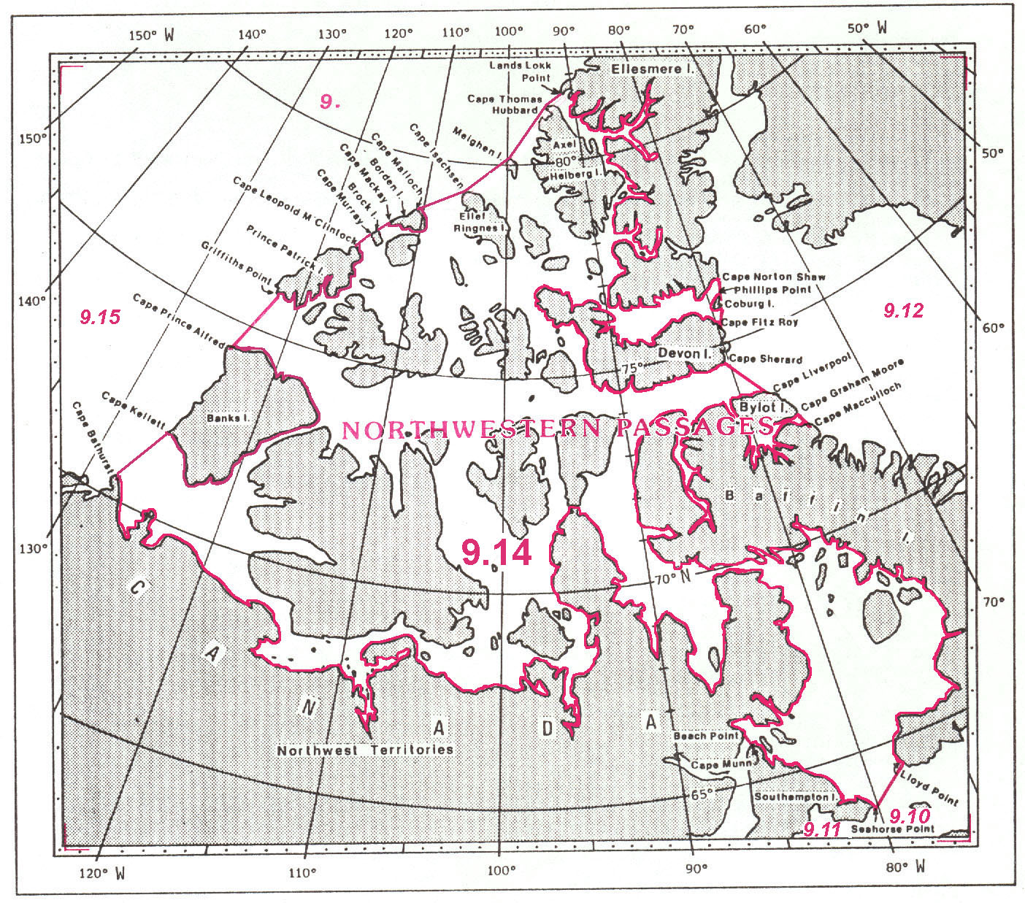

9.14 NORTHWESTERN PASSAGES

The limits of the Northwestern Passages, situated between the northern coast of Canada and the off-lying of the Northwest Territories of Canada, are the following:

On the North:
From Griffiths Point (76°06'N – 123°01'W), the western extremity of Prince Patrick Island, northeastward, along the northern coast of this island, to Cape Leopold M'Clintock (77°34'N – 116°24'W), the northern extremity thereof;
thence a line joining Cape Leopold M'Clintock northeastward to Cape Murray (77°58'N – 115°05'W), the western extremity of Brock Island;
thence from Cape Murray northeastward, along the northern coast of this island, to the northern extremity thereof (78°05'N – 114°20'W);
thence a line joining the northern extremity of Brock Island northeastward to Cape Mackay (78°21'N – 113°18'W), the western extremity of Borden Island;
thence from Cape Mackay northeastward, along the northern coast of this island, to Cape Malloch (78°46'N – 110°43'W), the northern extremity thereof;
thence a line joining Cape Malloch northeastward to Cape Isachsen (79°20'N – 105°26'W), the northwestern extremity of Ellef Ringnes Island;
thence a line joining Cape Isachsen northeastward to the northwestern extremity of Meighen Island (80°09'N – 99°46'W);
thence a line joining the northwestern extremity of Meighen Island northeastward to Cape Thomas Hubbard (81°22'N – 94°07'W), the northwestern extremity of Axel Heiberg Island;
and thence a line joining the northwestern extremity of Axel Heiberg Island northeastward to Lands Lokk Point (81°37'N – 91°54'W), the northwestern extremity of Ellesmere Island.

On the East:
From Lands Lokk Point southeastward, along the western and southern coasts of Ellesmere Island, to Cape Norton Shaw (76°24'N – 78°36'W), on the southeastern coast of this island;
thence a line joining Cape Norton Shaw southward to Phillips Point (76°06'N – 79°04'W), the northeastern extremity of Coburg Island;
thence from Phillips Point southward, along the western coast of this island, to the southeastern extremity thereof (75°51'N – 78°55'W);
thence a line joining the southeastern extremity of Coburg Island southwestward to Cape Fitz Roy (75°36'N – 80°07'W), on the northeastern coast of Devon Island;
thence from Cape Fitz Roy southward, along the eastern coast of Devon Island, to Cape Sherard (74°36'N – 80°14'W), the southeastern extremity of this island;
thence a line joining Cape Sherard southeastward to Cape Liverpool (73°40'N – 78°05'W), the northeastern extremity of Bylot Island;
thence from Cape Liverpool southeastward, along the eastern coast of Bylot Island, to Cape Graham Moore (72°52'N – 76°04'W), the southeastern extremity of this island;
thence a line joining Cape Graham Moore southeastward to Cape Macculloch (72°30'N – 75°10'W), on the northeastern coast of Baffin Island (the common limit with the Baffin Bay, see 9.12);
and thence from Cape Macculloch westward and southward, along the northern and eastern coast of Baffin Island, to Lloyd Point (64°26'N – 78°02'W), on the southwestern coast of this island.

On the South:
A line joining Lloyd Point southwestward to Seahorse Point (63°47'N – 80°09'W), the eastern extremity of Southampton Island (the common limit with the Hudson Strait, see 9.10);
thence from Seahorse northwestward, along the northern coast of Southampton Island, to Cape Munn (65°55'N – 85°32'W), the northern extremity of this island;
thence a line joining Cape Munn northwestward to Beach Point (66°12'N – 85°52'W), on the coast of Canada (the common limit with the Hudson Bay, see 9.11);
and thence from Beach Point westward, along the northern coast of Canada, to Cape Bathurst (70°35'N – 128°02'W).

On the West:
A line joining Cape Bathurst northeastward to Cape Kellett (71°58'N – 126°01'W), the western extremity of Banks Island;
thence from Cape Kellett northward, along the western coast of this island, to Cape Prince Alfred (74°21'N – 124°46'W), the northwestern extremity thereof;
and thence a line joining Cape Prince Alfred northward to Griffiths Point (76°06'N – 123°01'W), the western extremity of Prince Patrick Island (the common limit with the Beaufort Sea, see 9.15).

BEAUFORT SEA and CHUKCHI SEA

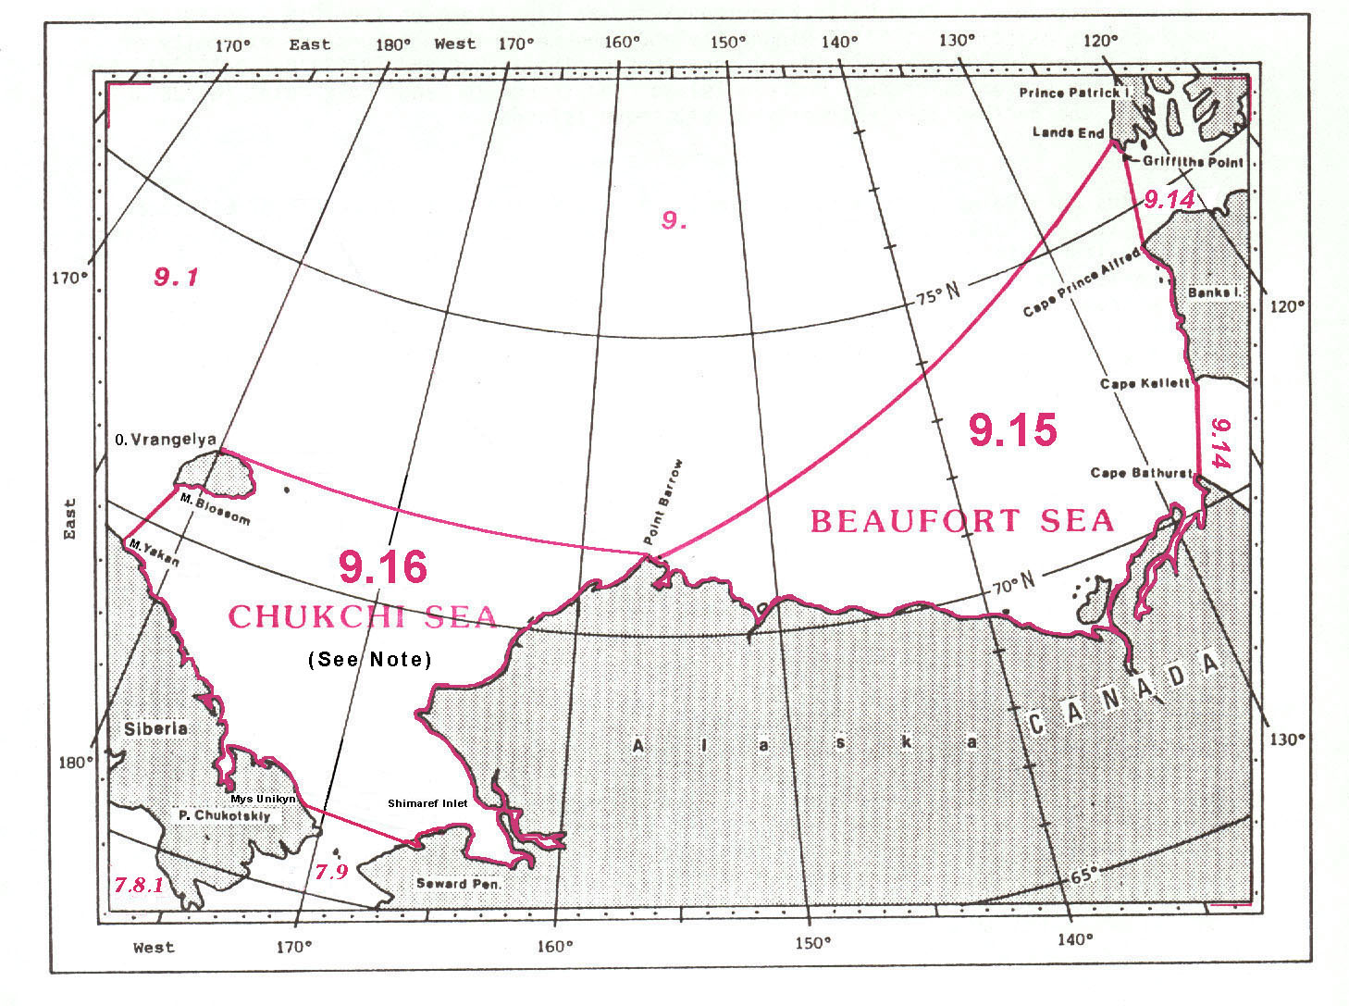
9.15 BEAUFORT SEA

The limits of the Beaufort Sea, situated off the northern coasts of Alaska and Canada, and bounded on the East by Prince Patrick and Banks Islands, are the following:

On the Northwest:
A line joining Point Barrow (71°24'N – 156°28'W), the northern extremity of Alaska, northeastward to Lands End (76°20'N – 122°35'W), on the northwestern coast of Prince Patrick Island.

On the East:
From Lands End southward, along the western coast of Prince Patrick Island, to Griffiths Point (76°06'N – 123°01'W), the western extremity of this island;
thence a line joining Griffiths Point southward to Cape Prince Alfred (74°21'N – 124°46'W), the northwestern extremity of Banks Island;
thence from Cape Prince Alfred southward, along the western coast of this island, to Cape Kellett (71°58'N – 126°01'W), the western extremity thereof;
and thence a line joining Cape Kellett southwestward to Cape Bathurst (70°35'N – 128°02'W), on the northern coast of Canada (the common limit with the Northwestern Passages, see 9.14).

On the South:
From Cape Bathurst westward, along the northern coasts of Canada and the USA, to Point Barrow (71°24'N – 156°28'W), the northern extremity of Alaska.

9.16 CHUKCHI SEA

The limits of the Chukchi Sea, situated between the northeastern coast of Siberia and the northwestern coast of Alaska, are the following:

On the North:
A line joining the north point of Ostrov¹ Vrangelya (71°32'N – 180°00'W), eastward to Point Barrow (71°24'N – 156°28'W), the northern extremity of Alaska.

On the East:
From Point Barrow southwestward, along the northwestern coast of Alaska, to position (66°11'N – 164°14'W), on the northern coast of Seward Peninsula.

On the South:
From the coast of Seward Peninsula, in Alaska, at the southern entrance to Shimaref Inlet (66°11'W – 166°14'W), to Mys² Unikyn (66°22'N – 170°35'W), on the coast of Poluostrov³ Chukotskiy, in Siberia (the common limit with the Bering Sea, see 7.11).

On the Southwest:
From position 66°22'N – 170°35'W, on the coast of Poluostrov Chukotskiy, northwestward, along the northeastern coast of Siberia, to Mys Yakan (69°35'N – 177°30'E).

On the West:
A line joining Mys Yakan northeastward to Mys Blossom (70°47'N – 178°45'E), the southern extremity of Ostrov Vrangelya;
thence from Mys Blossom northeastward, along the eastern coast of this island, to position 71°32'N – 180°00'W, on the northern coast thereof.

Note: See reservation by Russian Federation in Appendix A.
__________

1 Referred to by Russia as "Severnyy Ladovityy Ocean"
2 Poluostrov (Russian) = Peninsula
3 Faeroe Islands
4 Kap (Danish) = Cape
1 Ostrova (Russian) = Islands, Archipelago
2 Ostrov (Russian) = Island
3 Mys (Russian) = Cape
1 Ostrova (Russian) = Islands, Archipelago
2 Mys (Russian) = Cape
3 Ostrov (Russian) = Island
4 Poluostrov (Russian) = Peninsula
1 Ostrova (Russian) = Islands, Archipelago
2 Mys (Russian) = Cape
3 Ostrov (Russian) = Island
1 Kapp = (Norwegian) Cape
2 Ostrov (Russian) = Island
3 Mys = (Russian) Cape
4 Poluostrov (Russian) = Peninsula
1 Mys (Russian) = Cape
2 Poluostrov (Russian) = Peninsula
1 Kap (Danish) = Cape
2 Faeroe Islands
3 Kapp (Norwegian) = Cape
1 Faeroe Islands
2 Kap (Danish) = Cape
1 Referred to in Russia as "Baffin Sea"
2 Kap (Danish) = Cape
1 Ostrov (Russian) = Island
2 Mys (Russian) = Cap
3 Poluostrov (Russian) = Peninsula

