CHAPTER 1

NORTH ATLANTIC OCEAN
AND ITS SUB-DIVISIONS

CHARTLET-INDEX
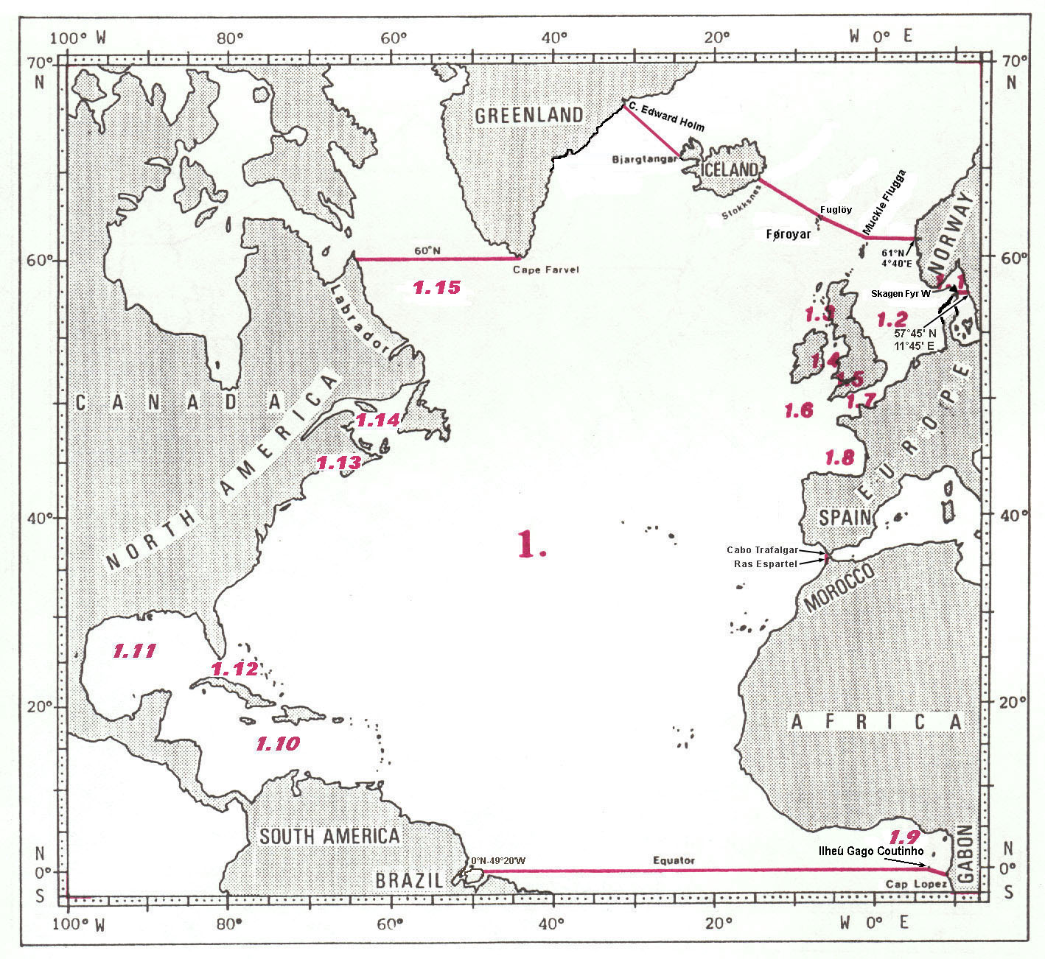
NORTH ATLANTIC OCEAN

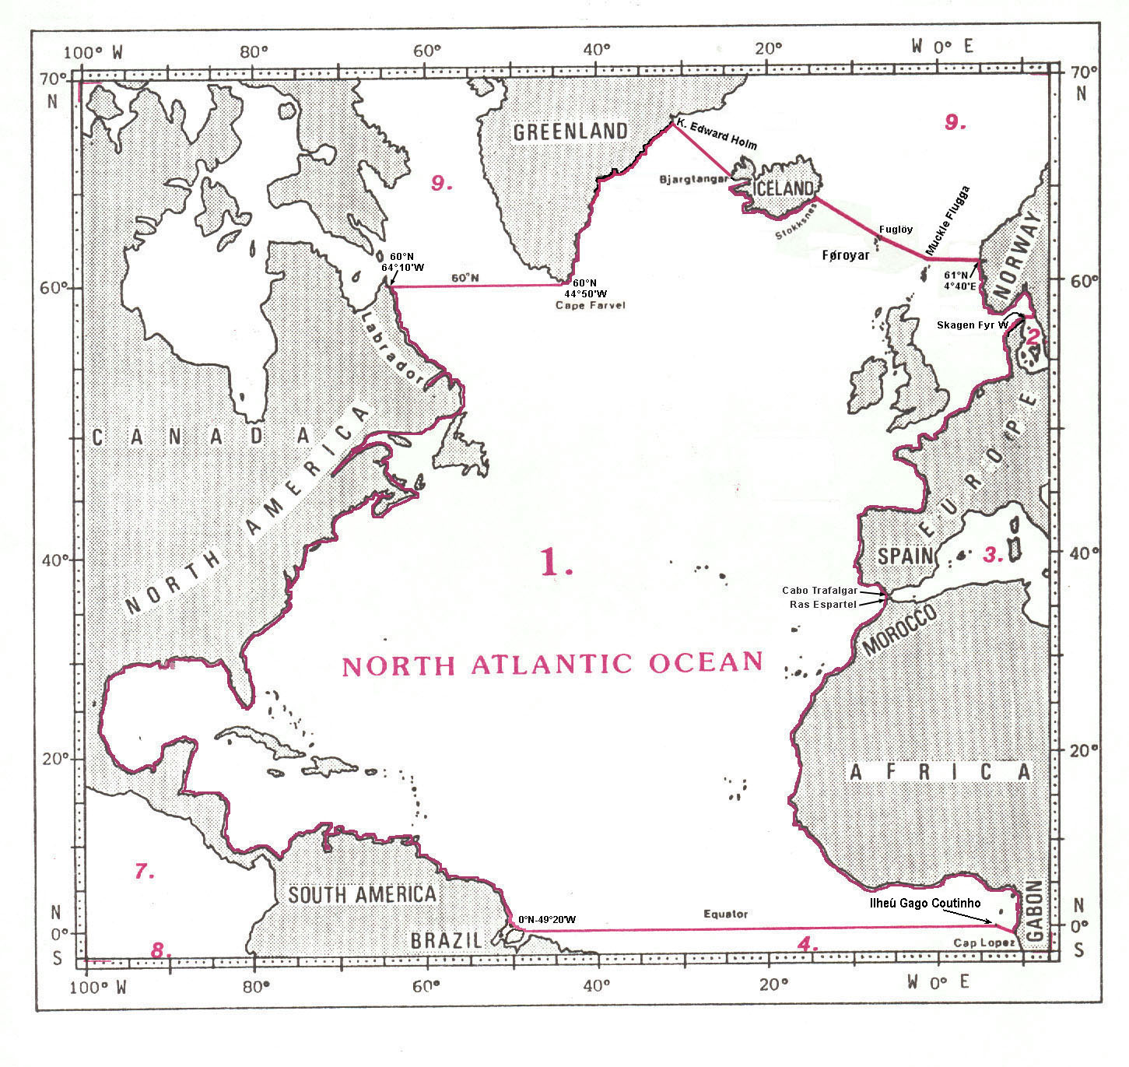
1. NORTH ATLANTIC OCEAN

The limits of the North Atlantic Ocean are the following :

On the North:
A line joining position 60°00'N – 64°10'W, on the coast of Labrador in Canada eastward, along the parallel of 60°N, to the southwestern coast of Greenland at position 60°00'N – 44°50'W;
thence from this position northeastward, along the southern and eastern coasts of Greenland, to Kap1 Edward Holm (67°51'N – 32°11'W), on the southeastern coast of Greenland;
thence a line joining Kap Edward Holm southeastward to Bjargtangar (65°30'N - 24°32'W), the western extremity of Iceland;
thence from Bjargtangar southeastward, along the western and southern coasts of Iceland, to Stokksnes (64°14'N - 14°58'W), on the eastern coast of Iceland;
thence a line joining Stokksnes southeastward to the north most extremity of Fuglöy (62°21'N - 6°15'W), in the Føroyar2;
thence a line joining the north most extremity of Fuglöy to Muckle Flugga (60°51'N – 0°53'W), the northern most point in the Shetland Islands;
and thence from Muckle Flugga eastward, along the parallel of 60°51'N, to the southwestern coast of Norway at position 60°51'N – 4°40'E. (The common limit with the Arctic Ocean, see 9.)

on the East:
From position 60°51'N – 4°40'E, on the southwestern coast of Norway southward, along the coasts of Norway and Sweden, to position 57°45'N – 11°45'E, on the southwestern coast of Sweden;
thence a line joining this position westward, along the parallel of 57°45’N, to Skagen Fyr3 W (57°45'N - 10°36'E), the northern extremity of Jylland4, in Denmark (the common limit with the Baltic Sea, see 2.);
thence from Skagen Fyr W southward, along the coasts of Europe, to Cabo5 Trafalgar (36°11'N - 6°02'W), on the southern coast of Spain;
thence a line joining Cabo Trafalgar southward to Ras6 Espartel (35°48'N - 5°55'W), in Morocco (the common limit with the Mediterranean Region, see 3.);
and thence from Ras Espartel southward, along the western coast of Africa, to Cap7 Lopez (0°37'S - 8°43'E), in Gabon.

On the South:
A line joining Cap Lopez northwestward to Ihléu Gago Coutinho (Ilhéu das Rôlas) (0°01'N - 6°32'E) (on the southwestern limit of Gulf of Guinea, see 1.9);
and thence a line joining Ihléu Gago Coutinho westward to the northern coast of Brazil at position 0°00' – 49°20'W (the common limit with the South Atlantic Ocean, see 4.).

On the West:
From position 0°00' – 49°20'W, on the northern coast of Brazil, northward, along the eastern coasts of the American continents, to position 60°00'N – 64°10'W, on the coast of Labrador in Canada.
SKAGERRAK and NORTH SEA

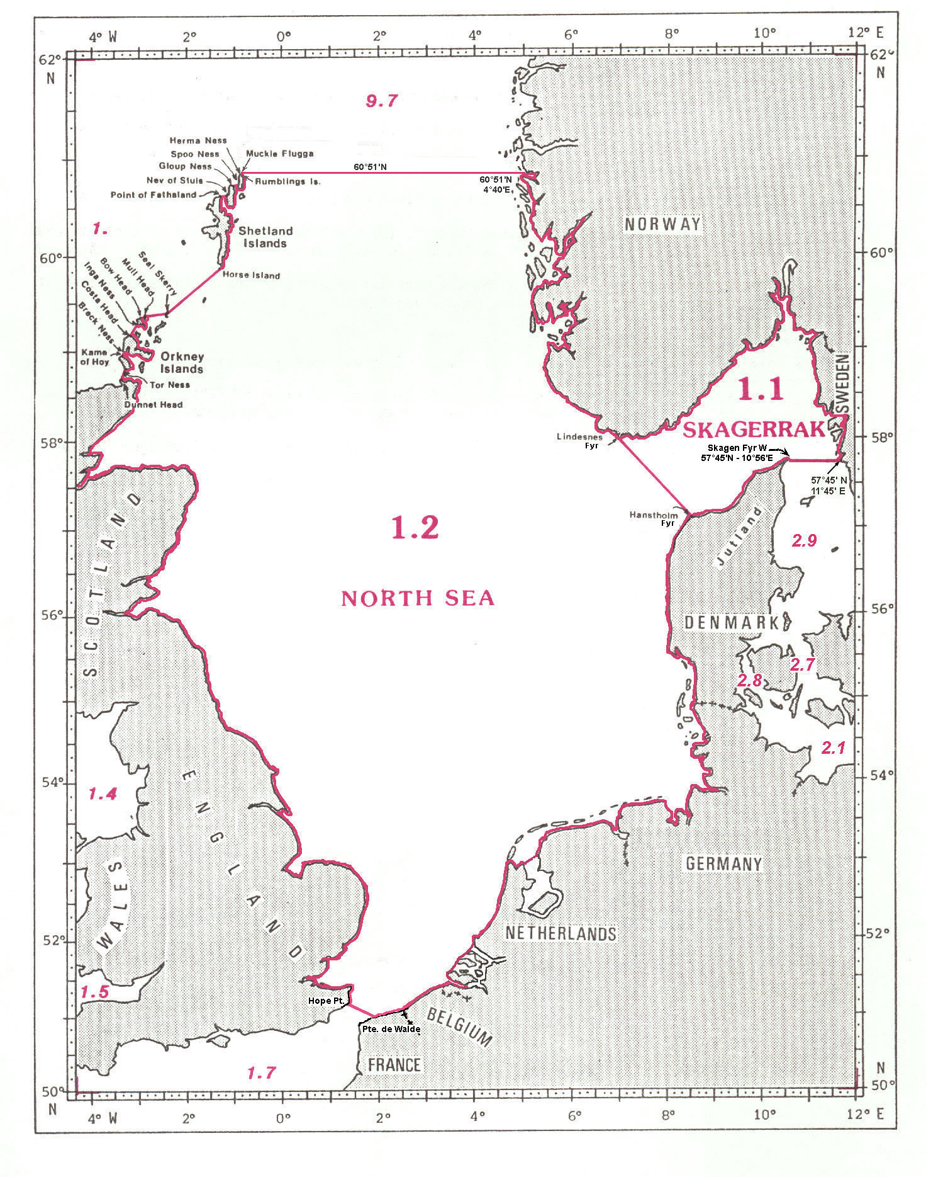
1.1 SKAGERRAK

The limits of the Skagerrak, a wide strait linking the North Sea and the Baltic Sea, are the following:

On the North and the East:
The southeastern coast of Norway and the western coast of Sweden, from Lindesnes Fyr1 (57°59'N - 7°03'E), in Norway, to position 57°45'N - 11°45'E, on the coast of Sweden.

On the South:
A line joining position 57°45'N – 11°45'E, on the western coast of Sweden westward, along the parallel of 57°45'N, to the northern extremity of Jylland2, Skagen Fyr W (57°45'N – 10°56'E) in Denmark (the common limit with the Kattegat, see 2.7);
and thence from Skagen Fyr W southwestward, along the coast of Jylland, to Hanstholm Fyr (57°07'N - 8°37'E).

On the West:
A line joining Hanstholm Fyr northwestward to Lindesnes Fyr (57°59'N - 7°03'E), on the southern coast of Norway (the common limit with the North Sea, see 1.2).

1.2 NORTH SEA

The limits of the North Sea, situated between the eastern coasts of the British Isles and the western coast of Europe, are the following:

On the North:
A line joining Muckle Flugga (60°51'N – 0°53'W), the northern most point in the Shetland Islands, eastward, along the parallel of 60°51'N, to the coast of Norway at position 60°51'N – 4°40'E (the common limit with the Arctic Ocean, see 9.).

On the East:
The coast of Norway, from position 60°51'N – 40°40'E, southward to Lindesnes Fyr (57°59'N - 7°03'E);
thence a line joining Lindesnes Fyr southeastward to Hanstholm Fyr (57°07'N - 8°37'E), in Denmark (the common limit with the Skagerrak, see 1.1);
and thence from Hanstholm Fyr southward, along the coasts of Denmark, Germany, Netherlands, Belgium and France to Pointe de Walde (51°00'N – 1°55'E), in France.

On the South:
A line joining Pointe de Walde northwestward to Hope Point (51°10'N – 1°24'E), on the southeastern coast of England (the common limit with the English Channel (La Manche), see 1.7).

On the West:
From Hope Point northward, along the eastern coasts of England and Scotland, to Dunnet Head (58°40'N - 3°23'W), the northern extremity of Scotland;
thence a line joining Dunnet Head northward to Tor Ness (58°47'N - 3°18'W), the southwestern extremity of Island of Hoy, in the Orkney Islands;
thence from Tor Ness northward, through Island of Hoy, to the Kame of Hoy (58°56'N - 3°24'W), the northwestern extremity of this island;
thence a line joining the Kame of Hoy northeastward to Breck Ness (58°58'N - 3°21'W), on the southwestern coast of Mainland Island;
thence from Breck Ness northward, through Mainland Island, to Costa Head (59°09'N - 3°13'W), the northern extremity of this island;
thence a line joining Costa Head northeastward to Inga Ness (59°17'N - 3°01'W), on the southwestern coast of Westray Island;
thence from Inga Ness northeastward, through Westray Island, to Bow Head (59°22'N - 2°57'W), the northern extremity of this island.
thence a line joining Bow Head northeastward to Mull Head (59°23'N - 2°53'W), the northern extremity of Papa Westray Island;
thence a line joining Mull Head eastward to Seal Skerry (59°24'N - 2°23'W), a reef off the northern extremity of North Ronaldsay Island;
thence a line joining Seal Skerry northeastward to Horse Island (59°51'N - 1°19'W), off the southern extremity of Mainland Island, in the Shetland Islands;
thence from Horse Island northward, through Mainland Island, to Point of Fethaland (60°38'N - 1°18'W), the northern extremity of this island;
thence a line joining Point of Fethaland eastward to Nev of Stuis (60°40'N - 1°09'W), on the western coast of Yell Island;
thence from Nev of Stuis northeastward, through Yell Island, to Gloup Ness (60°44'N - 1°04'W) the northern extremity of this island;
thence a line joining Gloup Ness eastward to Spoo Ness (60°45'N - 0°57'W), on the western coast of Unst Island;
thence from Spoo Ness northward, through Unst Island, to Herma Ness (60°51'N - 0°54'W), on the northwestern coast of this island;
thence a line joining Herma Ness northeastward to the southwestern point of Rumblings Islands (60°51'N - 0°54'W) and, through these islands, to Muckle Flugga (60°51'N - 0°53'W), all these being included in the North Sea area;
and thence from Muckle Flugga northward, along the meridian of 0°53'W, to position 61°00'N - 0°53'W, on the Hebridean Shelf.
INNER SEAS OFF THE WEST COAST OF SCOTLAND,
IRISH SEA and BRISTOL CHANNEL

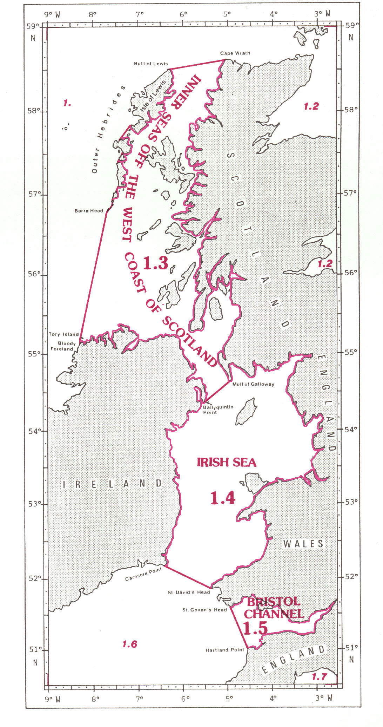
1.3 INNER SEAS OFF THE WEST COAST OF SCOTLAND1

The limits of the Inner Seas, situated between the western coast of Scotland, the eastern coasts of the Outer Hebrides Islands, and the northern coast of Ireland, are the following :

On the North:
A line joining the Butt of Lewis (58°31'N - 6°16'W), the northern extremity of Isle of Lewis, eastward to Cape Wrath (58°38'N - 5°00'W), the northwestern extremity of Scotland.

On the East:
From Cape Wrath southward, along the western coast of Scotland, to the southeastern extremity of Mull of Galloway (54°38'N - 4°51'W).

On the South:
A line joining the southeastern extremity of Mull of Galloway, in Scotland, southwestward to Ballyquintin Point (54°0'N - 5°30'W), in Ireland (the common limit with the Irish Sea, see 1.4);
and thence from Ballyquintin Point northward and westward, along the coast of Ireland, to Bloody Foreland (55°10'N - 8°17'W).

On the West:
A line joining Bloody Foreland, on the northwestern coast of Ireland, northward to the western extremity of Tory Island (55°16'N - 8°15'W);
thence a line joining the western extremity of Tory Island to Barra Head (56°47'N - 7°38'W), the southern extremity of Berneray Island, the southern island of the Outer Hebrides Islands;
and thence from the southern extremity of Berneray Island along the eastern coasts of the Outer Hebrides Islands, to Butt of Lewis (58°31'N - 6°16'W), the northern extremity of Isle of Lewis, in such a manner that the western coasts of the islands appertain to the North Atlantic Ocean and all the narrow waters appertain to the Inner Seas.

1.4 IRISH SEA

The limits of the Irish Sea, situated between the eastern coast of Ireland and the western coasts of Scotland, England and Wales, are the following:

On the North:
A line joining Ballyquintin Point (54°20'N - 5°30'W), in Ireland, northeastward to the southeastern extremity of Mull of Galloway (54°38'N - 4°51'W), in Scotland (the common limit with the Inner Seas off the West Coast of Scotland, see 1.3).

On the East:
From the southeastern extremity of Mull of Galloway eastward and southward, along the coasts of Scotland, England and Wales, to St. David’s Head (51°54'N - 5°19'W), in Wales.

On the South:
A line joining St. David’s Head, in Wales, northwestward to Carnsore Point (52°10'N - 6°22'W), in Ireland (the common limit with the Celtic Sea, see 1.6).

On the West:
From Carnsore Point northward, along the eastern coast of Ireland, to Ballyquintin Point (54°20'N - 5°30'W).

1.5 BRISTOL CHANNEL

The Bristol Channel is situated northeastward and adjacent to the Celtic Sea and bounded on the North, the East and the South by the coasts of Wales and England. Its western limit with the Celtic Sea is the following:

On the West:
A line joining St. Govan’s Head (51°36'N - 4°56'W), in Wales, southeastward to Hartland Point (51°01'N - 4°32'W), in England.
CELTIC SEA, ENGLISH CHANNEL (LA MANCHE),
DOVER STRAIT (PAS DE CALAIS)
and BAY OF BISCAY (GOLFE DE GASCOGNE)

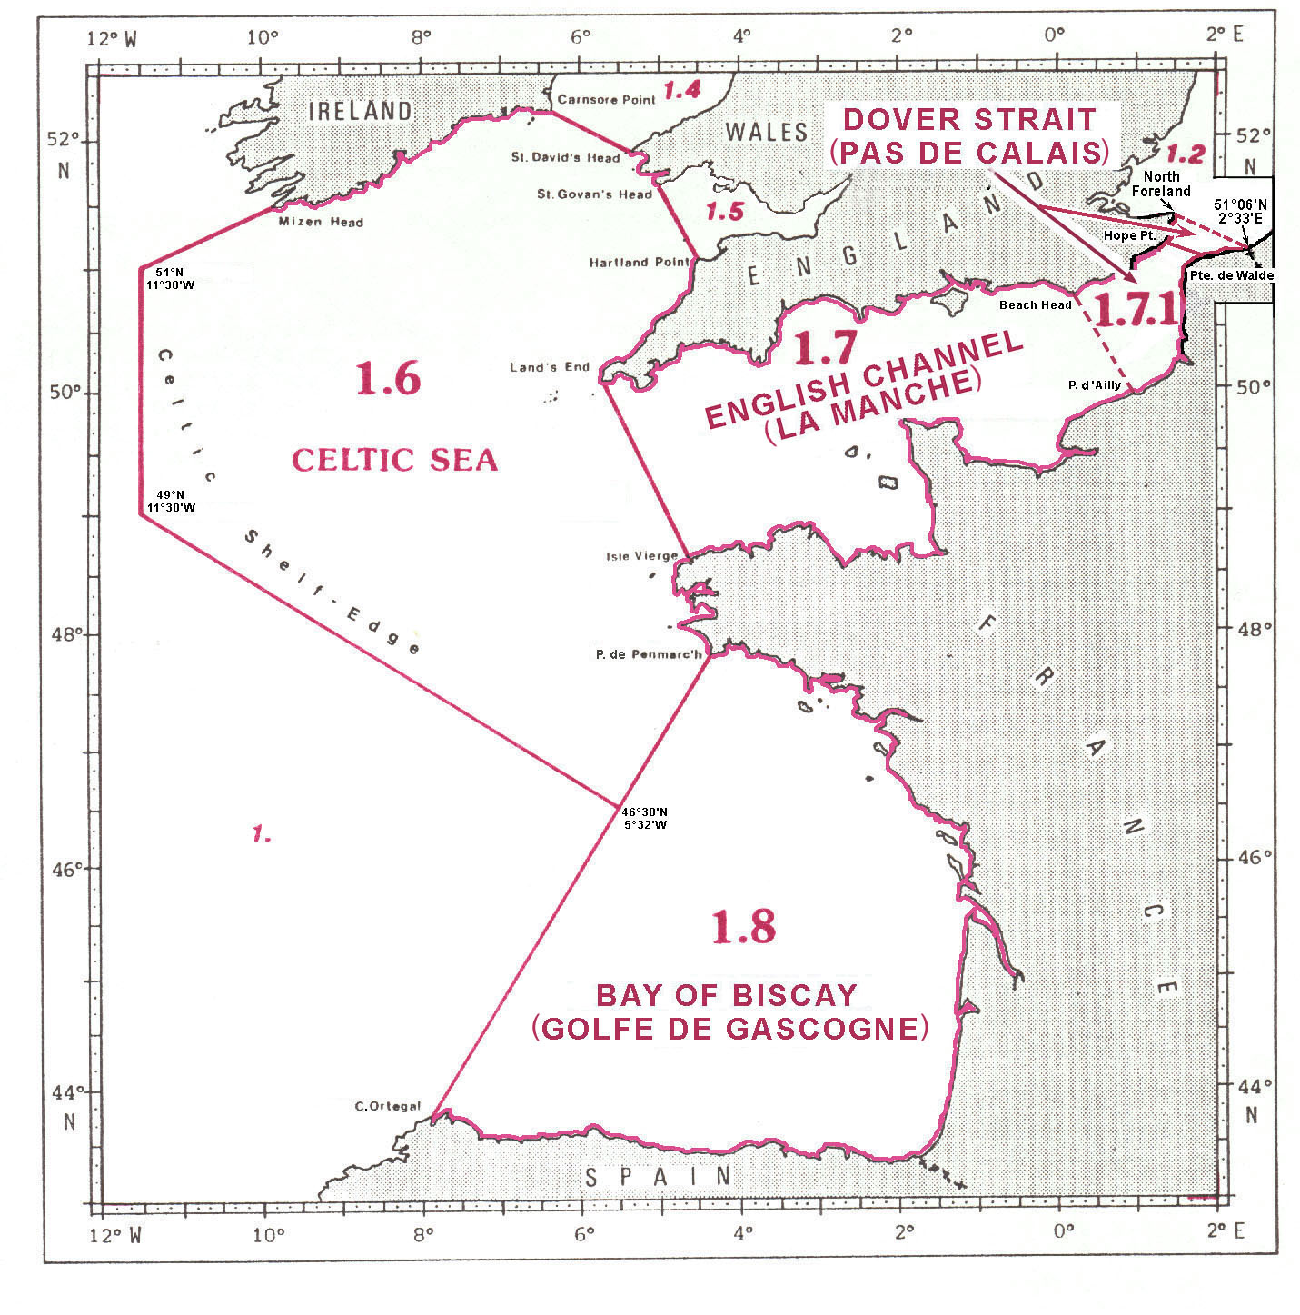
1.6 CELTIC SEA

The limits of the Celtic Sea, situated between the southern coast of Ireland, the southwestern coasts of Wales and England, the northwestern coast of France and the Celtic shelf-edge, are the following:

On the North:
From Mizen Head (51°27'N - 9°49'W) northeastward, along the southern coast of Ireland, to Carnsore Point (52°10'N - 6°22'W);
and thence a line joining Carnsore Point, on the southeastern coast of Ireland, southeastward to St. David’s Head (51°54'N - 5°19'W), in Wales (the common limit with the Irish Sea, see 1.4).

On the East:
From St. David’s Head southeastward, along the southwestern coast of Wales, to Saint Govan’s Head (51°36'N - 4°56'W);
thence a line joining Saint Govan’s Head southeastward to Hartland Point (51°01'N - 4°32'W), on the western coast of England (the common limit with the Bristol Channel, see 1.5);
thence from Hartland Point southwestward, along the southwestern coast of England, to Land’s End (50°04'N - 5°43'W), the western extremity thereof;
thence a line joining Land’s End, in England, southeastward to Ile1 Vierge (48°38'N - 4°34'W), off the northwestern coast of France (the common limit with the English Channel (La Manche), see 1.7);
and thence from Ile Vierge southward, along the western coast of France, to Pointe2 de Penmarc’h (47°48'N - 4°22'W).

On the South:
A line joining Pointe de Penmarc’h southwestward to position 46°30'N - 5°32'W, on the shelf-edge (on the limit with the Bay of Biscay (Golfe de Gascogne), see 1.8);
and thence a line joining position 46°30'N - 5°32'W northwestward to position 49°00'N - 11°30’W, on the shelf-edge.

On the West
A line joining position 49°00'N - 11°30'W northward to position 51°00'N - 11°30'W, on the shelf-edge;
and thence from position 51°00'N - 11°30'W northeastward to Mizen Head (51°27'N - 9°49'W), on the southwestern coast of Ireland.

1.7 ENGLISH CHANNEL (LA MANCHE)

Note: Both names can be used on charts according to IHO Technical Resolution A 4.2, paragraph 6. See Appendix C.

The limits of the English Channel (La Manche), situated between the southern coast of England and the northern coast of France and linking the North Sea and the Celtic Sea, are the following:

On the North:
The southern coast of England, from Land’s End (50°04'N - 5°43'W) eastward to Hope Point (51°10'N - 1°24'E).

On the East:
A line joining Hope Point southeastward to Pointe de Walde (51°00'N – 1°55'E), in France (the common limit with the North Sea, see 1.2).

On the South:
The northern coast of France, from Pointe de Walde southwestward to Ile1 Vierge (48°38'N - 4°34'W).

On the West:
A line joining Ile Vierge, in France, northwestward to Land’s End (50°04'N - 5°43'W), on the southwestern coast of England (the common limit with the Celtic Sea, see 1.6).

    - DOVER STRAIT (PAS DE CALAIS)

Note: Both names can be used on charts according to IHO Technical Resolution A 4.2, paragraph 6. See Appendix C.

The limits of the Dover Strait (Pas de Calais), situated between the southern extremity of the British Isles and the northern extremity of France, are the following:

On the West:
A line joining Beachy Head (50°44'N – 0°15'E), in England, to Pointe2 d’Ailly (49°55'N – 0°57'E) in France.

On the East:
A line joining North Foreland (51°23'N – 1°27'E), on the southeastern coast of England, southeastward to the France – Belgium border at position 51°06'N – 2°33'E.

1.8 BAY OF BISCAY (GOLFE DE GASCOGNE)

Note: Both names can be used on charts according to IHO Technical Resolution A 4.2, paragraph 6. See Appendix C.

The limits of the Bay of Biscay (Golfe de Gascogne), situated between the western coast of France and the northern coast of Spain, are the following:

On the North, the East and the South:
The western coast of France and the northern coast of Spain, from Pointe de Penmarc’h (47°48'N - 4°22'W), in France, southward and westward to Cabo4 Ortegal (43°46'N - 7°52'W), in Spain.

On the West:
A line joining Cabo Ortegal, in Spain, northeastward to Pointe de Penmarc’h, in France (the common limit with the Celtic Sea, see 1.6).

GULF OF GUINEA

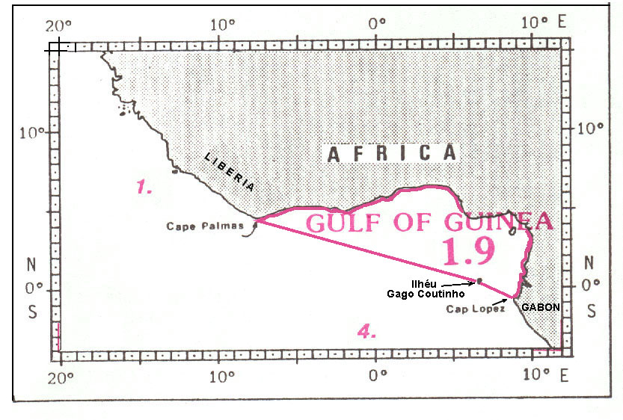

1.9 GULF OF GUINEA

The limits of the Gulf of Guinea, lying off the western coast of central Africa, are the following:

On the North and the East:
From Cape Palmas (4°22'N - 7°44'W), in Liberia, eastward and southward, along the western coast of central Africa, to Cap1 Lopez (0°37'S - 8°43'E), in Gabon.

On the Southwest:
A line from Cap Lopez (0°37'S - 8°43'E), in Gabon, northwestward to Ihléu Gago Coutinho (Ilhéu das Rôlas) (0°01'S – 6°32'E);
and thence a line from Ihléu Gago Coutinho northwestward to Cape Palmas (4°22'N - 7°44'W), in Liberia.
CARIBBEAN SEA
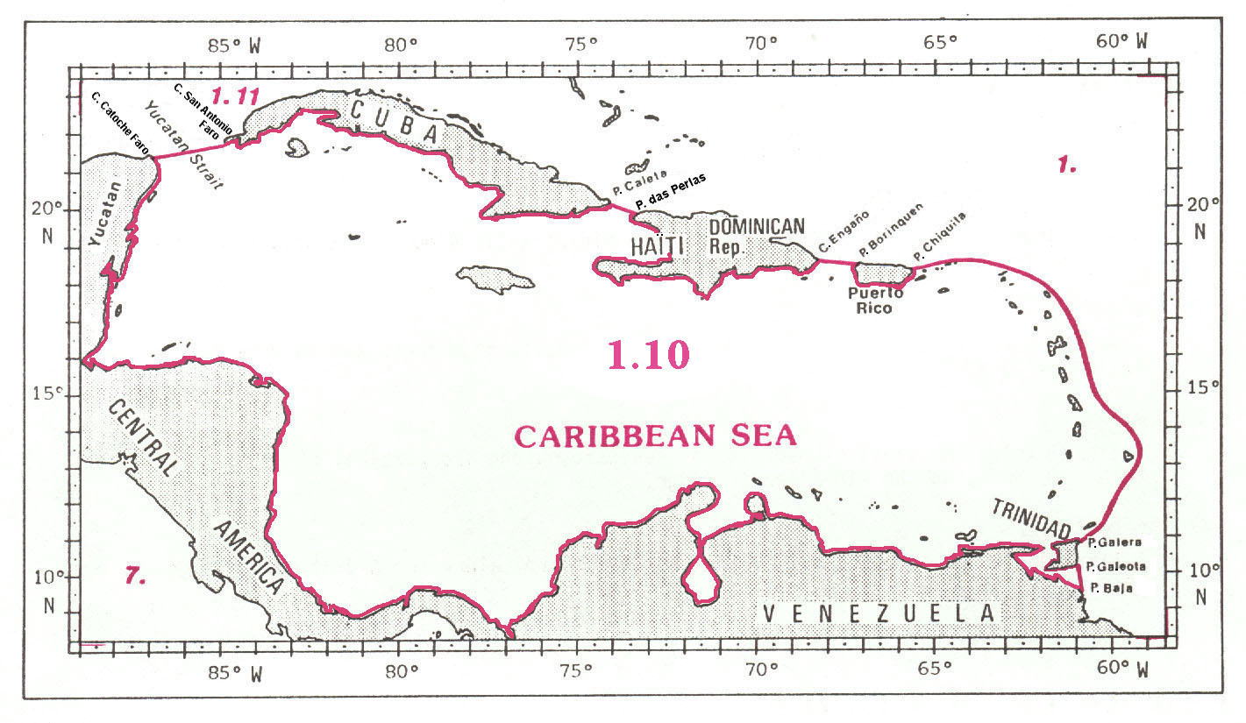

GULF OF MEXICO AND STRAITS OF FLORIDA
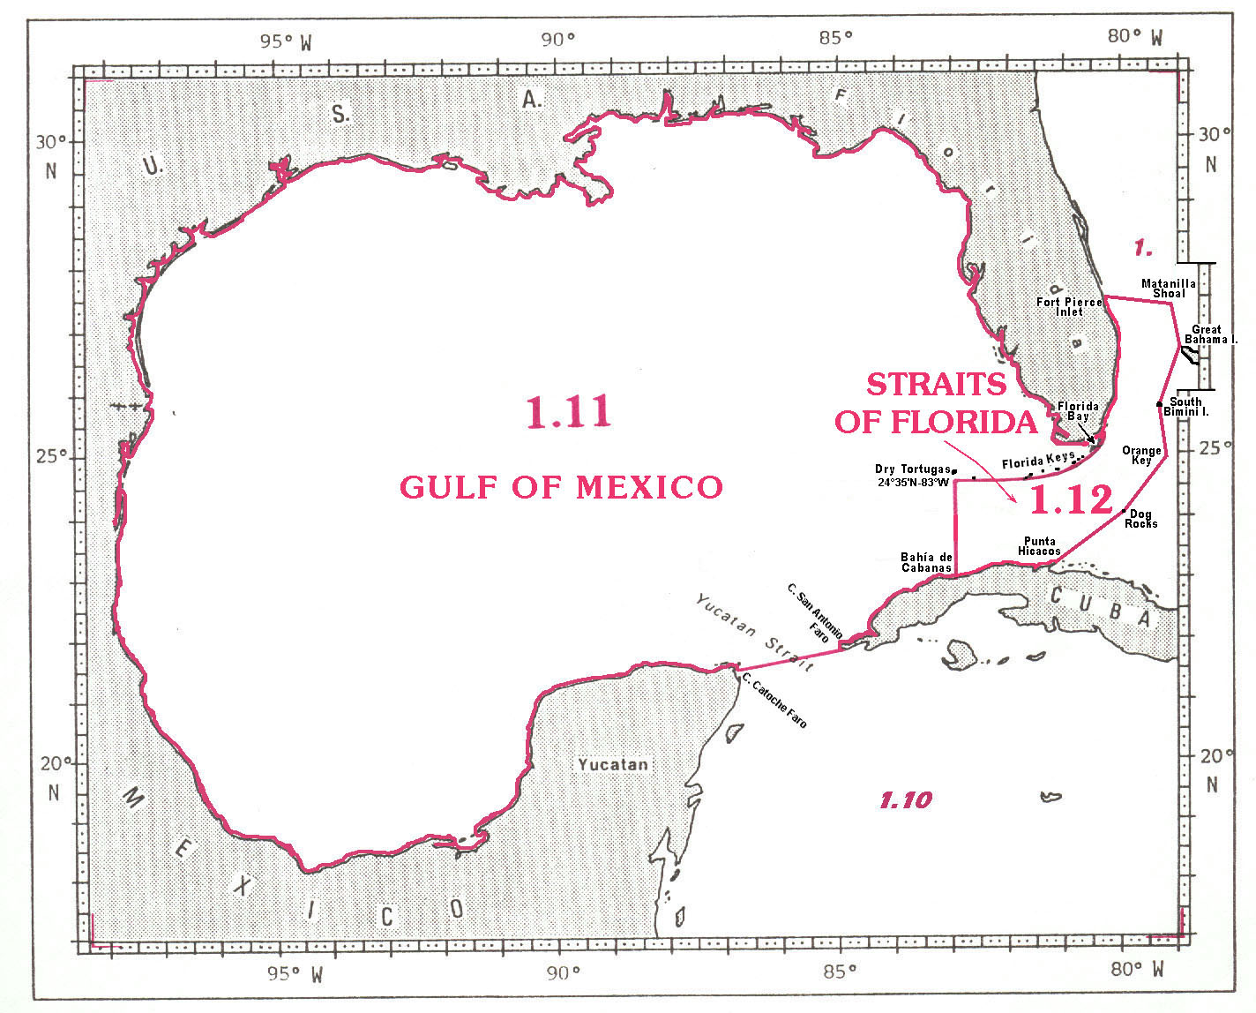
1.10 CARIBBEAN SEA

The limits of the Caribbean Sea, situated between the northern coast of South America, the eastern coast of Central America and the islands of the West Indies, are the following:

On the North:
A line joining Cabo1 Catoche Faro2 (21°36'N - 87°05'W), on the northeastern coast of Yucatan in Mexico, eastward to Cabo San Antonio Faro (21°52'N - 84°57'W), the western extremity of Cuba (the common limit with the Gulf of Mexico, see 1.11);
thence from Cabo San Antonio Faro eastward, along the southern coast of Cuba, to Punta3 Caleta. (20°04'N - 74°18'W), on the southeastern coast of this island;
thence a line joining Punta Caleta southeastward to Pointe4 des Perles (19°39'N - 73°25'W), on the northwestern coast of Haïti;
thence from Pointe des Perles southward and eastward, along the southern coast of Haïti and Dominican Republic, to Cabo Engaño (18°37'N - 68°20'W), the eastern extremity of the Dominican Republic;
thence a line joining Cabo Engaño eastward to Punta Borinquen (18°29'N - 67°10'W), on the north coast of Puerto Rico;
and thence from Punta Borinquen eastward, along the southern coast of this island, to Punta Chiquita (18°23'N - 65°39'W), on the northeastern coast thereof.

On the East:
From Punta Chiquita, on the northeastern coast of Puerto Rico, a line east-northeast to the western end of Anegada Island (18°45'N – 64°25'W);
thence from the western end of Anegada, along the south coast of this island, to the eastern end thereof (18°42'N – 64°16'W);
thence from the eastern end of Anegada, a line east-southeast to Isla Sombrero (18°36'N – 63°25'W);
thence from Isla Sombrero, a line to the northern end of Barbuda Island (17°44'N – 61°50'W);
thence from the northern end of Barbuda, along the west coast of this island, to the south-eastern end thereof (17°33'N – 61°43'W);
thence from the south-eastern end of Barbuda, a line south-southeast to the eastern end of La Désirade (16°20'N – 61°00'W)
thence from the eastern end of La Désirade, a line south-southeast to Kitridge Point (13°09'N – 59°25'W), in the eastern Barbados;
thence from Kitridge Point, a line south-southwest to Little Tobago (11°18'N – 60°30'W), at the eastern end of Tobago;
thence from Little Tobago, a line south-southwest to Punta Galera (10°50'N – 60°55'W), the north-western end of Trinidad;
thence from Punta Galera southward, along the western coast of Trinidad, to Punta Galeota (10°08'N - 61°00'W), the southeastern extremity of this island;
and thence a line joining Punta Galeota southward to Punta Baja (9°31'N - 60°58'W), on the eastern coast of Venezuela.

On the South and the West:
From Punta Baja, in Venezuela, westward and northward, along the northern coast of South America and the eastern coast of Central America, to Cabo Catoche Faro (21°36'N - 87°05'W), on the northeastern coast of Yucatan, in Mexico.

1.11 GULF OF MEXICO

The Gulf of Mexico is an almost enclosed sea situated in the western extremity of the North Atlantic Ocean and bounded by the eastern coast of Mexico, the Gulf coast of the United States of America and the northwestern coast of Cuba. It is connected through the Straits of Florida with the North Atlantic Ocean in the East, and through the Yucatan Channel with the Caribbean Sea in the Southeast.

The limits of the Gulf of Mexico in these straits are the following:

On the West and North:
From Cabo Catoche Faro (21°36'N – 87°05'W), on the northeastern coast of Yucatan, in Mexico, along the eastern coast of Mexico and the southern coast of USA, to the eastern end of Florida Bay (25°13'N – 80°30'W).

On the East (in the Straits of Florida):
A line joining the eastern end of Florida Bay southward and westward, through the Florida Keys and the shoals, to Rebecca Shoal (24°35'N - 82°35'W), and to position 24°35’N - 83°00'W, on the shelf edge - in such a way that all the narrow waters between the Dry Tortugas and the eastern end of Florida Bay are included in the Gulf of Mexico (the common limit with the Straits of Florida, see 1.12);
and thence from position 24°35'N - 83°00'W southward, along the meridian of 83°W, to Bahía1 de Cabanas (23°01'N – 83°00'W), on the northwestern coast of Cuba.

On the Southeast (in the Yucatan Channel):
From Bahía de Cabanas, on the northwestern coast of Cuba, southwestward to Cabo2 San Antonio Faro3 (21°52'N – 84°57'W), the western extremity of Cuba;
and thence a line joining Cabo San Antonio Faro, westward to Cabo Catoche Faro (21°36'N - 87°05'W), on the northeastern coast of Yucatan, in Mexico (the common limit with the Caribbean Sea, see 1.10).

  - STRAITS OF FLORIDA

The limits of the Straits of Florida, linking the Gulf of Mexico and the Atlantic Ocean are the following:

On the North:
From the southern point of the Dry Tortugas (24°35'N - 83°00'W), along the southern side of the Florida Keys and then along the east coast of Florida, to Fort Pierce Inlet (27°28'N - 80°18'W);
thence from Fort Pierce Inlet, a line eastward to Matanilla Shoal (27°22'N – 79°05'W), at the northwest edge of East Bahama Bank.

On the East:
From Matanilla Shoal southward, along Little Bahama Bank to the west end of Great Bahama Island at 26°41'N – 78°59'W;
thence from this position, a line southward, across Northwest Providence Channel, to the western end of South Bimini Island (25°43'N – 79°18'W);
thence from the western end of South Bimini Island, a line southward to Orange Cay (24°56'N – 79°10'W);
thence from Orange Cay, a line southwestward, across Santaren Channel, to the Dog Rocks (24°05'N – 79°53'W), on the Cay Sal Bank;
thence from Dog Rocks, a line southwestward, across Nicholas Channel, to Punta4 Hicacos (23°11'N – 81°07'W), in Cuba.

On the South:
Along the north coast of Cuba, from Punta Hicacos to Bahia de Cabanas (23°01'N – 83°00'W).

On the West:
Along the 83°W meridian, from Bahia de Cabanas to the southern point of the Dry Tortugas (83°00'W – 24°35'N) (the common limit with the Gulf of Mexico, see 1.11).
BAY OF FUNDY and GULF OF ST. LAWRENCE

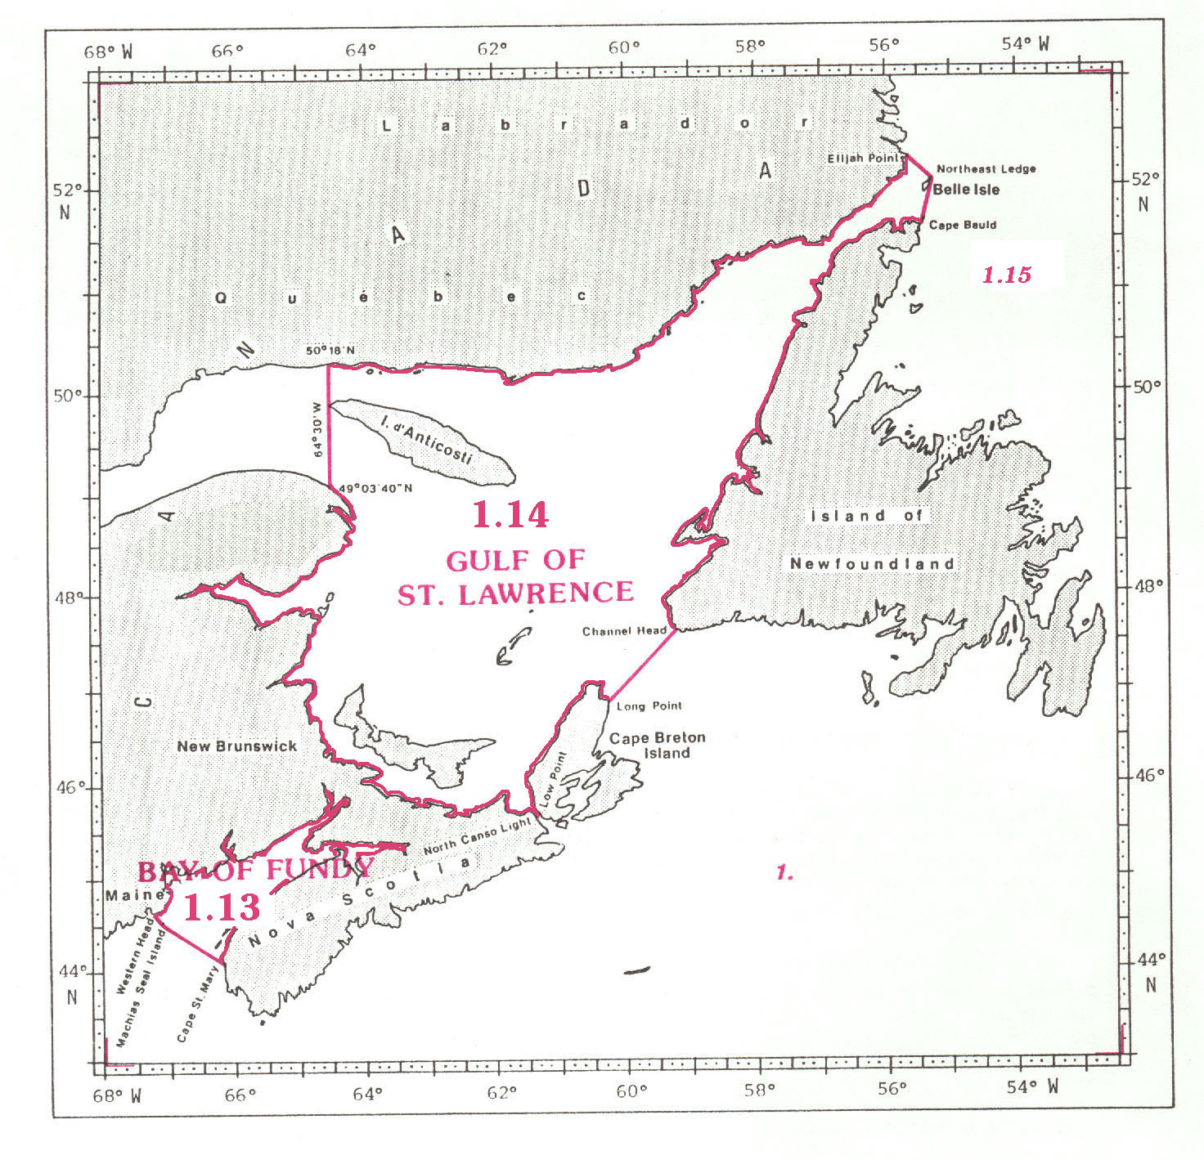

1.13 BAY OF FUNDY

The Bay of Fundy, situated on the eastern coast of North America, is bounded on the West, the North and the East by the coast of Maine, in the United States, and the coasts of New Brunswick and Nova Scotia, in Canada. Its southern limit with the North Atlantic Ocean is the following:

On the South:
A line joining Cape St. Mary (44°05'N - 66°13'W), on the southwestern coast of Nova Scotia, in Canada, northwestward to Machias Seal Island (44°30'N - 67°06'W), and thence to Western Head (44°39'N - 67°11'W), on the coast of Maine, in the United States.

1.14 GULF OF ST. LAWRENCE

The limits of the Gulf of St. Lawrence, situated in Canada, between the coasts of Quebec, Labrador, Island of Newfoundland, Nova Scotia and New Brunswick, are the following:

On the North:
From position 50°18'N - 64°30'W, on the southern coast of Quebec, eastward, along this coast and the southern coast of Labrador, to Elijah Point (52°13'N - 55°37'W), the eastern extremity of Cape St. Charles.

On the East:
A line joining Elijah Point southeastward to Northeast Ledge (rocks at 52°02'N - 55°16'W);
thence from Northeast Ledge southward, through the eastern extremity of Belle Isle, to Cape Bauld (51°38'N - 55°26'W), the northern extremity of the Island of Newfoundland (the common limit with the Labrador Sea, see 1.15);
thence from Cape Bauld southwestward, along the western coast of Island of Newfoundland, to Channel Head (47°34'N - 59°07'W);
thence a line joining Channel Head southwestward to Long Point1 (46°51'N - 60°18'W, on the northeastern coast of Cape Breton Island;
thence from Long Point southwestward, along the western coast of this island, to Low Point (45°43'N - 61°28'W), on the southern coast thereof;
and thence a line joining Low Point southwestward to North Canso Light (45°42'N - 61°29'W), on the northeastern coast of Nova Scotia.

On the South and the West:
From North Canso Light westward and northward, along the northern coast of Nova Scotia and the eastern coast of New Brunswick, to position 49°04'N - 64°30'W, on the coast of Quebec;
and thence a line joining this position northward, along the meridian of 64°30'W, to position 50°18'N - 64°30'W, on the coast of Quebec, including the whole of Ile2 d’Anticosti within the Gulf of St. Lawrence.

LABRADOR SEA

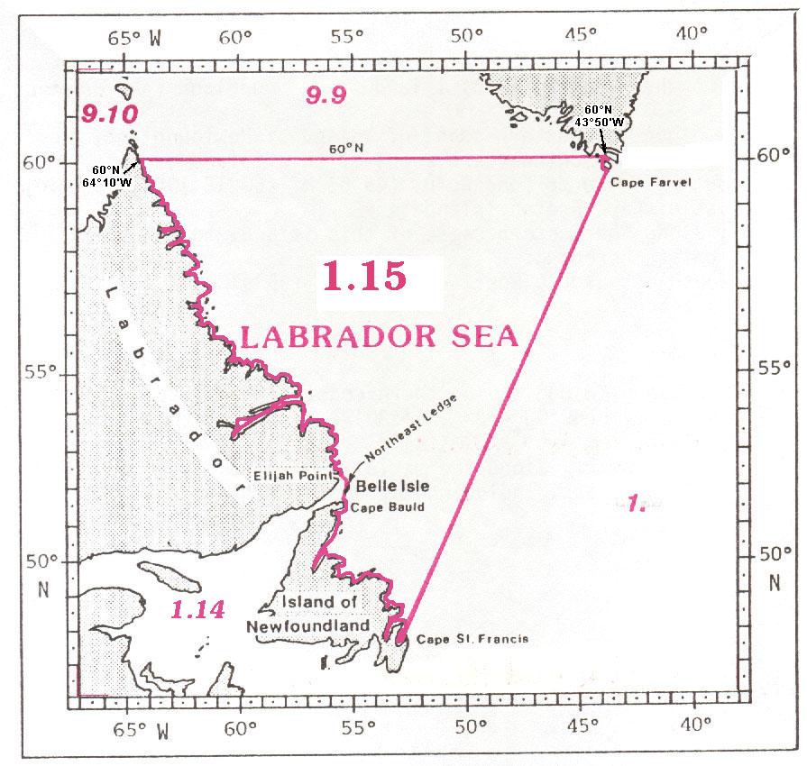

1.15 LABRADOR SEA

The limits of the Labrador Sea, situated in the northwestern part of the North Atlantic Ocean, between the eastern coasts of Labrador and the Island of Newfoundland, in Canada, and the southern extremity of Greenland, are the following:

On the North:
A line joining the northeastern coast of Labrador at position 60°00'N – 64°10'W eastward, along the parallel of 60°N, to the southern coast of Greenland at position 60°00'N – 44°50'W (the common limit with the Davis Strait, see 9.9);
and thence from this position southeastward, along this coast, to Kap1 Farvel (59°47'N - 43°55'W), the southern extremity of Greenland.

On the East:
A line joining Kap Farvel southwestward to Cape St. Francis (47°49'N - 52°47'W), on the southeastern coast of the Island of Newfoundland.

On the West:
From Cape St. Francis northwestward, along the eastern coast of Newfoundland, to Cape Bauld (51°38'N - 55°26'W), the northern extremity of this island;
thence a line joining Cape Bauld northward, through the eastern extremity of Belle Isle, to Northeast Ledge (rocks at 52°02'N - 55°16'W), and northwestward to Elijah Point (52°13'N - 55°37'W), the eastern extremity of Cape St. Charles, on the southeastern coast of Labrador (the common limit with the Gulf of St. Lawrence, see 1.14);
and thence from Elijah Point northwestward, along the eastern coast of Labrador, to position 60°00'N – 64°10'W.
__________

1 Kap (Danish) = Cape
2 Faeroe Islands
3 Fyr (Danish) = Lighthouse
4 Jutland
5 Cabo (Spanish) = Cape
6 Ras (Arabic) = Cape
7 Cap ( French) = Cape
1 Fyr (Norwegian, Swedish, Danish) = Lighthouse
2 Jutland
1 Referred to also as Malin Sea
1 Ile (French) = Island
2 Pointe (French) = Point
1 Ile (French) = Island
2 Pointe (French) = Point
4 Cabo (Spanish) = Cape
1 Cap (French) = Cape
1 Cabo (Spanish) = Cape
2 Faro (Spanish) = Light
3 Punta (Spanish) = Point
4 Pointe (French) = Point
1 Bahía (Spanish) = Bay
2 Cabo (Spanish) = Cape
3 Faro (Spanish) = Light
4 Punta (Spanish) = Point
1 Formerly Cape Egmont
2 Ile (French) = Island
1 Kap (Danish) = Cape

