CHAPTER 10

SOUTHERN OCEAN
AND ITS SUB-DIVISIONS

CHARTLET-INDEX
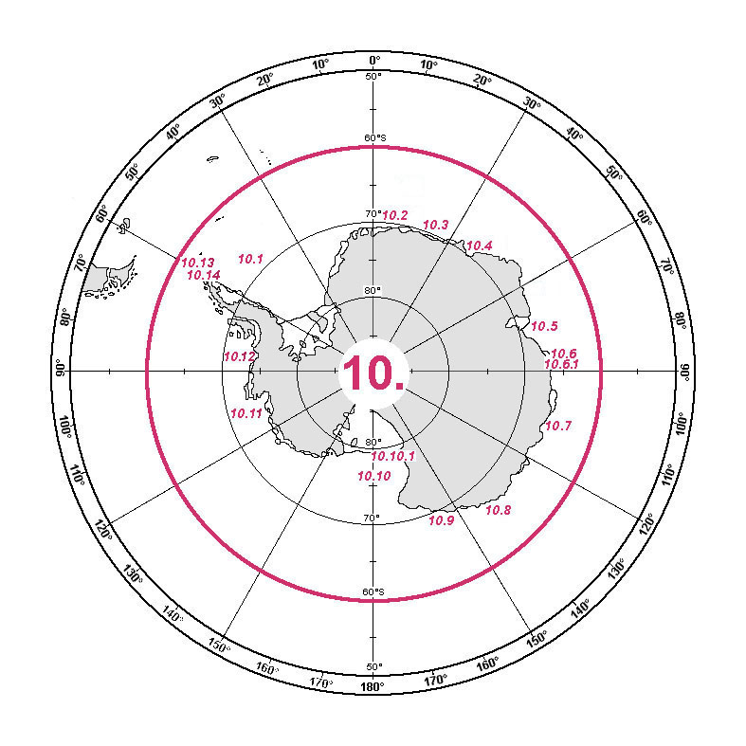

SOUTHERN OCEAN

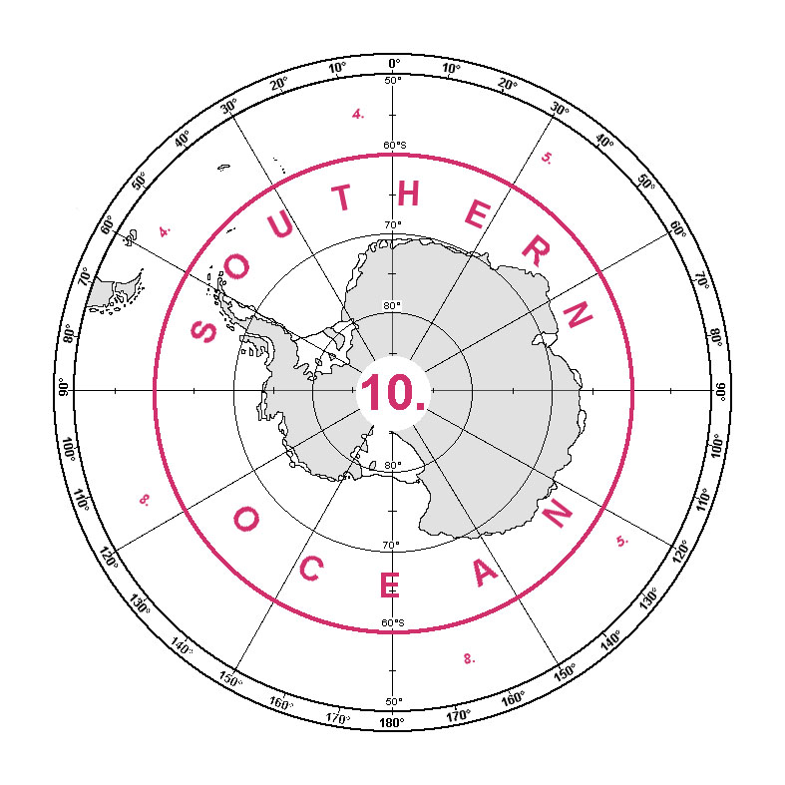

Note: In this chapter, due to the international nature of the Antarctic, English is used for the generic part of reference names.
10. SOUTHERN OCEAN

The limits of the Southern Ocean are the parallel of 60°S to the north (the common limit with the South Atlantic Ocean, see 4., the Indian Ocean, see 5., and the South Pacific Ocean, see 8.) and the coast of Antarctica, including the Antarctic Peninsula, to the south.

Note: See reservation by Australia in Appendix A.

WEDDELL SEA

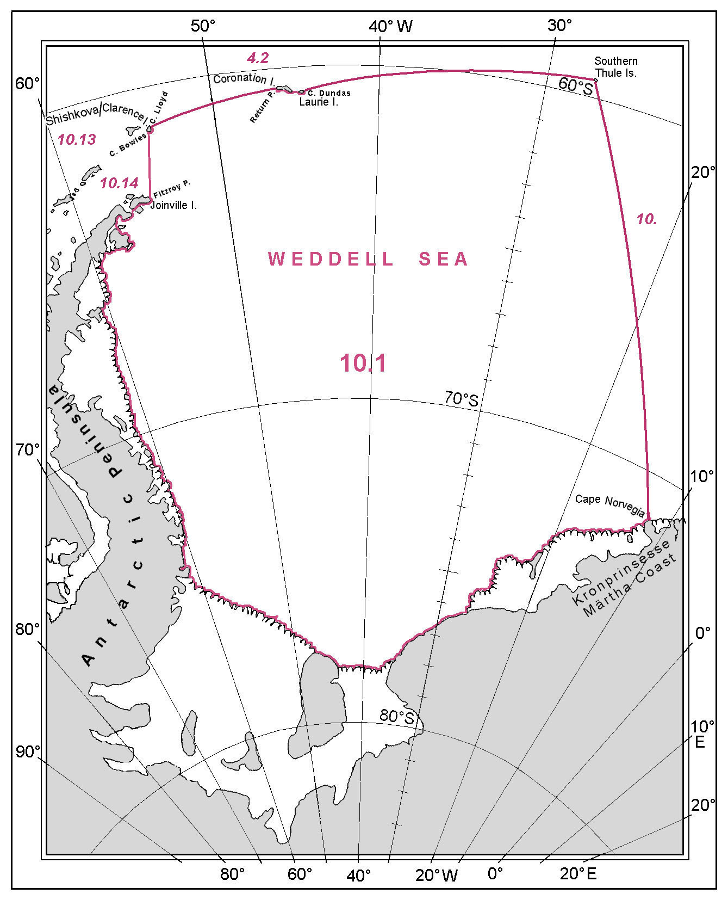
10.1 WEDDELL SEA

The limits of the Weddell Sea, a major indentation on the north west coast of Antarctica between the Antarctic Peninsula on the west and the main body of Antarctica to the south, are the following:

On the North:
From Fitzroy Point (63°11'S - 55°09'W), the northeastern extremity of Joinville Island, north eastward, a line to Cape Bowles (61°18'S - 54°06'W), the southern extremity of Shishkova / Clarence Island;
thence from Cape Bowles north eastward, along the east coast of Shishkova / Clarence Island, to Cape Lloyd (61°08'S - 53°59'W), the northeastern extremity of this island;
thence from Cape Lloyd, in an easterly direction, a line to Return Point (60°38'S - 46°03'W), the south west extremity of Coronation Island;
thence from Return Point eastward, along the south side of the South Orkney Islands, to Cape Dundas (60°44'S - 44°26'W), the southeastern extremity of Laurie Island;
and thence from Cape Dundas, a line eastward to Thule Island (59°27'S - 27°22'W), the western most island of the Southern Thule Islands.

On the East:
From Thule Island, in a south easterly direction, a line to Cape Norvegia (71°23'S - 12°16'W), projecting from the Kronprinsesse Märtha Coast.

On the South and West:
From Cape Norvegia south westward and westward, along the Antarctic coast, thence northward, along the eastern coasts of the Antarctic Peninsula and Joinville Island, to Fitzroy Point (63°11'S - 55°09'W), the point of commencement.

LAZAREV SEA, RIISER-LARSEN SEA and COSMONAUTS SEA

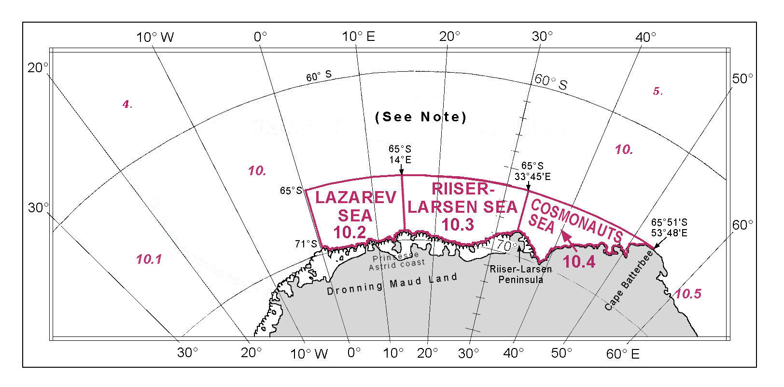

10.2 LAZAREV SEA

The limits of the Lazarev Sea, adjacent to the Prinsesse Astrid Coast of Dronning Maud Land, are the following:

On the West:
From position 71°00'S - 0°00'E, on the coast of Dronning Maud Land, northward, along the meridian 0°, to position 65°00'S - 0°00'E.

On the North:
From this position eastward, along the parallel of 65°S, to position 65°00'S - 14°00'E.

On the East:
From this position southward, along the meridian of 14°E, to the coast of Dronning Maud Land at position 70°00'S – 14°00'E.

On the South:
From this position westward, along the Antarctic coast, to position 71°00'S - 0°00'E, the point of commencement.

Note: See reservation by Norway in Appendix A.

  - RIISER – LARSEN SEA

The limits of the Riiser-Larsen Sea, adjacent to the Prinsesse Ragnhild Coast of Dronning Maud Land, are the following:

On the West:
From position 70°00'S – 14°00'E, on the Prinsesse Ragnhild Coast, northward, along the meridian of 14°E, to position 65°00'S - 14°00'E.

On the North:
From this position eastward, along the parallel of 65°S, to position 65°00'S - 33°45'E.

On the East:
From this position southward, along the meridian of 33°45'E, to the northern extremity of Riiser-Larsen Peninsula (68°35'S - 33°45'E).

On the South:
From the northern extremity of Riiser-Larsen Peninsula westward, along the Antarctic coast, to position 70°00'S – 14°00'E, the point of commencement.

10.4 COSMONAUTS SEA

The limits of Cosmonauts Sea, adjacent to the Antarctic coast of Dronning Maud Land and Enderby Land, are the following:

On the West:

From the northern extremity of the Riiser-Larsen Peninsula (68°35'S - 33°45'E) northward, along the meridian of 33°45'E, to position 65°00'S - 33°45'E;

On the North:

From this position eastward, along the parallel of 65°S, to position 65°00'S - 53°48'E.

On the East:
From this position southward, along the meridian of 53°48'E, to Cape Batterbee (65°51'S - 53°48'E), projecting from the Napier Mountains;

On the South:
From Cape Batterbee westward, along the Antarctic coast, to the northern extremity of the Riiser-Larsen Peninsula (68°35'S - 33°45'E), the point of commencement.

COOPERATION SEA1, DAVIS SEA, MAWSON SEA

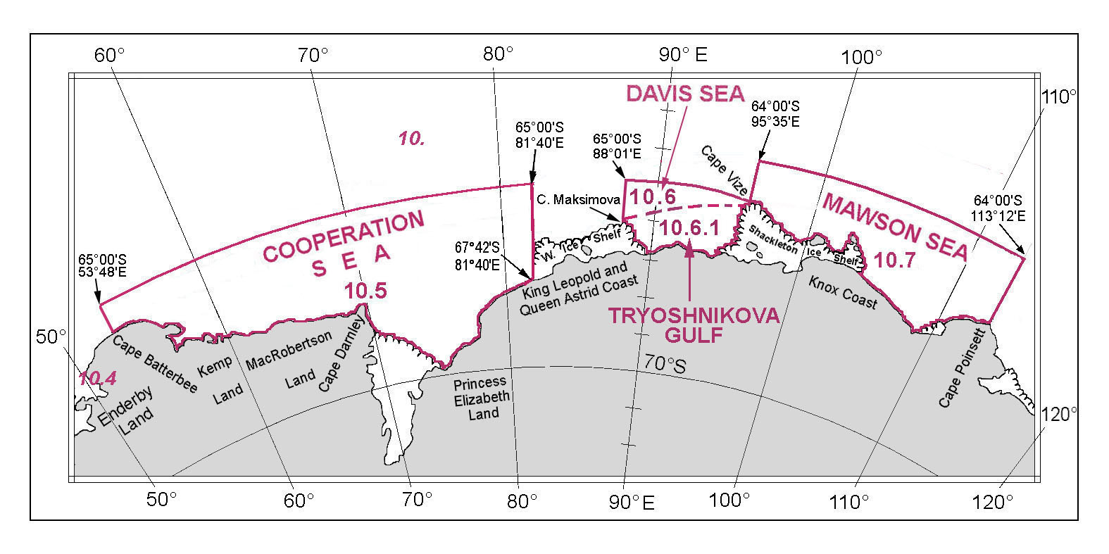

10.5 COOPERATION SEA

The Cooperation Sea is adjacent to the Antarctic Continent coast between Enderby Land and the West Ice Shelf. Its limits are the following:

On the West:
From Cape Batterbee (65°51'S – 53°48'E), the northern extremity of Enderby Land, northward, along the meridian of 53°48'E, to position 65°00'S – 53°48'E.

On the North:
From position 65°00'S – 53°48'E eastward, along the parallel of 65°00'S, to position 65°00'S – 81°40'E.

On the East:
From position 65°00'S – 81°40'E southward, along the meridian of 81°40'E, to King Leopold and Queen Astrid Coast at position 67°32'S – 81°40'E.

On the South:
From position 67°32'S – 81°40'E westward, along the Antarctic coast, to Cape Batterbee (65°51'S – 53°48'E), the point of commencement.

10.6 DAVIS SEA

The limits of the Davis Sea, adjacent to the King Leopold and the Queen Astrid Coast, stretching eastward to the Shackleton Ice Shelf, are the following:

On the West:
From position 67°32'S – 81°40'E on the Antarctic coast to the north, along the meridian of 81°40'E, to position 65°00'S – 81°40'E.

On the North:
From position 65°00'S - 81°40'E, a line northeastward to position 64°00'S – 95°35'E.

On the East:
From position 64°00'S – 95°35'E southward, along the meridian of 95°35'E, to Cape Vize (64°56'S– 95°35'E ), the northwestern extremity of the Shackleton Ice Shelf.

On the South:
From Cape Vize, generally westward, along the Shackleton Ice Shelf, the Antarctic coast and the West Ice Shelf, to position 67°32'S - 81°40'E, the point of commencement.

10.6.1 TRYOSHNIKOVA GULF

Located in the southern part of the Davis Sea, its limits are as follows:

On the North:
From Cape Maksimova (65°55'S – 88°01'E), the northeastern point of the West Ice Shelf, a line eastward to Cape Vize (64°56'S – 95°35'E), the northwestern extremity of the Shackleton Ice Shelf.

On the South:
From Cape Vize generally westward, along the Shackleton Ice Shelf, the Antarctic Coast and the West Ice Shelf, to Cape Maksimova (65°55'S – 88°01'E).

10.7 MAWSON SEA

The limits of the Mawson Sea, adjacent to Knox Coast, off the Shackleton Ice Shelf and eastward of Cape Poinsett, are the following:

On the West:
From Cape Vize (64°56'S – 95°35'E), the northwestern extremity of the Shackleton Ice Shelf, northward, along the meridian of 95°35'E, to position 64°00'S - 95°35'E.

On the North:
From position 64°00'S - 95°35'E eastward, along the parallel of 64°S, to position 64°00'S - 113°12'E.

On the East:
From position 64°00'S - 113°12'E southward, along the meridian of 113°12'E, to the northern extremity of Cape Poinsett (65°47'S - 113°12'E), on the Budd Coast.

On the South:
From Cape Poinsett westward, along the Antarctic coast and the Shackleton Ice Shelf, to Cape Vize (64°56'S – 95°35'E), the point of commencement.

DUMONT d’URVILLE SEA, SOMOV SEA,
ROSS SEA and McMURDO SOUND

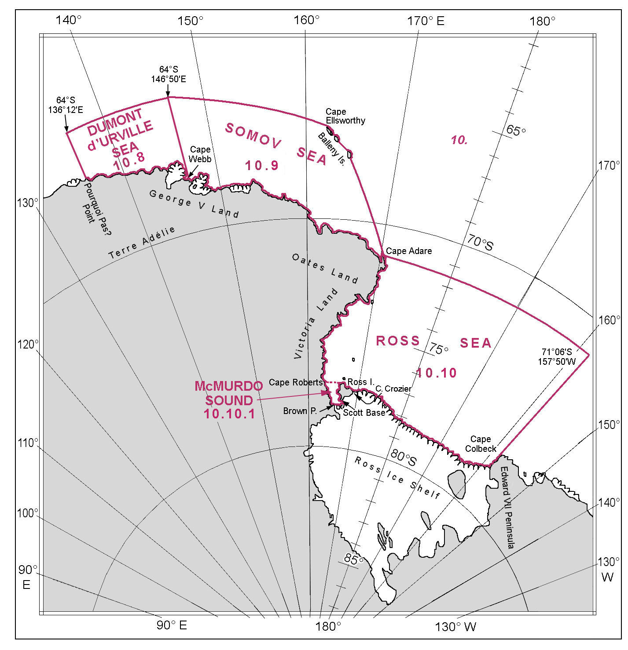

10.8 DUMONT d'URVILLE SEA

The limits of the Dumont d'Urville Sea, adjacent to the coast of Terre Adélie and George V Land, are the following:

On the West:
From Pourquoi Pas? Point (66°12'S - 136°12'E) northward, along the meridian of 136°12'E, to position 64°00'S - 136°12'E.

On the North:
From position 64°00'S - 136°12'E eastward, along the parallel of 64°S, to position 64°00'S - 146°50'E.

On the East:
From position 64°00'S - 146°50'E southward, along the meridian of 146°50'E, to Cape Webb (67°55'S – 146°50'E), projecting from George V Land.

On the South:
From Cape Webb westward, along the Antarctic coast, to Pourquoi Pas? Point (66°12'S - 136°12'E), the point of commencement.

10.9 SOMOV SEA

The Somov Sea is situated adjacent to George V Land and Oates Land and is partly encompassed by the Balleny Islands. Its limits are:

On the West:
From Cape Webb (67°55'S - 146°50'E), projecting from George V Land, northward, along the meridian of 146°50'E, to position 64°00'S - 146°50'E.

On the North:
From position 64°00'S - 146°50'E eastward, a line to Cape Ellsworthy (66°16'S - 162°19'E), the western extremity of Young Island.

On the East:
From Cape Ellsworthy south eastward, along the northeastern side of the Balleny Islands, to Smith Point (67°36'S - 164°49'E), the southern extremity of Sturge Island;
and thence from Smith Point south eastward, a line to Cape Adare (71°18'S - 170°14'E), the northern extremity of the Adare Peninsula.

On the South:
From Cape Adare generally north westward, along the Antarctic coast, to Cape Webb (67°55'S - 146°50'E), the point of commencement.

10.10 ROSS SEA

The Ross Sea is a major indentation on the eastern side of Antarctica, largely surrounded by the Antarctic shoreline, of which a major part is the edge of the Ross Ice Shelf. Its seaward limit is defined by:

On the North:
From Cape Adare (71°18'S – 170°14'E) eastward, along the parallel of 71°18'S, to position 71°18'S – 157°50'W.

On the East:
From position 71°18'S – 157°50'W southward, along the meridian of 157°50'W, to Cape Colbeck (77°06'S – 157°50'W).

On the South:
From Cape Colbeck westward, along the edge of the Ross Ice Shelf, to Cape Crozier (77°30'S – 169°20'E), on the eastern coast of Ross Island;
thence from Cape Crozier westward and southward, along the northern and western coasts of Ross Island, to Scott Base (77°52'S – 166°40'E), on the southern end of this island;
thence from Scott Base southeastward, a line to the northern extremity of White Island (78°00'S – 167°30'E);
and thence from the northern extremity of White Island westward, along the northern coasts of White Island and Black Island, and continuing northwesterly, to Brown Peninsula (78°02'S – 165°32'E), on the Hillary coast of the Antarctic mainland.

On the West:
From Brown Peninsula northward, along the coast of Victoria Land, to Cape Adare (71°18'S – 170°14'E), the point of commencement.

    - McMURDO SOUND

McMurdo Sound is the area between Ross Island and the Antarctic mainland coast, with the following limits:

On the West:
From Brown Peninsula (78°02'S - 165°32'E), on the Hillary Coast of the Antarctic mainland, northward, along the Antarctic coast, to Cape Roberts (77°00'S – 163°09'E).

On the North:
From Cape Roberts eastward, a line to the northern extremity of Ross Island (77°11'S - 166°50'E).

On the East:
From the northern extremity of Ross Island southward, along the western coast of Ross Island, to Scott Base (77°52'S – 166°40'E), on the southern end of this island.

On the South:
From Scott Base southeastward, a line to the northern extremity of White Island (78°00'S - 167°30'E);
and thence from this position westward, along the northern coasts of White Island and Black Island and continuing northwesterly, to Brown Peninsula (78°02'S - 165°32'E), the point of commencement.

AMUNDSEN SEA and BELLINGSHAUSEN SEA

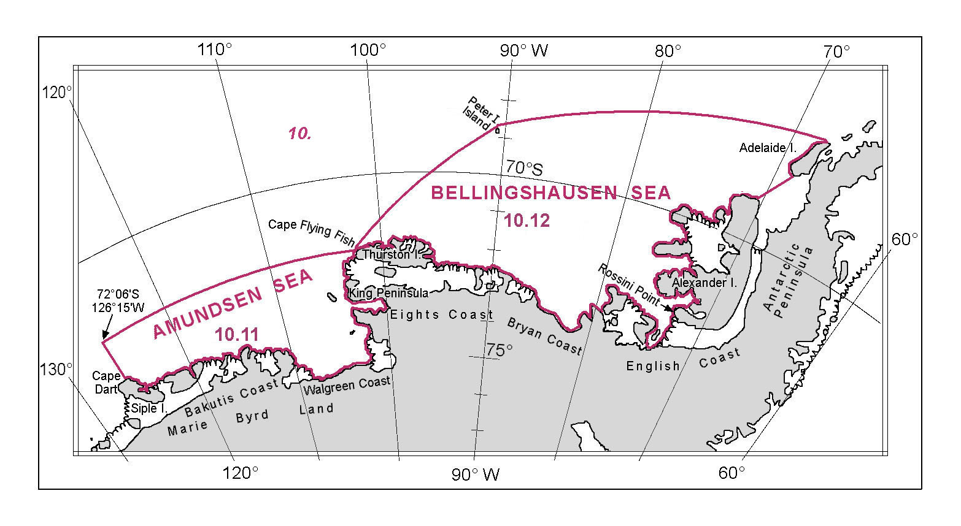

10.11 AMUNDSEN SEA

The Amundsen Sea is situated off the coast of Marie Byrd Land and westward of Thurston Island. Its limits are as follows:

On the West:
From Cape Dart (73°12'S - 126°15'W), the northern extremity of Siple Island, northward, along the meridian of 126°15'W, to position 72°06'S - 126°15'W.

On the North:
From position 72°06'S - 126°15'W eastward, along the parallel of 72°06'S, to Cape Flying Fish (72°06'S - 102°28'W), the western extremity of Thurston Island.

On the East and South:
From Cape Flying Fish southward, a line to position 72°43'S - 103°20'W, the northern extremity of King Peninsula;
and thence from this position southward and westward, along Walgreen Coast and Bakutis Coast, to Cape Dart (73°12'S - 126°15'W), the point of commencement.

10.12 BELLINGSHAUSEN SEA

The Bellingshausen Sea is located west of the Antarctic Peninsula and confined by Peter I. Island and Thurston Island, with the following limits:

On the North:
From Cape Flying Fish (72°06'S - 102°28'W), the western extremity of Thurston Island northeastward, a line to the northern extremity of Peter I Island (68°43'S - 90°37'W);
and thence from Peter I Island, in a north easterly direction, a line to the northern extremity of Adelaide Island (66°38'N - 67°48'W).

On the East:
From the northern extremity of Adelaide Island southward, along the western coast of Adelaide Island, to the southern extremity of this island (67°46'S - 68°55'W);
thence from the southern extremity of Adelaide Island south westward, a line to the northern extremity of Alexander Island (68°46'S - 70°32'W);
And thence from the northern extremity of Alexander Island, generally southward, along the western coast of Alexander Island, to Rossini Point (72°30'S - 73°00'W), the southwestern extremity of this island.
.
On the South:
From Rossini Point westward, along English Coast, Bryan Coast and the Eights Coast, then continuing along the northern coast of Thurston Island, to Cape Flying Fish (72°06'S - 102°28'W), the point of commencement.

DRAKE PASSAGE and BRANSFIELD STRAIT

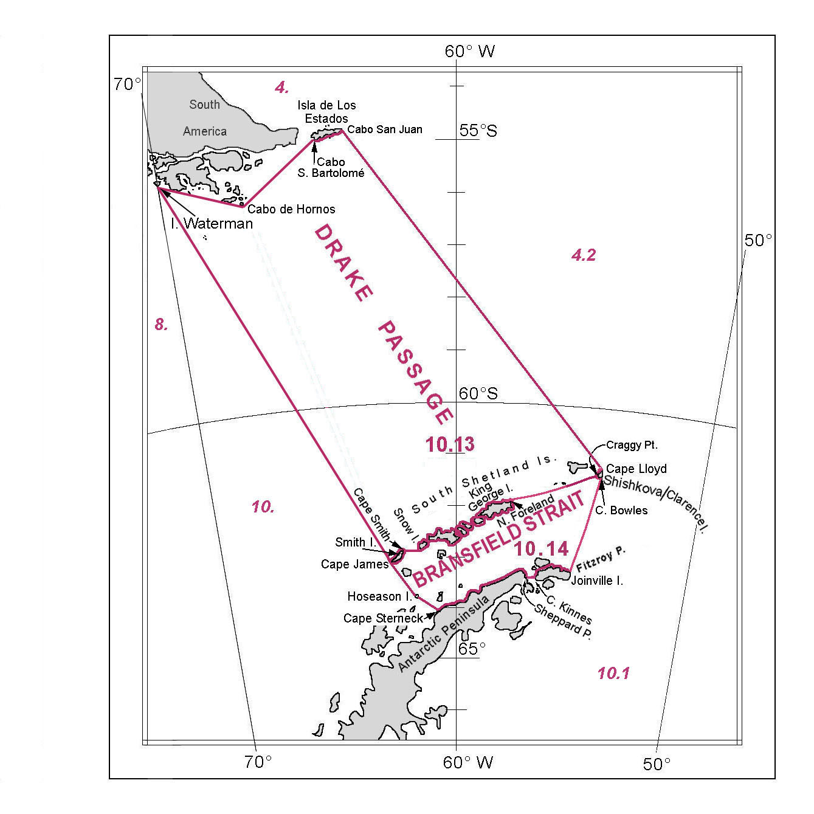

10.13 DRAKE PASSAGE

The Drake Passage is situated between the southern and eastern extremities of South America and the South Shetland Islands, lying north of the Antarctic Peninsula. As it extends north of 60°S, it is also described in Chapter 4 (South Atlantic Ocean). Its limits are the following:

On the North:
From the southern extremity of Isla Waterman (55°25'S – 70°00'W), a line eastward to Cabo de Hornos (55°59'S – 67°16'W) the southern extremity of Isla Hornos;
From Cabo de Hornos, a line northeastward to Cabo San Bartolomé (54°55'S – 64°42'W), the southwestern extremity of Isla de Los Estados;
and thence from Cabo San Bartolomé eastward, along the southern coast of Isla de Los Estados, to Cabo San Juan (54°43'S - 63°48'W), the eastern extremity thereof.

On the East:
From Cabo San Juan, a line southeastward to Cape Lloyd (61°08'S - 53°59'W), the northwestern extremity of Shishkova / Clarence Island.
On the South:
From Cape Lloyds southwestward, along the northwestern coast of Shishkova / Clarence Island, to Craggy Point (61°17'S – 54°14'W), the southwestern extremity thereof;
thence from Craggy Point, a line southwestward to North Foreland (61°54'S – 57°41'W), the northeastern extremity of King George Island;
thence from North Foreland, following the northern coasts of the South Shetland Islands, to Monroe Point (62°49'S – 61°31'W), on the western coast of Snow Island;
thence from Monroe Point westward, a line to Cape Smith (62°53'S – 62°18'W), the northeastern extremity of Smith Island;
and thence from Cape Smith southwestward, following the northwestern coast of Smith Island, to Cape James (63°06'S - 62°44'W), the southwestern extremity thereof.

On the West:
From Cape James, a line northwestard to the southern extremity of Isla Waterman (55°25'S – 70°00'W).

10.14 BRANSFIELD STRAIT

Bransfield Strait is situated between the South Shetland Islands and the northern part of the Antarctic Peninsula, with the following limits:

On the West:
From Cape James (63°06'S - 62°44'W), the southwestern extremity of Smith Island in the South Shetland Islands, southeastward, a line to Cetacea Rocks (63°43'S – 61°38'W), on the northeastern coast of Hoseason Island;
and thence from Cetacea Rocks, a line southeastward to Cape Sterneck (64°04'S - 61°02'W), on the Antarctic Peninsula.

On the South:
From Cape Sterneck north eastward, along the northern coast of the Antarctic Peninsula, to Sheppard Point (63°22'S – 56°59'W), on the northeastern coast of this Peninsula;
thence from Sheppard Point eastward, a line to Cape Kinnes (63°23'S – 56°33'W), the western extremity of Joinville Island;
and thence from Cape Kinnes eastward, along the northern coast of Joinville Island, to Fitzroy Point (63°11'S - 55°09'W), the northeastern extremity of this island.

On the East:
From Fitzroy Point, in a north easterly direction, a line to Cape Bowles (61°19'S – 54°06'W), the southeastern extremity of Shishkova / Clarence Island;
and thence from Cape Bowles westward, along the southern coast of Shishkova / Clarence Island, to Craggy Point (61°17'S – 54°14'W), the southwestern extremity thereof;

On the North:
From Craggy Point southwestward, a line to North Foreland (61°54'S – 57°41'W), the northeastern extremity of King George Island;
thence from North Foreland southwestward, following the southern coasts of the South Shetland Islands, to Monroe Point (62°49'S – 61°31'W), on the western coast of Snow Island;
thence from Monroe Point westward, a line to Cape Smith (62°53'S – 62°18'W), the northeastern extremity of Smith Island;
and thence from Cape Smith southwestward, following the southeastern coast of Smith Island, to Cape James (63°06'S – 62°44'W), the point of commencement.

__________

1 The Russian term for "Cooperation", "Sodruzhetsva", is used on the Russian nautical charts.

