Step 1: Create folder project
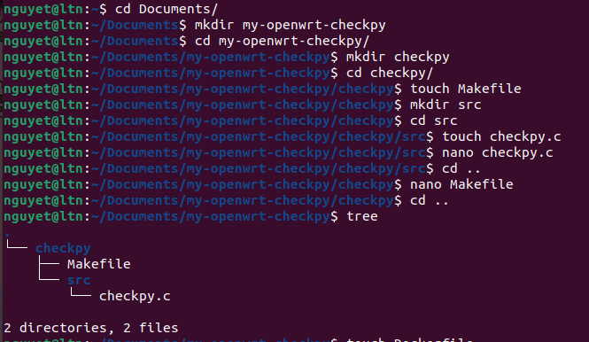

Step 2: Write Dockerfile, Makefile and checkpy.c

Step 3: Build image
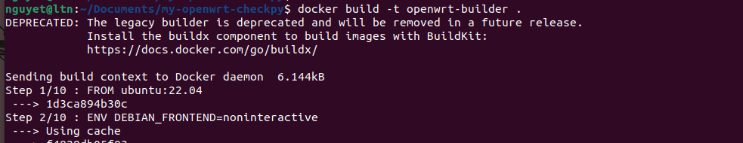
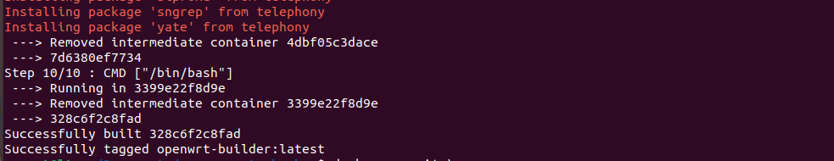

Step 4: Run container with mount volume
Make menuconfig
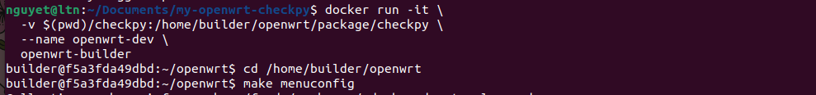
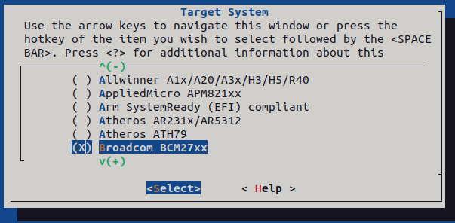
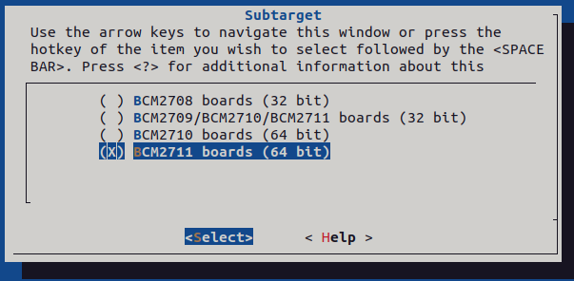
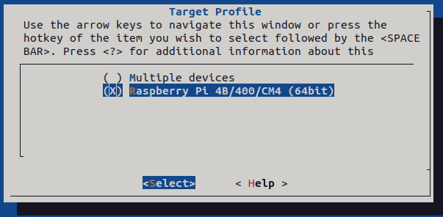
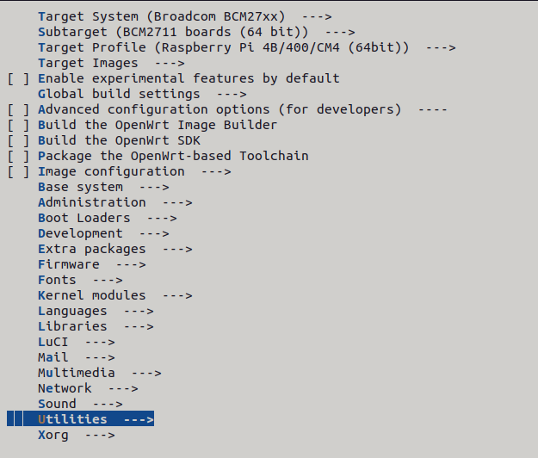
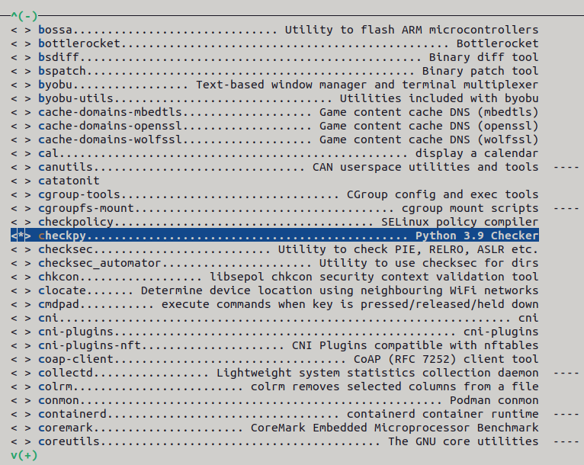

Step 5: Make package
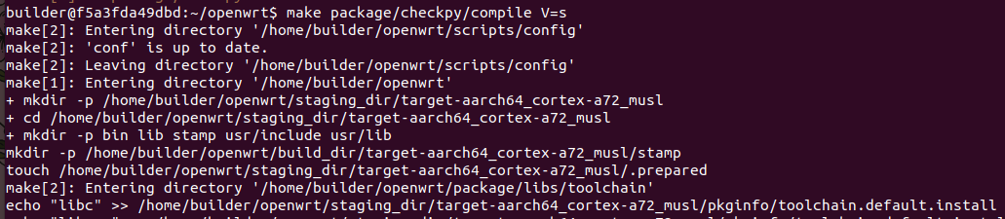

Step 6: Check file .ipk

Step 7: Extract file .ipk from host and copy file bin to Pi 4
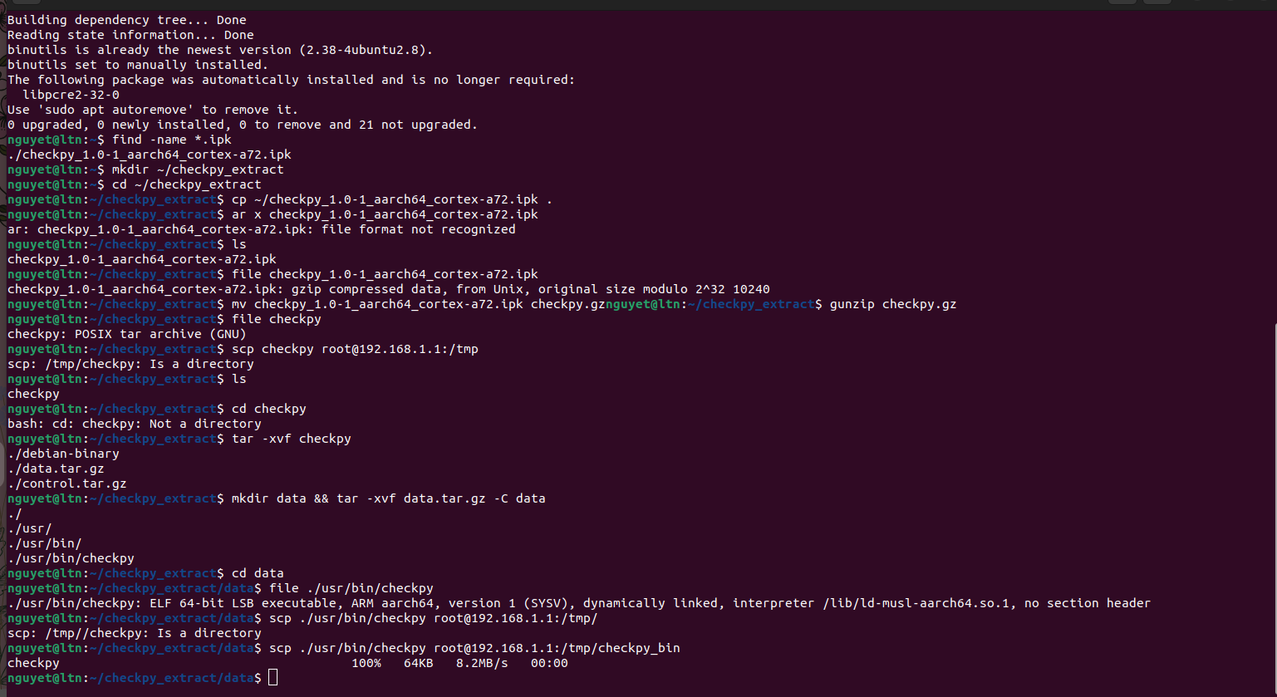


Step 8: Run package in Pi4
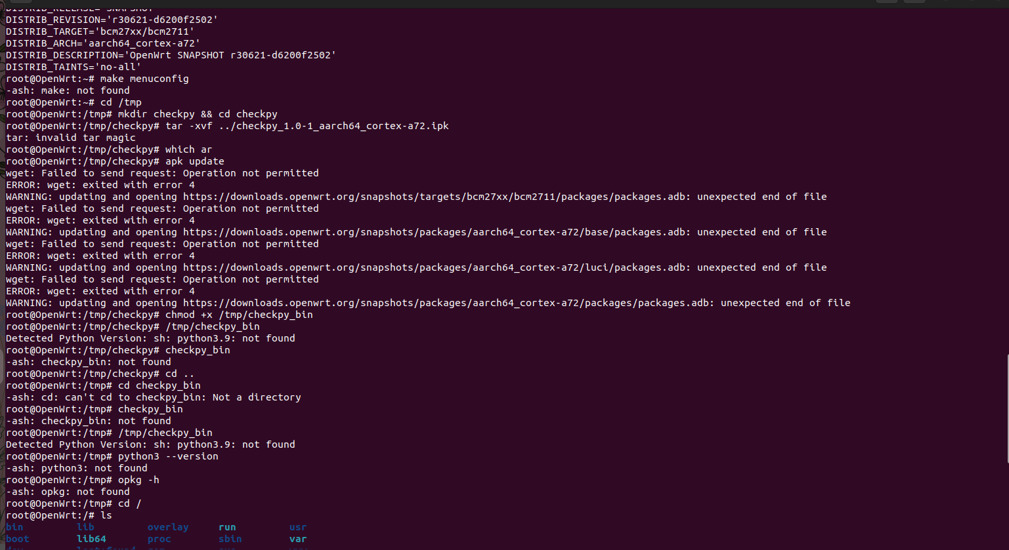

Step 9: Git commit
