**Title: The fastest growing and most destructive fires in the U.S. (2001-2020)**

**Authors:** Jennifer K. Balch1,2*, Virginia Iglesias1,3†, Adam L. Mahood4†, Maxwell C. Cook2,3, Cibele Amaral1,3, Amy DeCastro5, Stefan Leyk2, Tyler L. McIntosh3, R. Chelsea Nagy1,3, Lise St. Denis3, Ty Tuff1,3, Erick Verleye1,3, A. Park Williams6, Crystal A. Kolden7

**Affiliations:**

1Environmental Data Science Innovation and Inclusion Lab (ESIIL), University of Colorado Boulder; Boulder, CO, United States

2Department of Geography, University of Colorado Boulder; Boulder, United States

3Earth Lab, Cooperative Institute for Research in Environmental Sciences (CIRES), University of Colorado Boulder; Boulder, United States

4Water Resources, Agriculture Research Service, United States Department of Agriculture; Fort Collins, United States

5Research Applications Laboratory, National Center for Atmospheric Research; Boulder, United States

6Department of Geography, University of California Los Angeles; Los Angeles, United States

7University of California Merced, Management of Complex Systems Department, School of Engineering; Merced, United States

*Corresponding author. Email: Jennifer.Balch@colorado.edu

†These authors contributed equally to this work.

**Abstract:** Most of the destructive and deadly wildfires in U.S. history were also fast. Using satellite data (FIRED), we analyzed the daily growth rates of over 60,000 fires from 2001-2020 across the contiguous U.S. Nearly half of U.S. ecoregions experienced destructive "fast fires" that grew over 1,620 hectares on a single day. These accounted for 78% of structures destroyed and 61% of suppression costs ($18.9 billion). From 2001-2020, the average peak daily growth rate for these fires more than doubled (+249%, relative to 2001) in the western U.S. Nearly three million structures were within four kilometers of a fast fire during this time period across the U.S. Given recent devastating wildfires, understanding fast fires is crucial for improving firefighting strategies and community preparedness.

**One Sentence Summary:** Speed, not size, is the key factor making 'megafires' deadly and destructive, and they are getting faster.

**Main Text:** Some of the most deadly and destructive wildfires in contemporary U.S. history have occurred in recent years, with most having a common characteristic of extremely rapid growth. The 2018 Camp fire in California killed 85 people and destroyed over 16,000 homes in a matter of hours. The 2021 Marshall fire, driven by winds over 100 mph, burned more than a thousand homes and is now the most destructive wildfire in Colorado history. As of October 1, 2023, the Lahaina fire killed 98 people and has likely destroyed thousands of structures, becoming one of the nation’s most deadly wildfires. The modern era of ‘megafires’ is often defined based on size of events [(*1*)](https://www.zotero.org/google-docs/?MJIqzr), but should be defined based on how fast they grow. Speed of fire growth fundamentally dictates the deadly and destructive impact of 'megafires,' rendering the prevailing paradigm that defines them by size inadequate. While big fires contribute to toxic air quality [(*2*)](https://www.zotero.org/google-docs/?0iKmne), fire speed matters more for infrastructure risk and evacuation planning [(*3*, *4*)](https://www.zotero.org/google-docs/?UALSjl).

While the scientific community has explored trends in extreme fire size [(*5*, *6*)](https://www.zotero.org/google-docs/?g1vVJf) and burn severity [(*7*)](https://www.zotero.org/google-docs/?9kIi7x), as well as documented increasing burned area across the western U.S. [(*8*)](https://www.zotero.org/google-docs/?lt9wQE), we know relatively little about when and why fast fires occur at regional or national scales. We do know that most area burned in extremely large events is from the growth on a single day, which is driven by extreme fire weather, and is predicted to more than double with 2°C warming [(*9*–*11*)](https://www.zotero.org/google-docs/?ehH999). Humans also ignite fires in areas with lower tree cover, closer to structures [(*4*)](https://www.zotero.org/google-docs/?Ewlij1), and during times with more extreme fire weather [(*12*)](https://www.zotero.org/google-docs/?qvqT6r), resulting in more destructive fires [(*13*)](https://www.zotero.org/google-docs/?dtmBXI). Recent observational evidence is corroborated by empirical models [(*14*)](https://www.zotero.org/google-docs/?dbltTm) that derive relationships to predict fire growth [(*15*)](https://www.zotero.org/google-docs/?ySaFNC), as well as developing physical relationships to drive landscape fire simulations for individual events [(*16*)](https://www.zotero.org/google-docs/?klch0r). Such fire behavior models inform wildfire risk models which suggest that the most deadly and damaging wildfires are also some of the fastest [(*17*, *18*)](https://www.zotero.org/google-docs/?R89DH3). How fast fires burn also affects burn severity, spatial complexity [(*19*, *20*)](https://www.zotero.org/google-docs/?r9Eoea), and synchronicity [(*21*)](https://www.zotero.org/google-docs/?bE97ed). Yet, we do not know the patterns, drivers, and consequences of fast fires on a national scale.

Fire suppression policies, logging, the proliferation of invasive species, climate change, and anthropogenic ignition patterns have fundamentally altered the fire-evolved landscapes of post-colonial America [(*3*, *22*–*27*)](https://www.zotero.org/google-docs/?nqLwoL). Moreover, the expansion of the urban footprint [(*28*)](https://www.zotero.org/google-docs/?mD6piT) has placed tens of millions of homes squarely into this contemporary fuel matrix. The rapid expansion of this footprint has occurred largely without regard for wildfire risk, either through building policies or comprehensive community planning [(*29*)](https://www.zotero.org/google-docs/?DNl4Lp). As a result, nearly 60 million homes in the U.S. were threatened by a wildfire between 1992 and 2015 [(*4*)](https://www.zotero.org/google-docs/?qIsaf6), a number that has likely increased substantially in the intervening years due to record fires in California, Oregon, and Colorado. Wildfire risk models currently used at a national scale are based on probability of occurrence and area burned, intensity, or severity [(*21*, *30*–*33*)](https://www.zotero.org/google-docs/?A11tUs), rather than how fast wildfires could move. The lack of attention on fire growth is a critical risk assessment gap, particularly given the rapid expansion of the Wildland Urban Interface (WUI) into areas with the greatest probability of wildfire [(*34*, *35*)](https://www.zotero.org/google-docs/?cfdA3x). If we are to fully understand fire risk as it relates to property and lives we must understand how fast fires move.

Our lack of understanding is linked to our lack of national data on fire growth rates (FGR) across events. Recent data on individual fire events and how they progressed, coupled with fine-grained settlement data, enable us to explore how fast fires move at a national scale and how that affects residential exposure. We developed a Fire Event Delineation (FIRED) perimeter dataset for over 60,000 fire events [(*36*)](https://www.zotero.org/google-docs/?qQNG39). This dataset is derived from daily burn date estimations from the MODIS burned area product [(*37*)](https://www.zotero.org/google-docs/?vDXh6G), enabling calculation of daily fire growth rate and investigation of how fast fires grow on a daily basis at a national scale. It is important to note that FGR derived from satellite-detected burned area on a daily basis is different from, but certainly related to, how fast an actual burning fireline moves on the ground. Settlement data have also become available to measure trends of development over long time periods at fine resolution [(*28*)](https://www.zotero.org/google-docs/?PB9C6U). The Historical Settlement Data Compilation of the U.S. (HISDAC-US) [(*38*, *39*)](https://www.zotero.org/google-docs/?RAKci1), which is derived from over 200 million property and housing records, provides novel insights into the spatial distribution of built land. Moreover, we are able to consider simultaneously the effects of social-environmental extremes [(*40*)](https://www.zotero.org/google-docs/?y2yOcT), a critical framework for understanding and defining megafires. Government records during suppression activities (ICS-209-PLUS) enable us to further explore the societal consequences of wildfires by providing documentation on how many homes were threatened or destroyed during fire events [(*24*, *41*)](https://www.zotero.org/google-docs/?qoG3oe). The aggregation of ICS-209 reports also provides the best available information on the high costs of U.S. wildfires.

Given the critical need to understand fast-moving wildfires and the tens of millions of homes that stand in their paths, we analyzed megafires in the context of their speed and damage to homes. We: i) documented the fastest growing fires in the U.S. (2001-2020), exploring the maximum single-day FGR across an event, hereafter maximum FGR, ii) related maximum FGR with impact (i.e., homes damaged or destroyed) to provide a societally-relevant threshold for defining fast fires (maximum FGR > 1,620 ha/day), and iii) explored the trends in maximum FGR and how many total structures, and specifically homes, were exposed to fast fires over the past two decades.

**Fire growth rates in the contiguous United States**

Fire growth rates were highly variable across all events (N = 60,012), with fires growing at an average rate of 255 ha/day. Maximum FGR ranged from 21-214,200 ha/day, often multiple orders of magnitude greater than the mean FGR across the entire event (table S1). The maximum FGR accounted for over a third (38%) of the area burned across the U.S. (table S3), and more than 70% in some land cover types in certain ecoregions (e.g., shrublands in the Great Plains; table S3). The maximum FGR is very strongly associated with final fire size across land cover types (Fig. S1), with the log-log relationship suggesting that it follows a power law distribution (adjusted R2 = 0.97). The importance of this is that extreme fire weather on individual days is driving fire growth and has consequences for suppression efforts [(*42*)](https://www.zotero.org/google-docs/?zwip5I). Further, more than 90% of events last no longer than 20 days (Fig. S2A), and 83% of events reach their maximum growth rate within five days, across all ecoregions (Fig. S2B). In addition, there are distinct temporal and burn area characteristics across different vegetation types (e.g., grassland fires burn large areas within a few days while broadleaf forests sustain fire growth for longer periods of time; Fig. S3). Many modeling efforts at regional to national scales model fire activity at monthly to yearly timescales [(*5*, *43*)](https://www.zotero.org/google-docs/?u9Kpep). These results highlight the need for regional models based on fire behavior that use predictors at daily to hourly time scales, rather than burned area estimations based on topography and spatiotemporally coarse climate data. This is particularly important in the context of modeling the occurrence of extreme meteorological events and their ability to drive rapid fire growth [(*20*)](https://www.zotero.org/google-docs/?kqsKkr). We also found that mean and maximum FGR vary by land cover and ecoregion, with the fastest growing fires typically in the grasslands and savannas of arid ecoregions (table S2). The 10 fastest fires were in grassland-dominated vegetation which highlights the role of fine, flashy fuels and low wind friction in these ecosystems (table 1 and table S4). Three highlighted wildfires show how fast fires can grow within the first few days (Fig. 1).

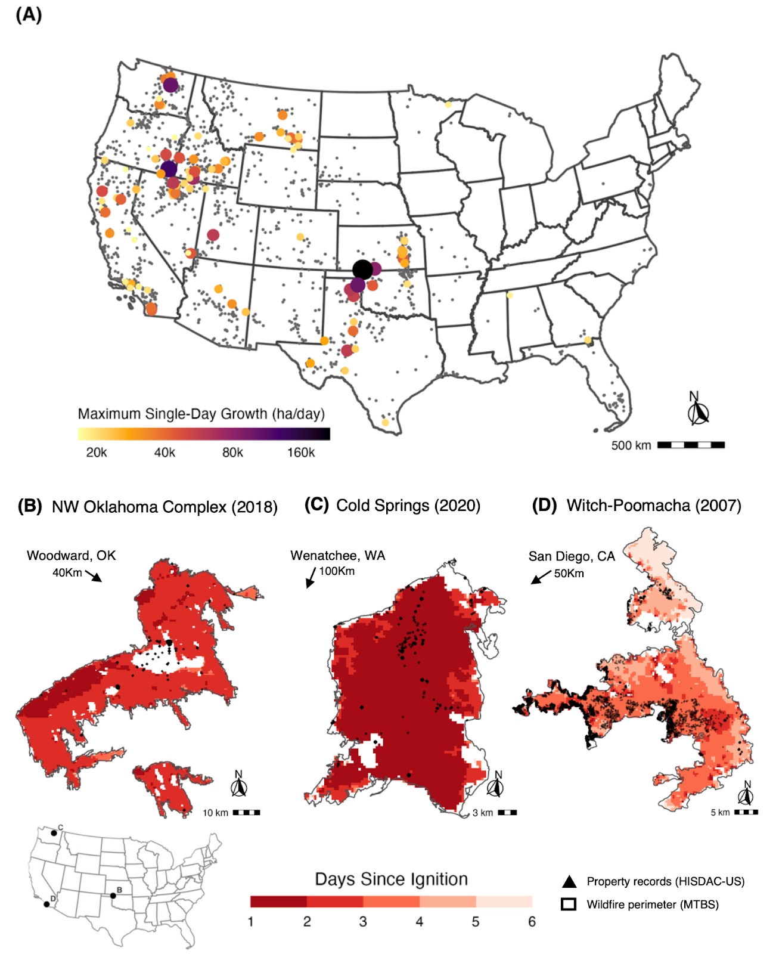

**Fig 1. (A)** Locations of all recorded fast fires (2001-2020, N = 1,616, in gray) in the contiguous United States (CONUS) with the top 100 fastest fires scaled in color and size by their maximum single-day fire growth in hectares/day. The fastest fires occurred primarily in the western United States and in the southeastern plains (Texas and Oklahoma), but across a wide range of ecoregions and fuel types. **(B-D)** Selection of the top 20 fastest fires highlighting the daily burned area from the MODIS Burned Area product (MCD64A1), Fire perimeters from the Monitoring Trends in Burn Severity (MTBS), and approximate locations of properties within the burned area from the HISDAC-US database. **(B)** The Northwest Oklahoma Complex fire in 2018 is the fastest recorded fire in the database with a single day maximum growth of 214,208 ha/day, burning in grasslands; **(C)** the Cold Springs fire in 2020 is part of the destructive labor day fires which burnedin high winds and together with the Pearl Hill and Whitney fires burned over 165,000 hectares in a matter of days. The Cold Springs fire was the largest of the three and burned almost entirely in a single day (102,198 ha/day); **(D)** the Witch and Poomacha fires in 2003 burned just outside of San Diego, CA, directly exposing over 8,000 properties within days (with more than 76,000 properties within 4 km of the burned area) and destroying 1,680 structures, making it one of the most destructive fast fires in the database.

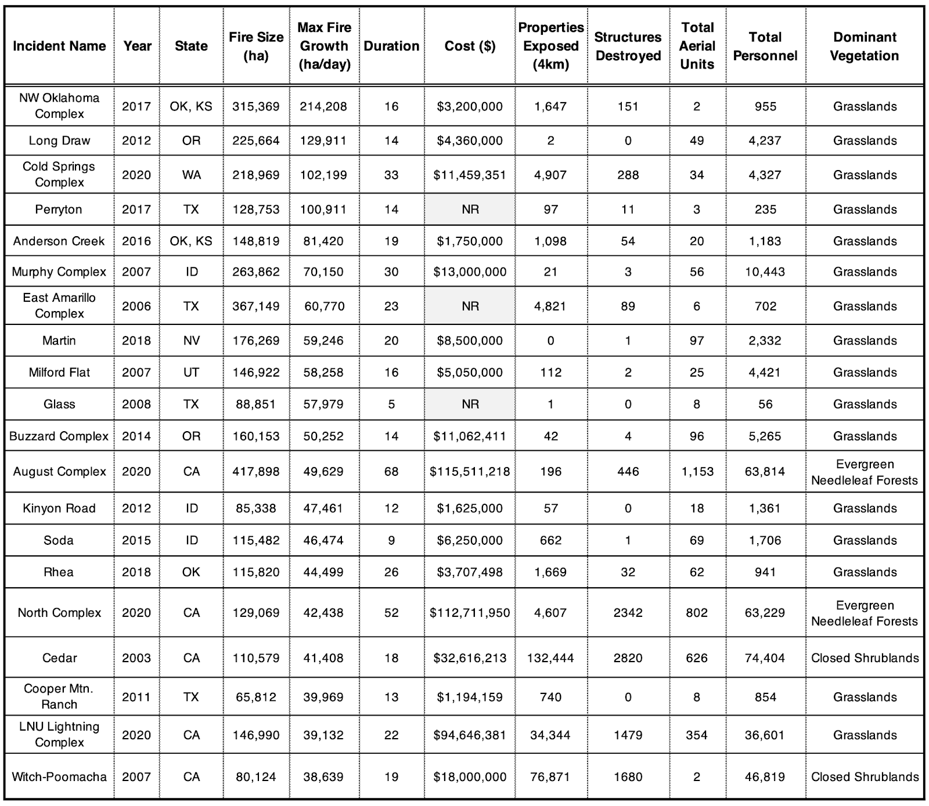

**Table 1. Top 20 fastest growing fires across the contiguous U.S. (2001-2020).** Summary statistics describing the top 20 fastest fires from FIRED linked to their associated incident command system summary report [(*41*)](https://www.zotero.org/google-docs/?5ZLfm1). The top 20 fastest fires accrued an estimated $398M in suppression costs alone, exposed 264,338 properties (within 4 km of a fire perimeter) and destroyed over 9,000 structures. Of the 20 fastest fires, 16 occurred primarily in grassland vegetation types (>50% grassland in burned area).

**Fast fires are also the most destructive and deadly ones**

While there has been substantial focus on megafires defined primarily by their size [(*44*)](https://www.zotero.org/google-docs/?utOyaO), we delineate a critical physical metric that links directly with impact: maximum daily fire growth rate. Treating wildfires as social-environmental extremes [(*40*)](https://www.zotero.org/google-docs/?vnCImW) and defining a subset of events based on *both* their physical behavior and destructive impact advances our understanding and ability to prepare for such events [(*45*)](https://www.zotero.org/google-docs/?oLnYdL). Fires growing faster than 1,620 ha on any single day damage or destroy a large number of structures (Fig. 2). Regression tree analysis (residual mean deviance = 2.39) indicates that one of the best predictors of whether or not a large number of structures were damaged or destroyed was whether the maximum FGR exceeded this threshold of 1,620 ha (Supplemental Materials and Methods). This speed corresponds to the 97th percentile of maximum daily fire growth registered between 2001 and 2020, representing 1,616 events out of 60,012 total events and 60.1% of the burned area in the FIRED record. We, therefore, define “fast fires” as events that grow more than 1,620 ha on a single day (i.e. maximum FGR > 1,620 ha/day). These fast fires represent only 2.7% of all events, yet they account for 77% of the total structures damaged or destroyed. Moreover, only fast fires destroyed more than 600 structures during a single event.

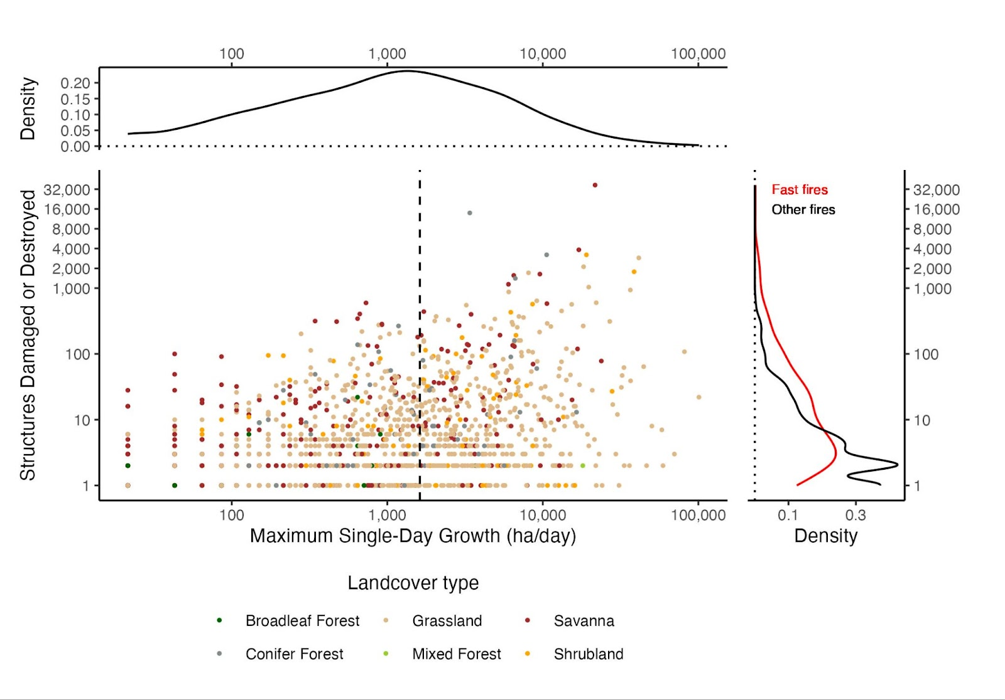

**Fig. 2.** Defining fast fires as a function of social-economic impacts. Scatterplot of maximum fire growth rate and log-transformed number of structures destroyed, with marginal probability density distributions. The dashed line shows the lower bound of growth of ‘fast fires’ (1,620 ha/day or above) that were also the most destructive ones. Note that the axes are in log scale and that only fast fires destroyed more than 600 structures.

Our results document that 58 of the 85 level 3 ecoregions in the contiguous U.S. experienced more than one fast growing fire between 2001 and 2020 (Fig. S4), representing an area of ~3,780,000 square-kilometers or 49% of CONUS land area. According to the ICS-209-PLUS fire suppression records (2001-2020); [(*41*)](https://www.zotero.org/google-docs/?71VJ9x), fast fires threatened 1,780,476 structures (67% of total) and resulted in $18.9 billion of suppression expenditures (61% of total). Moreover, 80,700 structures were destroyed (78% of total), and 57,883 were damaged (82% of total) across this time-period during fast fire events. This subset of fires represents a significant impact to society, including accounting for 337 fatalities (66% of total) and 5,623 injuries (43% of total).

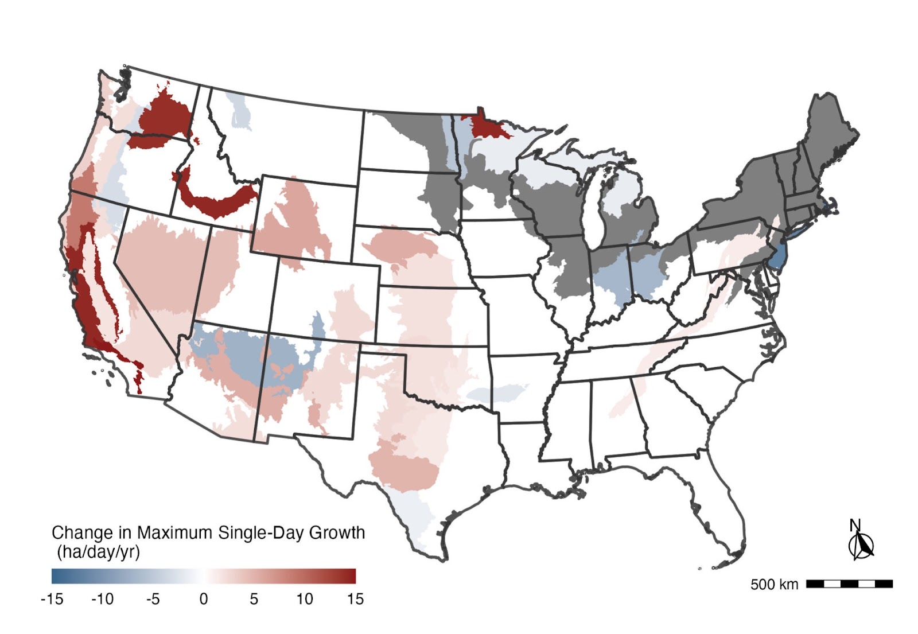

**Fig. 3.** Temporal trends in maximum annual fire growth on a given day for events longer than four days per EPA ecoregion level IV (2001-2020). Statistically-significant positive and negative regression coefficients (p < 0.05) are depicted in warm and cold colors, respectively. Regression coefficients that were not statistically significant from zero (i.e., no significant trend) are shown in white. Ecoregions without sufficient data for the analysis are indicated in gray.

**From 2001-2020, fast fires grew even faster across much of the western U.S.**

For all fires, mean and maximum FGR significantly increased in 38 and 20 ecoregions (84 total level III ecoregions), respectively (mainly in the West). Mean and maximum FGR significantly decreased in 16 and 9 of the ecoregions, respectively (mainly in the northeast; Fig. 3 and Fig. S5). Importantly, most of California’s ecoregions and coastal Oregon and Washington exhibited an increase in growth rate over this period. Most pronounced were the increases in event-level spread and daily growth rates in mediterranean California, with an increase of 300 ha/day in maximum daily growth in Southern California Mountains (Theil-Sen Coefficient = 15.0 ha/day/year; table S5). Across ecoregions in the state of California, the average maximum FGR increased by 4.2 ha/day/year (± 0.4, s.e.), or approximately 80 ha/day across the 19-year record (table S6). The Snake River Plain and Columbia Plateau of the North American Desert ecoregion also saw a substantial increase of more than 278 ha/day in maximum daily growth (Theil-Sen Coefficient = 13.9 ha/day/year; table S5). Across ecoregions in 11 western states, the mean of the maximum FGR increased by 2.1 ha/day/year (± 0.1, s.e.), or approximately 40 ha/day across the 19-year record (table S6). Based on these trends, fires grew 249% faster (based on maximum daily FGR) across the West by the end of the 19-year record (table S7). In California, fires grew 398% faster (based on maximum FGR) by the end of the 19-year record (table S7). (These percentage increases in California and the western U.S. represent the mean of the maximum FGR in 2020 as a percentage of mean maximum fire growth rate in 2001. See Supplemental Methods.)

Using the HISDAC-US Built-up Property Records (HISDAC-US; Uhl et al. 2021), we estimated that 184,917 properties were exposed directly to fast fires (e.g. within the fire perimeter), 722,017 structures were within one km of fast fire perimeters, and 2,948,501 structures were within four km of fast fire perimeters (Fig. 4 and Fig. S6). Firebrands have ignited WUI materials several kilometers from the main fire [(*46*)](https://www.zotero.org/google-docs/?FWOTQa), thus putting structures within this proximity at risk of loss.

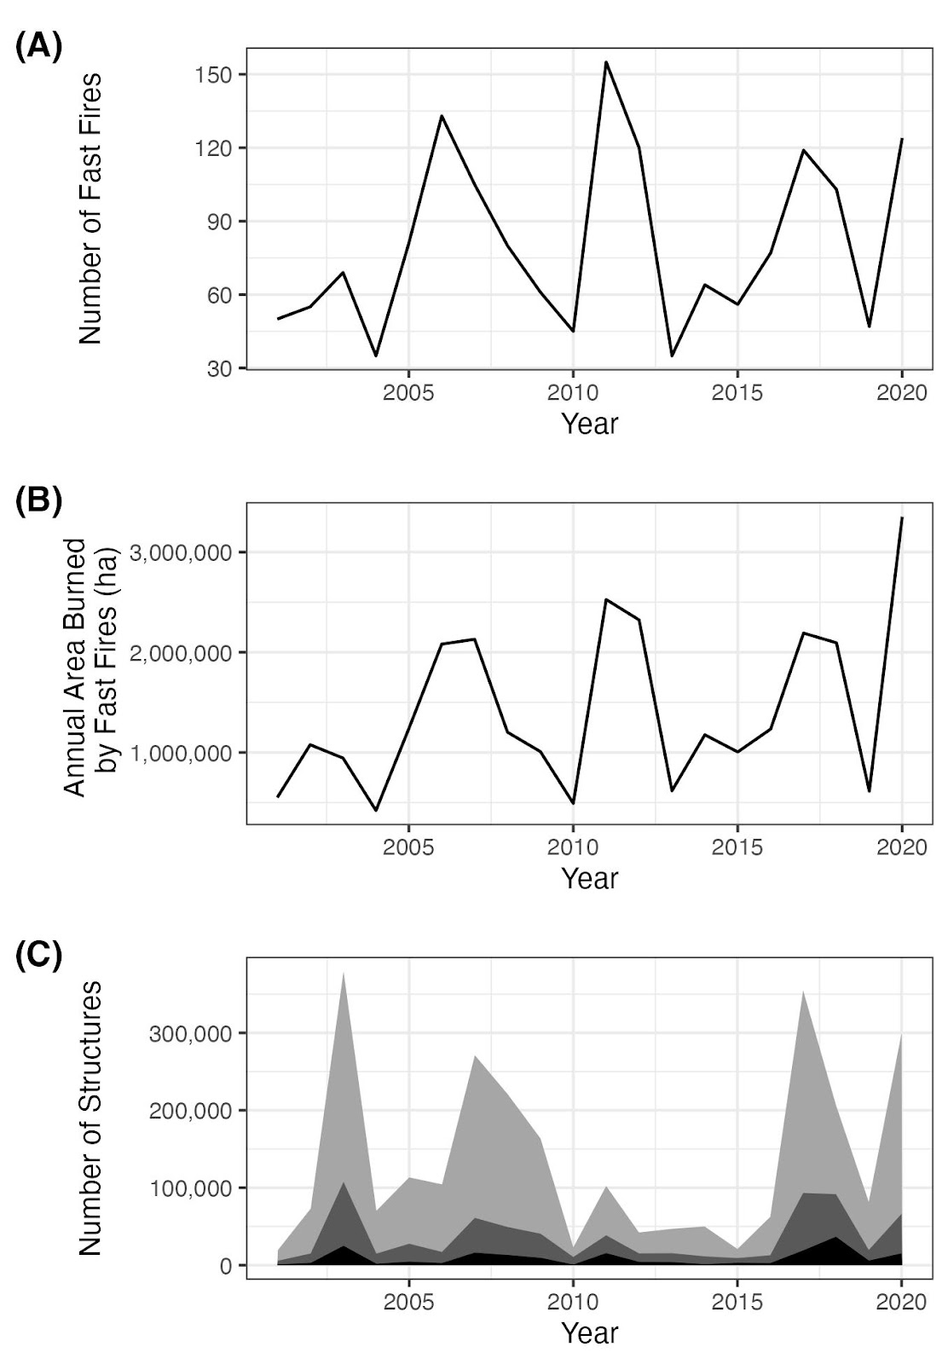

**Fig. 4. Exposure to fast fires (>1,620 ha/day) in 2001-2020.** (**A**) Number of fast fires per year. (**B**) Annual area affected by fast fires. (**C**) Trends in the number of structures within the perimeters of ***fast fires*** (black), within 1 km of the perimeters of fast fires (dark gray), and within 4 km of the perimeters of fast fires (light gray).

**Fire speed matters**

Fast-growing fires (those with a maximum FGR > 1,620 ha/day; 2.7% of total events) were associated with 78% of structures destroyed, and 61% of suppression expenditures between 2001-2020. Further, fires are getting faster in substantial portions of the contiguous U.S.; ecoregions that showed a significant increase in maximum daily growth constitute 48% of the land area (Fig. 2). Across the 11 western states, there was a 249% increase in the mean of the maximum FGR over just two decades (relative to 2001; table S7). These increases in speed have occurred predominantly in the western U.S., which is unsurprising given that annual burned area in the region has increased 444% since the mid-1980s (Fig. S7). As we demonstrate, there is a strong relationship between burned area and growth rate (Fig. S1); growth is the fundamental mechanism that will drive event size and burned area. In order to predict when and where events will have extreme socioeconomic impacts [(*47*)](https://www.zotero.org/google-docs/?c7WQzT), growth rate may be an even more important metric to consider than size or severity. New remote sensing-derived information on growth rate [(*48*)](https://www.zotero.org/google-docs/?uKtftK) offers an important proxy to understand fire speed across events and how it has changed through time. It is an inherent trait of wildfires that as they grow larger, their growth rate increases [(*49*)](https://www.zotero.org/google-docs/?EAXGYG); hence, megafires, by their very nature of being massive, are inherently fast growing. Future work should explore how wildfires spread quickly even before amassing a large footprint. Understanding the unexpected speed of growth, and drivers, will be critical for determining their potential danger.

There are several reasons why fires may be growing faster. Climate-driven increases in burned area have been documented in the U.S. [(*50*)](https://www.zotero.org/google-docs/?mBZEUR), as well as an observed tripling of fire frequency in the 2000s relative to the prior two decades [(*21*)](https://www.zotero.org/google-docs/?7lraxT). The explicit link between climate trends and fire growth is starting to become clear. Recent work demonstrated that daily fire activity is governed by threshold relationships with vapor pressure deficit globally [(*51*)](https://www.zotero.org/google-docs/?8Dw8eE) and with fuel moisture in California [(*9*)](https://www.zotero.org/google-docs/?NUwOol). Juang et al. (2022) found that the rapid increase in western U.S. forest-fire area since the mid-1980s was driven almost exclusively by rapidly increasing sizes of the largest forest fires [(*49*)](https://www.zotero.org/google-docs/?Riw8DC). The proposed mechanism is straight-forward and is a property of geometric growth: larger fires have more potential for growth than smaller fires because fires with longer firelines have greater potential for spread. It is also known that invasive grasses alone can drive increases in size [(*22*)](https://www.zotero.org/google-docs/?gpqc1p), occurrence, and frequency [(*23*)](https://www.zotero.org/google-docs/?zqOVsI). Thus, as grass-fueled fires are some of the fastest (table S2), it may then follow that where vegetation transitions occur, e.g., from forest or shrubland to grassland, fire speed may increase. Instantaneous rate of spread is largely controlled by wind speed [(*52*)](https://www.zotero.org/google-docs/?kOMmGb). And we know that there is a relationship between human ignitions and higher winds [(*12*, *53*)](https://www.zotero.org/google-docs/?FIRYK5), as lightning generally does not occur under high wind conditions due to the constraints surrounding the types of storms that are associated with lightning [(*53*)](https://www.zotero.org/google-docs/?URKXAX). Across the U.S., there has been a steady increase (9%) in the percent of wildfires started by human ignitions since 1992 [(*54*)](https://www.zotero.org/google-docs/?XtTbKd), but it has yet to be tested whether the co-occurence of windy conditions and human ignitions is resulting in faster wildfires.

The speed and timing of fire growth has a significant impact on emergency response, evacuation plans and community preparedness [(*55*)](https://www.zotero.org/google-docs/?VUDMP9). Incident command reports indicate that at least 925 emergency evacuation orders affected over 1.5 million households between 2001-2020 [(*41*)](https://www.zotero.org/google-docs/?vrYrSG); approximately half of these were within a kilometer of a fast fire (Fig. 4). Moreover, fast fires account for 88% of residential structures destroyed in the U.S. (2001-2020). Wildfire-related emergency evacuation success is influenced by the density of human settlements, road access [(*56*, *57*)](https://www.zotero.org/google-docs/?lSka8M), and efficient use of early warning systems and information delivery to impacted communities [(*58*, *59*)](https://www.zotero.org/google-docs/?WwVHny). Humans start nearly all the wildfires that threaten our homes [(*60*)](https://www.zotero.org/google-docs/?sRMNhn), making understanding of the drivers of fire speed critically important. The proximity of ignitions to the WUI and the speed of fire growth may influence emergency management mobilization times and effective communication of evacuation orders ahead of the fire. This impact may be exacerbated in areas of rugged terrain or where dense development coincides with wildland fuels and limited road networks or telecommunication infrastructure [(*57*)](https://www.zotero.org/google-docs/?SXZ0ae), although this is an important area of future research. With maximum daily growth occurring within the first five days after ignition for 83% of all events (Fig. S2B), this also emphasizes the need for preparedness and rapid response during extreme fire events [(*55*)](https://www.zotero.org/google-docs/?Zu67gi). This result reinforces the need to identify and suppress potentially dangerous wildfires before they threaten lives or property [(*61*)](https://www.zotero.org/google-docs/?TbR9u9).

Overall, the patterns and drivers of fire growth rate are important wildfire metrics to understand because fire speed can make wildfires dangerous and destructive. As a consequence, megafires should also be defined and considered based on their speed, not just their size. This work provides a critical advance in understanding national patterns and trends in fire growth rate, but more work is needed to understand fireline speed on finer temporal resolution (e.g., hourly), as this could influence fire containment and evacuation decisions. The fastest growing fires are in grassland systems, highlighting the need to rethink grassland fire management strategies, especially as more and more homes are also being built into these landscapes. Widespread post-fire regeneration failure in western U.S. forests [(*62*)](https://www.zotero.org/google-docs/?kRzXgg) could lead to much of that forest converting to invasive grasslands [(*63*)](https://www.zotero.org/google-docs/?hDhEFU). We expect that these land cover changes combined with increasing aridity and extreme weather events due to climate change will lead to increased occurrence of fast fires. The number of fire events that have destroyed more than 1,000 homes in just the last five years is alarming [(*64*)](https://www.zotero.org/google-docs/?ZU0kI0), and may be an expectation in coming years. Given devastating wildfires, such as the Camp wildfire in California, the Marshall wildfire in Colorado, or the Lahaina wildfire in Hawaii, it is critical to understand the pace of fire as we expect increasing losses in the future.

References and Notes

1. [F. Tedim, V. Leone, M. Amraoui, C. Bouillon, M. Coughlan, G. Delogu, P. Fernandes, C. Ferreira, S. McCaffrey, T. McGee, J. Parente, D. Paton, M. Pereira, L. Ribeiro, D. Viegas, G. Xanthopoulos, Defining Extreme Wildfire Events: Difficulties, Challenges, and Impacts. *Fire* **1**, 9 (2018).](https://www.zotero.org/google-docs/?eD5qVl)
2. [F. H. Johnston, N. Borchers-Arriagada, G. G. Morgan, B. Jalaludin, A. J. Palmer, G. J. Williamson, D. M. J. S. Bowman, Unprecedented health costs of smoke-related PM2.5 from the 2019–20 Australian megafires. *Nat. Sustain.* **4**, 42–47 (2021).](https://www.zotero.org/google-docs/?eD5qVl)
3. [J. K. Balch, B. A. Bradley, J. T. Abatzoglou, R. C. Nagy, E. J. Fusco, A. L. Mahood, Human-started wildfires expand the fire niche across the United States. *Proc. Natl. Acad. Sci.* **114**, 2946–2951 (2017).](https://www.zotero.org/google-docs/?eD5qVl)
4. [N. Mietkiewicz, J. K. Balch, T. Schoennagel, S. Leyk, L. A. St. Denis, B. A. Bradley, In the Line of Fire: Consequences of Human-Ignited Wildfires to Homes in the U.S. (1992–2015). *Fire* **3**, 50 (2020).](https://www.zotero.org/google-docs/?eD5qVl)
5. [M. B. Joseph, M. W. Rossi, N. P. Mietkiewicz, A. L. Mahood, M. E. Cattau, R. C. Nagy, V. Iglesias, J. T. Abatzoglou, J. K. Balch, Spatiotemporal prediction of wildfire size extremes with Bayesian finite sample maxima. *Ecol. Appl.* **29**, 1266–1281 (2019).](https://www.zotero.org/google-docs/?eD5qVl)
6. [R. C. Nagy, E. Fusco, B. Bradley, J. T. Abatzoglou, J. Balch, Human-Related Ignitions Increase the Number of Large Wildfires across U.S. Ecoregions. *Fire* **1**, 4 (2018).](https://www.zotero.org/google-docs/?eD5qVl)
7. [S. A. Parks, J. T. Abatzoglou, Warmer and Drier Fire Seasons Contribute to Increases in Area Burned at High Severity in Western US Forests From 1985 to 2017. *Geophys. Res. Lett.* **47** (2020).](https://www.zotero.org/google-docs/?eD5qVl)
8. [J. Buch, A. P. Williams, C. S. Juang, W. D. Hansen, P. Gentine, SMLFire1.0: a stochastic machine learning (SML) model for wildfire activity in the western United States. *Geosci. Model Dev.* **16**, 3407–3433 (2023).](https://www.zotero.org/google-docs/?eD5qVl)
9. [P. T. Brown, H. Hanley, A. Mahesh, C. Reed, S. J. Strenfel, S. J. Davis, A. K. Kochanski, C. B. Clements, Climate warming increases extreme daily wildfire growth risk in California. *Nature* **621**, 760–766 (2023).](https://www.zotero.org/google-docs/?eD5qVl)
10. [J. D. Coop, S. A. Parks, C. S. Stevens-Rumann, S. M. Ritter, C. M. Hoffman, Extreme fire spread events and area burned under recent and future climate in the western USA. *Glob. Ecol. Biogeogr.* **31**, 1949–1959 (2022).](https://www.zotero.org/google-docs/?eD5qVl)
11. [B. E. Potter, D. McEvoy, Weather Factors Associated with Extremely Large Fires and Fire Growth Days. *Earth Interact.* **25**, 160–176 (2021).](https://www.zotero.org/google-docs/?eD5qVl)
12. [S. Hantson, N. Andela, M. L. Goulden, J. T. Randerson, Human-ignited fires result in more extreme fire behavior and ecosystem impacts. *Nat. Commun.* **13**, 2717 (2022).](https://www.zotero.org/google-docs/?eD5qVl)
13. [A. D. Syphard, J. E. Keeley, M. Gough, M. Lazarz, J. Rogan, What Makes Wildfires Destructive in California? *Fire* **5**, 133 (2022).](https://www.zotero.org/google-docs/?eD5qVl)
14. [R. C. Rothermel, *A Mathematical Model for Predicting Fire Spread in Wildland Fuels* (Intermountain Forest & Range Experiment Station, Forest Service, US …, 1972)vol. 115.](https://www.zotero.org/google-docs/?eD5qVl)
15. [P. L. Andrews, BEHAVE: fire behavior prediction and fuel modeling system. *USDA For. Serv. Gen. Tech. Rep. INT* **194** (1986).](https://www.zotero.org/google-docs/?eD5qVl)
16. [A. L. Sullivan, Wildland surface fire spread modelling, 1990 - 2007. 1: Physical and quasi-physical models. *Int. J. Wildland Fire* **18**, 349 (2009).](https://www.zotero.org/google-docs/?eD5qVl)
17. [A. Maranghides, E. Link, W. “Ruddy” Mell, S. Hawks, M. Wilson, W. Brewer, C. Brown, B. Vihnaneck, W. D. Walton, “A Case Study of the Camp Fire – Fire Progression Timeline” (NIST TN 2135, National Institute of Standards and Technology, Gaithersburg, MD, 2021); https://doi.org/10.6028/NIST.TN.2135.](https://www.zotero.org/google-docs/?eD5qVl)
18. [C. C. Wilson, Fatal and Near-Fatal Forest Fires The Common Denominators. *Int. Fire Chief* **43**, 9–10, 12–15 (1977).](https://www.zotero.org/google-docs/?eD5qVl)
19. [D. A. Falk, E. K. Heyerdahl, P. M. Brown, C. Farris, P. Z. Fulé, D. McKenzie, T. W. Swetnam, A. H. Taylor, M. L. Van Horne, Multi-scale controls of historical forest-fire regimes: new insights from fire-scar networks. *Front. Ecol. Environ.* **9**, 446–454 (2011).](https://www.zotero.org/google-docs/?eD5qVl)
20. [X. Wang, T. Swystun, J. Oliver, M. D. Flannigan, One extreme fire weather event determines the extent and frequency of wildland fires. *Environ. Res. Lett.* **16**, 114031 (2021).](https://www.zotero.org/google-docs/?eD5qVl)
21. [V. Iglesias, J. K. Balch, W. R. Travis, U.S. fires became larger, more frequent, and more widespread in the 2000s. *Sci. Adv.* **8**, eabc0020 (2022).](https://www.zotero.org/google-docs/?eD5qVl)
22. [J. K. Balch, B. A. Bradley, C. M. D’Antonio, J. Gómez-Dans, Introduced annual grass increases regional fire activity across the arid western USA (1980-2009). *Glob. Change Biol.* **19**, 173–183 (2013).](https://www.zotero.org/google-docs/?eD5qVl)
23. [E. J. Fusco, J. T. Finn, J. K. Balch, R. C. Nagy, B. A. Bradley, Invasive grasses increase fire occurrence and frequency across US ecoregions. *Proc. Natl. Acad. Sci.* **116**, 23594–23599 (2019).](https://www.zotero.org/google-docs/?eD5qVl)
24. [P. E. Higuera, M. C. Cook, J. K. Balch, E. N. Stavros, A. L. Mahood, L. A. St. Denis, Shifting social-ecological fire regimes explain increasing structure loss from Western wildfires. *PNAS Nexus* **2**, pgad005 (2023).](https://www.zotero.org/google-docs/?eD5qVl)
25. [C. Naficy, A. Sala, E. G. Keeling, J. Graham, T. H. DeLuca, Interactive effects of historical logging and fire exclusion on ponderosa pine forest structure in the northern Rockies. *Ecol. Appl.* **20**, 1851–1864 (2010).](https://www.zotero.org/google-docs/?eD5qVl)
26. [S. J. Pyne, *Fire in America: A Cultural History of Wildland and Rural Fire* (University of Washington Press, Seattle, Pbk. ed., 1997)*Cycle of fire*.](https://www.zotero.org/google-docs/?eD5qVl)
27. [A. P. Williams, J. T. Abatzoglou, Recent Advances and Remaining Uncertainties in Resolving Past and Future Climate Effects on Global Fire Activity. *Curr. Clim. Change Rep.* **2**, 1–14 (2016).](https://www.zotero.org/google-docs/?eD5qVl)
28. [S. Leyk, J. H. Uhl, D. S. Connor, A. E. Braswell, N. Mietkiewicz, J. K. Balch, M. Gutmann, Two centuries of settlement and urban development in the United States. *Sci. Adv.* **6**, eaba2937 (2020).](https://www.zotero.org/google-docs/?eD5qVl)
29. [H. A. Kramer, V. Butsic, M. H. Mockrin, C. Ramirez-Reyes, P. M. Alexandre, V. C. Radeloff, Post-wildfire rebuilding and new development in California indicates minimal adaptation to fire risk. *Land Use Policy* **107**, 105502 (2021).](https://www.zotero.org/google-docs/?eD5qVl)
30. [G. K. Dillon, J. P. Menakis, F. fay, Wildland Fire Potential: A Tool for Assessing Wildfire Risk and Fuels Management Needs. *USDA For. Serv. Proc. RMRS-P-73*, 17 (2015).](https://www.zotero.org/google-docs/?eD5qVl)
31. [M. A. Finney, C. W. McHugh, I. C. Grenfell, K. L. Riley, K. C. Short, A simulation of probabilistic wildfire risk components for the continental United States. *Stoch. Environ. Res. Risk Assess.* **25**, 973–1000 (2011).](https://www.zotero.org/google-docs/?eD5qVl)
32. [J. R. Haas, D. E. Calkin, M. P. Thompson, A national approach for integrating wildfire simulation modeling into Wildland Urban Interface risk assessments within the United States. *Landsc. Urban Plan.* **119**, 44–53 (2013).](https://www.zotero.org/google-docs/?eD5qVl)
33. [R. G. Haight, D. T. Cleland, R. B. Hammer, V. C. Radeloff, T. S. Rupp, Assessing Fire Risk in the Wildland-Urban Interface. *J. For.* **October/November**, 41–48 (2004).](https://www.zotero.org/google-docs/?eD5qVl)
34. [V. C. Radeloff, D. P. Helmers, H. A. Kramer, M. H. Mockrin, P. M. Alexandre, A. Bar-Massada, V. Butsic, T. J. Hawbaker, S. Martinuzzi, A. D. Syphard, S. I. Stewart, Rapid growth of the US wildland-urban interface raises wildfire risk. *Proc. Natl. Acad. Sci.* **115**, 3314–3319 (2018).](https://www.zotero.org/google-docs/?eD5qVl)
35. [K. Rao, A. P. Williams, N. S. Diffenbaugh, M. Yebra, A. G. Konings, Plant-water sensitivity regulates wildfire vulnerability. *Nat. Ecol. Evol.*, doi: 10.1038/s41559-021-01654-2 (2022).](https://www.zotero.org/google-docs/?eD5qVl)
36. [J. K. Balch, L. A. St. Denis, A. L. Mahood, N. P. Mietkiewicz, T. M. Williams, J. McGlinchy, M. C. Cook, FIRED (Fire Events Delineation): An Open, Flexible Algorithm and Database of US Fire Events Derived from the MODIS Burned Area Product (2001–2019). *Remote Sens.* **12**, 3498 (2020).](https://www.zotero.org/google-docs/?eD5qVl)
37. [L. Giglio, L. Boschetti, D. P. Roy, M. L. Humber, C. O. Justice, The Collection 6 MODIS burned area mapping algorithm and product. *Remote Sens. Environ.* **217**, 72–85 (2018).](https://www.zotero.org/google-docs/?eD5qVl)
38. [S. Leyk, J. H. Uhl, HISDAC-US, historical settlement data compilation for the conterminous United States over 200 years. *Sci. Data* **5**, 180175 (2018).](https://www.zotero.org/google-docs/?eD5qVl)
39. [J. H. Uhl, S. Leyk, C. M. McShane, A. E. Braswell, D. S. Connor, D. Balk, Fine-grained, spatiotemporal datasets measuring 200 years of land development in the United States. *Earth Syst. Sci. Data* **13**, 119–153 (2021).](https://www.zotero.org/google-docs/?eD5qVl)
40. [J. K. Balch, V. Iglesias, A. E. Braswell, M. W. Rossi, M. B. Joseph, A. L. Mahood, T. R. Shrum, C. T. White, V. M. Scholl, B. McGuire, C. Karban, M. Buckland, W. R. Travis, Social‐Environmental Extremes: Rethinking Extraordinary Events as Outcomes of Interacting Biophysical and Social Systems. *Earths Future* **8** (2020).](https://www.zotero.org/google-docs/?eD5qVl)
41. [L. A. St. Denis, K. C. Short, K. McConnell, M. C. Cook, N. P. Mietkiewicz, M. Buckland, J. K. Balch, All-hazards dataset mined from the US National Incident Management System 1999–2020. *Sci. Data* **10**, 112 (2023).](https://www.zotero.org/google-docs/?eD5qVl)
42. [M. Goss, D. L. Swain, J. T. Abatzoglou, A. Sarhadi, C. A. Kolden, A. P. Williams, N. S. Diffenbaugh, Climate change is increasing the likelihood of extreme autumn wildfire conditions across California. *Environ. Res. Lett.* **15**, 094016 (2020).](https://www.zotero.org/google-docs/?eD5qVl)
43. [M. A. Moritz, M.-A. Parisien, E. Batllori, M. A. Krawchuk, J. Van Dorn, D. J. Ganz, K. Hayhoe, Climate change and disruptions to global fire activity. *Ecosphere* **3**, art49 (2012).](https://www.zotero.org/google-docs/?eD5qVl)
44. [S. L. Stephens, N. Burrows, A. Buyantuyev, R. W. Gray, R. E. Keane, R. Kubian, S. Liu, F. Seijo, L. Shu, K. G. Tolhurst, J. W. van Wagtendonk, Temperate and boreal forest mega-fires: characteristics and challenges. *Front. Ecol. Environ.* **12**, 115–122 (2014).](https://www.zotero.org/google-docs/?eD5qVl)
45. [M. C. Cook, “Drivers of wildfire-related home loss across the western United States 2001-2018,” thesis, University of Colorado (2021).](https://www.zotero.org/google-docs/?eD5qVl)
46. [C. A. Kolden, C. Henson, A Socio-Ecological Approach to Mitigating Wildfire Vulnerability in the Wildland Urban Interface: A Case Study from the 2017 Thomas Fire. *Fire* **2**, 9 (2019).](https://www.zotero.org/google-docs/?eD5qVl)
47. [J. K. Balch, V. Iglesias, A. E. Braswell, M. W. Rossi, M. B. Joseph, A. L. Mahood, T. R. Shrum, C. T. White, V. M. Scholl, B. McGuire, C. Karban, M. Buckland, W. R. Travis, Social‐Environmental Extremes: Rethinking Extraordinary Events as Outcomes of Interacting Biophysical and Social Systems. *Earths Future* **8** (2020).](https://www.zotero.org/google-docs/?eD5qVl)
48. [J. K. Balch, L. A. St. Denis, A. L. Mahood, N. P. Mietkiewicz, T. M. Williams, J. McGlinchy, M. C. Cook, FIRED (Fire Events Delineation): An Open, Flexible Algorithm and Database of US Fire Events Derived from the MODIS Burned Area Product (2001–2019). *Remote Sens.* **12**, 3498 (2020).](https://www.zotero.org/google-docs/?eD5qVl)
49. [C. S. Juang, A. P. Williams, J. T. Abatzoglou, J. K. Balch, M. D. Hurteau, M. A. Moritz, Rapid Growth of Large Forest Fires Drives the Exponential Response of Annual Forest‐Fire Area to Aridity in the Western United States. *Geophys. Res. Lett.* **49**, e2021GL097131 (2022).](https://www.zotero.org/google-docs/?eD5qVl)
50. [J. T. Abatzoglou, A. P. Williams, Impact of anthropogenic climate change on wildfire across western US forests. *Proc. Natl. Acad. Sci.* **113**, 11770–11775 (2016).](https://www.zotero.org/google-docs/?eD5qVl)
51. [J. K. Balch, J. T. Abatzoglou, M. B. Joseph, M. J. Koontz, A. L. Mahood, J. McGlinchy, M. E. Cattau, A. P. Williams, Warming weakens the night-time barrier to global fire. *Nature* **602**, 442–448 (2022).](https://www.zotero.org/google-docs/?eD5qVl)
52. [M. G. Cruz, M. E. Alexander, M. Kilinc, Wildfire Rates of Spread in Grasslands under Critical Burning Conditions. *Fire* **5**, 55 (2022).](https://www.zotero.org/google-docs/?eD5qVl)
53. [J. T. Abatzoglou, J. K. Balch, B. A. Bradley, C. A. Kolden, J. T. Abatzoglou, J. K. Balch, B. A. Bradley, C. A. Kolden, Human-related ignitions concurrent with high winds promote large wildfires across the USA. *Int. J. Wildland Fire* **27**, 377–386 (2018).](https://www.zotero.org/google-docs/?eD5qVl)
54. [M. E. Cattau, C. Wessman, A. Mahood, J. K. Balch, Anthropogenic and lightning‐started fires are becoming larger and more frequent over a longer season length in the U.S.A. *Glob. Ecol. Biogeogr.* **29**, 668–681 (2020).](https://www.zotero.org/google-docs/?eD5qVl)
55. [T. J. Cova, D. Li, L. K. Siebeneck, F. A. Drews, Toward Simulating Dire Wildfire Scenarios. *Nat. Hazards Rev.* **22**, 06021003 (2021).](https://www.zotero.org/google-docs/?eD5qVl)
56. [P. E. Dennison, T. J. Cova, M. A. Mortiz, WUIVAC: a wildland-urban interface evacuation trigger model applied in strategic wildfire scenarios. *Nat. Hazards* **41**, 181–199 (2007).](https://www.zotero.org/google-docs/?eD5qVl)
57. [M. A. Moritz, E. Batllori, R. A. Bradstock, A. M. Gill, J. Handmer, P. F. Hessburg, J. Leonard, S. McCaffrey, D. C. Odion, T. Schoennagel, A. D. Syphard, Learning to coexist with wildfire. *Nature* **515**, 58–66 (2014).](https://www.zotero.org/google-docs/?eD5qVl)
58. [E. Kuligowski, Evacuation decision-making and behavior in wildfires: Past research, current challenges and a future research agenda. *Fire Saf. J.* **120**, 103129 (2021).](https://www.zotero.org/google-docs/?eD5qVl)
59. [J. McLennan, B. Ryan, C. Bearman, K. Toh, Should We Leave Now? Behavioral Factors in Evacuation Under Wildfire Threat. *Fire Technol.* **55**, 487–516 (2019).](https://www.zotero.org/google-docs/?eD5qVl)
60. [N. Mietkiewicz, J. K. Balch, T. Schoennagel, S. Leyk, L. A. St. Denis, B. A. Bradley, In the Line of Fire: Consequences of Human-Ignited Wildfires to Homes in the U.S. (1992–2015). *Fire* **3**, 50 (2020).](https://www.zotero.org/google-docs/?eD5qVl)
61. [D. E. Calkin, J. D. Cohen, M. A. Finney, M. P. Thompson, How risk management can prevent future wildfire disasters in the wildland-urban interface. *Proc. Natl. Acad. Sci.* **111**, 746–751 (2014).](https://www.zotero.org/google-docs/?eD5qVl)
62. [K. T. Davis, S. Z. Dobrowski, P. E. Higuera, Z. A. Holden, T. T. Veblen, M. T. Rother, S. A. Parks, A. Sala, M. P. Maneta, Wildfires and climate change push low-elevation forests across a critical climate threshold for tree regeneration. *Proc. Natl. Acad. Sci.* **116**, 6193–6198 (2019).](https://www.zotero.org/google-docs/?eD5qVl)
63. [B. K. Kerns, C. Tortorelli, M. A. Day, T. Nietupski, A. M. G. Barros, J. B. Kim, M. A. Krawchuk, Invasive grasses: A new perfect storm for forested ecosystems? *For. Ecol. Manag.* **463**, 117985 (2020).](https://www.zotero.org/google-docs/?eD5qVl)
64. [K. Barrett, T. Preston, K. Pohl, P. Hernandez, “Wildfires destroy thousands of structures each year” (Headwaters Economics, 2020); https://headwaterseconomics.org/natural-hazards/structures-destroyed-by-wildfire/.](https://www.zotero.org/google-docs/?eD5qVl)
65. [J. Eidenshink, B. Schwind, K. Brewer, Z.-L. Zhu, B. Quayle, S. Howard, A Project for Monitoring Trends in Burn Severity. *Fire Ecol.* **3**, 3–21 (2007).](https://www.zotero.org/google-docs/?eD5qVl)
66. [Commission for Environmental Cooperation, Ecological regions of North America: toward a common perspective. (2006).](https://www.zotero.org/google-docs/?eD5qVl)
67. [J. M. Omernik, G. E. Griffith, Ecoregions of the Conterminous United States: Evolution of a Hierarchical Spatial Framework. *Environ. Manage.* **54**, 1249–1266 (2014).](https://www.zotero.org/google-docs/?eD5qVl)
68. [Y. Chen, S. Hantson, N. Andela, S. R. Coffield, C. A. Graff, D. C. Morton, L. E. Ott, E. Foufoula-Georgiou, P. Smyth, M. L. Goulden, J. T. Randerson, California wildfire spread derived using VIIRS satellite observations and an object-based tracking system. *Sci. Data* **9**, 249 (2022).](https://www.zotero.org/google-docs/?eD5qVl)
69. [A. DeCastro, “Integrating Remote Sensing, Behavior Modeling, and Machine Learning to Better Understand the Patterns and Drivers of Wildfire,” thesis, University of Colorado Boulder (2022).](https://www.zotero.org/google-docs/?eD5qVl)
70. [P. K. Sen, Estimates of the Regression Coefficient Based on Kendall’s Tau. *J. Am. Stat. Assoc.* **63**, 1379–1389 (1968).](https://www.zotero.org/google-docs/?eD5qVl)
71. [X. Wang, Q. Yu, Unbiasedness of the Theil–Sen estimator. *J. Nonparametric Stat.* **17**, 685–695 (2005).](https://www.zotero.org/google-docs/?eD5qVl)
72. [L. A. St. Denis, N. P. Mietkiewicz, K. C. Short, M. Buckland, J. K. Balch, All-hazards dataset mined from the US National Incident Management System 1999–2014. *Sci. Data* **7**, 64 (2020).](https://www.zotero.org/google-docs/?eD5qVl)
73. [L. Breiman, J. H. Friedman, R. A. Olshen, C. J. Stone, *Classification And Regression Trees* (Routledge, ed. 1, 1984; https://www.taylorfrancis.com/books/9781351460491).](https://www.zotero.org/google-docs/?eD5qVl)
74. [J. H. Uhl, S. Leyk, Uncertainty surfaces accompanying the BUPR, BUPL, and BUA gridded surface series, Harvard Dataverse (2020); https://doi.org/10.7910/DVN/T8H5KF.](https://www.zotero.org/google-docs/?eD5qVl)
75. [A. C. Fernandez-Pello, Wildland fire spot ignition by sparks and firebrands. *Fire Saf. J.* **91**, 2–10 (2017).](https://www.zotero.org/google-docs/?eD5qVl)

**Acknowledgments:** We are grateful to Stephen Pyne, Nathan Mietkiewicz, Michael Koontz, and Johannes Uhl for discussions that informed this effort.

**Funding:**

Earth Lab, University of Colorado - Boulder, Grand Challenge and CIRES (JKB, RCN, CA, EV, TT, VI, AM, LS)

National Science Foundation Macrosystems Program grant 2017889 (JKB, TLM)

National Science Foundation CAREER Program grant 1846384 (JKB, TLM)

National Science Foundation HNDS-I Program grant 2121976 (SL, JKB)

Joint Fire Sciences Program grant 21-2-02-29 (JKB, MC)

Zegar Family Foundation and the Moore Foundation (APW)

**Author contributions:**

Conceptualization: JKB, ALM, VI, MCC, APW

Methodology: JKB, ALM, VI, MCC, AD

Investigation: JKB, ALM, VI, MCC, RCN, AD

Visualization: VI, MCC, ALM, TLM, JKB

Data Curation: CA, EV, LS, MCC, JKB

Software: CA, EV, MCC, TT, JKB

Funding acquisition: JKB, RCN

Project administration: JKB, RCN

Supervision: JKB

Writing – original draft: JKB, ALM, VI, MCC, APW, RCN, TT, SL, CK, AD, CA

Writing – review & editing: JKB, ALM, VI, MCC, APW, RCN, TT, TLM, SL, CK, AD, CA

**Competing interests:** Authors declare that they have no competing interests.

**Data and materials availability:** All data used in this analysis is publicly available at the following DOIs and URLs. All code used in this analysis is available at https://github.com/viriglesias/fast-fires. All-hazards dataset mined from the US National Incident Management System 1999-2020: https://doi.org/10.6084/m9.figshare.19858927.v3. Fire Events Delineation (FIRED) CONUS-AK 2001-2022: https://scholar.colorado.edu/concern/datasets/d504rm74m. United States Environmental Protection Agency ecoregions: https://www.epa.gov/eco-research/ecoregions. Monitoring Trends in Burn Severity (MTBS): https://www.mtbs.gov/.

Supplementary Materials

Materials and Methods

Figs. S1 to S7

Tables S1 to S7

References (*65*–*75*)