

Supplementary Materials for

The fastest growing and most destructive fires in the U.S. (2000-2020)

Jennifer K. Balch, Virginia Iglesias, Adam L. Mahood, Maxwell C. Cook, Cibele Amaral, Amy DeCastro, Stefan Leyk, Tyler L. McIntosh, R. Chelsea Nagy, Lise St. Denis, Ty Tuff, Erick Verleye, A. Park Williams, Crystal A. Kolden

Correspondence to: [Jennifer.Balch@colorado.edu](mailto:Jennifer.Balch@colorado.edu)

**This PDF file includes:**

Materials and Methods

Figs. S1 to S7

Table Descriptions S1-S5

Tables S6 to S7

**Other Supplementary Materials for this manuscript include the following:**

Tables S1-S5

Materials and Methods

I. Characterizing fire growth rates for 60,000 events across the contiguous U.S.

We used the Fire Event Delineation algorithm (FIRED) [(*36*)](https://www.zotero.org/google-docs/?3OzJs5) to define fire events from which we obtained information on the daily progression of all fires in the U.S. from the MODIS Collection 6 MCD64A1 Burned Area Product for 2001-2020. FIRED is a spatiotemporal flooding algorithm that inputs an area of interest, temporal extent, and spatial and temporal parameters, and uses these inputs to group gridded, daily burned area detections into events. We used spatio-temporal parameters of five 463-m pixels and 11 days based on a Monitoring Trends in Burn Severity (MTBS)-based optimization [(*36*, *65*)](https://www.zotero.org/google-docs/?44y1oq). FIRED outputs each event as a single fire perimeter as well as daily progression maps. In order to minimize the confounding effect of fires that were intentionally started, we excluded croplands. We utilized 60,012 events for these analyses. For each fire event, we calculated the fire growth rate (FGR) for an entire fire event, and the maximum single-day fire growth rate, or maximum FGR. FGR was calculated as the burned area for the entire event divided by the duration, and maximum FGR was the area burned on the day with the largest burned area.

Fire growth rate in the contiguous U.S. is highly variable. To identify areas of fast versus slow fire spread, we overlaid the FIRED data layers with Environmental Protection Agency level IV ecoregions [(*66*)](https://www.zotero.org/google-docs/?iSA7S0). These ecoregions reflect spatial differences in geology, landforms, soils, vegetation, climate, land use, wildlife, and hydrology [(*67*)](https://www.zotero.org/google-docs/?GYxKAC). For each ecoregion, we calculated the maximum FGR (single day within an event), median FGR (across an event), and mean FGR (across an event).

It is important to note that daily growth rate is not equivalent to the spread rate of an actual fireline, although they are certainly related variables. Daily growth rate is integrated across a burned area pixel (~25 ha, or 250,000 m2) on an approximate daily basis based on the temporal resolution of the MODIS burned area product (MCD64A1). The MCD64A1 approximates the day of burning based on rapid changes in MODIS surface reflectance and is thus subject to uncertainties based on image quality, availability, and the output of the change detection algorithm [(*37*)](https://www.zotero.org/google-docs/?gitutY). Work is being done to integrate active fire satellite products to better characterize linear fireline spread on much finer spatial and temporal resolutions [(*68*)](https://www.zotero.org/google-docs/?OUT4q7) and to understand how to approximate linear growth from areal growth [(*69*)](https://www.zotero.org/google-docs/?xIyY8L).

II. Detecting temporal trends in fire growth rates and event duration (2001-2020)

To identify temporal changes in fire dynamics, we produced a time series of maximum annual FGR (i.e., at one-year timesteps) for each level III ecoregion [(*66*)](https://www.zotero.org/google-docs/?t393ph). We chose to segment the contiguous U.S. with level III ecoregions, which are coarser than level IV ecoregions, to ensure that most time series had sufficient data points to allow for meaningful trend analysis and detection.

The probabilistic distribution of fire growth rates has a very heavy left tail. To obtain robust temporal trends, we excluded events shorter than five days and ecoregions with less than 10 data points. We then used the Theil-Sen estimator to fit linear models to the time series that satisfied these conditions. By estimating the median of all slopes defined by all pairs of points in a two-dimensional space [(*70*)](https://www.zotero.org/google-docs/?MQidFa), this method provides an unbiased estimate of the regression slope [(*71*)](https://www.zotero.org/google-docs/?hWRrit) and it is less sensitive to outliers. The statistical significance of each trend was assessed with Wilcoxon tests (p < 0.05).

We also estimated trends in maximum FGR in California and the 11 western states (table S6), where most fast fires have taken place (i.e., Washington, Oregon, California, Idaho, Utah, Nevada, Arizona, Montana, Wyoming, Colorado, and New Mexico). To this end, we produced time series of maximum single-day growth for ecoregions within California or the western U.S. boundary and excluded events shorter than five days. We then randomly drew 2,500 bootstrap samples with replacement from the resulting data set and used the Theil-Sen estimator to compute the Kendall-Theil robust line (or Sen’s slope). We repeated this procedure 1,000 times. This allowed us to estimate the standard errors of the mean and median regression slope and intercepts.

III. Defining fast fires based on societal impact

Fire impacts depend not only on the physical properties of fire but also on the assets in harm’s way. This work operationalizes a definition of fast fires, based on a framework that defines socio-environmental extremes given both their physical characteristics and social consequences [(*47*)](https://www.zotero.org/google-docs/?R7kbtD). Defining fast fires required partitioning the continuum of fire speeds into two discrete classes, fast and non-fast. Given that ‘fast’ is a relative concept, the threshold between these classes is conditioned by the fundamental question of ‘fast with respect to what?’. Here, we focus on fires whose spread rates are higher than those that are not likely to have significant societal impact.

To estimate this threshold, we constructed a dataset that combined fire growth rates from FIRED [(*36*)](https://www.zotero.org/google-docs/?prdyln) and information on the number of structures damaged or destroyed per event obtained from incident command reports [(*72*)](https://www.zotero.org/google-docs/?iNvJFo) via spatiotemporal overlay. To account for the negligible potential of fires in remote areas to affect the built environment, we excluded from the dataset all fires that had not damaged or destroyed any structures. We then applied a regression tree [(*73*)](https://www.zotero.org/google-docs/?2ThZbd) to predict the number of structures damaged or destroyed as a function of maximum fire growth on a single day. The resulting tree was pruned to obtain two classes of fires, i.e., ‘very destructive’ and ‘not very destructive’. Prior to fitting the model, the data were log-transformed to reduce the influence of anomalously large values on the classification.

The regression tree results indicate (Fig. 2) that fires with a maximum FGR greater than 1,620 ha/day damage or destroy a larger number of structures. We choose this threshold as the minimum growth rate for a wildfire to be considered ‘fast’. For each EPA ecoregion level IV, we calculated the total number of fast fires and the proportion of fast to total fires in 2001-2020.

IV. Assessing the exposure of the built environment to fast fires

To assess the exposure of the built environment to fast fires, we obtained information from the Historic Settlement Data Compilation of the U.S (HISDAC-US) Built-up Property Records (BUPR) [(*38*)](https://www.zotero.org/google-docs/?hYTtnx) which is based on Zillow’s Transaction and Assessment Database (ZTRAX). The ZTRAX database offers a unique source of gridded property information at fine spatial (250 m) and temporal (semi-decade) resolutions (1810-2015). It is worth noting that some uncertainties exist in the ZTRAX database. For example, the ZTRAX database is incomplete in some regions or does not fully account for the number of built structures on the property [(*74*)](https://www.zotero.org/google-docs/?TJvFrD). Additionally, the database may not capture areas of significant rebuild following disturbances, which may impact the count of structures in regions with multiple fires or other natural hazards. Despite these limitations, which are propagated to HISDAC-US, these data sets provide critical information on the location of structures within the built environment.

We calculated trends in exposure to fast fires across the contiguous U.S. by overlaying the perimeters of fast fires (1,620 ha/day maximum FGR) between 2001-2020 and HISDAC-US. Specifically, we calculated the annual number of structures within fast fire perimeters, as well as within 1 and 4 km of these fires. We chose to summarize the number of properties exposed to fast fires within 4 km of perimeters due to the risk of long-distance ember throw and home ignition at the fire front [(*75*)](https://www.zotero.org/google-docs/?CKpUEC).

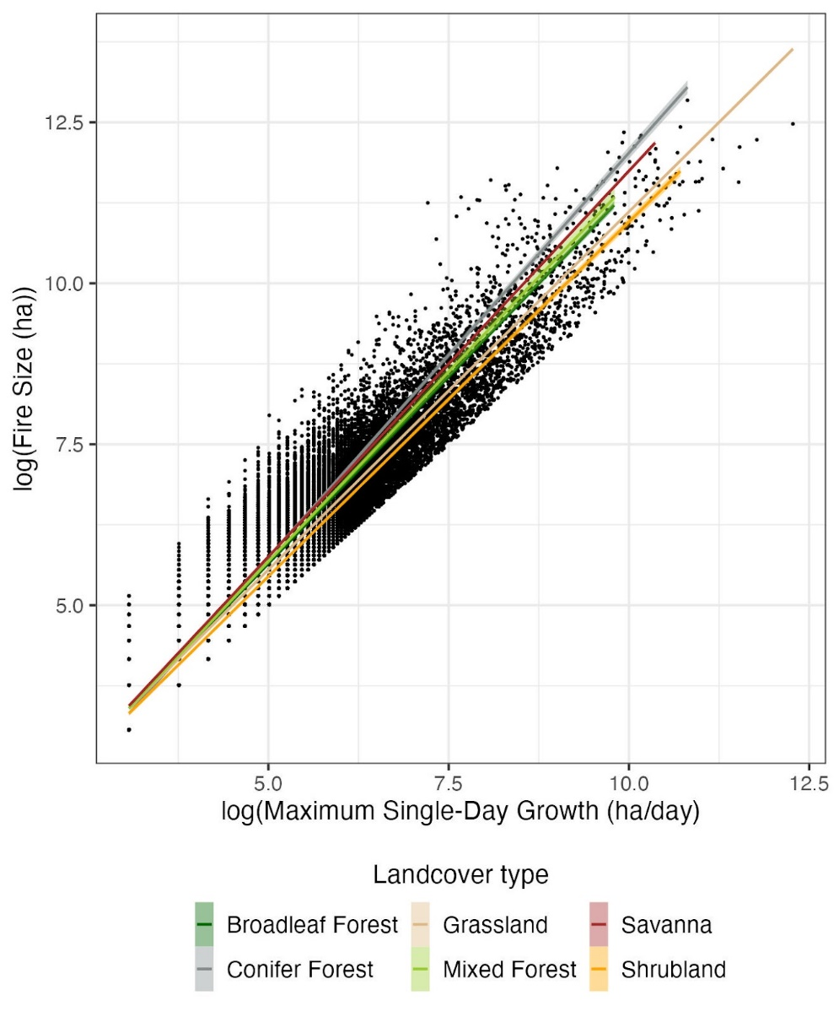

Fig. S1.

**Relationship between maximum daily fire growth rate and final fire size in each land cover class in 2000-2020.** The log-log transformed variables are strongly correlated, suggesting that they follow a power law (broadleaf forest: coeff = 1.16, adjusted R2 = 0.9; conifer forest: coeff = 1.26, adjusted R2 = 0.919; grassland: coeff = 1.11, adjusted R2 = 0.924; mixed forest: coeff = 1.18, adjusted R2 = 0.878; savanna: coeff = 1.2, adjusted R2 = 0.882; shrubland: coeff = 1.1, adjusted R2 = 0.96).

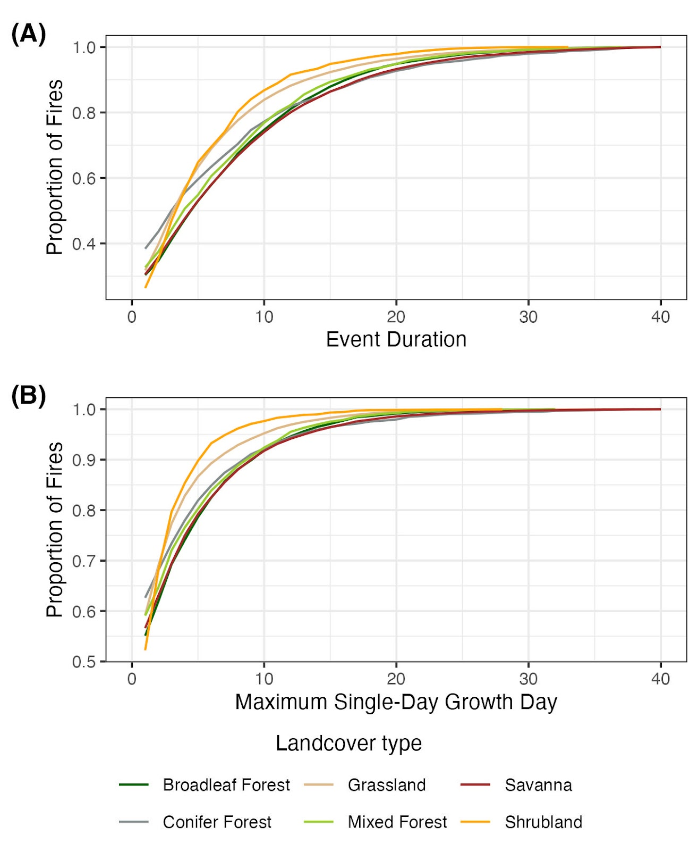

Fig. S2.

Empirical cumulative distribution of (**A**) fire duration and (**B**) maximum growth day for all fires analyzed.

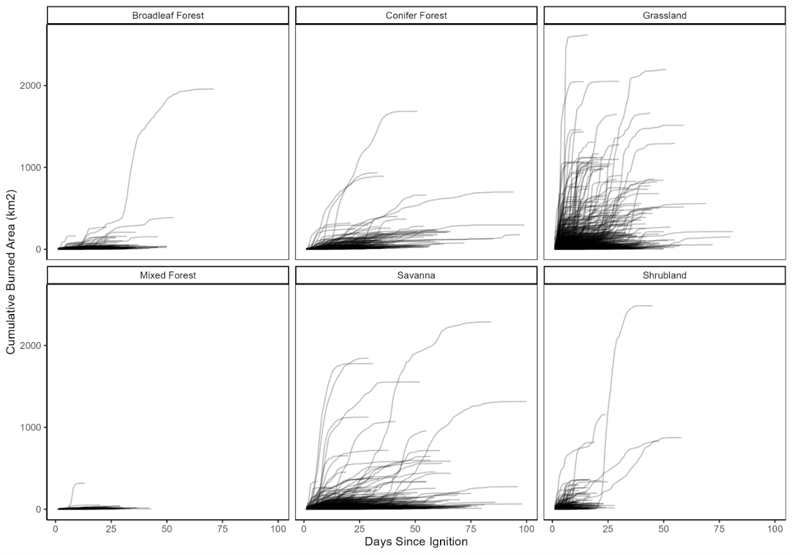

Fig. S3.

**Cumulative area burned by the modal land cover type of the event**. Most fires that become very large are characterized by a short period of rapid growth. The time period immediately following ignition often has the most fire growth, but the variation in the day of extreme fire growth shows that there is not necessarily one critical period for management. In grasslands and savannas, for many fires almost all of the burned area occurs in a few days. This can occur immediately after ignition, or in many cases pulses of rapid fire growth follow periods of little to no growth.

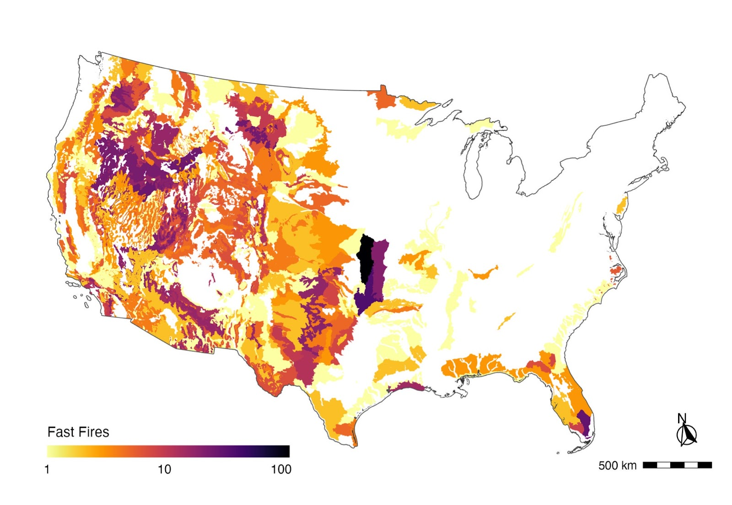

Fig. S4.

**Number of fast fires (>1,620ha/day maximum FGR) per EPA ecoregion level IV (2001-2020).** Ecoregions that were not affected by fast fires in 2000-2020 are shown in white.

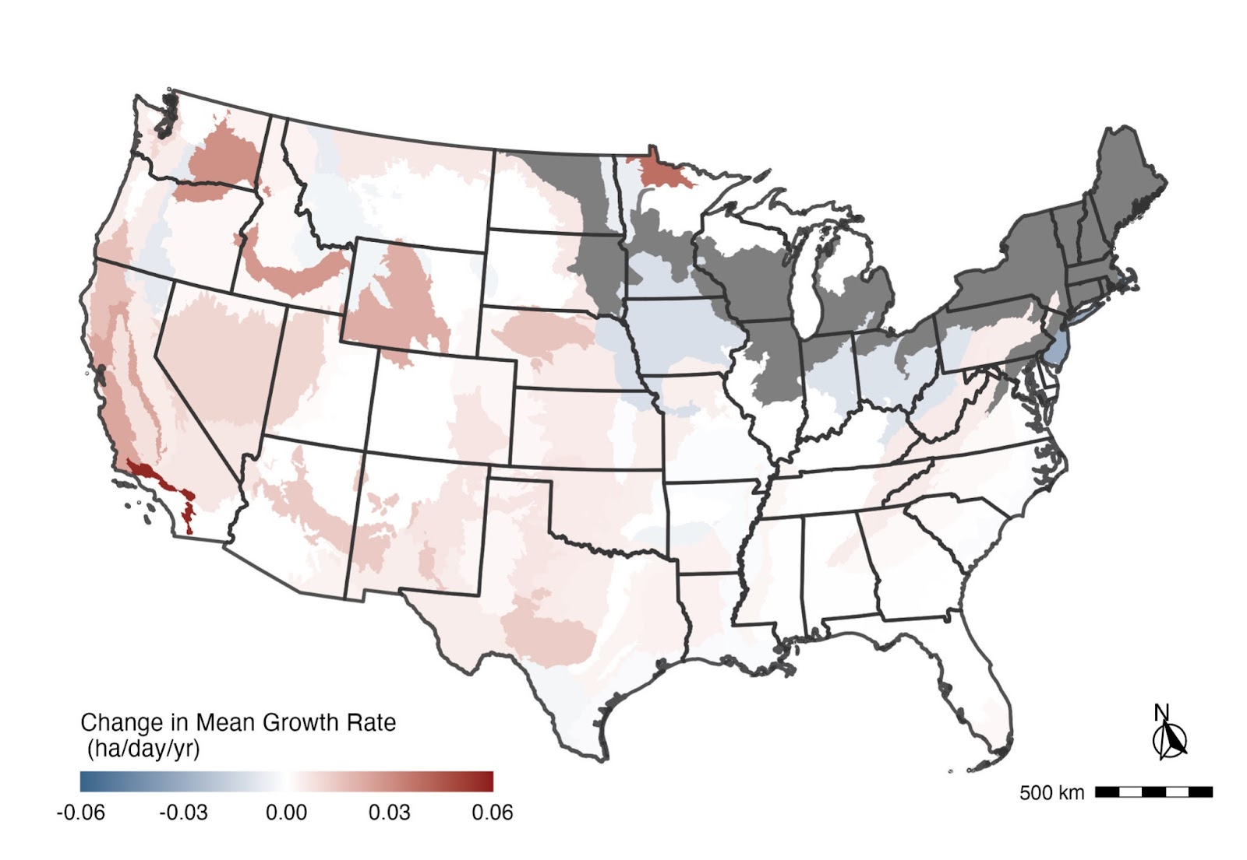

Fig. S5.

**Temporal trends in mean fire growth** for events longer than four days per EPA ecoregion level IV (2001-2020). Statistically-significant positive and negative regression coefficients (p<0.05) are depicted in warm and cold colors, respectively. Regression coefficients that were not statistically significant from zero (i.e., no significant trend) are shown in white. Ecoregions without sufficient data for the analysis are indicated in gray.

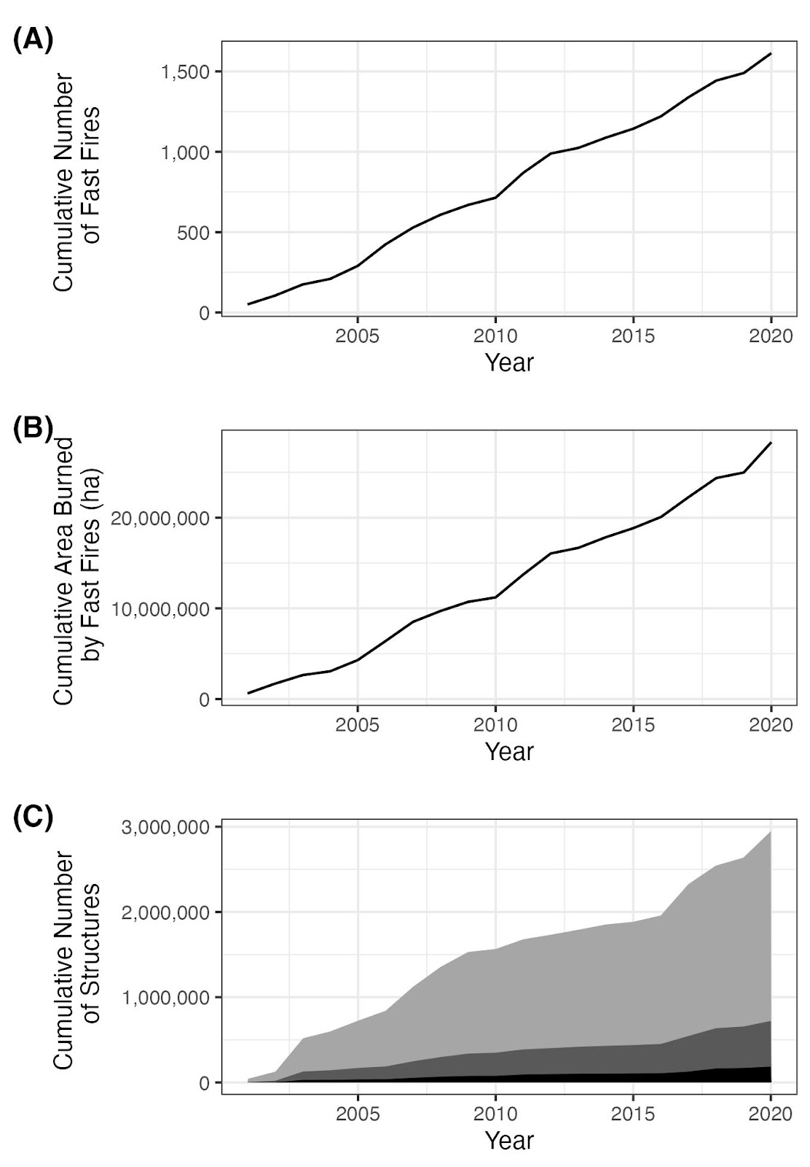

Fig. S6.

Exposure to fast fires (>1,620 ha/day) in 2001-2020. (A) Cumulative number of fast fires. (B) Cumulative area affected by fast fires. (C) Trends in the cumulative number of structures within the perimeters of *fast fires* (black), within 1 km of the perimeters of fast fires (dark gray), and within 4 km of the perimeters of fast fires (light gray).

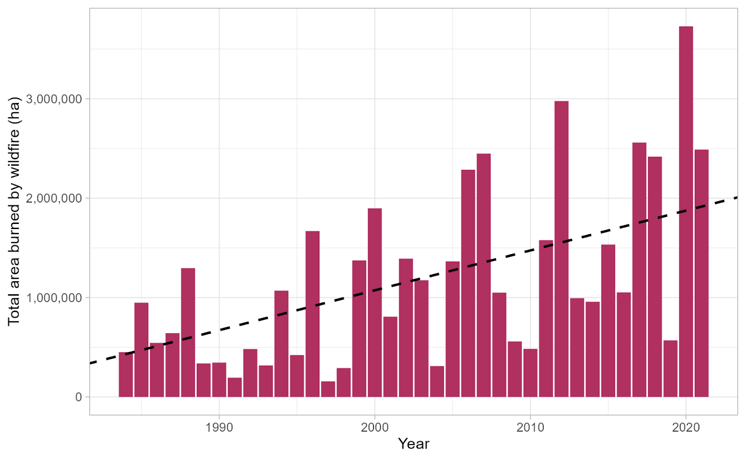

Fig. S7.

**Increase in western United States annual burned area, 1984-2021.** Annual burned area from large wildfires (>400 ha) in the western U.S. is based on the MTBS for 1984-2021. Trend line determined by Theil-Sen regression, coefficient = 40,109 ha/year (*p* <0.0001). Trend burned area as a percentage of 1984 grew to 444% in 2021.

Table S1.

**Ecoregion Fire Characteristic Summaries, 2001-2020.** Ecoregions marked with “*” are defined by EPA Level I Ecoregions. Within the contiguous United States 60,012 fires were included for analysis, of which 1,616 (2.69%) were Fast. The mean of the single day maximum fire growth rate was 297.9 ha/day. Reported characteristics include: *Median Single Day Maximum Fire Growth Rate (ha / day), Mean Single Day Maximum Fire Growth Rate (ha / day), Maximum Single Day Maximum Fire Growth Rate (ha / day), Median Fire Growth Rate (ha / day), Mean Fire Growth Rate (ha / day), Median Fire Duration (days), Mean Fire Duration (days), Median Fire Size (ha), Mean Fire Size (ha), Total Number of Fires, Number of Fast Fires, and Fast Fires Percentage of Total Fires (%).*

Table S2.

**Land cover Fire Characteristic Summaries for CONUS and the western United States, 2001-2020.** Within the contiguous United States 60,012 fires were included for analysis, of which 1,616 (2.69%) were Fast. The mean of the single day maximum fire growth rate was 297.9 ha/day. Reported characteristics include: *Median Single Day Maximum Fire Growth Rate (ha / day), Mean Single Day Maximum Fire Growth Rate (ha / day), Maximum Single Day Maximum Fire Growth Rate (ha / day), Median Fire Growth Rate (ha / day), Mean Fire Growth Rate (ha / day), Median Fire Duration (days), Mean Fire Duration (days), Median Fire Size (ha), Mean Fire Size (ha), Total Number of Fires, Number of Fast Fires, and Fast Fires Percentage of Total Fires (%).*

Table S3.

**Statistics for area burned during the day of maximum fire growth for land cover types within ecoregions, 2001-2020.** Across 60,012 events within the contiguous United States, over 47 million hectares were burned between 2001 and 2020. Of this total area burned, 37.9% was burned during the day of maximum fire growth for each event. The ‘Non-vegetated’ land cover type includes >60% barren, permanent wetlands, and >60% snow/ice. Statistics reported include: *Number of Fire Events, Total Area Burned (ha), Area Burned During Day of Maximum Growth across all Events (ha), Area Burned During Day of Maximum Growth for the Fastest Event (ha), Percent of Total Area Burned During Day of Maximum Growth across all Events (%), Percent of Total Area Burned During Day of Maximum Growth for the Fastest Event (%), Average Event Area Burned During Day of Maximum Growth (ha)*

Table S4.

**Top 100 fastest growing fires across CONUS (2000-2020).** Summary of statistics from the top 100 fastest fires from FIRED linked to their associated incident command report [(*41*)](https://www.zotero.org/google-docs/?nqHDKk). For only one of the top 100 fastest fires, there was not a one-to-one match between a FIRED perimeter and associated incident command report so we do not report the statistics from that event. The top 100 fastest fires accrued an estimated $3.37B in suppression costs, exposed 905,781 properties (within 4 km) and destroyed structures. Of the 100 fastest fires, 68 occurred primarily in grassland vegetation types (>50% grassland in burned area). Statistics reported include: *Incident Name, Ignition Year, State, Fire Size (ha), Max Fire Growth (ha/day), Fire Duration (days), Cost ($), Properties Exposed (within 4km), Structures Destroyed, Total Aerial Units, Total Personnel, Dominant Vegetation Type*

Table S5.

**Fire characteristic trend coefficients and p-values by EPA Level III Ecoregions.** P-value significance symbols: 0.05 (*), 0.01 (**), 0.001 (***).  Trend coefficients and p-values reported include: *Single Day Maximum Fire Growth Rate Theil-Sen Coefficient (ha/day/year), Single Day Maximum Fire Growth Rate P-value, Single Day Maximum Fire Growth Rate P-value Significance, Fire Duration Theil-Sen Coefficient (day/year), Fire Duration P-value, Fire Duration P-value Significance, Simple Fire Spread Rate Theil-Sen Coefficient (ha/day/year), Simple Fire Spread Rate P-value, Simple Fire Spread Rate P-value Significance.*

|  |  |  |  |  |  |  |  |
| --- | --- | --- | --- | --- | --- | --- | --- |
| Region | Mean Increase in Fire Growth Rate (ha/day/year) | Median Increase in Fire Growth Rate (ha/day/year) | Bootstrapped Increase in Fire Mean Growth Rate (ha/day/year) | Bootstrapped Increase in Fire Median Growth Rate (ha/day/year) | Total Increase in Fire Growth Rate Across 19 Years (ha/day) | Mean Fire Growth Rate Across 20 Years (ha/day) | Growth Rate Increase as a Percentage of 20-year Mean Fire Growth (%) |
| California | 4.24 +/- 0.38 | 2.39 +/- 0.28 | 4.3 +/- 0.4 | 2.25 +/- 0.31 | 80.56 | 124.28 | 64.82 |
| West | 2.14 +/- 0.12 | 0 +/- 0.75 | 1.0 +/- 0.26 | 0 +/- 0.88 | 40.66 | 159.33 | 25.52 |

Table S6.

**Temporal changes in fire growth rate for California and the western United States.** For each region we calculated the mean and median (+/- standard errors) of Theil-Sen regression coefficients of all sub-ecoregions, in addition to the bootstrapped estimation of the Theil-Sen coefficient.

|  |  |  |  |  |  |  |
| --- | --- | --- | --- | --- | --- | --- |
| Region | Mean maximum fire growth rate in 2001 (ha/day) | Median maximum fire growth rate in 2001 (ha/day) | Mean maximum fire growth rate in 2020 (ha/day) | Median maximum fire growth rate in 2020 (ha/day) | Mean maximum fire growth rate in 2020 as a percentage of mean maximum fire growth rate in 2001 (%) | Median maximum fire growth rate in 2020 as a percentage of median maximum fire growth rate in 2001 (%) |
| California | 1,175 | 515 | 4,676 | 1,009 | 397.96 | 195.92 |
| West | 1,025 | 258 | 2,557 | 451 | 249.46 | 174.81 |

Table S7.

**Percent increases in maximum fire growth rate between 2001 and 2020 for California and the western United States.** Values are calculated from raw data and exclude croplands.