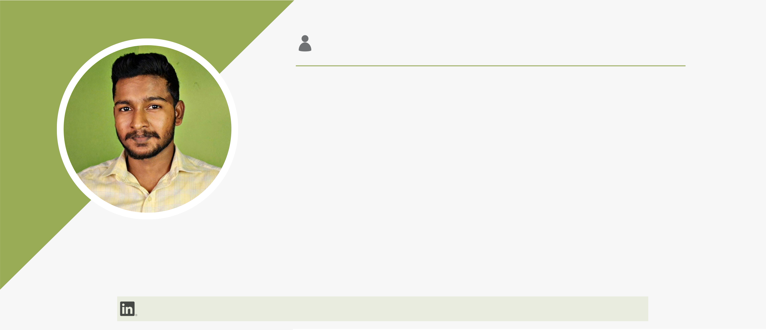
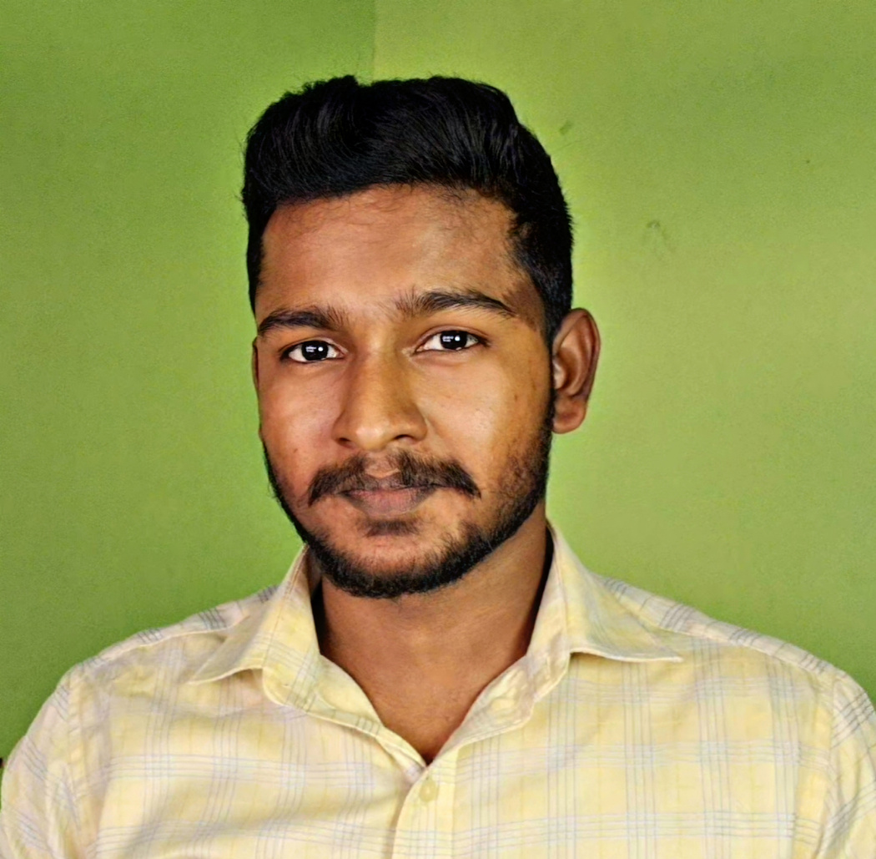
About Me
Head of Training & Development with 7 years of experience in
Academic Operations. Proven expertise in curriculum design,
team leadership, and strategic planning. Combines technical
foundation with psychological insights to enhance student
employability. Dedicated to transforming technical graduates
into industry-ready professionals through faculty development
Virlin V H |  | and outcome-based training.
 | Experience (Full Time)
Head of Training & Operations (OET/IELTS/NCLEX/DHA/HAAD/SNB...) @ Target Nurses Academy (2020 – Present)
Strategic Leadership: Managing the end-to-end training lifecycle for 700+ candidates annually, achieving a consistent pass rate every year-on-year. Curriculum Architecture: Redesigned the LSRW & Technical curriculum to align with global standards, transitioning from rote learning to Competency-Based Training.
Faculty Development:Leading a team of 15+ trainers; implemented a standardized "Train-the-Trainer" (TTT) framework to ensure uniform delivery quality.
Data-Driven Interventions: Introduced Training Needs Analysis (TNA) to segregate students based on skill gaps, reducing dropout rates.
Operations Management:Overseeing resource allocation, batch scheduling, and exam coordination for high-stakes licensure exams.
OET Trainer
@ Greens Institute (2020)
Instructional Delivery:Facilitated intensive OET training for healthcare professionals, focusing on advanced LSRW strategies.
Performance Analytics:Conducted weekly diagnostic assessments to track student band scores.
Feedback Mechanisms: Implemented a structured feedback loop for writing and speaking modules, helping students bridge the gap between "Grammar" and "Medical Context."
Communicative English Trainer
@ Edufox (2019)
Executed Lesson Planning for interactive sessions across diverse proficiency levels, drove Skill Development in Communicative English and Soft Skills to build confidence, and ensured Engagement by adapting teaching styles to suit different learners.


 | Freelance/Part-Time
@ Annammal college of Nursing | Visiting Faculty | (2021 - Present)
@ CSI college of Nursing | External Faculty - Soft Skills | (2025 - Present)
Focused on Training Delivery through interactive English and etiquette sessions, while managing Student Assessment via continuous feedback. Delivered specialized Employability Training to equip graduates with essential soft skills for campus placements.
@ Planetspark | Public speaking and creative writing expert | (2023)
 | Executed | Virtual | Facilitation | for | Public | Speaking | sessions,
implemented Curriculum Customization for personalized learning paths, and drove Skill Development in confidence and storytelling.
Education
B.E. Mechanical Engineering | St. Xavier's Catholic College of Engineering | 72% | 2019
MBA (H R Management) | Pondicherry University | Expected 2027
MSc (Psychology) | Tamil Nadu Open University | Expected 2026
HSC | 89% | 2015 |  | SSLC | 88% | 2013
 | Skills | SSLC | 88% | 2013
Core L&D Competencies
 | Training Needs Analysis (TNA):Skill Gap Assessment, Competency
 | Mapping, | Pre- | & | Post-Training | Evaluation. | Curriculum |  | Design:
 | Instructional Design (ADDIE Model), Outcome-Based Learning (OBE),
 | Competency-Based |  |  | Education. | Training | Delivery: | Classroom
 | Management, Virtual/Hybrid Training, Train-the-Trainer (TTT) Facilitation, Remedial Coaching. Assessment & ROI
Strategic Leadership & Operations
 | Academic Operations: Faculty Development, Resource Allocation, Batch Scheduling, Exam Coordination. Employability Strategy: Campus-to-
 | Corporate | Programs, | Soft | Skills | for | Engineers, | Mock | Interview
 | Simulations. Stakeholder Management:Reporting to Management, Cross-functional Collaboration, Student Counseling.
Technical & Digital Tools
Ed-Tech Tools: LMS Administration, AI in Education (Prompt Engineering), Virtual Classroom Tools (Zoom/Teams). Content Creation: Canva (Visual Aids) , Video Editing (Adobe Premiere Pro/CapCut for micro-learning), MS Office Suite.

