IT 230 Coding Activity Submission Template

Submit your work on the coding activities for Modules One, Two, Three, Four, and Six in this document. In addition to this document, you should submit a ZIP file containing all your Visual Studio project files and source code that can be run in Visual Studio on a different computer.

For each coding activity, complete the following steps:

- Download and rename this document to meet the file naming conventions requested in the assignment instructions.
- Fill in the required information below by replacing the bracketed text with the relevant information.
- Submit this document and your ZIP file for grading and feedback. Your ZIP file should follow the same naming conventions.

Document your work in the coding activity by completing each of the following items:

- Provide a screenshot of the output that resulted from running your program successfully in Visual Studio. See the coding assignment instructions for an example of what should be included in the screenshot. Your screenshot must include the following elements:
  - Your last name as the first printed text on the screen
  - Verification that the program is fully functioning and data results are accurate for the given problem

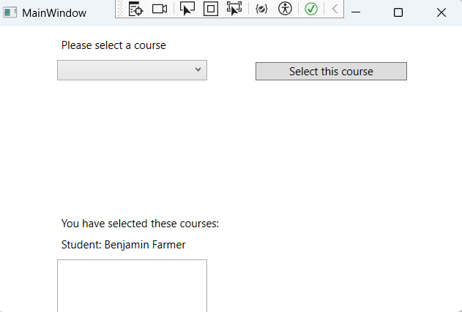

- Copy and paste the source code text you wrote for this assignment from the *.cs file into the space below. Only providing the *.cs files or a screenshot does not meet the requirements for this part of the assignment. Code should be logically organized. It should also follow proper syntax and conventions noted in the Coding Activity Guidelines and Rubric.

using System;
using System.Collections.Generic;
using System.Linq;
using System.Text;
using System.Threading.Tasks;
using System.Windows;
using System.Windows.Controls;
using System.Windows.Data;
using System.Windows.Documents;
using System.Windows.Input;
using System.Windows.Media;
using System.Windows.Media.Imaging;
using System.Windows.Navigation;
using System.Windows.Shapes;

namespace CreateClassesObjs
{
/// <summary>
/// Interaction logic for MainWindow.xaml
/// </summary>
public partial class MainWindow : Window
{
Course choice;

public MainWindow()
{
InitializeComponent();
}

private void Window_Loaded(object sender, RoutedEventArgs e)
{

Course course1 = new Course();
Course course2 = new Course();
Course course3 = new Course();
Course course4 = new Course();
Course course5 = new Course();
Course course6 = new Course();
Course course7 = new Course();

course1.setName("IT 145");
course2.setName("IT 200");
course3.setName("IT 201");
course4.setName("IT 270");
course5.setName("IT 315");
course6.setName("IT 328");
course7.setName("IT 330");

this.comboBox.Items.Add(course1);
this.comboBox.Items.Add(course2);
this.comboBox.Items.Add(course3);
this.comboBox.Items.Add(course4);
this.comboBox.Items.Add(course5);
this.comboBox.Items.Add(course6);
this.comboBox.Items.Add(course7);

}
private void button_Click(object sender, RoutedEventArgs e)
{

choice = (Course)(this.comboBox.SelectedItem);
this.listBox.Items.Add(choice);
}
}

// =====================================================
// Course class — ADDED to complete the project
// =====================================================
class Course
{
// private string field to hold the course name
private string name;

// method to set the name field
public void setName(string courseName)
{
name = courseName;
}

// method to retrieve the name field
public string getName()
{
return name;
}

// override ToString so the name displays in the UI
public override string ToString()
{
return name;
}
}
}

- Show that you understand the task by explaining the design of your program in the space below. Include the process and steps you took to write your code. Explain how you arrived at the solution to the problem and completed the activity.

For this activity, I completed an existing WPF project that was missing the Course class. I first reviewed the provided XAML and code-behind files to understand how the program was supposed to function. The application creates several Course objects, assigns each one a name, and adds them to a ComboBox. When the user selects a course and clicks the button, the selected course is added to a ListBox.
To complete the project, I created the Course class with a private string field to store the course name, along with methods to set and retrieve the name. I also overrode the ToString() method so the course names would display correctly in the ComboBox and ListBox. Finally, I updated the XAML layout to display my name as a static label in the output section above the ListBox, matching the instructor’s example. After testing the program, I confirmed that it compiled, ran correctly, and produced the expected output.

- Reflect on your learning experience and what you learned from completing the activity.

This activity helped me better understand how classes and objects are used in a WPF application. I learned how overriding the ToString() method allows objects to display properly in UI controls. I also gained a clearer understanding of the separation between XAML for layout and C# for program logic. Overall, this assignment improved my confidence in working with object-oriented concepts and designing simple WPF interfaces.

