“CLASSLY – SMART CLASSROOM MANAGEMENT SYSTEM”
A Project Report Submitted in partial fulfillment of the requirements for the award of the degree of
BACHELOR OF TECHNOLOGY
in
DEPARTMENT OF COMPUTER SCIENCE ENGINEERING
By
AKSHITH 25200300122
CHARISHMA 2520030140
PRANAVI 2520030026
Under the Esteemed Guidance of
Dr. S. Spandana
Assistant Professor
Department of Computer Science and Engineering
K L (Deemed to be) University


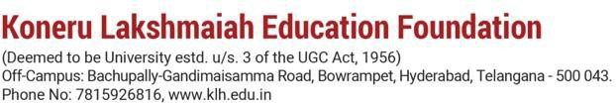

DECLARATION
We hereby declare that the project report entitled “Classly – Smart Classroom Management System” is a record of the work carried out by AKSHITH (25200300122), CHARISHMA (2520030140) and PRANAVI (2520030026), in partial fulfillment of the requirements for the award of the Bachelor of Technology degree. The work presented in this report is based on the project implementation and study undertaken by our team.
We further declare that this report describes the current project version and that its technical details have been prepared with reference to the supplied website prototype, source code archive, API routes, README and project presentation. Implemented functionality is distinguished from proposed future enhancements.

Akshith – 25200300122
Charishma-2520030140
Pranavi - 2520030026

CERTIFICATE
This is to certify that the project report entitled “Classly – Smart Classroom Management System” is a bonafide work carried out and submitted by AKSHITH, CHARISHMA and PRANAVI in partial fulfillment of the requirements for the award of the degree of Bachelor of Technology at K L (Deemed to be) University.

The report presents a web-based classroom management application comprising a browser interface for rooms, faculty, subjects, timetables and bookings, and a Flask REST service with a MongoDB database for users, rooms and bookings. The project work has been prepared in accordance with the academic requirements of the programme.

Signature of the Guide | Signature of the Course Coordinator | Signature of the HOD

ACKNOWLEDGEMENT
We express our sincere gratitude to everyone who supported and encouraged us during the development of Classly – Smart Classroom Management System. The completion of this project has been possible through the guidance, feedback, and cooperation of our faculty members, colleagues, and family members.
We are especially thankful to our project guide, Dr. S. Spandana, Assistant Professor, Department of Computer Science and Engineering, for valuable guidance, suggestions, and encouragement throughout the project. The feedback helped us approach the problem systematically and improve the organization of the project work and its documentation.
We express our gratitude to the Head of the Department, the course coordinator, and the faculty members of the Department of Computer Science Engineering for providing the academic environment and facilities required to complete this work.
We also thank the teaching and non-teaching staff members, classmates, and friends who offered suggestions and assistance during the development and review process. Finally, we are grateful to our parents and family members for their patience, motivation, and continued support.

AKSHITH | CHARISHMA | PRANAVI

ABSTRACT
Classly is a web-based smart classroom management system that digitises how a campus organises its learning spaces. Classrooms are among the most shared resources on a campus, yet many institutions still manage them through paper registers, spreadsheets, phone calls and e-mails. This leads to double-bookings, poor visibility of which rooms are free, under-used spaces and slow approval of room requests.
Classly brings rooms, faculty, subjects, timetables and bookings into a single workspace. The interface provides a role-based sign-in screen (Administrator, Faculty, Student), a dashboard with campus statistics and live room status, a searchable and filterable classroom directory, faculty and subject directories, a weekly timetable, a room-booking workflow with time validation and approval, an analytics and reports page with CSV export, a rule-based assistant for room suggestions and a settings page. The interface uses a blue visual theme built from a primary blue (#315cf5), a deep navy (#172554) and a soft background (#f4f6fc).
The project is built as a layered application using HTML, CSS and vanilla JavaScript for the front end, and Python with Flask, Flask-CORS and PyMongo for the back end, with MongoDB as the database. The back end exposes REST endpoints under the /api path for user registration and login (with hashed passwords), room listing and creation, and booking creation, listing and status update. The booking endpoint validates required fields, checks that the end time is later than the start time and rejects bookings that overlap an existing non-cancelled booking for the same room and date.
The current version is a working front-end prototype running on sample data, together with a starter back end that has not yet been wired to the interface. Faculty, subjects, timetable, reports and the assistant do not yet have database APIs. The project does not claim to provide real authentication tokens, notifications, automatic timetable generation or a machine-learning assistant; these are discussed as future enhancements.
Overall, Classly provides a structured foundation for classroom visibility and booking control. It demonstrates interface design, REST API development, document-database modelling, input validation, interval-based clash detection and secure password storage.

INDEX
Chapter | Title | Contents
1 | Introduction | Background, problem statement, scope, objectives, importance, target users
2 | System Requirements | Hardware, software, development tools and frameworks
3 | Technology Stack | Frontend, backend, database, configuration and version control
4 | System Architecture | Layered architecture, data flow and deployment design
5 | Design | Data model, data dictionary and interface design
6 | Implementation | Modules, frontend logic, REST API integration and authentication
7 | Features | Dashboard, rooms, faculty, subjects, timetable, bookings, assistant, reports
8 | Testing | Test strategy, API checks, integration cases and test records
9 | Deployment | Prerequisites, configuration, startup and hosting considerations
10 | Challenges & Limitations | Development considerations, mitigations and current boundaries
11 | Future Enhancements | Integration, notifications, security and scalability
12 | Conclusion | Summary, achievements, learning outcomes and final observations
13 | References | Technical documentation and learning resources
14 | Appendices | API reference, setup guide, user guide, website screenshots, geo-tag photos

CHAPTER 1 – INTRODUCTION

1.1 Background of the Project
A campus has a fixed number of classrooms, seminar halls and labs, and every department competes for them. A typical engineering college runs dozens of rooms across several blocks, with different capacities and facilities such as projectors, smart boards, air-conditioning, audio systems and Wi-Fi. Faculty need a room that fits their class size and equipment needs; students need to know where a class is held; administrators need to approve special requests such as guest lectures, workshops and project reviews.
In many institutions this coordination is still done manually. Timetables are kept in spreadsheets, special bookings are requested by phone or e-mail, and the status of a room (free, in use or under maintenance) is known only to the person who last updated the register. As the number of rooms and requests grows, manual coordination becomes slow and error-prone.
Classly was conceived as a connected workspace that replaces these scattered records. It presents rooms, faculty, subjects, timetables and bookings in one dashboard, adds a booking workflow with clash detection and approval, and includes an assistant that answers common questions such as “Which rooms are free?” or “Which rooms have a projector?”. The project presentation describes the scale it is designed for: 48 classrooms, 32 classes scheduled in a day and 6 departments.
The project is delivered in stages. Stage one is the visual front-end prototype with sample data, which validates the user experience and workflows. Stage two, already started in the source archive, is a Flask and MongoDB back end for authentication, rooms and bookings. Later stages will connect the two and extend persistence to faculty, subjects and timetables.
From an academic perspective, the project demonstrates how HTML, CSS and JavaScript can present a database-backed workflow, how a REST controller validates and stores data, and how a document database models rooms and bookings.

1.2 Problem Statement
Campus classrooms are managed inefficiently because scheduling and booking information is scattered across paper registers, spreadsheets and informal communication. The following problems were identified.
- Manual scheduling. Paper registers and spreadsheets cause errors and double-bookings; two groups may arrive at the same room at the same time.
- Poor visibility. Staff cannot see which rooms are free right now, so they walk between blocks or phone the administration office.
- Under-used spaces. There is no utilisation data, so some rooms sit idle while others overflow, and capacity planning is guesswork.
- Slow approvals. Booking requests travel by phone or e-mail and are easily lost, leaving faculty uncertain whether a room is confirmed.
Room identification is part of the problem: similar room names and inconsistent descriptions make it hard to find a suitable space. Classly stores each room with a code, building, capacity, status and list of facilities so that rooms can be searched and filtered. Booking clashes are another major concern; the server compares the requested time range with existing active bookings for the same room and date and rejects overlaps.
The project therefore aims to provide one system in which room data, booking requests and schedules are stored centrally, availability is visible at a glance, clashes are detected before a booking is accepted, and administrators can approve requests from a single screen.

1.3 Scope of the Project
The scope of Classly covers a web application for classroom administration and room booking. It is designed for a campus administrator, faculty members and students.
The room management scope includes viewing rooms with code, building, capacity, status and facilities; searching by code or building; filtering by status (Available, Occupied, Maintenance) and minimum capacity; and adding a room. The booking scope includes a request form with validation, a register showing Pending, Approved and Cancelled requests, and an Approve action. The directory scope covers searchable faculty and subject tables. The timetable scope covers a weekly Monday–Friday calendar and a today’s-schedule list. The reporting scope covers campus metrics, department utilisation bars and CSV export. The assistant answers a fixed set of question types using keyword rules.
On the technical side, the scope includes HTML, CSS and JavaScript, Python 3, Flask, Flask-CORS, PyMongo, python-dotenv, Werkzeug and MongoDB. The API listens on port 5000 and uses the database classly_db.
Not implemented in the current version: connecting the front end to the API; persistent faculty, subject and timetable data; session or token-based authentication; role-based authorisation; e-mail or push notifications; automatic timetable generation; and a true machine-learning assistant. These appear in Chapter 11 as future work.

1.4 Objectives of the Project
- Centralise rooms, faculty, subjects and timetables in one system.
- Show real-time classroom availability and status.
- Let users request room bookings and avoid time clashes.
- Give administrators one place to approve or review requests.
- Provide analytics to improve room utilisation.
- Offer an assistant for quick room suggestions.
From a learning perspective, the project also aims to demonstrate the integration of a responsive front end, a REST API, a document database and secure password handling in a single full-stack application.

1.5 Importance of the Application
A classroom is a time-bound resource: an unused hour cannot be recovered. Better visibility of availability and utilisation directly improves how much teaching can be scheduled in the same infrastructure. Digital booking removes the ambiguity of phone and e-mail requests and gives every request a visible status. Clash detection reduces the disruption caused by double-bookings. Analytics such as department-wise utilisation help administrators decide where to add, merge or re-allocate rooms.
For students and faculty, a single searchable workspace saves time that would otherwise be spent finding the right room or the right contact. For the development team, the project is a practical exercise in front-end design, REST API design, NoSQL data modelling and security basics. The design also provides a foundation for extension to notifications, recurring bookings, timetable auto-generation and live occupancy sensing.

1.6 Target Users / Audience
User role | Typical needs in Classly
Administrator | Monitor campus statistics, approve or cancel booking requests, manage rooms, faculty and subjects, review utilisation reports
Faculty | Find rooms by capacity and facilities, request a room for a class or event, view the weekly timetable, ask the assistant for suggestions
Student | View room availability and the timetable, check where classes are held

Project evaluators, faculty members and future developers are a secondary audience for this report; it records the design decisions, API contracts and known limitations.

CHAPTER 2 – SYSTEM REQUIREMENTS

2.1 Hardware Requirements
Classly is a lightweight web application. The prototype runs entirely in a browser and the back end is a small Python process, so modest hardware is sufficient. No performance benchmark has been carried out; the figures below are practical recommendations for development and demonstration.
Component | Minimum | Recommended
Processor | Dual-core, 2 GHz | Quad-core (Intel Core i5 / AMD Ryzen 5 class)
Memory | 4 GB RAM | 8 GB RAM or more
Storage | 2 GB free | SSD with 5 GB free (code, dependencies, MongoDB data, screenshots)
Display | 1280 × 720 | 1920 × 1080
Network | Local only for demo | Broadband to download dependencies

End users need only a modern desktop, laptop or mobile browser. The sidebar collapses behind a menu button on narrow screens.

2.2 Software Requirements
Category | Requirement
Operating system | Windows, Linux or macOS
Browser | Current Chrome, Edge or Firefox
Language runtime | Python 3 for the Flask back end
Python packages | flask, flask-cors, pymongo, python-dotenv, werkzeug (from requirements.txt)
Database | MongoDB running locally on port 27017
Editor | Visual Studio Code with the Live Server extension
API testing | Postman, Insomnia, curl or a browser for GET routes
Version control | Git

2.3 Development Tools and Frameworks
2.3.1 HTML5. Defines the page shell, sections, forms and modal dialogs.
2.3.2 CSS3. Provides the blue theme, grid and flex layouts, status badges, cards, tables, the calendar grid and responsive behaviour.
2.3.3 Vanilla JavaScript (ES6). Handles navigation, rendering, filtering, validation and the assistant. No front-end framework or build step is used.
2.3.4 Flask. A lightweight Python web framework used for the REST API. Routes are declared with decorators such as @app.get and @app.post.
2.3.5 Flask-CORS. Allows the browser front end, served from a different port by Live Server, to call the API.
2.3.6 PyMongo. The MongoDB driver. The bson ObjectId class converts string identifiers when updating a booking.
2.3.7 python-dotenv. Loads the MongoDB connection string from a .env file.
2.3.8 Werkzeug security. Provides generate_password_hash and check_password_hash so that passwords are never stored in plain text.
2.3.9 Technology-stack summary. The current implementation uses HTML, CSS, JavaScript, Python, Flask, Flask-CORS, PyMongo, python-dotenv, Werkzeug and MongoDB. It does not use React, Node.js, Express, MySQL or a machine-learning library.

CHAPTER 3 – TECHNOLOGY STACK

3.1 Front-End Technology
The front end is the presentation layer through which users interact with Classly. It lives in the frontend folder as three files: index.html (markup), css/style.css (styling) and js/app.js (logic), plus an assets folder for images. A single-file version of the same interface, Classly – Blue Theme Smart Classroom, is also provided with the CSS and JavaScript inlined for easy sharing and demonstration.
3.1.1 HTML Structure. After sign-in, the page shows a sidebar and nine sections: dashboard, rooms, faculty, subjects, timetable, bookings, assistant, reports and settings. Only one section is active at a time. Modal dialogs provide the booking form and a generic add form.
3.1.2 CSS Styling. CSS custom properties define the theme (primary #315cf5, secondary #172554, background #f4f6fc, text #172033). Reusable classes provide cards, tables, status pills (available, occupied, maintenance, pending, approved), modal backdrops, toast notifications and the weekly calendar grid.
3.1.3 JavaScript Rendering. Rendering functions build HTML from JavaScript arrays: renderRooms, renderFaculty, renderSubjects, renderBookings, renderSchedule and renderCalendar. The navigate function toggles the active section and sidebar button and updates the page title and breadcrumb.
3.1.4 Forms and Validation. The booking form collects room, faculty, date, purpose, start time, end time and attendance. It rejects an end time that is not later than the start time. The sign-in form checks that an e-mail and password are provided.
3.1.5 Search and Filters. The room list supports text search and status and capacity filters; faculty and booking tables support instant text search.
3.1.6 Responsive Presentation. The interface uses CSS grids and flexible panels. On narrow screens the sidebar collapses behind a menu button.

3.2 Back-End Technology
The back end is a single file, backend/app.py, containing a Flask application with CORS enabled. It reads MONGO_URI from .env (default mongodb://127.0.0.1:27017/) and uses a database named classly_db with three collections: users, rooms and bookings. A helper function converts MongoDB ObjectId values to strings so documents can be returned as JSON.
3.2.1 User Operations. POST /api/register validates name, e-mail and password, rejects an already-registered e-mail (409), hashes the password and inserts the user. POST /api/login checks the hash and returns the user’s id, name, e-mail and role, or 401 for invalid credentials.
3.2.2 Room Operations. GET /api/rooms lists all rooms. POST /api/rooms creates a room; the name is required and capacity is converted to an integer.
3.2.3 Booking Operations. GET /api/bookings lists bookings newest first. POST /api/bookings checks required fields, checks that end time is later than start time and runs the overlap query before inserting a Pending booking. PUT /api/bookings/<id> changes status to Pending, Approved or Cancelled.
3.2.4 Error Responses. The API returns JSON error messages with 400 (invalid input), 401 (invalid login), 404 (booking not found) and 409 (duplicate e-mail or overlapping booking).

3.3 Database Technology
MongoDB is a document database that stores flexible JSON-like documents. It suits Classly because rooms have a variable list of features (for example Projector, AC, Wi-Fi), bookings are self-contained records and the schema is expected to evolve as faculty, subjects and timetables are added.
3.3.1 Database Configuration. The connection string is supplied through the MONGO_URI environment variable. The database classly_db and its collections are created automatically on the first insert.
3.3.2 Identifiers and Uniqueness. Every document has an auto-generated ObjectId. User e-mail uniqueness is enforced in application code by checking before insert; a unique index on the email field is recommended as an improvement.
3.3.3 Relationships. Bookings refer to a room by its code and to a faculty member by name. These are loose references rather than enforced foreign keys; stable room ids are recommended in a later version.

3.4 Build, Configuration and Version Control
There is no build step. Dependencies are installed with pip install -r requirements.txt. Configuration is held in backend/.env, which currently contains only the MongoDB connection string. Because .env files commonly hold secrets, it should be listed in .gitignore, and a sanitised .env.example should be committed instead. The README documents the folder structure, run steps and API routes.

CHAPTER 4 – SYSTEM ARCHITECTURE
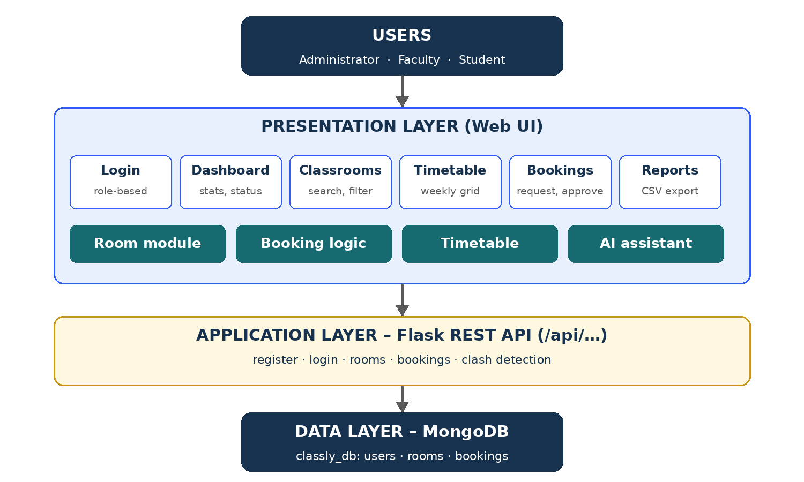
Figure 4.1 – Classly system architecture

4.1 High-Level Architecture
Classly follows a three-tier architecture. Users (Administrator, Faculty, Student) interact with a presentation layer in the browser. The presentation layer contains the login, dashboard, classrooms, timetable, bookings and reports views, and four logical modules: the room module, booking logic, timetable and the assistant. The application layer is a Flask REST API, and the data layer is MongoDB.
Tier | Component | Current status
Presentation | HTML/CSS/JS single-page workspace | Implemented, uses sample data
Application | Flask REST API (/api/…) | Implemented as a starter, not yet connected to the UI
Data | MongoDB database classly_db | Collections created on first insert

The presentation summarises the roadmap as “Now: sample data in JavaScript · Next: REST API and database”. The source archive shows that the REST API and database layer have since been drafted.

4.2 Description of Each Layer
4.2.1 Presentation layer. Renders views, validates input (for example end time must be after start time), filters lists and shows feedback. At present it reads from in-memory arrays (rooms, faculty, subjects, bookings) and resets when the page is reloaded.
4.2.2 Application layer. Exposes JSON endpoints, validates required fields, hashes passwords, checks for booking overlaps and updates booking status. It returns appropriate HTTP codes: 201 for creation, 400 for invalid input, 401 for failed login, 404 for a missing booking and 409 for conflicts.
4.2.3 Data layer. Stores users, rooms and bookings as documents. Bookings are sorted by created_at (newest first) when listed.

4.3 Deployment Architecture
4.3.1 Local Development. Three processes run on one machine: MongoDB (port 27017), Flask (port 5000) and VS Code Live Server serving the front end (typically port 5500). Flask-CORS allows the cross-origin calls between the last two.
4.3.2 Server Deployment. A production deployment would place the static front end on a web server or CDN, run Flask behind a WSGI server such as Gunicorn with HTTPS, and use a managed or secured MongoDB instance with authentication enabled. The current source does not include a cloud deployment manifest, so this is a proposed deployment option rather than an implemented capability.

CHAPTER 5 – DESIGN

5.1 Design Overview
The design follows three principles: one workspace (every task is reachable from the sidebar), status at a glance (colour-coded pills for Available, Occupied, Maintenance, Pending and Approved) and validate early (the form rejects invalid times before a request is created, and the server repeats the check). The data model is document-oriented: each collection stores self-contained records, and relationships are expressed by values such as the room code stored inside a booking.

5.2 Data Model
Collection | Purpose | Relationship
users | Registered accounts with role | Standalone; e-mail acts as the unique key
rooms | Classrooms, halls and labs | Referenced by code from bookings
bookings | Room requests and their status | Refers to a room and a faculty name

Faculty, subjects and timetable entries currently exist only as sample arrays in the front end. Their intended future collections are described in Chapter 11.

5.3 Database Tables and Data Dictionary
Users collection
Field | Type | Description
_id | ObjectId | Auto-generated identifier
name | String | Full name, required
email | String | Lower-cased and trimmed; must be unique (checked before insert)
password | String | Salted hash created with Werkzeug; plain text is never stored
role | String | Administrator, Faculty or Student (default Student)
created_at | DateTime | UTC time of registration

Rooms collection
Field | Type | Description
_id | ObjectId | Auto-generated identifier
name | String | Room code such as C-204 or Seminar Hall, required
building | String | Block and floor, e.g. Block C · 2nd Floor
capacity | Integer | Number of seats
status | String | Available (default), Occupied or Maintenance
features | Array of String | Facilities such as Projector, AC, Wi-Fi, Smart board, Audio

Bookings collection
Field | Type | Description
_id | ObjectId | Auto-generated identifier
room | String | Room code being requested
faculty | String | Person or club making the request
date | String | Booking date (YYYY-MM-DD)
start_time / end_time | String | 24-hour HH:MM times; end must be later than start
purpose | String | Reason, e.g. Guest lecture
students | Integer | Expected attendance
status | String | Pending (default), Approved or Cancelled
created_at | DateTime | UTC time the request was created

5.3.1 Booking overlap rule. A new booking conflicts with an existing one when both are for the same room and date, the existing booking is not Cancelled, the existing start time is before the new end time, and the existing end time is after the new start time. Because times are compared as zero-padded HH:MM strings, they sort correctly.

5.4 User Interface Design
The interface uses a blue theme with white cards on a pale background. The sign-in page has a hero panel (“Make every classroom count.”) beside the sign-in form. After sign-in, the workspace shows a left sidebar, a top bar with breadcrumb, date, notification button and a New booking button, and the active page. Screenshots of every screen are provided in Appendix G.
Screen | Key elements
Login | E-mail, password with SHOW/HIDE toggle, role selector, Forgot password, Demo login
Dashboard | Stat cards (48 classrooms, 16 available now, 32 classes today, 5 pending requests), utilisation by department, today’s schedule, featured rooms
Classrooms | Search box, status filter, capacity filter (30+, 60+, 100+), room cards with Book room button, Add classroom
Faculty | Search, table of name, department, subject, weekly classes, availability; Add faculty
Subjects | Table of subject, code, department, faculty, student count; Add subject
Timetable | Weekly calendar grid, Add schedule
Bookings | Search, status table, Approve action, New booking form
AI assistant | Chat window with suggestion prompts
Reports | Campus metrics, department utilisation, Export CSV
Settings | Campus name, default booking duration, notification toggles, Save preferences

The department utilisation figures in the sample data are Computer Science 86%, Electronics & Communication 74%, Mechanical Engineering 62% and Business Administration 48%.

CHAPTER 6 – IMPLEMENTATION

6.1 Module-Wise Implementation
6.1.1 Authentication Module. The front end validates that an e-mail contains “@” and that a password is entered, then hides the login screen, shows the workspace and derives a display name, initials and role label from the e-mail and role selection. The Demo login button pre-fills admin@classly.edu and enters as Administrator. The back end implements POST /api/register and POST /api/login with hashed passwords, but the interface does not call them yet.
6.1.2 Room Module. The front end renders room cards from a rooms array and supports search by code or building, status filtering and capacity filtering. The back end offers GET and POST /api/rooms.
6.1.3 Booking Module. On submit, the front end rejects an end time that is not later than the start time and performs a basic clash check against the sample list. A valid request is inserted as Pending and the user is taken to the bookings page. An administrator can click Approve to change the status to Approved. The back end implements the full rule set: required-field check, time order check, overlap check (409 on conflict) and a status update endpoint.
6.1.4 Timetable and Schedule Module. renderSchedule draws today’s classes and renderCalendar builds a Monday–Friday grid for the 09:00–13:00 slots with colour-coded events from sample data.
6.1.5 Faculty and Subject Module. These render sample tables with live search. The Add buttons open a generic dialog that appends a placeholder row.
6.1.6 Assistant Module. sendMessage appends the user’s message, then chooses an answer by keyword: room, free or available lists available rooms and recommends one for a class of 60; conflict or clash gives a conflict-checking tip; underused points to low-utilisation spaces; schedule or today summarises the day’s sample classes; projector lists rooms with a projector. It is a rule-based demo and does not call a language model.
6.1.7 Reports Module. The Export report button generates a CSV in the browser (Classrooms 48, Available now 16, Classes today 32, Average utilization 72%, Total bookings 1284) and downloads it as classly-campus-report.csv.

6.2 Front-End Logic and State Handling
State is held in plain JavaScript variables: rooms, faculty, subjects and bookings. Each user action changes the variable and calls the matching render function, which rewrites the relevant HTML. Because the state is in memory, it resets when the page is refreshed. Helper functions $ and $$ wrap querySelector and querySelectorAll. Modal dialogs open by adding a show class and close on the × button or a click on the backdrop.

6.3 API Integration
The back end is complete enough to be called, but the front end must be changed to use it. The intended integration is: on load, call GET /api/rooms and GET /api/bookings and render the results; on booking submit, call POST /api/bookings and show the server’s error message on 400 or 409; on Approve, call PUT /api/bookings/<id> with the new status; and on sign-in, call POST /api/login. The Fetch API with JSON bodies and the base address http://127.0.0.1:5000 is recommended. A field-name mapping is required, because the front end uses id for the room code and arrays for bookings, whereas the API uses name, start_time, end_time and objects.

6.4 Authentication and Authorization
Passwords are hashed with Werkzeug before storage and verified at login. The login response returns the user’s id, name, e-mail and role. The current version does not issue a session cookie or token, and endpoints do not check who is calling them; any client can create bookings or approve them. Role-based protection (only an Administrator may approve, only Faculty may request) is a priority item in Chapter 11. Registration currently accepts any role value from the client, which must be restricted before real use.

CHAPTER 7 – FEATURES

7.1 List of Main Features
- Smart room booking with validation, clash checking and approval.
- Live availability with Available, Occupied and Maintenance states.
- Weekly timetable planning view.
- Searchable faculty and subject directories.
- Reports and analytics with CSV export.
- Assistant that suggests rooms and flags conflicts.
- Role-based sign-in screen and a settings page.
- Responsive layout with a collapsible sidebar.

7.2 How Each Feature Works
7.2.1 Smart Room Booking. The user opens the booking dialog from a room card or the New booking button, fills the form and submits. The system checks the times and clashes and creates a Pending request. An administrator approves it from the bookings page (see Figure G.7).
7.2.2 Live Availability. Each room carries a status. Cards show a coloured pill and facility chips. Filters narrow the list by status and minimum capacity (see Figure G.3).
7.2.3 Timetable Planning. A grid with weekday columns and hourly rows; each occupied cell shows the subject and room (see Figure G.6).
7.2.4 Faculty and Subjects. Tables with instant text search; faculty rows show department, subject, weekly class count and availability (see Figures G.4 and G.5).
7.2.5 Reports and Analytics. Department utilisation bars and key metrics; Export creates a CSV file in the browser (see Figure G.9).
7.2.6 Assistant. Keyword matching over the room list produces readable answers inside a chat window; quick-prompt buttons send common questions (see Figure G.8).
7.2.7 Notifications. The bell shows a message such as “You have 5 booking requests waiting for review”. E-mail or push delivery is not implemented.

CHAPTER 8 – TESTING

8.1 Testing Objectives
Testing should confirm that (a) every user workflow in the interface behaves as described, (b) each API route returns the correct data and status code for valid and invalid input, and (c) the booking clash rule never allows two overlapping active bookings for the same room and date. No automated test suite is included in the supplied archive, so the results column is left for the team to fill after execution.

8.2 API Testing
Use Postman, Insomnia or curl. Recommended checks: health returns 200 with the message “Classly backend is running”; register with missing fields returns 400; registering the same e-mail twice returns 409; login with a wrong password returns 401; creating a room without a name returns 400; creating a booking with end time earlier than start returns 400; creating two overlapping bookings returns 201 then 409; a booking for adjacent times (end equals next start) is accepted; updating a booking with an invalid status returns 400; updating with a malformed id returns 400; updating a non-existent id returns 404.

8.3 Integration Testing
Once the front end is wired to the API, test the full path: sign in, load rooms, submit a booking, observe it as Pending in the list after refresh, approve it, and confirm that a second booking for the same slot is rejected with the server’s message. Also test behaviour when the back end or MongoDB is stopped; the interface should show a clear error rather than a blank page.

8.4 Tools Used and Test Case Register
Tools: Web browser developer tools, Postman or curl, MongoDB shell or Compass. The register below is a verification template. Execute each case, record the actual result, attach relevant screenshots or API responses, and update the status column. No test is marked as passed solely because the corresponding source code exists.
ID | Scenario | Expected result | Status
TC-01 | Demo login | Workspace opens as Administrator | To be executed
TC-02 | Login with empty password | Error message shown, login screen stays | To be executed
TC-03 | Filter rooms by Maintenance | Only maintenance rooms listed | To be executed
TC-04 | Filter rooms by 100+ seats | Only C-101 and Seminar Hall listed (sample data) | To be executed
TC-05 | Booking with end time before start | Message: end time must be later than start time | To be executed
TC-06 | Valid booking | Added as Pending; bookings page opens | To be executed
TC-07 | Approve pending booking | Status changes to Approved | To be executed
TC-08 | Assistant: “Which rooms are free?” | Lists Available rooms | To be executed
TC-09 | Export report | classly-campus-report.csv downloads | To be executed
TC-10 | API overlapping booking | Second request returns 409 | To be executed
TC-11 | API duplicate registration | Second request returns 409 | To be executed
TC-12 | API invalid booking status | Returns 400 | To be executed

CHAPTER 9 – DEPLOYMENT

9.1 Deployment Requirements
Python 3 with pip, a running MongoDB server, VS Code with Live Server (or any static file server), and a modern browser. The Flask terminal and the Live Server must both stay open while using the application.

9.2 Environment Configuration
backend/.env holds MONGO_URI (default mongodb://127.0.0.1:27017/). The database name classly_db is set in app.py. For deployment, move secrets to environment variables, enable MongoDB authentication, restrict CORS to the real front-end origin and disable Flask debug mode.

9.3 Hosting and Startup
See Appendix D for the exact run steps. For hosting, serve the frontend folder from any static host, run the Flask app behind Gunicorn or a similar WSGI server with HTTPS, and point the front end’s API base URL to the deployed server. Back up the MongoDB database regularly.

CHAPTER 10 – CHALLENGES AND LIMITATIONS

10.1 Development Considerations
Building the interface as a single-page experience without a framework required careful management of state and re-rendering. Designing realistic sample data for rooms, faculty, subjects and timetables was needed so that filters, search and the assistant could be demonstrated meaningfully. Booking clash logic must compare time ranges rather than exact matches, and it must be enforced on the server because browser checks can be bypassed.

10.2 Solutions and Good Practices
The overlap query on the server uses the standard interval test (existing start earlier than new end, and existing end later than new start). Passwords are hashed. Inputs are trimmed and lower-cased where appropriate. Errors use meaningful HTTP codes. Styles are driven by CSS variables so the theme can be changed in one place.

10.3 Current Limitations or Known Boundaries
- The front end is not connected to the back end; data resets on refresh.
- The front-end clash check only compares the day of the month and room, not the time range; the server check is the reliable one.
- Login in the interface is local; any e-mail containing “@” and any password is accepted.
- No tokens or sessions; endpoints are unprotected; registration accepts any role; CORS is open to all origins and debug mode is on.
- Faculty, subjects, timetable and reports have no database support; report numbers and availability states are static sample values.
- The assistant is rule-based and cannot reason about real data.
- Room identity differs between layers (id in the front end, name in the API) and bookings reference rooms by name rather than by a stable id.
- No automated tests, pagination or input sanitisation beyond basic checks.
- Notifications, forgot-password and the Add dialogs are placeholders.

CHAPTER 11 – FUTURE ENHANCEMENTS

11.1 Planned Features
From the project roadmap: a connected back end and database, real authentication, notifications and timetable auto-generation. Additional suggestions are persistent faculty, subject and timetable collections; recurring bookings; booking edit and cancel by the requester; a calendar view of bookings per room; and faculty clash detection.

11.2 Possible Integrations and Optimizations
Integrate an e-mail or SMS service for approval alerts, a campus single-sign-on provider, and a language-model API so the assistant can answer from live data. Add utilisation analytics computed from actual bookings, QR-code room check-in and optional IoT occupancy sensors to make the Available and Occupied status truly live.

11.3 Security, Reliability, and Scalability
Issue JWT or session tokens and enforce role checks on every route; restrict registration roles; add a unique index on users.email and indexes on bookings (room, date); store secrets outside source control; add rate limiting, logging and HTTPS; use a production WSGI server; write automated tests; and migrate to a managed MongoDB cluster with backups for scalability.

CHAPTER 12 – CONCLUSION

12.1 Summary of the Project
Classly is a connected workspace for rooms, timetables and bookings that turns classroom management into a simple, visual, digital workflow. It addresses manual scheduling, poor visibility, under-used spaces and slow approvals.

12.2 What Was Achieved
The team delivered a complete front-end prototype with nine functional pages, a validated booking workflow, filters and search, CSV export and a rule-based assistant, together with a starter Flask and MongoDB back end that includes password hashing and server-side clash detection.

12.3 Skills Learned During Development
Responsive UI design with HTML, CSS and JavaScript; REST API design with Flask; NoSQL modelling with MongoDB; password hashing and basic security thinking; team collaboration and documentation.

12.4 Limitations and Future Work
The main next step is to connect the interface to the API and extend persistence to the remaining modules, followed by authentication and authorisation, notifications and timetable auto-generation.

12.5 Final Conclusion
Classly demonstrates that a simple, well-organised digital workspace can replace paper registers and spreadsheets for classroom management. With the planned back-end integration and security work, it can grow from a prototype into a deployable campus system.

CHAPTER 13 – REFERENCES

13.1 Technical References
- Flask documentation – https://flask.palletsprojects.com
- Flask-CORS documentation – https://flask-cors.readthedocs.io
- PyMongo and MongoDB manual – https://www.mongodb.com/docs
- Werkzeug security utilities – https://werkzeug.palletsprojects.com
- MDN Web Docs (HTML, CSS, JavaScript, Fetch API) – https://developer.mozilla.org
- python-dotenv documentation – https://pypi.org/project/python-dotenv

CHAPTER 14 – APPENDICES

APPENDIX A – API REFERENCE
Base URL (development): http://127.0.0.1:5000
Method | Route | Body | Success | Errors
GET | /api/health | – | 200 message | –
POST | /api/register | name, email, password, role | 201 Registration successful | 400 missing field; 409 e-mail exists
POST | /api/login | email, password | 200 message and user (id, name, email, role) | 401 invalid credentials
GET | /api/rooms | – | 200 array of rooms | –
POST | /api/rooms | name, building, capacity, status, features | 201 id | 400 name required
GET | /api/bookings | – | 200 array, newest first | –
POST | /api/bookings | room, faculty, date, start_time, end_time, purpose, students | 201 id, status Pending | 400 missing or bad times; 409 overlap
PUT | /api/bookings/<id> | status | 200 Booking updated | 400 bad status or id; 404 not found

Sample booking request:
{ "room": "C-204", "faculty": "Dr. Meera Sharma", "date": "2026-11-02", "start_time": "10:00", "end_time": "11:00", "purpose": "Data Structures tutorial", "students": 64 }

APPENDIX B – DATABASE COLLECTION SUMMARY
Collection | Main fields | Purpose
users | name, email, password (hash), role, created_at | Accounts and roles
rooms | name, building, capacity, status, features | Classroom inventory
bookings | room, faculty, date, start_time, end_time, purpose, students, status, created_at | Room requests and approval status

APPENDIX C – SAMPLE MONGODB QUERIES
Purpose | Query (mongosh)
List available rooms | db.rooms.find({ status: "Available" })
Rooms with 60 or more seats | db.rooms.find({ capacity: { $gte: 60 } })
Pending requests | db.bookings.find({ status: "Pending" })
Overlap check for a slot | db.bookings.find({ room: "C-204", date: "2026-11-02", status: { $ne: "Cancelled" }, start_time: { $lt: "11:00" }, end_time: { $gt: "10:00" } })
Approve a booking | db.bookings.updateOne({ _id: ObjectId("…") }, { $set: { status: "Approved" } })

APPENDIX D – INSTALLATION AND SETUP GUIDE
Step 1: Install Python 3, MongoDB and Visual Studio Code with the Live Server extension.
Step 2: Make sure MongoDB is running locally on port 27017.
Step 3: Open a terminal in the backend folder and run pip install -r requirements.txt.
Step 4: Check that backend/.env contains MONGO_URI=mongodb://127.0.0.1:27017/.
Step 5: Run python app.py and open http://127.0.0.1:5000/api/health to confirm the server is running.
Step 6: Open frontend/index.html in VS Code and choose Open with Live Server.
Step 7: Keep both the Flask terminal and Live Server running while using the application.

APPENDIX E – USER GUIDE
Signing in. Choose your role, enter e-mail and password, or click Demo login.
Finding a room. Open Classrooms, type a room code or building, and use the status and capacity filters.
Booking a room. Click Book room on a card or New booking at the top, fill in faculty, date, purpose, start, end and attendance, and submit. The request appears as Pending.
Approving a request. Open Bookings and click Approve beside a pending request.
Asking the assistant. Open AI assistant and type a question or click a suggested prompt.
Exporting a report. Open Reports and click Export report to download a CSV.

APPENDIX F – PROJECT FILE MAP
File / Directory | Purpose
frontend/index.html | Markup for login, workspace sections and modals
frontend/css/style.css | Blue theme and layout
frontend/js/app.js | Sample data, rendering, validation, assistant, CSV export
frontend/assets/ | Placeholder for images
backend/app.py | Flask API for users, rooms and bookings
backend/requirements.txt | Python dependencies
backend/.env | MongoDB connection string
README.md | Folder structure, run steps and route list
Classly – Blue Theme Smart Classroom.html | Single-file version of the interface
Smart_Classroom_Management.pptx | 12-slide project presentation

APPENDIX G – WEBSITE SCREENSHOTS
Paste each screenshot into the box below its caption (click the box, then Insert > Pictures). Delete the grey instruction text after inserting.
Figure G.1 – Login screen
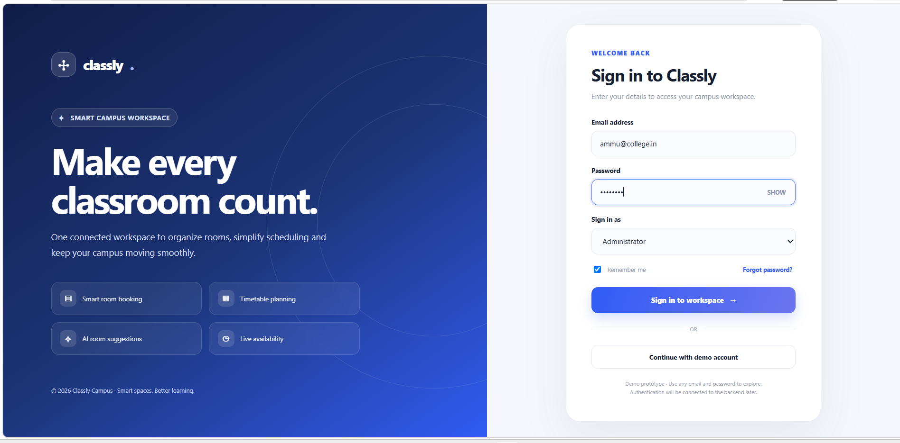

Figure G.2 – Dashboard
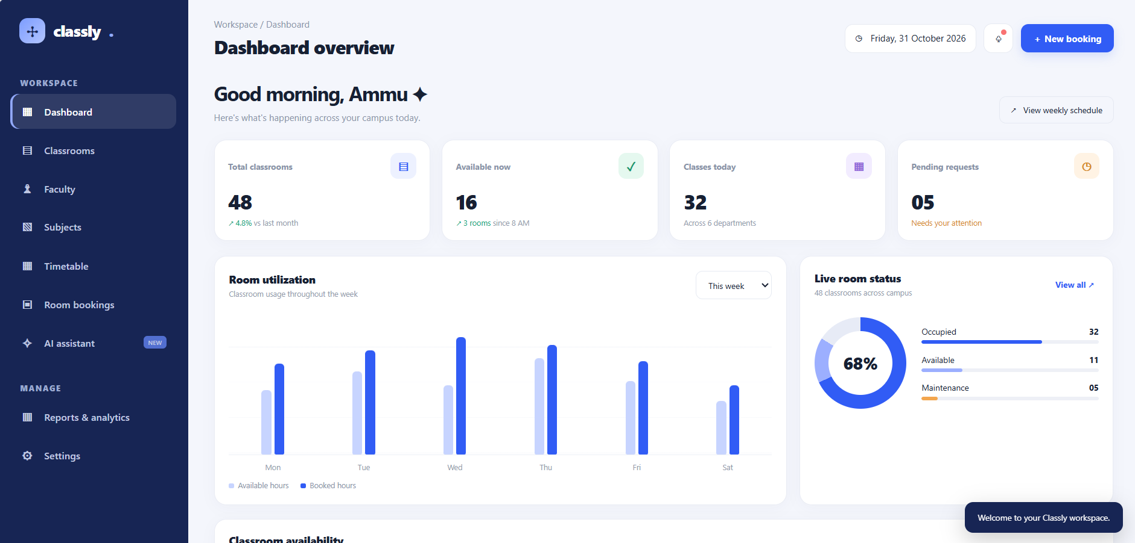

Figure G.3 – Classrooms
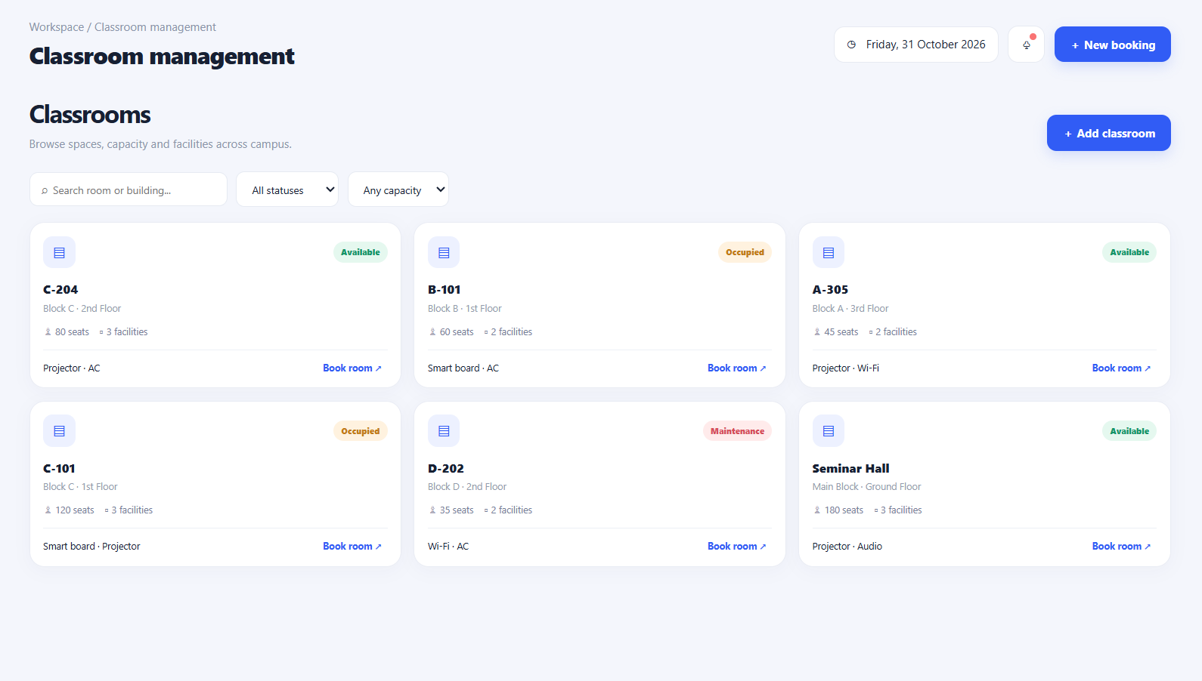

Figure G.4 – Faculty directory
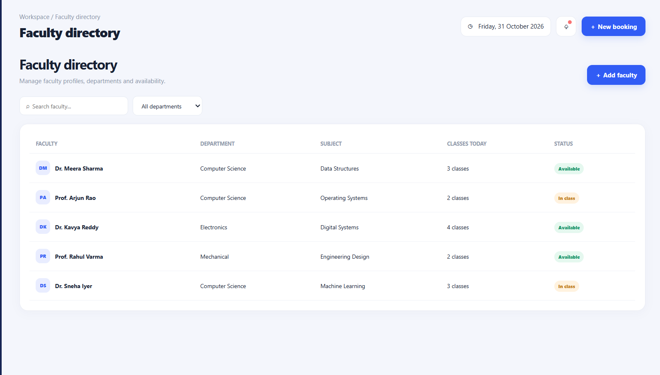

Figure G.5 – Subjects
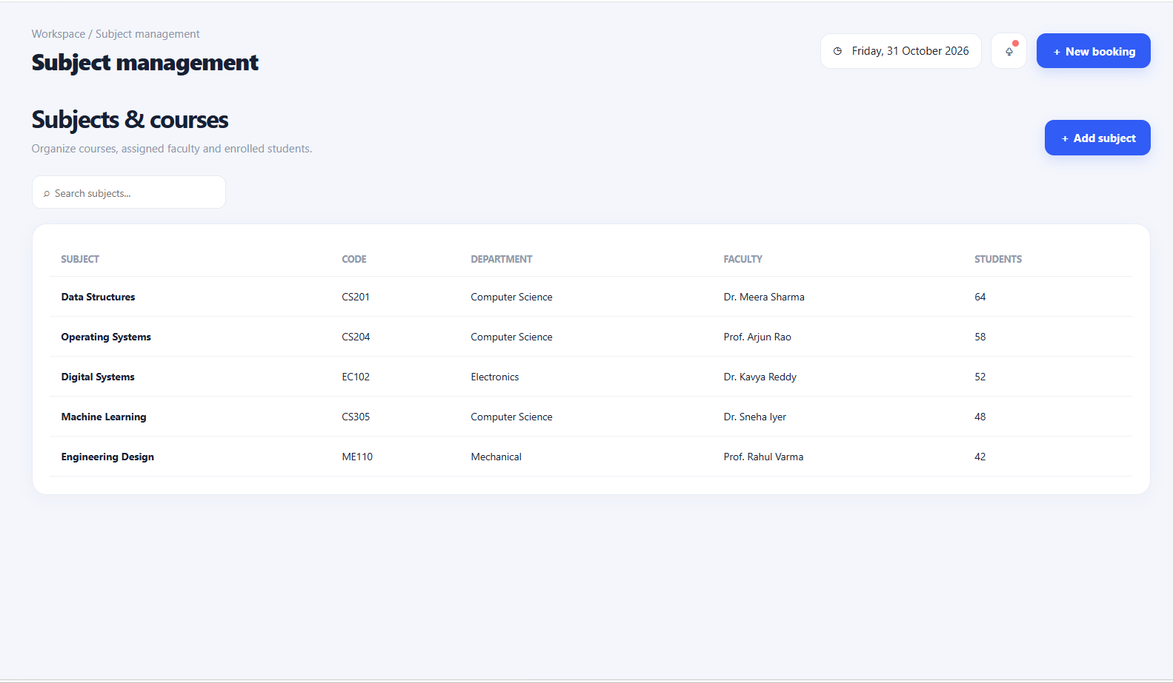

Figure G.6 – Weekly timetable
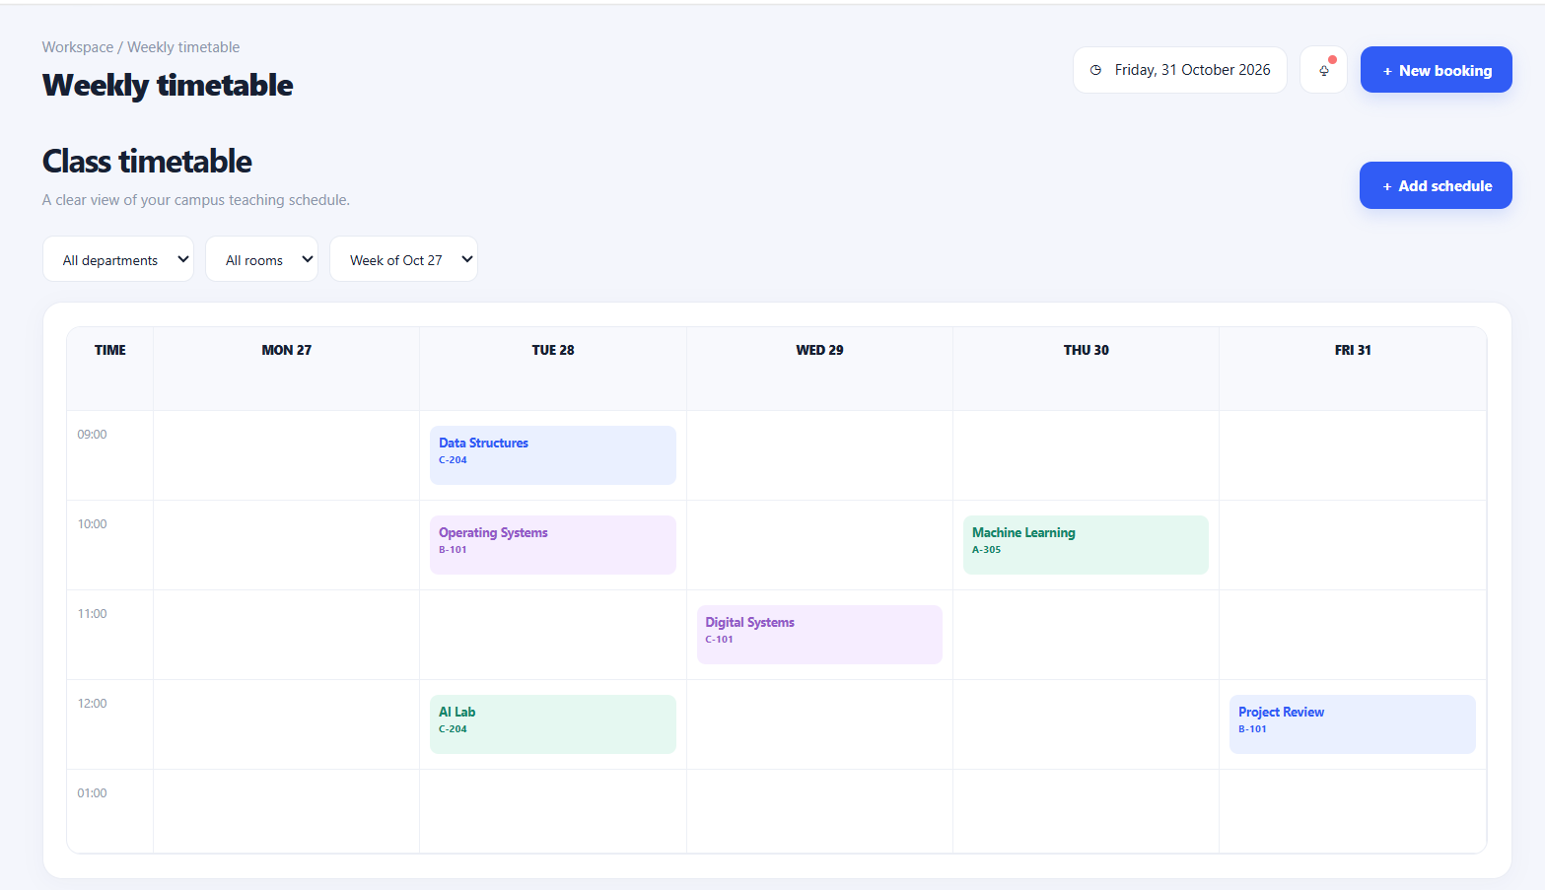

Figure G.7 – Room bookings
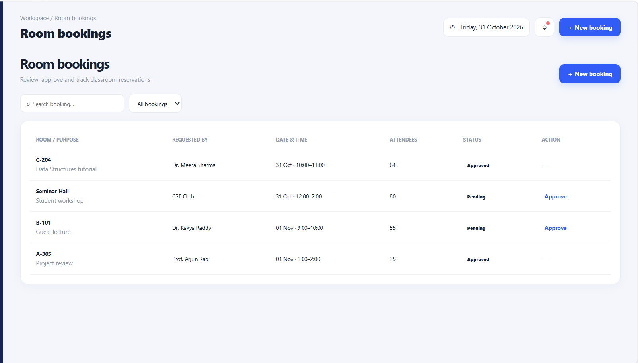

Figure G.8 – New booking form
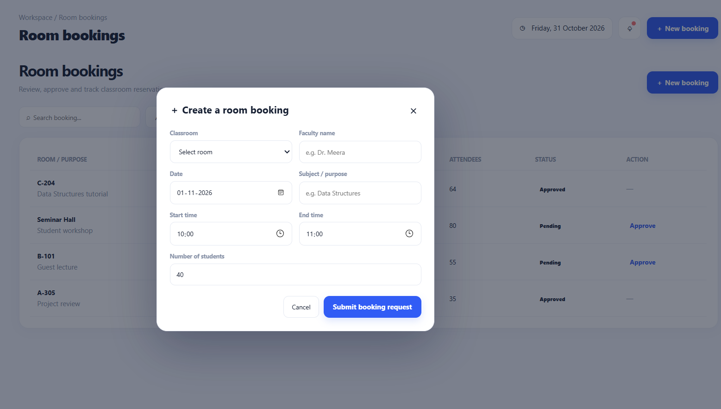

Figure G.9 – AI assistant
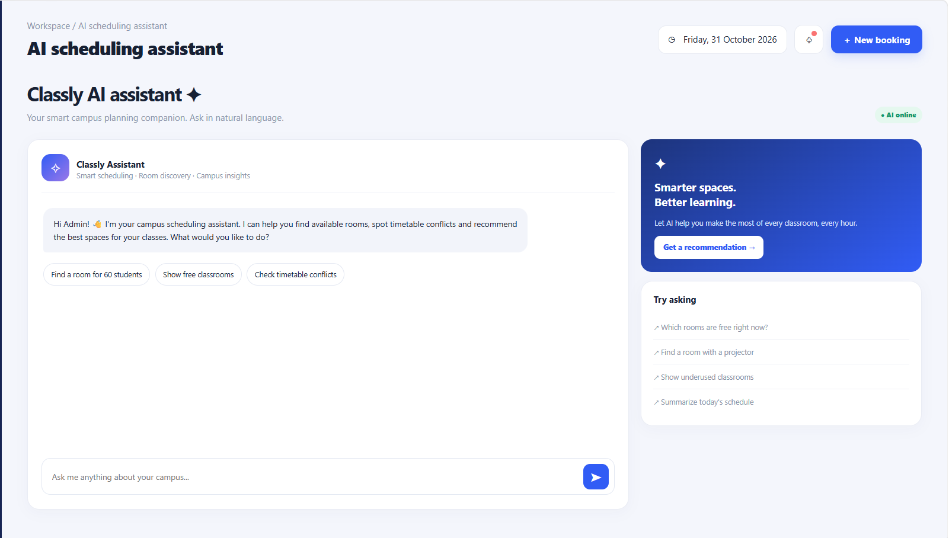

Figure G.10 – Reports and analytics
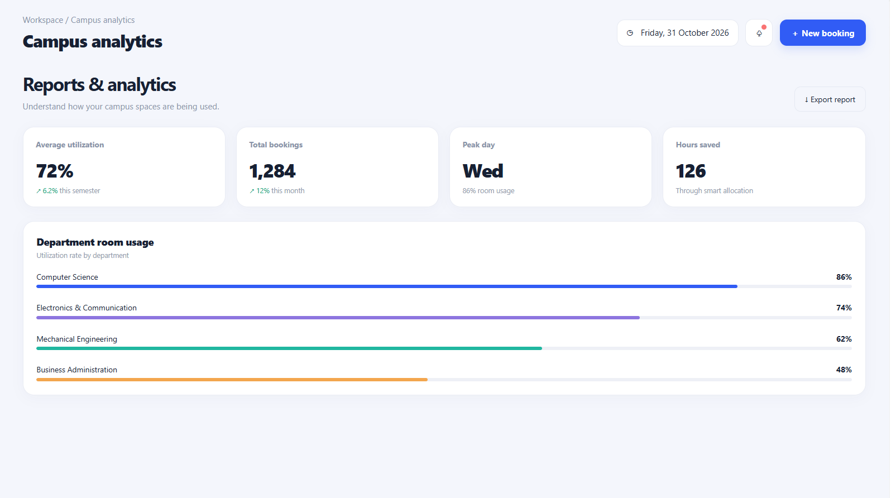

Figure G.11 – Settings
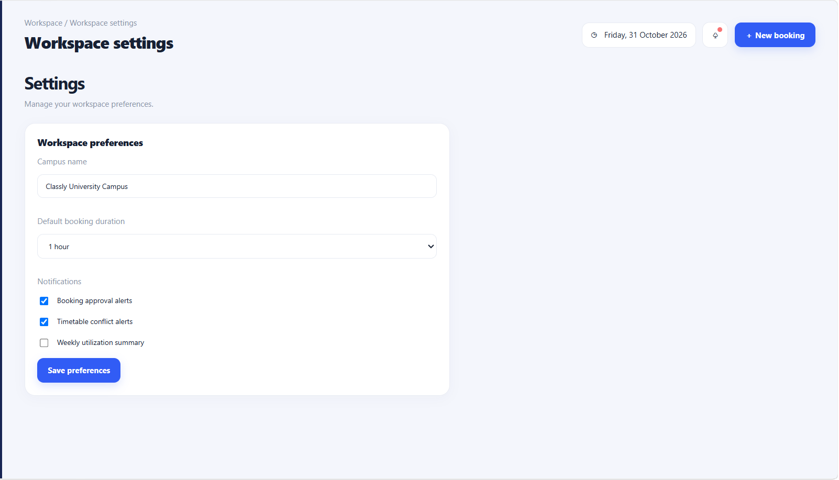

APPENDIX H – GEO TAG PHOTOS
Insert geo-tagged photographs of the team working on the project (GPS location, date and time visible on the photo).
Geo-tag photo 1


