Database System Engineering and Distributed Backend Development
Course Code: 25CS1302E
WEEK-4 practical Name: V. Charishma
Roll no: 2520030140
Query 1:
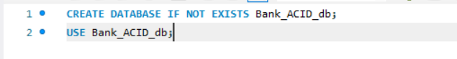
Output:
Query2:
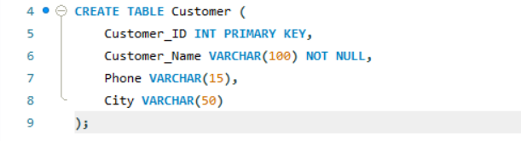
Output:
Query3:
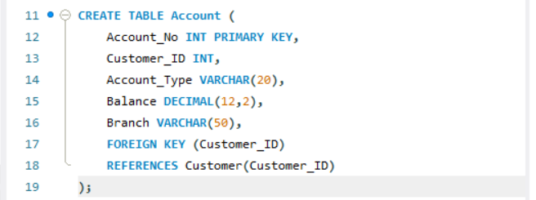
Output:
Query4:
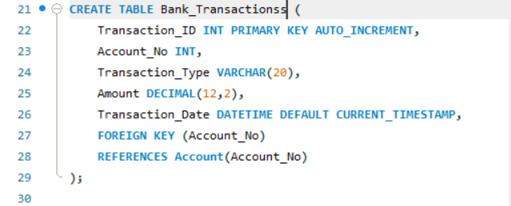
Output:
Query 5:
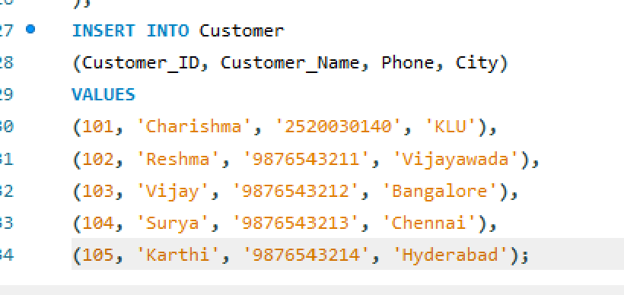
Output:
Query 6:

Output:
Query 7:
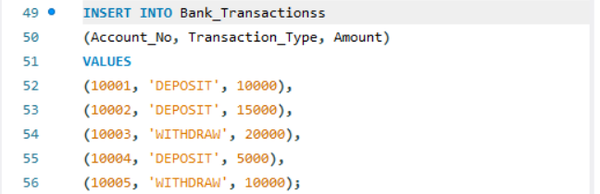
Output:
Query 8:
Output:
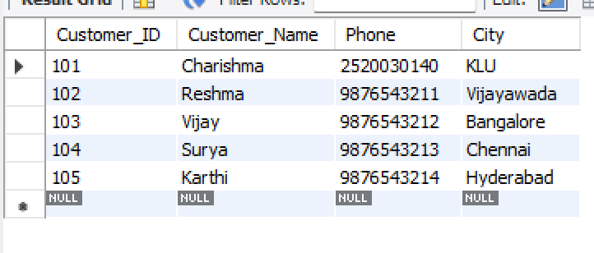
Query 9:
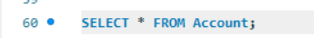
Output:
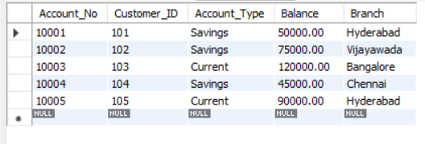
Query 10:
Output:
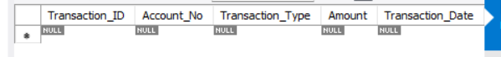
Query11:
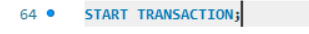
Output:
Query12:
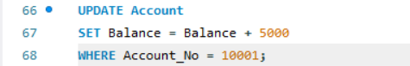
Output:
Query13:
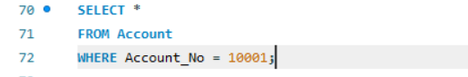
Output:
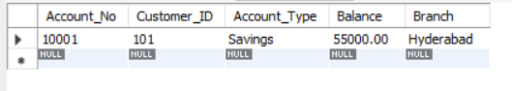
Query14:
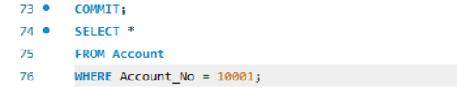
Output:
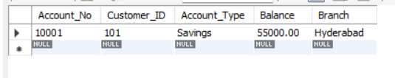
Query15:
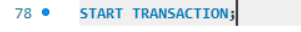
Output:
Query16:
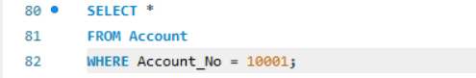
Output:
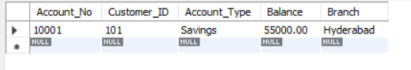
Query17:
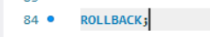
Output:
Query18:
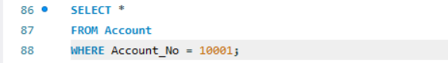
Output:
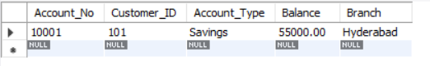

Query19:
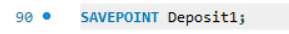
Output:
Query20:
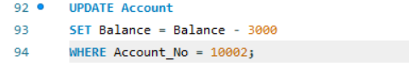
Output:
Query21:
Output:
Query22:
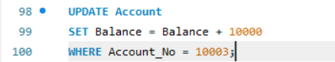
Output:
Query23:
Output:
Query24:
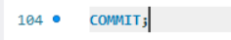
Output:
Query25:
Output:
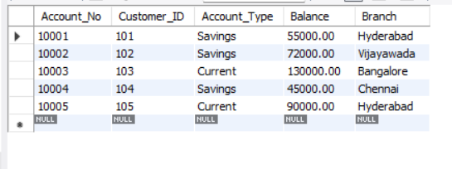
Query26:
Output:
Query27:
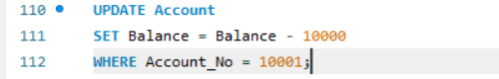
Output:
Query28:
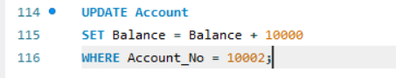
Output:
Query29:
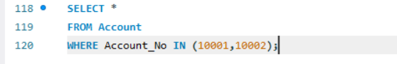
Output:
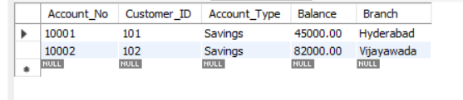
Query30:
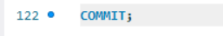
Output:
Query31:
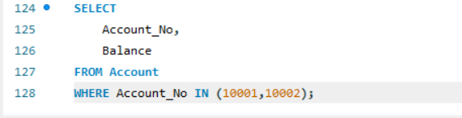
Output:
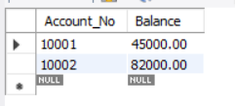
Query32:
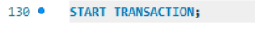
Output:
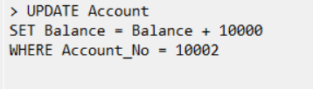
Query33:
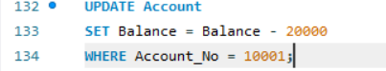
Output:
Query34:
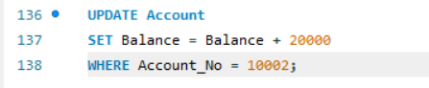
Output:
Query35:
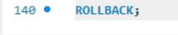
Output:
Query36:
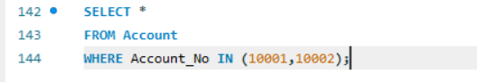
Output:
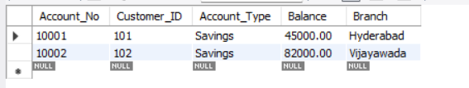
Query37:
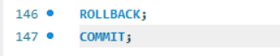
Output:
Query38:
Output:
Query39:
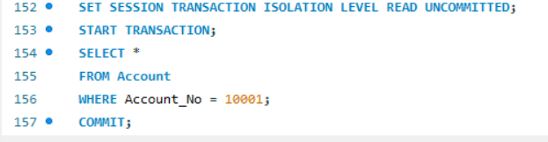
Output:
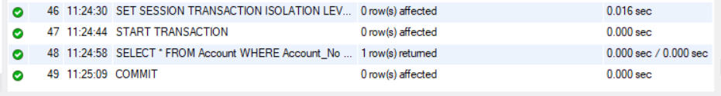
Query40:
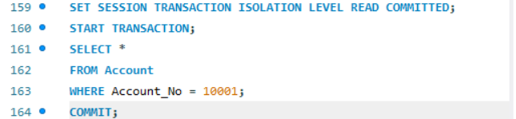
Output:
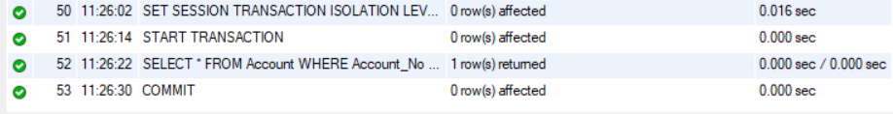
Query41:
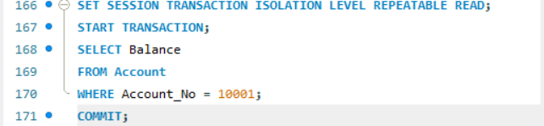
Output:
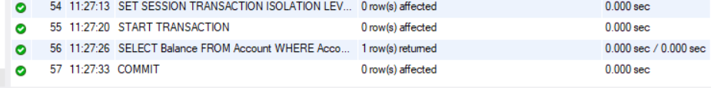
Query42:
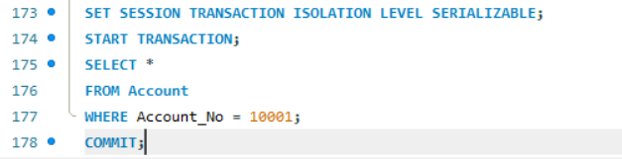
Output:
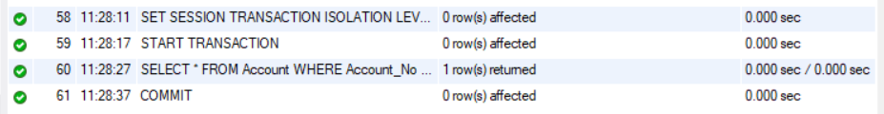
Query43:
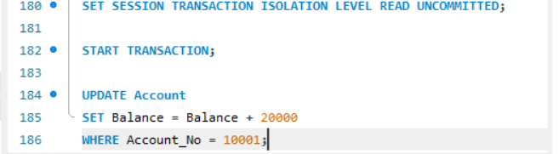
Output:
Query44:
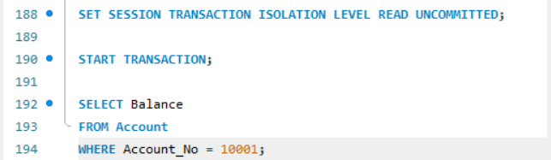
Output:
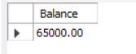
Query45:
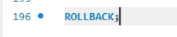
Output:
Query46:
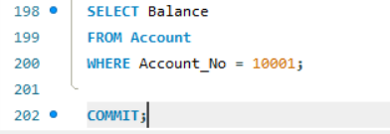
Output:

